

www.gov.uk/naturalengland

Request for Quotation

## 

## Request for Quotation

**Geological Monitoring Programme: Mere Sands Wood SSSI**

You are invited, to submit a quotation for the requirement described in the specification below.

Please confirm, by email, receipt of these documents and whether you intend to submit a quote.

Your response should be returned to the following email address by:

**Email:** [**dan.burgess@naturalengland.org.uk**](mailto:dan.burgess@naturalengland.org.uk) **and** [**hannah.townley@naturalengland.org.uk**](mailto:hannah.townley@naturalengland.org.uk)

**Date: 1st September 2023**

**Time: 17:00**

Ensure you state ‘Geological Monitoring Programme: Mere Sands Wood and ‘Final Submission’ in the subject field to make it clear that it is your response.

**Contact Details and Timeline**

Dan Burgess and Hannah Townley will be your contacts for any questions linked to the content of the quote pack or the process. Please submit any questions by email and note that, unless commercially sensitive, both the question and the response will be circulated to all tenderers.

|  |  |
| --- | --- |
| Action | Date |
| Date of issue of RFQ | 21-Aug-2023 at 13:45 GMT |
| Deadline for clarifications questions | 01-Sept-2023 at 17:00 GMT |
| Deadline for receipt of Quotation | 15-Sept-2023 at 12:00 GMT |
| Intended date of Contract Award | 18-Sept-2023 |
| Intended Contract Start Date | 25-Sept-2023 |
| Intended Delivery Date / Contract Duration | 02-Jan-2024 |

### Glossary

Unless the context otherwise requires the following words and expressions used within this Request for Quotation shall have the following meanings (to be interpreted in the singular or plural as the context requires):

|  |  |
| --- | --- |
| “Authority” | Means the Department for Environment, Food and Rural Affairs acting as part of Natural England |
| “RFQ” | Means this Request for Quotation and all related documents published by the Authority and made available to suppliers |
| “Contract” | Means the contract to be entered into by the Authority and the successful supplier. |

### 

### Conditions applying to the RFQ

You should examine your response to the RFQ and related documents ensuring it is complete prior to submitting your completed quotation.

Your quotation must contain sufficient information to enable the Authority to evaluate it fairly and effectively. You should ensure that you have prepared your quotation fully and accurately and that prices quoted are arithmetically correct for the units stated.

The supplier by submitting a quotation is deemed to accept the terms and conditions in the RFQ. Failure to comply with the instructions set out in the RTQ may result in the supplier’s exclusion from this procurement.

### Acceptance of Quotations

By issuing this RFQ the Authority does not bind itself to accept any quotation and reserves the right not to award a contract to any supplier who submits a quotation.

#### Costs

The Authority will not reimburse you for any costs and expenses which you incur preparing and submitting your quotation, even if the Authority amends or terminates the procurement process.

#### Mandatory Requirements

The RFQ includes mandatory requirements and, if you do not comply with them, your quotation will not be evaluated. All mandatory requirements are set out in Bravo.

#### Clarifications

The Authority reserves the right to discuss, confidentially, any aspect of your quotation with you prior to any award of Contract to clarify matters.

#### Amendments

The Authority may amend the RFQ at any time prior to the deadline for receipt. If it amends the RFQ the Authority will notify you in writing and may extend the deadline for receipt in order to give you a reasonable time in which to take the amendment into account.

#### Conditions of Contract

The terms and conditions - [Condensed Terms and Conditions](https://assets.publishing.service.gov.uk/government/uploads/system/uploads/attachment_data/file/419955/standard-condensed-terms.doc) will be included in any contract awarded as a result of this RFQ process. The Authority will not accept any material changes to these terms and conditions proposed by a supplier.

#### Specification

The Authority is Natural England. The Authority’s priorities are to secure a healthy natural environment; a sustainable, low-carbon economy; a thriving farming sector and a sustainable, healthy and secure food supply. Further information about the Authority can be found at: [Natural England](http://www.naturalengland.org.uk/)

1. **Introduction**

Natural England is the government’s advisor for the natural environment in England, helping to protect England’s nature and landscapes for people to enjoy and for the services they provide.

Natural England assesses the condition of Sites of Special Scientific Interest (SSSIs) for its notified features as part of its Common Standards Monitoring (CSM) programme. In order to do this effectively, sufficient baseline information for each feature must be available (documented).

This contract is required to aid understanding of the geological feature at Mere Sands Wood SSSI.

Results from this project will aid future monitoring and management of the site.

1. **Requirement**

**Access permissions and risk assessments**

As part of the RFQ bid APPLICATION the contractor must provide Natural England with:

* A generic risk assessment, covering detailed requirements about how you will take various risks into account as well as the current risk of avian influenza– you must send this as part of the bid application. Site-specific risk assessments will be required on award of the contract. Further guidance on avian influenza can be found at: https://www.gov.uk/government/news/bird-flu-avian-influenza-latest-situation-in-england#guidance
* Covid-19 is no longer required to be considered as a specific Health & Safety risk but should be assessed as one of the many infectious respiratory diseases that may be encountered, along with appropriate measures to control its risk. Further guidance can be found at: https://www.gov.uk/coronavirus

The site owner may require you to attend a safety briefing and to provide insurance and risk assessments in advance of your visit. Please budget for this in your quote.

The project will be co-ordinated by Natural England’s geology specialists.

**The SSSI**

The boundary of the SSSI and map can be found in Annex 1. One report is required for Mere Sands Wood SSSI.

Mere Sands Wood SSSI is notified for it’s Late Devensian coversands, known as the Shirdley Hill formation. These windblown sands were deposited at the end of the last Ice Age, when the landscape was sparsely vegetated, and winds moved silts and sands from glacial outwash. The coversands are approximately 1m thick under the modern soil, but locally can be anywhere up to 5m thick. A series of pits were excavated at the site to extract the coversands (silica sand) for use in the glass industry.

Since the closure of the pits, the site has been managed as a nature reserve by Lancashire Wildlife Trust (LWT). The site is now a mature woodland with a series of lakes and ponds which are the flooded former sand pits. There are a series of paths and trails around the site with bird hides plus a car park, visitor centre and café.

The site is classified as Finite Buried Interest. It is not appropriate to keep the geology exposed, given the soft sediments, exposures will degrade very quickly. However, favourable condition requires that the sediments are easily exposable in areas of the site which are managed for their geological conservation.

**The Survey**

Natural England requires a modest invasive survey at Mere Sands Wood SSSI to establish key locations where intact deposits of the Shirdley Hill Sand Formation can be found onsite. Once the locations of intact deposits have been determined, they will form locations for geoconservation management and future monitoring surveys at the site.

A walkover survey took place in October 2022 by Natural England and Lancashire Wildlife Trust staff, and the following four locations were identified as having potential for surviving intact deposits. The corresponding Map detailing locations is attached at Annex 2.

|  |  |  |  |
| --- | --- | --- | --- |
|  | **Location** | **Map symbol** | **Suggested method for accessing sediments for inspection** |
| 1 | Field A dry heath, grid reference SD446159 | Black square | Borehole/trial pit |
| 2 | Grid reference SD44771568. Drain between End Lake and Heath Lake | Dark blue square | Clear section in drain |
| 3 | Main drain approximately in line with the southern bank of End Lake | Light blue square | Clear section in drain |
| 4 | Arboretum/forest school area point E | Green square | Borehole/trial pit |

All natural sediments exposed in sections or trial pits, and all boreholes are required to be logged, photographed, and described.

A trial pit can be used to assess the uppermost part of the stratigraphy within safe depth limits for the sediments present. An adjacent borehole at a suitable distance can then be used to examine sediments at a greater depth.

The boreholes/trial pits must be geo-referenced so that this can be used to inform future monitoring and potentially further research. The excavations must be backfilled, and the topsoil reinstated to the satisfaction of Natural England and Lancashire Wildlife Trust.

For suggested section locations, exposures of the sediments should be obtained in the sides of the drain. Arisings should be stored according to instructions from Lancashire Wildlife Trust. The size of the exposure should be the minimum necessary for exposing the natural sediments. If after reasonable endeavours, natural sediments cannot be found, excavations should be halted and backfilled as required by Lancashire Wildlife Trust.

**Outputs**

* A copy of any correspondence with the landowner
* Confirmation (including maps, logs, photographs etc.) of the depth and potential extent of the notified features within the SSSI
* The precise borehole/trial pit/section locations and restoration methodology must be detailed in the final report
* A recommendation of potential locations for future Condition Monitoring of the SSSI

Reports to be provided as an MS Word file (including embedded photographs and maps). Tenderers should be aware that Natural England and Defra may subsequently publish reports

**Post contract award activities:**

1. Provision of/access to resources including:

* Individual [SSSI citations](https://designatedsites.naturalengland.org.uk/SiteSearch.aspx) and associated [maps](https://magic.defra.gov.uk/) can be downloaded

1. Access permissions – Natural England will obtain permission for your work and provide landowner contact details.
2. The site survey will involve liaison with land managers (as above). Agreed risk assessments and H&S procedures should always be followed, including appropriate bio-security measures.
3. Post survey a report will be produced (see outputs) to the Natural England Project Officer for the site.

All site surveys and working practice to be undertaken with an agreed risk assessment that is Covid compliant and meeting relevant government guidelines.

**Tender evaluation**

**Evaluation criteria**

The contract will be awarded to the tender which best fits the profile of requirements. This will be assessed by the project officer in consultation with relevant colleagues using the evaluation criteria below.

We will award this contract in line with the most economically advantageous tender as set out in the following award criteria:

Price – 40%

Quality – 60%

|  |  |  |
| --- | --- | --- |
| Quality Criteria | Weighting | To include |
| Technical knowledge - geology | 30% | Demonstration of sufficient geological knowledge to be able to carry out work (can include CV of key contractors, evidence of similar work undertaken) |
| Technical experience – site survey | 25% | Demonstration of field experience in this type of work (can include CV of key contractors, evidence of similar work undertaken) |
| Methodology | 5% | An outline of the methodology that will be adopted and applied |

|  |  |
| --- | --- |
| **Score** | **Justification** |
| For a score of hundred (100): | Excellent - Response is completely relevant and excellent overall.  The response is comprehensive, unambiguous and demonstrates a thorough understanding of the requirement and provides details of how the requirement will be met in full. |
| For a score of seventy (70): | Good - Response is relevant and good.  The response demonstrates a good understanding and provides details on how the requirements will be fulfilled. |
| For a score of fifty (50): | Acceptable - Response is relevant and acceptable.  The response provides sufficient evidence to fulfil basic requirements. |
| For a score of twenty (20): | Poor - Response is partially relevant and/or poor.  The response addresses some elements of the requirements but contains insufficient / limited detail or explanation to demonstrate how the requirement will be fulfilled. |
| For a score of zero (0): | Unacceptable - Nil or inadequate response.  Fails to demonstrate an ability to meet the requirement. |

**Quotation Submission**

The submission will be assessed against the methodology (5%), knowledge and experience of geology and surveys (55%) under quality and cost (40%). Using the bidder template provided please include a detail explanation of the methodology you intend to use for the surveys.

In addition, include information relating to your quality assurance and project management procedures.

You will also be required to submit a brief curriculum vitae for each person that will be carrying out work in relation to this contract. This must include their qualifications and experience relating to these surveys..

As outlined above, we require a detailed risk assessment covering;

* A generic risk assessment. Site-specific risk assessments will be required as part of your submission. Please see examples attached to the email
* Assurance that contractors will work within government guidance on working outdoors: <https://www.gov.uk/guidance/working-safely-during-coronavirus-covid-19/construction-and-other-outdoor-work>

**Timescales**

W/C 10th July 2023 – Inception meeting between project officers and supplier by teleconference if required (alternately happy to correspond by email)

w/c 1st January 2024 – Final reports, in digital format via e-mail, due to project officer

Prices will remain fixed for the duration of the contract award period. We may at our sole discretion extend this contract to include related or further work or if there are extenuating circumstances meaning you cannot access the sites. Any extension shall be agreed in advance of any work commencing and may be subject to further competition.

We will raise purchase orders to cover the cost of the services and will issue to the awarded supplier following contract award.

Suppliers will be required to invoice after the final reports have been received and signed off by Natural England.

**Prices**

Prices must be submitted in £ sterling, inclusive of VAT (where applicable).

Please provide a breakdown of the costs in the copy of this table in the bidder template document.

|  |  |  |  |  |
| --- | --- | --- | --- | --- |
|  | **Item of work** | **Day £ rate of staff** | **Number of days** | **Total Price £**  **(ex. VAT)** |
| 1 | Fieldwork |  |  |  |
| 2 | Laboratory Analyses |  |  |  |
| 3 | Hire of Equipment (If applicable) |  |  |  |
| 4 | Reporting |  |  |  |
| 5 | Travel and subsistence costs |  |  |  |
| 6 | Other costs (please specify) |  |  |  |
| 7 | Sub-total |  |  |  |
| 8 | VAT at 20% if applicable |  |  |  |
| **8** | **Total** |  |  |  |

**Contract Management**

This contract shall be managed on behalf of the Authority by:

Dan Burgess

[Dan.burgess@naturalengland.org.uk](mailto:Dan.burgess@naturalengland.org.uk)

07503 180206

Hannah Townley

hannah.townley@naturalengland.org.uk

07780 688 242

**Disclosure**

All Central Government Departments, their Executive Agencies and Non Departmental Public Bodies are subject to control and reporting within Government. In particular, they report to the Cabinet Office and HM Treasury for all expenditure. Further the Cabinet Office has a cross-Government role delivering overall Government policy on public procurement, including ensuring value for money and related aspects of good procurement practice.

For these purposes, the Authority may disclose within Government any details contained in your quotation. The information will not be disclosed outside Government during the procurement.

In addition, the Authority is subject to the Freedom of Information Act 2000 and the Environmental Information Regulations 2004, which provide a public right of access to information held by public bodies. In accordance with these two statutes, the Authority may be required to disclose information contained in your quotation to any person who submits a request for information pursuant to those statutes.

By submitting a quotation you consent to these terms as part of the procurement.

### Disclaimers

Whilst the information in this RFQ and any supporting information referred to herein or provided to you by the Authority have been prepared in good faith the Authority does not warrant that this information is comprehensive or that it has been independently verified.

The Authority does not:

* make any representation or warranty (express or implied) as to the accuracy, reasonableness or completeness of the RFQ;
* accept any liability for the information contained in the RFQ or for the fairness, accuracy or completeness of that information; or
* accept any liability for any loss or damage (other than in respect of fraudulent misrepresentation or any other liability which cannot lawfully be excluded) arising as a result of reliance on such information or any subsequent communication.

Any supplier considering entering into contractual relationships with the Authority following receipt of the RFQ should make its own investigations and independent assessment of the Authority and its requirements for the goods and/or services and should seek its own professional financial and legal advice.

**Protection of Personal Data**

In order to comply with the General Data Protection Regulations 2018 the contractor must agree to the following:

* You must only process any personal data in strict accordance with instructions from the Authority
* You must ensure that all the personal data that we disclose to you or you collect on our behalf under this agreement are kept confidential.
* You must take reasonable steps to ensure the reliability of employees who have access to personal data.
* Only employees who may be required to assist in meeting the obligations under this agreement may have access to the personal data.
* Any disclosure of personal data must be made in confidence and extend only so far as that which is specifically necessary for the purposes of this agreement.
* You must ensure that there are appropriate security measures in place to safeguard against any unauthorised access or unlawful processing or accidental loss, destruction or damage or disclosure of the personal data.
* On termination of this agreement, for whatever reason, the personal data must be returned to us promptly and safely, together with all copies in your possession or control.

**General Data Protection Regulations 2018**

For the purposes of the Regulations the Authority is the data processor.

The personal information that we have asked you provide on individuals (data subjects) that will be working for you on this contract will be used in compiling the tender list and in assessing your offer. If you are unsuccessful the information will be **held and destroyed within two years** of the award of contracts. If you are awarded a contract it will be retained for the duration of the contract and destroyed within **seven years** of the contract’s expiry.

We may monitor the performance of the individuals during the execution of the contract, and the results of our monitoring, together with the information that you have provided, will be used in determining what work is allocated under the contract, and in any renewal of the contract or in the award of future contracts of a similar nature. The information will not be disclosed to anyone outside the Authority without the consent of the data subject, unless the Authority is required by law to make such disclosures

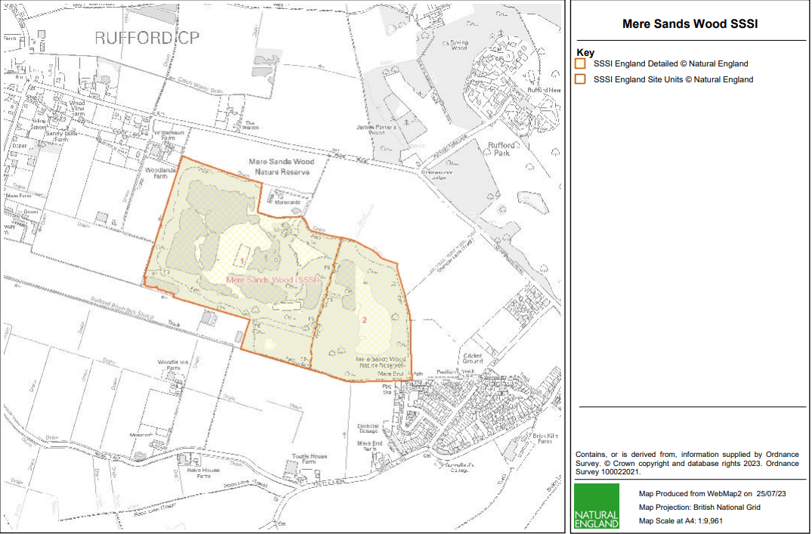**Annex 1: - Map of Mere Sands Wood SSSI**

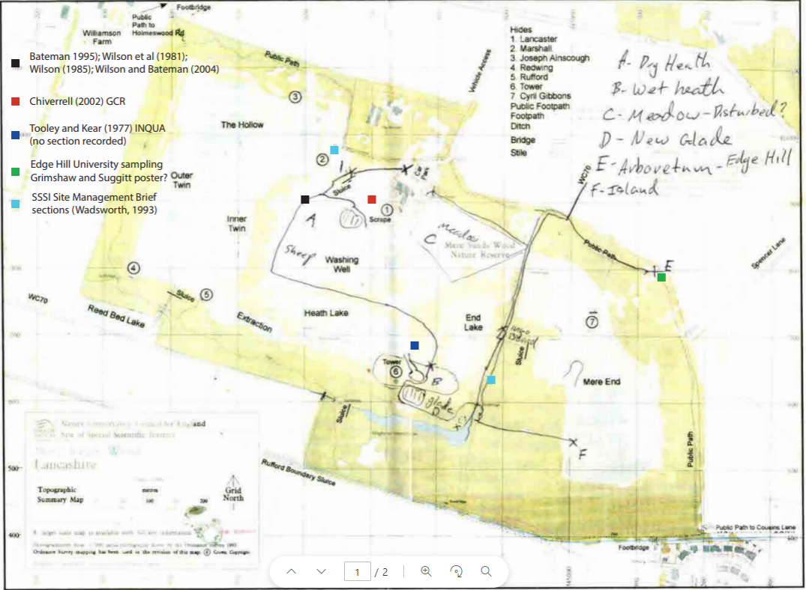**Annex 2: - Potential Surveying Locations**