

Council Offices, South Street, Farnham, Surrey GU9 7RN

Hale Cemetery Garden Project

Briefing document for tenders in respect of the

Demolition of Chapels and the Creation of a Garden

at Hale Cemetery, Alma Lane, Farnham GU9 OLR

You are invited to submit a tender for this project.
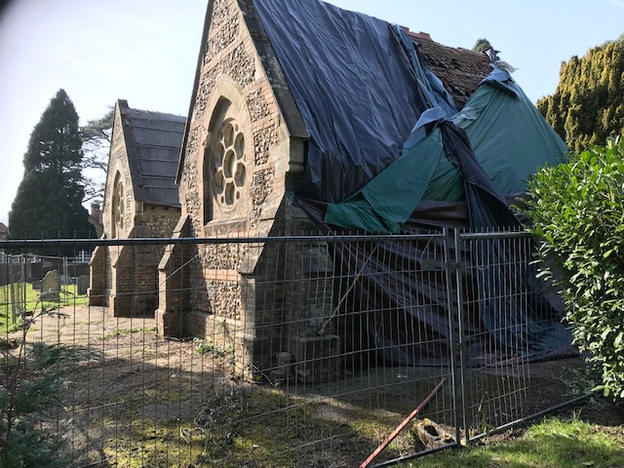
Image courtesy of Graduate Landscapes

Contents
Section |  | Page
1. | Background | 2-3
2. | Statement of Requirements | 3-6
3. | Outcomes | 7
4. | Timescale | 7
5. | Resources | 7
6. | Contract Management and Performance | 7-8
7. | Insurance | 8
8. | Form of Contract and CDM responsibilities | 8
9. | Site Visit | 8
10. | Tender return date and format | 8-9
 | Appendices B-F | 11-21

Background

- Context and history
The cemetery chapels were designed by Sidney Stapley in 1871, and built in 1872, on
land donated to the parishioners of Hale by the War Office. As was typical at the time, one chapel was consecrated for use by the Church of England, with the other chapel being for use by other denominations. In 2012, the Guildford Diocese agreed to remove the legal effects of consecration which paved the way for a sympathetic development.

The chapels are built from local flint with a brick plinth and string courses, stone copings and buttress cappings, windows and door openings. The rooves are clay tiles.

The chapels are approached from a lychgate in Alma Lane.

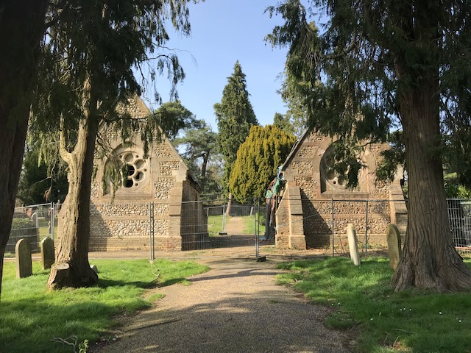

- Condition
The chapels are now in very poor condition, with large areas of each roof badly damaged and exposed to the elements. The buildings have no electrical or other services.

- Proposal
It is proposed to demolish the chapels and create a Garden of Reflection to the design created by Graduate Landscapes (see Appendix A – a separate document) which incorporates and redeploys elements of the existing chapels.

Statement of Requirements

Please read the following carefully.
The successful contractor will be bound by contract to demolish the chapels and deliver the specified garden in accordance with the requirements and within the contractor’s costings quoted in the Price Schedule (Appendix B).
  - Overview

- Management Responsibilities

- The successful tenderer will be the Principal Contractor for the duration of the works, responsible for, amongst other things, the Health and Safety aspects of the work including all Health and Safety documentation, the supervision of all work on site, attending fortnightly client meetings and the production of the O&M manual on completion.

- As detailed below, great emphasis is placed on the sensitivities involved when undertaking work within a cemetery. As part of this, collaboration with the Town Council in informing cemetery users and the local community is a vital element of the contractor’s responsibilities.

- Site Preparation

- This will include setting up the site in the context of the cemetery, to include site delineation, specifically areas for WC, any office facilities, plant and equipment storage and protection with suitable security fencing, boarding on designated grassed areas, and CCTV. It should be noted:

- that the cemetery is not staffed and is unsecured making it particularly vulnerable after dark. Valuable equipment and machinery should not be left overnight;
- access to cemetery areas outside of the site, including vehicular access by Town Council workforce staff and equipment should not be impeded by the works carried out by the contractor;
- the cemetery sits on a busy road with inadequate parking. Delivery and disposal vehicles should be scheduled to minimise the impact on local traffic. It is a specific planning condition that no HGV movements to or from the site shall take place between the hours of 8.30am and 9.15am and 2.45pm and 4pm, nor shall the contractor permit any HGVs associated with the development at the site to be laid up, waiting, in Alma Lane during these times;

- access to the cemetery is via a narrow lychgate. Contractors may consider that the gate needs to be carefully removed during some of the works and refitted to its original position at the earliest opportunity and should, therefore allow for this in their costings;

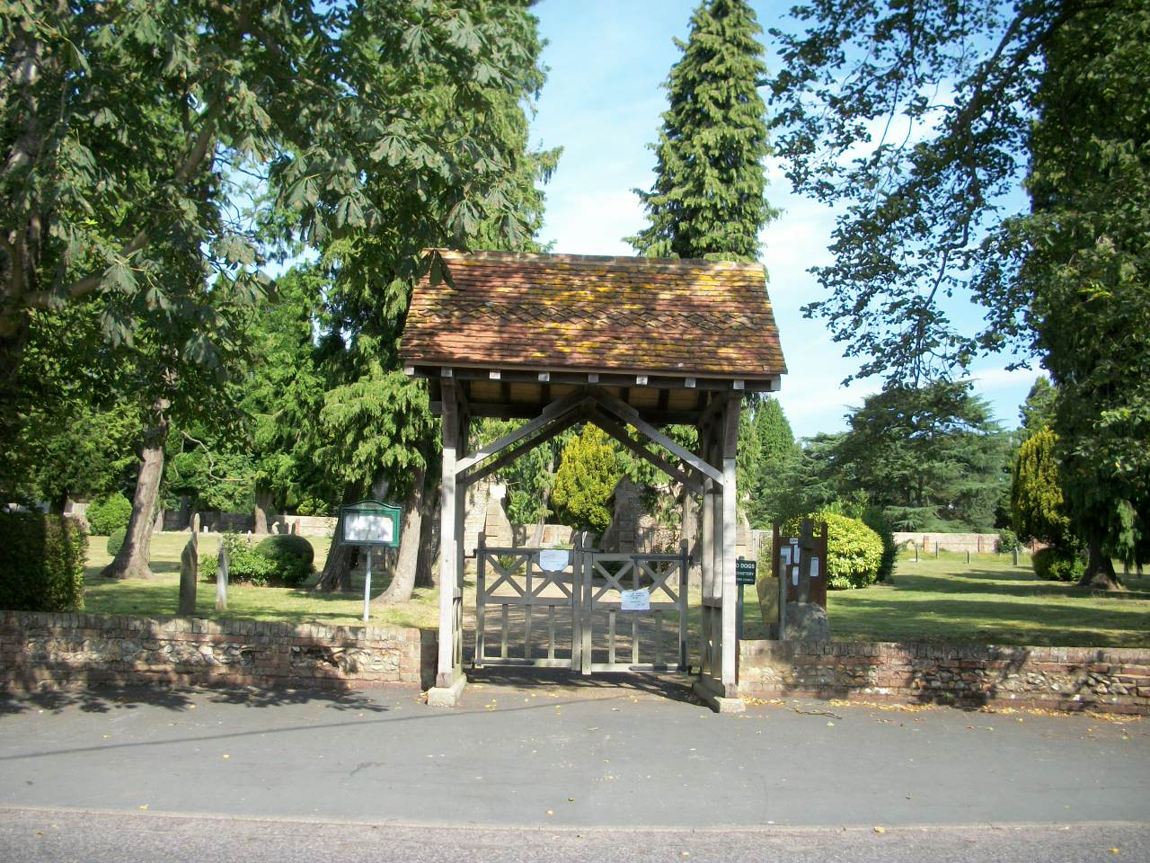
The Lychgate

- furthermore, all works should cease in the event of a burial taking place (approximately 4 per year) and due consideration given to users of the cemetery. In this respect it is important that times and dates for demolition and clearance are clearly set out and adhered to. A temporary notice board should be erected by the contractor at the entrance to the cemetery updating users of the cemetery and the community of planned work and progress.
- Similarly, due regard should be given to the effects of noise and dust on the nearby properties, including the cemetery lodge, neighbouring school and housing. The contractor should consider any activities that are likely to create any dust or emissions, including noise, in order to control these at the source. Controls may include dampening down of the site during any dusty activities and consideration for the type of equipment to be used.
- All work should be carried out within the confines of the site as defined on the attached plan (Appendix F) or by specific written arrangement with the Town Council.
- Damage to gravestones, graves, gates, walls, footpaths, turfed areas and roads will be repaired at the expense of the principal contractor.
- In view of the above it would be expected that method statements covering demolition and disposal will have to be approved before the awarding of the contract.

- Demolition of the two chapels involving:

- the careful dismantling and storage on site of features that are to be re-used in the construction of “The Folly” Garden (Appendix A);
- the retention in places of reduced walls that form part of the structure of the garden;
- setting aside specified stonework that is required for purposes of the Town Council; and
- removal from site of all other materials – e.g. stone, wood, tiles, bricks, foliage, soil, tarmac – not required for the instalment of the new garden.

- Hard landscaping

- The garden will be constructed in accordance with the design for “The Folly” produced by Graduate Landscapes Ltd. (Appendix A). Any proposed variation must be agreed with the Town Council.
- The successful contractor will be expected to produce detailed construction drawings for the hard landscaped areas of the site, including low level walls, seating, paving, drainage and features to be approved before the commencement of the contract. The cost of producing these drawings should be included in the tender submission.

- Planting

- Planting Plans should be explicit in terms of the suitability of plants in relation to the “Biblical Garden theme”, soil type, texture, pH, site aspect, drainage, seasonal interest, height and spread, seasonal maintenance requirements (e.g. pruning times) and plants should described by both Latin and common names.

- If it is not sensible to plant everything at the time of construction then planting timescales should be given.

- Services
- Currently there are no services connected to the site.

- However, both electricity and water services will be required and installed under this contract. Water will be required for a subsequent water feature and electricity will be required both to service permanent CCTV coverage and the pump/filters of the water feature (the design and construction of which will begin after the contract is awarded and installed either as an add on to this contract or separately). Bearing this in mind contractors, for their own usage might wish to initiate these services at the outset of the contract. In any event, the laying on of these services from the mains should be explicitly factored into the costs set out in Appendix B.

Image courtesy of Garden Landscapes

Outcomes

The Farnham Town Council requires that:
- The garden shall be fully operational allowing visitors to have safe and comfortable enjoyment of the garden. A structural engineer’s report produced by the contractor to certify the safety of the constructions will be required and should be included in the tender costs.
- The garden should be designed to a level allowing operation with a simple maintenance schedule that is manageable by basically trained personnel.
- The project should be carried out in a timely manner.
- Health and safety risks shall be minimised to all involved in the work at all stages of the work and in particular the public during demolition and clearing activities.
- Work and progress inspection by Farnham Town Council will be required during the progress of the work.
- Transparency in 3rd party contracts placed in support of the contract fulfilment is required.
- The project should be well documented for Council records, including materials used, methods employed and photographic records.

Timescale
Tenders should include the proposed timescale for the project.

Resources
All resources (costs and staffing) required for the work route to be undertaken and the outcomes to be met are to be provided by the project. Only inspection and review resources will be provided by Farnham Town Council.

Contract Management and Performance
- Review Process
Formal reviews will be linked to the payment plan and progress targets (Appendix C). Informal inspection may occur at anytime during the contract period. Access to the site should be allowed for nominated Town Council staff or their designated representatives.
- Project Progress and Payment Plan
Tenders should set out proposed payment schedule against progress.

- Sub-contracting

The successful contractor is required to notify Farnham Town Council of any proposed, significant external contracts (e.g. for demolition) and the Town Council reserves the right to veto such proposals should there be good reason.

Insurance
The successful tenderer will be asked to provide evidence of public liability insurance of at least £10m.

8. Form of Contract and CDM Responsibilities
The form of contract for this project will be a JCT Minor Works Building Contract, with the successful tenderer being appointed as the Main Contractor and Principal Designer under the CDM Regulations and as such will be responsible, inter alia, for the production of the Construction Phase Plan and the Health & Safety File.

9. Site Visit
Contractors are welcome to visit the site at any time. However, in order to view the inside of the chapels and closely inspect the fabric it will be necessary to visit on Tuesday 27th September, between 11.00am and 1.00pm. It is strongly suggested that significant intended sub-contractors (e.g. for demolition) are also invited to attend by the tenderer. Please notify Iain Macready by e-mail – iain.macready@farnham.gov.uk if you intend to visit on this date. And please bring a hard hat on the day! It may be possible to arrange for visits on other days, although this cannot be guaranteed and may leave tenderers with little time to properly complete the required documentation.

10. Tender
1. Tenders should include the completion and return of the following Annexes:
- Appendix B – Schedule of charges
- Appendix C – Timescale and proposed payment schedule
- Appendix D - References
- Appendix E – Main Tender Document (Form of Tender)

2. You are required to submit a fixed priced tender, and this is to remain open for acceptance for 12 weeks from the date of Tender return. Contingency sums should be included separately and explained. If necessary, drawing upon contingency sums will be subject to agreement with Farnham Town Council.

3. The proposed start date is to be agreed with Farnham Town Council. However, completion (subject only to planting conditions) must be no later than 28 February 2023.

4. Farnham Town Council does not undertake to accept either the lowest or any Tender bid. The tender bid will be assessed by cost, programming and start date and quality of submission to include health and safety.

5. Neither the Farnham Town Council or Servant of the Employer shall have any authority to make any representation or explanation to persons tendering as to the meaning of the Contract Document or as to anything to be done or supplied by the Tenderer or as to any other matter or things so to bind the Employer or fetter the judgement or discretion of Farnham Town Council in the exercising of its powers and duties under the terms of the Contract.

6. Should the Tenderer be uncertain as to the meaning or intention of or wish to qualify anything contained within the Contract Documents he must set forth the particulars of each uncertainty or qualification in writing. The Form of Tender shall be endorsed accordingly and such written particulars shall be submitted with the Tender.

7. The Tenderer is hereby notified of the complexity of the works and site conditions. The tenderer is clearly advised to visit the site before completing this tender, and take this factor into account at tender stage, as no claims will be entertained in the future owing to circumstances relating to these factors.

8. No Tender will receive consideration unless submitted by the due date and time, and comply with all instructions.

9. Tenders should arrive by no later than 1.00pm on Friday, 7th October 2022 addressed as follows:
Tender Document
Not to be opened until
1.00pm on 7th October 2022

The Town Clerk
Farnham Town Council
Council Offices
Farnham
Surrey GU9 7RN

TENDERS RECEIVED AFTER 1pm ON 7th OCTOBER 2022 WILL NOT BE CONSIDERED. IT IS RECOMMENDED THAT CONTRACTORS SEEK TO RETURN THEIR TENDERS BY 6TH OCTOBER TO AVOID ANY POSTAL DELAYS. ELECTRONIC SUBMISSIONS (E.G. BY E-MAIL) WILL NOT BE ACCEPTED).

Appendix B

Tender Price Schedule - Hale Cemetery Project, Alma Lane, Farnham GU9 0LT

Item | Description | Quantity | Unit Rate | Price  £ (ex. VAT) | Sub-totals  £ (ex. VAT)
1 | PRELIMINARIES
 | Access: move lychgate and arch to enable works and relocate back on completion
 | Site protection fencing, boarding and CCTV
 | Site office, WC facilities
 | Health and Safety document
 | Setting out and supervision
 | Client meeting, fortnightly designer report
 | Temporary scaffold
 | Plant & equipment
 | O&M manual on completion
 |  |  |  | Sub-total | £
2 | DEMOLITION
Demolish 2 Cemetery Chapels
All works carried out in accordance with BS6187/2011 – Code of Practice for Full or Partial Demolition

To carefully demolish the existing structures. down to
approx.H900mm above ground level for those elements required in the final design (Appendix A refers).

To salvage and set aside the bricks, flints and stone windows for re-use in the new proposed "Folly Garden" as shown
on Graduate Landscape Drawings: Concept A, The Folly (Appendix A)

 | After garden works, to clear the demolition arisings from site.
 | Remove and safely dispose of hazardous materials e.g. asbestos if found
To provide information required for Health
And Safety documentation.

 |  |  |  | Sub-total | £
3. | EXCAVATION
 | By machine excavate to reduce levels,  Profile new formation levels  Tree Root Protection Areas: No Dig  Paving @ D250mm  Walls: No dig  New tree pits @ D600mm  New plant beds @ D350mm | 120m3
 | Muck-away excavated spoil from site | 120m3
 |  |  |  | Sub-total | £
4. | WALL CONSTRUCTION
 | Ensure the integrity of the walls both after demolition and after construction, including the production of a report from a qualified structural engineer.
Construct walls as per Graduate Landscape Design (Appendix A) utilising site reclaimed
materials brick, flint and stone masonry pieces.

Wall: Double faced
Bond - style to match existing flint, brick bonds
Bond - stone re-laid as shown on drawing
Seats: - Reclaimed Yorkstone Paving,
min. 75mm thick, bespoke cut to size with hand fettled
edges.
Bed: on 10mm Natural hydraulic lime mortar, AM
with gritty sharp sand
Finish: flush, brushed back finish to expose aggregates
Voids: fill with concrete

 | Remove surplus materials from the site
 |  |  |  | Sub-total | £
5. | EDGES
 | Install 75mm high, 6mm thick metal edges on steel stakes – finish: natural steel. | 165m
 |  |  |  | Sub-total | £

6. | PAVING
 | - Cobbles
 | GEOTEXTILE  Material: Terram 1000  Supply and place geotextile membrane to grade | 10m2
 | SUB-BASE:  Type 1 to a depth of 150mm compacted | 2m3
 | RECLAIMED FLINT COBBLES  Size: random  Bond: random style to match existing  Bed: bedding mortar  Joints: - Gap random, jointing mortar in a colour to be agreed with client | 10m2
 |  |  |  | Sub-total | £
- Tar and chip gravel surface, central garden area.

Please note that as well as the requirement below the Town Council might wish to discuss with the successful contractor an option of a porous surface.

 | GEOTEXTILE  Material: Terram 1000 | 200m2
 | SUB-BASE:  Type 1 to a depth of 150mm compacted | 36m3
 | AC20 DENSE BINDER ASPHALT  To supply and lay to a depth of AC20 dense binder 100/150 asphalt | 200m2
 | TAR & CHIP SURFACING  To supply and lay hot K170 bitumen with 6mm golden pea shingle consolidated with vibrating roller | 200m2
 |  |  |  | Sub-Total | £
7. | TOPSOIL, COMPOST & MULCH
 | IMPORTED TOPSOIL  Certified multi-purpose Topsoil BS3882:2015  Product: TS6 10mm Topsoil loamy sand  For:  New Tree pits at a depth of 600mm  New plant Beds at a depth of 350mm  RPA’s at a depth of 100mm 50:50 topsoil/compost mix | 24m3
 | MULCH  Loose composted fine bark 1-15mm  For: new plant beds at a depth of 50mm | 53m2
 |  |  |  | Sub-total | £

8. | PLANTING
 | New garden borders | 53m2
 | 2 New Trees, including tree anchors and tree root rain urban irrigation tubes
 |  |  |  | Sub-total | £

9. | PROVISIONAL SUMS
 | Interpretation Board Sign (s) – Provisional Sum – details to be discussed with client |  |  | £4000
 | Outdoor Lighting, electrics and water |  |  | £5000
 |  |  |  | Sub-total | £9,000
10. | CONTINGENCY SUM
 |  |  |  | Sub-total
11. | OTHER – PLEASE SPECIFY
 |  |  |  | Sub-total

Summary of Costs
Sub-totals
Excluding VAT
1 | PRELIMINARIES | £
2 | DEMOLITION | £
3 | EXCAVATION | £
4 | WALL CONSTRUCTION | £
5 | EDGES | £
6 | PAVING | £
7 | TOPSOIL, COMPOST, MULCH | £
8 | PLANTING | £
9 | PROVISIONAL SUMS | £9000.00
10 | CONTINGENCY SUM | £
11. | OTHER | £
 | GRAND TOTAL

Appendix C

Proposed Payment Schedule – Hale Cemetery Project

Payment | % of Tender Cost | Trigger for payment
Completion |  | Inspection of completed work
Retention
Total | 100%

Proposed Timescale – Hale Cemetery Project

Overall duration of works ……………….. weeks (please be realistic)
Preferred start date …………………
Planned end date……………………..

Appendix D
Referees- Hale Cemetery Project
Please supply details of 2 referees that can be approached by Farnham Town Council in respect of this project.
Name of Organisation…………………………………………………….
Contact…………………………………………………………………………..
Address…………………………………………………………………………..
……………………………………………………………………………………….
……………………………………………………………………………………….
Post Code ………………………………………………………………….
Tel.
e-mail
Relevant project (s)

Name of Organisation…………………………………………………….
Contact…………………………………………………………………………..
Address…………………………………………………………………………..
……………………………………………………………………………………….
……………………………………………………………………………………….
Post Code ………………………………………………………………….
Tel.
e-mail
Relevant project (s)

Appendix E

Form of Tender

Hale Cemetery Project

Demolition of Chapels and the Creation of a Garden

at Hale Cemetery, Alma Lane, Farnham GU9 OLR

The Town Clerk
Farnham Town Council
Council Offices
Farnham
Surrey GU9 7RN

I/We the undersigned, having examined the invitation letter, Notice to Tenderers, Preliminaries, Conditions of Contract, Schedule of Works and Reference Specification for the above Works, do hereby offer and agree to enter into a Contract to provide, execute, comply, complete and maintain the whole of the said works in accordance with the said Briefing Document, Conditions of Contract, Specification and Schedule of Costs for the sum:

.......................................................................................................................

.........................pounds.............................................. pence excluding VAT

£......................................p excluding VAT

This offer is valid for a period of 12 weeks from the Tender return deadline.

My/Our provisional indication of the amount of tax that the Employer will be called upon to pay under the VAT agreement amounts to the sum of:

£......................................p

I/We hereby under to complete the whole of the works within 3 months of the agreed start date.

Works will commence within two weeks of receipt of order / letter of intent or earlier by agreement – subject to compliance with CDM Regulations.

I/We further agree that, until the formal contract is prepared and executed, this Tender, with the written acceptance thereof under the hand of the Town Clerk (or other duly authorised Officer) shall constitute a binding Contract between us.

I/We understand that you are not bound to accept the lowest or any tender you may receive and that you will not pay any expenses incurred directly or indirectly by me/us associated with the preparation of this Tender.

I/We undertake that in the event of my/our tender being accepted by you, I/we will, within 14 days of being called upon so to do, execute a formal contract under seal, forming a binding agreement in the form and containing the terms and conditions and other matters referred to in the Tender Documents and in accordance with the Tender programme.

I/We warrant compliance with all Acts of Parliament, directives, regulations, rules, orders and other legislative requirements of the EU and United Kingdom (England and Wales specifically).

I/We acknowledge that any correspondence with you or records of statements made to you by me/us be incorporated into and form part of the Contract if you so require.

I/We acknowledge that this invitation to Tender must be treated as private and confidential by me/us and that the Tender Documents and the copyright therein are and remain your property. I/We undertake not to release details of this tender or the fact that I/we have been invited to tender except in confidence to professional advisors or others who have a legitimate need to know. I/We warrant that I/we have not entered into any arrangement or agreement with any person regarding the amount of my/our tender.

I/We understand that the successful Tenderer(s) will be deemed to be the Principal Contractor.

As witness my/our hand(s) this ........................ day of................................... 2022

Signature Signature of Witness

.............................................................. ................................................................

Name Name of Witness

.............................................................. ................................................................

In the capacity of

………………………………………………………………………………………………

Address

.............................................................................................................................................
.............................................................................................................................................
.............................................................................................................................................

Duly authorised to sign Tenders for and on Occupation
behalf of:

Company..........................................................................................................................

Address of Registered Office

................................................................................................................................................

................................................................................................................................................

Telephone number ...................................................................

e-mail address…………………………………………………………………………

Appendix F
Hale Cemetery Project – Site Plan
It is recommended that all tenderers visit the site to assess building and site requirements.
Contractor’s Work Zone in orange

