

JAGGAER Commercial System
Supplier Registration Guidance

February 2023

Contents
1. Introduction 3
2. How to register as a supplier 3
2.1 How to access the Supplier Registration page 3
2.2 Registration Data 4

Introduction

This document will take the user through the steps required to register as a supplier.

How to register as a supplier

How to access the Supplier Registration page

Navigate to the Jaggaer log in page
url for Jaggaer registration
https://education.app.jaggaer.com/web/login.html

Click the ‘Click here to register!’ button
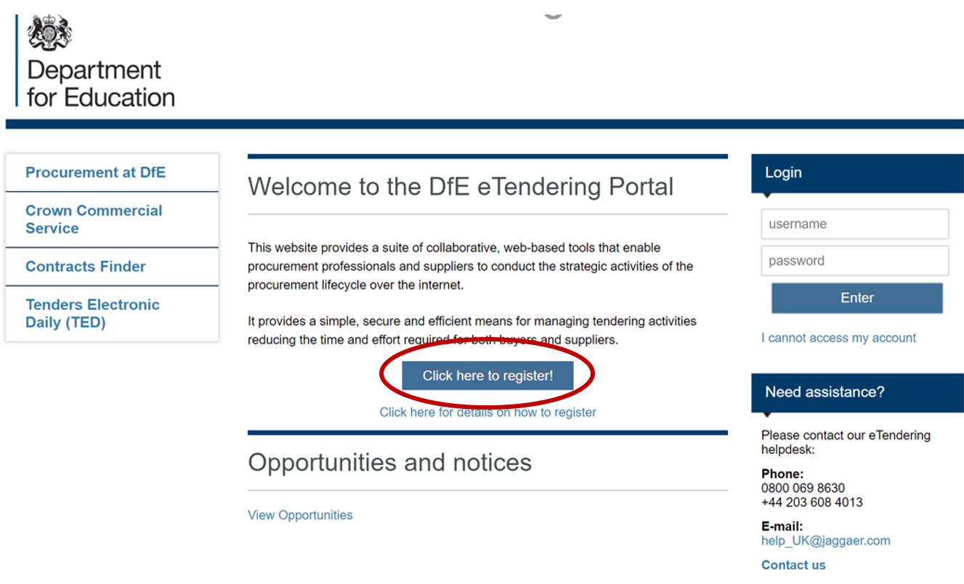

Registration Data

To register as a supplier on Jaggaer it is necessary to complete the information in the three tabs shown below:
‘Registration data’, ‘Basic Profile Forms’, ‘My Category Selection’

Registration Data tab
The mandatory fields should be completed for ‘Organisational Details’ and ‘User Details’. Once satisfied with your answers click the ‘Save’ button.
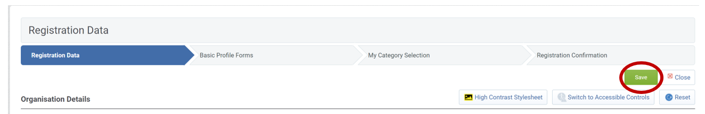
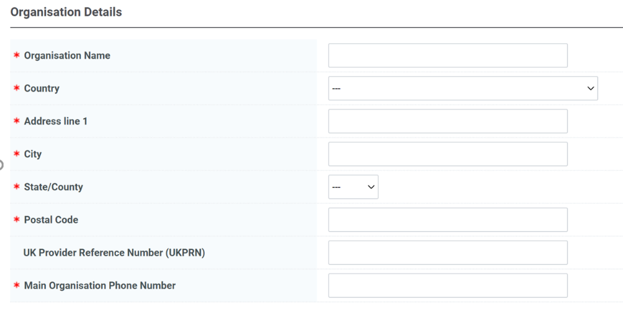
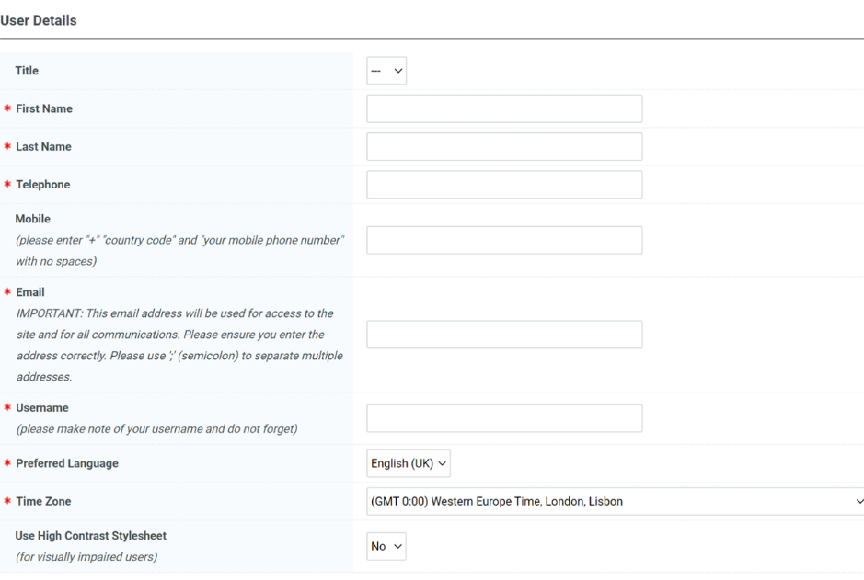

If any mandatory fields have been missed there will be a pop-up message stating the error. Revisit the answers and check for blank answers in the form, then click save when completed.
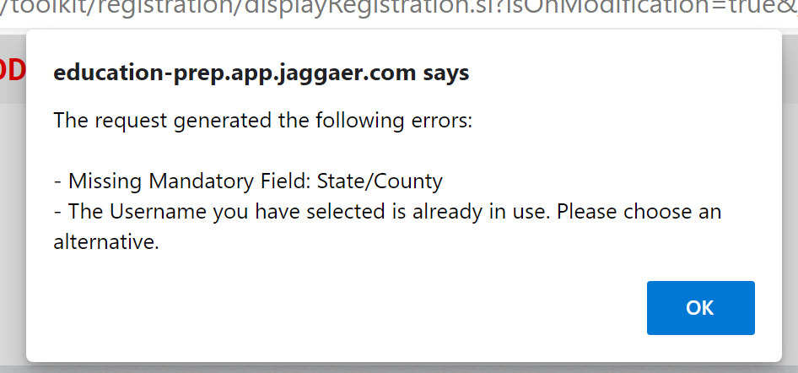

Basic Profile Forms
There are 3 mandatory questions to answer in the ‘Basic Profile Forms’.
Once complete click the ‘Save & Continue’ button.
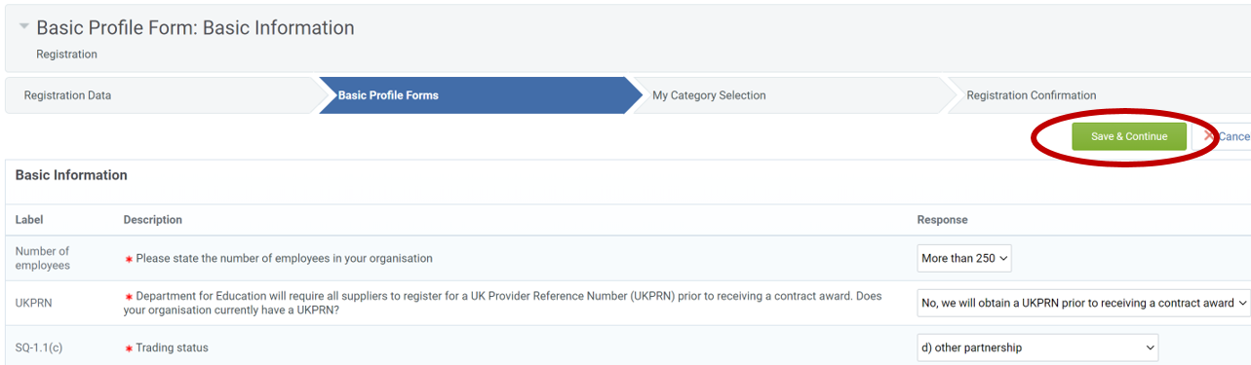

My Category Selection
You will receive alerts to any open opportunities published by the DfE that align to categories you have selected. Please add categories to your profile that describe the services your organisation delivers.
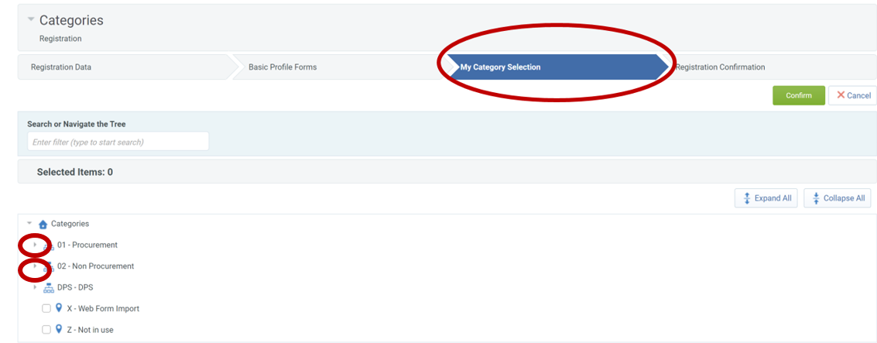

An example of the drop-down menu when opened is shown below:
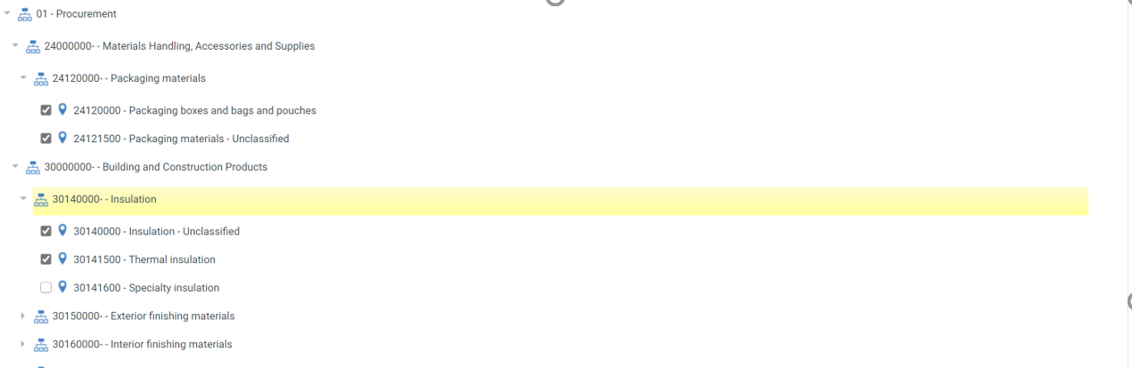

Registration Complete
Once all the information is complete, the final tab is ‘Registration Confirmation’. You will receive an email with your username and password, which you can use to log into Jaggaer, please notify us by reply to this email and you will be added to the opportunity.
