**ELEVATION PHOTOGRAPHS**

**GRAFTON LOCK HOUSE**

Grafton

Nr Letchlade

OX18 2RY

July 2024

**FRONT ELEVATION**

South East - Facing onto Lock Side

**Front/Right-Side Elevation**

Corner of building facing East

**Right Side Elevation (From lockside)**

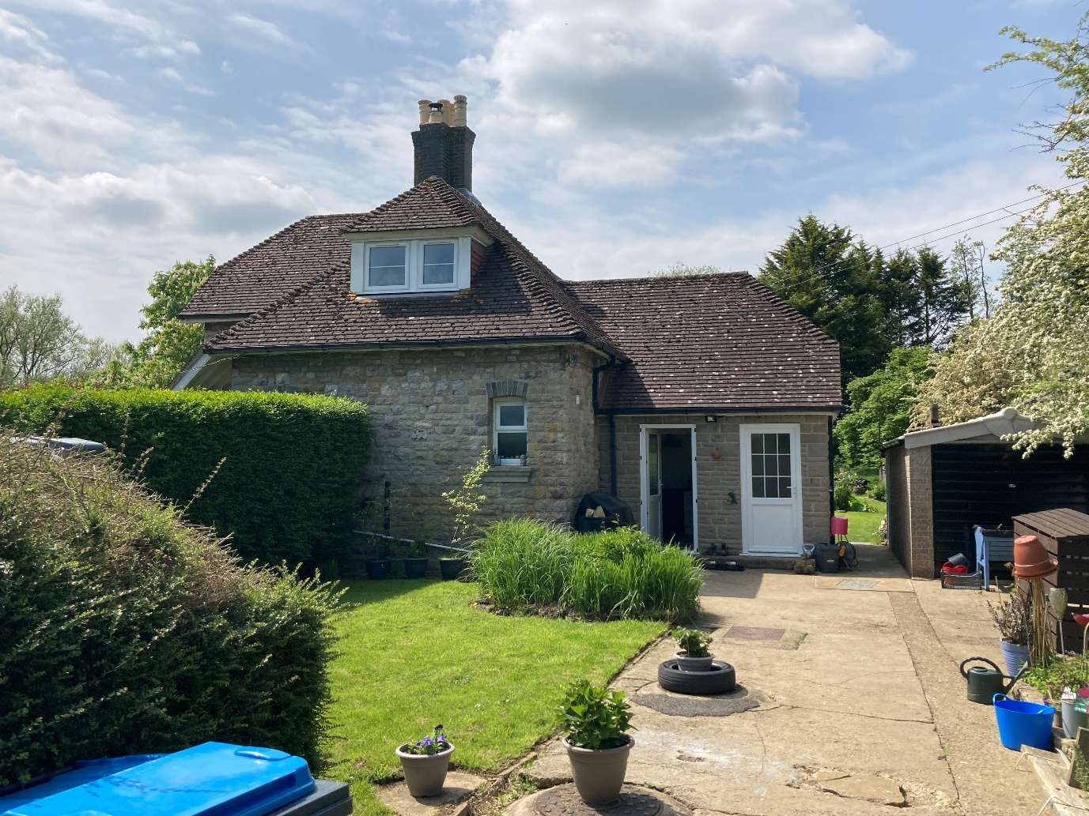

**Right Side Elevation**

Overlooking access drive facing North-East

**Rear/Right Side (NE) Elevation**

Corner facing North

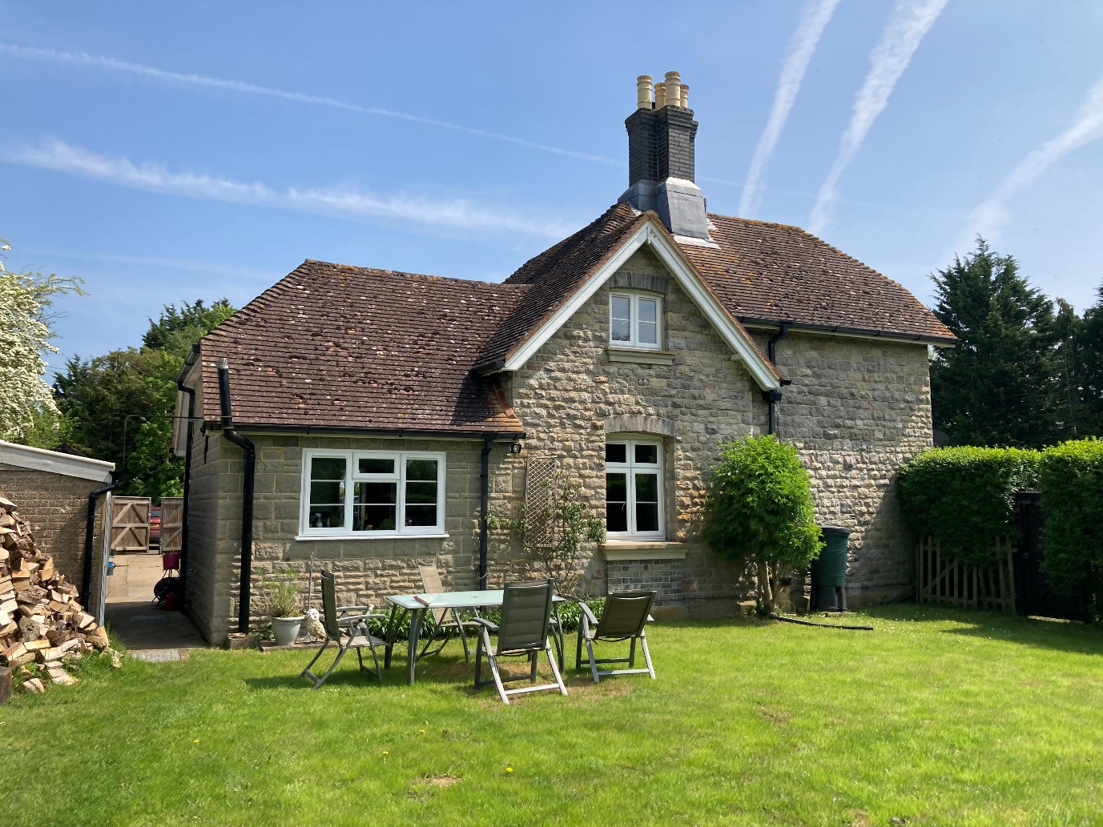

**Left Side Elevation**

Overlooking rear garden – facing South-West

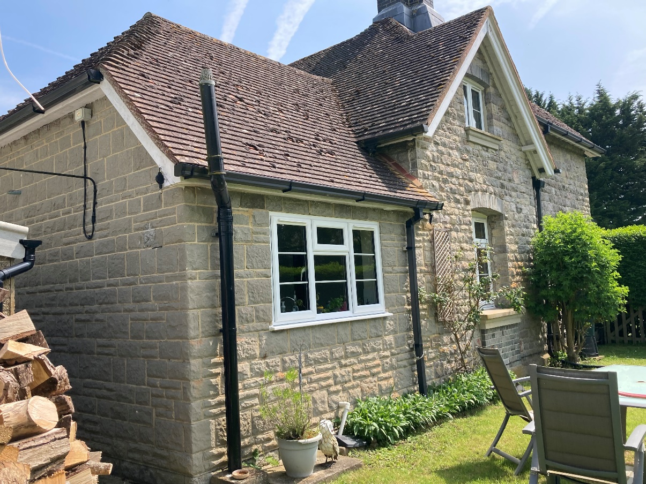

**Rear/Left Side Elevation**

Corner Facing West