|  |  |
| --- | --- |
|  |  |

412_13_SD04

Environment Agency

NEC3 professional services contract (PSC)

Scope

Project / contract information

|  |  |
| --- | --- |
| Project name | Leeds FAS Phase 2 Survey |
| Project 1B1S reference |  |
| Contract reference | J00468 |
| Date | 12/07/2016 |
| Version number | 3 For Issue |
| Author | B Cackett |

Revision history

|  |  |  |
| --- | --- | --- |
| Revision date | Summary of changes | Version number |
| 26/05/2016 | Draft | 0 |
| 07/06/2016 | Procurement advice taken | 1 |
| 07/07/2016 | Final edits for issue | 2 |
| 12/07/2016 | Named files for contract mapping and GIS | 3 |

This Scope should be read in conjunction with the latest version of the current National Survey Specification at the Contract Date. In the event of conflict, this Scope shall prevail. The *services* are to be compliant with the national survey specification.

1 Introduction 1

1.1 Background 1

1.2 Objectives 1

2 Specified Requirements 3

2.1 Project Management 3

2.2 Product Delivery 3

2.3 Previous Studies and Data Sources 3

2.4 Survey 4

2.4.1 General requirements applicable to all surveys, 4

2.4.2 Survey Control 4

2.4.3 Channel Surveys 5

2.4.4 Surveys of flow gauging sites 6

3 Health and Safety 7

4 Specifications and Guidance 8

4.1 Guidance documents 8

5 Programme 9

5.1 Requirements of the Programme 9

*6* Services and other things provided by the *Employer* 10

6.1 Data and information management and intellectual property rights 10

6.2 Data custodianship 10

6.3 Licensing information 10

6.4 Data management and metadata 10

6.5 Data security 10

|  |  |
| --- | --- |
|  |  |
|  |  |
|  |  |
|  |  |
|  |  |
|  |  |
|  |  |

# Introduction

## Background

**Purpose of Survey:** This survey is being commissioned to allow hydraulic modelling of the River Aire from Bell Busk Weir, near Gargrave to Leeds City Centre. Following significant flooding over Christmas 2015 a second phase of Leeds Flood Alleviation Scheme (Leeds FAS phase 2) is proposed.

The modelling will inform the options and then the detailed design of the scheme, as well as improving flood mapping and warning along other reaches of the Upper and Middle Aire.

The property threshold survey will allow for detailed flood warning trigger levels to be calculated and the topographic surveys will be used to assist in options appraisal and design of the potential flood defences.

Stakeholders for the project include Leeds City Council and their flood risk management consultant (yet to be appointed).

**----------------------------------------------------------------------------------------------------------------**

**Location and Extent of Survey:**

Upstream extent: Bell Busk Weir (near Gargrave) SD 9076 5663

Downstream extent: Leeds Station SE 2993 3318

See plan below;

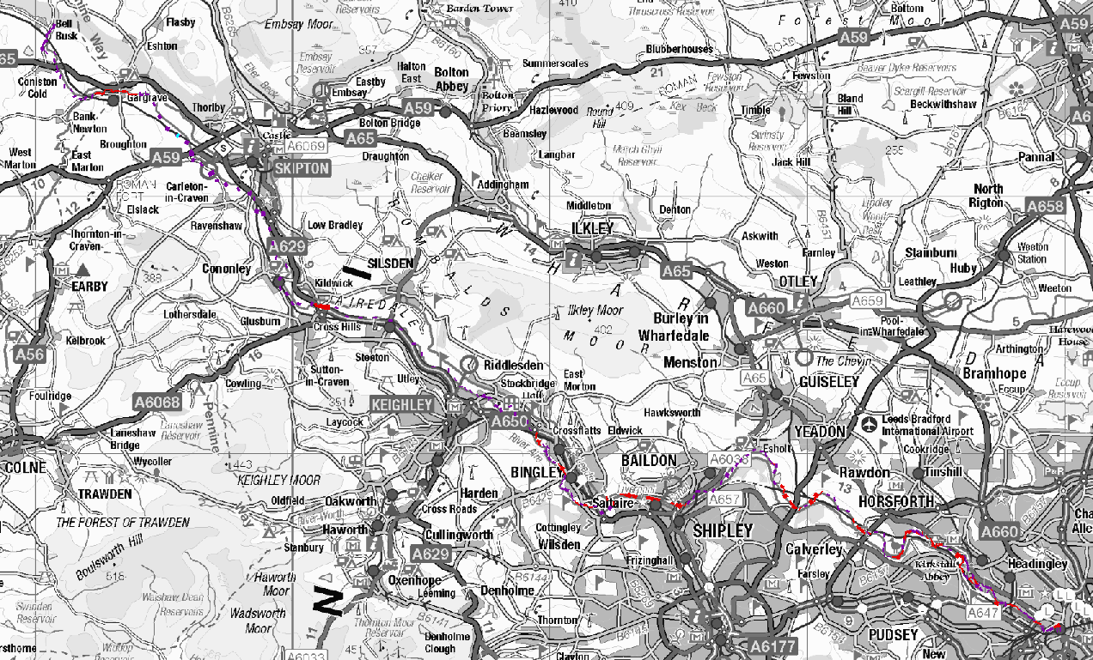

## Objectives

This contract is for the provision of a variety of survey outputs as described in Section 2.

The *Consultant* shall undertake survey as required and in all cases in accordance with the Environment Agency National Survey Technical Specification. The *Consultant* shall deliver the outputs as described in Section 2 of this Scope.

The survey products delivered will be used by the *Employer* to deliver fluvial and coastal flood models for the River Aire in order to improve the flood mapping and forecasting capabilities in this area, as well as allowing for design of a potential Leeds FAS Phase 2.

These products will include;

- Installation of survey control network covering study area

- Survey of river channel cross sections at locations indicated on contract mapping

- Topographic surveys of 3 No. flow gauging sites

- Delivery of suitable outputs in line with Environment Agency Technical Survey Specification

# Specified Requirements

The *services* include, but are not limited to, the provision of the items specified in Section 2.4.

## Project Management

Day to day management of project delivery shall be the responsibility of the *Consultant*.

In managing the *services* the *Consultant* shall undertake the following:

1. Maintain weekly contact with the *Employer’s* Project Manager such that the *Employer* is fully informed of progress and issues.
2. The first Friday of every month the *Consultant* shall revise and issue to the *Employer* their monthly expenditure forecast. This shall show spend to date and forecast cost to complete, broken down monthly and separately for each activity within the project for the duration of the Programme.
3. The *Consultant* shall produce a Programme that shows all supplier*,* and *Employer’s* activities required to deliver the *services.*
4. The *Consultant* shall capture lessons learnt relevant to the delivery the project under a lessons learnt log.

## Product Delivery

In delivering the *services* the *Consultant* shall:

1. Produce the specific deliverables in Section 2.4 below in accordance with the current version of the Environment Agency National Survey Technical Specification.
2. Ensure all deliverables and products show evidence of a quality control system. The *Consultant* shall define and present a detailed quality process for this commission. General quality tolerances should consist of:

a) All first draft deliverables shall be free from significant error and be consistent with other documents, avoiding repetition.

b) All first draft products shall tell a logical story with a clear audit trail of consultation and decision making processes, supported by robust evidence, which can be easily transferred and interpreted by future users.

c) All first draft deliverables shall be grammatically correct and clearly presented, with consistent formatting.

d) All first draft deliverables shall satisfy the relevant latest guidance and legislative requirements.

e) All first draft deliverables shall conform to the latest and necessary guidance and meet the template requirements, unless otherwise agreed with the *Employer* in advance of submission.

f) Products shall be suitable for the audience and written using ‘plain English’.

1. Ensure that project information provided to the *Consultant* by the *Employer* such as; model files, survey data or anything of a personal nature, such as; questionnaires or address data is maintained and subsequently returned to the *Employer* in an encrypted format and marked with appropriate government security classifications as per the latest guidance.

## Previous Studies and Data Sources

The *Consultant* shall ensure that appropriate use is made of existing data, to avoid duplicating work already undertaken. The data supplied with this scope is from a previous catchment-wide survey carried out in 2002. This data is supplied to help the *Consultant* locate and re-survey cross sections in the same locations. Additional cross sections to this survey are also required (see Section 2.4 below).

## Survey

The *Consultant* shall

1. Obtain all consents and approvals required for the survey to be undertaken (access to private land will be following reasonable attempts by the *Consultant* to contact the occupier/owner and comply with their reasonable requirements). The *Consultant* is to maintain a record of who has been contacted regarding access to land.
2. Maintain close contact with the *Employer* throughout the survey.
3. Deliver each aspect of the project to the timeframes specified in the programme in Section 5.1.
4. Provide final outputs of the survey to the *Employer* in a digital format as described in the National Survey Technical Specification.
5. Provide a suitable folder structure for the supplied data.
6. Ensure that all survey results including the survey report are delivered via EA ShareFile.

### **2.4.1** General **requirements applicable to all surveys,**

The *Consultant* shall:

Submit all documents with the EA contract reference (J00468) in the file name.

Name drawing files A-J00468-BB.dwg where A may be:

|  |  |
| --- | --- |
| **Letter** | **Meaning** |
| L | Long section |
| X | Cross sections |
| T | Topographic plan |

BB is a sequential sheet number – 01, 02 etc.

Prepare weekly progress reports and deliver to the EA Project Manager by email.

Deliver PDF plots of each AutoCAD drawing sheet.

No hard copy deliverables are required.

### **2.4.2** Survey **Control**

The *Consultant* shall:

Establish suitable permanent survey control (minimum E2 grade) in accordance with the National Survey Technical Specification for the entire study reach (Bell Busk Weir to Leeds Station). Observation to the OS Net Stations is likely to be the most efficient technique.

Provide RINEX data for all reference and rover observations with the survey report.

Number EACS shall use a point numbering system agreed with the client.

Supply EACS description cards as .doc and PDF with the EACS number as the file name.

### **2.4.3** Channel **Surveys**

The *Consultant* shall:

Allow within their pricing for two day walkover of the site with the EA project manager.

Survey the following cross sections (numbers provided for guidance);

Re-survey of existing sections: 124 (ExistingSections.shp)

Survey of channel cross sections: 182 (NewSurveySections.shp)

Provide channel survey data in ISIS format.

Supply data in EACSD V3.2 format and include CES1 and CES2 data. EACSD shall be passed through the Environment Agency’s online validator program and the validation certificate presented in the survey report.

Survey channel cross sections in locations indicated on the contract mapping (J00468_Contract_Mapping.pdf and shapefiles: ExistingSections.shp and NewSurveySections.shp). Where open sections are indicated to be 2002 surveyed sections (ExistingSections.shp), the location should not be moved more than absolutely necessary in order to provide the best data for comparison.

Survey channel hard bed levels. Separate digital data files are to be provided for hard and for soft bed data.

Extend cross sections a minimum of 5m beyond the river bank into the flood plain.

Number cross sections in the following format: X.YYY where X is a number 1-10 indicating channel number (1 for main watercourse, 2etc for braids and subsidiary channels) and YYY is cross-section number starting with 001 at downstream end of job and increasing upstream.

Present cross sections at 1:100 natural scale and longitudinal sections at 1:2500 horizontal and 1:100 vertical scale.

Where existing surveyed cross sections exist, present the 2002 profile and levels on a suitable layer in the AutoCAD drawing for ready comparison of section profile. Where significant change in levels or profile is measured, this should be identified in the survey report as the area may warrant further investigation.

Survey weirs and drop structures if their head of water is 0.1m or greater.

Survey a structure section for all pipes crossing the water course which have a diameter greater than 0.15m.

Show ghosted on the section drawing for upstream elevations of bridges and culverts, the downstream soffit, top of parapet, invert, bed level and bank crests.

Survey outfalls entering the watercourse of 250mm diameter or greater and show on the long profile.

Produce gaugeboard description cards using template gaugeboard_blank.doc.

Gaugeboards known to the employer are the following locations;

|  |  |
| --- | --- |
| **Name** | **Grid Ref** |
| Gargrave | SD 9373 5395 |
| Snaygill | SD 9873 4940 |
| Cononley River Level | SD 9976 4689 |
| Kildwick | SE 0110 4568 |
| Stockbridge | SE 0720 4225 |
| Bingley | SE 1044 3946 |
| Cottingley Bridge | SE 1139 3797 |
| Apperley Bridge | SE 1940 3797 |
| Kirkstall Abbey | SE 2611 3597 |
| Armley | SE 2807 3403 |
| Leeds City Station | SE 2969 3329 |

### **2.4.4** Surveys of flow gauging sites

The *Consultant* shall:

Carry out a standard site survey at the following flow gauging sites;

|  |  |
| --- | --- |
| **Name** | **Grid Ref** |
| Kildwick | SE 0110 4568 |
| Bingley | SE 1044 3946 |
| Armley | SE 2807 3403 |

The area of the required survey is shown on the contract mapping - J00468_Contract_Mapping.pdf.

# Health and Safety

1. Health and safety is of the highest priority for the *Employer*. The *Consultant* shall promote and adopt safe working practices for their own activities and Subconsultants working for them and shall, in consultation with the *Employer*, deliver surveys that take due regard for health and safety in their performance with regard to the public and anyone else concerned.
2. The *Consultant* shall demonstrate that they have followed the principles of hazard identification, elimination and management in their survey work.
3. The *Consultant* shall ensure that their staff are suitably trained and equipped to carry out survey work in and alongside a major river.
4. The *Consultant* shall ensure that they comply with the specific health and safety requirements of landowners and occupiers along the river (e.g. Network Rail)

# Specifications and Guidance

## Guidance documents

The *Consultant* shall undertake the survey in accordance with the specifications and guidance listed below.

|  |  |  |
| --- | --- | --- |
| **Ref** | **Report Name** | **Where Used** |
| - | National specification for surveying services. | Topographic survey |

# Programme

## Requirements of the Programme

1. The *Consultant* shall provide to the *Employer* each of the deliverables by the dates specified in the project programme outlined below.

The final deadline for all deliverables is 23/12/2016.

The task-specific deadlines are as below;

|  |  |  |
| --- | --- | --- |
| Task | Sub-task | Completion Date |
| Installation of survey control | --- | 30/09/2016 |
| Channel Survey | Leeds Ring Road to Leeds Station | 21/10/2016 |
|  | Baildon Bridge to Leeds Ring Road | 11/11/2016 |
|  | Keighley to Dowley Gap (Shipley) | 02/12/2016 |
|  | Bell Busk to Keighley | 23/12/2016 |
| Gauging site topographic surveys | --- | 23/12/2016 |

1. In delivering the *services* the *Consultant* shall submit all products to the *Employer* initially as ‘draft for review’ followed by ‘final for acceptance’. Formal advance notice of submission shall be given to the *Employer* and all product submissions will be subject to a **two week** review period by the *Employer.* The submission dates and review periods shall be included on the Programme for each aspect of the project. The *Consultant* shall agree the product submission Programme with the *Employer* such that it meets the *Employer’s* capacity to undertake reviews.

# Services and other things provided by the *Employer*

## Data and information management and intellectual property rights

All of the data listed as being supplied to the *Consultant* as part of this study remains the Intellectual Property (IP) of the *Employer*.

## Data custodianship

The data custodian for project deliverables from this commission will be the *Employer’s* Partnership & Strategic Overview team.

## Licensing information

Relevant licences for data supplied will be provided to the *Consultant* upon award of this commission.

## Data management and metadata

Metadata requirements are governed by the relevant section of the National Technical Survey Specification.

## Data security

1. All model and survey information will be provided to the *Consultant* in an encrypted format (using WinZip 128 bit encryption) according to *Employer* data security policy. Once the commission is completed, all the original data sent to the *Consultant*, which is classed as commercially sensitive, shall be returned to the *Employer* in an encrypted format using WinZip 128 bit encryption.
2. Project deliverables such as model files, survey data or anything of a personal nature such as questionnaires or address data must also be returned in an encrypted format using WinZip 128 bit encryption.
3. Further details regarding security measures will be discussed at the start-up meeting for this commission