Invitation to Tender

Laverstock & Ford Parish Council

Grass Cutting & Grounds Maintenance

Contents

1. Invitation to Tender 2

2.0 Parish Council Business Address 2

3.0 Parish Contact 2

4.0 Tender Submission 2

5.0 Contract Timing 3

6.0 Schedule of Prices 3

7.0 Invoicing and Payment 3

8.0 Conditions of Contract 3

9.0 General Conditions 4

10.0 Grass Cutting Specification and Schedule 5

11. General Specification for Grounds Maintenance Work 6

Appendix A – Laverstock 9

Appendix B – Bishopdown Farm & Hampton Park 10

Appendix C – Old Sarum & Longhedge (including Mown Path and Skate Park) 11

Appendix D – Ford 12

Appendix E – Grass Cutting – Play Parks 13

Appendix F – Grass Cutting – Open Spaces 15

Appendix G – Hedge Cutting & Weed Strimming 17

Appendix H – Tender Submission Document 18

## Invitation to Tender

Laverstock & Ford Parish Council are inviting tenders for the grass cutting and grounds maintenance of the public estate of the Parish Council, as described, defined, and conditioned in this document.

Tenderers should be apprised of the following:

1.1 Should a pre-tender meeting or site tour be required this could be arranged with all tenderers invited to attend at the same time. Any resultant matter requiring clarification which is fundamental to the tender will be notified to all tenderers in writing.

1.2 If any tenderer is to their knowledge related to any member or office holder of the Council, they and their relative should disclose the fact to the Parish Clerk in writing. Failure to do so will result in the tenderer’s disqualification from the contract.

1.3 Canvassing of any member of the Council shall disqualify tenderers from the contract.

1.4 A member of the Council shall not solicit/recommend any person for the contract. However, they may submit to the Council a statement of any tenderer’s ability, experience, or character.

1.5 There may be an opportunity to extend the scope of the contract should the Parish Council assume responsibility for any additional land within the parish boundary, and also, subject to a competitive price offer.

1.6 Tenderers must acknowledge receipt of this ITT (Invitation to Tender) for any subsequent quotation to be considered. Submission of a Tender expressly confirms the Tenderers compliance in full of all aspects of this ITT, unless specified otherwise within the tender document.

## 2.0 Parish Council Business Address

3 Pilgrims Way

Laverstock

Salisbury

Wiltshire

SP1 1RZ

## 3.0 Parish Contact

Parish Clerk, Gale Pettifer [parish-clerk@laverstockford-pc.gov.uk](mailto:parish-clerk@laverstockford-pc.gov.uk)

## 4.0 Tender Submission

4.1 All tenders must be received, by email or post, no later than noon on Friday 31st January 2025. Any tender received thereafter will not be considered.

4.2 Tenders will be opened and considered at the earliest opportunity following the tender return expiry time. The Parish Council expects to award the contract following its scheduled meeting on 17th February 2025.

4.3 Tenderers are advised that selection will not be made on price alone and that the Council is not bound to accept the lowest, or any tender.

## 5.0 Contract Timing

5.1 The Contract start date is 1st April 2025. The successful contractor must ensure that all equipment, personnel, and support facilities necessary for the successful execution of the contract are available for deployment on that date.

### 5.2 Termination Date

The termination date of the contract is assumed to be 31st March in the following year, subject to provisions of 5.3 below.

### 5.3 Period of Contract

The contract will run for an initial period of one year [2025/26]. The parish council reserves the option for extending it for a second period of one year [2026/27] and then a third and final period of one year [2027/28], subject to performance, and agreement on any annual inflationary price changes.

## 6.0 Schedule of Prices

6.1 Pricing must include all work as specified by serial number at appendices E, F and G (please Tender submission document at appendix H below)

6.2 The contract prices shall be those set out in the Schedule of Prices submitted by the Tenderer and shall apply throughout the initial period of the Contract unless amended by agreement following a variation to the Contract.

## 7.0 Invoicing and Payment

### 7.1 Invoices

Shall be submitted to the Responsible Finance Officer of the Parish Council, on the last day of the calendar month, and must include the date or dates on which the work was carried out.

### 7.2 Payment Date

Provided the invoice is in order, payment will be made within twenty-eight days of the date the invoice is received.

### 7.3 Payment

The successful Tenderer may request for the annual cost to be divided by 12, or another figure to be agreed with the Council, and invoiced accordingly. Payment will be made by the end of the month following the date of invoice. Subject to the provisions of 8.3 below, should the contract terminate part way through the year, final invoice amounts will need to be agreed between the council and the contractor.

## 8.0 Conditions of Contract

### 8.1 Variations to the Contract

The Parish Council may issue an instruction to the Contractor to vary the quantity or specification of any work or to carry out work covered by a provisional sum. Any such instruction shall be in writing and issued by the Clerk to the Parish Council. Should any instruction to vary the work involve an omission or addition to the contract prices then the amount of such omission or addition shall be agreed by the parties prior to the issue of the instruction.

### 8.2 Sub-Contracting

The Contractor shall not sub-contract all or any part of the Contract without permission in writing from the Parish Council and that permission shall not be unreasonably withheld. Should the Contractor wish to sub-contract all or any part of the Contract then he/she shall apply in writing to the Parish Council giving the reasons for wishing to subcontract and details of the firm or firms to whom he/she wishes to subcontract. Notwithstanding permission in writing from the Parish Council, the Contractor will remain entirely liable for provision of the Service under the Contract including any acts or omissions of a sub-contractor.

### 8.3 Termination of Contract

A) The Contract will terminate automatically at the end of the initial period on 31st March 2026 unless the option to continue the Contract for a second period of one year is taken upby the parish council. In the event of the Contract continuing for a second period of one year the Contract will terminate automatically at the end of that second period of one year on 31st March 2027 unless the option to continue the Contract for a third and final period of one year is taken up. The Contract may be terminated at any time by either party giving three (3) months’ notice in writing to the other party and such notice shall be sent by recorded delivery post.

B) Any such notice by the Contractor shall be sent to the Clerk to the Parish Council. A notice by the Parish Council shall be sent by the Clerk to the Parish Council to the registered address of the Contractor. In the event of the Contractor becoming bankrupt, entering liquidation, or ceasing to trade the Contractor's employment under the Contract will terminate automatically. If the Contract is terminated before the end of any period, then the Parish Council may employ another contractor or contractors to carry out and complete any work outstanding under the Contract and shall be entitled to recover from the original Contractor the reasonable cost of any loss or additional expense it may incur in completing the Contract.

### 8.4 Insurance

The Contractor shall have public liability insurance of at least five million pounds (£5,000,000). The Contractor shall provide when requested evidence of this insurance and of any subsequent renewal. The Contractor shall provide when requested the original insurance document or documents for inspection.

## 9.0 General Conditions

### 9.1 Traffic Management

Shall comply with Chapter 8 of the Department of Transport's Traffic Manual and adhere to all relevant Health and Safety procedures and legislation. Operators should be aware of pedestrians and not impede their progress.

### 9.2 Health and safety

Personal Protective Clothing as appropriate shall be provided by the contractor. The contractor shall ensure that all machinery and/or equipment operators and/or users are professionally trained and competent to do so.

### 9.3 Mowers and other Equipment

Must comply with manufacturer safety standards. They shall be fitted with anti-roll bars if required.

### 9.4 First aid boxes

First aid boxes shall be available to the contractor operatives on site.

### 9.5 Control of substances hazardous to health (COSHH)

COSHH data sheets for any chemicals or other potentially hazardous substances used in connection with the works shall be available on site. Management, use, and storage of all such materials should be documented on site, and all site personnel instructed and made aware.

### 9.6 Collection and Removal of Cuttings and Arisings

When the Contractor is required to collect and remove grass cuttings, arisings, debris, litter or rubbish as stated in Appendix F and G, it shall be collected up and safely and securely contained and removed in accordance with current legislation by a licenced waste carrier and this shall be allowed for in the prices. Collection shall be carried out immediately following work to a particular area and removal from site shall be the same day as collection, except where instructed otherwise e.g. cut and collect.

### 9.7 Litter and Rubbish

The Contractor shall be responsible for collecting and removing minor occasional items of litter and rubbish which might prevent him/her from achieving a satisfactory finish to grass cutting or other grounds maintenance work. Litter shall be deemed to include, amongst other things, plastics, tin cans, shopping trolleys, glass, fallen branches etc.

### 9.8 Risk Assessments

The contractor must have a documented work specific Risk Assessment in place pertaining to all aspects of his/her contract. The contractor will be required to produce a copy of the Risk Assessment on request.

## 10.0 Grass Cutting Specification and Schedule

The locations of the work are specified in the Appendices below. Post codes provide a general indication of an accessible point of entry to the site of work.

### 10.1 Areas to be cut

All grass areas shall be cut for their whole area. When a grass verge or area contains flowering bulbs, or designated wildflower area the area shall not be included in the cut until at least six weeks after the flowering period has ended unless instructed otherwise by the Parish Council.

### 10.2 Standards for grass cutting

Grass verges and areas shall be cut so that the height of vegetation does not exceed 75mm and is not less than 25mm. The whole area shall be cut leaving no areas uncut between the rows or at the edges. Where drains cross the verge the grass mowing shall follow the profile of the drain. Cutting shall be carried out by manual or mechanical means

All machinery shall be suitable for the purpose and fitted with all appropriate screens and safety guards as specified by the manufacturer. All blades shall be kept sharp and shall cut and not rip the grass.

10.3 Grass adjacent to walls and around street furniture, safety fencing, statutory undertakers' apparatus, and other apparatus (telephone boxes, grit bins, markers, and the like) shall be cut using hand strimmer’s or similar. Strimmer’s are NOT to be used near trees and or wooden pole structures which are part of playground apparatus, wooden benches or wooden sign board posts unless a strim guard is present.

10.4 When the verge on one side of any section of road is cut the verge on the opposite side shall be cut within one day. Large grass areas such as open spaces and greens shall be cut in different directions on the succeeding cuts. There is no requirement for the direction of cutting (stripes) to be visible.

## 11. General Specification for Grounds Maintenance Work

### 11.1 General

The Contractor shall carry out regular grass cutting of all specified grass areas. Grass growth regulators will not be permitted.

### 11.2 Standards

The grass mowing schedule (section 10) details standards for grass cutting.

In order to avoid confusion, the term “grass” shall be deemed to include all plants growing in the lawn area, and will include such things as bents, flower spikes etc.

On each occasion, in accordance with the schedule, the Contractor shall cut the grass on or before reaching the maximum height of growth permitted in the case of grass areas, and during the times specified in the case of rough grass areas. The height of the cut shall be set to obtain the minimum height of growth shown.

Grass cutting around obstacles, grass margins and along boundary areas which cannot be cut by mower shall be trimmed by other means, to the same standard as the surrounding grass immediately after the grass is cut.

The sward shall be cut cleanly and evenly on each occasion with no tearing or ripping.

### 11.3 Mowing

The Contractor’s staff shall ensure that all movement of mowing machinery, whether mowing, turning or in transit, does not damage the sward or its finished appearance. Particular care must be taken to avoid skidding, “balding” or the effects of fast turns.

All clippings, which land on hard surface shall be cleared and the area shall be left clean and tidy.

### 11.4 Frequency

The frequency of mowing will depend on the area and prevailing conditions and all grass cutting shall be carried out in accordance with 10.2 Standards for Grass Cutting.

In very wet and frosty weather, all grass cutting operations shall be deferred until ground conditions allow operations to continue. The Contractor shall resume work as soon as possible in accordance with the Schedule.

In any location where the growth of grass exceeds 1.5 times the maximum permitted height, the Supervising Officer may require the Contractor to rake-up and remove all clippings, for which no additional payment will be made.

### 11.5 Mowing Strip

Subject to the approval of the Supervising Officer, the Contractor may, if he so wishes, maintain a 150mm mowing strip free from grass and weeds at the base of the walls, fences and park furniture.

### 11.6 Damage

Any damage as a result of the Contractor’s maintenance operation shall be rectified by the Contractor at his/her own expense. Any areas of damage shall be reported to the Supervising Officer within 24 hours.

### 11.7 Site Visit

The Contractor is advised to visit each location to ascertain for him/herself the nature of the grass cutting required in each location. No additional payment will be entertained because the Contractor has failed to make an adequate inspection.

### 11.8 Nature and extent of additional work

The nature and extent of additional grounds maintenance work is decided by the Parish Council as it arises. Although it is the intention that additional work will be carried out by the Contractor there is no undertaking by the Parish Council that all or any of this work will be offered to the Contractor. Any of the additional gardening work that is offered to the Contractor will be dealt with as a variation to the Contract.

### Hedge Trimming

Hedges shall be trimmed vertically and horizontally to fine except where otherwise specified in the Schedule of other Grounds Maintenance Work. Trimming shall be carried out by manual and/or mechanical means. All blades shall be kept sharp and shall cut and not rip the hedge.

### Pruning Shrubs and Bushes

Pruning shrubs and bushes shall be undertaken to encourage and maintain proper growth and shape and shall whenever possible, take account of the requirements for the particular species. Cutting back and trimming shrubs and bushes shall be undertaken to prevent obstruction to pedestrians and shall whenever possible, take account of the whole shrub or bush and not just the parts causing the obstruction.

### Weeding Beds

Weeding beds shall be carried out using hand tools and shall endeavour to remove all underground roots and shoots to prevent regrowth.

### Redefining Edges

When an edge is required to be redefined it shall be cut back to the original fine using a sharp edging tool and the overgrowing grass or vegetation removed and the exposed hard surface (usually tarmacadam or hoggin) thoroughly cleaned off. The original line shall be taken as the permanent edging to the hard surface or where there is no permanent edging then the original line shall be defined by the Parish Council.

### 12.0 Evidence of Compliance

Submission of a Tender expressly confirms the Contractor’s ability and willingness to provide documentary evidence of its agreed compliance to all aspects of this document and subsequent Contract, if requested by the Parish Council.

### 13.0 Indicative Maps

The attached maps at Appendices A, B, C and D are indicative only and grassed areas are not to scale. Tenderers will be responsible for establishing the precise location, surface area for grass cutting and the overall length and height of any hedges in the setting out of costs.

## Appendix A – Laverstock

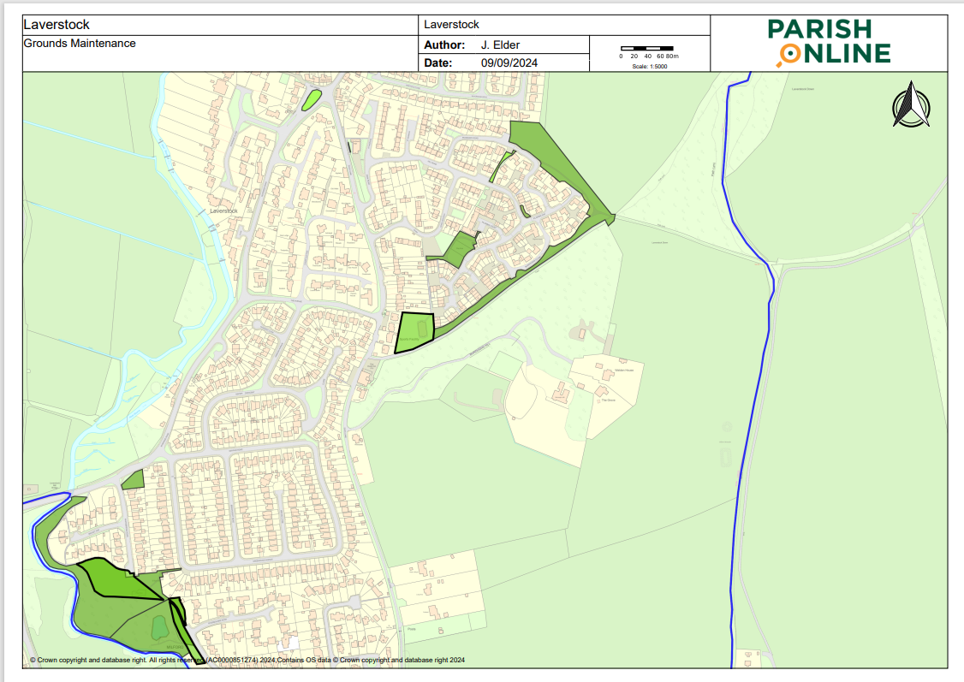

## Appendix B – Bishopdown Farm & Hampton Park

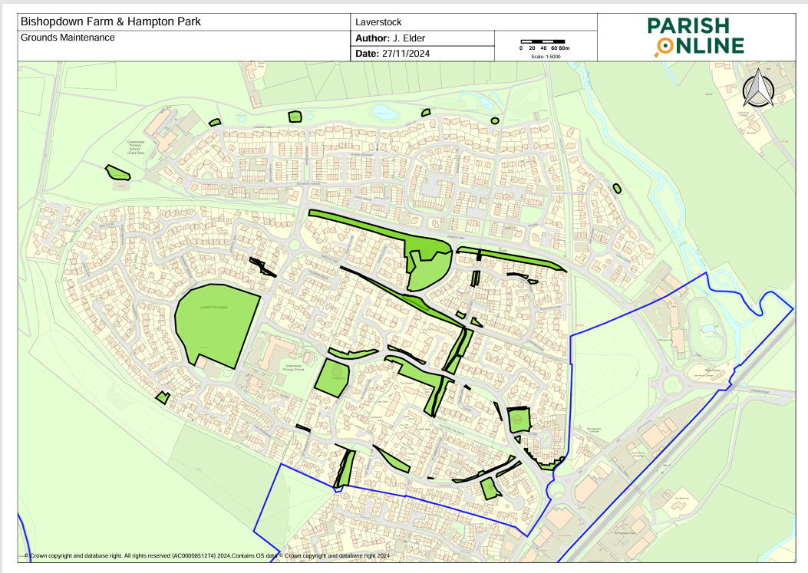

## Appendix C – Old Sarum & Longhedge (including Mown Path and Skate Park)

## Appendix D – Ford

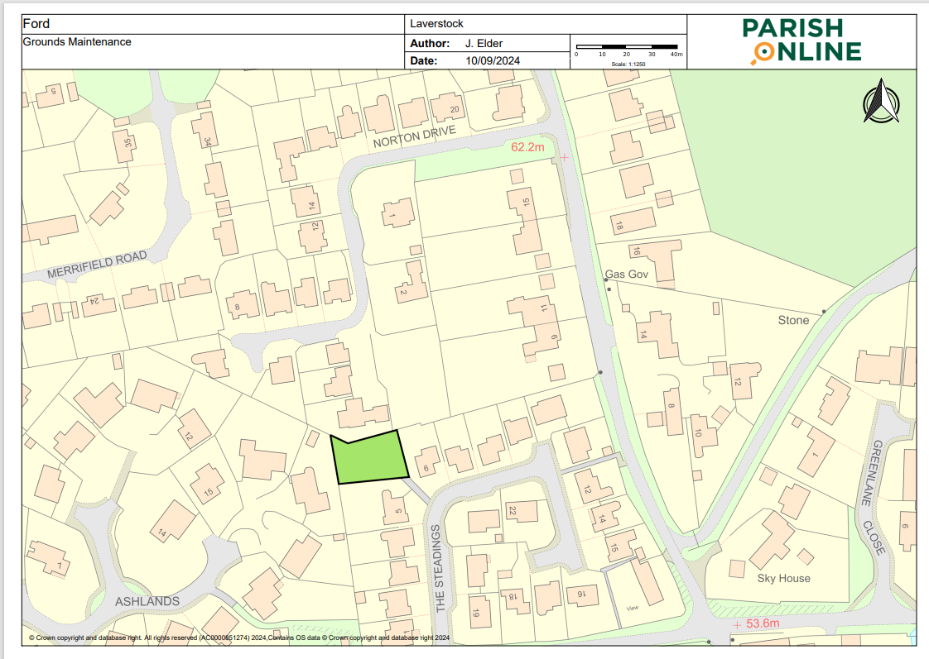

## Appendix E – Grass Cutting – Play Parks

|  |  |  |  |  |  |  |
| --- | --- | --- | --- | --- | --- | --- |
| Serial Number | Location | Post Code | Including external grassed area | Frequency & Number of Cuts | Notes | Price |
| E1 | Pilgrims Way Laverstock | SP1 1RZ | Yes | In accordance with paragraph 11.4 |  | £ |
| E2 | Bundy Lane Bishopdown Farm | SP1 3PE | No | In accordance with paragraph 11.4 |  | £ |
| E3 | Burden Drive Bishopdown Farm | SP1 3QG | No | In accordance with paragraph 11.4 |  | £ |
| E4 | Drake Close Bishopdown Farm | SP1 3GJ | Yes | In accordance with paragraph 11.4 |  | £ |
| E5 | Fulton Road Bishopdown Farm | SP1 3BF | No | In accordance with paragraph 11.4 |  | £ |
| E6 | Hensler Drive Bishopdown Farm | SP1 3DQ | No | In accordance with paragraph 11.4 |  | £ |
| E7 | Holmes Road Bishopdown Farm | SP1 3DF | No | In accordance with paragraph 11.4 |  | £ |
| E8 | St Jude’s Close Bishopdown Farm | SP1 3FA | No | In accordance with paragraph 11.4 |  | £ |
| E9 | St Luke’s Close Bishopdown Farm | SP1 3FD | Yes | In accordance with paragraph 11.4 |  | £ |
| E10 | St Peter’s Road Bishopdown Farm | SP2 0LH | Yes | In accordance with paragraph 11.4 |  | £ |
| E11 | Saunders Avenue Bishopdown Farm | SP1 3PG | No | In accordance with paragraph 11.4 |  | £ |
| E12 | Sycamore Drive Bishopdown Farm | SP1 3GZ | Yes | In accordance with paragraph 11.4 | See F1 - The Green – Sycamore Drive/Ash Crescent Bishopdown Farm | £ |
| E13 | Norman Drive Old Sarum | SP4 6FP | Yes | In accordance with paragraph 11.4 | See Serial F7 below – Old Sarum Country Park | £ |
| E14 | Old Sarum Community Centre | SP4 6GH | Yes | In accordance with paragraph 11.4 | See Serial F8 below – The Green Old Sarum | £ |
| E15 | Partridge Way Old Sarum | SP4 6PX | No | In accordance with paragraph 11.4 |  | £ |
| E16 | Skate Park Old Sarum | SP4 6GW | Yes | In accordance with paragraph 11.4 | See appendix F2 | £ |
| E17 | Virginia Way Old Sarum | SP4 6GY | No | In accordance with paragraph 11.4 | See Serial F3 below – Virginia Way/Norman Drive – Amenity Grass | £ |
| E18 | Campbell Vale Longhedge | SP4 6JF | No | In accordance with paragraph 11.4 |  | £ |
| E19 | Hannah Way Longhedge | SP4 6SY | Yes | In accordance with paragraph 11.4 |  | £ |
| E20 | Hawker Green Longhedge | SP4 6SE | No | In accordance with paragraph 11.4 |  | £ |
| E21 | Liddel Gardens Longhedge | SP4 6SD | No | In accordance with paragraph 11.4 |  | £ |
| E22 | Mannock Field Longhedge | SP4 6SU | Yes | In accordance with paragraph 11.4 |  | £ |
| E23 | McCleod Green Longhedge | SP4 6SR | Yes | In accordance with paragraph 11.4 |  | £ |
| E24 | McCudden Grove Longhedge | SP4 6SQ | Yes | In accordance with paragraph 11.4 |  | £ |
| E25 | Middleton Green Longhedge | SP4 6PJ | Yes | In accordance with paragraph 11.4 |  | £ |
| E26 | Palmer Green Longhedge | SP4 6RJ | Yes | In accordance with paragraph 11.4 |  | £ |
| E27 | Robinson Grove Longhedge | SP4 6SH | No | In accordance with paragraph 11.4 |  | £ |
| E28 | Trigg Green Longhedge | SP4 6PR | Yes | In accordance with paragraph 11.4 |  | £ |
| E29 | Ward Grove Longhedge | SP4 6GZ | No | In accordance with paragraph 11.4 |  | £ |
| E30 | Whitebridge | SP1 1QA | Yes | In accordance with paragraph 11.4 | See F9 | £ |

## Appendix F – Grass Cutting – Open Spaces

|  |  |  |  |  |  |  |
| --- | --- | --- | --- | --- | --- | --- |
| Serial Number | Location | Post Code | Frequency & Number of Cuts | Cuttings Removed? | Notes | Price |
| F1 | The Green – Sycamore Drive/Ash Crescent Bishopdown Farm | SP1 3GZ | In accordance with paragraph 11.4 | Yes |  | £ |
| F2 | Skate Park | W3W///flaunting.quieter.lunge | In accordance with paragraph 11.4 | Yes | Mown paths and skate park. | £ |
| F3 | 9A/B |  | In accordance with paragraph 11.4 | Yes | Mown paths, Annual SuDS cut. | £ |
| F4 | Duck Lane MUGA Green | SP1 1RZ | In accordance with paragraph 11.4 | Yes |  | £ |
| F5 | The Green Laverstock | SP1 1QR | In accordance with paragraph 11.4 | Yes |  | £ |
| F6 | Norton Drive Ford | SP4 6DA | 1 In accordance with paragraph 11.4 | Yes |  | £ |
| F7 | Norman Drive | SP4 6FP | 1 In accordance with paragraph 11.4 | Yes | Old Sarum Country Park, bounded by Norman Drive, Sherbourne Drive and The Portway. To include shrub bed maintenance on the country park | £ |
| F8 | The Green Old Sarum | SP4 6GH | In accordance with paragraph 11.4 | Yes | To include white lining of football pitch following every second cut. | £ |
| F9 | The Green Whitebridge Road | SP1 1QA | In accordance with paragraph 10In accordance with paragraph 11.4 | Yes |  | £ |
| F10 | Hartley Way/Pearce Way | SP1 3WS | In accordance with paragraph 10 | Yes |  | £ |
| F11 | Kimpton Avenue | SP1 3WZ | In accordance with paragraph 11.4 | Yes | Either side of junction with Appleshaw Way | £ |
| F12 | Apostle Way/Sycamore Drive | SP1 3GD | In accordance with paragraph 11.4 | Yes | Path between Apostle and Sycamore | £ |
| F13 | Pearce Way | SP1 3GU | In accordance with paragraph 11.4 | Yes | From Green Lane to end of rear garden boundary at 1 Hartley Way | £ |
| F14 | St Thomas Way | SP1 3FG | In accordance with paragraph 11.4 | Yes | Various parcels of land, see map at Appendix C | £ |
| F15 | St Clements Way | SP1 3FE | In accordance with paragraph 11.4 | Yes | Various parcels of land, see map at Appendix C | £ |
| F16 | Lindford Road | SP1 3WX | In accordance with paragraph 11.4 | Yes | Small green to front of 39 and 41 | £ |

## Appendix G – Hedge Cutting & Weed Strimming

|  |  |  |  |  |  |  |
| --- | --- | --- | --- | --- | --- | --- |
| Serial Number | Location | Post Code | Frequency of Cuts | Cuttings Removed? | Additional information | Price |
| G1 | Milford Boardwalk - Strimming | SP1 2RT | As instructed | No | Cut back nettle and weed growth 1 metre from both sides of boardwalk | £ |
| G2 | Whitebridge Spinney Boardwalk - Strimming | SP1 1QA | As instructed | No | Cut back nettle and weed growth 1 metre from both sides of boardwalk | £ |
| G3 | The Portway Old Sarum – Hedge Cutting | SP4 6EB | As instructed | Yes | Alongside tarmac path from the junction of Sherbourne Drive and The Portway to the entrance to the Country Park | £ |
| G4 | St Peter’s Rd/St Thomas Way Bishopdown Farm – Hedge Cutting | SP2 0LH | As instructed | Yes |  | £ |
| G5 | Lindford Road Bishopdown Farm – Hedge Cutting | SP1 3WX | As instructed | Yes |  | £ |
| G6 | Monxton Close Bishopdown Farm – Hedge Cutting | SP1 3WY | As instructed | Yes |  | £ |
| G7 | Pilgrims Way | SP1 1RZ | As instructed | Yes | Hedges to the side and rear of the play park and at the front of properties 30, 32, 34 and 36 | £ |
| G8 | Appleshaw Way, Bishopdown Farm | SP1 3ZA | As instructed | Yes |  | £ |
| G9 | Swales and Skate park |  | As instructed | No | Annual SuDs cut | £ |
| G10 | 9A/B |  | As instructed | Yes | Cut and collect once annually as instructed | £ |
| G11 | Lindford Road, Bishopdown Farm | SP1 3WX | As instructed |  | 21 to 23, 39 to 41 frontage of 39 | £ |

## Appendix H – Tender Submission Document

All parties wishing to submit a tender must complete and submit the following details and any questions and provide documents no later than Friday 17 January 2024. Please note that all answers and documents provided will form part of the Terms and Condition if successful.

Tenders should be submitted by email to parish.clerk@laverstockford-pc.gov.uk and clearly marked ‘TENDER RESPONSE: GRASS CUTTING & GROUNDS MAINTENANCE (Private and Confidential)’.

Receipt of all tenders will be acknowledged by return of email.

|  |  |  |  |
| --- | --- | --- | --- |
| Supplier Details | Answer | | |
| Full name of the Supplier |  | | |
| Registered company address |  | | |
| Registered company number |  | | |
| Registered charity number |  | | |
| Registered VAT number |  | | |
| Name of immediate parent company |  | | |
| Name of ultimate parent company |  | | |
| Please mark ‘X’ in the relevant box to indicate your trading status. | i. A public limited company  ii. A limited company  iii. A limited liability company  iv. Other partnership  v. Sole trader  vi. Other (please specify) | Yes ☐  Yes ☐  Yes ☐  Yes ☐  Yes ☐ | No ☐   No ☐   No ☐   No ☐   No ☐ |
| Please mark ‘X’ in the relevant boxes to indicate whether any of the following classifications apply to you. | a. Voluntary, Community and Social Enterprise VCSE)  b. Small or Medium Enterprise (SME)  c. Sheltered workshop  d. Public service mutual | Yes ☐  Yes ☐  Yes ☐  Yes ☐ | No ☐  No ☐  No ☐  No ☐ |

The following documents must be provided as part of the tender process. Each applicant must submit two hard copies of all documents in addition to a USB containing electronic copies. These documents should be in a sealed envelope. Please ensure that all plans and supplementary evidence submitted for evaluation do not have logos or company names on the documents. Responses to questions should be no more than 500 words.

|  |  |
| --- | --- |
| Documentation | Please tick to confirm document’s  inclusion in submission |
| An outline of the schedule of works detailing the anticipated commencement. |  |
| Copies of public liability, professional liability, product liability and employer’s liability insurance  which must specify the level of indemnity. |  |
| Necessary risk assessments and method statements must be provided. |  |
| Details of any proposed subcontractors. |  |
| A total annual cost for all Serials at Appendix E and Appendix F |  |
| An itemised cost for all entries at Appendix G (periodical as instructed works) |  |
| Three examples of references and contact details. If you are unable to provide references, you must  provide an explanation of why references are not available. |  |

I declare that to the best of my knowledge the answers submitted to these questions are correct. I understand that the information will be used in the selection process to assess my organisation’s suitability to be invited to participate further in this procurement, and I am signing on behalf of (*Insert name of supplier here*)

I understand that Laverstock & Ford Parish Council may reject my submission if there is a failure to answer all relevant questions fully or if I provide false / misleading information. I have provided a full list of any Appendices used to provide additional information in response to questions.

I also declare that there is no conflict of interest in relation to the Authority’s requirement.

|  |  |
| --- | --- |
| TENDER SUBMISSION DOCUMENT COMPLETED BY | |
| Name in block capitals: |  |
| Role in organisation: |  |
| Date: |  |
| Signature: |  |