

MANOR GROVE
NEWBURN
NEWCASTLE UPON TYNE
NE15 8YJ

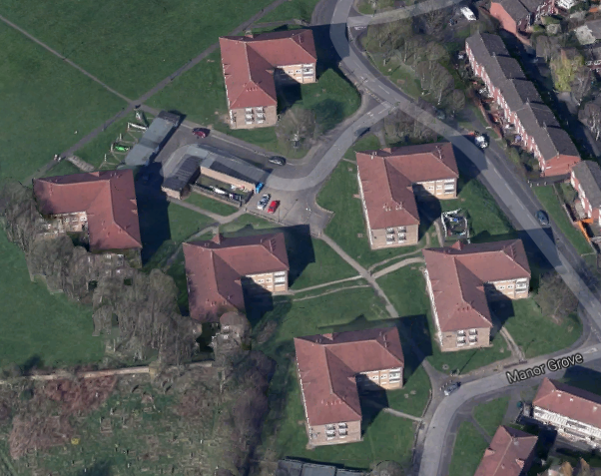

BACKGROUND / BRIEF

Manor Grove and Hareside Court are situated in the Newburn area of Newcastle upon Tyne.

There are 6 three storey blocks each containing 14 flats that have internal storage/bin cupboards on the ground floor. These bin stores have had problems with fly tipping and have been misused over many years.

The blocks have raised fire risk due to buildup of rubbish and have suffered infestation of vermin, raising health and safety fears for residents.

Housing Management has incurred costs for clearance of the bin areas on a regular basis and all attempts to solve this problem in the past have failed.

There has been consultation with tenants, Housing Management, Planning and Environmental services to come up with an acceptable solution to relocate the waste collection areas externally.

The solution that has been designed involves construction of ‘1 x Recycling’ and ‘6 x General Waste Compounds’. These will be constructed in brick with a boarded fence above and a concrete base with connecting paved access path. The compounds will be screened with suitable low maintenance planting.

It is expected that this work should take no longer than 4 weeks to complete.

Bins will be provided by Newcastle City Council

SPECIFICATION

MANOR GROVE BIN STORES ENVIRONMENTAL SCHEME ENV0023
Bin enclosures

Construct 7 no. bin enclosures complete including landscaping planting..
This schedule/specification should be read in conjunction with all PCI provided and all costs included in the final tender submission should cover all items associated with the works

Item | Description | Quant | Unit | Rate - £ | Total
 | Mark out each site and excavate to reduced levels including all excavations to accept new paving and strip foundations, ensure a good sound base, infill and compact any soft spots, remove all arising’s for recycling off site. |  | item
 | Lay concrete strip foundation for walls 500x150 minimum 300mm below fgl | 112 | lm
 | Build off foundation in frost proof matching facing brick to approx. 650mm above fgl with brick on edge coping. Allow for solid brick finish on ends. | 112 | lm
 | Lay minimum 150mm thick type 1 sub base well compacted in bin areas and connecting access footpaths | 130 | m2
 | Lay 150mm pc concrete edging to both sides of access paths on concrete footings fully haunched to outer edges. | 30 | lm
 | Fit 100x12mm Fillcrete Fillaboard or similar to internal perimeter of brickwork prior to laying concrete | 112 | lm
 | Lay concrete slab to bin areas and access footpaths minimum 100mm thick with brushed and steel finish | 130 | m2
 | Break up existing footpath and excavate to reduced depth to extended width of 1500mm up to main footpath. Lay 150mm thick type 1 sub base, compacted. | 52 | m2
 | Lay 150mm pc concrete edging to both sides of footpaths on concrete footings fully haunched to outer edges. | 31 | lm
 | Lay minimum 100mm thick concrete with brushed and steel finish to extended footpaths | 52 | m2
 | Install fencing on top of walls to achieve overall height of 1600 above fgl inside bin areas.  Filcris recycled plastic fencing or similar product, colour=Brown  100x75 posts at maximum 1800 centres set in concrete and resin bolted to brickwork with 2no. 12mm bolts per post, nut and washer to be recessed into the posts.  2x 100x50 horizontal rails.  150x25 boards. | 112 | lm
 | Supply and fit pair of offset gates to match fence. Gates to have 3 horizontal rails and diagonal bracing. (1@ 1m wide 1@ 500mm wide on 3 no. heavy duty hinges per gate with 1no. drop bolt and 1no. ring gate latch. All ironmongery to be galvanised finish. | 7 | pair
 | Backfill and make good around each site, include for drainage where walls are retaining, import topsoil in preparation for planting in 1m strip around each site | 112 | m2
 | Plant out each site as per attached planting schedule (Appendix 10) |  | item
 |  |  |  | TOTAL

