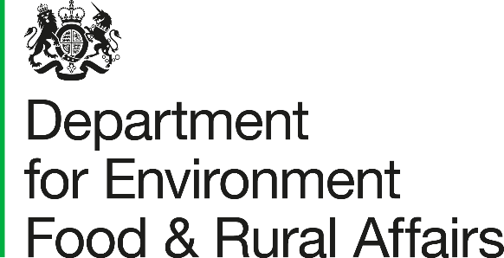
Farming and Countryside Programme: Tests and Trials

Annex A: Call Purpose and Scope

Tests and Trials provide evidence to help shape the development and delivery the environmental land management schemes and others that are part of the Farming and Countryside Programme. They are aimed at conducting research to contribute to our understanding of how parts of environmental land management schemes (Sustainable Farming Incentive, Countryside Stewardship and Landscape Recovery) work in a real-life environment. We are using Tests and Trials to support the delivery of the schemes by working with farmers to identify issues and develop solutions. Our work also feeds into wider policy areas.
We are working with a wide range of stakeholders, across different geographies to undertake the Tests and Trials, including farmer groups, representative bodies and non-governmental organisations.
By testing and trialling elements of the schemes, Defra is looking to work together with farmers, land managers and other stakeholders to harness their ideas, gain their feedback and build something that works for the diverse needs of the agriculture sector, whilst also improving our environment.
We are inviting proposals from stakeholders to Test and Trial mechanisms to improve and develop the schemes and actions, encourage uptake, and ensure schemes deliver the targets and goals of the Environmental Improvement Plan. For example, we are interested in testing how farmers and land managers can stack public and private finance, or trialling Payments by Results as a mechanism at a whole farm scale.
It is envisaged that proposed tests and trials will have a duration of no longer than 12 months. Longer proposals will be considered on a case-by-case basis. This will ensure that learning from Tests and Trials is delivered in a timely manner to inform the design of our new schemes, contributing to the wider evidence base supporting the ongoing rollout of the schemes.
We have used a phased approach to deliver Tests and Trials. This has enabled us to target calls for proposals at emerging priorities and gaps. Tests and Trials contribute evidence towards one or more of our themes, as well as contributing to schemes:
- Role of advice and guidance – the level and role of advice and guidance land managers and farmers would need to deliver actions effectively
- Payments – to test different approaches to payments and how these might work in practice
- Collaboration – to test how different methods of collaboration work to deliver environmental outcomes on a greater scale
- Innovative Delivery Mechanisms – to test how innovative solutions work on the ground and in what circumstances. Examples include blending public and private finance and Payment by Results
- Monitoring and Verification – to test what methods could be employed to allow farmers and land managers to monitor delivery against scheme requirements?
- Legal Standards/Regulations - What activities/outcomes can you self-monitor to demonstrate compliance with regulations
- Evolving ELM – testing how we evolve ELM to ensure farmers are delivering the right actions to meet our targets
The purpose of Tests and Trials is to provide evidence to help shape the policy and delivery of our environmental land management schemes. Tests and trials are not a vehicle for testing or recommending approaches that are only applicable in specific circumstances or locations. Tests and Trials does not validate if specific delivery methods achieve environmental outcomes.
We are seeking to answer several questions as part of this new call, helping to fill gaps in our evidence and address emerging priorities. The questions are designed to provide policy with more specific evidence to help inform scheme development and delivery.
The specific areas of interest identified for this call are outlined in Annex B
Tests and Trials Purpose and Scope
Tests and Trials are important components of our test, learn and adapt approach to building the schemes that reward environmental land management. We use an iterative process, allowing for policy interaction and regular delivery of evidence.
We began the Tests and Trials work in 2018 as a vehicle to engage with a wide range of farmers, land managers and stakeholders to harness their ideas to conduct research to contribute to the design of the new schemes. Farmers and land managers taking part in the Tests and Trials co-design elements or building blocks of the new scheme(s) in their real-life environment. We use this evidence and learning they generate to understand farmer and market behaviour and to help shape and inform scheme design.
As well as testing the key building blocks of the new schemes, we are also trialling new ideas and innovative approaches to understand if and how they could be built into the new schemes. The learning they generate will help us build and refine our schemes.
The scope of Tests and Trials is outlined below:
- Co-design and test how new policies work in a real-life environment, with different user groups, across different geographies and sectors
- Trial new or innovative approaches that we haven’t previously utilised to understand if and how they could be used within a new scheme
- Provide real time evidence to help shape policy and scheme design
- It will not assess if specific interventions or delivery practices achieve environmental outcomes
This call represents our fourth phase, with Tests and Trials due to continue until 2028, supporting the design and implementation of the schemes. This approach has enabled us to prioritise testing the building blocks as we analyse and evaluate the results from Tests and Trials to feed into our policy development process.

