Background to Natural England

Natural England is the government’s advisor on the natural environment. We provide practical advice, grounded in science, on how best to safeguard England’s natural wealth for the benefit of everyone.

Our remit is to ensure sustainable stewardship of the land and sea so that people and nature can thrive. It is our responsibility to see that England’s rich natural environment can adapt and survive intact for future generations to enjoy.

Natural England's purpose is to ensure that the natural environment is conserved, enhanced and managed for the benefit of present and future generations, thereby contributing to sustainable development.

This purpose includes:

* Promoting nature conservation and protecting biodiversity
* Conserving and enhancing the landscape
* Securing the provision and improvement of facilities for the study, understanding and enjoyment of the natural environment
* Promoting access to the countryside, open spaces and encouraging open air recreation
* Contributing in other ways to social and economic wellbeing through management of the natural environment

Microbial Communities as Indicators of Non-Persistent Pesticides

Background to the specific work area relevant to this purchase

This specification relates to work to be carried out for Natural England's Geology, Landscape and Soils Team, and aims to provide evidence to support the government's ambitions to deliver sustainable management for 60% of agricultural soils by 2030.

We do not currently have an approach for monitoring exposure and impacts of pesticides to soil biological communities and impacts on soil health. This project aims to deliver a short-term soil microcosm experiment to reveal the soil microbial responses to application of commonly used pesticides. Analysis of the microbial communities using metabarcoding will be used to identify any consistent community changes which might be used as indicators of exposure, or to evaluate pesticide impact. These indicators would be used to interpret microbial community data from the England Ecosystem Survey, a national soil monitoring programme, to indicate possible levels of pesticide exposure.

The project would involve planning stages during December 2024, with the soil microcosms being set up, initial communities sampled, and experimental treatments applied during January 2025. Subsequent sampling would occur in early February and March 2025, with a brief technical report produced before end of March 2025.

Requirement

**Rationale and Background**

Soil health refers to an integrated measure of how well soils function to deliver the services best suited to them. One area where there is an evidence gap is in understanding the extent to which soils are exposed to agricultural pesticides and other biologically active contaminants, and the impact that such chemicals have on soil ecosystem processes. As part of the government’s Natural Capital and Ecosystems Assessment programme, Natural England is an extensive soil sample collection programme under the England Ecosystem Survey. The ambition is to, every 5 years, collect 4-6 bulked samples from 16m by 16m soil plots, and analyse these for a range of physical, chemical and biological properties.

One of the biological assessments applied in the programme is metabarcoding of 16SrRNA and ITS genes to provide a profile of the microbial community at each of these plots. There is much evidence that soil microbial communities change in response to exposure to pesticides, either disadvantaging certain taxa, or promoting the abundance of others which benefit from using the chemical as a substrate, or from elimination of competitor taxa. Indeed, some studies show that certain taxa are almost exclusively indicative of application of particular pesticides. Furthermore, the microbial community has the capacity to integrate, over time, the impacts of regular applications of one or more pesticides (as is becoming increasingly common practice), resulting in a longer-term detectable signal of the applications. Finally, if we can link application of pesticides to changes in the abundance of microbial taxa, we may be able to identify the functional roles of these taxa in delivering specific ecosystem services (e.g. nitrogen fixation, ammonia oxidation, methanotrophy etc.), and thereby begin to model the impacts of pesticides on these important ecosystem function across the wider environment.

**Specification**

To progress this idea, we are commissioning a project with the following objectives:

* To agree a limited range of ~5 commonly applied pesticides to investigate, probably based on the FERA pesticide usage survey. These are likely to include the following pesticides, but priority should be given based on likely usage in England and consider the extent to which microbial responses have already been well characterised for English soils.
  + a fungicide (Tebuconazole, Folpet, Prothioconazole)
  + A herbicide (Glyphosate, diflufenican/flufenacet, fluroxypyr)
  + An insecticide (Lambda-cyhalothrin: 70% of total treated area; Esfenvalerate:14% of total treated area; Tau-fluvalinate, Pirimicarb:
  + A growth regulator (Chlormequat)
* To carry out a rapid literature review of international publications to evaluate and characterise likely microbial community responses to application of these pesticides.
* To carry out a microcosm experiment to evaluate the response of selected English soils to this range of pesticides, in terms of their microbial community as assessed by metabarcoding. Specifically to:
  + collect arable soils from ~3 of different soil types (texture, natural pH, geographical location) from well-established organic farms, which would represent communities most unaffected by past pesticide applications – ideally these would have low organic matter contents (eg. Following recent tillage) to avoid the known community change-buffering response that this typically provides.
  + To homogenise soils, and add aliquots to micocosms, at this point also sampling the soil test material (5 replicate samples) to enable genetic characterisation of the initial microbial communities in these soils.
  + To apply a range of pesticides, or control treatments of no application, to these soils, with ~5 replicates of each treatment including the control of no pesticide application. Consideration should be given to the rate of application to the microcosms to reflect likely levels of field exposure, management of the soil in the pots – for example by growing a single winter wheat plant in each to mimic field conditions.
  + To destructively sample these microcosms after 1 month (early February 2025) and 2 months (early March 2025) following application.
  + To assess the impacts of these treatments on microbial community using 16SrRNA and ITS metabarcoding approaches, at various time stages following (or during) application of treatments.
  + To carry out bioinformatics analysis of the resulting data, to identify communities based on assemblages of OTUs and of their taxonomic identifications following BLAST.
  + To analyse the impacts on the whole community (using dimension reduction approaches) but also to identify taxa with strong and consistent responses, that might be used as indicators for specific pesticides or groups of pesticides.
* To briefly write up the literature review, and the methods and results of the experiment in a brief technical report. We will aim to develop this into a fuller Natural England research report, and/or a paper for publication in a peer reviewed journal, potentially by combining the results of the experiment with microbial community data from the EES.
* To prepare a presentation on the project suitable for delivery at a future Natural England Soil Health Conference
* To share all data generated with Natural England, including the FASTA and other raw data files.

Sustainability

Natural England protects and improves the environment and is committed to reducing the sustainability impacts of its activities directly and through its supply chains. We expect the Contractor to share this commitment and adopt a sound, proactive sustainable approach in keeping with the 25yr environmental plan/our commitments compliant with all applicable legislation. This includes understanding and reducing direct and indirect sustainability impacts and realising opportunities, including but not restricted to; resilience to climate change, reducing greenhouse gas emissions, water use and quality, biosecurity, resource efficiency and waste, reducing the risk of pollution, biodiversity, modern slavery and equality, diversity & inclusion, negative community impacts.

As a delivery partner, the successful contractor is expected to pursue sustainability in their operations, thereby ensuring the Contracting Authority is not contracting with a supplier whose operational outputs run contrary to the Contracting Authority’s objectives. The successful contractor will need to approach the project with a focus on the entire life cycle of the project

Outputs and Contract Management

The table and Gannt chart below provides a suggested project outline and dates for key deliverables. The contractor, however, is asked to review this and provide their own project outline, reflecting their delivery capabilities and plans.

|  |  |  |  |
| --- | --- | --- | --- |
| Reference | Deliverable | Responsible Party arty | Date of completion of completion |
|  | Project initiation meeting | Contractor/NE | 06/12/2024 |
|  | Source suppliers of likely pesticides for use. | Contractor | 13/12/2024 |
|  | Identify sources of experimental soil | Contractor/NE | 13/12/2024 |
|  | Pesticide review and pre-experiment project meeting | Contractor/NE | 20/12/2024 |
|  | Collect soils | Contractor | 03/01/2024 |
|  | Set up microcosms and sample soils for initial microbial community | Contractor | 10/01/2024 |
|  | Apply pesticide treatments | Contractor | 10/01/2024 |
|  | Analyse initial soil sample by metabarcoding | Contractor | 17/01/2024 |
|  | Apply bioinformatic processing for initial soil samples | Contractor | 24/01/2024 |
|  | Statistical processing and analysis and write up of initial results | Contractor | 31/01/2025 |
|  | Project meeting | Contractor/ NE | 31/01/2025 |
|  | Conduct 1st post- treatment sampling. | Contractor | 07/02/2025 |
|  | Analyse 1st post- treatment samples by metabarcoding | Contractor | 14/02/2025 |
|  | Apply bioinformatic processing for 1st post treatment samples | Contractor | 21/03/2025 |
|  | Statistical processing, analysis and write up of results of 1st post treatment samples. | Contractor | 28/02/2025 |
|  | Project meeting | Contractor/NE | 28/02/2025 |
|  | Conduct 2nd post- treatment sampling. | Contractor | 07/03/2025 |
|  | Analyse 1st post- treatment samples by metabarcoding | Contractor | 14/03/2025 |
|  | Apply bioinformatic processing for 2nd post treatment samples | Contractor | 21/03/2025 |
|  | Statistical processing, analysis and write up of results of 2nd post treatment samples. | Contractor | 28/03/2025 |
|  | Final reports, results and presentation submitted to NE | Contractor | 31/03/2025 |
|  | Final project wrap up meeting | Contractor/NE | 31/03/2025 |

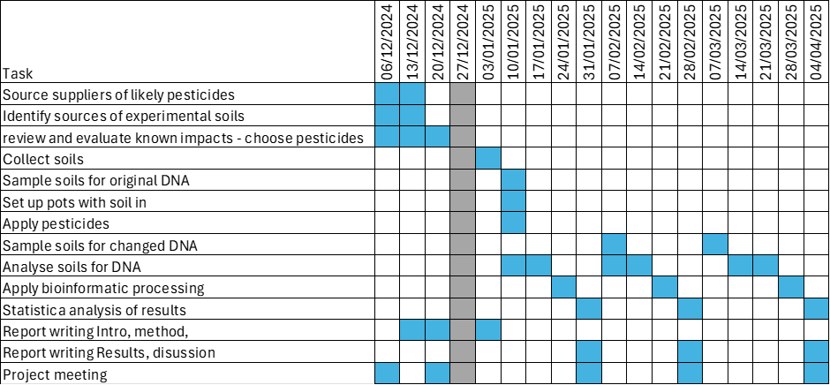

The project will be managed by Matthew Shepherd and Jonathan Griffiths for Natural England, with regular online meetings organised by the contractor, to provide updates and clarify issues and risks. Any risks identified by the contractor to the delivery of this project should be raised as early as possible by email or telephone to the project manager. All deliverables will be supplied as electronic copies. We would value suggestions from the contractor on how best to proceed with publication of the report, or a paper closely derived from it, in a peer reviewed academic journal.