Conversion of MAN 15T HX77
Support Vehicles to EPLS Mk3 Variant
OSVP/0032

Vehicle Presentation Handover Standard

Annex I

V2

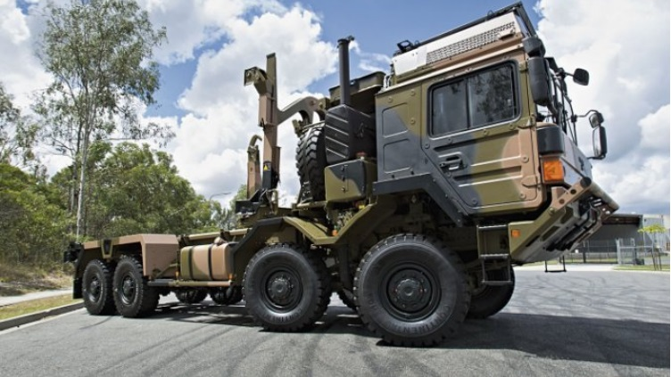

Version History

Issue: V1

Author:

Date: 29 September 2017.
Authorised by:

Signature:

Date: 29 September 2017
Checked for The Authority by:

Signature:

Date:

 | Version | Amendment |  |  | Date
 | V1 | First Submission Document |  |  | 29/09/17
 | V2 | Ammendments prior to CA |  |  | 14/12/17

Contents

1. Introduction 4
2. Objective 4
3. Inspection and Preparation Process 5
4. Assumptions 6
5. Appendix A - EnSIR 8

Table 1: Table of Abbreviations

Abbreviation | Interpretation for this Document
CES | Complete Equipment Supplies
ILHS | Integrated Load Handling System
EPLS | Enhanced Palletised Loading System
MTB UK | MAN Truck and Bus UK Limited
SI | Service Information
EnSIR | Entry Standard Inspection Report
JAMES | Joint Asset Management and Engineering Solutions

- Introduction
This document sets out the Vehicle Presentation Handover Standard for Contract OSVP/0032.
- Objective
The conversion of the HX77 vehicles requires that the donor vehicles are sourced from the existing SV Fleet of HX77 chassis. These can be either the Flatbed or the Cargo variant.
The Vehicle Presentation Handover Standard is set to ensure that only fully roadworthy vehicles to a predetermined standard are entered into the conversion programme.
The Handover process shall meet the following minimum conditions:
- the donor vehicle is to a predetermined specification;
- each vehicle passes through the Authority’s entry inspection;
- any defects found in point ii above which render the vehicle untaskworthy are rectified by the Authority’s representative before submission;
- any minor defects are documented and agreed by both parties;
- as far as practicable, all outstanding SI’s are completed;
- each vehicle is inspected by the Contractor according to the Entry Standard Inspection Report (EnSIR).
- Inspection and Preparation Process
A simplified chart outlining the Vehicle Presentation Handover Standard is shown below:
Vehicles arrive at a site tbc

The Authority’s representative carry out Roadworthiness inspection
Rectiification work reqd
Fail

Pass

Rectification work reqd. by
Babcock/DSG
Contractor carries out EnSIR
Fail

Pass

Vehicle passed over for delivery to Convertor

All donor chassis will be shipped and stored at a site tbc. The stocking level will meet that required in the schedule at Annex B. This stocking level to be maintained throughout the term of the Contract.
Each vehicle will undergo an inspection and preparation by the Authority’s representative. All CES equipment together with any sideboards, tailgates and canopies, will be removed. Removal and storage of such components will be handled solely by the Authority’s representative.
Any deficiencies noted on the Inspection Report that render the vehicle unroadworthy will be rectified prior to being submitted to the Contractor’s representative/agent. Any minor defects will be noted on the Inspection Report. A copy of the Inspection Report will be handed over with the vehicle to the Contractor’s agent.
Upon receipt of a prepared vehicle, the Contractor’s representative/agent will conduct an EnSIR (see Appendix A), including a battery discharge test and compare the results to the Inspection Report supplied with the vehicle.
Any major deficiencies noted during the EnSIR which are considered to render the vehicle unacceptable for conversion will be referred back to the Authority’s representative for rectification. The Authority will be informed of the rejection and the reasons thereof.
The Authority’s representative is to provide a reasonable turn-round time for all vehicles submitted for rectification work so that the Contract Schedule is not adversely affected.
The contractor shall take photographic and/or video evidence of any damage or breakages to the vehicle so that a comparison can be conducted after conversion.
Once a vehicle has been accepted into the programme, it will be handed over to the collection and delivery personnel for movement to the Converter’s premises in Manchester.
- Assumptions

For the Handover process to work efficiently and effectively, all involved parties must collaborate and communicate so that the end goal is achieved. To achieve this working harmonisation, a set of assumptions have been made which are outlined below. The failure of one or more of these assumptions may lead to a reduction in the number of vehicles being available to fulfill the schedule, thereby potentially affecting the overall conversion.
  - The Authority to ensure provision of suitable facilities within the Handover site e.g.
- Access to a covered workshop with pit;
- Power and light.

  - The Authority to ensure that access to the site by the Convertor and its respective sub-contractors is dealt with in an efficient and timely manner.
  - The vehicles must be presented in a timely manner.
  - The vehicles must be in a clean condition.
  - Each vehicle must be capable of starting under its own power.
  - Each vehicle must be presented with a completed FMT 932(W2) Inspection Report carried out within the last 3 months.
  - Any known outstanding defects cited on (Joint Asset Management and Engineering Solutions) JAMES must be made known at the time of presentation. Vehicles with major defects or defects that could result in the conversion schedule being delayed may be rejected until such time as the defects have been satisfactorily rectified.
  - Each vehicle must have at least ½ tank of fuel provided.
  - Each vehicle must have any outstanding SI’s* completed.
  - The contractor is to provide correctly licenced drivers that have been familiarised with the 15T/EPLS vehicles.
  - The contractor is to drive the vehicles between Ashchurch and Manchester conversion facility and the return journey post conversion.
  - The contractor is responsible for the insurance of the vehicle from the moment of handover.
*Where SI’s are shown to be ‘open’ on a vehicle submitted into the programme, it is possible that the vehicle can still be accepted into the conversion process and the outstanding SI’s carried out at the Convertor’s workshop.
Whilst every effort will be taken to ensure that these ‘open’ SI’s can be accommodated so as not to affect the conversion schedule; this cannot be guaranteed. The Authority understands that the Convertor will require recompense for any work outside of the warranty/recall terms and conditions and may allocate a conversion slot to another vehicle until such time as the affected vehicle has been rectified; at which point the vehicle will be reintroduced into the programme.
- Appendix A - EnSIR
