

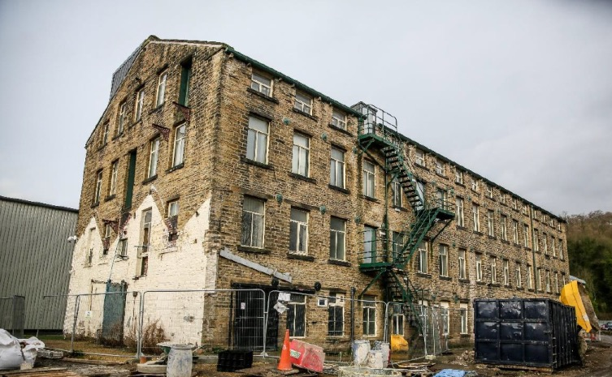

  - DEVELOPMENT OF THE MENDING ROOMS

  - INVITATION TO TENDER FOR:

DESIGN TEAM SERVICES
Including Architecture, Structural Engineering, Cost Consultancy, BREEAM and CDM

  - Appendix 1 Only
  - October 2018





APPENDIX 1: TENDER SUBMISSION

Part A: General Information

Contracting Party

Name of Organisation
Company Registration Number
VAT Registration Number
Address
Name and title of individual to whom communications should be sent
Telephone Number
Mobile Number
e-mail address
Is the above named organisation a Subsidiary?  * Delete as appropriate | * Yes / No
If selected to provide works or services would you provide an ultimate Parent Company Guarantee? * Delete as appropriate | * Yes / No

Organisation providing Architecture and Lead Design Consultant Services

Name of Organisation
Company Registration Number
VAT Registration Number
Address
Key Personnel
Telephone Number
Mobile Number
e-mail address
Is the above named organisation a Subsidiary?  * Delete as appropriate | * Yes / No
If selected to provide works or services would you provide an ultimate Parent Company Guarantee? * Delete as appropriate | * Yes / No
If different than the Contracting Party, how will this company be appointed by the Contracting Party

Organisation providing Structural Engineering Services

Name of Organisation
Company Registration Number
VAT Registration Number
Address
Key Personnel
Telephone Number
Mobile Number
e-mail address
Is the above named organisation a Subsidiary?  * Delete as appropriate | * Yes / No
If selected to provide works or services would you provide an ultimate Parent Company Guarantee? * Delete as appropriate | * Yes / No
If different than the Contracting Party, how will this company be appointed by the Contracting Party

Organisation providing Cost Consultancy Services

Name of Organisation
Company Registration Number
VAT Registration Number
Address
Key Personnel
Telephone Number
Mobile Number
e-mail address
Is the above named organisation a Subsidiary?  * Delete as appropriate | * Yes / No
If selected to provide works or services would you provide an ultimate Parent Company Guarantee? * Delete as appropriate | * Yes / No
If different than the Contracting Party, how will this company be appointed by the Contracting Party

Organisation providing BREEAM Advisory Services

Name of Organisation
Company Registration Number
VAT Registration Number
Address
Key Personnel
Telephone Number
Mobile Number
e-mail address
Is the above named organisation a Subsidiary?  * Delete as appropriate | * Yes / No
If selected to provide works or services would you provide an ultimate Parent Company Guarantee? * Delete as appropriate | * Yes / No
If different than the Contracting Party, how will this company be appointed by the Contracting Party

Part B: Economic and Financial Capacity

      - Set out below an overview of the Contracting Party’s financial standing including statements of turnover and profitability. If the firm can be defined as an SME then this should be stated. [Max 1 page]
      - Set out below details of Professional Indemnity Insurance, Public Liability Insurance and Employer’s Liability Insurance for the Contracting Party and all companies that will be responsible for delivering the required services.
      - Please make a statement as to whether any of the circumstances described in Clause 57 of the Public Services Contract Regulations 2015 applies to any member of the respondent organisation. [Max ¼ page]
      - Candidates should also declare the following in as far as they may apply:

- details of any material difference in past, current or projected turnover and profit from that detailed in the most recent submitted audited accounts;
- details of any known past, pending or anticipated future event (including events within parent or associated companies) that may materially impact upon the organisation’s current financial standing and credit rating;
- details as at the last reporting date of any contingent liability or loss not otherwise reported which would require disclosure in accordance with International Accounting Standard 10;
- a statement of whether the organisation knows of any material or pending or threatened litigation or other legal proceedings; and
- a statement of any conviction of any Directors, Partners or the proposed advisors of a criminal offence related to business conduct.
[Max ¼ page unless further details necessary]

Part C: Technical Capacity and Capabilities

    - Please present a summary of the key design/technical issues that you feel the Client will face in taking this project forward.

    - Please present a summary of your approach to design in working with historic buildings whilst creating a modern working environment.

    - Please summarise how you would go about ensuring that the project is delivered within budget and to meet the project timescales.

    - Please summarise your experience in innovative structural designs in historic buildings.

    - Please set out your approach to delivering a successful environment for occupiers.

    - Please set out your approach to leadership and coordination of projects of this nature.

    - Please confirm the key members of staff that you would allocate to work on the project on a day to day basis.
[Max 6 members of staff]
    - For each member of staff above, please provide details of their personal experience on projects of a similar nature and value to this project.

    - Case Studies: Please provide details of 2 case studies of comparable projects:

    - For each case study above, please provide contact details of the client for each of the above 2 projects with whom we can make contact for references (without prior recourse to you):

Part D: Pricing

The Client requires a fixed fee proposal to deliver the required services

Project Milestone | Fixed fee based upon providing all the services set out for the relevant discipline within this ITT
 | Lead Consultant and Architect | Structural Engineer | Cost Consultant | BREAM Assessor
Submission of revised Planning Application and Listed Building Consent

Completion of Design Proposals and all other work necessary to seek Contractors’ Tenders

Commencement of construction work on site

Construction work 30% complete (by value)

Construction work 60% complete (by value)

Practical Completion including submission of As Built information and Building Manual

Completion of activities at end of Contractor’s Defects Liability Period (at release of retention)

Sub-total

TOTAL

Note: fees will be paid monthly in arrears against proportions of the design stage reached – all fee accounts must be agreed in draft with the Development Manager before submission to the Client. It is expected that the selected consultant will make good progress with the design work during December to allow an initial grant claim to be made by the end of 2018.

Whilst no additional work is anticipated, Candidates are invited to set out rates in the table below (inclusive of disbursements, but exclusive of VAT.

Staff Position | Names of staff at each level | Daily Rate  (8 hr day)
Partner/ Director
Senior Associate
Associate
Senior Consultant
Consultant
Junior/ Trainee Consultant

Part E: Supplementary Information

Tenderers are required to submit the following information to support their application:

Copies of insurance certificates supporting question in Part B, Question 2.

Part F: Tender Submission Certificate
(Incorporating Certificate of non-collusive tendering and Certificate against canvassing)

To: Park Valley Huddersfield Ltd
Lockwood
Huddersfield
HD4 7BH

Name & Address of Company:

Lead Contact:

Position:

Tel. No.

e-Mail:

I/We (the Tenderer) having read

- the requirements and conditions set out in this Invitation to Tender
- the draft Form of Contract

hereby offer to supply the goods or services specified in the Invitation to Tender (to the extent which the Company may determine in accepting this Tender) at the price(s) and time(s) stated herein in this Form of Tender and the attached Tender Response.

I/We understand that you may accept a Tender, which may not be the lowest, or may accept a Tender(s) in whole or in part, or may not accept any Tender whatsoever, and that your acceptance of my/our Tender will not constitute a guarantee that I/we will be asked to take forward the commission to the end of construction on site. No Tenderer will be reimbursed for any costs incurred in submitting a Tender.

I/We agree that Tenders are submitted on the condition that the Client’s authorised representative(s) may, after opening of the tender discuss verbally or in writing with any Tenderer details of the documents submitted relating to the proposed Contract prior to formal acceptance of a tender without any way committing the Client to accept such a tender.

It is hereby agreed that any other Contractual Terms and Conditions or any general reservations included in correspondence emanating from the Tenderer and relating to this Tender (or subsequent Contract) shall not be applicable.

We further certify that this is a bona fide tender, and that we have not fixed or adjusted the amount of the tender by or under or in accordance with any agreement or arrangement with any other person. We also certify that we have not done and we undertake that we will not do at any time before the hour and date specified for the return of this tender any of the following acts:
a) communicate to a person other than the person calling for those tenders the amount or approximate amount of the proposed tender, except where the disclosure, in confidence, of the approximate amount of the tender was necessary to obtain insurance premium quotations required for the preparation of the tender.
b) enter into any agreement or arrangement with any other person that they shall refrain from tendering or as to the amount of any tender to be submitted
c) offer or pay or give or agree to pay or give any sum of money or valuable consideration directly or indirectly to any person for doing or having done or causing or having caused to be done in relation to any other tender or proposed tender for the said work any act or thing of the sort described above.

We also certify that we have not canvassed or solicited any employee of the Client or any consultant employed by the Client in connection with the award of this tender or any other tender or proposed award of the tender and that to the best of our knowledge and belief no person employed by us or acting on our behalf has done any such act.

We further hereby undertake that we will not in future canvas any employee of the Client or any consultant employed by the Client in connection with this tender or any other tender or proposed award of the tender and that no person employed by us or acting on our behalf will do any such act.

In this certificate, the word ‘person’ includes any persons and any body or association, incorporate or unincorporate; and ‘any agreement or arrangement’ include any such transaction formal or informal, and whether legally binding or not.

Signed on behalf of the Tenderer:……………………………………………………………………..

Position:………...…………………………………………..Date:……………..………………………

Address if other than above:………….………………………………………………………………..

Tel:………………………………………….Email:.........................................................................

