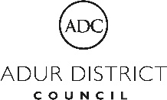

**Early Market Engagement Request**

**Introduction**

Arun District (ADC), Adur District and Worthing Borough Council's (ADWB) are looking to gather information from the market about a joint proposed Environmental Health and Licensing Out of Hours Service to inform any future procurement.

ADC will be the contracting Authority for the proposed service, both Councils are located on the south coast of West Sussex (please see Geographical Area below).

Please read the Proposed Service Overview and the detailed Service Specification held below, and then respond appropriately to the following questions contained under Questions.

Deadline for submitting responses is 31st May 2022, 17:00. Please submit responses via In-Tend Portal, by using the correspondences feature.

**Proposed Service Overview**

The primary purpose of the contract is to secure evidence of nuisance issues and to establish if there is, or is likely to be, a public or statutory nuisance. This may include noise, smoke, odour, dust, or light complaints about commercial or residential premises and will involve accepting referral calls from our call handlers and then responding to residents either by telephone, in person, or both, dependant on specified criteria.

Examples of complaints can include car alarms, noise from house parties, bonfires, house or store alarms, music noise from commercial premises, noise from construction work, lights on property and odour from commercial premises.

Requests may be made to monitor events or existing complaints on a pre-planned basis. Further information on the proposed service can be found in the service specification below.

The service will run overnight weekdays from Monday 18:00 to Friday 08:00 and then the weekend Friday 17:00 to Monday 08:00. In addition, a full 24 hours per day shall be provided when the Council Offices are closed which will include nationally recognised public and Bank Holidays for all three Authorities. The same conditions will apply over the period between Christmas and New Year for ADC to cover a Christmas shut down (dates to be stated annually in advance).

It is proposed that the initial contract duration is two years with the option of two further one-year extensions giving a maximum contract duration of four years. The proposed maximum annual budget is £30,500.

**Service Specification**

The Service Provider will not be expected to take initial receipt of out of hours calls. Calls will be referred to the Service Provider for a response by ADC and ADWB Councils’ Duty Officers, Supervising Officers or their nominated deputies, the Police, or any other agency authorised by the Authority.

Referrals require a response to the complainant within 15 minutes and when attendance is required on site, the response time shall be within one hour of notification of the complaint or within 45 minutes of departure from a previous site visit within the Districts of Arun, Adur, or the Borough of Worthing if and when the following circumstances prevail.

(a) The complaint relates to alleged nuisance from residential or non-residential premises, including any works of construction or demolition, or any highway works, where there is likely to be a significant impact on local residents (usually when two or more complaints from separate residents have been notified in any instance via the Duty Officer). (The number of complaints triggering a referral can be varied by the Authority) or if a response is required in accordance with a list of addresses requiring a response to complaints.

(b) The complaint relates to a vehicle alarm or other audible alarm, or

(c) The complaint relates to an ongoing investigation of noise or other nuisance by the Authority and of which the Service Provider has been previously notified, or

(d) There is a major pollution incident notified by the emergency services, the Environment Agency or the Council.

In relation to item (d) above, action will be limited to on-site verification of the circumstances and prompt onward referral to the Authority if appropriate.

Unless deemed unwarranted in exceptional circumstances, the Staff will be expected to gather evidence, to give advice to the parties (both orally and by providing any relevant written information supplied by the Supervising Officer) and to seek a remedy if appropriate through advice or mediation. Noise recordings and noise level readings should be taken when appropriate using Class 1 sound level meters, and in accordance with any procedure provided by the Supervising Officers. Any noise recordings and details of levels taken shall be emailed to the Supervising Officer no later than 09:00 at the beginning of the next working day.

Those persons visiting site will need to be capable of writing statements which can be used as evidence as part of an investigation. Statements and evidence in person may be required for court.

Service of a Statutory Notice or Fixed Penalty Notice may be necessary or desirable in certain circumstances. This may include obtaining warrants and undertaking works in default which can include confiscation of equipment and the silencing of alarms.

Monthly performance data shall be provided on a quarterly basis or on request.

The Service Provider’s personnel who deliver under the proposed service must have had a Disclosure and Barring Service check carried out and full results provided to the satisfaction of the Councils’.

The Service Provider must be able to demonstrate that they can handle and process data in accordance with Data Protection legislation, providing details of how they will achieve this.

The Service Provider is expected to have a minimum of £5M for both Public Liability and Employers Liability.

**Questions**

Question 1 - If your organisation can deliver the required service meeting the stated specification and within the proposed budget, please detail your proposed delivery model:

|  |
| --- |
|  |

Question 2 - If your organisation is unable to deliver the required service, please provide feedback on our proposed service:

|  |
| --- |
|  |

**Geographical Area**

Arun District Council: 1 Maltravers Rd, Littlehampton, BN17 5LF

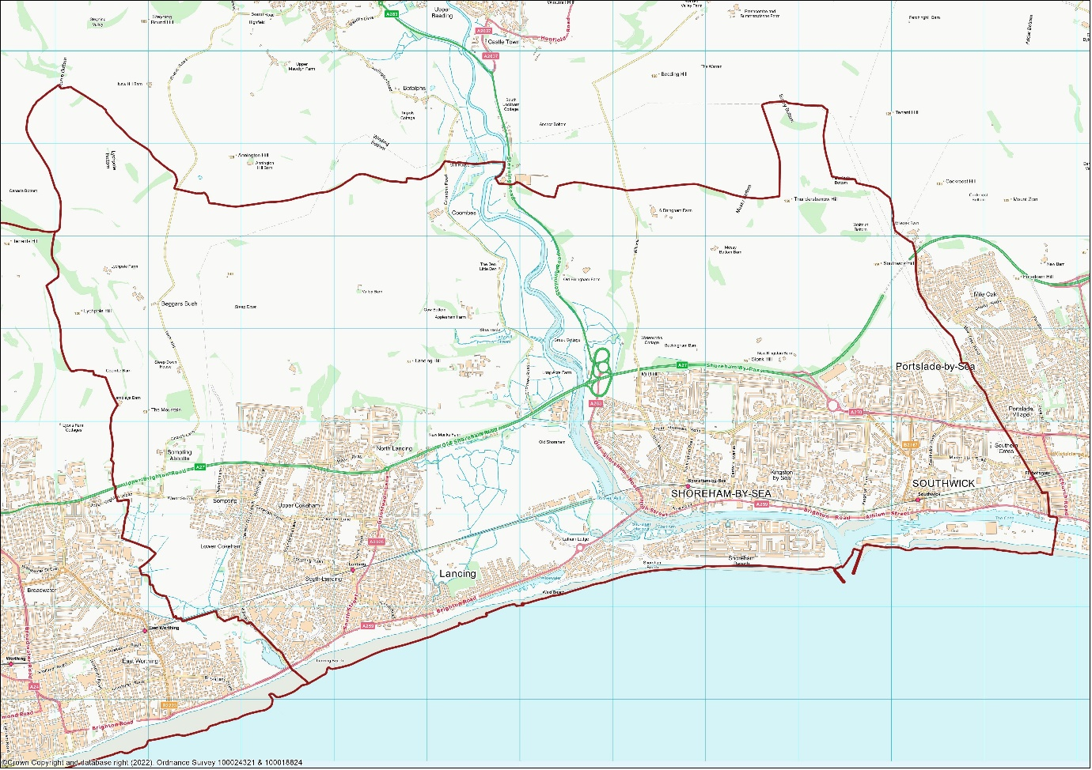

Adur District Council: Town Hall, Chapel Rd, Worthing, BN11 1HA

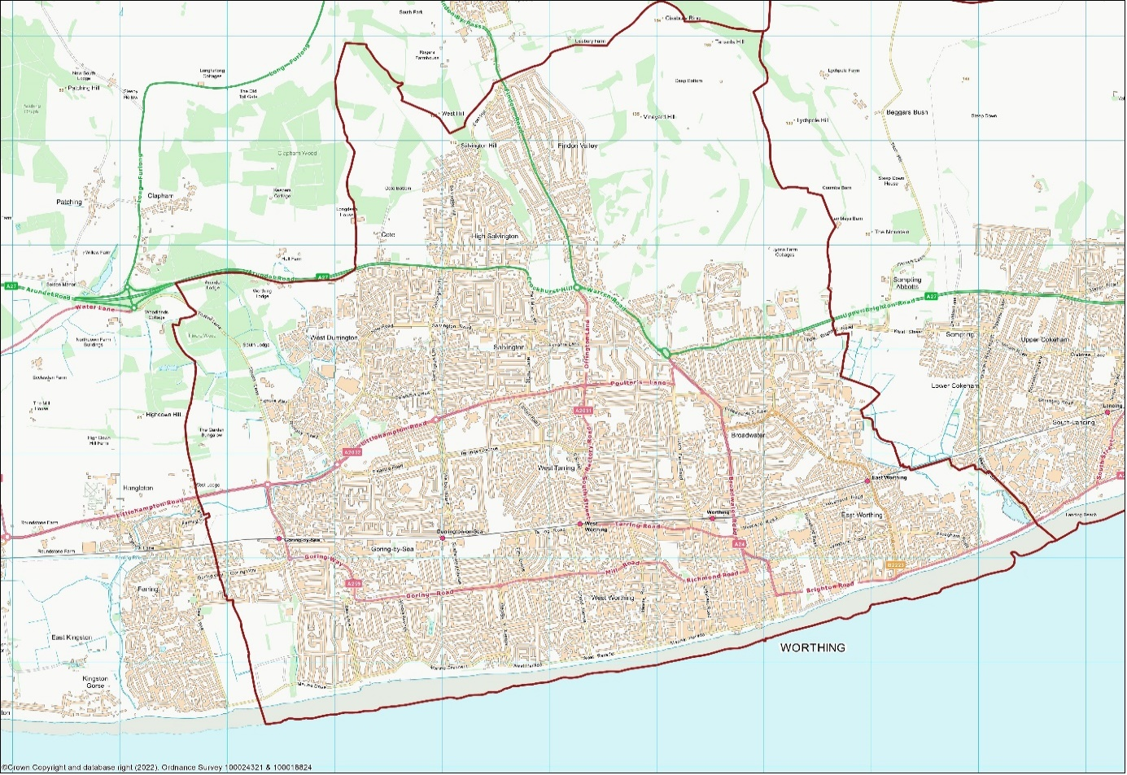

Worthing Borough Council: Town Hall, Chapel Rd, Worthing, BN11 1HA