REQUEST FOR TENDER (RFT)

BIDDERS MUST COMPLETE ALL THE AREAS SHADED IN YELLOW TO ENSURE THEIR BID IS PRESENTED IN A COMPLIANT FORMAT

SECTION ONE – LEOMINSTER TOWN COUNCIL’S CONTACT DETAILS

RFT Title | Old Priory Fire Alarm System
Department | Property
Originator telephone number | 01568 611734
RFT clarifications email address | townclerk@leominstertowncouncil.gov.uk
RFT response address | firealarmsystems@leominstertowncouncil.gov.uk
Leominster Town Council’s originator of RFT | Julie Debbage/Liz Womack

SECTION TWO – TIMESCALES

Date RFT Developed | 6th February 2025
Date/time RFT response to be received by email to the Leominster Town Council originator as identified in Section One | Sunday 23rd February 2025 at midnight.
RFT Validity Period (calendar days) | 90 days
Planned notification of the result to bidders | Monday 3rd March 2025
Estimated Contract Award Date | Monday 3rd March 2025
Contract Duration | 3 months (for design and installation works)
Payment Terms | Payment schedule will be agreed at a scoping meeting following the award of the contract.  Payment will be no longer than 30 days from receipt of invoice.

SECTION THREE – SCOPE OF WORKS

Description of the Scope of Works
SITE
The Old Priory, Leominster, Herefordshire, HR6 8EQ. Scheduled Ancient Monument list entry number 1005529.

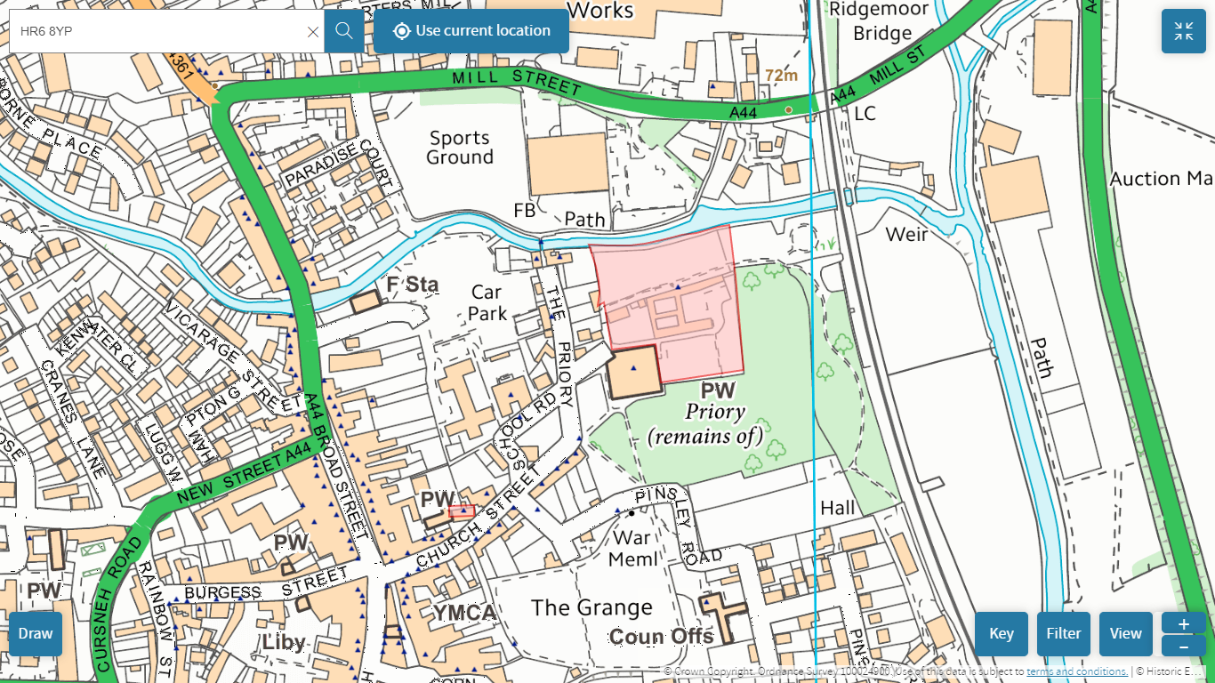

BACKGROUND

Located in the centre of the rural market town of Leominster, the Old Priory building is a large (1740m²) grade 2 listed building and scheduled ancient monument within walking distance of Leominster’s High St. Ownership of the Old Priory building was transferred to Leominster Town Council from Herefordshire Council in September 2022 via Community Asset Transfer.

The Old Priory has played an important role in Leominster’s community life for over 900 years. The building currently accommodates a number of essential organisations that sustain our community, providing vital support and representation to many of Leominster’s residents. Tenants include:
- Leominster Foodbank (www.leominsterfoodbank.org): providing emergency food support, debt advice and signposting to those in need. Also a Talk Community (Herefordshire-wide community support network) Hub.
- Leominster Meeting Centre (www.leominstermeetingcentre.co.uk): provides activities, advice, discussion groups and one-to-one support for people affected by dementia.
- ECHO (www.echoherefordshire.org.uk): a leading provider of services for people with disabilities living in Herefordshire.
- Leominster Youth Hostel (www.yha.org.uk/hostel/yha-leominster)
- Hereford Diocese (https://www.hereford.anglican.org/) – rental of storage space to support children and families ministry
Approximately 30% of the Old Priory building is currently vacant.

Leominster Town Council has worked in collaboration with the building’s current tenants and other local organisations to ensure that the Old Priory remains at the heart of Leominster’s community life as a sustainable and economically viable multi-use community asset. One that will:
- be financially sustainable, generating sufficient income to cover the costs of ongoing building management, maintenance and conservation.
- utilise the full potential of the Old Priory as a community resource.
- respect, preserve and celebrate the historical value of the Old Priory building and its significance within Leominster’s heritage.
- support community organisations and services by offering affordable, versatile and accessible office, meeting and outreach space.
- support the town economy by encouraging business development, innovation and diversification.
- support the town’s tourism by providing high quality accommodation and enhancing heritage.
- be environmentally responsible, in line with a climate and ecological emergency declaration made by Leominster Town Council.
- complement existing town services and businesses, while minimising competition.
Specifically, our vision for the Old Priory Centre incorporates:
- Community Support: the Old Priory already accommodates a number of essential community services that provide vital support and representation. By offering shared office and meeting space that can be rented on a long-term or flexible short-term basis, the Old Priory will become an outreach hub for a wide variety of county-wide support organisations - helping to improve local access to services, supporting the well-being and quality-of-life of Leominster residents, and assisting with community recovery and resilience following the recent cost of living crisis.
- Incubation Hub & Office Space Rentals: sections of the Old Priory premises will be converted into a purpose-designed facility for supporting the start-up of local services and businesses that need low-cost office space/hot desks, shared meeting rooms and other support. The facility will be the first of its kind in Leominster, offering business services that complement, rather than compete with, those available at Grange Court and the Leominster Community Centre.
- Accommodation: sections of the Old Priory building will be converted into self-catering accommodation that complements the current offer available at the Leominster Youth Hostel, while responding to a local need for additional visitor accommodation.
- Heritage: There is significant potential to preserve, enhance and celebrate the Old Priory’s rich heritage by providing opportunities for interpretation and education, while also adding to Leominster’s tourism offer.
Much of the Old Priory building is not currently in use and no sizeable investment in the property has been made in a number of years. Since taking on the asset in September 2022, Leominster Town Council has addressed urgent repair needs at the site, however significant investment is required to preserve and rejuvenate existing tenant spaces and bring unused areas back into use, ensuring that the Old Priory centre remains architecturally sound, economically sustainable and of maximum benefit to residents, businesses and community groups in the town for the long-term future. Grants from the Leominster High Street Heritage Action Zone Scheme in 2022 enabled Leominster Town Council to commission a condition report, heritage statement, architectural drawings and a feasibility study, assessing and confirming the viability of our plans to develop the building for community use.
In March 2024, Leominster Town Council was offered a grant from Central Government’s Community Ownership Fund to enable the implementation of phase 1 of the Old Priory Centre development plans. The funded works will focus on making much needed repairs and improvements to areas of the building currently occupied by essential local support services and community groups, in addition to renovating unoccupied areas in order to provide additional office suites, incubation and co-working spaces, self-catering accommodation units and several small/medium size meeting rooms. The Old Priory is a very large site, so replacement and repair of items that are essential to the safe and effective running of the building (e.g. wiring, fire alarm systems, window replacements, heating provision) are significant costs.
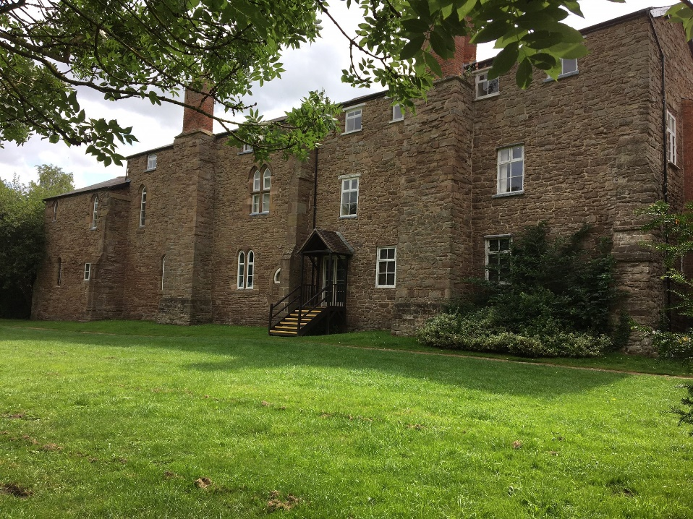

THE BRIEF
Leominster Town Council wishes to procure the services of an accredited fire safety engineer to design, install and service a new L1 fire alarm system at the Old Priory.

The work will include:-

The design, installation, servicing and maintenance of a new L1 (BS5839-1:2017) fire alarm system for the Old Priory.

Design Requirements
- Stage one: attend a conception meeting on site to discuss specification of system required.
- Stage two: supply system specification design to Leominster Town Council and Historic England.
- Stage three: revise any design specification or provide information in response to feedback from Leominster Town Council and Historic England.
- Stage four: Final design specification agreed by Leominster Town Council and Historic England.

No installation work can begin until the system design and specification has been agreed. If the design specification cannot be agreed, then the contract will not progress further and no payments will be made towards installation or maintenance costs.

Designs should seek to minimise impact on building fabric.

Installation
- Installation must be completed by 1st June 2025
- Works must respect the heritage significance of the site, complying with Scheduled Monument Consent and minimising impact on the building fabric.

Maintenance and Servicing Requirements
- 3-year contract.
- Quarterly servicing.
- 24 hours emergency call out.

Works must:
- include appropriate lighting, signage and guarding to protect members of the public for the duration of the works and to meet all health and safety legislation.
- include disposal of all waste material, meeting all legislative guidelines.
- ensure that all materials and equipment are appropriately secured at all times to prevent any unauthorized access.
- include issuing of all industry standard certificates/warranties for the works.
- comply with all Scheduled Monument Consent requirements communicated by the client.
- leave the site clean, tidy and ready for use.
Please note: a site visit is required prior to the submission of the tender due to the unique nature of the building.

The successful firm must be able to demonstrate previous experience working on historically sensitive and complex sites.

Facilities: public toilets are located at the site, so no additional temporary facilities will be required.

Tenderers are:
- expected to inspect and examine the site and its surroundings before submitting their tenders
- advised to obtain all necessary information which they feel is necessary to submit their tender.
It will be a condition of the invitation to tender that the tenderer should not at any time prior to notification of the award of the contract disclose to or otherwise discuss with any other tenderer or any other third party its actual or intended tender price or any approximation of that price. Your indication that you wish to submit a tender will be taken as acceptance of that condition. The client offers no guarantee that the lowest or any tender will be recommended for acceptance or accepted. The client will not be responsible for any cost incurred in the preparation of any tender.

All tenderers are to complete sections 4-12 and return their submission by Sunday 23rd February 2025 at midnight to: firealarmsystems@leominstertowncouncil.gov.uk

SUPPORTING DOCUMENTS
- Annex 1: Fire risk site report November 2024
- Annex 2: Site plans
- Annex 3: Asbestos Survey

SECTION FOUR – QUESTIONNAIRE

Q1 | Service Delivery  Please describe how you will deliver the works outlined within the specification in Section 3. Your answer should:  - Set out a detailed programme and timescales for the delivery of the works.  - Address how you will meet any specific requirements set out in the specification.

Bidder response

Q2 | Experience  Please demonstrate your experience, knowledge and skills relevant to delivering the works outlined within the specification in Section 3. Your answer should:  - Provide evidence of previous experience in working with heritage sites, specifically scheduled monuments and listed buildings.  - Address the company and individual team members’ experience and qualifications.  - Outline any experience in delivering similar works, reflecting the type, nature and scale of the service provision.

Bidder response

SECTION FIVE – PRICE

The Bidder shall confirm the price (exclusive of VAT) to complete the works outlined in Section 3. Costs must be itemised to indicate costs of completing each of the three contract areas: Design, Installation, Maintenance & Servicing.

Bidder response
Design cost (excl. VAT):
Installation cost (excl. VAT):
Maintenance & Servicing cost (excl. VAT):

Total cost (excl. VAT):

SECTION SIX – REFERENCES

The Bidder shall include reference details of one contract relevant to this particular activity, which is still running or has been completed within the last three years.

The bidder shall support the reference with the following information:
- Reference Company Name
- Description of the work carried out
- Approximate annual contract value (£)
- Contract start and end date

Bidder response | Reference
Company Name
Address
Contact Name
Telephone No.
Email
Description of the work carried out
(word count 200 words)
Approximate annual contract value (£)
Contract start and end date

SECTION SEVEN – EVALUATION MODEL

The evaluation model below shall be used for this RFT, which will be determined to two decimal places.

Pass/Fail Criteria
Failure of any one of the pass/fail questions listed below will mean automatic disqualification from this quotation process.
RFT response received on time:  RFT response in the correct format: | Pass / fail  Pass / fail
Adherence to all areas in Section Eight ‘Legal Compliance’ | Pass / fail
Insurance levels acceptable | Pass / fail
Adherence to all areas in Section Nine ‘Financial Information’ | Pass / fail

Scoring Criteria (out of 100% rounded to two decimal places)
S4: Q1 Service Delivery | 33%
S4: Q2 Experience | 33%
S5: Price | 34%
Total | 100%

Evaluation Criteria
Non-Price elements will be judged on a score from 0 to 10, which shall be subjected to a multiplier – so criteria worth 20% will have a 0-10 score and a multiplier of 2. The 0-10 score shall be based on:
0-1 The Question is not answered or the response is completely unacceptable. It does not meet the minimum requirement or fails to address the point of the question
2-3 Very poor response and not acceptable – fails to meet the minimum requirement/standard. Requires major revision to the proposal to make it acceptable. Only partially answers the requirement, with major deficiencies and little relevant detail proposed.
4-5 Poor response only partially satisfying requirement/standard with deficiencies apparent. Some useful evidence provided but response falls well short of minimum requirements.
6-7 Response is acceptable and meets minimum requirement but remains basic and could have been expanded upon.
8-9 Response meets our expected requirement/standard and exceeds minimum expectations, including a level of detail that adds value to the bid.
10 – Excellent response – comprehensive and useful, which exceeds the specified performance or capability in a beneficial way. The response is innovative and includes a full description of techniques and measurements to be employed.
Price elements will be judged on the following criteria.
The lowest price for a response which meets the pass criteria shall score 10. All other bids shall be scored on a pro rata basis in relation to the lowest price.
For example - Bid 1 £100,000 scores 10, Bid 2 £120,000 differential £20,000 or 20% remove 20% from price scores 8, Bid 3 £150,000 differential £50,000 remove 50% from price scores 5, Bid 4 £175,000 differential £75,000 remove 75% from price scores 2.5. The lowest score possible is 0. All scores are then subjected to a multiplier e.g. if price has a scoring criteria of 55%, the multiplier will be 5.5.

SECTION EIGHT – LEGAL COMPLIANCE

All Bidders must provide an acceptable response to the questions detailed below.

1. Please mark ‘X’ in the relevant box to indicate whether you are: |  | A) Bidding as a Prime Contractor and delivering 100% of the key contract deliverables yourself.
 |  | B) Bidding as a Prime Contractor and will use third parties to deliver some of the contract deliverables.
 |  | C) Bidding as a Prime Contractor but will operate as a Managing Agent and will use third parties to deliver all of the contract deliverables.
 |  | D) Bidding as a consortium
If you have selected B), C) or D) above, please provide further details here:
2. Grounds for Mandatory Exclusion  i) Within the past five years, has your organisation (or any member of your proposed consortium, if applicable), Directors, partners or any other person who has powers of representation, decision or control, been prosecuted under UK or EU law or convicted of any criminal offences; including bribery, corruption, conspiracy, terrorism, fraud and money laundering, theft, and tax evasion? | Yes/No
If you have answered ‘Yes’ to question 2. i), please provide further details here:
3. Grounds for Discretionary Exclusion  i) Within the past five years, has your organisation (or any member of your proposed consortium, if applicable), Directors, partners or any other person who has powers of representation, decision or control, been accused of misconduct, distortion of competition, or breaches of environmental, employment, equity legislation or health and safety law? | Yes/No
If you have answered ‘Yes’ to question 3. i), please provide further details here:
ii) Within the past five years, has your organisation shown significant or persistent deficiencies in performance of a prior contract that have led to early termination of that contract, damages or other sanctions? | Yes/No
If you have answered ‘Yes’ to question 3. ii), please provide further details here:
iii) Are you aware of any legal or financial proceedings currently in progress that might affect the performance of contract obligations?
If you have answered ‘Yes’ to question 3. iii), please provide further details here:
4. Conflicts of Interest  Leominster Town Council may exclude a supplier if there is a conflict of interest that cannot be effectively remedied. A conflict of interest includes any situation where relevant staff members have, directly or indirectly, a financial, economic or other personal interest which might compromise their impartiality or independence in the context of the procurement procedure. | Please declare any potential conflicts of interest here.
5. Health and Safety  i) Does your organisation have a Health and Safety Policy that complies with current legislative requirements? | Yes/No
ii) If you use sub-contractors, do you have processes in place to check whether they have a Health and Safety Policy that complies with current legislative requirements? | Yes/No
6. Employment and Recruitment  i) Does your organisation have policies in place to ensure fair recruitment and adherence to employment law, including right to work obligations? | Yes/No
ii) If you use sub-contractors, do you have processes to check whether they have policies in place to ensure fair recruitment and adherence to employment law, including right to work obligations? | Yes/No

SECTION NINE – INSURANCE

Please confirm that you shall have the following insurance cover:
Public liability (a minimum of) £10,000,000 | Yes/No
Employers liability (a minimum of) £5,000,000 | Yes/No
Professional indemnity (a minimum of) £2,000,000 | Yes/No

SECTION TEN – FINANCIAL INFORMATION

Please provide one of the following to demonstrate your economic/financial standing: | Please indicate with an ‘X’ which document you have provided as an accompanying document (or indicated where records can be accessed online).
A) A copy of audited accounts for the most recent two years.
B) A statement of the turnover, profit & loss account, current liabilities and assets, and cash flow for the most recent year of trading for your organisation.
C) A statement of your organisation’s cash flow forecast for the current year and a bank letter outlining the current cash and credit position.
D) Alternative means of demonstrating financial status, if any of the above are not available.

SECTION ELEVEN - BIDDER DETAILS
Bidder name and registered address

Email address
Phone number
RFT completed by

SECTION TWELVE - DECLARATION
I declare that to the best of my knowledge the answers submitted within sections 4-10 are correct. I understand that the information provided will be used in the selection process to assess my organisation’s suitability to provide services outlined in section 3.

I declare that I have permission to complete and submit answers within sections 4-10 on behalf of the organisation listed in section 11. I understand that Leominster Town Council may reject my submission if there is a failure to answer all relevant questions fully or if I provide false/misleading information.

Declaration made by:
(please print name)

Signature:
Date:

