Didcot Town Council


Environment Committee
20th July 2020
Report author: Guy Langton

Stubbings Land connection to Great Western Park (south)

Introduction
- The Planning and Development Committee, at its meeting on the 29th January 2020 heard from a member of the public that the connection between Stubbings Land and the public open space (POS) at Reed Street on Great Western Park (GWP) had been very muddy for a number of

- At the time of writing, there had been 50 responses, or a 25% response rate.

- Of the 50 responses, respondents could be categorised as being in favour (“yes”), against (“no”) or wanting further information (“other”). A significant number of both the “yes” and “no” responses were accompanied by comment. Both “other” responses wanted to know the route of the path before making comment.

Table 1: results

- Those who were against the laying of a path all commented that it would be better to improve the path at the end of Bluebell Lane, past Pill Pond to Wantage Road, connecting it to the existing path network by installing a path along the southern side of Wantage Road or a crossing to the northern side.

- Of those wanting to see the path installed, five also mentioned that the path described at 9 above needed improving in the same way. Three mentioned incidents of witnessing people fall over on the mud.

- Other comments included:
  - Ensuring a cycle/motorcycle barrier was installed (3 responses)

  - Fencing off the ditch to make it safe (1 response)

- Six respondents suggested routes for the path:
  - two proposed a diagonal bisecting Stubbings Land, from the Reed Street entrance to the central path (yellow line on the map overleaf). Six respondents actively did not want this, whilst also being in favour of a path.

  - four respondents favoured a short link from Reed Street to Wheatfields, which in turn leads to the path running from Drake Avenue, past Brunel Road and on to Portway (red line overleaf). One of these also suggested connecting that path to Collingwood Avenue at the North-eastern end of the path (blue line overleaf.

- Finally, one respondent thanked the team for keeping Stubbings Land well mown and in good condition.
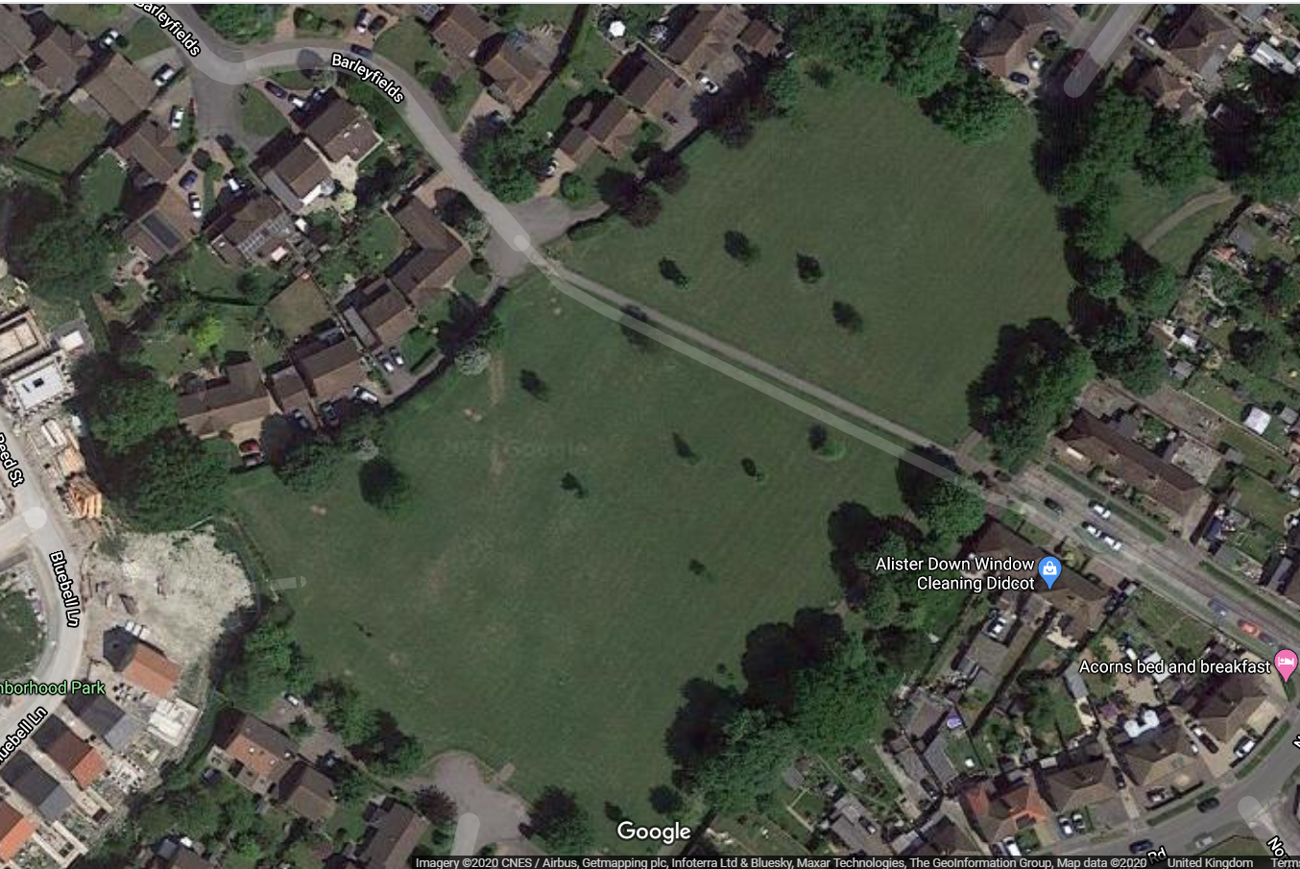

Financial Implications
- Any works undertaken by the Council would incur a cost, in materials and labour.
- The developer had previously offered to undertake work to improve the surface of the entrance only, by laying shingle over the rest of the connecting path and rubber grass matting in a fan-shape extending onto Stubbings Land. The quoted cost for this was included in a previous report for this Committee and totalled £4,257.66
- Other third party costs had not been sought by the Officers.
- The leaflet distributed.

