

Bid Pack For Call Off Competition
Appendix D – Response Criteria; How To Bid Including - Evaluation Criteria
Contract Reference: 700006374
Title: Provision of Portsmouth Naval Base Strategic Support Partner – Maritime Support Delivery Framework

Contents
Bid Pack For Call Off Competition 1
1. How To Make Your Bid 2
2. How The Questionnaires Are Structured: 2
3. Award Criteria 14
4. Marking Scheme 16
5. Quality Evaluation 17
6. Price Evaluation 18
7. Final Decision to Award 20

How To Make Your Bid

Your bid must be made by the organisation that will be responsible for providing the deliverables if your bid is successful.

Explain any limitation on the bidding for Lots.

Remember to:

Accept or Decline this Bid Pack. If you Decline please provide a reason for doing so

Enter your bid into the e-Sourcing Suite. We can only accept bids that we receive through the e-Sourcing Suite

Make sure you answer every question

Each question must be answered in its own right. You must not answer any of the questions by cross referencing other questions or other materials e.g. reports located on your website.

Submit your bid in good time and before the bid submission deadline.

Upload ONLY those attachments we have asked for in line with the requirements specified – any other supporting evidence, certificates for example, will be requested separately by us.

If we do not require attachments and have specified this please only use the Text Boxes provided for your answer.

Check for messages in the e-Sourcing Suite throughout the competition.

Press the Submit all Draft Bids button when your bid is ready, otherwise we will not be able to see it.

If you are unsure, ask questions before the Clarification Questions Deadline.

How The Questionnaires Are Structured:

A summary of all the questions in the quality questionnaire, along with the marking scheme, and weightings for each question is set out below:

QUESTIONNAIRE 1 - KEY PARTICIPATION REQUIREMENTS

QUESTIONNAIRE 2 - CONFLICTS OF INTEREST

QUESTIONNAIRE 3 - INFORMATION ONLY

QUESTIONNAIRE 4 - QUALITY - TEAM AND SKILLS

QUESTIONNAIRE 5 - QUALITY - PROJECT DELIVERY

QUESTIONNAIRE 6 - QUALITY - RISK MANAGEMENT

QUESTIONNAIRE 7 – PRICE

QUESTIONNAIRE 1 - KEY PARTICIPATION REQUIREMENTS

Response Guidance

The following questions are ‘Pass/Fail’ questions. If Potential Bidders are unwilling or unable to answer “Yes”, their submission will be deemed non-compliant and shall be rejected. Potential Bidders should confirm their answer by selecting the appropriate option from the drop down menu.

Question Number | Question | Your Response
1.1 | Do you accept the competition rules? | Yes/No
1.2 | Have you read, understood and accepted the Bid Pack and all associated attachments, specifically the Statement of Requirement? | Yes/No
1.3 | Do you agree, without caveats or limitations, that in the event that you are successful, call off contract will govern the provision of this contract? | Yes/No
1.4 | Have you completed the Supplier Assurance Questionnaire against Cyber Risk Assessment RAR-A77M2WQA (in accordance with Paragraph 15 - SECURITY & CONFIDENTIALITY REQUIREMENTS) of the Statement of Requirement? | Yes/No
1.5 | Do you confirm your Organisation’s e-Sourcing suite profile is complete and accurate at the time the bid closed and that any amendments made following acceptance of this event will be notified to the buyer in writing? | Yes/No

QUESTIONNAIRE 2 – CONFLICTS OF INTEREST

Response Guidance

Question 2.1 is a ‘Yes/No’ question and will dictate whether or not question 2.2 needs to be answered.

Question 2.2 is a Pass / Fail question. Potential Bidders are required to provide details of how the identified conflict will be mitigated.

The Contracting Authority will review the mitigation in line with the perceived conflict of interest, to determine what level of risk this poses to them. Therefore, if Potential Bidders cannot or are unwilling to suitably demonstrate that they have suitable safeguards to mitigate any risk then their Bid will be deemed non-compliant and will be rejected.
Question Number | Question | Your Response
2.1 | Please confirm whether you have any potential, actual or perceived conflicts of interest that may by relevant to this requirement. | Yes/No
2.2 | We require that any potential, actual or perceived conflicts of interest in respect of this Bid Pack are identified in writing and that companies outline what safeguards would be put in place to mitigate the risk of actual or perceived conflicts arising during the delivery of these services. | Text Box

QUESTIONNAIRE 3 – INFORMATION ONLY

Response Guidance

The following questions are for information only and do not form part of the evaluation. Information provided in response to these questions may be used in preparation of any Contract Award and any omissions may delay completion of this procurement.
Question Number | Question | Your Response
3.1 | Please provide details of where the Award Outcome should be directed. Your response must include their;  - Full Name  - Role/Title  - Registered Address  - Email Address | Text Box
3.2 | Please provide details of any sub-contractors you propose to use in order to meet your obligations should you be awarded a Contract. Your response must include their;  - Trading Name(s)  - Registered Address(ees) and contact details  - Goods/Services to be provided | Text Box

QUESTIONNAIRE 4 - QUALITY – TEAM & SKILLS (Overall Weighting 35%)

Response Guidance
Potential Bidders MUST answer ALL the following questions. The method of response; page limit on attachments and evaluation criteria is set per question.

Attachments may be submitted in Microsoft Word, Excel. PDF format and must be in Arial font size 11. Page limits include the use of headers and footers, but do not include diagrams. Upload ONLY those attachments we have asked for – any other supporting evidence, certificates for example, will be requested separately by us

No costings should be included in responses to this Questionnaire.

Question Number | Question | Your Response | Minimum Acceptable Score | Maximum Available Score | Weighting
4.1 | Please provide details of those individuals that will make up your team; their relevant skills and experience and indicate why this would make them suitable for conducting this work. | CV's (max. 10, and each CV should not exceed 1 side of A4) | 66 | 100 | 50
4.2 | Please provide details of those specific tasks which your team members will have been involved in previously, where the skills at 4.1 have been applied. Your response should indicate: The sector (private/public/voluntary), The industry (eg. Defence, Retail etc).  Any specific challenges that may be relevant to those tasks outlined in the SOR for this requirement, should be described along with the outcomes of that activity. | CV's (max. 10, and each CV should not exceed 1 side of A4) | 66 | 100 | 50

QUESTIONNAIRE 5 - QUALITY – PROJECT DELIVERY (Overall Weighting 30%)

Response Guidance
Potential Bidders MUST answer ALL the following questions. The method of response; page limit on attachments and evaluation criteria is set per question.

Attachments may be submitted in Microsoft Word, Excel. PDF format and must be in Arial font size 11. Page limits include the use of headers and footers, but do not include diagrams. Upload ONLY those attachments we have asked for – any other supporting evidence, certificates for example, will be requested separately by us

No costings should be included in responses to this Questionnaire.

Question Number | Question | Your Response | Minimum Acceptable Score | Maximum Available Score | Weighting
5.1 | Please provide details of how you would intend to conduct the Review. Your response should reflect:  • Time to mobilise team  • Expected duration of activity  • Your overall approach this activity.  • An outline of activity for the period of the work including dependencies leading to formal delivery of milestones  • The roles and responsibilities for delivery of outcomes ascribed to each Team Member.  Your attachments should not exceed 3 sides of A4. | Attachment | 66 | 100 | 30
5.2 | Please state how you would approach testing Operating Model This should include:  - The type of analysis you plan to undertake.  - Details of the MI that you would seek/provide to illustrate the effectiveness or otherwise of performance  - Details of the maturity model you would propose to use to assess maturity, deliverability and sustainability of the model. As a minimum this should include tests for: the system overall, personnel and skills, risk assessments.  Please give examples explaining why and how this meets the requirements, where you have used similar before and the results. You should indicate any benchmarking references that you would have access to and propose to utilise. You should state why this information will help add value to your proposition.  Your attachment should not exceed 2 sides of A4. | Attachment | 66 | 100 | 25
5.3 | Please provide details of the types of inputs and information you require to conduct this work. This should include:  • Those key pieces of information you would wish to gather  • Proposed methods of gathering data  • How you would cover any gaps in data  • What comparative benchmarks you might use to compare operations, cost efficiency and productivity (including with other sectors)  • Any expectations of the Authority to help/assist in the collation of data.  Your attachment should not exceed 1 sides of A4. | Attachment | 66 | 100 | 15
5.4 | Please provide details of how you would ensure required skills and knowledge transfer to Authority personnel within this contract phase.  Your attachment should not exceed 1 sides of A4. | Attachment | 66 | 100 | 15
5.5 | Please provide details of proposed governance processes and in particular reporting arrangements to the Authority.  Please explain, with evidence where possible, how this will assure a quality output.  Your attachment should not exceed 1 sides of A4. | Attachment | 66 | 100 | 15

QUESTIONNAIRE 6 - QUALITY – RISK MANAGEMENT (Overall Weighting 5%)

Response Guidance
Potential Bidders MUST answer ALL the following questions. The method of response; page limit on attachments and evaluation criteria is set per question.

Attachments may be submitted in Microsoft Word, Excel. PDF format and must be in Arial font size 11. Page limits include the use of headers footers, but not diagrams. Upload ONLY those attachments we have asked for – any other supporting evidence, certificates for example, will be requested separately by us

No costings should be included in responses to this Questionnaire.

Question Number | Question | Your Response | Minimum Acceptable Score | Maximum Available Score | Weighting
6.1 | Please provide a risk management plan for this task. This should include a risk register, setting out the top 10 risks to the delivery of effective outputs, together with mitigating actions.  Your attachment should not exceed 1 sides of A4. | Attachment | 66 | 100 | 100

QUESTIONNAIRE 7 – PRICE (Overall Weighting 30%)

Response Guidance
Potential Bidders must enter costs by uploading the relevant - Price Schedule.

Prices should be submitted in pounds Sterling inclusive of any expenses but exclusive of VAT.

Potential Bidders will be scored in accordance with the marking scheme at Section 2.

Question Number | Question | Your Response | Minimum Acceptable Score | Maximum Available Score | Weighting
7.1 | Please confirm, by selecting ‘YES’ that you have attached a completed Price Schedule to the response to this question. In so doing, you are also confirming that prices offered are inclusive of any expenses, exclusive of VAT and firm for the period following the Deadline for Submission as stated in the Invitation to tender.  The price attachment should include a breakdown of the overall price for the initial phase. Details of any discounts and free days support should be specified.  A rate card should also be provided which may be used for the future phases of activity under this contract. Within your attachment please confirm the validity of rates stated therein. | Yes/No  Attachment | N/A | 100 | 100
7.2 | Please confirm, by selecting ‘YES’, that you have uploaded a formal, company-headed price quote for the items, in addition to completing Price Schedule? | Yes/No  Attachment

Award Criteria

The award stage consists of a quality evaluation and a price evaluation, based on the pricing for the initial phase of activity.

The award of the resultant contract will be on the basis of the ‘Most Economically Advantageous Tender’ (MEAT).

The total weighting for the quality evaluation is 70% and the price evaluation is 30%.

Award process - What you need to do

Answer the questions in section 2 above in the e-Sourcing suite.

Complete the Price Schedule.

You must upload your completed Price Schedule into the e-Sourcing suite.

What we will do
1 | Compliance Check  First, we will complete a mandatory evaluation to make sure that you have answered all questions and have completed the Price Schedule in line with our instructions. All bids passing the mandatory evaluation will be progressed to the Quality Evaluation.
2 | Quality Evaluation  We will give your responses to the QUALITY questionnaires to the Contracting Authorities evaluation panel. Each evaluator will independently assess your responses to the quality questions using the response guidance and the evaluation criteria.  They will give a score and a reason for their score for each question they are assessing. The evaluators will enter the scores and reasons into the e-Sourcing suite.  If the evaluation panel wishes to clarify any areas of your bid, bid clarification questions will be issued via the e-Sourcing suite on an individual basis.
3 | Consensus  Once the evaluators have independently assessed your answers to the questions we will arrange for the evaluators to meet. We will facilitate the discussion.  At this meeting, the evaluators will discuss the quality of your answers and review their scores and reasons for that score. The discussion will continue until they reach a consensus regarding the score, and reason for that score, for each question.  These final scores will be used to calculate your quality score.  If the evaluation panel wishes to clarify any areas of your bid, bid clarification questions will be issued via the e-sourcing suite on an individual basis.
4 | Quality Threshold  If you have not met the minimum acceptable score for each question, you will be excluded from the competition. We will tell you that you have been excluded from the procurement and why at award stage.
5 | Evaluate Pricing  We will then evaluate your price and calculate your price score using the evaluation criteria specified.  If we wish to clarify any areas of your bid, bid clarification questions will be issued via the e-sourcing suite on an individual basis.
6 | Final Score  Your quality score will be added to your price score, to create your final score.
7 | Award  Award will be made to the successful bidder, subject to contract.  We will notify successful and unsuccessful bidders providing feedback.

Marking Scheme

The evaluation criteria set out below will be used during the Quality Evaluation:
Marking Scheme | Description
100 - Good | The response fully meets all requirements with detail provided minimising risks to delivery.  The response is comprehensive and unambiguous, demonstrating a thorough understanding of the requirements and provides details of how the requirement will be met in full without additional support from the Contracting Authority, other than that outlined within the Statement of Requirements.
66 – Acceptable – Minor Concerns | The response is acceptable and meets all the basic requirements. However, the response, is not sufficiently detailed to minimise risk and/or the proposed approach may require additional support (in addition to that outlined in the Statement of Requirements) from the Contracting Authority to meet its deliverables.
33 – Non Acceptable - Major Concerns | The response has met some, but not all elements of the requirement, which poses risk that the proposal will not meet the deliverables required.  The response does not demonstrate a full understanding of the requirement posing major concerns.
0 - Unsuitable | The response does not meet any of the requirements or no response has been provided. An unacceptable and/or non-compliant response with serious reservations, demonstrating no understanding of the requirement.

Quality Evaluation

Questionnaires Q1 and Q2 are mandatory question(s) and will be evaluated PASS / FAIL. If you fail any of these questions, you will be excluded from the competition. We will tell you that your bid has been excluded.

When the consensus meeting has taken place and the final score for each question has been agreed by the evaluators, your final score for each question will be multiplied by that questions weighting to calculate your weighted score for that question.

Each weighted score for each question you have submitted a bid for will then be added together to calculate your quality score.

Please see table A below for an example of how your quality score will be calculated (note this uses a differing scoring scale).

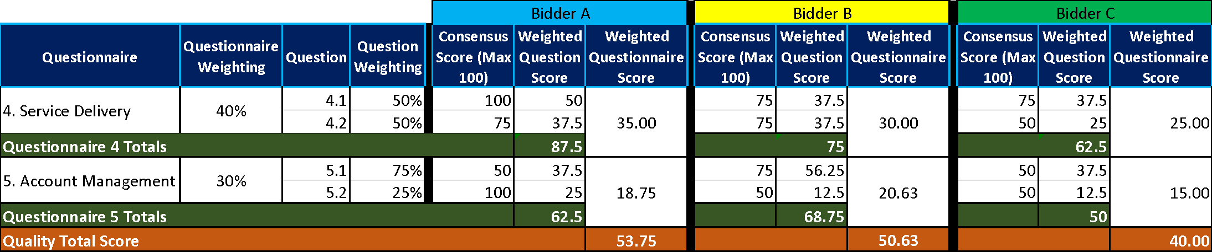
Table A – EXAMPLE ONLY

Price Evaluation

This section contains information on how to complete Price Schedule and the price evaluation process.

How to complete your – Price Schedule

Read and understand the instructions in the Price Schedule, and in this section before submitting your prices.

Your prices should compare with the quality of your offer.

Your prices must be sustainable and inclusive of all costs for example your operating costs and profit.

Your prices are to exclude VAT.

Pricing is to be exclusive of expenses.

The currency is British pounds sterling, up to two decimal places.

The percentages submitted shall be up to two decimal places.

Pricing will be based on:

Eight (8) hour Working Day; and

Rounded to the nearest £10.

Zero bids will not be allowed.

We will investigate where we consider your bid to be abnormally low.

The prices submitted shall not exceed the relevant framework contract rates.

You must download and complete the Price Schedule for the tender you are submitting a bid for. Further detail may be provided within the Price Schedule.

When you have completed your Price Schedule, you must upload this into the e-Sourcing Suite. If you do not upload your Price Schedule your bid may be rejected from this competition.

Do not alter, amend or change the format or layout of the Price Schedule.

Price Evaluation Process

This is how we will evaluate your pricing:

We will check you have completed the Price Schedule as instructed.

Failure to complete the Price Schedule as instructed may result in your bid being deemed non-compliant and may be rejected from this competition.

The price evaluation will be undertaken separately to the quality evaluation process.

The Potential Bidder with the lowest total price for the pricing table will be awarded the maximum score available for that pricing table.

All other Potential Bidders will get a price score relative to the lowest total price.

The calculation we will use to evaluate your total price is as follows:
Price Score = Lowest total price * maximum score available Potential Bidders total price

Please see table B below for an example of how your Price score will be calculated.

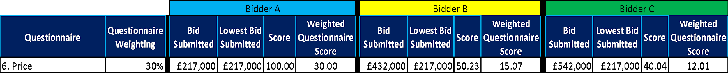
Table B – EXAMPLE ONLY

All other bidders will get a score relative to the total highest score.

The calculation we will use to evaluate the total price score is as follows:
Price Score = Potential Bidders Total Score * maximum score available
Highest Total Score

Where we consider any of the total price(s) you have submitted to be abnormally low will ask you to explain the price(s) you have submitted (as required in regulation 69 of the Public Contracts Regulations 2015).

Final Decision to Award

We will add your quality score to your price score to calculate your final score.

Please see table C below for an example of how your Quality score and Price score will be added together to identify your final score.
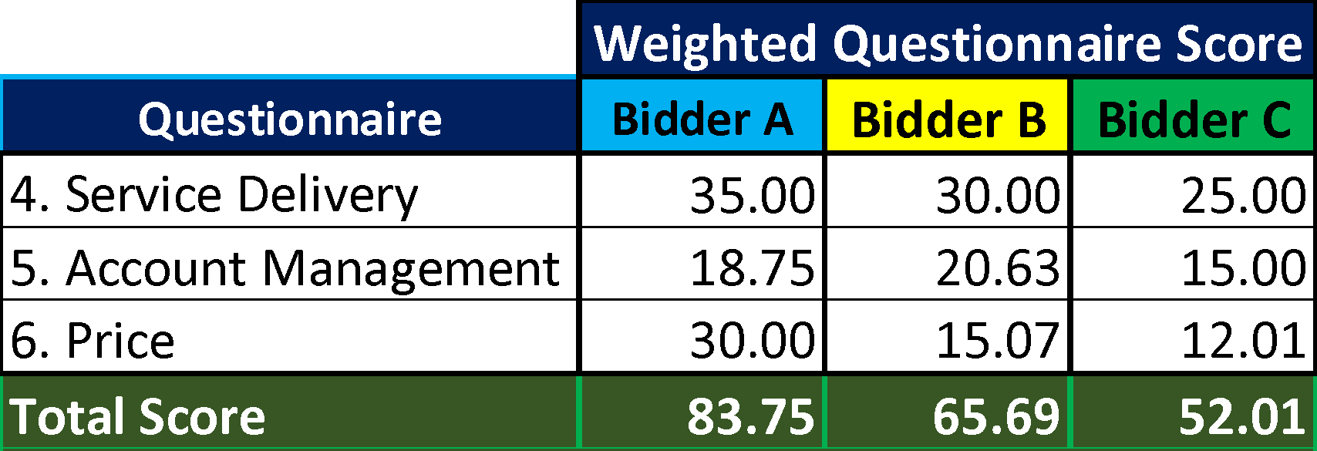
Table C – EXAMPLE ONLY:

The bidder with the highest final score will be awarded the contract.
  - We will tell you if you have been successful or unsuccessful via the e-Sourcing Suite.

