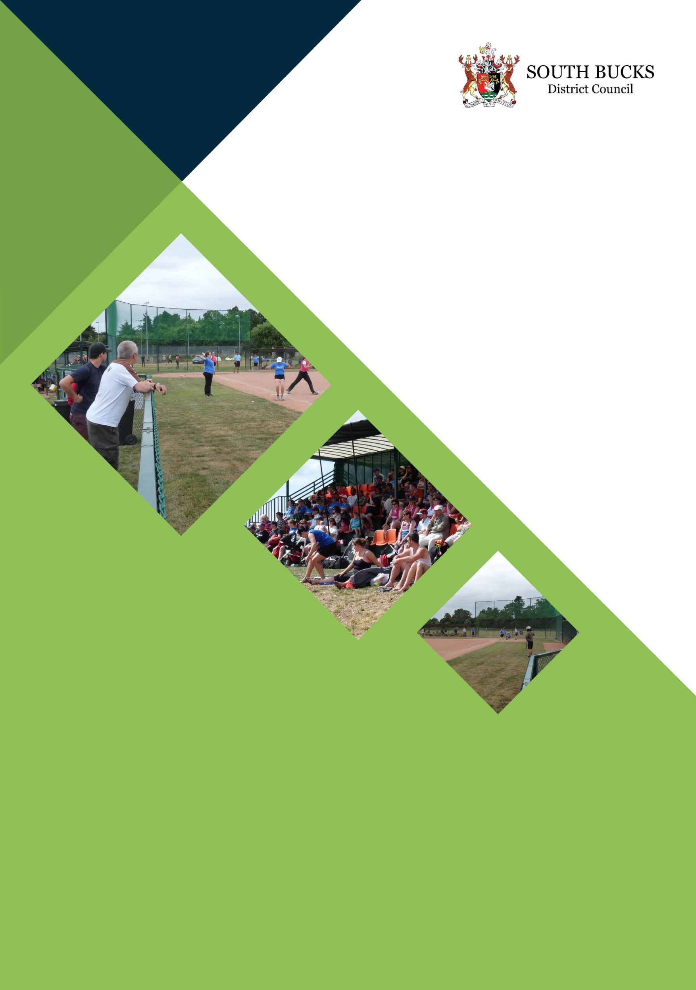

Farnham Park Playing Fields Consultancy Specification

April 2017

Proposal
To undertake a design and feasibility study of the Farnham Park Playing Fields, including stakeholder consultation to identify the opportunities to deliver a modern purpose built sports hub delivering health and fitness, function room, changing facilities to meet some of the outdoor club sporting needs for the area, and also to help mitigate the loss of the Evreham Centre in Iver which is due to close in 2021. It is the intention that the development of the playing fields will identify opportunities to improve income generation to deliver facilities with minimal running costs to the council tax payer.

Contract

The contract will be let in two stages with the second stage only being awarded should South Bucks District Council wish to progress to a fully costed design.

Stage 1; a preliminary Feasibility Study to develop proposals to redevelop Farnham Park Playing Fields

Stage 2; the second stage will be to invite detailed proposals and business case for the chosen design

Background

Farnham Park Playing Fields are held in trust by South Bucks District Council for use as a public amenity for the area, to promote health and wellbeing.

For many years it has provided playing pitches for a range of sports, and there are five buildings on the site used by different local sports clubs.
- BSUK (old bungalow)
- Slough Town FC
- Phoenix Old Boys FC – (building includes 8 changing rooms and referees room)
- Unity Martial Arts
- Farnham Royals Rugby Club

A sixth building serving both the South Buckinghamshire Golf Course and Farnham Park Playing Fields is used as the Green Keepers compound.

A number of these buildings are at the end of their useful lives and are no longer fit for purpose.

Part of the site is leased to Softball UK and the playing fields are a significant location for this sport in the region. Other uses are rugby, football and martial arts.

In terms of pitches there are presently six football pitches, two rugby pitches (one of which is not used), one rugby training area, two dedicated softball/baseball fields, and two softball fields. There are also two areas of disused floodlit courts, incorporating 3 tennis courts

The playing fields adjoin the South Buckinghamshire Golf Course which is operated by South Bucks District Council, and there is a single management and grounds maintenance team responsible for the playing fields and the golf course.

Stage 1
  - In accordance with the needs identified in the 2015 – 2045 Strategic Leisure Facilities study, review the current use of the site and the aspirations of the Council, local community, existing club tenants and National Governing Bodies of Sport to undertake a preliminary Feasibility Study to develop proposals to redevelop Farnham Park Playing Fields with the aim of:

- Increasing usage of the site

- Improving the quality of facilities including changing accommodation to meet the needs of the current users of the site, and raise the standard of facilities to accommodate higher levels of sporting participation

- Enabling the development of a multi-sports facility hub that could replace the health and fitness facilities at the Evreham Centre

- Identifying the required facility mix for the site to meet local needs of both formal and informal leisure users

- Considering how usage could be increased by the installation of modern synthetic surfaces that are capable of accommodating significantly more use and meeting national governing body requirements

- Liaising with Planning officers to ensure compliance with current and or proposed planning policy requirements

- Reducing the on-going revenue costs for the site through increased income and more efficient operational buildings to achieve cost neutral or income surplus

- Identifying opportunities for capital investment in the site and grant/lottery funding.

- Producing an action plan with key milestones for the development of a sports hub

  - Producing and presenting a number of options for consideration by the Council which should include outline project designs, site layout and both capital and operational costs, and a business case and which should reflect the end user groups need and have undergone effective and innovative consultation.

  - Developing a realistic capital funding plan to take account of external funding opportunities and to reflect the potential phasing of the plan

  - Ensuring that the facility designs and site layout reflect innovation and sustainability and are fit for purpose and that, where applicable, the design meets the Sport England Facilities Technical Guidelines or any other relevant standards and guidelines.

  - Ensuring that development plans reflect links to all other relevant policies and locally based initiatives including Buckinghamshire Physical Activity Strategy, South Bucks Community Wellbeing Plan, South Bucks Indoor Leisure Facility Strategy, Chiltern and South Bucks Open Spaces and Playing Pitch Strategy and the Sustainable Community Strategy. The potential development of Farnham Playing Fields would impact positively on the various cross cutting themes these strategies aim to address including improving health and wellbeing, reducing health inequalities, supporting community infrastructure and protecting the local environment. Therefore performance data demonstrating this should include

- Enabling opportunities for younger and older people to live more active lives and improve the health and wellbeing of the population
- Enabling the provision of high quality, low cost and accessible sport and leisure opportunities to facilitate increased participation in sport and physical activity to improve health and wellbeing
- Enabling people to be more active by encouraging and supporting less active people to change their behaviour

Stage 1 - Completion Deadline - 31 August 2017

South Buckinghamshire Panel - 20 September

SBDC Cabinet - TBA late September/Early October

Stage 2

Confirmation of decision whether to proceed based on feasibility work, October 2017

2.1 Produce detailed proposals for the chosen design including:

- RIBA Stage 2 Designs and cost plans
- Business Plan
- Sports Development Plan, including strategy for sports grant/lottery funding applications.

2.2 Ensure that development plans reflect links to all other relevant policies and locally based initiatives within e.g. Buckinghamshire Physical Activity Strategy, South Bucks Community Wellbeing Plan, South Bucks Indoor Leisure Facility Strategy, Chiltern and South Bucks Open Spaces and Playing Pitch Strategy and the Sustainable Community Strategy

Stage 2 - Completion of second stage procurement - 28 February 2018

3. Project Management

The project will be overseen during the first stage of the proposed work by a Project Board comprising:

Director of Resources
- Head of Healthy Communities
- Principal Leisure & Wellbeing Officer

  - The appointed organisation will be required to:

- Share regular updates and draft and submit reports at times to be agreed or, in the absence of agreement, advised by South Bucks District Council
- Produce two bound copies of the final report and electronic version covering each Stage detailed in this tender brief including evidence of background papers that support all of the proposed recommendations
- Undertake two formal presentations to South Bucks District Council (Members and senior officers) outlining its key findings and recommendations
The work shall be carried out by the persons specified in the Proposal submitted.
4. Project Timetable
Task | Date | Notes | Format
Stage 1
Closing date for receipt of submissions | 31st May 2017 |  | Submissions must comply with this Brief.
Select and appoint consultant. | 9th June 2017 | The decision as to whether to hold interviews will be made after receipt of submissions; if interviews are needed, then the selection date and the dates below may be amended. | n/a
Initial kick off meeting with appointed consultants. | Week commencing 19th June 2017 | To be held at South Bucks District Council offices to discuss inter alia [local issues, methodology and data availability etc.] | n/a
Submission of first draft of report | Stage 1 – 1st August 2017 |  | Can be provided by email
Council to provide comments on draft report | Stage 1 – 15th August 2018 |  | By email.
Submission of final reports | Stage 1 – 31st August 2017 |  | Hard copies and disc
Undertake presentations to Members and senior officers | Stage 1 dates to be confirmed |  | Power-point

Stage2
Confirmation of decision whether to proceed to stage 2 based on feasibility work, | October 2017 |  | By email.
Presentations to Members and senior officers, | November 2017 |  | Power-point
Submission of draft  - RIBA Stage 2 Designs and cost plans  - Business Plan  - Sports Development Plan, including strategy for sports grant/lottery funding applications | 15th January |  | Hard copies and disc
Submission of final documents | 28th February 2018 |  | Hard copies and disc
Undertake presentations to Members and senior officers | March 2018 |  | Presentation

Evaluation of Tenders and Short-listing

  - Submissions will be assessed for works covering the two stages. This will entail evaluation with regards to the aims as set out previously, and in terms of previous experience, innovative ideas and value for money. (Response to sections 1.1, 1.2,1.3, 1.4, 1.5, 2.1, 2.2 and a fully costed fixed price quotation, detailing amount of days and rate per day for each stage)

5.2 Assessment on your suitability to deliver the brief will be made as outlined below as well as the weighting for each section.

Stage 1

A Compliance to specification 40%
(Response to sections 1.1, 1.2, 1.3, 1.4, 1.5, 2.1, 2.2)

B Fully Costed fixed price quotation Stage 1 20%

Stage 2 20%

C Presentation and Interview with Panel 20%

5.3 It is envisaged the highest scoring organisations from Stage 1 will proceed to Stage 2 – subject to member approval to proceed

6. CONTACTS

  - Consultants will be responsible for organising their own meetings and interviews with key stakeholders whilst undertaking the study.

  - The successful consultants will be provided with a list of key contacts at the initial review meeting.
  - The lead project officer is Paul Nanji, Principal Leisure and Wellbeing Officer Paul.Nanji@Southbucks.gov.uk

7. PAYMENT PROFILE & SUBMISSION INSTRUCTIONS

7.1 20% of the stage 1 fee will be paid after 6-8 weeks following the first formal review meeting with representatives from South Bucks District Council and the appointed company.

7.2 30% of the stage 1 fee will be paid on completion to the reasonable satisfaction of the Council and submission of the first draft of the report.

  - 40% of the stage 1 fee will be paid on submission of the final report, provided that in the reasonable opinion of the Council it meets the requirements set out in this tender document brief

  - The final 10% of the stage 1 fee will be paid one month after the submission of the final report, subject to the full requirements of the brief being met in the reasonable opinion of the Council.

  - A payment schedule will be agreed in relation to Stage 2

  - Submissions in writing should be marked ‘Quote for South Bucks District Council Feasibility Study of the Farnham Park Playing Fields’ addressed to Martin Holt, South Bucks District Council, Capswood, Oxford Road, Denham, Bucks, UB9 4LH to arrive no later than noon on 31st May 2017. No submission received after this time and date will be accepted or considered.

  - All quotations are compiled at the submitting organisation’s expense. Organisations will be deemed by their own independent observations and enquiries, including site visits and inspections, to have fully informed themselves as to the exact nature, extent and practicability of the service required and the work involved. No claim will be entertained or responsibility accepted by the Councils on the basis of want of information once a contract has been entered into.

  - South Bucks District Council is not bound to accept the lowest or any quotation. Submitting organisations are required to keep their submissions valid for acceptance for a period of not less than 90 days following the closing date for submissions referred to herein.

