Jewish and Congregationalist
Cemeteries at Ponsharden,
Falmouth, Cornwall
Conservation Management Plan
Volume 1: Report
CA Project: 880188
CA Report: 17200
prepared by
Clive Meaton, Heritage Consultant
&
Claire Newman, Chartered Conservation Architect (pdp Green Consulting Ltd)
date November 2017
checked by Duncan Coe, Principal Heritage Consultant
date November 2017
approved by Duncan Coe, Principal Heritage Consultant
signed
date November 2017
issue 1
This report is confidential to the client. Cotswold Archaeology accepts no responsibility or liability to any third
party to whom this report, or any part of it, is made known. Any such party relies upon this report entirely at their
own risk. No part of this report may be reproduced by any means without permission.
Cirencester
Building 11
Kemble Enterprise Park
Cirencester
Gloucestershire
GL7 6BQ
t. 01285 771022
f. 01285 771033
Milton Keynes
41 Burners Lane South
Kiln Farm
Milton Keynes
Buckinghamshire
MK11 3HA
t. 01908 564660
Andover
Stanley House
Walworth Road
Andover
Hampshire
SP10 5LH
t. 01264 347630
Exeter
Unit 53
Basepoint Business Centre
Yeoford Way
Marsh Barton Trading
Estate
Exeter
EX2 8LB
t. 01392 826185
e. enquiries@cotswoldarchaeology.co.uk
1
Jewish and Congregationalist Cemeteries, Ponsharden,CMP ©Cotswold Archaeology

CONTENTS
1. INTRODUCTION...................................................................................................... 6
2. STAKEHOLDERS ....................................................................................................15
3. UNDERSTANDING THE SITE .................................................................................16
4. ASSESSMENT OF SIGNIFICANCE.........................................................................59
5. RISKS AND OPPORTUNITIES................................................................................79
6. AIMS & OBJECTIVES..............................................................................................97
7. COSTED AND PRIORITISED ACTION PLAN..........................................................113
8. PROVISIONAL MANAGEMENT PLAN AND MAINTENANCE SCHEDULE .............115
9. REFERENCES.........................................................................................................117
2

Illustrations
Fig. 1 Site location plan
Fig. 2 Topographic Survey Results
Fig. 3 Modern setting of the Site
Fig. 4 1788 Duke of Leeds estate map
Fig. 5 1814 Survey by Richard Thomas for the Basset estate
Fig. 6 1793 Basset estate map
Fig. 7 1880 1st Edition 25-inch Ordnance Survey
Fig. 8 Jewish grave monuments
Fig. 9 Congregationalist grave monuments
Fig. 10 Boundaries and entrances
Fig. 11 Phase 1 habitat distribution
Fig. 12 Trees recorded during tree inspection
Fig. 13 Site issues
Fig. 14 A2 Site: Vospers / Sainsbury’s – Mixed use housing
Fig. 15 A3 Site: Industrial / retail use, or housing if A2 not forthcoming
Photographs
Photograph 1 Boundary with Falmouth Road looking south-west
Photograph 2 Falmouth Road entrance to the Jewish Cemetery looking south
Photograph 3 Green gas shelter box looing south-east
Photograph 4 Entrance to the former gasworks looking south-west
Photograph 5 Within the cemeteries looking west towards the former Vospers Garage
Photograph 6 Southern approach to the Site
Photograph 7 Jewish Cemetery looking north-west
Photograph 8 Congregationalist Cemetery looing south
Photograph 9 Mound within the Congregationalist cemetery looking north-west
Photograph 10 WWII Structure looking south-west
Photograph 11 Grave Monuments (C50 and C51) looking south
Photograph 12 Within the Congregationalist cemetery looking north
Photograph 13 Looking east at Ponsharden industrial units
Photograph 14 Grave Monuments C13 and C5
Photograph 15 Jewish grave monuments J37 (bottom left) and J38 (centre)
Photograph 16 Congregationalist grave monument C78
Photograph 17 Congregationalist grave monument (C4)
3

Photograph 18 Example of recent damage (2012) to grave markers in the Jewish Cemetery.
(photo curtesy of Ann Preston-Jones).
Photograph 19 Inside concrete bunker showing use by rough sleepers
Photograph 20 Recent open day for members of the public
Photograph 21 Gas Governor in lay-by
Photograph 22 Rear of hoarding to former gas works/Vospers site
Photograph 23 Green security fencing to the east boundary of the site
Photograph 24 Google search of images for raised boardwalks
Tables
Table 1 Jewish Cemetery: Summary of the tree inspection report
Table 2 Congregationalist Cemetery: Summary of the tree inspection report
Table 3 Summary of key risks and opportunities
Table 4 Costings summary
4

ABBREVIATIONS
BAP Biodiversity Action Plans
BOD (Heritage Ltd) Board of Deputies of British Jews
CEC Ltd Cornwall Environmental Consultants
CMP Conservation Management Plan
CA Cotswold Archaeology
CSHER Cornwall and Scilly Historic Environment Record
CMP Conservation Management Plan
DoB Defence of Britain
FoPC Friends of Pondsharden Cemeteries
FTC Falmouth Town Council
HAR Heritage at Risk Register
HE Historic England
LBC Listed Building Consent
NADFAS National Association of Decorative and Fine Arts Society
NGR National Grid Reference
OD Ordnance Datum
OS Ordnance Survey
PDP pdp Green Consulting Ltd
SMC Scheduled Monument Consent
SMM Cornwall’s Scheduled Monument Management
TPO Tree Preservation Order
5

SUMMARY
Project Name: Ponsharden Jewish and Congregationalist Cemeteries
Location: Falmouth
NGR: 179462 33840
Cotswold Archaeology in partnership with pdp Green Consulting Ltd were
commissioned by Falmouth Town Council and the Friends of Ponsharden
Cemeteries to undertake a Conservation Management Plan for the Jewish and
Congregationalist Cemeteries at Ponsharden, Falmouth. The key objective of the
work is to inform restoration and develop a plan for the future maintenance, access
and interpretation of the Site.
The Site is designated as a Scheduled Monument and recorded on the Historic
England Heritage at Risk Register. It is considered to be in poor condition, at high
risk of further damage and encircled by modern development. The plan outlines and
develops key themes relevant to an understanding of the Site, including, landscape
setting, buried archaeology, history, structures and ecology and wildlife. These are
used to develop an assessment of significance, so that impacts can be appropriately
managed. A relative scale of heritage significance is assigned for individual
elements within the cemeteries, graded A – E, so that where necessary,
management proposals can be prioritised. A condition survey has been undertaken,
with costed repairs for specific grave monuments, boundaries and entrances.
Risks and opportunities relevant to the Site have also been assessed. The key
issues identified are associated with the present condition of the cemeteries; their
current and future usage along with public access; survey development; site
clearance and vegetation management; buried archaeology and ecological
constraints and opportunities. Issues affecting the setting of the cemeteries have
also been considered, including those relating to the potential development of
adjacent sites, and the large green gas shelter box which lies within the scheduled
area, just beyond the cemetery boundary.
Management strategies are outlined for all key issues, framed within the context of
an over-arching philosophy for the conservation of the Site and a set of general
guiding principles; there is a costed action plan based on relative levels of heritage
significance, as well as a costed provisional management plan and maintenance
schedule.
6

1. INTRODUCTION
Project Background
This Conservation Management Plan has been prepared 1.1. in partnership by Cotswold
Archaeology and pdp Green Consulting Ltd (hereafter PDP) on behalf of Falmouth
Town Council (hereafter FTC) and the Friends of Ponsharden Cemeteries (hereafter
FoPC). It has been undertaken as part of a conservation strategy and to assist with
grant applications for addressing the management and condition of the Jewish and
Congregationalist Cemeteries at Ponsharden, Falmouth, a Scheduled Monument
(List Entry No. 1020815). The Site is owned by FTC and by the Board of Deputies of
British Jews (hereafter BOD Heritage Ltd).
1.2. The cemeteries are centred on NGR: 179462 33840 (hereafter ‘the Site, Fig. 1).
Combined they occupy approximately 0.186 hectares; the Congregationalist
Cemetery forming roughly two-thirds of the overall Site. The Scheduled Monument
area extends slightly to the south of the southern boundary of the Congregationalist
Cemetery to encompass a separate grassed area, where there is a concrete block
structure of probable World War II origin.
1.3. The Site was scheduled in 2000, with two of the oldest headstones within the
Jewish cemetery listed at the same time. These designations were undertaken in
response to threats from development, both to the east and west of the Site,
particularly from proposals to develop the site of the old gasworks, adjacent to the
west. The scheduling noted the need for a CMP. In 2007 the Scheduled Monument
was placed onto Historic England’s Heritage at Risk Register (HAR) due to the poor
condition and risk of damage as a result of vandalism. In 2012 Cornwall’s
Scheduled Monument Management (SMM) programme identified the cemeteries as
being in the highest priority for improvement.
1.4. Although now fenced and maintained, the Site remains in generally poor condition
and at continuing risk of damage and vandalism. Across the Congregationalist
cemetery there are a large number of self-sown sycamores, the trunks and roots of
which, in some instances, present an ongoing risk to the physical fabric of individual
monuments and structures.
1.5. This CMP comprises two separate volumes. The substantive body of work is
included here as Volume 1 (hereafter Vol. 1), whilst appendices are included as
Volume 2 (hereafter Vol.2).

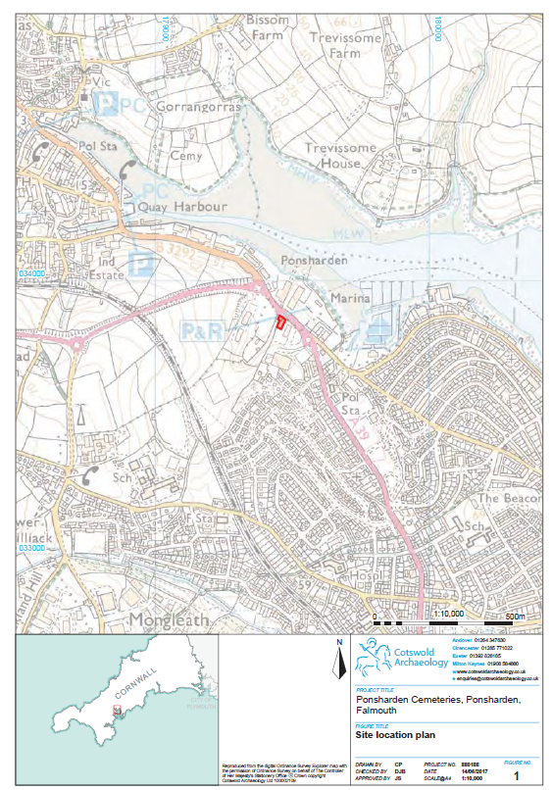

Scope and Objectives
The key objective of this CMP is to help inform restoration o 1.6. f the cemeteries and to
develop a plan for the future maintenance, access and interpretation of the Site.
Specific objectives are set out in the brief provided by and on behalf of Falmouth
Town Council and the Friends of Pondsharden Cemeteries (FoPC) and by the Offer
of Service submission prepared by CA and PDP (2017).
1.7. The primary objective is to achieve as full and complete an understanding of the
Site as is possible utilising a combination of existing management information and
reports, desk based research and specialist condition surveys. A detailed gazetteer
for the asset has then been prepared, combining the information about different
types of heritage into one single inventory. The following thematic elements have
been considered fundamental in achieving an understanding of the Site:
• Landscape, topography and geology;
• Buried archaeological remains;
• Historical background;
• Gravestones, tombs and other funerary monuments;
• Ruined structures and buildings within the cemeteries, including the former
mortuary chapel, steps and paths;
• Boundaries to the Site including entrances;
• Natural environment, habitats and species
1.8. Understanding of the site is the framework used to address the following aims and
objectives pertaining to management and conservation.
• To assess how and to whom the Site is significant: initially addressing the
site as a whole, then individual elements within the cemeteries assessing
how these combine, scale and contribute to the overall significance;
• To evaluate risks and opportunities: outlining how the significance of the
asset is vulnerable and what other threats and issues threaten its long-term
future; identifying opportunities for enhancing the significance of the Site;
• To develop conservation management plans through consultation with FTC,
FoPC and HE: producing policies in line with Conservation Management
Planning (2008) specific to the needs of the heritage asset and the people
who value it. These are based on an understanding of the asset, how it is
valued and current management issues;
9

• To produce a costed action plan for repair and management work in line
with policies contained in the conservation management plan; differentiating
between repair work based on heritage priorities and repair work that is
necessitated in the interest of safety, access and interpretation;
• To produce a costed plan for the routine maintenance of the Site in line with
the policies contained in the conservation management plan
Constraints
The Jewish and Congregationalist cemeteries at 1.9. Ponsharden are legally protected
as a Scheduled Monument (List Entry Number 1020815) and the headstones to
Isaac Benjamin and Alexander Moses in the Jewish cemetery are additionally
protected as Grade II Listed Buildings (List Entry Number 1061396).
1.10. Scheduled Monuments are legally protected under the Scheduled Monuments and
Archaeological Areas Act 1979 (as amended). It is a criminal offence under the Act
to undertake unauthorised works to a Scheduled Monument without the required
Scheduled Monument Consent (hereafter SMC). Any proposals for works affecting
the Cemeteries, including any ground works on or in the vicinity of the monument
must be discussed beforehand with Historic England (hereafter HE) who will advise
whether formal consent will be required. It should be noted that works such as the
repair of animal burrows, erosion, tree removal etc. will require formal SMC.
1.11. Listed Buildings are legally protected under The Planning (Listed Buildings and
Conservation Areas) Act 1990 which sets out the laws on planning controls with
regard to Listed Buildings and areas of special architectural or historic interest
(Conservation Areas). It states that ‘any works for the demolition of a listed building
or for its alteration or extension in any manner which would affect its character as a
building of special architectural or historic interest’, will require Listed Building
Consent (hereafter LBC) from the local planning authority. However, it should be
noted that Scheduled Monument Consent takes precedence over Listed Building
Consent. Impacts on setting do not require LBC but are a material consideration in
planning and carry great weight.
1.12. The Hedgerows Regulations (1997) provides protection for ‘important’ hedgerows
within the countryside, controlling their alteration and removal by means of a system
of statutory notification.
10

Statute, Policy and Guidance
National heritage statute policy 1.13. and guidance relevant to the Site is included in
Vol.2: Appendix I.
1.14. The Site is located within the administrative boundary of Cornwall Council. The main
policy document is the Cornwall Local Plan: Strategic Policies 2010 – 2030. Full
detail can be accessed at: http://www.cornwall.gov.uk/localplancornwall. Policy 24
pertaining to the ‘Historic Environment is repeated in Vol. 2 Appendix I: Statute,
Policy and Guidance.
1.15. Other local planning documents, strategies and guidance considered relevant to the
Site are discussed in Sections 5.64 to 5.75 Potential development of adjoining sites
Methodology
1.16. The methodology for the undertaking of this CMP was presented in the brief
supplied by and on behalf of FTC and FoPC and in the Offer of Service prepared by
Cotswold Archaeology (2017) and is not to be repeated here in detail. However, the
CMP was undertaken in accordance with Historic England’s Conservation
Principles, Policies and Guidance (2008). Key texts, such as Informed Conservation
(Clark 2001), Conservation Plan Guidance (Heritage Lottery Fund 2012) and
Conservation Plans in Action (Historic England 1999) were consulted.
1.17. Additional guidance was sought on the management and conservation of
cemeteries. Key texts included Caring for Historic Graveyard and Cemetery
Monuments (Historic England 2011); Paradise Preserved: An Introduction to the
assessment, evaluation, conservation and management of historic cemeteries
(Historic England 2007) and Jewish Burial Grounds: Understanding Values (Barker
Langham 2015).
1.18. In recent years there have been various research projects and monument surveys
undertaken for the Site. The principle narrative works consulted for this report
include Falmouth Jewish and Congregationalist Cemeteries, Cornwall (Parkes
2010); The Jews of Cornwall: A History - Tradition and Settlement to 1913 (Pearce
2014) and The Dissenters’ Burying Ground Ponsharden, Cornwall: Monument
Survey (Nunn and Weller 2014). Other existing reports consulted in the preparation
of this CMP include an archaeological survey undertaken by Historic Environment
Projects, Cornwall County Council (Sturgess, 2011), conservation reports prepared
11

by S & L Kelland (Kelland 2013 & 2016) and two tree inspection reports undertaken
by Cornwall County Council (Mitchell 2016a & 2016b).
This CMP had been prepared in two volumes. This volume 1.19. (Vol: 1) comprises the
narrative body of the report; Volume 2: contains the following appendices:
• Appendix A: Gazetteer of Jewish Grave Monuments
• Appendix B: Gazetteer of Congregationalist Grave Monuments
• Appendix C: Gazetteer of Boundaries and Entrances
• Appendix D: Gazetteer of Trees
• Appendix E: Composite Figure of Gazetteer References
• Appendix F: Condition Survey: Comments and Observations
• Appendix G: 10 Year management and maintenance plan
• Appendix H: Phase 1 - Habitat Survey Report
• Appendix I: Heritage Statute Policy and Guidance
• Appendix J: Planning Application Search
• Appendix K: Extract from the Spatial Strategy Document
• Appendix L: Services Searches
• Appendix M:Results of Consultation with WWU
1.20. Figure 2 below illustrates the topographic survey of the Site undertaken during April
2017 (for greater detail see Figs 8 – 12). This survey formed the baseline from
which Site gazetteers were compiled and to which pre-existing survey data was
correlated, principally those detailed in Sturgess (2011), Kelland (2013 and 2016),
Nunn & Weller (2014) and Pearce (2014). Wherever possible individual correlations
were made, but given the number of gravestones written in Hebrew, combined with
those that were displaced, lost or damaged exact identification was not always
possible. It was considered beyond the scope of this report to entirely reconcile and
verify the accuracy of the different sources source of information.
1.21. The gazetteers include a short description of each monument, an assessment of
condition and of relative heritage significance, recommendations and proposals for
repair, maintenance proposals and associated costings. They are included in Vol. 2
as Appendices A – D, with a composite figure of gazetteer references included as
Appendix E.
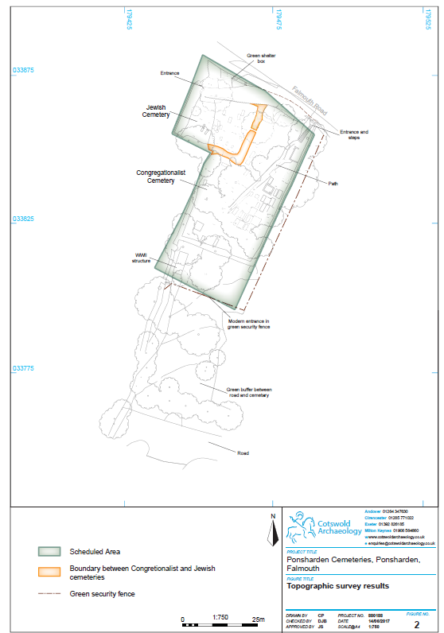2
13

For the purposes of consistency the numbering 1.22. sequences used by Sturgess (2011)
have been utilised here for The Jewish cemetery so that gravestones are identified
as J1 through J45. The ‘ohel’ or ‘bet tohorah’ is identified as J101 to avoid confusion
(Vol. 2 Appendix A: Gazetteer of Jewish Grave Monuments). For the
Congregationalist cemetery the numbering sequence used by Nunn and Welller
(2014) has been adopted and conformed to, but prefixed with the letter C so that
grave monuments and structures are recorded as C1 through C92 (Vol. 2 Appendix
B: Gazetteer of Congregationalist Grave Monuments). Additional structural elements
within the Congregationalist cemetery are identified from C101 through C104; these
include the mortuary building (C101), the path (C102), an earthwork mound (C103)
and just to the south of the southern boundary the WWII structure (C104).
Boundaries and entrances are recorded as B1 through B8 (Vol. 2 Appendix C:
Gazetteer of Boundaries and Entrances)
1.23. The identifiers generated for the Tree Inspection Report (Vol. 2 Appendix D:
Gazetteer of Trees) are utilised here, but prefixed with a J for the Jewish Cemetery
(JT1-3 & JG1-2) and a C for the Congregationalist Cemetery (CT2=21 & CG1-5). In
both instances the ‘T’ denotes individual trees and the ‘G’ groups of trees.
1.24. Determination of significance has been undertaken according to the industrystandard
guidance on assessing heritage value provided within ‘Conservation
Principles’ (Historic England 2008). This approach considers heritage significance to
derive from a combination of discrete heritage values, principal amongst which are:
i) evidential (archaeological) value, ii) historic (illustrative and associative) value, iii)
aesthetic value, iv) communal value, amongst others.
1.25. Gravestones, memorials, boundaries, entrances and other structures have been
assessed for relative levels of significance. The criteria used for assessing this
significance includes: cemetery type, condition, monument type and rarity,
materials, inscriptions, date and individual and/or family renown. Significance levels
are graded from A through E, so that level A is considered to have greater
significance than B and level B great than C, with level E representing the lowest
level of significance. Relative levels of significance are generated as guidance to
help inform and prioritise management proposals and implementation. It is
recommended that when necessary, reappraisal of assigned grades can and should
be carried out utilising the criteria set out below, but by those with the relevant depth
of Site specific knowledge and/or specialist skill. This approach allows for pragmatic
14

and consistent decision making to be retained by those implementing future
management works and proposals.
This CMP has been produced by 1.26. Cotswold Archaeology and co-authored in
partnership with PDP. The ecology survey was undertaken and written by Cornwall
Environmental Consultants (CEC Ltd). Indicative costings for proposed repairs and
maintenance have been produced by Trevor Humphries Associates. The tree
survey and inspection report was prepared by the Environmental Team, Cornwall
Council in November 2016. Sections 1 to 4, 7 and 9 were written by Cotswold
Archaeology with a contribution from CEC Ltd. Sections 5, 6 and 8 were written by
PDP with a contribution from CEC Ltd. The gazetteers were complied jointly by
Cotswold Archaeology and PDP. The report (Volumes 1 and 2) was compiled by
Cotswold Archaeology.
1.27. A digital archive is appended to this report. It includes the following items:
• Microsoft Excel spreadsheets for gazetteers A – D
• Microsoft Excel spreadsheet for the 10 year Management and Maintenance
Plan
• Condition Survey Observations and Comments (PDP)
• Phase 1 Habitat Survey (CEC Ltd)
• Service Searches
• Site Photographs
15

2. STAKEHOLDERS
At the time of scheduling (2000) the ownership o 2.1. f the Jewish Cemetery was
acknowledged by BOD Heritage Ltd, although at that time no owner could be
established for the Congregationalist Cemetery. Since then FTC have successfully
registered a claim of adverse possession to acquire ownership of the
Congregationalist Cemetery, as none could be established. Since 2011 the
cemeteries have found an active group of supporters, now united as the Friends of
Ponsharden Cemeteries. The key stakeholders involved in the commission of this
report are as follows:
• FTC
• FoPC
• BOD Heritage Ltd
• Kehillat Kernow (The Jewish Community of Cornwall)
2.2. Key stakeholders consulted during the preparation of this plan include:
• FTC
• FoPC
• HE
• BOD Heritage Ltd
• Cornwall Council
• Cornwall Council Record Office
• Sainsbury’s and occupants of the adjacent Ponsharden industrial units
• People who live in the area; principally at Ashfield House to the south of the
Site
2.3. Other stakeholders involved in the preparation of this plan
• Cotswold Archaeology (Exeter Office)
• Pdp Green Consulting Ltd (Truro)
• Trevor Humphries Associates (116 Belmont Rd, St. Andrews, Bristol BSA
5AU)
• Environmental Team, Cornwall Council (Cornwall Council, Carrick House,
Pydar Street, Truro TR1 1EB)
• Cornwall Environmental Consultants (CEC Ltd, Five Acres, Allet, Truro TR4
9DJ))

3. UNDERSTANDING THE SITE
Landscape context
The Site is located on the northern fringes 3.1. of Falmouth in an area known as
Ponsharden, roughly 1km south-east of Penryn. Falmouth is located on the south
Cornish coast, where Henry VIII built Pendennis Castle in 1540 to defend the deeply
sheltered River Fal estuary - known as Carrick Roads - from naval attack. Sir John
Killigrew created the town of Falmouth shortly after in 1613. At that the time the
main settlement in the district was Penryn, which at Domesday formed part of the
Bishop of Exeter’s manor of Trelivel. Penryn straddles the head of the Penryn
Estuary north-west of Site; its name means ‘the end of the point’ or ‘‘promontory’,
emphasising the relationship between topography and settlement (Taylor 2016).
3.2. The Site is located on the steeply graded north and north-west facing valley slope of
the Penryn River, at the end of a small spur which runs down to the tidal mouth,
some 160m to the north-east. The Site encompasses land between 18m and 9m
above sea level (above OD), although the gradient becomes increasing pronounced
towards the north of the Site, most notably within the Jewish Cemetery. Overall the
Site measures c. 0.186ha with the Jewish Cemetery being 0.055ha in extent and the
Congregationalist 0.11ha. The area of scheduling extends slightly to the south of the
Congregationalist Cemetery to include a concrete block structure, of probable WWII
II origin. However, it should be noted that the HE digital plan does not encompass
the entrance and lower steps to the Congregationalist cemetery, although these are
clearly described in the designation. The mapped area also slips over the southwest
boundary, beyond the extent of the Site. Clearly, the HE mapping does not conform
to the Site boundaries and should be rectified as soon as possible.
3.3. The northern Site boundary is demarcated by the former turnpike road, (now the
A39 and hereafter the Falmouth Road) linking the post-medieval port of Falmouth to
the south-east with the earlier medieval port of Penryn to the north-west. The course
of the modern road has been cut deeply into the underlying geology, so that at its
maximum the road surface lies approximately 4m below the adjacent ground level
within the Congregationalist Cemetery. There is no retaining wall fronting the
Falmouth Road (A39), only an earthen bank overgrown with vegetation and
exposed roots flanking the pedestrian pavement (Photograph 1). On the north-east
corner of this boundary there is an arched slate rubble entrance and stairway
leading up to the Congregationalist Cemetery, although this is now dis-used and
structurally compromised (Photograph 1). Similarly, there is an entrance to the
Jewish Cemetery from the Falmouth Road on the north-west corner of the Site; the
brick piers here are overgrown and the simple wooden garden style door padlocked
(Photograph 2).

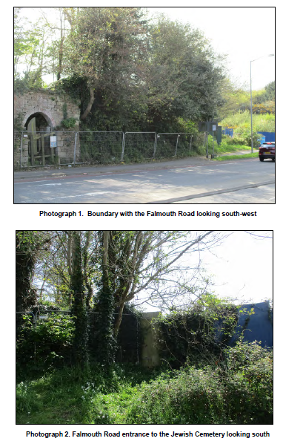

Adjacent to the Jewish Cemetery at street level 3.4. with the Falmouth Road there is a
layby, within which a green shelter box is situated (Photograph 3). This is owned by
and the responsibility of Wales and West Utilities (WWU). It contains a gas governor
that reduces pressure before supplying gas into the Penryn and Falmouth network,
along with associated electricity supply to operate the equipment.
Photograph 3. Green gas shelter box looking south-east
3.5. Figure 3 shows the area surrounding the Site, known as Ponsharden. Beyond the
A39 to the north-east there is parking and commercial units adjacent to the
waterfront as well as a park and ride facility serving Falmouth; there is a marina to
the east of the park and ride. From its northern corner through to the south-west, the
Site adjoins an open area of scrub which was formerly the site of a gas works; this
area was presumably levelled and landscaped during the 20th century construction
of the gas works. Adjacent to the northern corner of the Site, from the Falmouth
Road there was formerly access onto the gas works, although this is now blocked
with Heras Panels and concrete blocks (Photograph 4). Blue hoardings now a form
a boundary along the former access to the gas works and the Jewish Cemetery.
19

Fig. 3 Modern setting of the Site (Scale 1:2500 at A4)
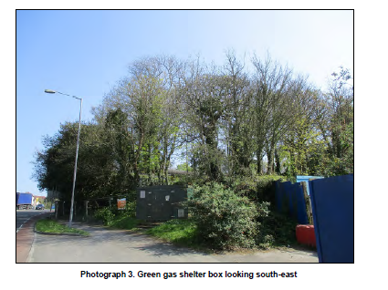
20

Photograph 4. Entrance to the former gasworks looking south-west
The site of the former gas works is currently 3.6. for sale as development land. The
former Vospers garage and show rooms formerly occupied its north-west extent,
approximately 80m north-west of the cemetery boundaries, but this area is now
vacated. From Vospers, the ground rises abruptly to the north-west across enclosed
agricultural fields and towards a ridge line straddled by the A39 bypass which is set
within a deep cutting. Generally, the topography of the land to the west of the Site is
indicative of a dry tributary headland, formerly feeding into the Penryn Estuary, the
south-east facing slope of which forms a highly visible element from within the Site
(Photograph 5).
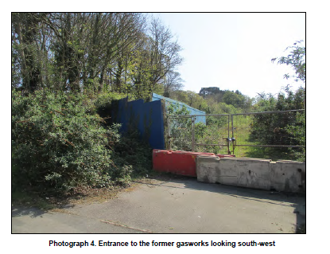

3.7. To the south-east the Site is bounded by small scale industrial units beyond which
there is hard standing for parking and a road linking to the roundabout on the A39.
Immediately south of the Site there is a small area of undeveloped green space,
which serves as a much needed buffer given the context of surrounding urban
expansion and associated commercial development (Photograph 6). To the south of
the green space there is an access road for the adjacent Sainsbury’s supermarket
with its attendant parking.
21

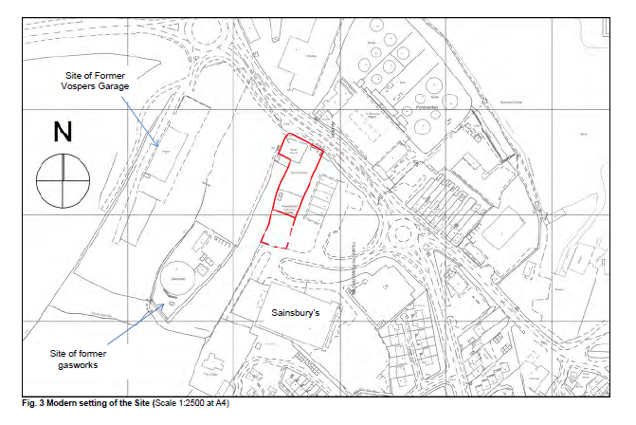

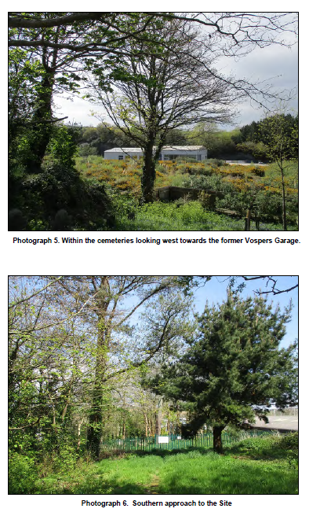

Photograph 5. Within the cemeteries looking west towards the former Vospers Garage.
Photograph 6. Southern approach to the Site
22

The Site is beset to all sides by modern development 3.8. which has clearly fractured
physical and visual associations with its formative historical setting. From within the
Site, views of enclosed fields on the dry valley slope to the north-west and west are
all that remain of the rural vista. Views in other directions are highly restricted; to the
south-west by vegetation and topography and to the south-east by modern small
scale industrial units, the roof and walls of which are highly visible from within the
Congregationalist Cemetery blocking any visibility beyond. To the north, lines of
sight are heavily broken by vegetation, although fragmented views across modern
industrial roof tops and through boat masts towards the north valley slope of the
Penryn River are possible; these are probably more extensive during the winter
months when foliage is sparse. Historically it is possible that the cemeteries were
enclosed by vegetation growing on the hedge banks, however, any external views
will have predominantly encompassed rural fields and open countryside. As such
the historical setting of the Site has been significantly denuded.
3.9. The underlying geology within the site is mapped as Mylor Slate Formation,
comprising metamorphic Hornfelsed slate and siltstone bedrock formed during an
igneous intrusion in the Devonian period, approximately 359 to 385 million years
ago. (British Geological Survey Online Viewer accessed 29th March
2017: http://mapapps.bgs.ac.uk/geologyofbritain/home.html)
3.10. The soils across Site are described as feely draining acid loams of generally low
fertility suitable for arable and grassland cover. Their natural habitats comprise
deciduous woodlands, with brackens and gorse in the uplands (Cranfield Soilscapes
accessed 29th March 2017: http://www.landis.org.uk/soilscapes/).
3.11. Presently, the Jewish Cemetery is dominated by semi-improved grassland with an
abundance of primrose (Photograph 7). The Congregationalist Cemetery comprises
an area of broadleaved woodland plantation dominated by self-sown sycamore with
an abundance of ash (Photograph 8). Ground flora includes a number of grass
species as well as umbellifer species, orchids, lesser celandine and daffodils (see
Sections 3.88 to 3.116 below: Ecology and Wildlife).
23

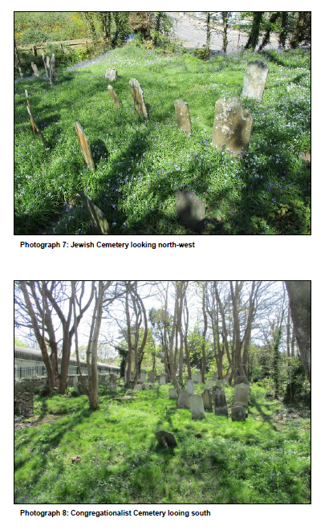

Photograph 7: Jewish Cemetery looking north-west
Photograph 8: Congregationalist Cemetery looing south
24

Buried Archaeology
The potential for previously unrecorded archaeological 3.12. deposits or features being
present within the Site; predating both the Jewish and Congregationalist Cemetery
was undertaken as part of the 2010 archaeological assessment (Parkes 2010). This
work identified no prehistoric remains within the vicinity of the Site, although it was
considered that the sheltered setting overlooking the Penryn Estuary may have
presented an attractive location for late prehistoric and Romano-British activity.
Indeed, evidence from the broader landscape indicates that the Fal Estuary was a
focus for waterborne trade and ritual activity during these periods.
3.13. Given the potential for late prehistoric activity in the broader landscape, the 2010
archaeological assessment identified a possible Bronze Age barrow at the north end
of the Congregationalist Cemetery, partly crossing the boundary into the Jewish
Cemetery. This feature was recorded as being overgrown, but roughly rounded with
a flattish top, measuring approximately 9m across by 1.1m (Photograph 9).

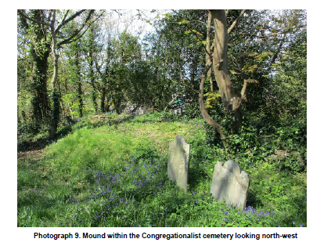

Photograph 9. Mound within the Congregationalist cemetery looking north-west
3.14. The mound was not considered to be recent given the covering of well established
blue bell rich vegetation. However, Bronze Age barrows are normally sited in
clusters or linear alignments most frequently in elevated positions, either false
crested or along a ridge line, with wide ranging inter-visibility orientated in specific
25

directions. Therefore, given the low lying position of this mound combined with the
lack of similar monuments in the immediate landscape, an alternative interpretation
seems more likely. The mound most likely relates to activity within the Site, possibly
upcast from grave digging or boundary work, or from work undertaken along the
adjacent Falmouth Road, when the cutting was deepened in the first half of the
nineteenth century, necessitating the need for a new entrance and stones steps to
access the Congregationalist Cemetery (see also Section 3.37 below).
A review of the Cornwall and Scilly Historic 3.15. Environment (hereafter CSHER),
identified no new entries, and confirmed there are no recorded prehistoric, Romano-
British or early medieval sites present within a 500m radius of the Site (Cornwall
Council Interactive Mapping accessed 29th March
2017: https://www.cornwall.gov.uk/community-and-living/mapping/). There is a
possible medieval entry identified approximately 120m to the north-east of the Site,
comprising parallel field banks, formerly visible as cropmarks but now destroyed by
modern development (CHER Ref: MCO33910).
3.16. Place name evidence (the Cornish pons, meaning bridge) would suggest that there
was once a bridge present in the area, which may have crossed a stream into a
small promontory into the Penryn River (once known as The Island, now lost) early
in the post-medieval period (Pearce 2014). The land within the site at this time was
likely to have been farmland, situated on the boundary of the woodland deerpark
associated with the medieval college and Bishop’s palace of Glasney. It appears to
have remained under arable cultivation until the cemeteries were established in the
late 18th or early 19th century.
3.17. The Cornwall Historic Landscape Characterisation classifies the Site as within an
area of 20th century settlement, defined as areas settled from larger farming
settlements upwards (https://map.cornwall.gov.uk/website/ccmap - accessed
29/03/2017).
3.18. Those elements of buried archaeology, both recorded and previously unrecorded,
which relate to the Jewish and Congregationalist Cemeteries are considered in
detail below.
History
3.19. In recent years the history of the Ponsharden cemeteries has been well documented
most notably by Nunn & Weller (2014) and Pearce (2014), and in an Archaeological
26

Assessment produced by Cornwall Council Historic Environment Service (Parkes
2010). The following section presents a summary of these findings, the focus of
which is it to contextualise the overall heritage significance of the Site and thereby
provide a framework with to which to address how, why and to whom the Site is
significant. The full scope of the earlier research is not repeated here; the above
works should be consulted for a more detailed history.
The Foundations of the Jewish and Congregationalist Communities in
Falmouth
A Jewish population in the south-west of England i 3.20. s referenced as early as the 12th
century in Exeter, and in smaller groups across the area before being expelled by
royal order in 1290. The Jewish community in Exeter had been re-established by the
1730s, soon expanding southwards with Jews subsequently settling in Plymouth,
Falmouth, and Penzance (Parkes 2010). In Falmouth, the economic and social
changes experienced by the Jewish community throughout the 18th, 19th and 20th
centuries is evident in the establishment, use, and subsequent neglect of the
Ponsharden cemeteries; a pattern which can also be recognised in the
Congregationalist communities in Falmouth.
3.21. It is understood that in Falmouth, the Jewish community was established in the mid-
18th century, although foreign Jews certainly had contact with this part of the
Cornish coast earlier than this. There are records of trade within or via Falmouth
between Barbadian Jews and Amsterdam in the latter half of the 17th century. A
pamphlet published by former customs officer Samuel Hayne in 1685 provides
evidence of this, detailing illegal trade exposed in 1680 (Pearce 2014). By the 18th
century the arrival of foreign traders in Falmouth was commonplace, and the local
community had become familiar with accommodating visitors from a variety of
nationalities and religious backgrounds (Pearce 2014). As the Jewish population
began to settle in Falmouth, the trading port remained a significant draw, with a
plethora of economic opportunities, including a market and business centre, ready
access to the Cornish mining industry as well as the agricultural, and fishing
industries, both prevalent in the surrounding area. A number of Jews are known to
have moved into Falmouth to sell clothes and trinkets from their homes in Alsace,
France, where they were forbidden to live in towns (Parkes 2010). Alexander Moses
(also known as Zender Falmouth) moved to Falmouth from Alsace in the mid-18th
century and was a crucial figure in the establishment of the Jewish congregation in
Falmouth, and in providing a system for economic expansion. Benjamin Woolf (or
27

Wolf), who arrived in Falmouth from Holland at the same time, played a similarly
important role in the growth of the congregation in the 18th century (Parkes 2010).
The appeal of economic growth around the international 3.22. port at Falmouth also
brought Nonconformist faiths into the area, at a time when the numbers of
Nonconformist congregations were growing rapidly throughout Cornwall. These
faiths were established in England in the 16th century for those who wished to
worship in their own way, without the direct influence of the Church of England
(Nunn & Weller 2014), and included the Congregationalists (also known as
Dissenters). The Nonconformist community in Cornwall remained a small minority
until the mid-19th century, when the census for Falmouth indicates that 6.4% of the
population was represented by Nonconformists (Parkes 2010).
3.23. Through the 16th to early 19th centuries, places of worship and burial grounds were
established in Falmouth to meet the needs of the growing multi-faith population.
This included the cemeteries at Ponsharden.
3.24. The land for the Jewish cemetery was the first to be obtained as a burial site at
Ponsharden. Documentary evidence indicates that the land was leased in 1779, 20
years subsequent to a request for the land made by Zender Falmouth (NHLE Listing
Details, List Entry Number 1020815). At that time, the land was owned by the
Basset family - later to become Lords de Dunstanville – who had their county seat at
Tehidy on the north-west coast of Cornwall. A lease dated 1829 details the provision
of both burial grounds for 400 years after an initial 50 year lease expired (the initial
lease has since been lost) (Parkes 2010). This joint grant of land ‘provides an
excellent example of the increasing acceptance of, and provisions for, minority
religious and religious groups outside the Established Church during the later 18th
century’ (NHLE Listing Details 2002, List Entry Number 1020815).
3.25. Of the two cemeteries, the Jewish cemetery was the first to be established,
sometime during the late 18th century. The Congregationalist burial ground was in
use by the early 19th century. The history of each cemetery is detailed below.
The Jewish Cemetery
3.26. Following his contribution to the establishment of the Jewish community in
Falmouth, Zender Falmouth was one of the first to be buried in the Jewish cemetery
at Ponsharden, in 1791 (J38). There are a small number of earlier graves within the
Jewish cemetery, including that of Isaac Benjamin, son of Benjamin who was buried
28

here in 1790, formerly thought to be the earliest surviving in situ grave (J37). The
slate gravestones of Zender Falmouth (Alexander Moses) and Isaac Benjamin are
Grade II Listed (NHLE Listing Details 2002; List Entry Number 1061396). However,
the earliest grave in the Jewish Cemetery is now thought to be that of Esther Elias
(or Esther Levy) who died in 1780 (J45). Although the description is barely
decipherable her grave monument is in good condition, located next to the southern
boundary, comprising a granite gravestone on granite base. It was found after 2011.
By the time of Zender Falmouth’s 3.27. death in 1791, there were around 12 Jewish
families in Falmouth, and the congregation was prominently embedded into the local
community. The numbers buried at the Ponsharden cemetery were close to their
highest during the first ten years of use, which subsequently varied between two
and six per decade (Parkes 2012).
3.28. As burial numbers increased, some effort was made to enhance the burial ground.
The boundaries of the cemetery are shown as dashed lines, perhaps indicating
fence-lines or temporary boundaries on the 1788 Duke of Leeds Estate map (Fig.
4), whereas hedgerow boundaries are illustrated on the 1814 survey by Richard
Thomas for the Basset Estate (Fig. 5).

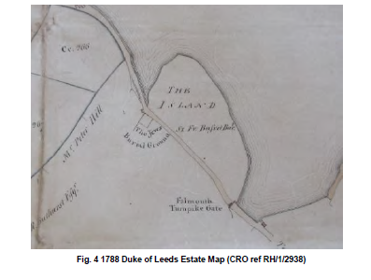

Fig. 4 1788 Duke of Leeds Estate Map (CRO ref RH/1/2938)
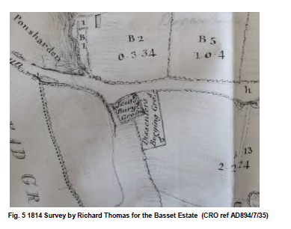
Fig. 5 1814 Survey by Richard Thomas for the Basset Estate (CRO ref AD894/7/35)
The entrance to the site also appears to have 3.29. undergone some improvement during
this period, which is evident from the symbol of a gate in the north-west corner of
the cemetery, shown in the 1793 Basset Estate map (plot b, Fig. 6).
Fig. 6 1793 Basset Estate Map (CRO ref RH/1/2938)

Indeed, it has been suggested that there have 3.30. been several alterations to the
entrance of the cemetery, including the incorporation of a significant former funerary
chapel, known as an ohel, at this location inside the site. This is well illustrated by
the cartographic evidence, with the late 18th century maps marking a possible
structure outside of the northern corner of the Jewish Cemetery (Figs 3 and 6).
Conversely, the 1814 map shows no structure (Fig. 5) whereas the 1840 parish of
Budock tithe map (not reproduced) and the 1880 1st Edition 25-inch Ordnance
Survey showing a structure within the boundary but on the same corner (Fig. 7).

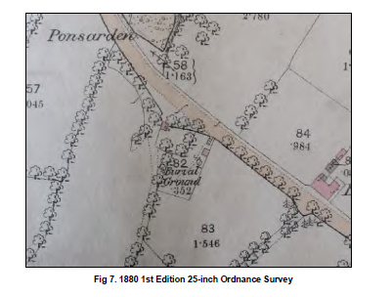

Fig 7. 1880 1st Edition 25-inch Ordnance Survey
3.31. There were on average between two and six burials at the Falmouth Jewish
Cemetery per decade until the 1830s, although ten burials were placed in the
1830s; the reason for this increase is uncertain, although this was a time of known
economic downturn in Cornwall. It was during this phase of use, however; that the
traditional Hebrew gravestone inscriptions began to contain a combination of
Hebrew and English text.
3.32. The economic decline continued into the mid-19th century when the Jewish
community sought opportunities elsewhere and moved away from Falmouth. Three
Jewish families remained in the area by 1875, but the limited need for worship
space resulted in the closure of the synagogue in 1879. One final burial was placed
31

in 1913, for local publican Nathan Vos, long after the Jewish community had largely
dispersed from Falmouth (J2).
The Jewish Cemetery at Ponsharden i 3.33. s one of seven predating the early 19th
century in the south-west, and one of about twenty-five nationally. In Cornwall there
is another Jewish burial ground at Penzance, considered to be the most perfectly
preserved of the seven in the south-west. Combined, the burial grounds at
Ponsharden and Penzance are considered to be ‘visible legacies of the 18th and
19th century Jewish communities in Cornwall’ (Pearce, 2014, p.358).
The Congregationalist Cemetery
3.34. The establishment of the Congregationalist cemetery at Ponsharden followed
several years after the first burials in the adjacent Jewish cemetery. Documentary
evidence indicates that the land was acquired in 1808 ‘through the kindness and
liberality of Mr Samuel Tregelles, a reputable merchant in Falmouth’ (after Nunn &
Weller, 2014, p.13). The land was provided on the condition that the burial ground
would be ‘enclosed by a good stone wall, to encompass the Jew’s Burial Ground’
(ibid.). The plot was immediately enclosed with a stone wall to the east and possibly
a new stone retained hedgebank the south, presumably whist utilising existing
boundary hedgebanks to the north and west.
3.35. It is evident that the opening of the new Congregationalist burial ground was a
substantial event in the local community. The Congregationalists (or Dissenters as
they were referred to in the early use of the site) began to use the site immediately,
with the first of Penryn’s congregation, Abia, daughter of John and Dolly Nichols of
Gwennap, being buried here in late in the summer of 1808 ‘amid a vast concourse
which had filled the Ground from the novelty of a Burial amongst Dissenters’ (ibid.).
The first burial recorded by the church here was that of Mrs Christina Daubuz’ in
November 1808; ‘one of the chief supporters of the Independent Chapel’ (Nunn &
Weller, 2014, p.13-15).
3.36. In 1829, the Bassets granted the congregations a 400 years lease with the condition
that the land be ‘kept and preserved sacred only for the burial of persons belonging
to the said Religious Independent Congregations at Penryn and Falmouth’ (after
Nunn and Weller, 2014, p. 15).
3.37. The burial registers for Ponsharden show that the initial use of the cemetery saw an
average of 72 burials per decade (Nunn & Weller, 2014, p.15). The grounds were
32

well maintained, with a number of alterations and improvements made during the
1820s, including the addition of granite topping to the eastern wall in 1821 and a
new entrance with stairs in 1827. The latter was undertaken to improve access after
the adjacent Falmouth Road was cut deeper into the underlying geology, reducing
the gradient of the road opposite the Site. The stairs and arched slate rubble
entrance have a tunnel like appearance, and remain in place today, but are derelict
and not safely accessible due to structural failures. These alterations were paid for
by donations from the congregations, and by a local mason. By this time, there were
also small number of burials attributed to other Nonconformist faiths within the
cemetery (Nunn & Weller 2014).
There are 91 monuments identified within the cemetery, 3.38. with 235 names inscribed
representing 235 burials. However the burial registers indicate a minimum of 585
individual burials, leaving 382 unmarked graves, some of which are evident from
elongated low mounds (Nunn and Weller 2014, p.22). A relative lack of early
marked burials may well be a reflection of changing funerary patterns and/or
increased wealth, with the earlier burials representing a higher percentage of the
unmarked graves.
3.39. As well as the name, date of birth and family details, monument Inscriptions often
provide a place of origin, and the profession of the interred. Research has shown
that 80% hailed from Falmouth, 16% from Penryn and 4% from elsewhere.
Moreover, the burials represent a diverse selection of the community, including at
least one Congregationalist minister, a mayor and several surgeons, as well as
builders, shoe makers, carpenters, merchants, tailors and drapers, fisherman, and
Royal Navy and merchant seamen. Notable individuals include Dr James Cornish
who was twice mayor of Falmouth, as well as being an Alderman and Magistrate;
Dr James Trevosso who provided free medical care to Falmouth poorer residents
and Elizabeth Elliot who is credited with introducing the printing press to Cornwall
(Nunn and Weller 2014, p.28)
3.40. There was sharp decline in burials by the late 19th century, although burial records
were less well kept by this time, possibly indicating that more burials were made
than recorded. However, it is evident from the number of gravestones in the
cemetery that its use was declining. Nunn and Weller (2014) suggest the most likely
cause was space; the relatively small burial ground had reached its capacity, with
an estimated 585 burials contained therein, discounting the high potential for the
33

disturbance of earlier graves. Given the space to burial ratio, it seems clear that by
the late 19th the Congregationalist cemetery had reached its capacity. However,
other factors such as alternative local cemeteries being opened, and a reduction in
the congregation, much like that of the Jewish congregation, are likely to also have
contributed to this decline.
Attempts to sell the land under the aforementioned c 3.41. ondition placed by the Bassets
failed. The site was kept and maintained well into the mid-20th century, but since
then has gradually deteriorated, becoming overgrown and unkempt (Nunn & Weller
2014).
Recent History
3.42. The designated scheduling encompasses the Jewish and Congregationalist
Cemetery as well as a small grassed area immediately south of the
Congregationalist Cemetery. Within this area, along the north-west boundary there
is a rectangular structure, measuring approximately 6.5m long by 2.5m wide,
constructed of concrete blockwork with a reinforced concrete slab roof (C104,
Photograph 10).

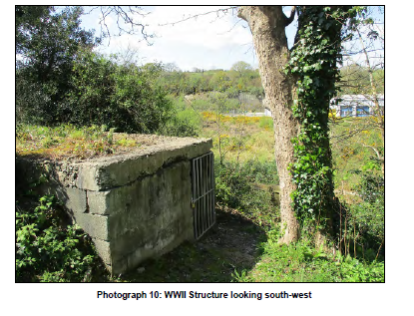

Photograph 10: WWII Structure looking south-west
34

This structure is carefully positioned, having 3.43. been built into the slope, with westerly
facing openings commanding views across the dry valley towards the opposite ridge
line. Given its location and form, this structure is presumed to date to the Second
World War, most likely as a defensive position overlooking the valley, although it is
not as solidly constructed as is usually the case with WWII pillboxes so is more
likely interpreted as an air raid shelter or warden shelter. Interestingly, the Defence
of Britain database records a WWII pillbox located almost directly opposite, down in
the dry valley, approximately 75m to the south-west (DoB S0003212). It is built into
a wall on the left hand side entrance to the (former) Falmouth Gasworks and
comprises a standard five-sided concrete pillbox hidden in undergrowth with two
gun embrasures on the walls opposite to the entrance.
3.44. Aerial photographs from the 1930s show the Site to have been relatively well
maintained (Nunn and Weller 2014). However, after this period, it seems the Site
was reclaimed by nature so that by the end of the 20th century it was overgrown
with low lying scrub and broadleaf woodland - dominated by self-sown sycamore.
During this time large scale roots and trunks caused extensive damage and
displacement to grave monuments and structures as well as to boundary walls and
entrances; although this impact is currently monitored, a number remain at risk of
further damage (Photograph 11).

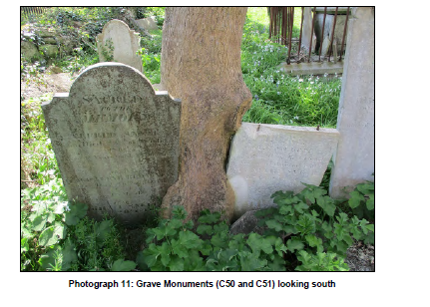
Photograph 11: Grave Monuments (C50 and C51) looking south
35

The trees clearly enhance the ‘romantic’ and neglected wild aes 3.45. thetic of the Site, but
within the Congregationalist cemetery, in a number of instances, they present a
clear and present danger to the physical fabric of the Scheduled Monument.
Conversely, within the body of the Jewish Cemetery there remains a single standing
tree, so that this type of threat, prevalent with the Congregationalist Cemetery, is not
present. Instead the Jewish Cemetery is dominated by semi-improved grassland
with an abundance of primrose
3.46. In recent years there has been increasing interest and activity connected with the
Site. The major events leading the present phase of work are summarised below:
• (2000) - The cemeteries are first visited for the purposes of designation;
• (2002) - The cemeteries are Scheduled (List Entry 1020815) and the two
headstones Listed (Issac Benjamin & Alexander Moses – List Entry
1061396);
• (2004) - The Congregationalist Cemetery is recorded as seriously
overgrown;
• (2010) – The Jewish Cemetery is recorded in reasonable condition, although
headstones are found broken and the Congregationalist Cemetery remains
overgrown. Cornwall Council Archaeological Assessment is undertaken. The
development of land to the north-west of the Site is proposed by Sainsbury’s
and there is an initial consultation with English Heritage regarding these
proposals. FTC commission CC to undertake initial clearance work at the
Congregationalist Cemetery;
• (2011) – Site meeting with developers (and their agents), HE and FTC,
where a CMP is first proposed. Further clearance work is undertaken at the
Congregationalist Cemetery with ground surveys undertaken for both
cemeteries (Sturgess 2011); Jewish headstones are recorded by NADFAS
and temporary fencing erected around the Site;
• (2012) – Robert Nunn and Tom Weller begin clearance and headstone
recording in the Congregationalist Cemetery; damage and vandalism of
headstones reported for both cemeteries;
• (2013) – Temporary fencing is damaged; Kelland’s report and estimate for
repair of Jewish headstones produced; first meeting of FoPC and
constitution agreed;
36

• (2014) – More permanent security fence installed; Congregationalist’s first
open day; issues of ownership raised;
• (2015) – Kelland condition survey of Congregationalist headstones;
• BOD Heritage Limited obtained registered title of the Jewish Cemetery
(CL320173) and FTC obtain registered title of the Congregationalist
Cemetery (CL323875); Sainsbury advise they are selling the site below the
cemeteries (to the northwest).
Structures: Gravestones, Memorials and Boundaries
Gazetteers have been produced that record individual 3.47. elements within the
cemeteries including gravestones, memorials, boundaries and entrances: Vol. 2
Appendices A, B and C. These are illustrated on Figs. 8, 9 and 10. Levels of
relative significance are also assigned (see Section 4 below). For boundaries,
entrances and other associated structural features, the gazetteers are accompanied
by Appendix F: Condition Survey Comments and Observations, which provides
more detailed description with condition appraisal and remedial proposals. A full
photographic record of each individual grave monument can be found in Kelland
(2013 and 2016) and Nunn and Weller (2014).
3.48. Grave memorials were compiled utilising existing survey work - principally those
detailed in Sturgess (2011), Kelland (2013 & 2016), Nunn & Weller (2014) and
Pearce (2014). These were used in combination with the topographic survey and
condition survey undertaken as part of this CMP and an associated site visit to
investigate any clear anomalies identified between the different bodies of work.
However, it was considered beyond the scope of this CMP to verify the accuracy of
the source information or to reconcile every individual grave identified on the most
recent survey with the existing data. Wherever possible correlations were made, but
given the number of gravestones, especially those written in Hebrew, combined with
those that were displaced, lost or damaged, 100% identification was not always
possible.
Jewish Cemetery: Gravestones and Memorials
3.49. There have been various surveys of Ponsharden Jewish Cemetery undertaken
between c.1850 and 1998. These are reconciled and built upon in Pearce (2014)
where headstone translations and biographical information (where possible) are
included alongside a schematic plan, illustrating the original location of the
37

headstones but without reflecting recent changes to location or condition (Pearce
2014, p.405). Pearce records fifty-three graves: thirty-three with headstones.
A topographical survey was also undertaken by Cornwall 3.50. Council in 2011 (Sturgess)
which recorded extant, visible features within both cemeteries. Within the Jewish
cemetery a single grave number was assigned to each headstone or monument
partnered with an associated grave, and also to unmarked grave cuts or mounds
and gravestones that were not considered to be in situ. A total of 44 headstones
and/or graves were recorded, numbered J1 through J44. Subsequent work by
Kelland in 2013 linked the 2011 Survey to named headstones (as per Pearce 2014)
to produce a condition survey with costed recommendations. Kelland utilised the J1
through J44 designations, with five additions J1a, J16a, J21a (duplication – same as
C43) J30a and J45.
3.51. The numbering sequence utilised by Sturgess (2011) and Kelland (2013) has been
maintained here (J1 – J45). In addition, although no longer upstanding, the
presumed site of the funerary chapel known as an ‘ohel’ is recorded as J101.
3.52. The results of the survey are summarised in Vol. 2 Appendix A: Gazetteer of Jewish
Grave Monuments and illustrated in Fig 8.
3.53. On the whole the topographical survey undertaken as part of this work, correlated
well with earlier surveys, although there was some movement of fallen headstones
noted since 2013. With the exception of J44 and J45 all the gravestones recorded
on the Sturgess (2011) and Kelland surveys (2013) were reconciled (J1 – J43). In
respect of J44, recorded as a fallen headstone in Sturgess (2011), this was not
located by Kelland in 2013 or by the most recent survey. However, the south-west
corner where it was formerly identified is very overgrown, so it is entirely possible
that this headstone remains concealed within the undergrowth. Furthermore,
although the burial of Esther Elias is noted in Pearce (2014), the gravestone was
only recently uncovered. It is recorded as J45, comprising a granite stone on a
granite base, and is the earliest marked grave in the cemetery dating to 1780.
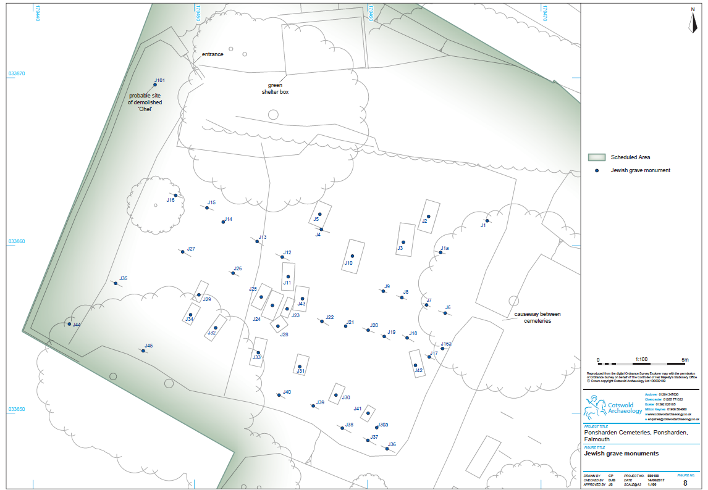
39

Excluding J44 (not found) the survey identified 3.54. a total of 47 locations with
headstones, or substantive fragments (as per Kelland 2013). Of these there were 38
slate and 8 sandstone headstone with one granite stone on a granite base (J45). A
total of 25 remained upstanding with 20 identified that were fallen and/or broken,
another two comprised broken bases largely concealed in the undergrowth (J14 and
J21). These broken bases are considered to be the in situ locations of J29 (Leah)
and J43 (Phoebe Jospeh) respectively (Kelland 2013); given these duplications the
number of identified gravestones is 45. Most of the gravestones have curvilinear
upper edges, inscribed in either Hebrew or a mixture of Hebrew and English.
3.55. The graves were originally arranged ESE to WNW in what the EH Listing describes
as six neat rows running broadly SSW to NNE across the Site. However, given the
disturbance and number of fallen stones, on the ground, it is now quite challenging
to trace the full extent of any given row. The earliest graves are located on the
higher ground in the SSW corner of the cemetery, where the community leader
Alexander Moses (Zender Falmouth) was buried in 1791. The date range in each
row, trends later downslope towards the WNW, although in places later insertions
and presumably gravestone displacements break this sequence. Burials range in
date from 1780 (J45) to 1913 (J2), although generally spanning the 100 years
between 1780 to 1880. However it is thought likely that there are unidentified graves
which pre-date 1780 (Pearce 2014, p.360). The latest burial is an outlier,
undertaken in 1913 for Nathan Vos, a local Jewish publican, buried after the
Falmouth Jewish community had dispersed.
3.56. Prior to 1838 the inscriptions are exclusively Hebrew, but from then on most also
include the name of the buried individual in English as well as the year of death in
the Jewish and/or Civil Calendar. This trend towards increasing use of English is
exemplified by the last gravestone of Nathan Vos (1913) which has more English
text than Hebrew. Headstone transcriptions combined with biographical information
and a schematic plan is included in Pearce (2012), and should be consulted for
further detailed information.
3.57. The entrance to the Jewish cemetery is located on its north-west corner at the base
of the slope adjacent to the Falmouth Road (see Section 3.86 below – B1a). It is
thought that a small funerary prayer chapel was once located within the cemetery
and entered directly from the main entrance (J101). Certainly, the mid 19th century
and early 20th maps illustrate a building here. The 1880 1st Edition 25-inch
40

Ordnance Survey map (Fig 5) depicts a relatively substantial building, measuring
approximately 5m by 4.5m, which may be interpreted as an ‘Ohel’ or alternatively a
‘Bet Torhorah’ where the body was washed and wrapped in a linen shroud, in
preparation for burial (Pearce 2014). Interestingly though, the late 18th century
maps (Figs 2 & 4) show a possible structure outside, but adjacent to the north-west
corner of the Jewish cemetery. Given the scale of these maps, both seem quite
specific in locating a building externally, hence it is entirely possible that the original
funerary chapel was located just beyond the cemetery boundaries. If so, sometime
during the 19th century it was re-built inside the main entrance; the remains of which
are described on the EH Listing as comprising an initial phase northern brick wall
and a later phase rubble eastern wall. Otherwise, there are no standing remains and
the extent or survival of any buried remains is unknown.
Congregationalist Cemetery: Gravestone and Memorials
The 2011 survey undertaken by Cornwall 3.58. Council (Sturgess 2011) included the
Congregationalist cemetery; recording extant and visible features. More recently the
excellent monument survey undertaken by Nunn and Weller (2014) includes a
condition survey framed within historical research to produce individual monument
logs. Monument IDs 1-91 were recorded and subsequently utilised for the condition
survey undertaken by Kelland (2016).
3.59. It should be noted that a number of monuments recorded by Sturgess (2011) were
not identified by either Nunn and Weller (2014) or Kelland (2016) or during the
present survey. All excepting one, were located in the south-west corner of the
cemetery; recorded as fallen by Strugess. It is possible they are buried in the long
grass thereabouts; however, it is also possible that vandals have thrown them over
the adjacent boundary, where the ground beyond falls steeply away, if so they may
now be hidden from view by topography and vegetation. Alternatively, they may
have been stolen from the Site
3.60. For consistency the numbering sequence used by Nunn and Welller (2014) and
Kelland (2016) has been adopted and conformed to here, but prefixed with the letter
C; grave monuments are recorded as C1 through C91. These are listed in Vol. 2
Appendix B: Gazetteer of Congregationalist Grave Monuments and plotted on Fig 9.
All the monuments recorded by Nunn and Weller were identified, although an
additional fallen headstone dedicated to Henry and Esther Jolly was also recorded
along with an associated tag fixed in the ground alongside and numbered 92; this is
41

recorded and plotted here as C92. To maintain a sequential differentiation additional
structural elements within the Congregationalist cemetery are identified from C101
through C104; these include the mortuary building (C101), the path (C102), an
earthwork mound (C103) and just to the south of the southern boundary the
presumed WWII structure (C104). The mortuary building, cemetery path and WWII
structure are discussed in greater detail in Vol. 2 Appendix F: Condition Survey
Comments Observations.
Given the far more comprehensive survey undertaken 3.61. by Nunn and Weller, and that
it correlates directly with the work undertaken by Kelland (2016) and the more
recent topographical survey, their results are repeated below (Nunn and Weller
2014, p.21).
3.62. Excluding C92, a total of 91 monuments were recorded surviving in varying
conditions, on which there were 235 names engraved. Of these:
• 8% are displaced, or original location unknown
• 12% with badly weathered inscriptions
• 36% damaged by vandalism
• 19% have been or still are being damaged by trees
3.63. In respect of monument types:
• 63% are simple headstones
• 21% are headstones combined with some form of grave feature
• 10% are ledger or raised/chamfered tombs
• 4% are pedestal tombs
• 2% are of unknown form due to vandalism
3.64. Stone types recorded are:
• Limestone (44 monuments)
• Slate (29 monuments)
• Sandstone (10 monuments)
• Granite (6 monuments)
• Unknown due to damage (2 monuments)
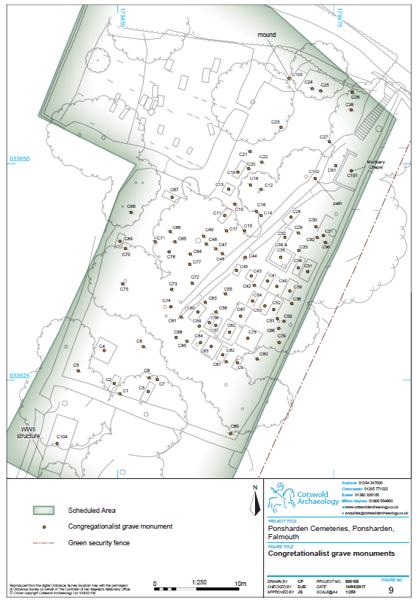

It should be noted that although now monitored, 3.65. in a number of instances the threat
presented by the trunks and roots of self-sown sycamores remains ongoing,
presenting a very real and imminent danger to the physical fabric of the
Congregationalist cemetery. Indeed, there is a high risk of further significant
damage to a number of individual grave monuments and structures; these are
identified in Vol. 2 Appendix B: Gazetteer of Congregationalist Grave Monuments.
3.66. The earliest gravestones, dating between 1808 and the 1830s, appear to have been
located on the high ground in the east and south of the Site. The phase plans
included in Nunn and Weller (p.411 – 421) illustrate the chronological development
well and should be consulted for further information. Similarly, their work identified
some spatial correlation between burials and profession, although they thought it
most likely that this relates to generations of families following the same trades,
rather then discrete burial areas for specific professions (Nunn & Weller 2014 p. 26).
3.67. Although there are 91 monuments identified within the cemetery, with 235 names
inscribed representing 235 burials, the burial registers indicate a minimum of 585
individuals. Therefore the gravestones represent only 34% of the total burials,
leaving 382 unmarked graves some of which are evident from elongated low
mounds. This is a large number for a relatively small space, even given a number of
juvenile burials and the use a simple wooden crosses as grave markers (for further
discussion see Nunn and Weller 2014, p.22). The Congregationalist cemetery
seems to have reached full capacity before going entirely out of use.
3.68. In the north-east corner of the cemetery, at the top of the entrance steps, there is a
ruined building, interpreted by English Heritage as a mortuary chapel. This structure
is included in Vol. 2 Appendix B: Gazetteer of Congregationalist Grave Monuments
as C101 and is discussed in greater detail in Vol 2 Appendix F: Condition Survey
Comments and Observations. Its long axis is orientated north-east to south-west; it
measures approximately 3.65m long by 2.55m wide and abuts the cemeteries east
wall (B5). It is present on the 1880 Ordnance Survey map (Fig 5.), but not on the
1840 Budock Parish Tithe Map (not reproduced), so its construction is most likely
bracketed by these dates. The years have taken their toll on the fabric of the chapel,
which has been severely damaged by a combination of neglect, human activity and
tree/root/scrub growth. The low surviving walls are of red brick construction and the
building appears to have incorporated the slate rubble cemetery boundary along its
south-east extent, although this section of boundary wall is now in a state of
44

collapse. Slate fragments and the remains of a glazed ridge tile indicate that the
building may once have had a pitched roof finish. Thin sheets of fractured glass
have also been found next to the building and patches of lime render survive on
interior facing walls, implying that the building was windowed and rendered
internally. Given the poor state of survival, entrances to the chapel are uncertain.
Immediately to the west of the building there is a rectangular 3.69. structure, exposed in
plan by a single course of slate, red brick and sandstone embedded in the earth
(C91). This structure is possibly a grave monument, but may alternatively be a
structural element to the mortuary chapel.
3.70. A path runs centrally through the cemetery, curving sinuously from the top of the
entrance steps in the north-east corner of the Site to the south-west boundary
(C102). In places the path retains brick edging, visible on its western side from the
top of the steps as far as grave monument C46. On the eastern side, south of
monument C11, the brick edging is replaced by a low stone wall. To the south of
grave monuments C61 and C74 the route of the path is unclear; historic maps show
it extending part-way through the cemetery, but not as far as the south boundary.
Boundaries and Entrances
3.71. Boundaries and entrances are recorded as B1 through B8. These are summarised
in Vol. 2: Appendix C: Gazetteer of Boundaries and Entrances and plotted on Fig.
10, accompanied by Appendix F: Condition Survey Comments and Observations
which provides more detailed description, photographic record, condition appraisal
and remedial proposals. The results of the condition survey are summarised below
followed by a brief historical analysis (for more detailed historical discussion see
Parkes 2010). For ease of discussion the boundaries are discussed in terms of
north, east, south and west (B4 forming the northern boundary).
Jewish Cemetery: Boundaries and Entrances
3.72. The Jewish cemetery is bounded on four sides. To the west there is a low rubble
stone wall approximately 1m high to its inner face and 1.5m high to its outer face,
reflecting approximately a 500mm change in the level of the ground surface here
(B1). The wall is overgrown with vegetation and there is concrete coping on top for
much of its length. The wall makes a return on the south west corner, forming a
c.5m stretch of the south facing boundary (B2). It also returns on the north-west
corner integrating with the entrance (B1a).
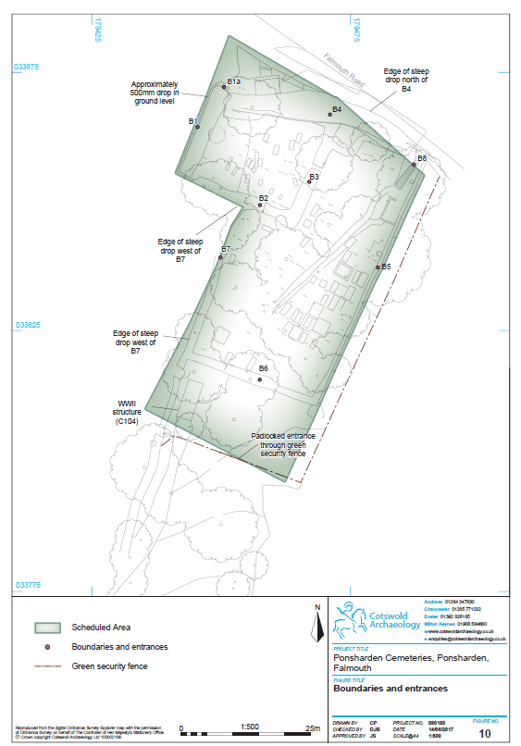Excluding the returned section of wall 3.73. (B1), the south facing boundary (B2)
comprises a hedgebank following the contours of the steeply sloping topography.
Indeed, as the boundary runs upslope there is an increasingly sharp drop in the
ground level beyond, indicating a phase of ground reduction immediately outside the
cemetery boundary to the south-west. There is also a disused badger sett evident in
the internal face on boundary B2 (see Section 3.107 – 3.108 for further discussion).
3.74. The earth bank recorded as B3 forms the boundary the Jewish Cemetery and the
Congregationalist, measuring between 1m and 1.5m high. There is a break in this
boundary at roughly the mid-point allowing access between the two cemeteries. The
bank is relatively sound, although in places badly impacted by root action and a disused
badger sett.
3.75. The north boundary to both cemeteries is formed by a continuous earthen bank
planted with hedgerows and trees (B4). There is a significant drop from the surface
of this bank to the adjacent ground surface beyond, following the topography within
the cemeteries, and ranging from approximately 4m to 2m in height. This earthen
bank is considered to be in potentially unsound condition, with clear evidence of
historical slumping and exposed tree roots fronting Falmouth Road.
3.76. The formal entrance to the Jewish cemetery is recorded as B1a and located on the
north-west corner. It forms a simple opening in rendered brick and stone walling with
coping stones, fitted with a standard modern wooden frame and board garden style
door. The door is padlocked. The curved stone wall return – on the side of boundary
B4 - is thought to be the possible remains of the ‘ohel’ (J101). The entrance and
associated brickwork is sound, although there are some missing coping stones.
3.77. Historically, the earliest representation of the Jewish cemetery is on the Duke of
Leeds estate map of Penryn dated to 1788 where it is marked as ‘The Jews Burial
Ground’ (Fig. 4). At this time its northern boundary (B4) would probably have been
formed by the surviving hedgebank, beyond which was the Falmouth Turnpike
Road, prior to the 19th century cutting, when presumably the road surface was more
equivalent to that inside the cemetery. Dashed lines on the 1788 map also suggest
that new boundaries, probably fences, were constructed to delineate the east (B3)
and south (B2) fronting boundaries. This map also shows the west facing boundary
(B1) as a hard line continuing to the south from the south-west corner of the
cemetery, possibly indicating the use of an early boundary. Conversely, on the 1793
47

Basset estate map (Fig. 6), this continuing boundary line is offset further to the
south-east, away from the corner of the cemetery, so that it is uncertain whether the
original field boundary has been shifted, or the 1788 alignment was in error. Given
that a surviving break of slope within the Jewish cemetery aligns well with the 1793
estate map and subsequent mapping, it seems most likely that the 1788 alignment
is an illustrative/scale error.
The 1793 estate map (Fig. 6) clearly shows the entrance (B1a) 3.78. in its current position
at the north-west corner of the cemetery. As per the HE Listing it is likely the
entrance has undergone several phases of construction during the 19th century,
including its incorporation with the ‘ohel’ or ‘Bet tohorah’ (J101) and from at least
1840 onwards, when it is illustrated on the Budock parish tithe map (not
reproduced), it seems the cemetery entrance opened directly into the ‘ohel’ or a
similar funerary structure (J101).
3.79. The 1814 Basset estate map by Richard Thomas (Fig. 5) illustrates the modern
fossilized footprint of both cemeteries. The surviving banks forming the east (B3)
and south (B2) boundaries of the Jewish cemetery are most probably constructed
by this time. It is uncertain whether the stone walling (B1) which now forms the west
boundary (returning at both ends) was upstanding at this time, although faint curved
and sweeping lines illustrated on this map, appear to depict a naturally sloping
topography to the south-west of both cemeteries. In contrast, the 1880 Ordnance
Survey map (Fig. 5) shows some changes in this direction with a path marked
flanking the west boundaries to both cemeteries (B1 and B7). This is not shown on
the 1840 Budock tithe map, so possibly, the wall was constructed between 1840
and 1880 during landscaping associated with the adjacent path. However, it may
also have been constructed at the same time as those for the Congregationalist
cemetery, not long after 1808. In respect of the abrupt differences in ground levels
evident to the south-west today, they seem more likely to have occurred during
landscaping associated with the construction of the modern gas works.
3.80. In summary, boundaries B1, B2 and B3 as well as entrance B1a are considered to
be concomitant with the late 18th and 19th century development of the Jewish
cemetery. Conversely, the northern boundary fronting the Falmouth Road (B4) is
likely to have some greater antiquity, as least matching that of the adjacent road.
Indeed, given the old road alignment here it has potential for medieval or even
prehistoric origins. That said, this boundary (B4) may have been significantly
48

impacted/altered when the adjacent road cutting was considerably deepened,
sometime around 1827.
Congregationalist Cemetery: Boundaries and Entrances
Shared Boundaries to the north (B4) and on the west 3.81. side of the Congregationalist
cemetery (B2 and B3) are discussed above, although it should be noted that the
changing ground level surfaces are greatest from within the Congregationalist side –
up to a maximum of 4m fronting the Falmouth Road.
3.82. On its east side, the cemetery is bounded by a rubble stone wall with granite coping
for its entire length (B5). The condition of the wall is highly variable. The first 3-4m
from the entrance steps appears in generally good condition, however; in places
further to the south, such as opposite the mortuary chapel (C115), there is an
almost total collapse. Elsewhere there are sections of partial collapse, interspersed
with sections in good condition. It is uncertain whether coping stones ran the full
length of the wall, especially at its southern end.
3.83. The southern boundary comprises a Cornish stone faced bank, surviving less than
1m in height (B6). At its eastern end the stone facing is clearly visible, but less so
centrally and to the west.
3.84. On its western side the cemetery is bounded by another hedgebank, also surviving
to around 500mm in height (B7). There are several places along this boundary
where the bank is breached, allowing ready access down the steep slope to the
hoardings bounding the neighbouring site. This boundary is shown as upstanding on
the late 18th and 19th century maps (Figs. 4 – 7) and most likely predates the
establishment of the Jewish and Congregationalist cemeteries.
3.85. Land for the Congregationalist cemetery was acquired around 1808 and it was most
likely that the walls were constructed soon after, with an entrance constructed at its
north-east corner, leading directly to the Falmouth Road. It is uncertain whether a
new wall was built along the boundary fronting the Falmouth Road (B4), or if the
existing hedgebank was utilised. Given that an earthen bank is still upstanding here,
it is likely the existing boundary was used, although possibly upgraded with stone
revetting. The 1814 estate map by Richard Thomas (Fig. 5) map is the first
cartographic evidence showing the enclosed area of the Congregationalist
cemetery.
49

The tunnel like entrance and stairway which r 3.86. emain upstanding were constructed
sometime around 1827, when it was noted that ‘the Turnpike road [was] sunk for the
purpose of reducing the hill’ (after Nunn and Weller 2014, p.15). This created a
marked change in the ground level, necessitating a new entrance off the Falmouth
Road with steps leading up into the cemetery (B8). This entrance survives but in a
considerable state of disrepair. Around the entrance, boundary bank B4 is retained
with a wall, comprising a lower course of rubble shillet with more regular slabs
forming the upper courses and rab or earth mortar and lime pointing (Parkes 2010).
A round headed brick archway allows access through the retaining wall, where the
remains of a wooden door lead onto a flight of granite steps. The door is made with
traditional broad timber, and probably original. Although partly broken away, it
measures approximately 1.8m across its maximum width and 2.6m high. Slate
rubble walls retain the substrate to either side of the stairway as it rises into the
cemetery, although part of the retaining wall on the west side has collapsed due to
lateral pressures from the ground. The granite steps are partly buried beneath a
layer of debris and vegetation.
3.87. In summary, boundaries to the east (B5) and south (B6) are considered to be
contemporary with the early 19th century construction of the Congregationalist
cemetery. Similarly, dividing boundaries with the Jewish cemeteries (B2 and B3) will
be of late 18th or early 19th century date. In contrast, the westerly boundary (B7)
may well have greater antiquity, predating both cemeteries and of late medieval
origins, although an earlier date is conceivable. However, it is also possible that
19th and/or 19th century landscaping directly to the west truncated the early
hedgebanks, so that the modern feature is a more modern replacement. The
entranceway and steps date to c.1827, and are contemporary with the 19th century
development of the Congregationalist cemetery.
Ecology & Wildlife (by CEC Ltd)
3.88. A Phase 1 Habitat Survey Report was undertaken by Cornwall Environmental
Consutants (CEC Ltd) during March and April 2017, the body of which is reproduced
in the relevant sections below. The full report is included in Vol. 2 Appendix H:
Phase 1 Habitat Survey.
50

Methodology & Limitations
This assessment been carried out in accordance with the ‘3.89. Guidelines for Preliminary
Ecological Appraisal’ produced by the Chartered Institute of Ecology and
Environmental Management (CIEEM, 2013).
3.90. It comprises three elements: a desk study, a site survey and a report. The desk
study consisted of a search of all existing ecological records within a 1km radius of
the site using the information held by the Environmental Records Centre for
Cornwall and the Isles of Scilly (ERCCIS, to 2017). A walkover site survey was
undertaken to identify plant species and map habitats present according to standard
‘Phase 1’ categories (JNCC, 2010). Signs of faunal species were also searched for;
including tracks, prints, droppings, hairs, feeding remains, nests and burrows. This
report describes and evaluates the ecological interest of the site, identifies any
ecological constraints and opportunities.
3.91. March is not an optimal time of year to undertake vegetation surveys as many
species will not be visible at this time of year. It is however, possible to assign
habitats under the broad Phase 1 Habitat classification system. The site had free
access to all areas excluding the internal areas of the building which was secured
by a padlocked gate. The survey was undertaken in dry and overcast conditions,
with occasional sunshine and light winds.
3.92. Ecological features can change over time, particularly if site management/ use
changes; as a guide it is recommended that this report is valid until April 2018. This
ecological assessment does not include a search for Tree Preservation Orders
(TPO’s) or Conservation Area status.
Site and Habitat Description
3.93. The site can broadly be divided in to three distinct areas, the Jewish Cemetery
which is dominated by semi-improved grassland with an abundance of primrose.
The Congregationalist Cemetery which comprises an area of broadleaved woodland
plantation dominated by sycamore with an abundance of ash and a ground flora
which includes a number of grass species as well as umbellifer species, orchids,
lesser celandine and daffodils. To the south of the cemeteries is an area of semiimproved
grassland which has become rank in nature and is dominated by tussocks
of cock’s-foot. Additional habitats and ecological features which are located
throughout the site include scattered trees, stone walls, hedgerow and areas of
scattered scrub. The scattered scrub is characterised by a dominance of bramble
and is most noticeable on the eastern and western boundary.

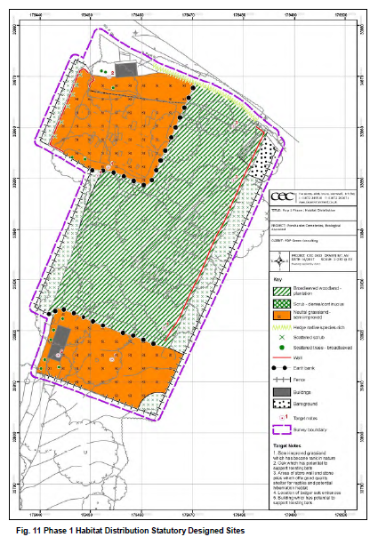

Fig. 11 Phase 1 Habitat Distribution Statutory Designed Sites

The distribution of habitats is shown above (3.94. Fig 11) and a species list for each
habitat can be found in Vol 2 Appendix H: Phase 1 Habitat Survey Report
3.95. There is one statutory designated site located within a 1km radius of the site. Fal
and Helford Special Area of Conservation (SAC) is located c. 850m to the east of
the site and has been designated primarily for four Annex 1 habitat types (mudflats,
sandbanks, large shallow inlets and bays and Atlantic salt meadows) and one
Annex 1 species (shore dock). There are also two other Annex 2 habitats (estuaries
and reefs) which are present, but not primary reasons for designation.
Non-Statutory Designated Sites
3.96. There are two Cornwall Roadside Inventory Geological Sites located within a 1km
radius of the development site and are both earth science sites. Site GS1 is located
c. 120m to the northwest of the site has been designated due to the Devonian slates
which are exposed within the cutting. Site GS24 is located c. 800m southeast of the
site and has been designated due to a cutting which exposes features in Mylor
slates.
Habitats: Graveyards
3.97. Graveyards are often ecologically diverse habitats which support a wide variety of
species particularly floral species and lichen (YWT, 2011). They often comprise a
mosaic of habitats located within a relatively small area and are likely to be subject
to minimal disturbance. Therefore it should be considered that the Cemeteries at
Ponsharden are likely to be ecologically important.
Habitats: Grassland
3.98. The species density recorded within the grassland located on site was not
noticeably high at the time of survey. However, it is anticipated that the grassland
has been subject to minimal disturbance/ management over the years and therefore
it is possible that these support a diverse floral diversity. It is considered that a
survey later in the year may have recorded a number of additional species and
therefore it is likely that the grassland is an important habitat.
Habitats: Cornish Hedge
3.99. The site is bound to the north and partially on the western boundary by Cornish
hedge. The species diversity of the hedgerow is limited, holly dominates the woody
species and the ground flora is dominated by ivy. However, the hedgerows on site
are likely to be UK BAP and Cornwall BAP priority habitat.
53

Species: Vascular Plants
A total of 47 vascular plant species were recorded dur 3.100. ing the March 2017 site visit.
The species richness of the site is considered to be good in relation to the size of
the site and habitats present. However, this is not necessarily reflected by the
number of species recorded during the survey visit and it is thought that a survey
undertaken later in the year would most likely have recorded a number of additional
species. The ERCCIS desk study revealed that 62 species of conservation value
have been recorded within 1km of the site, many of which are associated with
arable habitats and therefore not present on site. Those with potential to occur onsite
include maidenhair fern and lanceolate spleenwort which both have an
association with mortared walls. It is possible that these species may be present
within the site, however, they were not recorded during the survey.
3.101. At least two species of orchid were identified within the site, however, it was not
possible to identify these to species level during the survey due to a lack of flowers.
Therefore a visit in early summer would be required to identify this species.
Species: Lower Plants
3.102. A specialised survey for non-vascular plants, bryophytes and lichens, was outside
the scope of this study. The desk study revealed 14 records for lower plant species
of conservation importance. However, none of the species identified are considered
to be likely to occur within the site.
3.103. In general cemeteries are considered to offer good habitat to support lower plant
species as they are often undisturbed and there is likely to a number of different
substrates to colonise based on the diversity of stone materials used for head
stones. Based on this it is considered that the cemeteries will support a different
assemblage of lower plant species than that of the habitats in the wider area. Not
only do they have potential to support woodland species but also those associated
with old stone. Therefore the cemeteries have the potential to be ecologically
important for lower plant species.
Species: Bats
3.104. The ERCCIS desk study revealed records for common pipistrelle, soprano
pipistrelle, noctule, Natterer’s bat, brown long-eared bat and lesser horseshoe bat
within a 1km radius of the site.
54

All UK bat species and their roosts are legally 3.105. protected under the Conservation
Regulations 2010 (HM Government, 2010). Brown long-eared bat, soprano
pipistrelle and lesser horseshoe bat are UK BAP Priority Species and soprano
pipistrelle and lesser horseshoe bat are Cornwall BAP Priority Species.
3.106. During the site visit an assessment was made of the potential for the habitats on site
to support bat species. There is a building located within the south-western corner of
the site which has the potential to support roosting bats. The building is single storey
and constructed from concrete blocks with a flat concrete roof, notable access
points for bats include the main entrance which is covered with a metal grilled door.
In addition a single oak tree on the southern boundary was considered to offer
potential roosting features for bats. The majority of trees present within the site are
not mature enough to contain features which may be utilised by roosting bats. The
habitats present on site offer a good foraging habitat for bats, in particular the
broadleaved plantation woodland and hedgerows. The areas of suitable habitat are
relatively small and therefore on their own would be of limited use to bats. However,
the site is connected to suitable habitat to the south and west and therefore the site
is a small parcel of suitable bat habitat on the northern fringe of a much larger area.
The site does also have connectivity to the train line to the south which in turn is
likely to provide a navigational feature to a large amount of suitable habitat.
Therefore, any potential roosts present on site could be important as they are in a
location which would give bats access to a large range of foraging habitat.
Species: Badger
3.107. The ERCCIS desk study revealed seven records for badger within a 1km radius of
the site. Two badger sett entrances were identified within an earth bank located
adjacent to the Jewish Cemetery. The entrances looked to be relatively well worn,
however, no fresh spoil was noted outside of the entrances. In addition no further
evidence of badgers was identified within the site. The habitats on site provide good
foraging and sett building habitat, however, on their own are relatively small. The
site is connected to suitable habitat to the south and west, including woodland and
hedge bound fields. The site is considered to represent the northern edge of any
badger range in the vicinity as beyond the boundary to the north is an urban
environment unsuitable for badgers. The majority of the site is surrounded by a
fence which is likely to restrict badger movements into and out of the site, although
55

this is not considered to prevent badgers accessing the site as it is thought that
there is an area in the south-western corner where access can be gained.
Although widespread and common in Cornwall, badgers 3.108. and their setts are legally
protected under the Protection of Badgers Act 1992 (HM Government, 1992 - see
full report Vol. 2 Appendix H).
Species Other Mammals
3.109. The ERCCIS desk study revealed records for hedgehog, otter and harvest mouse
have been recorded within a 1km radius of the site.
3.110. The site contains habitats which would support hedgehog, including trees and
hedgerows which may be utilised for hibernation and grassland which provides good
foraging habitat. The fences are considered unlikely to represent an issue for
hedgehogs as there are suitable sized gaps for them to enter the site. The site is
unlikely to support otter or harvest mouse due to a lack of riparian habitat and
grassland margins adjacent to dense scrub respectively.
Species: Birds
3.111. The ERCCIS desk study revealed that 80 bird species of conservation value have
been recorded within a 1km radius of the site. A large number of these species are
associated with the estuarine habitat located c. 160m to the north of the site.
3.112. The cemeteries are considered to offer a small area of both foraging and nesting
habitat for a range of common bird species including house sparrow and dunnock
which have been identified in the desk study data. The broadleaved woodland and
hedgerows offer nesting opportunities and the grassland, scrub, woodland and
hedgerows offer foraging habitat. The site makes up a small proportion of suitable
habitat available in the wider area. It is considered unlikely that wetland birds will
visit the site as it is both small in area and relatively enclosed.
3.113. The management of woodland and hedgerows during the bird nesting season has
the potential to disturb nesting birds. All birds are legally protected whilst nesting
under the Wildlife & Countryside Act 1981, as amended.
Species: Reptiles and Amphibians
3.114. The ERCCIS desk study revealed ten records for slow worm, one d for grass snake,
two for adder and one record for common lizard within a 1km radius of the site.
56

The habitats on site are considered to offer good potential 3.115. for reptile species. There
is rank grassland and scrub edge which will provide good foraging habitat in close
association with stone walls and piles of stone which will provide both shelter and
hibernation habitat. The site is relatively small in area and the trees and woodland
within the site and surrounding areas are likely to mean that areas of the site are
shaded. However, the undeveloped area of land to the west of the cemeteries may
contain suitable foraging habitat for reptiles and therefore in combination with the
good hibernation habitat within the cemeteries may support a population of reptiles.
3.116. All British amphibian species require standing water to reproduce. The site supports
no ponds and OS mapping shows that there are no ponds within a 1km radius of the
site boundary. It is possible that there are garden ponds within this area which do
not feature on OS mapping. The grassland, woodland and scrub edge habitats on
site offer good foraging potential and the woodland and stone walls and stone piles
offer good hibernation habitat. The cemeteries represent a small proportion of the
total suitable habitat available for amphibian species in the wider area.
Species Invertebrates
3.117. The ERCCIS desk study revealed 36 records for invertebrate species of
conservation concern. The site is small in area and the habitats on site are not
considered to support the most diverse assemblage of invertebrate species.
However, the site does offer a good mosaic of suitable habitats, including,
grassland, woodland and hedgerow together with bare areas for basking, such as
wall tops, and as a cemetery, is a relatively undisturbed site. Therefore, it is
considered that the site will support a range of common invertebrate species.
Tree Inspection (by Cornwall Council)
3.118. A tree inspection survey was undertaken by Cornwall Council during November
2016 (separate from the Phase 1 Habitat Survey) and comprises two discrete
reports (Mitchell 2016a and 2016b). The results of this work are summarised below
with reference to Fig 12 and to Vol. 2 Appendix D: Tree Gazetteer:
3.119. There are no TPOs within the Jewish Cemetery and no safety works identified.
Some general management works are recommended, summarised in Table 1:
3.120. There are no TPOs recorded in the Congregationalist Cemetery and no safety
works identified. However some management works are recommended; where
relevant these are summarised below in Table 2:
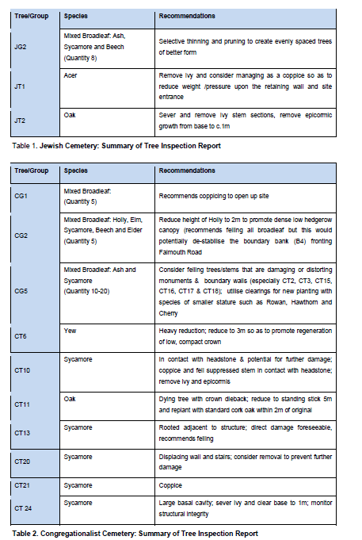

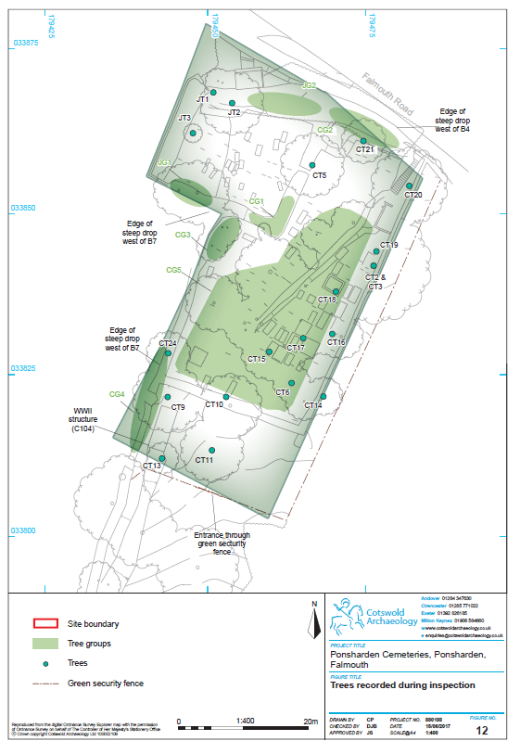

4. ASSESSMENT OF SIGNIFICANCE
Introduction
The assessment of significance is divided into five 4.1. thematic sections: landscape
setting; buried archaeology; history; structures and ecology. For landscape setting,
buried archaeology, history and ecology a narrative assessment of significance is
outlined, utilising the industry-standard guidance on assessing heritage value as
outlined in ‘Conservation Principles’ (Historic England 2008); however, for grave
monuments and structures, as well as boundaries and entrances, a relative scale of
significance is also adopted (A, B, C, D and E) so as to provide guidance and
enable management prioritisation of remedial works and repairs. Methodology and
criteria for relative scales of significance are discussed below (Section 4.28 – 4.30);
associated grades are listed in the relevant gazetteers.
4.2. Although prepared using industry standard guidance for assessing heritage value
(ibid.), it should be recognised that scales of relative significance are generated here
for the purposes of conservation management only and should in no way detract
from the national designation encompassing the entire Site. Indeed, the Jewish and
Congregationalist cemeteries at Ponsharden are protected as a Scheduled
Monument (List Entry Number 1020815); classified as a designated heritage asset.
As such, Ponsharden cemeteries are offered legal protection and considered to be
of the ‘highest’ level of heritage significance: they are of national importance (Vol. 2
Appendix I: Heritage Statue and Policy Guidance). Moreover, the headstones to
Isaac Benjamin and to Alexander Moses in the Jewish cemetery are also
designated as Listed Buildings (List Entry Number 10613936); defined as having
‘special architectural or historic interest’ (Vol. 2 Appendix I: Heritage Statue and
Policy Guidance ).
4.3. As with graveyards and burial grounds across the country, Ponsharden provides an
invaluable record of social and economic history, intimately connected with the
communities and religious faiths for which they were established. In the modern
world with multiple competing voices, they also provide a connection to the past,
blending together nature, architecture, sculpture, history, poetry and landscape into
a unique local resource. This is a resource that should be readily available to local
residence, members of the wide community and more distant visitors. Indeed, the
significance of the Jewish and Congregationalist cemeteries at Ponsharden will be
of importance to an eclectic range of disparate groups and individuals. Principal
60

interested parties are listed below, although by no means should this be considered
an exhaustive list:
• The key stakeholders involved in the preparation of this plan (Section 1.11
and 1.12);
• Individuals and groups interested in the social and economic history of
Falmouth and its environs;
• Individuals and groups interested in the social and economic history of
Cornwall and the south-west;
• Individuals and groups interested in Jewish history;
• Individuals and groups interested in the history of nonconformist minority
faiths;
• Individuals and groups interested in genealogical research;
• Individuals and groups interested in burial grounds;
• Individuals and groups interested in gravestone rubbing;
• Individuals and groups interested in graveyard furniture and architecture;
• Local residents and passers-by using the cemeteries out of spontaneous
interest, or while passing through between destinations;
• Nearby residents concerned about their local environment;
• Local residents, passers-by or visitors using the cemeteries for relaxation
and contemplation.
An interim statement of significance w 4.4. as prepared by Parkes (2010) and the online
HE listing sets outs explicit reasons for designation. These are developed and
expanded upon in the thematic sections below.
Landscape Setting
4.5. The landscape setting of a designated asset can make neutral, positive or negative
contributions to an assets heritage significance through impacts on evidential
(archaeological), historic (illustrative and associative), aesthetic and communal
values.
4.6. The historical landscape setting of the cemeteries at Ponsharden has dramatically
altered during the late 20th century. During the 18th, 19th and first half of the 20th
century, historic maps show that the Site occupied a rural location alongside the
Falmouth road, set within a patchwork of enclosed agricultural fields (Figs. 4 – 7). It
is likely that the burial site was deliberately selected so as to be peripheral to the
61

urban communities in Falmouth and Penryn, yet readily accessible along the
Falmouth Turnpike Road. This reflects Jewish traditions, of perceiving ‘the dead to
be impure…..this sense of impurity leads to the physical distancing of cemeteries
from their associated communities’ (Barker Langham 2015, p.3). That said, the
exact location may have been equally contingent on availability rather than
suitability; or alternatively on the willingness of the landowner to lease the plot. It
also seems likely that once the Jewish burial ground was established, the
Congregationalists were attracted by the pre-existing nonconformist burial traditions,
rather than a religious and/or aesthetic pre-disposition for this location.
The historical setting at Ponsharden was clearly rural. 4.7. However, from within the
Jewish cemetery, topography would have dictated the orientation and extent of
views, to the north these may have encompassed the Penryn Estuary and
countryside beyond along its northern bank. To the west there were most likely
views across rural fields occupying the dry valley and its south-east facing slope
opposite the cemetery; although in this direction more distant views would have
been blocked by the attendant ridge line. The Congregationalist cemetery occupies
the higher ground, but has a similar aspect, that said it is possible that views to the
north-east and east across open fields may have been possible, although southward
views would have been restricted by topography.
4.8. During the second half of the twentieth century, the historical landscape setting has
been fragmented and heavily denuded. For instance, modern development to the
south and east, including a modern supermarket with extensive parking and access
roads as well as nearby industrial units, has completely fractured all rural
associations with post-medieval farmland in these directions. To the north, the rural
fields that formerly occupied an area of land projecting out in the Penryn estuary –
formerly known as The Island - are now commercially developed for modern
riverside activities and industries. That said, screening along the northern boundary
combined with topography preclude any sustained views down onto the water,
allowing only fragmented views of the Falmouth Road, where boat masts and
industrial units are visible, as well as fleeting glimpses of rural fields situated on the
north banks of the estuary (Photograph 12). From this direction, road traffic noise
travels readily across the Site.
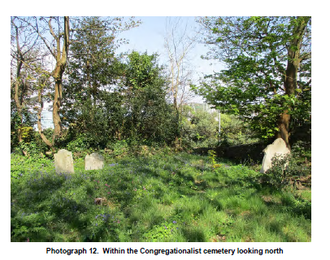
Photograph 12. Within the Congregationalist cemetery looking north

Furthermore, on the roadside, adjacent 4.9. to the northern boundary, on the Falmouth
Road near the entrance to the Jewish cemetery there is a large green shelter box
which is owned by Wales and West Utilities. The roof of this shelter box is readily
apparent from within the Jewish cemetery, but more importantly when viewed from
outside the cemeteries, at roadside, it forms an entirely incongruous and visually
deleterious element in the landscape the setting (Photograph 3).
4.10. To the west of the Site, there is the site of the former gas works and more recently
Vospers Garage. However, the land here has recently been abandoned, so that is
has largely been reclaimed by scrub, although the former Vospers garage and
showroom still stands (Photograph 5). This area has now been assigned for
residential development. Green fields are also visible beyond on the opposite valley
slope, although the Jewish cemetery is bounded in this direction by unsightly
wooden hoardings. At present the landscape in this direction retains some of its
historical character.
4.11. To the south, east and north the modern landscape setting is entirely out of keeping
with the formative and historical setting of the Ponsharden cemeteries, which for the
18th, 19th and larger part of the 20th centuries was both rural and peripheral to the
urban environment. The modern setting in these directions is now developed and at
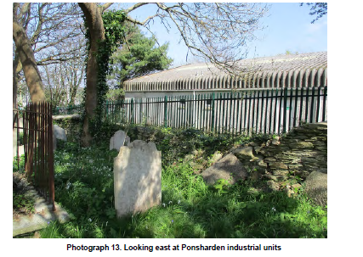
odds with the historical landscape (Photograph 13), so is considered to have
negatively impacted the heritage significance by adversely affecting historical,
aesthetic and communal attributes. That said, a small area of grass and trees
buffers the Site from modern development immediately to the south, largely
obscuring views from hereabouts to the supermarket and its attendant
infrastructure. This plot contributes positively to the setting of the Site and should be
retained if at all possible.
Photograph 13. Looking east at Ponsharden industrial units
Similarly, the green shelter box negatively impacts the 4.12. setting. Even though only
partly visible from within the Jewish cemetery, it is readily apparent from along the
Falmouth Road, clearly framing the entrance to the Jewish cemetery, as does the
wooden hoarding, which runs from the entrance along the western boundary of the
Jewish cemetery (Photograph 3 & 4).
4.13. Combined, these negative impacts on the setting and heritage significance of the
Site will be readily apparent to most users of the cemeteries, especially those with
specific historical, architectural, communal and/or aesthetic interests. These impacts
will certainly be felt by those with an ongoing physical and historical association with
the Site. That said, current impacts are to some extent mitigated by screening.
Trees and vegetation along and adjacent to the north, and south boundaries mostly
64

restrict outward (and inward) views, so that the ruinous passage of time is brought
to the fore, creating a sense of enclosure and isolation. Moreover, this screening will
most likely be contemporary with the 20th century historical development of the Site,
reflecting the dynamics of the changing landscape as it was infilled by modern urban
expansion.
Other than screening, the impact of 4.14. modern development on the setting of the
Ponsharden cemeteries cannot be easily undone. This emphasises the importance
of the relatively undeveloped land to the west of the Site, which now represents the
last surviving remnant of the historic rural landscape, dominant here until the second
half of the 20th century. As such inward and outward views in this direction form an
integral aspect of the setting, making positive contributions to historical, communal
and aesthetic attributes of heritage significance. Modern built development in this
direction will necessarily offer a negative impact to the heritage significance,
although the extent of any such impact might may be mitigated to ‘less than
substantial harm’ by carefully planned development that is sensitive to the needs of
this significant Scheduled Monument.
4.15. Similarly, the heritage significance of Ponsharden cemeteries would benefit from
relocating the green shelter box at distance, so that it no longer dominates the
entrance to the Jewish cemetery. After all, the inanimate built environment bounding
Ponsharden cemeteries should if at all possible respect the historical significance of
this rare Scheduled Monument.
4.16. In the short term, the setting and associated heritage significance of Ponsharden
cemeteries could be readily enhanced by replacing the wooden hoardings fronting
the former Vospers site with a more appropriate boundary (Photographs 3 & 4).
Moreover, the site is currently bounded to the east and south by substantial green
security fencing which is out of keeping with the historical context (Photographs 6 &
13), the situation here would be improved if this were painted black to mimic other
metalwork in the cemetery, or replaced with black cast iron fencing.
Buried Archaeology
4.17. It is considered unlikely that buried archaeology deposits pre-dating the late 18th
century establishment of the Jewish cemetery survive within the Site. If once
present, any deposits pertaining to the prehistoric, Romano-British or medieval
periods, are not likely to have survived the extensive grave digging that has taken
65

place across the Site. Burial registers indicate a minimum of 585 individual burials in
the Congregationalist cemetery alone (Nunn and Weller 2014), so given the
relatively small spatial area, it seems highly plausible that the substrate across the
entire Site will have been truncated during the cemeteries active life span.
The exception is the possible Bronze A 4.18. ge barrow identified by Parkes (2010)
located at the north end of the Congregationalist Cemetery (C103), partly crossing
the boundary into the Jewish Cemetery (Photograph 9). This topographic anomaly is
overgrown, but roughly rounded with a flattish top, measuring approximately 9m
across by 1.1m high. However, as discussed in Section 3.13 – 3.14 above, its
location does not fit the normal criteria for Bronze Age barrows, and as such is
considered more likely to be the result of upcast from grave digging, or works to the
adjacent roadside cutting and hedgebank. That said, given the restricted space
combined with the density of burials, it seems strange that such an anomaly should
have survived the burial ground’s raison d’ètre. Therefore, on this basis, it is
possible the feature was either created after the cemeteries went out of use, or
instead, was considered to be of some significance and left intact during the life of
the burial grounds.
4.19. At present the mound is of unknown origin. The common sense interpretation would
suggest that it is most likely a product of activity associated within the burial
grounds, or alternatively post-dates their use. However, an earlier date cannot be
entirely discounted. Until this feature is characterised and dated, it is not possible to
assess its significance; therefore, archaeological investigations are recommended to
resolve this uncertainty.
History
4.20. Despite some damage and decay due to sustained neglect and minor vandalism the
disused Jewish and Congregationalist cemeteries at Ponsharden survive well. They
represent a fossilised record of nonconformist burial traditions dating from the late
18th through to the 19th and early 20th centuries. Their significance is derived from
a variety of historical factors, including: siting, rarity and group value, most
importantly they provide direct evidence for past religious, social and economic
activity relating to Falmouth, its hinterland and the broader Cornish landscape. They
represent a social and economic biography of place and provide a fulcrum for
connecting the present with the past and the living with the dead.
66

Unusually for disused burial grounds, 4.21. the cemeteries at Ponsharden have not been
disturbed, reorganised or expanded. This means that a cohesive record spanning
the working life of the Site – predominantly 1780 to 1880 – has been preserved.
This was a period of unprecedented economic and social growth, for the most part
predicated on the hugely successful Cornish mining industries, which, during the
late 18th and 19th centuries made Cornwall one of the richest places on earth. The
cemeteries at Ponsharden reflect the growth of religious minority groups during this
time, each of which played an important and distinctive role in the flourishing
economy and social history of the area. Notably, the land was granted jointly to both
religious communities by Sir Francis Basset, Lord de Dunsanville, providing an
example of the increasing acceptance and tolerance for minority religious faiths
outside of the established church. More specifically, it can potentially be seen to
demonstrate, early and possibly widespread local support for nonconformists
religious groups in the surrounding parish of Budock.
4.22. After the mid-19th century, the sudden decline in the use of the cemeteries mirrors
the rapid social and economic crash that took place at this time, when depressed tin
and copper prices led to the collapse of the local economy and the loss of
Falmouth’s role as a packet station. This was a time when Jewish communities left
the district.
4.23. The Jewish cemetery is particularly rare, nationally it is one of only 25 such extant
burial grounds pre-dating the 1830s, of which seven are located in the south-west of
England; considered to form ‘the richest and best preserved regional group outside
of London’ (HE listing information). Ponsharden clearly has group value with these
seven cemeteries, located at Exeter, Plymouth, Torbay and Penzance. This is
particularly evident with the exceptionally well preserved cemetery at Penzance, as
gravestone texts from both Penzance and Ponsharden, demonstrate important
historical links between the communities. More widely, genealogical studies of those
buried at Ponsharden provide evidence for family and economic connections
between the Falmouth Jewish community and those elsewhere in England and
overseas (Pearce 2014).
4.24. The well documented foundation of the Jewish cemetery at Ponsharden
contextualises its origins within the mid-18th century expansion of Jewish
communities from London out into the English provinces. Moreover, the subsequent
siting of the Congregationalist cemetery beside the Jewish plot is of particular
67

interest in that it indicates close ties, as well as mutual respect and tolerance
between the different faiths.
The cemeteries provide an invaluable and irreplaceable 4.25. wealth of information
concerning specific individuals, families, religious groups and communities, casting
light on funerary and religious traditions, along with social, economic and
professional status. For the Congregationalist community in particular this
information is poorly documented elsewhere, so that grave stone texts, especially
those with named occupations and places of residence record the social
composition at a time when the religious group was at the height of its popularity
(HE listing information).
4.26. Textual information combined with spatial distribution further highlights information
about inter-community and familial relationships. For instance, the founders of the
Jewish group in Falmouth form a discrete but pronounced cluster in the upper
south-east corner of their ground whilst within the Congregationalist cemetery there
appears a clear preference for family plots. Changing traditions and social norms
are also reflected in the historic development of the burial grounds. The gradual
introduction of English onto the Jewish gravestones after 1838 along with the clear
influence of local non-Jewish traditions in the shaping of gravestones demonstrates
adaptation and integration between cultures (HE listing information). Notably, by the
time of the final Jewish burial, that of Nathan Vos in 1913, the inscription contained
a larger proportion of English than Hebrew.
4.27. In summary, the Ponsharden cemeteries provide a well preserved and nationally
important historical record of the inter-relationship between nonconformist faiths and
the wider community in which they are embedded. They open a window into the
social, economic and religious history of Cornwall, revealing information about
individuals, families, groups and communities, at a time when the county was
experiencing rapid fluctuations and unprecedented social and economic change.
Structures: Gravestones, memorials, boundaries, entrances and other structures
4.28. Gravestones, memorials, boundaries, entrances and other structures have been
assessed for relative levels of significance. These are intended as guidance, so that
if necessary, management proposals potentially dependent on restricted funds can
be prioritised. Relative levels of significance are graded coarsely, from A through E,
so that level A is considered to have greater significance than B and level B great
68

then C, with level E representing the lowest level of significance. Although relative
levels of significance are generated here as a management tool, the Jewish and
Congregationalist cemeteries at Ponsharden are jointly designated as a Scheduled
Monument, and as such are considered to have the highest significance nationally.
Relative levels of significance have been assessed using 4.29. a number of criteria,
framed in a qualitative narrative rather than a strictly prescriptive quantitative
methodology. The criteria used for assessing internal levels of significance include:
cemetery, condition, monument type and rarity, materials, inscriptions, date and
finally individual and/or family renown. These are considered in greater detail below,
with examples where necessary. Levels of significance are included in the
respective gazetteers (Vol 2 Appendices A – C). A photographic record of each
monument is contained in Kelland (2013 and 2016) and Nunn &
Weller (2014).
4.30. It should be reiterated that relative levels of significance are ascribed as guidance;
as such, it is recommended that when necessary, reappraisal of assigned grades
can and should be carried out utilising the criteria set out below. Indeed, given the
depth of site specific knowledge possessed by those members of FoPc, FTC and
HE responsible for the guardianship of Ponsharden cemeteries, reassessment
should be encouraged, undertaken on a case by case basis by those with the
relevant and/or specialist knowledge. By adopting this approach, scope for
pragmatic and contingent decision making is retained by those responsible for
prioritising and implementing future management works and proposals.
Cemetery
4.31. The Jewish cemetery is extremely rare, it is one of only 25 pre-dating the 1830s,
and one of only seven located in the south-west (see Section 4.23 above) whereas
the Congregationalist cemetery is part of a more extensive and well recorded
nonconformist tradition. As such individual monuments contained within the Jewish
cemetery will be considered to have a higher level of significance than those of
comparative similarity in the Congregationalist cemetery. Furthermore, based on our
assessment of the historical significance of the Jewish cemetery, monuments
contained therein will not be considered to fall below level C significance.
69

Condition
Those gravestones, structures and memorials 4.32. in the best condition will be
considered to have a higher level of significance than equivalent monuments in poor
condition. For instance, headstones that have fallen and broken into multiple
fragments or have just fallen will be considered to have lower significance than
those that are upstanding in situ and in good condition. As an example, within the
Jewish cemetery, slate headstone monument J26 marks the burial of Israel Levy; it
is upright and considered to be in good condition. Overall it is rated as significance
level A, whereas the slate headstone monument J35, to Gershan Elias, has fallen
and broken into several separate pieces so, with other factors remaining equal it is
rated as significance level C. Similarly, within the Congregationalist cemetery,
monument C55 to Amos and Elizabeth Fish dated 1866 is displaced and broken into
multiple pieces. Given the poor state of survival it is assessed as significance level
E, whereas monument C8 marking the burial of Lavinia Featherstone, dated 1879
and assessed to be in situ and in fair condition, is classified as significance level C.
Rarity of type
4.33. The rarity of monument type also informs the level of heritage significance. Within
the Jewish cemetery, grave monuments are restricted to headstones so are less
susceptible to this assessment of monument type, however, with the
Congregationalist cemetery there is a more varied monument form. For instance,
over 60% of the monuments here are simple headstones, 21% are headstones
combined with other grave features such as kerbing, 10% are ledger or
raised/chamfered tombs and only 4% are of a pedestal form (Nunn and Weller
2014). Therefore, with other factors remaining equal, a rarer monument type such
as a pedestal tomb will be considered to have greater significance than a more
common monument type such as a simple headstone.
4.34. For example, monument C13 is a pedestal tomb and family vault belonging to the
Downing family. Its large granite cross has fallen and is lying at the base of the
pedestal, otherwise it is considered to be in fair condition; therefore, given its
relative rarity, it is assessed as significance level A (Photograph 14). In contrast, a
headstone of similar condition but of a more common type, such as the in situ
headstone monument C5 to Mary and Laura Greenaway, dated 1868 and 1880, is
assessed as significance level C (Photograph 14).
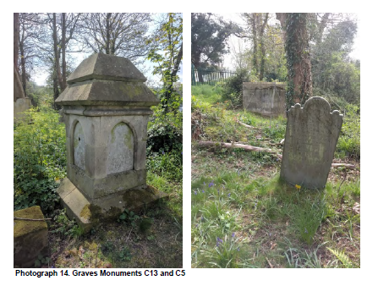
Photograph 14. Graves Monuments C13 and C5
When a grave monument or structure is exceptionally 4.35. rare within the Site, other
categories will automatically be trumped, and the highest level of significance
assigned.
4.36. In this context all boundaries banks, walls, entrances and mortuary buildings are
classified as being of level A significance. For example, entrances to the Jewish
Cemetery (B1a) and to the Congregationalist Cemetery (B8) are standalone
examples in relation to their respective burial grounds and as such form an
exceptionally rare and important component to the Scheduled Monument. They are
considered to have level A significance.
4.37. Likewise, the upstanding remains of the Congregationalist mortuary chapel is the
only example within the Site (C101), as are any surviving remains of the ‘ohel’
(J101) – buried or upstanding - thought to be located directly inside the entrance to
the Jewish cemetery. In fact evidence for an ‘ohel’ is considered to be very rare (HE
listing information).
4.38. Boundary banks B4 and B7 are the only possible examples of Cornish boundary
hedgebanks pre-dating the formation of the formation of the Jewish cemetery, and
71

may be of early origin; hence they will be encompassed by The Hedgerows
Regulations 1997 (Vol. 2: Appendix I Heritage Statute Policy and Guidance).
Therefore, they are also considered to be of level A significance, although it should
be noted that both original banks may have been truncated and replaced during
episodes of 18th, 19th century landscaping; possibly during work associated with
the cutting for the turnpike road and also for the construction of the gas works.
Boundary walls B5 and B1 are a similarly rare component 4.39. of the joint cemeteries,
as are boundary banks B2, B3 and B6, all of which are of level A significance;
considered fundamental elements in the establishment of the cemetery boundaries.
The path running through the Congregational cemetery is also the solitary example
of this type of feature (C102), so is likewise assessed as level A.
Materials
4.40. The type and variety of materials used in the construction of grave monuments is
also considered to contribute to the level of heritage significance. Within the Jewish
cemetery where headstones of sandstone and slate are almost entirely dominant
this is less of a consideration. However, within the Congregationalist cemetery the
range of materials is more diverse, for example recorded stone types indicate 44
monuments using limestone, 29 with slate, 10 with sandstone, and 6 with granite
(Nunn and Weller 2014). Where comparatively rarer (non-local) and/or more
expensive stone is used such as granite, or where a combination of materials has
been employed, such as stone and iron work, then with all else remaining equal, a
higher level of significance is attributed.
4.41. For example, monument C39 to John Halingey comprises a headstone with granite
kerbing and low iron railings. Although the iron railings are partly missing, this
monument is considered to be in fair condition so, given its comparative rarity and
materials used, is assessed with a significance level of B. In contrast, within the
Congregationalist cemetery, upstanding headstones of fair or better condition,
constructed of limestone or slate, and with no other notable attributes, are generally
assessed as significance level C.
Inscriptions
4.42. The form and rarity of inscriptions is also a material consideration in attributing
levels of significance. This is best exemplified in the difference between the
cemeteries. Within the Jewish cemetery inscriptions are either in Hebrew or a
72

combination of Hebrew and English, whereas Congregationalist monuments are
almost uniformly in English. Given the general rarity of Hebrew or Hebrew and
English inscriptions, these are considered to have a higher level of significance than
those in plain English. This factor, combined with the historic significance of the
Jewish cemetery, is why relative levels of significance assigned therein are not
considered to fall below level C.
For example, within the Jewish cemetery, 4.43. in situ headstone monument J16 to
Moses Samuel Jacob dated 1858 and described in good condition, is inscribed in a
mixture of Hebrew and English so assessed as level A significance.
4.44. In comparison, within the Congregationalist cemetery, in situ monument C65 to
Charles Werey dated 1865, described as being in good condition and with a simple
English inscription ‘In memory of Charles Werey who died Novr 17th 1865 Aged 51
years: His end was peace’, is assessed as level C significance.
Individuals
4.45. The local renown and social notability of given individuals or families is also
considered to be of material consideration in assessing the level of heritage
significance. Especially noteworthy are those individuals or families who are
considered to have played formative or significant roles within the community, or
within the wider social and/or economic landscape.
4.46. For example, both Alexander Moses (also known as Zander Falmouth) and
Benjamin Wolf are considered to be founding members of the Jewish community.
Their headstones, recorded as monuments J38 (dated 1791) and J37 (dated 1790)
respectively, are both assessed as level A (Photograph 15). Such was the
importance of Alexander Moses in the development of the Jewish community in
Falmouth, his family became connected through family to most other families, so
that Jews descended from them can readily trace their family tree back to him
(Pearce 2014, p.387).
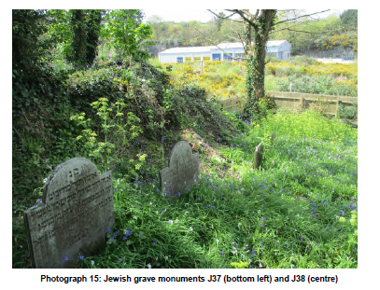
Photograph 15: Jewish grave monuments J37 (bottom left) and J38 (centre)
Within the Congregationalist cemetery, the monument 4.47. to Dr James Cornish (C62)
and is also assessed as significance level A, even though this ledger is in poor
condition, being broken in several places. Dr Cornish (1792 – 1858) was of some
local importance, being twice mayor of Falmouth, an alderman and a magistrate. He
was considered a man ‘fierce intelligence’ and entertained the prime minister to be,
Benjamin Disraeli, on a visit to Falmouth (Nunn and Weller 2014, p. 27 & 279-284).
Interestingly, two other notable individuals are interred beneath and also dedicated
on monument C62. Elizabeth Elliot is credited with introducing the printing press to
Cornwall and Dr James Trevosso who provided free medical care to the poorer
residents of Falmouth. Also assessed with level A significance is the monument to
the Glasson family (C78; Photograph 16). This family tomb was found to be in poor
condition, damaged and vandalised, it has missing railings and cracked and broken
slabs. However, given that William Glasson (1781 – 1843) was a wealthy merchant
of ‘some repute’ in Falmouth (Nunn and Weller 20104, p.352) combined with the
comparative rarity of this style of tomb, the monument is assessed with the highest
level of relative significance (A). Indeed, when in 1809 Richard Mogg Glasson and
Henry Mogg, both aged 21, drowned in Falmouth harbour over 200 mourners
attended the funeral and their interment at this monument (Nunn and Weller 2014).
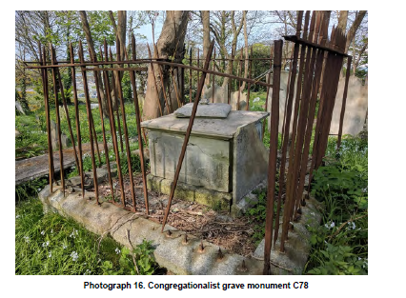
Photograph 16. Congregationalist grave monument C78
Date
Finally, the date of the burial 4.48. and associated monument is also considered to be a
contributing factor in assessing relative heritage significance. This is particularly so
when the date is considered to be one of the earliest or the latest within the
respective burial ground, thereby bracketing its use.
4.49. For example, within the Jewish cemetery the gravestone of Esther Elias is of an
unusual type, comprising a granite headstone on a granite base (J45). It is also the
earliest by some 10 years, being dated to 1780, so is considered to be of level A
significance. Esther Elias was from London, although her family was originally from
Germany. She was the wife of Barnet Levey, whose headstone is also early, dated
1791, and of level A significance (J39). He was an immigrant from Alsace, who
prospered as a pedlar under the patronage of Alexander Moses (Pierce 2014, p.
387 & 389). The headstone of Nathan Vos (1833 – 1913) marks the latest burial in
the ground (1913) and is the only marker to contain a larger proportion of English
text than Hebrew (J2). Nathan Vos, was a local publican; in 1913 long after the
Falmouth Jewish community had dispersed, permission was given for his interment,
possibly as he had maintained the burial ground prior to his death. Therefore,
despite, the fact that his slate headstone has recently been vandalised and broken,
75

it is assigned the highest level of significance (A). Before, Nathan Vos, the last burial
in the Jewish ground is that of Gershan Elias aged 84 (J35), dated 1868. This slate
headstone is also in bad condition, presently lying broken on the ground; it is
assessed as level B significance.
In the Congregationalist cemetery, although some of 4.50. the oldest burials are recorded
to 1808 (Nunn and Weller) the first marked grave dates to 1811. The limestone
headstone of William Dunstan who died in 1811 aged 6 years and 3 months is in fair
condition and assessed as level B significance (C79). Elsewhere, the family tomb
recorded as C4, holds the remains of James Poat, who died aged 5 weeks in 1811
(Photograph 17). Given the rarity of this type of monument combined with the early
date, it is assessed as level A significance. Headstone monument C89 is the
youngest marked grave in the Congregationalist cemetery, recording the burial of
Elizabeth Cook, dating to 1912. This headstone, although of common form is of
granite, a comparatively rare material here, so this fact combined with the late date
means the cook gravestone it is assessed as level A significance.

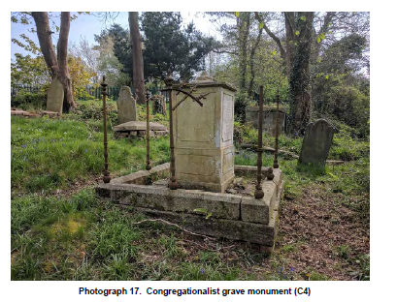
Photograph 17. Congregationalist grave monument (C4)
WWII Structure
4.51. The presumed WWII structure (C104) is located south of the Congregationalists
southern boundary (B6), but remains within the Scheduled Monument area
76

(Photograph 10); as such it enjoys the legal protection which that designation
affords. The structure is orientated to the west, overlooking the former gasworks,
and almost directly faces the five-sided pillbox which survives below in the old
entrance wall of the gasworks below, approximately 75m to the south-west (DoB ref:
S0003212). The two structures clearly reference each other, and as such have
group value. They form part of the nationwide WWII defences, constructed in the
event of invasion and/or attack. Notably the pillbox in the gasworks wall contains
gun emblasures, whereas structure (C104) contains none, although it does have
vents and a baffle door for blast protection. It seems most likely that the WWII
structure within the Scheduled Monument is either an air shelter or warden shelter,
possibly associated with the gasworks.
Structure C104 appears to have been constructed as 4.52. part of the national WWII
defences, with evidential, historical and communal values making positive
contributions to its heritage significance, which in part, is further enhanced by the
structures comparatively unusual location next to the nonconformist burial ground.
Moreover, its setting, overlooking the dry valley below is largely intact. In respect of
its relative significance, this structure lies outside the cemeteries, and beyond the
principal intent of the scheduling; however, its relative significance level is assessed
as C.
Ecology
4.53. The phase 1 habitat survey undertaken by Cornwall Environment Consultants Ltd
(Section 3.88 to 3.116 above) found that the graveyards at Ponsharden are likely to
comprise a mosaic of habitats located within a relatively small area and should be
considered ecologically important. Likewise, it was also felt that the grassland
therein, has been subject to minimal disturbance, so may support a diverse floral
diversity. Conversely, species diversity on the hedgbanks was found to be limited,
dominated by holly and ivy, although it was considered that they are likely to be
encompassed by UK and Cornwall Biodiversity Action Plans (BAPs). These are
plans that identify habitats and species of nature conservation at national and
country level; it is the Local Authorities duty to further the conservation of UK BAP
priority and species (for further information see Vol. 2 Appendix H: Phase 1 Habitat
Survey).
4.54. There was considered to be good species richness for vascular plants in relation to
the size of the Site, with at least two species of orchid identified. The site also has
77

potential for species of conservation value, such as maidenhair fern and lanceolate
spleenwort, both of which are associated with mortared walls. In respect of lower
plants such as mosses and lichens, it is considered that the diversity of stone
substrate within the cemeteries will support a different assemblage to that of the
wider landscape hereabout, and as such the cemeteries have the potential to be
ecologically important for lower plant species.
Bats are legally protected, and although not identified 4.55. during the survey, there are
considered to be good potential roosts, most notably the WWII structure (C104) and
an oak on the norther boundary, near the old entrance to the Jewish entrance (JT2).
Two badgers sett entrances were also identified on Site, within earthen boundary
bank B2 (southern boundary to the Jewish cemetery), indicating that on occasion
badgers utilise the Site, although no fresh spoil was noted outside the entrances.
Badgers and their setts are legally protected. The Site contains habitats which
would support hedgehogs, as well as a small area of both foraging and nesting
habitat for a range of common birds including house sparrow and dunnock. The
habitats on Site are also considered to offer good potential for reptile species,
including slows worms, grass snakes and lizards. Finally, it is thought that the Site
will support a range of common invertebrates.
4.56. The Site is beset to three sides by concrete, tarmac, buildings, cars and people,
nevertheless it provides an oasis of diverse ecological habitats for British flora and
fauna. Although there are no TPOs within the Site, the woodland is dominated by
self-sown sycamores which provide potential habits to a range of species. Moreover
the trees within the Site have grown hand in hand with the abandonment and disuse
of the burial grounds, so that they now form an element to the historic character,
having been present for almost as long as the cemeteries were used for interring the
dead. Moreover, the trees provide screening, protecting the Site from the sights and
sounds of the modern world beyond; helping to create a sense of isolation and
liminality, part natural: part cultural. The yew tree is of particular significance (CT6),
given its size it is likely to be contemporary with the burial ground, most likely
planted deliberately during the early life span of the Congregationalist cemetery.
This is interesting in that yew trees are often associated with more traditional burial
sites of ancient churchyards, their significance seemingly of pagan origin, pre-dating
Christian traditions, signifying both eternal life and the grief of loss.
78

Clearly, the trees contribute positively to the ov 4.57. erall significance of Ponsharden
cemeteries, enhancing historic, aesthetic and communal attributes; however, where
they threaten the upstanding physical fabric of the Scheduled Monument, then their
significance, and the aesthetics they conjure, should not be calculated to outweigh
the historical significance of the monuments themselves.
4.58. In summary, given the urban development in which the Ponsharden cemeteries
survive, significance can be seen to reside strongly within the ecology and wildlife
contained within their boundaries, not least because of the opportunity they afford
for niche habitats to flourish in an otherwise inhospitable environment. The burial
grounds can be considered as a pocket of countryside, an ecological reservoir
within the modern built landscape. They are visibly rich in plant life, wild flowers,
broadleaf trees, lichens, mosses and bluebells creating a sanctuary for the living
amongst the dead; exemplifying the co-existence of art and nature and the visually
diverse aesthetic it offers. Moreover, this entwining of nature and culture engenders
a sense of place, enabling peaceful contemplation by creating a space in which
past, present and future can become connected in the minds of the living.
79

5. RISKS AND OPPORTUNITIES
Condition
What condition are the Cemeteries in and what issues does this raise?
The site is currently securely fenced and access is 5.1. limited to prior arrangement with
FoPC or FTC. This is primarily due to the safety and security of the site. As a result
of damage from vegetation and vandalism many areas of the site are unsafe for
public access. There are several hidden trip and fall hazards and the potential risk of
further damage to the assets is high as many monuments are unstable and have
been subject to both intentional and unintentional damage.
5.2. The lack of available public access is increasing the vulnerability of the site as it
becomes less known and understood locally. The ‘hidden’ nature of the site also
makes it vulnerable from antisocial behaviour and rough sleepers.
5.3. The site has recently undergone some vegetation clearance by the Friends group
and detailed cataloguing and survey work on the assets.
5.4. The site is currently at risk from several key condition issues. The original
Congregationalist entrance is blocked due to being unsafe and partially collapsed.
Ruined monuments and collapsed boundary walls have several Health and Safety
implications, including trips and falls. Overgrowth and trees threaten the condition
and integrity of several monuments, and collapsed and fallen monuments are at risk
of further damage if not preserved.
5.5. The gazetteers in appendices A to D give a detailed summary of the condition of
each individual asset within the scheduled monument. Further information on the
boundaries and key structures within the site can be found in the additional
Condition Survey Comments and Observations in Vol. 2: Appendix F.
Current Use
5.6. Historically, until recently both sites have been used as a short cut and open to the
public. Due to extensive issues with vandalism and antisocial behaviour and as the
site had several health and safety issues, it has now been fenced and closed to
visitors, other than by appointment with the Friends Group.
5.7. The closed nature of the site has made it less visible to the public and awareness of
the site is low.
80

Examples of vandalism in the Jewish cemetery 5.8. include the deliberate toppling,
misplacement and shattering of headstones (Photograph 18). An example of the
latter is the slate headstone of Nathan Vos (1833-1913), the last person to have
been buried in the cemetery. A photograph of the headstone appears in Plate 45 of
Pearce’s book. It was standing and intact when the photograph was taken in 1999.
It now lies on the ground, broken into many fragments.
5.9. Anthony Fagin of the Friends group explains (Pers. Comm. 2017): “Until the security
fence was went up, the cemetery was being used as a drinking den. The drinkers
seem to have made a point of discarding their bottles all over the site, but not before
they had smashed them - presumably on the headstones? Like others over the
years - but especially during an intensive 2-person clean-up exercise a couple of
years ago - I have personally filled a large number of plastic rubble bags with broken
bottles and removed them from the site.”
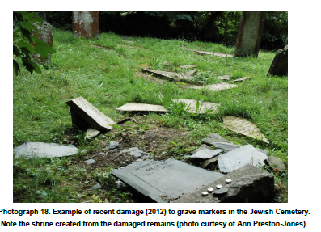
Photograph 18. Example of recent damage (2012) to grave markers in the Jewish Cemetery.
Note the shrine created from the damaged remains (photo curtesy of Ann Preston-Jones).
5.10. The concrete structure to the south west of the site has historically been used as a
refuge for rough sleepers (Photograph 19)
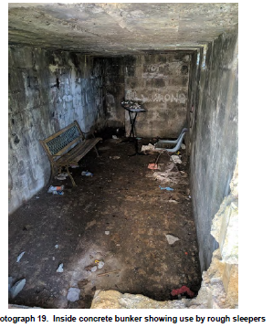
Photograph 19. Inside concrete bunker showing use by rough sleepers
Access
Current Situation
The fencing to the south and eas 5.11. t of the site, was paid for and erected by
Sainsbury’s, the adjoining landowners, in June 2014 to help with making the site
secure. Nonetheless, there are currently a couple of areas where security is weak
and access is possible by those wishing to enter. To the south west of the site the
fencing stops at the site boundary bank and it is possible to scramble around the
side of the fencing to obtain access, the ease of this depends on the time of year
and subsequent vegetation growth. Access is also possible from the north of the
site, behind the Gas Governor box, although this area has been reinforced with
better positioning of the heras fence panels.
5.12. The site is currently inaccessible without prior arrangement and permission. Access
from the south end is through a secure gate, accessible only by prior appointment
with the Friends. This access is relatively straightforward, although in the height of
spring/summer, high vegetation makes it slightly difficult.
82

The access points to both the Congregationalist 5.13. and Jewish cemeteries from the
North, which would have been the original entrance points are both securely
blocked. The Jewish site does have a combination code lock on the gate, but it is
not thought that this has been used in recent years. The Congregationalist arched
entrance and steps has been blocked with heras fencing. The timber door to this
entrance is decayed, beyond functionality. The retaining wall to the steps up to the
burial site, have partially collapsed on the western side, which partially blocks the
access and makes it unsafe for the public.
5.14. The lack of a safe route through the site has meant that the site is no longer able to
be visited and as such the opportunities for members of the public to visit and
understand the site are limited to open days and remote study via the web site and
other literature.
5.15. Better access is of primary importance to re-establish community awareness and
interest in the site.
5.16. Access between the two cemetery sites is currently through a partial break in the
boundary bank between the two sites. Access into the Jewish Cemetery from the
Congregationalist side passes immediately over two graves. This is not respectful
to the site, and an alteration of this access is a key priority.
Public and Community Expectations
5.17. The scope of development of this CMP has not allowed for extensive public
consultation. However there have been several well attended open days recently,
organised by the Friends of the Dissenters (Photograph 20). Anthony Fagin says
(Pers. Comm. 2017): “Local people and visitors alike seemed surprised that the
cemeteries existed and displayed genuine interest in learning about this important
part of local history. Rob Nunn and Tom Weller have given public talks on the
Dissenters’ Burial Ground; and I have been invited to address the Falmouth Civic
Society on the history of the Jewish cemetery next week (Mon 22 May).”
Site Risk Factors
5.18. The following are potential risks to the site:
Natural Risk Factors
5.19. Fire: Risks of fire are most likely to be due to human intervention as there are no
electrical or other features which could provide a fire risk.
83

Flood: The site is not within a flood risk area therefore 5.20. any damage from water is
likely to be as a result of excessive rain fall. Any proposed capital project works
should take into account site drainage and provide increased weatherproofing to
reduce these risks.
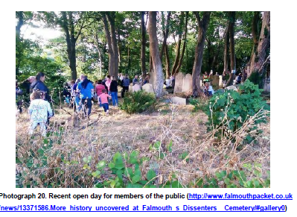

Photograph 20. Recent open day for members of the public (http://www.falmouthpacket.co.uk
/news/13371586.More_history_uncovered_at_Falmouth_s_Dissenters__Cemetery/#gallery0)

5.21. Lightning strike: The potential damage and fire risk from lightning strike is very low
as although the site is surrounded by trees, the neighbouring buildings would be
more likely to be affected by any strike.
5.22. Storms or other adverse weather conditions: The site is at medium risk from
wind damage to trees. Any damage to a tree could result in the tree falling on
monuments or boundaries and causing further damage. This risk should be
mitigated by regular inspections of all trees to ensure they are in good condition with
no damaged limbs.
Human Risk Factors
5.23. Theft, Arson and Vandalism: There is a serious risk of vandalism on the site due
to its isolated location. There are also further risks associated with racially motivated
attacks on the Jewish Cemetery. Controlled opening hours and careful maintenance
of boundaries to ensure the site is not accessible when the gates are closed should
mitigate against these risks.
84

Increased social and educational links with l 5.24. ocal schools and community groups
should also help to make the site more understood and respected within the local
community which should further help to improve the situation.
Resource Risk Factors
5.25. Specialist Skills and Resources: Whilst the friends group have a range of
expertise and knowledge between them, there will by the nature of a volunteer run
project, be a lack of specialist skills and lack of resources available to keep up an
extensive maintenance strategy.
5.26. Responsibility: FTC have taken responsibility for maintenance and produced a
maintenance plan. However, there remains potential for confusion over
maintenance issues between FoPC and Falmouth Town Council. It will be important
to further develop the Management and Maintenance Strategy to ensure all parties
are aware of their roles and responsibilities.
5.27. Equipment: The Friends Group may wish to purchase and maintain some simple
gardening tools. One possible location for the storage of these, could be in the
concrete bunker building to the south of the site.
Knowledge and Management Risks
5.28. Not understanding the heritage: The members of the Friends group have a great
deal of knowledge on the site between them. There have also already been
extensive recording undertaken for both cemeteries within the Nunn and Weller and
Pearce publications (Nunn and Weller 2014; Pearce 2014).
5.29. Poor record keeping: All maintenance works should be well recorded within a
standard template form. Due to the volunteer nature of the site management, it is
important that any required record keeping is practical and of specific use to the
Friends Group. With such limited resources, energy should not be wasted on
unnecessary record keeping. However the importance of recording current activities
for future generations is well understood.
Survey Development – Risks and Opportunities
5.30. As discussed previously, the gazetteer developed as part of this Conservation
Management Plan has been based on a reconciliation of pre-existing surveys,
specifically: Kelland 2013 and 2016; Mitchell 2016a and 2016b; Nunn and Weller
2014; Parkes 2010; Pearce 2014; Sturgess 2011).
85

These reports were supplemented with further fieldwork 5.31. undertaken by Claire
Newman and Mark Gendall of pdp Green Consulting and Clive Meaton of Cotswold
Archaeology. Due to the limited scope of this Conservation Management Plan, it has
not been possible to fully reconcile and confirm with complete accuracy those
situations where monuments are shown on one report or survey but either have
been unable to locate on site or are missing from other references.
5.32. We suggest that in the next stage of works a complete reconciliation exercise is
undertaken following some further site vegetation clearance to ensure that the
gazetteer is accurate and complete.
Site Clearance – Risk and Opportunities
5.33. We recommend, prior to any further detailed development of repair proposals, that
clearance of vegetation from site boundaries and around monuments is essential.
The repairs suggested within the condition proposals are based on limited
inspections of the site. Much of the boundary walls are covered in extensive
vegetation growth. For example the low stone walls to the west of the Jewish
Cemetery are nearly completely obscured by vegetation, as are the remains of the
Jewish entrance and possible Ohel (Jewish prayer hall).
Ecological Constraints and Opportunities (by CEC Ltd)
Badger
5.34. There is evidence that badgers on occasion utilise the site and have built a sett
within the bank adjacent to the Jewish Cemetery. Further survey would be required
to determine the current extent of the use of the site by badgers. Due to the location
of the sett entrances on the edge of cemetery it is anticipated that the setts are
unlikely to be damaging or undermining graves. However, should the sett extend
towards the Jewish cemetery in the future, then this would likely be an issue which
would require intervention. It is therefore recommended that a regular monitoring
program is set up to record if the sett starts to extend, it is possible that this could be
undertaken by Friends of Ponsharden Cemeteries. Monitoring would be particularly
important if developments are taken forward on the surrounding sites as this may
cause a disturbance to badgers resulting in them using other setts which they have
in their range.
5.35. If the monitoring identifies serious concerns regarding badgers within the cemeteries
one consideration would be to close the sett. In this instance it would be necessary
86

to determine if the sett is currently in use and if so apply to obtain a licence from
Natural England to disturb and permanently close the sett. Closing a sett would
require excluding badgers from the sett for a minimum of 21 days between July and
November and subsequently destroying the sett. This is typically done by
excavation. However, this may not be practical within the cemeteries site. An
alternative would be to review the fencing around the site and undertake works, as
necessary to make the fence impenetrable to badgers (after the sett closure is
complete).
Reptiles
To preserve the suitability of the site for reptiles, 5.36. there is the opportunity for an area
of rank grassland to be retained on site (see Grassland below). The stone walls and
stone piles with the cemetery are good locations for sheltering and hibernating
reptiles (and amphibians). Preferably these should be left in situ and left in their
current state. However, it is understood that in some instances this may not be
feasible. It is therefore recommended that the movement of any stone piles should
be undertaken by hand between April and October (outside of reptile hibernation
period) and during a period of warm weather. This will avoid disturbing hibernating
reptiles, should a reptile be found during the works, the material should be carefully
replaced, if it is safe to do so, and CEC contacted for further advice.
5.37. A reptile survey could be undertaken between April –June and September –
October to determine the presence or absence of reptiles within the site.
Scrub Encroachment
5.38. It has been noted that there is scattered bramble scrub located on the western and
eastern boundary to the site. It is recommended that this is not allowed to encroach
further within the site. The aim should not be to eradicate the bramble scrub from
site as it does have ecological benefits, providing a food source, shelter and if it
were to become denser, potentially bird nesting habitat. Therefore, it is
recommended that it is contained outside of the walled area of the cemetery, i.e. to
the west of the wall which forms the western boundary to the Jewish cemetery and
between the eastern wall of the Congregationalist cemetery and the perimeter
fence. Bramble should be cut back using hand tools (e.g. loppers and billhooks or
brushcutter) between October and February (outside of the bird nesting season), to
maintain the current extent of habitat and prevent further encroachment.
87

Grassland
There exists the opportunity for a cutting regime designed 5.39. to increase the floral and
structural diversity of the grassland located within the site. This could be achieved
by leaving cutting to later in the season and undertaking the first cut in July (as
opposed to a more regular regime). This would allow a variety of herbs to flower and
set seed. Once cut the arisings should be left in situ for a number of days allowing
any seeds to drop, before being collected and composted.
5.40. Raking up grass cuttings is fairly labour intensive, however, on a site of this size it is
thought to be achievable. This should create good quality foraging habitat for a
range of species including invertebrates, birds, reptiles and small mammals. It may
be that this management strategy does not agree with the overall vision for the
cemeteries and therefore it may that it is better to target this management to
selected areas around the edges of the site.
5.41. The grassland to the south of the cemeteries is rank in nature and this provides
good habitat for reptiles. Rank grassland develops through under management and
may appear undesirable; however, a change of management could result in
reduction in the suitability of habitat for reptiles. It is therefore recommended at least
some of this area is retained as rank grassland, and should only be cut once a year
in October.
5.42. However, if a reptile survey is undertaken and determines that reptiles are absent
from the site the rank grassland could be managed for floral interest instead. In this
instance the grassland should be managed as mentioned above (i.e. with a cut in
July).
Lower Plant Species
5.43. The Site provides a diversity of stone substrate. Therefore, it is recommended that
where possible lower plant species such as lichen and moss are not cleaned from
headstones. In addition, it will also be beneficial to these species if headstones are
not re-set. Lower plant species require specific conditions and small changes in the
orientation of a headstone could change this e.g. moving a lichen so that it is now in
full shade when it as not previously.
5.44. It is recommended that a chemical free approach is adopted towards the
management of habitats within the cemeteries. This will therefore not inadvertently
88

impact non target species such as invertebrates and lower plant species. As the site
is fairly small in area this is thought to be achievable.
As it is possible that the cemeteries 5.45. support important lower plant species a
monitoring visit by a specialist could be undertaken at the site to survey for lower
plant species and lichen. The specialist would then be able to provide specific
advice on management.
Habitat Improvement and Retention (by PDP)
5.46. Ecological surveys of the site have established the presence of protected and
notable species including badger. Diverse ecology, whilst being of great benefit
environmentally, also presents opportunities that will be seen favourably by an HLF
application. HLF view a cross over between historical sites and ecology very
favourably, and memorable rare species can add interest and variation to one
application over another similar historic project.
Combining Ecology and History (by PDP)
5.47. To be successful the project needs to have a strong well defined scope as well as a
detailed and enacted maintenance strategy in order to both increase biodiversity
and to protect built assets from damage by encroaching vegetation. On this Site
there is the opportunity to educate volunteers about the risks of vegetation
mismanagement, appropriate management techniques (eg. damage to gravestones
by strimmer wires) and the benefits of vegetation management in increasing
biodiversity. There is also the opportunity for volunteers to become involved in
maintenance work, which has the benefits of improving management of the graves,
helps ecology, and present educational opportunities about respective values.
5.48. Much of the intangible value of the site is in its neglected and ruinous value, and as
a ‘hidden gem’ surrounded by light industry and vacant sites. This character of
‘benign neglect’ is one which should as far as possible be maintained and exploited
in the promotion of the site to the public. It is the unique combination of burial
ground remains and nature and their close and complex relationship, which provides
the interest value within the site. The accidental and organic way that nature takes
over the site is the key attribute of the intangible value. The value and appreciation
of carefully managed benign neglect present an opportunity for drawing people to
the Site; people who may in turn help to monitor and maintain it.
89

“The attractions of decay are seldom solely aesthetic, Indeed 5.49. it was the sad, sinister
or violated look of ruins that appealed to the Romantics. Dismay as well as delight
at the look of age give rise to manifold reflections.” (Lowenthal 1985).
5.50. A careful balance of undertaking repair works to elements that require it, and having
a programme of management of vegetation so as not to risk further damage to the
structures gives a holistic approach to conservation. It is important to ensure that
this is a controlled and reasoned approach.
5.51. “…the approach to conserving a ruin and its site must be holistic, encompassing an
understanding in its ecological as well as its archaeological, architectural and
historical significance. By adopting this approach it is possible for the built and
natural heritage to be managed in conjunction, so that the site and its inhabitants
can be sustained in harmony.” (Ferraby 2007).
5.52. Vegetation clearance needs to be carefully managed to avoid risk to wildlife both
during the clearance work and from a loss of permanent habitat. Clearance work
also has implications for site safety and needs to be undertaken in conjunction with
stabilisation and safety works. Dense boundary vegetation provides an opportunity
to protect the site from unwelcome access and thus vandalism, it can also be used
to prevent access to areas of the site which may be unsafe. There is also the
opportunity for vegetation to be used to form an impenetrable barrier to the site. A
five yearly review of the maintenance programme is essential in the management of
this.
Gas Governor in green shelter box – Risks and Opportunities
5.53. A green pre-formed storage building of approx. 4m long and 2.5m wide sits to the
north west of the site in the layby adjacent to the historic entrance to the Jewish
Cemetery (Photograph 21). Pdp pGreen Consulting have undertaken some initial
consultation with Wales and West Utilities to establish the ownership and use of this
building. It is understood that the existing building was installed in 2009 (replacing
an earlier structure), under statutory legislation which enables utilities companies to
install such infrastructure without consultation or permission.
5.54. Following consultation with Wales and West the following facts were established.
The green shelter box is owned by and the responsibility of Wales & West Utilities
(WWU).It contains a gas governor that reduces gas pressure, supplying low
pressure gas network into Penryn and Falmouth, with an electricity supply to
90

operate the internal equipment. It was installed around 2009 and considered to be
on the highway verge and not within the SM area. As a gas transporter WWU has
permitted development rights for such installations. WWU advised that it is possible,
given certain constraint, to relocate a gas governor, ideally to a nearby location. The
full results of the consultation with WWU are included in Vol. 2 as Appendix M.

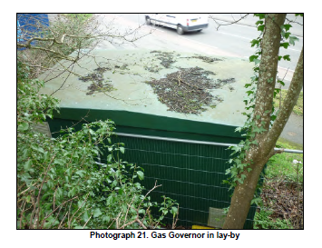

Photograph 21. Gas Governor in lay-by
Risks
The gas governor building clearly has a negative ef 5.55. fect on the setting of the
scheduled monument. It restricts a view of the Jewish Cemetery from the pavement
below the site (Photograph 3), and is a very industrial and utilitarian intervention
within the historic site.
Opportunities
5.56. As can be seen from the responses above it may be possible in the future to
consider working with Wales and West to agree relocation of the gas governor. It is
felt that in the current circumstances this is probably un-realistic, but in co-ordination
with future redevelopment of the neighbouring site this may be a possible
negotiating point with potential developers.
5.57. Engagement with the utilities company and some educating of them as to the
importance of the setting of the scheduled monument may have some value, but
until the adjoining site re-development is progressed, it is not felt that an alternative
91

location can sensibly be proposed. The ‘overall vision’ discussion in section 6 below
suggests that relocation of the gas governor is on a list of key proposals for the
Friends Group to discuss with potential neighbouring developers.
Services
There are no water or power services crossing or 5.58. overhanging the site, however
water, power and gas services are all in close proximity to the boundaries of the
site. The detailed location of these services should be brought to the attention of all
contractors and consultants working on the site. In particular, works to the bank to
the north of the site will be in relatively close proximity to existing power, gas and
water service.
5.59. Search maps from South West Water, Western Power and Wales and West Utilities
are found in Vol. 2 Appendix L Service Searches.
Potential development of adjoining sites and local planning policy
The Current Situation
5.60. The site to the west of the Cemeteries was previously a Vospers Car showroom and
garage, but has since been left vacant. The vacant and overgrown nature of the site
has a negative impact on the site. To the east of the site the existing light industrial
units are reasonably well maintained and all units seem to be occupied. To the
south/east the existing Sainsbury’s store and associated car park and service yard
are well maintained, but do not provide any benefit to the setting of the site and
further isolate and surround the Cemetery sites with urban development.
5.61. There are existing risks concerning the durability and appearance of the hoarding to
the boundaries of the site. Opportunities exist to improve the appearance of this in
the future in conjunction with the developers (covered in more detail in section 6.27
to 6.29). The existing security fencing to the east and west of the cemeteries could
also be improved to be more sensitive and in keeping with the historic character of
the site.
5.62. There are also current risks regarding the maintenance of this boundary and
consideration should be made to ensuring the current landowner maintains this
appropriately to stop access from this area. Encroaching vegetation from the
adjoining site also needs to be controlled as far as possible to avoid damage to the
boundaries and monuments within the scheduled monument site.
92

Future development
A detailed search for existing and proposed planning 5.63. development around the site
has been undertaken as part of the research for this report. Documents which have
been consulted include:
• Falmouth Neighbourhood development Plan
• Spatial Strategy, Integration and Design Guidance and Housing Groups:
Final Report
• Falmouth & Penryn Community Plan 2009
• Cornwall Local Plan
• Strategy Map Town Sites
• Strategy Map Town Centre
• Strategy Map Development Possibilities
• Strategy Map Community & Urban Extension
• Cornwall Council Planning Lists
5.64. There is a list of Planning Applications which have been submitted in the last 25
years immediately surrounding the site contained in Vol 2. Appendix J Planning
Application Searches. There are no current applications on any of the land
immediately around the cemetery site, however the adjoining Vospers/Sainsbury’s
site has been identified in the Spatial Strategy as Site A2 for mixed housing,
including student housing.
5.65. The Spatial Strategy Report states:
This is a large enclosed site and could provide good opportunity for considerable
growth. The boundaries of Falmouth and Penryn divide the site into two, so part of
the site is outside the NDP area. […] The potential for the site is for mixed use, and
is suitable for student accommodation and high density housing, especially social
and affordable accommodation in the form of apartments for rent. […] The adjoining
Dissenters and Jewish Cemeteries are a Scheduled Monument and Listed, and
therefore are protected. Funding was to be provided by Sainsbury’s if a store was to
be built, and it may still be possible if the value of the development would support it.
5.66. The full extract from the Spatial Strategy document is given in Vol. 2 Appendix K:
Extract from the Spatial Strategy Document.

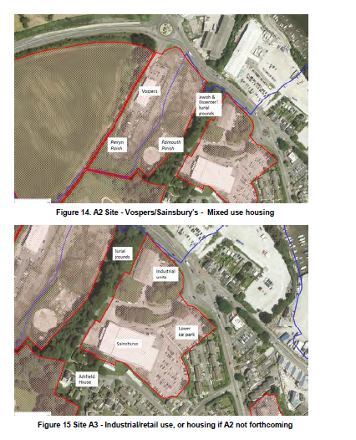

Figure 14. A2 Site - Vospers/Sainsbury’s - Mixed use housing
Figure 15 Site A3 - Industrial/retail use, or housing if A2 not forthcoming
The existing Sainsbury’s store site and the adjoining light 5.67. industrial/commercial
buildings to the south and east of the cemeteries has also be identified as a
potential development site. The Spatial Strategy states:
If the Vospers/New Sainsbury’s site is developed for student/social/affordable
housing, then the retail function should be maintained, plus, perhaps an
intensification of employment usage. If not, then it is a suitable site for housing, and
similar issues pertain.
94

The Falmouth Neighbourhood Development Plan, also 5.68. refers to the A2 and A3 sites,
and reiterate the proposed uses as residential and mixed use along with retail and
industrial uses:
Sites that have a possibility of becoming available in the future include A2 the
Sainsbury/Vospers site which was considered suitable for mixed use and student
housing, […]. The existing Sainsbury’s site A3 has the potential for intensification
with retail and industrial uses. (Falmouth Neighbourhood Development Plan First
Draft - December 2016, p.23 http://planforfalmouth.info/wp-content/uploads/2016/12
/Strategy-Housing-Final-Report-Dec-2016-.pdf
5.69. The opportunities for the cemeteries sites in relation to neighbouring development
have already been mentioned elsewhere in this report, however in summary these
include:
• Engagement with any new development at an early stage so as to highlight
the heritage significance of Ponsharden;
• The opportunity for any new residential development to dovetail with the
heritage significance of Ponsharden, possibly through a section 106
agreement;
• To protect physical and visual associations of the historic landscape setting
of Ponsharden - where it survives and as far as is practicable – through
engagement with new development and existing landowners;
• Potential parking provision for cemetery visitors within a designated area of
the proposed development sites;
• Potential relocation of the gas governor, resulting in an improvement to the
setting of the scheduled monument;
• Replacement of the timber hoarding with cast iron railings, maintenance of
banks, and associated vegetation. Replacement of the security railings with
more sensitive cast iron historic railings.;
• Improvement to the setting of the scheduled monument, a decreased sense
of abandonment;
• Improved overlooking and self-policing, reducing the risk of vandalism and
damage to the scheduled monument;
5.70. Associated with any potential development on adjoining sites there are also a
selection of risks, which should be considered and mitigated against:
95

• Overuse of the site resulting in erosion of footpaths, damage to monuments,
decrease in ecological diversity.
• Increased potential of vandalism and antisocial behaviour due to more
residential properties close to the site.
• Increased noise levels in surrounding area, in particular during construction
works, but also possibly once construction complete. Negative impact to the
environment of the site, damage to ecology, damage to the unique character
of the site.
• Specific issues in relation to the setting of the Jewish Cemetery where the
beliefs are such that it is vital that peace and relative isolation remain.
It is reassuring to note that the proximity 5.71. of the Cemetery has already been
mentioned in relation to adjoining development within the Spatial Strategy Plan, and
it will be key for the Friends Group to keep a close eye on any proposals for
development and to contact developers at an early stage to be involved in any
decision making and to be consulted on schemes coming forward.
Buried Archaeology
5.72. All maintenance and repair works on the site will need to be carefully considered to
avoid potential buried archaeology. It is not anticipated that general site clearance
and repairs to boundaries and monuments will offer much risk, and these will be
mitigated by a watching brief by a qualified archaeologist. Repair works to the
western side of the Congregationalist entrance will require some excavation in order
to install a replacement retaining wall. This needs to be carefully designed so as to
minimise potential disruption to graves above, and all works will need to be
undertaken under a watching brief. Likewise repairs to the northern boundary bank
adjacent to the road below, also need to be carefully designed to minimise
disruption to the ground above.
5.73. Historic mapping shows evidence of an earlier building, a possible Ohel, adjacent to
the Jewish Cemetery building. An opportunity exists here for an archeologically
investigation to try and expose the boundaries of this building and its exact form and
location. Potential opportunities for a community archaeological project could be
considered in future proposals.
Summary of Key Risks and Opportunities
5.74. A summary of the key risks and opportunities are outlined in Table 3 below.

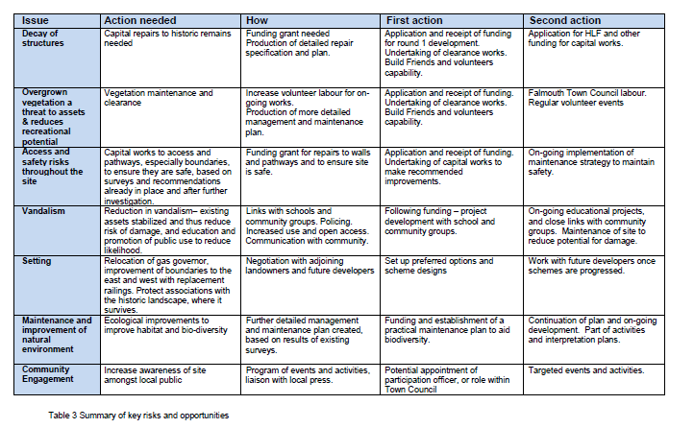

6. AIMS & OBJECTIVES FOR CONSERVATION, ACCESS,
MANAGEMENT AND MAINTENANCE (by pdp Green)
Overall Vision
The aim of this CMP is to clearly identify 6.1. a ‘comprehensive and integrated approach’
to the varied needs of the cemeteries.
6.2. The vision needs to consider all legal controls including Ministry of Justice
guidelines for the treatment of human remains.
Policy Context
6.3. The policies and vision outlined in this document have been developed in
accordance with recommendations in Historic England’s document ‘Paradise
Preserved’ (Historic England 2007)
How are we going to conserve and enhance the heritage?
6.4. Sections 6.11 – 6.31 below give details of the general principles agreed for the
conservation of the cemeteries.
Resolving conflicts between different types of heritage
6.5. There are several resulting conflicts to any potential development of the site, which
need to be sensitively and carefully considered.
6.6. Access: The extent and duration of access to the sites is something that is causing
conflict between the Jewish and Congregationalist sites. Historically the public use
of the two differing religions cemetery spaces (as discussed in section 6.37 – 6.38)
mean that the expectations of owners and visitors vary between the sites. However
there is an agreement between both sides, that the relationship between the
cemeteries is a key part of the uniqueness of the site, and there is no intention to
separate the accessibility or form a new boundary between the two sites.
6.7. Ecology and Archaeology: The conflict between retaining the existing trees and
conserving the ruinous nature of the site, against conserving and preserving the
historic monuments has already been discussed at length in other sections of this
report. This is one of the main conflicts in the conservation philosophy of the site.
Others include the balance between persevering lichens and the headstone on
which they live; as well as enabling a habitat badgers whilst preserving the physical
fabric of the cemeteries.
98

Meeting Conservation Standards
All works will be subject to scheduled monument 6.8. consent. Any works to the two
gravestones specifically listed as Grade II, within the Jewish Cemetery will also
require listed building consent, although the scheduled monument consent will take
precedence.
6.9. Prior to any formal application, discussion should be undertaken with Historic
England, to ensure their full support of the project. Preliminary discussions have
already been undertaken with Historic England, through Ann Preston-Jones’
involvement with FoPC, and with her role as local Historic England representative.
Conservation of the Heritage
6.10. Following the outline condition report undertaken by PDP, initial recommendations
for conservation repairs and remedial works have been proposed within the
gazetteers (Vol. 2 Appendices A – D)
General Principles
6.11. The following are a set of general guiding principles for the conservation and
maintenance for each of the key aspects of the site. These should be read in
conjunction with the further information in the gazetteer on each individual asset.
Figure 13 provides a summary of all the main issues affecting the Site, including
those relating to condition, access and setting.
Boundaries
6.12. Enclosing walls:
• Repair and restore all stone boundary walls to their original height
• Reinstate stone cappings and concrete copings where clearly evident
• Keep vegetation clear of walls to maintain their integrity
6.13. Enclosing Earth Banks
• Consolidate and secure earth bank to Northern boundary against road
• Preserve vegetation of earth banks to help provide screening and security to
site
6.14. Cornish Hedge Banks
• Conserve and repair existing Cornish hedge to southern boundary of site.
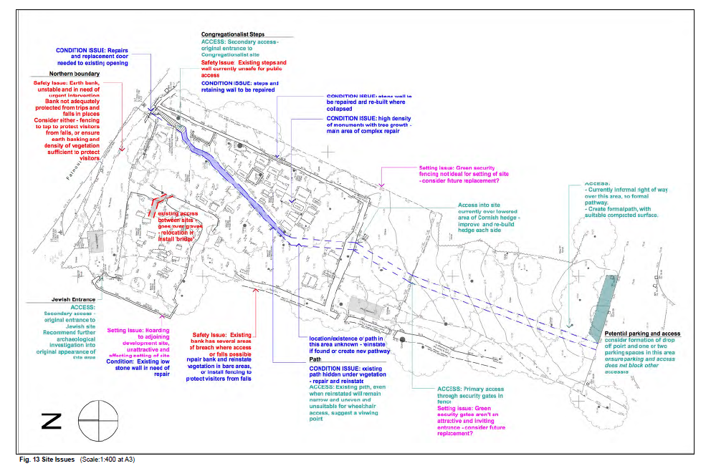
Fig. 13 Site Issues (Scale:1:400 at A3)

Adjoining dev 6.15. elopment plot hoarding (Photograph 22)
• The neighbouring development plot to the west of the site is currently
protected by an intrusive solid timber hoarding. Whilst this land is outside of
the Cemetery ownership, a recommendation would be that in consultation
with the adjoining landowner during any development works on the site,
consideration is given to replacing this hoarding with a more transparent
boundary treatment.
• A vertically proportioned metal railing (cast iron), would provide a less
intrusive but still secure site boundary.
• Maintenance of the existing hoarding is the responsibility of the current
landowner, and until the future of the area is decided, it is important that the
barrier is well maintained in order to keep the site secure.
• The opportunity for interpretation or other art work on the inner face of the
hoarding could be considered as a temporary wall to lessen the impact of
the bare wood hoarding on the site.

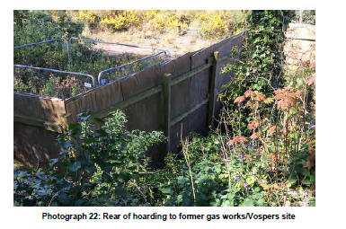

Photograph 22: Rear of hoarding to former gas works/Vospers site

6.16. Existing Security Fencing (Photograph 23)
• Sainsbury’s paid for and installed the security fencing to the south and east
of the site. This fencing is not very sensitive to the historic character of the
site, but does provide good secure vandal resistant boundary protection.
• This fencing should, along with the hoarding above be seen as a temporary
barrier, and replacement with a more historically sensitive barrier design,
such as cast iron railings, should be considered in the future.
101

• Negotiation with future or existing landowners during any re-development of
the surrounding area should be undertaken to try and improve the setting of
the site.
Photograph 23: Green security fencing to the east boundary of the site
Site
6.17. Bluebell rich grassland:
• preserve and enhance biodiversity,
• create pathways to protect grassland from visitor foot fall.
6.18. Existing footpath through Congregationalist site:
• Clear and restore the existing footpath through the Congregationalist site.
• Excavate to discover if the existing footpath continues all the way to the
southern boundary. If not, create new footpath to link with southern metal
gates and beyond over the Sainburys land to the south.
6.19. Access between the two cemetery sites:
6.20. There is an issue with the existing organically formed pedestrian link between the
two cemeteries. Over time a pathway has been formed through the earth bank
separating the sites, this in principle forms a natural connection between the
cemeteries whilst also conserving the original site boundaries. However as can
been seen on Figure 13 the existing route results in visitors walking over graves
within the Jewish cemetery site. J7 and J6 are particularly affected. The following
options are considered as the most appropriate solutions to this issue:
102

• Retain existing access but re-direct people obliquely across the boundary to
avoid graves, this should respect the graves whilst also maintaining the
natural character of the site, and without the need for a contemporary
intervention.
• If on further design development it becomes clear a re-orientation of the
access through the back isn’t possible, it may be necessary to form a new
timber stepped bridge type structure over the existing bank, which could
then continue over the neighbouring graves until landing on clear ground
beyond.
It has been agreed that a formal barrier, 6.21. such as a railing or planted bank and gate
between the sites is not desirable as this would work against the unique historic
juxtaposition of the two sites.
Monuments
6.22. Gravemarkers/Headstones:
• Within the accompanying gazetteer a brief condition description and repair
proposal has been indicated, the detail within these will need to be
confirmed following a more detailed in depth study of the condition and a full
repair schedule developed.
• As a general principle all gravemarkers/headstones which are lying on the
ground or are structurally unstable are to be re-bedded in the ground. This
will protect the historic fabric of the stones, which are much more vulnerable
to damage when laid flat on the ground.
• Re-erecting of fallen markers should only be undertaken where the original
location is known. If the original location can not be confirmed, the markers
should be re-sited around the edge of the cemetery.
• A detailed assessment of the significance of each monument has been
summarised in the gazetteer. In principle the more significant the monument
the greater the priority is for repair.
6.23. Larger tombs and grave monuments (Congregationalist Cemetery):
• As a general principle the larger tombs and monuments within the
Congregationalist cemetery are all in need of some level of repair and
maintenance. Repair proposals are indicated to restore these monuments
as far as practicable with the remains still present on site, without overly
sanitising the site and loosing all of the ‘ruinous’ nature of the site.
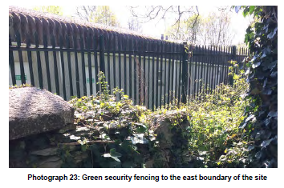

6.24. Remains of mortuary and other buildings:
• The concept for treatment of the remains of buildings within the site is one of
repair and consolidation.
• There is no clear documentary evidence as to the appearance of the
mortuary building, it would therefore be pure conjecture to re-construct this
building in any way.
• We propose to clear the debris from the inside of the building and
consolidate and secure the remaining brick walls.
• This will make clearer on site where the original openings in the building are,
and coupled with some simple interpretation information will inform visitors
as to its original purpose.
Trees
6.25. There are three possible policies for the treatment of tree clearance:
1. Complete removal of all trees within the cemetery site.
It is thought that all of the sycamore trees within the Congregational site are
self-seeded, one philosophy would be to return the site to its original
appearance as a clear open area. However as discussed in section 5.48,
much of the intangible value of the site rests in its abandoned and
overgrown nature, and thus retention of trees is strongly recommended
where this can be done without compromising the fabric of monuments.
2. Selective removal of key trees which are clearly causing structural
damage to monuments and headstones.
The key heritage significance of the site resides in the physical fabric of the
upstanding monuments, therefore where there is ongoing damage to an
upstanding monument from a tree, there should be a presumption in favour
of preservation, which will most likely require the tree to be felled, or
alternatively coppiced, if the threat can be mitigated or managed in this way.
3. Retention of all trees unless they are at risk of falling.
A more minimal approach of retaining all trees, unless they themselves are
in a poor condition, threatens the structural integrity of several monuments
104

within the Congregationalist site, this would put these monuments at risk in
the future so can not practically be recommended.
Therefore, the recommended approach will be option 2. By 6.26. dealing with trees on an
individual case by case basis, it is hoped that the character of the site can be
preserved whilst also minimising their further impact on the historic monuments.
Setting: Adjoining Development
6.27. FoPC should be attentive to development proposals affecting the immediate area,
addressing the need to mitigate development impacts, as well as making clear
opportunities for enhancing the heritage significance and setting of Ponsharden
Cemeteries.
6.28. The potential for the friends group to gain from a S106 planning agreement with the
adjoining (previous Vospers site) is great.
6.29. In relation to any new potential development the following list of works should be
considered:
• Relocation of the gas governor;
• Creation of accessible parking spaces near to the site;
• Improvements to site boundaries – landscaping and new railings. Black
vertical railings are deemed to be the most aesthetically appropriate and
would allow views through and provide a less obtrusive backdrop to the
Jewish Cemetery;
• Funding for replacement of the security fence to the east of the site;
• Further interpretation and access opportunities;
• Funding for further community participation etc.
• Access from the west.
Setting: Gas Governor in green shelter box
6.30. The gas governor building is a key threat to the sites setting, as discussed in section
5.53 to 5.55, there is potential for this to be relocated as part of the future redevelopment
of the old Vospers site. An outline proposition for this should be
developed by the Friends group, to enable early negotiation and a possible S106 or
similar agreement being established with any neighbouring developer.
105

Setting: Parking
There is currently no designated parking provision for the s 6.31. ite at all. Most visitors
currently park in the neighbouring Sainsbury’s supermarket car park, which currently
has no parking restrictions or timescales. Figure 13 highlights some of the access
issues around the site and shows the potential for two parking bays in the area of
land to the south of the site, currently owned by Sainsbury’s. Provision of a layby
area with potential parking would provide improved disabled access to the site, and
a drop off area for volunteers with tools and equipment etc for maintenance and on
open day events. It is hoped that more general parking in the mid term can still be
accommodated in the Sainsbury’s car park.
6.32. In the future, development of the adjoining old Vospers site, may well allow for
negotiation with the developer to provide additional parking for the Cemeteries.
Relocation of the gas governor would also give potential for a drop off or disabled
parking space to be created closer to the Jewish Cemetery.
Access and Interpretation
Principles of Access
6.33. “Uncontrolled access has been a major factor in the site’s decline.” (FTC & FoPC
2017, p.15). Is public access desirable? To what extent? How will it be controlled
and managed?
6.34. The Jewish and Congregationalist Cemeteries are clearly a small oasis of green in
an increasingly developed and commercial area. Depending upon the success of
development on the vacant ‘Vospers’ site, the site may soon be completely
surrounded by residential and commercial development. A strategy for the level and
extent of public access therefore needs to be established which will both protect and
preserve the site for the future, whilst also allowing for members of the public to
appreciate and understand the heritage.
6.35. What is the point of preserving and conserving the site if it is hidden from public
view? The issue is to what extent should public access be provided?
6.36. There are several factors which influence this decision:
• Adjoining development – will it help police the site?
• Will it encourage or discourage vandalism and non- antisocial behaviour or
will the potential be greater?
106

• Is open access suitable for a cemetery site?
• Should the access strategy for the Congregationalist and Jewish cemeteries
be different?
What sort of access is appropriate for an abandoned cemetery?
Jewish Cemeteries have a very different historical 6.37. access approach to that of other
faiths, “the everyday use of Jewish cemeteries differs greatly from that of other
faiths, particularly Christianity. With specific times and dates designated for visitation
and strict rules around access and behaviour, Jewish burial grounds occupy a
distinctive place in the historic or urban landscape. They are often peripheral and
may be locked – a situation that gives rise to significant risks, but may also aid in
protection from vandalism. Regular visitation is seen as important for highlighting
the problems individual cemeteries face, but this goes against Jewish tradition. The
common approach taken by bodies such as Historic England to sites of heritage –
that increased use equals better protection – may therefore not be appropriate for
Jewish cemeteries. Any encouragement of use should therefore be sensitively
managed and respectful of Jewish law.” (Barkham Langham 2015, p.17)
6.38. Christian sites have traditionally encouraged cemetery sites to be used in the wider
sense as parks and places for spending time in, they are traditionally landscaped
and actively promote visitors to both the graves and in a wider context as parkland.
In contrast to this, Jewish burial sites are clearly seen as far more private spaces,
which are more utilitarian in function. In order to respect the values of the Jewish
site, should this site be closed to all but pre-arranged public access? “This sense of
the continued holiness of a Jewish cemetery also shapes accepted behaviours at
such sites. Because graves are places from which no benefit may be derived, Jews
(and others) are restricted from lounging in the burial ground. This is in stark
contrast to the Christian and secular perception of cemeteries as recreational
spaces, or at least areas of peaceful respite from the modern world.” (Barkham
Langham 2015, p.5).
6.39. What is the solution for Ponsharden? As stated in Jewish Burial Grounds:
Understanding Values; “Crucial to remember here though is that established means
of protecting sites of heritage through increased use (i.e. visitation) may not be
appropriate in this context.” (Barkham Langham 2015, p.30). The document goes on
to say; “In terms of protection, there is a clear tension between approaches that
favour ‘hiding’ sites so that they are inaccessible to potential vandals, and those that
107

wish to make cemeteries more visible as a means of discouraging anti-social
behaviour.” (Barkham Langham 2015, p.23).
This conflict between access and protection 6.40. is a key issue which needs to be
addressed. At the Penzance Jewish Cemetery the access is by appointment only.
This access is arranged by Penlee Museum. One option for Ponsharden is to have
a similar method for controlled access, where Falmouth Town Council and the
Friends group hold the key and access can be arranged. There can also be a
programme of open days and events during which there would be open access.
Public Access during Works
6.41. Public access to the Site during conservation works will not be possible for safety
reasons, unless volunteers are helping with some aspects such as archaeological
excavations.
6.42. It is recognised that there will be local public interest in the Site during the project
works. Efforts should be made to meet this requirement through both on and off site
information. On site, safe viewing areas and information panels on safety fences
should be provided, although Site access should not be allowed whilst
conservations works are actively being undertaken. Off site, communication with the
local press will help keep people informed and promote the project. The friends
group can co-ordinate this element of the project and provide material to the local
media.
Opportunities for Engagement
6.43. The project partners should devise a programme of opportunities for engagement of
local people and interested groups, these should be within the constraints of health
and safety legislation. As stated in The Situation, Preservation and Care of Jewish
Cemeteries in the United Kingdom (Kadish 2015); “For the wider public, cemeteries
are a valuable resource. School visits to Jewish cemeteries can be a way of
educating young people about the cultural diversity of British society.”
6.44. Site visits by local groups (eg Dracaena Centre) and local schools, should be
encouraged and this could be undertaken in conjunction with Kehillat Kernow, the
Jewish Community of Cornwall (https://kehillatkernow.com). The appointment of a
participation officer, or designated time by a member of Falmouth town council for
this roll is essential.
108

Access for the Construction Works
Some of the access for the construction works is anticipated 6.45. to be from the south of
the site, immediately off of the Sainsbury’s’ access road. This access will need to be
negotiated with Sainsbury’s who are the landowner of the strip of land over which
access is required.
6.46. Access for works to the retaining bank to the north of the site and for works to
stabilise the collapsed wall of the entrance archway will need to be from the road. It
may be possible to use some of the small lay-by area next to the green gas
governor to store materials and equipment.
6.47. During the stabilisation works to the retaining bank there will likely be the need to
temporarily close the pedestrian footpath beside the road and divert pedestrians to
the footpath on the opposite roadside. A Temporary Traffic Regulation Order
application will need to be made to Cornwall Council. This will need coo-ordination
with the local authority to ensure the appropriate notice periods and application
processes are adhered to.
Access for All
6.48. Improving the existing access to and around the site, can be achieved by
formalising the pathway from the south of the site, subject to negotiations with the
landowner. This will be key to providing more inclusive access.
6.49. It is suggested that a drop off bay and possibly one or two parking spaces are
created on the land to the south of the site, whilst paying close attention to ensure
that these are designed in such a way as to not obstruct or encourage further
parking along the access road to Ashfield house.
6.50. Improvements to the surfacing, and creation of a formal pathway into the
Congregationalist cemetery from this side would enable those with mobility issues to
get into the cemetery. It is not practical to create a fully accessible path throughout
both cemetery sites, as this would change both the character and appearance of the
site. It would also be very difficult to achieve practically through the existing
monuments and remaining trees.
6.51. One suggestion is the creation of a raised walkway/gangway through the site (as
discussed above in section 6.20), which could over sail some of the graves and
would provide a level access path (Photograph 24). This would however be very
109

intrusive into the character of the site and would not achieve scheduled monument
consent.

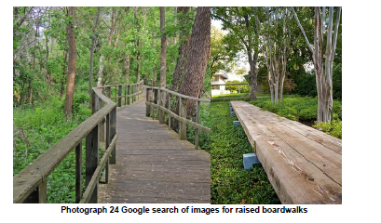

Photograph 24 Google search of images for raised boardwalks

It is felt that the access up the original Congregationalist 6.52. entrance steps will always
have limitations on inclusive access. The existing steps are granite slabs built into
the side walls, which appear to be relatively level and regular, although as they are
currently covered in vegetation debris, the detail is difficult to determine. The
provision of a handrail would aid the accessibility of these steps, but should be
carefully weighed against the impact of a modern intervention against the historic
fabric of the site.
6.53. Surfacing to any proposed parking bays and pathways should be such that it is
sufficiently well compacted as to be manoeuvrable by a wheelchair.
Interpretation
6.54. Consider the desirability of interpretation, and when and where might be
appropriate?
6.55. “Understanding is the first step to caring for places – but before that we need to
persuade people they are worth understanding” (Bee 2010).
6.56. Developing the right balance of on and off site interpretation, and creating
information which is interesting and appropriate to the visitor is a complex operation.
It is recommended that early on in the process an interpretation strategy is
110

developed and adopted by the group, this should be closely linked to the activities
strategy.
The research already undertaken in the s 6.57. tudies by Nunn and Weller and Parkes, are
invaluable for interpretation of the site, however, there are several areas of further
research recommended which will further aid the quality of information available for
interpretation.
• Further Archaeological research and recording – to establish actual
distribution and form of graves, to investigate location and extent of remains
of Ohel in the Jewish side, research into the type and style of doors to both
Cemetery entrances.
• Research into relationship between the two faith groups.
• Further planning for ecological improvement, detailed in the ecology report.
• Research into the relationship between ecology and the historical assets –
eg. lichen growth on monuments.
6.58. Within these few suggestions (the list is in no way exhaustive) there are many
opportunities for linkages with other community groups and activities opportunities.
6.59. The Friends group are already promoting and developing interpretation for the site.
A coherent interpretation strategy needs to be written to plan for and develop the
ideas initially suggested for educational and community events and activities.
6.60. Initial suggestions include:
• Increase the existing effort for local and regional press coverage.
• An organised and coherent approach to contacting local organisations
including; schools, Guide and Scout groups, Youth Club and Church groups.
• Links with other local groups – history groups, walking groups
• Inclusion of the Friends Group work in local volunteer networks (CN4C,
Cornwall Heritage Trust, Volunteer Cornwall, Falmouth U3A)
• Linked events with Kehillat Kernow.
• Open days, including links with Heritage Open Days web site (Heritage
Open Days, ‘Home Page’, http://www.heritageopendays.org.uk/).
• Inclusion of the site in Falmouth Town Guides and Historical information.
111

Maintenance
An outline maintenance plan is included in Vol 2: 6.61. Appendix G: 10 Year Management
and Maintenance Plan. Details of the plan are discussed in section 8 below. The
plan outlines schedules for long term maintenance for the site. It includes:
• Annual inspections of the site.
• Timings for various works
• Costs and resources required
• Indications of who should undertake the work.
Management
6.62. The site has suffered as a result of minimal or no management in the past.
Appropriate management is therefore an important issue to address. The
establishment of the Friends of Ponsharden Cemeteries has already set up a strong
and proactive group who will assist in the future management of the Cemeteries.
This will be undertaken in conjunction with Falmouth Town council who are
responsible for formal maintenance of the site.
6.63. This Conservation Management Plan aims to set up the framework for dealing with
site maintenance and security in the future without compromising or negatively
impacting on the sites heritage or wider public interest.
6.64. Section 6.33 - 6.40 above details the proposals for controlled public access to all
areas of the site, during defined opening hours. Outside of these hours the site will
be securely fenced and closed, thus reducing opportunities for antisocial behaviour.
Visitors will be able to freely access the site during daylight hours, and it is hoped
that this open access will be self-policing, and will protect the monuments from any
vandalism or damage. This will of course need to be carefully monitored and reassessed
on a regular basis. Regular monitoring and checking on the stability of
monuments and structures will also need to be undertaken to ensure the site
remains safe, this is detailed in the maintenance strategy in section 8.
6.65. There are clearly conflicts between the public accessibility of both sites, and the
open access through the Congregationalist site needs to respect the wish for the
Jewish site to remain a more quiet and private space. The current proposal for open
access at all times will need to be discussed and agreed with BOD, and should be
reviewed at regular intervals to ensure all parties remain happy with the proposals.
112

The management and maintenance plan in Vol 6.66. 2: Appendix G gives detail of the
annual maintenance and surveys required to ensure that the site remains safe and
accessible for the general public. This also gives an initial indication of the
resources required and the approximate costs of this work to ensure that provision
is available for the site to remain accessible in the future.
113

7. COSTED AND PRIORITISED ACTION PLAN
The gazetteers (Vol.2 Appendices A – D) include an i 7.1. ndicative cost of the proposed
repairs identified for each asset (produced by Trevor Humphries Associates,
Bristol). The costs are at current prices - as at July 2017 – and include an allowance
for general main contractor preliminaries. The costings for repairs to grave
monuments (gazetteers A and B) have been based upon the Kelland pricing
(although Trevor Humphries associates note that there are some anomalies in the
Kelland specialist summary prices with the detailed resource estimates later taken
for cost estimates (2013 and 2016)).
7.2. The tree works are considered as a separate specialist contract.
7.3. Costs do not include: declared contingency; allowances for further surveys and fees;
allowances for any interpretation; activity delivery; VAT.
7.4. Table 4 provides a summary of the costs involved. Total estimated costs are given
for each gazetteer: Jewish Grave Monuments; Congregationalist Grave monuments;
Boundaries and Entrances; Trees. Total costs per level of relative heritage
significance (A – E) are also included.
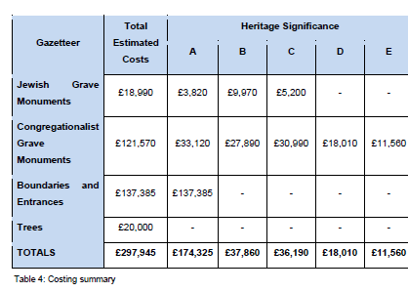
Priority ratings for recommended works should 7.5. be ascertained by consulting the
heritage significance ratings. Recommended work to monuments of level A
significance should be prioritised over monuments of level B significance. Likewise,
level B significance should be prioritised over level C; level C over level D and D
over E.
7.6. If there is a conflict of priorities due to limited funds, then, given its comparative
rarity, works on the Jewish Cemetery should be prioritised over the
Congregationalist Cemetery.
7.7. If there are further conflicts of priority when it comes to implementing proposed
repairs and actions, then these should be resolved on the basis of monuments at
greatest risk of further damage and/or on health and safety issues. However, these
should be evaluated within the framework of heritage significance ratings.
7.8. It is also recommended that HE are approached at the earliest opportunity and
requested to amend the digital plan of the Scheduled Monument area so that it
correctly reflects the Site boundaries (see section 3.2). This should be considered a
priority action, albeit one with no substantive cost attached.
115

8. PROVISIONAL MANAGEMENT PLAN AND MAINTENANCE
SCHEDULE (by pdp Green)
The schedule in Vol. 2 Appendix 8.1. G gives a provisional Management and
Maintenance strategy for the Jewish and Congregationalist cemeteries.
Scope of the Plan
8.2. The following plan is for all areas of the Jewish and Congregationalist cemeteries
site including boundaries and fencing. It excludes the area of land to the south of the
site which is owned by Sainsbury’s, but over which access is required to approach
the Site from the south.
8.3. The plan at this stage does not go into detailed ecological and landscape
recommendations in order to improve biodiversity. It is recommended that as part of
future works an Ecological Management Plan is developed by a suitably qualified
ecologist.
Management and Maintenance Aims
8.4. Generally the overarching aim of the Management and Maintenance plan for the site
will be ensure that the grounds and monuments are maintained in a good condition
and that the capital works undertaken are managed in order to minimise the costs of
future maintenance.
Management and Maintenance Objectives
8.5. Specific objectives of the plan should include:
• Maintaining security and safety to and around the site.
• Ensuring that safe access is available to visitors and volunteers around and
within the site.
• Ensuring that the monuments are structurally stable and safe.
• Maintaining the existing features, structures and monuments.
• Maintaining paths, fences and gates.
• Maintaining and protecting buried archaeology.
Arrangements for the Annual Inspection of the Site
8.6. It is proposed that the friends group undertake non-specialist inspections to check
on the condition of monuments and boundaries to the site on a bi-annual basis, or
more frequently following any extreme weather or act of vandalism, etc. Qualified
116

inspection of the structural stability of the monuments should also be undertaken on
an annual basis or following any damage discovered on site.
Timing of Maintenance Work
Work is to be undertaken in accordance with t 8.7. he timings suggested in the attached
management and maintenance schedule and any further detailed maintenance
schedules suggested as the works develop.
8.8. It is important that tree and vegetation works are undertaken at times appropriate for
ecological issues. For example vegetation clearance should not be undertaken
during bird nesting season. Mowing should be undertaken from late in the season
(July) to allow for wild flowers to drop seeds; cuttings should be collected to prevent
grassland being smothered. These should be undertaken in accordance with the
recommendations outlined in the habitat survey report (Vol. 2 Appendix H).
8.9. It is strongly recommended that a detailed Ecological Management Plan is
developed and followed for the site.
Costs and Resources
8.10. Wherever possible it is anticipated that ground work could be undertaken by FoPC
volunteer groups. More complex work such as all works to trees should be
undertaken by competent professionals.
8.11. The site has been managed in part by Simon Penna of Falmouth Town Council over
the last 30 years; the range and proliferation of wildflowers in the Jewish Cemetery
are down to his involvement and management.
8.12. It is suggested that a formal management agreement is put in place, with the
Falmouth Town Council to manage the overall ground work on the Site.
Responsibilities
8.13. As discussed above, FTC are responsible for the day to day site maintenance of the
Site, however, wherever necessary and practicable, FoPC may supplement this
work. It is recommended that a contractor or an agreement with FTC is arranged for
the annual mowing, and for regular tree works.
Arrangements for Keeping an Ongoing Maintenance Log
8.14. It will be the responsibility of FoPC or FTC to maintain records and to ensure the
management and maintenance plan is kept up to date and enacted.
117

9. REFERENCES
Barker Langham (on behalf of Historic England), 2015. Jewish Burial Grounds:
Understanding Values.
Bee, S. 2010. ‘Local Engagement in a Global Context’, in ‘People Engaging with
People’, Conservation Bulletin, Issue 63, Spring, 2010: p.3
CIEEM [Chartered Institute of Ecology and Environmental Management], 2012.
Guidelines for Preliminary Ecological Appraisal, CIEEM,
Winchester. http://www.cieem.net/guidance-on-preliminary-ecologicalappraisal-
gpea-
Clark, K. 2001. Informed Conservation: Understanding Historic Buildings and Their
Landscapes for Conservation., English Heritage: London
Falmouth Town Council & Friends of Ponsharden Cemeteries. 2017. Brief for the
preparation of a Conservation Management Plan for the Jewish and
Congregationalist Cemeteries at Ponsharden, Falmouth, Cornwall
Ferraby, S. 2007. In Ashurst, J. (ed.) Conservation of Ruins. Elsevier Ltd: p.209
Heritage Lottery Fund 2008. Conservation Management Planning.
Heritage Lottery Fund 2012 Conservation Plan Guidance.
Historic England, 1999. Conservation Plans in Action: Proceedings of the Oxford
Conference.
Historic England, 2007. Paradise Preserved: An Introduction to the assessment,
evaluation, conservation and management of historic cemeteries.
Historic England, 2008. Conservation Principles: Policies and Guidance.
Historic England, 2011.Caring for Historic Graveyard and Cemetery Monuments.
JNCC, 2010. Handbook for Phase 1 Habitat Survey - A Technique for Environmental
Audit. ISBN 0 86139 636 7.
Kadish, S. 2015. The Situation, Preservation and Care of Jewish Cemeteries in the
United Kingdom (https://journals.ub.uniheidelberg.
de/index.php/icomoshefte/article/viewFile/20217/14004)
118

Kelland, S. & L. 2013. Jewish Cemetery, Ponsharden, Falmouth, Cornwall:
Conservation Report and Recommendations. Unpublished Report.
Kelland, S. & L. 2016. The Dissenters’ Burying Ground, Ponsharden, Cornwall:
Conservation Survey and Proposals for the Monuments. Unpublished Report.
Lowenthal, D. 1985. The Past is a Foreign Country. Cambridge University Press,
Cambridge: p.173
Mitchell, J. 2016a. Tree Inspection Report: Burial Ground, Congregational Church,
Falmouth. Cornwall County Council Unpublished Report.
Mitchell, J. 2016b. Tree Inspection Report: Jewish Cemetery, Falmouth. Cornwall
County Council Unpublished Report.
Nunn, R. & Weller, T. 2014. The Dissenter’s Burying Ground Ponsharden, Cornwall:
Monument Survey. Privately Published.
Parkes, C. 2010. Falmouth Jewish and Congregationalist Cemeteries, Cornwall:
Archaeological Assessment. Unpublished Report Historic Environment
Cornwall Council.
Pearce, K. 2014. The Jews of Cornwall: A History - Tradition and Settlement to 1913.
Halsgrove, Wellington, Somerset.
Sturgess, J. 2011. The Jewish and Congregationalist Cemeteries , Falmouth,
Cornwall: Archaeological Survey: Historic Environment Projects, Unpublished
Cornwall County Council report
Taylor, E. 2016. Land at Falmouth, Cornwall: Heritage Desk Based Assessment.
Unpublished Cotswold Archaeology Report.
Thorn, C. & F. (Eds.). 1979. Domesday Book: Cornwall.. Philimore, Chichester
Cartographic sources
1788 Duke of Leeds estate map (CRO ref RH/1/2938)
1793 Basset estate map (CRO ref RH/1/2938)
1814 Survey by Richard Thomas for the Basset estate (CRO ref AD894/7/35)
1840 Budock parish tithe map (CRO digitised access)
119

1880 1st Edition 25-inch Ordnance Survey
Ordnance Survey 1:25,000 Explorer (105 Falmouth and Mevagissey).
120
Kemble Airfield, Kemble, Gloucestershire, Heritage DBA

