

Durant’s School,
Enfield, London, EN3 5BY

OJEU South 13 Batch
PSBP 2066
URN: 102066
Invitation to Tender

July 2018

Document History
Version | Date | Author | Change Status
1.0 | 04/05/18 | Pablo Espinosa Almenara | Draft
1.3 | 04/06/18 | Adrian Hyde | Final
1.4 | 19/06/18 | Adrian Hyde | Final with amended dates

Contents

Part 1 – Background information
- Introduction
- Description of works
- Key Programme Dates
- Funding Statement
- Form of contract
- Enquiries

Part 2 – Specific Information
- Project Brief
- Outline Programme
- Location
- Surveys
- Employers Requirements / Output Specification (Refurbishment Tool)

Part 3 – Technical Requirements
- Instructions
  - Programme for Tendering
  - Tender Response Format
  - Tender Response Delivery
  - Tender Response Clarification
  - Reserve bidder
  - Consortium Bids
- Form of Tender and certificate of Bone Fide Tender and Pre-qualification Criteria
- Qualitative Questions
- Quantitative / Pricing Questions
- Evaluation Methodology

Annex List:

Annex 1 Programme
Annex 2 Form of Contract
Annex 3 Survey Information
Annex 4 Employers Requirements
Annex 5 Form of Tender Response and Pre-qualification Questions and Guidance
Annex 6 Qualitative Questions and Evaluation Methodology
Annex 7 Quantitative Questions
Annex 8 Instructions on Using the e-Tendering Portal
Annex 9 Supporting Information

PART 1 – BACKGROUND INFORMATION
1.1 Introduction
The Education and Skills Funding Agency (ESFA) the “Employer” is inviting submissions from contractors interested in taking part in a Competition for the Scheme, reference number PSBP 2066 URN 102066 within the OJEU South 13 Batch.
The Durant’s School is a Special Educational Needs (SEN) Secondary School catering for pupils aged 11-19 years old with Autism (ASC) and sits within the responsibility of the London Borough of Enfield, with an eight-person Governing Body chaired by Mrs S Hart. The published admission number for the school (based on the 2014 PAN capacity) is 105 pupils with Statements for Autism.
The Contract Notice will be published on 5th July 2018 on Contracts Finder, representing the beginning of the Competition. This ITT including all relevant appendices are made available from this date onwards via the AWARD Portal (Instructions on using the e-Tendering Portal are set out in Annex 8 of this document).
The purpose of the Competition is to identify the contractor who can best deliver the Scheme by application of the criteria included in this document. Through this Competition process, the ESFA will assess each Bidder’s team, approach and understanding of issues for this Scheme in order to identify the Selected Bidder who will be taken forward to deliver the Scheme.
The Qualitative Response (refer to Annex 6) must be concise and factual and clearly reflect each Bidder’s position. The Qualitative Response provides Bidders with the opportunity to present their case for being selected to deliver the Scheme.
Bidders must obtain for themselves at their own expense all information necessary for the preparation of their Tender Response.
The Education and Skills Funding Agency reserves the right not to award any contract pursuant to this procurement exercise and/or to abandon this procurement exercise at any time and/or to award a contract for part of the works at its sole discretion. The Education and Skills Funding Agency shall have no liability whatsoever to any applicant or tenderer as a result of its exercise of that discretion. For the avoidance of doubt, all costs incurred by any applicant and/or tenderer before signature of any contract with the Education and Skills Funding Agency shall be incurred entirely at that applicant's/tenderer's risk.
1.2 Description of the Works
The site consists of six main buildings, blocks EFAA, EFAB, EFAC, EFAD, EFAE and EFAF. The successful block is block EFAC which is connected to blocks EFAA, EFAD and EFAD. The works involve heavy refurbishment of block EFAC. However, works to the Site Manager’s flat (located in the first floor of block EFAC) are limited to external works only, which are as a ‘consequence’ of the heavy refurbishment of the successful block. Any further services or amendments required are to be provided by the Local Authority.

In summary the heavy refurbishment scope of works for the successful blocks will include:

External Works:
- Replace rainwater goods, fascias and soffits.
- Replace critical windows.
- Brick repairs and re-pointing.
- Replace external doors.
- Replacement of safety play surface in the main Courtyard.

Mechanical and Electrical Works:
- Renewal of the Fire Alarm.
- Replace Emergency lit exit signs in classrooms and corridors.
- Replace Emergency Lighting in staff areas, toilets and storage areas.
- Modify the Intruder Alarm to alarm all blocks.
- Renewal of mains water supply.
- Replacement of boilers and radiators.
- Replace lighting in the kitchen, corridor, changing rooms and gym/sports hall.

Internal Works:
- Refurbishment of staff toilets, and the Girls and Boys Changing Rooms.
- Refurbishment of the kitchen.
- Renewal of floor covering where necessary.
- Review suitability of Fire Doors installed in 2015 to ensure meet Standards, address if necessary.

Refer to the Scope of (Refurbishment Works) Tool for full details (Annex 7 – Part B1)

Additional surveys shall be undertaken to help develop the scope of works. Asbestos has been identified within some areas of the building and must be removed where disturbed by the works.
1.3 Description of the Site
The Durant’s School is located on Pitfield Way, Enfield, EN3 5BY and is surrounded by residential properties to the east and north as per Figure 1. Adjacent to its main entrance off Pitfield Way, is a separate school, Enfield Heights Academy.

The school site occupies an area of approximately 8,950 m² and consists of a number of blocks as shown on Figure 2. The successful block (EFAC) was built in 1930s with further additions made in 1960s to create the gym and changing facilities. The successful block has a total GIFA of 1,282m² Several extensions were made in the 1970s, 2000s and more recently block EFAD being added in 2009/10. Additional stand-alone blocks were added in circa 1985 and 1999. These later additions are either in well-maintained condition or newly built and do not form part of the PSBP2 works.

The school’s main entrance is off the northern end of Pitfield Way, which accommodates three further access points including access to the school’s car park at the south of Pitfield Way.

As shown in the existing site plan (refer to Figure 1– Existing Site Analysis below), the external space within the site provides car parking to the south and west of the site and a central hard play area and games court areas.
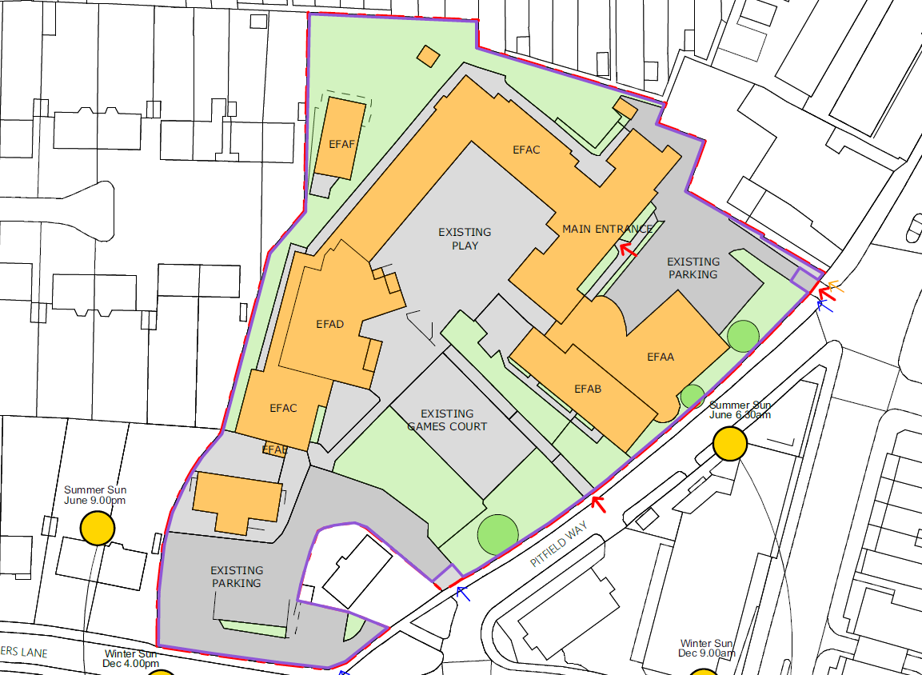
Figure 1

The school site has seen additional blocks added to the site since it first opened in the late 1920s/early 1930s, which have maximised any available land for expansion.

EFAC block forms part of a traditionally built school comprising a two-storey block at the south-east side of the site and this block extends as a single-storey L-shape to the gym at the north-west end of the site. Additionally, there is a basement plantroom at the front of the block. Overall the structure is in a good condition, however, deterioration was noted to the lintels.

1.4 Key Programme dates
Tender Programme
The tender programme is based on a two-stage procurement process. The pre-qualification has been integrated as an initial step to pass prior to tender evaluation. The timetable for this process is as follows:
- Issue Prior Information Notice | 28th June 2018
- ITT made available to all interested bidders | 5th July 2018
- Site visit and bidder’s day | 19th July 2018 at 12pm
- Deadline for bidders’ confirmation of willingness to bid (yes or no with reasons)*¹ | 26th July 2018
- Deadline for receipt of Tender Responses including Pre-qualification documents*² | 2nd August 2018 at 12pm
- Assessment of Pre-qualification documents and Tender Evaluation*  - Notification of award of Scheme to successful and unsuccessful Bidders | 23rd August 2018  24th August 2018

*¹It is not mandatory for Bidders to confirm willingness to bid in order to be considered. It is however expected that bidders not willing to participate post Bidders’ Day are to confirm withdrawal, together with reasons.
*²Where a Bidder fails to provide the requested information and/or does not pass the minimum criteria as set out in Annex 5, the bid will be rejected, and no further evaluation will be carried out.
Delivery and Construction Programme Key dates
The anticipated pre-construction activity completion dates for the scheme are:
- Appoint selected Bidder | 24th August 2018
- Enter in to PCSA | 13th September 2018
- Completion of RIBA 2 | 11th October 2018
- Completion of RIBA 3 | 22nd November 2018
- Submit Planning Application (if required) | 22nd November 2018
- Completion of RIBA4  - Issue Contractor’s Proposals | 29th January 2019  12th March 2019
- Agreement of main contract sum / execute main works contract | 23rd April 2019

The anticipated construction dates for the Scheme are:
- Decant off-site | 12th April to 11th July 2019
- Mobilisation period | 24th April to 2nd July 2019
- Start on Site | 11th July 2019
- Completion of Works | 30th April 2020
- Decant back to school | 1st May to 23rd July 2020
- End of Rectification Period | 30th April 2021
An indicative pre-construction and construction programme is contained within Annex 1
1.5 Funding Statement
Funding has been made available for this work and cost estimates indicate that this project will be valued at circa £3,318,838.17 (excluding VAT). This funding is comprised of the following:
Funding Allowance | Sum | Responsibility for delivery
Construction costs | £2,394,053.16 | Contractor
External Works & Abnormals | £391,832.32 | Contractor
Fees | £348,235.69 | Contractor
Principal Designer Fee | £5,000.00 | Contractor
Fittings and fixed furniture | £128,200.00 | Contractor
ICT Infrastructure | £51,517.00 | Contractor
ICT active infrastructure | £0.00 | By School’s ICT Contractor

The sum of £3,381,903.53 is the overall funding envelope available to the Bidder for the design and build of this Scheme.
1.6 Form of Contract
The forms of contract to be entered in to between the Employer and Selected Bidder will be:
- The PCSA; and
- JCT Design Build

Draft versions of the PCSA and Scheme Contract can be found at Annex 2. The JCT Contract will contain the ESFA Schedule of Amendments.

Note: The PCSA will be entered in to between the Employer and Selected Bidder following completion of the Competition.
Clarifications can be made up to 26th July 2018. Any received after this date will not be answered.

PART 2 – SPECIFIC INFORMATION
2.1 Project Brief
The project involves the medium refurbishment of Block EFAA as described above. The Employers Requirements are contained within Annex 4 and this includes:
- Part A – General Conditions
- Part B – Output Specification
- Part C – School Specific Brief
- Part D – Refurbishment Scope of Works Tool
The school is to remain open for the duration of the works.

Proposed Phasing Strategy
The decant strategy involve all students and staff to be de-canted to the Michenden Site for the duration of the construction works. Given the nature of the student’s SEN, the school have advised there will need to be a phased move to the temporary site and estimate this will take place over the course of the Spring term (2019) to enable the Durant’s’ site to be vacated ready for works to commence in Summer 2019. The cost for the decant and recant have been added into the cost estimate.

The Michenden site is being created to increase SEN capacity in the borough and once the Durant’s’ PSBP2 scheme is complete only students ages 11 – 13yrs will return. This will also need to be a phased decant.

The decants will be carefully planned and managed by the school and the Local Authority, and supported by the appointed Contractor. A detailed phasing strategy will be developed by the contractor through Client Engagement Meetings as well as meetings with the school during the works.

The Contactor shall undertake various surveys (as listed within Annex 7) as part of the PCSA to further develop the scope of works. The Contractor shall plan these surveys with the school to minimise disruption to the school’s operation.

The Contractor shall confirm their commitment to this and provide the relevant pricing information within their response to this ITT. The Contractor should allow for making good of disturbed areas and for obtaining clean air certificates before the school is reoccupied.

At the time of preparing this ITT it is unknown whether a Planning application is to be submitted for this scheme. The Contractor should price for drafting and submitting a planning application as part of the PCSA scope of services as a separate cost as well as closing out any pre-commencement conditions. The Employer reserves the right to remove this from the scope where required.
2.2 Location and General Site Information
The Durant’s School is located on Pitfield Way, Enfield, EN3 5BY and is surrounded by residential properties to the east and north as per Figure 2. Adjacent to its main entrance off Pitfield Way, is a separate school, Enfield Heights Academy.
School specific information including class times and third-party user groups, etc. can be found in the School Specific Brief which is contained within Annex 4 – Employer’s Requirements.
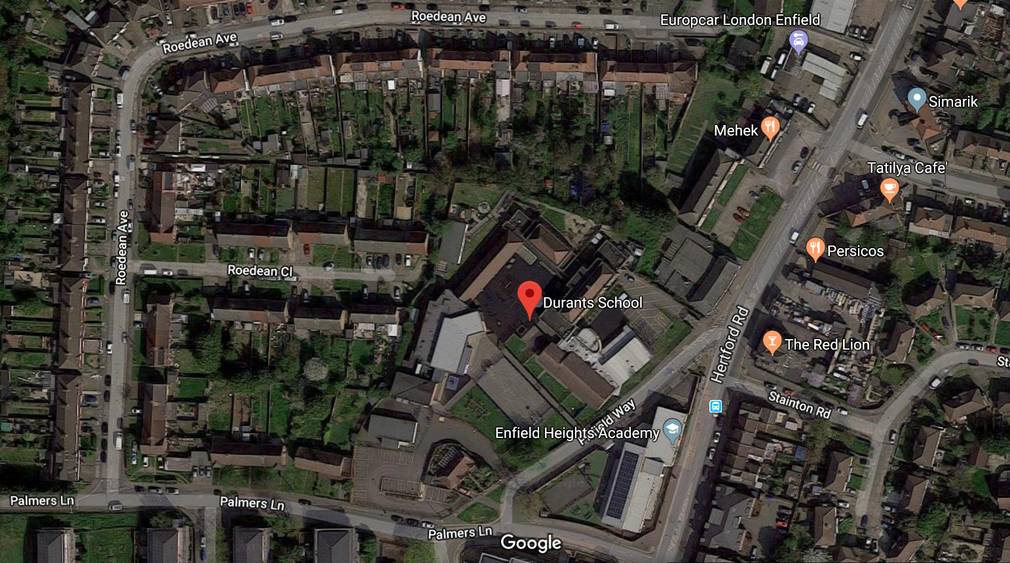
2.3 Surveys
As for the purposes of this Competition, the following table outlines the surveys provided. All survey information is included at Annex 3.
Survey | Date | Warranted/ Unwarranted
Structural Stage 1 – Basic Condition Survey | 29/06/2017 | Warranted
Acoustic Survey | 03/08/2017 | Warranted
Transport Feasibility Survey | 29/08/2017 | Unwarranted
Preliminary Flood Risk Appraisal | 30/08/2017 | Unwarranted
Stage 1 Mechanical and Electrical (M&E) - Basic | 28/06/2017 | Unwarranted
Building Condition Survey | 02/06/2017 | Warranted
Preliminary Ecological Appraisal Survey | 05/09/2017 | N/A
Topographical Survey and Underground Utilities Survey (using GPR) | 15/08/2017 | Warranted
Measured Building Survey (Internal GIFA Check) | 22/08/2017 | Unwarranted
Non-core surveys
Drainage CCTV Survey | 30/08/2017 | Warranted
Management Asbestos Survey | 28/07/2017 | Warranted

2.4 Employers Requirements / Output Specification
Works are to be provided in accordance with the Education and Skills Funding Agency’s standard set of Employers’ Requirements documents and Output Specifications. The Employer’s Requirements are contained within Annex 4 and comprise:
- Part A – General Conditions
- Part B – Output Specification
- Part C – School Specific Brief
- Part D – Refurbishment Scope of Works Tool
The Refurbishment Tool describes the detailed specification of the works on an elemental basis and serves as a basis for the bidder for both the Qualitative Response as part of the Tender return as well as the Quantitative Response.
PART 3 – TECHNICAL REQUIREMENTS
3.1 Instructions
3.1.1 Programme
Bid Responses to this ITT must be uploaded to AWARD, the e-Tendering Portal being used by the ESFA, by no later than 12 noon 2nd August 2018 (this date being the Closing Date).
Bid sections are to be uploaded in line with the Bid structure set out on AWARD, see below for further details on this portal.
3.1.2 Tender Response Format
3.1.2.1 Each Tender Response must comprise:
- Form of Tender and Certificate of Bona Fide Tender and Completed pre-qualification response as set out in section 3.2 and Annex 5, Part 1.
- The Qualitative Response as described in section 3.3 and included at Annex 6.
- Completed Quantitative Response as set out in section 3.4 and included at Annex 7.
3.1.2.2 All Tender Responses must be in English.
3.1.2.3 Written responses must be in Arial font size 11 and must not exceed the page counts stipulated.
3.1.2.4 The Tender Response must be marked with the following details:
- Project title and
- Bidder’s name.
3.1.2.5 Bid Responses shall be uploaded to AWARD. Further instructions are provided in Annex 8. In order to gain access to AWARD, bidders will be required to submit to the appointed Administrator of AWARD Lisa Cummings (lisa.cummings@education.gov.uk) and Adrian Hyde Adrian.Hyde@arcadis.com, no more than two e-mail addresses. Once submitted you will be sent a link to the AWARD log-in page along with a password, which should be changed immediately.
3.1.2.6 The person signing the Bid Response must state their capacity and official position in the Bidder’s organisation and must be the person empowered and duly authorised to sign Bid Responses for and on behalf of the Bidder and nominated for that purpose in the Form of Tender and Certificate of Bona Fide Tender in Annex 5.
3.1.2.7 The ESFA may reject a tender which is non-compliant with the requirements of this ITT. Bidders submitting any qualifications should therefore give explicit justification and reasoning for entering a qualification.
3.1.3 Tender Response Delivery
3.1.3.1 Bid Responses must be delivered by the Closing Date of no later than 12 noon 2nd August 2018 via the AWARD e-tendering portal.
3.1.3.2 Instructions on using the AWARD e-tendering portal are set out at Annex 8.
3.1.3.3 The ESFA reserves the right to reject any Bid Response that is uploaded after the Closing Date.
3.1.4 Tender Response Clarification
3.1.4.1 The ESFA or its appointed advisors will manage the clarification process to ensure that an effective dialogue is maintained with the client throughout the ITT process.
During Bid Response preparation, Bidders may submit questions and requests for clarification or further information on or before 26th July 2018. AWARD is to be used for all enquiries and guidance on how to do this is provided in Annex 8.
All questions and requests for clarification or further information, and the corresponding responses, will be circulated to all Bidders
Request for information which may be commercially sensitive should be marked: “confidential – not to be circulated to other Bidders” (and Bidders are expressly requested not to mark a question as confidential in this way unless this is genuinely the case). At its discretion, the ESFA will respond to that specific request privately, providing that the principle of equal availability of information to all Bidders is not breached.
If the ESFA considers that it is unable to respond to the question or request for clarification or further information on a confidential basis it will inform the Bidder, and the Bidder must as soon as practicable thereafter respond via AWARD requesting that either the query be withdrawn or treated as not confidential. The ESFA will deem that the question or request for clarification or further information has been withdrawn if the ESFA is not contacted via AWARD within three working days following informing the Bidder as referred to above.
Bidders should note that all responses to requests for clarification cannot be relied upon unless the Contact Officers subsequently confirms that clarification or further information in writing. Bidders should therefore ensure that all requests for clarification or further information have been the subject of written correspondence.
3.1.4.2 The ESFA will at its sole discretion decide whether to respond to any requests for clarification or further information received after 26th July 2018.
3.1.5 Reserve Bidder
The second highest scoring bidder in this competition shall (subject to signing a letter of acceptance) be appointed as Reserve Bidder.
The Secretary of State for Education may, in the circumstances set out in this section, award the contract to the Reserve Bidder if the Selected Bidder:
(a) develops the ITT submission during the post-ITT period such that the ITT submission is no longer affordable;
(b) develops the ITT submission during the post-ITT period such that it is materially different to that submitted at ITT stage; or
(c) in the reasonable view of the Education and Skills Funding Agency the Selected Bidder has or is behaving in a manner which threatens the successful delivery of the Scheme.
The replacement of the Selected Bidder with a Reserve Bidder may only be exercised (in accordance with this section) during the period between appointment of Selected Bidder and the grant of planning permission for the School.
The Secretary of State for Education is undertaking this project, which is funded by the ESFA and prior agreement of ESFA must be sought prior to exercising the discretion set out in this section.
The Reserve Bidder will be asked to confirm their commitment to keeping their offer open for a period of 16 weeks and accept the status of Reserve Bidder. The Reserve Bidder will be asked to confirm acceptance of this position during the standstill period. For the Selected Bidder the notification that there is a Reserve Bidder, including the circumstances where the Reserve Bidder may become the replacement Selected Bidder, will be set out in the letter of appointment.
In the circumstances where a Reserve Bidder is not willing to confirm the position, the Education and Skills Funding Agency reserves the right to offer this position to the next highest scoring bidder.
3.1.6 Consortium Bids
The ESFA welcomes bids from consortia.

Where a consortium bid is proposed, a consortium response must be submitted to the pre-qualification questions as follows:
- Each member of the consortium must submit its own response to Questions C1, but the response must make clear that the submission is part of a consortium bid.
- The consortium must submit a single, combined response to Questions C2, C3, and C4.
Where a Bidder intends to sub-contract certain of its obligations under the Contract, it must declare its sub-contractors as consortium partners if (but only if) it intends to rely upon the capacity and standing of those sub-contractors in its response to the pre-qualification questions.
ESFA reserves its right to require consortia (other than consortia consisting of sub-contracting arrangements only) to form a separate legal entity by the time the Contract is signed as the ESFA may only sign the Contract with a single entity and not with its individual members. However, there is no requirement to form a separate legal entity at the time of submitting a response to the ITT.
A Bidder may not submit a bid as a member of a consortium in addition to a bid in its own name.
Consortium members should note that all pass/fail elements in the PQQ must be passed by ALL members of the consortium in order for the consortium bid to pass the relevant PQQ elements. If one member of the consortium fails any part of the PQQ then the consortium as a whole will fail.
ESFA reserves the right to reassess the consortium before award of contract to ensure it still meets the pre-qualification criteria. Consortia are obliged to keep ESFA informed where members of their consortium leave, new members are added, or members are otherwise replaced.
3.2 Tender and Pre-qualification
The tender response letter and pre-qualification requirements as set out in Annex 5, Part 1 must be completed and signed. These requirements will be for information only or pass/fail criteria as indicated in Annex 5, Parts 1 and 2.
Where a Bidder fails to provide the requested information and/or does not pass these minimum criteria the bid will be rejected, and no further evaluation will be carried out.
3.3 Qualitative Response
The Qualitative Response is in the form of a number of questions as set out in Annex 6.
There is no design evaluation within this tender. Should any designs, initial sketches etc. be received as part of the Bidder’s Qualitative Response, they will be disregarded prior to evaluation.
Bidders should note that the page limits for each technical question within the Qualitative Response are not to be exceeded and are based on the criteria specified in Section 3.1.2 in this document. Responses will be ignored to the extent that they do not comply with these instructions or exceed the relevant page limit.
Bidders when loading the Qualitative Responses onto AWARD are to ensure relevant Quality Sub-Criteria are uploaded in line with the corresponding section headings outlined on AWARD. Bidders are advised to allow sufficient time to do this correctly before the Closing Date.
3.4 Quantitative Questions - Pricing Response
The Pricing Response is in the form of two pricing schedules (Part A and Part B1) as set out in Annex 7.
Part B1 includes the completion of the Refurbishment Tool (Annex 7, Part B1) with corresponding instructions for completion (Annex 7, Part B2).
Part A1 – Instructions for Completing Pricing Schedule
The Pricing section of the evaluation gives the highest mark to the contractor with the greatest amount of money available for construction works (item 3 on the Pricing Schedule)
To complete the pricing section, the following methodology needs to be followed:
- Complete the Preliminaries Pricing (starting with the number of weeks on the summary, then inserting periods and rates for all items required
- Price the separate refurbishment tool spreadsheet and insert the total cost at item 9 on the Pricing Schedule tab (cell E29). The total to carry forward to the pricing schedule is in the Architecture tab of the refurbishment tool, cell AC105
- Complete the pre-construction services and surveys tabs
- Complete the percentages for items 8, 9, 10, 11, 12 and 14 on the Pricing Schedule tab
- Insert a first pass estimate of the target funding available for the works (cell G17)
- Note the difference in cell J17
- Adjust the target funding available for the works and or percentages entered at step 3 to reduce the difference
- Repeat steps 4 to 6 until the difference box turns green (target and actual are very close); refine as required
Notes
- When completing sections in this document, you are required to provide a fully itemised breakdown of your costs however, if there are individual line items that are not required in your price breakdown you do not need to insert a cost against these items.
- When pricing the preliminaries section, you are required to include for preliminaries associated with all areas of the works. Your pricing of preliminaries should not leave significant areas of preliminaries costs to be included later as part of the new build works cost (e.g external perimeter scaffold (if required) should be priced in full here as part of the preliminaries).
- The PCSA figure will be composed of
  - Pre-construction services
  - Fees for completion of the works and planning stages
  - Survey costs
- If successful in this tendering exercise, a fully detailed elemental breakdown of the costs will need to be prepared once a detailed design has been created. Evidence of competitive tendering of sub-contract packages will need to be evidenced in at least the following areas:
  - roofing
  - external walls
  - mechanical and electrical works.
Part B1 - Pricing notes for Refurbishment Scope of Works Tool
Note: The items within the refurbishment tool will be fixed price at the point of tender. If further survey works demonstrate that an alternative solution is available (or further works are recommended), this should be presented in sufficient detail to allow the Employer to review the alternative solution (or need for further works). If the Employer wishes to vary the works this will be done via a formal instruction.
Tenderers are to review the works for each line item including the indicative quantity shown in column K. Please note this needs to be completed in both the Architectural Elements and Mechanical & Electrical tabs.
Tenderers are to provide their feasibility proposals in column W, their value engineering scope in column X and their proposed compliance designation in column Y based on the information provided.
Tenderers should then insert their proposed quantity, unit and rate into columns Z to AB.
Please note the above needs to be completed in both the Architectural Elements and Mechanical & Electrical tabs within the Refurbishment Scope of Works Tool.
Tenderers should then insert their proposed quantity, unit and rate into columns Z to AB.
Architecture: The total will automatically be calculated in column AC for each item with the total for the Architectural tab calculated at cell AC 347.
Mechanical & Electrical: The total will automatically be calculated in column AC for each item with the total for the Mechanical & Electrical tab calculated at cell AC 62. This total then carries forward to the Architecture tab in AC 348.
The total for both the Architecture and Mechanical & Electrical tabs totals is in cell AC 350 on the Architecture tab. This is the figure that should be inserted into the Part A – Durants Pricing Schedule document pricing schedule tab item 9 cell E29.
The prices tendered are to be open for a period of three calendar months from the closing date for tenders. The prices tendered must include all elements of the requirement requested at this stage of the procurement and should be broken down according to format presented in Annex 7 – Pricing Response. Tendered prices are to be expressed in Pound Sterling.
3.5 Evaluation

The Tender Response will be evaluated on a weighting of 60% for the Qualitative Response and 40% for the Quantitative Response.
3.5.1 Evaluation of the Qualitative Response
The Qualitative Response will be evaluated using the scoring model and weightings set out in Annex 6.
3.5.2 Evaluation of the Quantitative Response
The overall estimated cost for compliant tenders will be expressed as a percentage of the lowest compliant overall estimated cost and then each will be weighted by 40% as above. e.g. If there were three compliant tenders of value £100,000, £150,000 and £175,000 they would be scored as follows:
Overall estimated cost | % of lowest | Weighted Score
£100,000 | 100% | 40%
£150,000 | 67% | 27%
£175,000 | 57% | 23%

