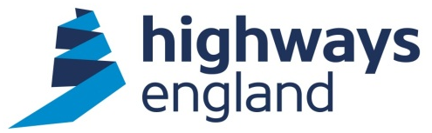  Our ref: HEITT1789  Your ref:  Flexiform Business Furniture Ltd. | Procurement Business Partner, Commercial & Procurement  4 South  Lateral  8 City Walk  Leeds LS11 9AT  Direct Line:  16th July 2018

COMMERCIAL - SENSITIVE

Dear***************,

SUPPLY, DELIVERY AND INSTALLATION OF OFFICE FURNITURE FOR HIGHWAYS ENGLAND at ATLANTIC HOUSE, BIRCHWOOD, WARRINGTON under CCS Framework Agreement RM3812-Lot 2

Thank you for submitting your proposal following the further competition process under the terms and conditions of the CCS Framework Agreement number RM3812 – Lot 2.

On behalf of Highways England, I accept your offer (dated 1st June 2018) to undertake the supply, delivery and installation of Office Furniture under the CCS Framework Agreement number RM3812 – Lot 2 Terms of Agreement.

This Call off Agreement commenced 10th July 2018 with an end date 31st December 2018.

Please find the call off agreement document, for your signature and return, attached.

The following documents will form a binding contract between Highways England and Flexiform Ltd:

- Your returned, completed CCS Framework Agreement number RM3812 Further Competition Response Template and Quality Questionnaire
- The signed Form of Tender and
- Call Off Order Form and Call Off Terms for the Supply, Delivery and Installation of Furniture and associated Services Framework Agreement RM3812 – Lot 2.

In addition to:
- Highways England Anti-Collusion Certificate
- Highways England Fair Payment Charter
- Highways England Anti-Bribery Code of Conduct
- Highways Agency Anti-Fraud Code of Conduct

Invoices should be forwarded directly to Highways England, FS Payments, The Cube, 199 Wharfside Street, Birmingham B1 1RN or invoices@highwaysengland.co.uk
quoting ************name and the Purchase Order number that will be advised shortly.

Please acknowledge receipt of this letter.

Yours sincerely

Procurement Business Partner
Email @highwaysengland.co.uk

