
OBTAINING A DUNN AND BRADSTREET NUMBER

UK SHARED BUSINESS SERVICES EMPTORIS TRAINING MODULE

Dunn and Bradstreet references are required for Bidders to register on Emptoris e sourcing. To find a company’s Dunn and Bradstreet number you must visit. http://salesmarketing.dnb.co.uk/find_my_company/
Complete the form with your contact details and the security code and press ‘next’. You will then face a page like this.
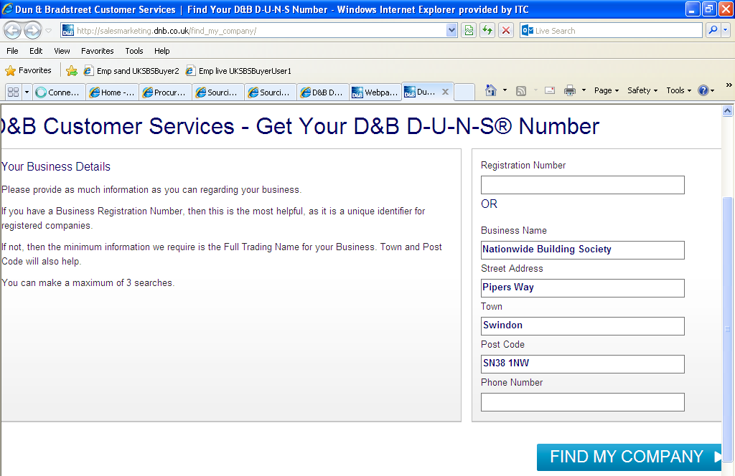

The next page will request that you confirm the bidder name.

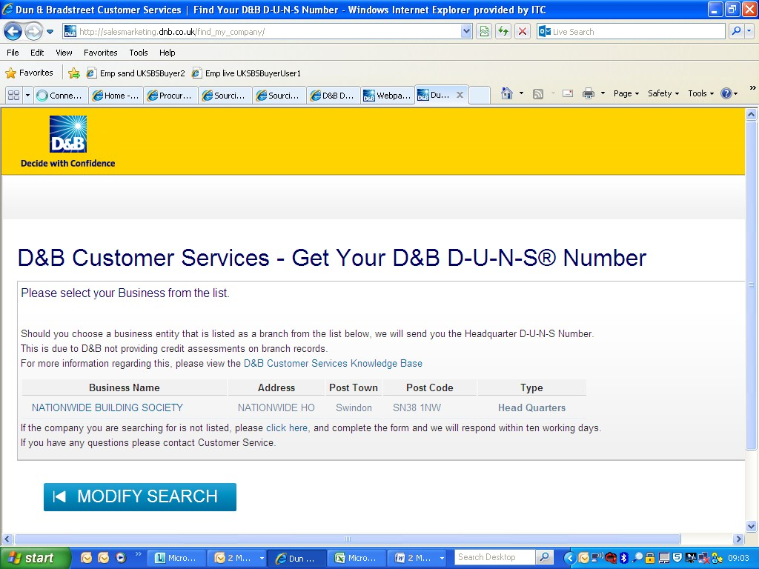

Click on the name to find their address and ensure it is the right bidder. Once you have confirmed the bidder name you will see this message.

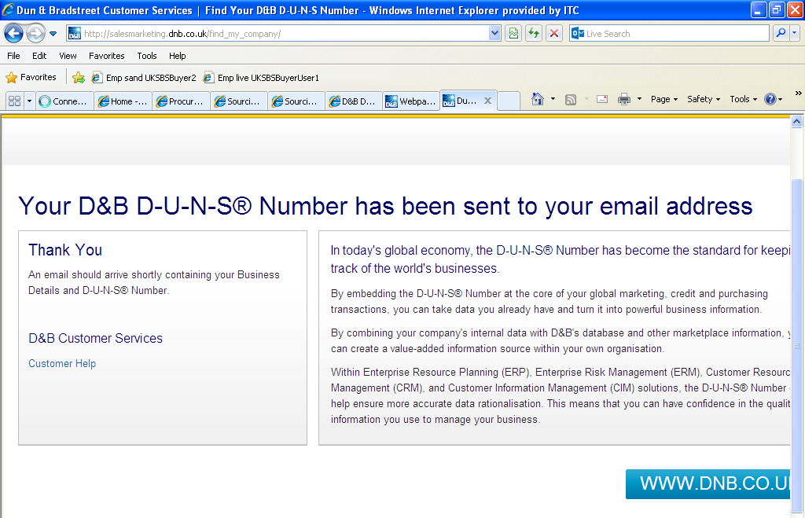

You will receive an email which looks like this.

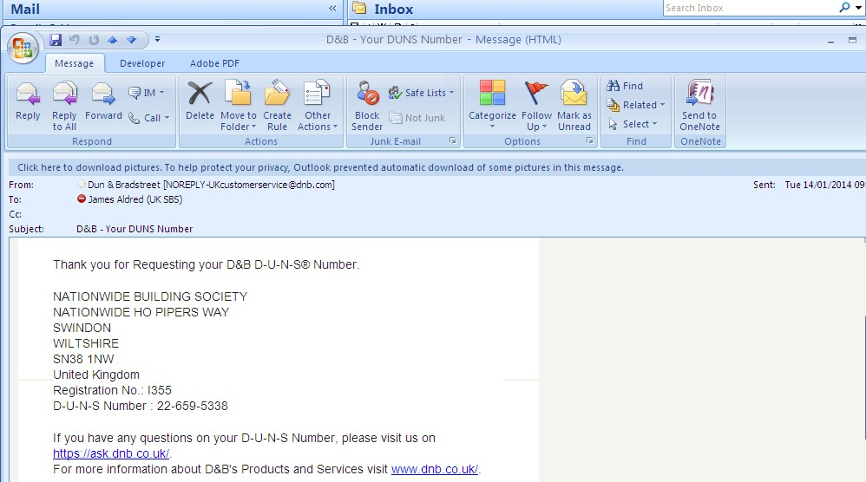

You are limited to 3 free searches.

If you have any problems with this search facility please contact Emptoris@uksbs.co.uk to ask the Emptoris Esourcing team to assist you in finding the correct bidder DUNS reference.

TEMPLATE VERSION CONTROL

Version | Date | Author(s) | Comment
1.0 | 14/1/2014 | James Aldred | Final Version

