

# 

# TENDER

# FOR

**BATFORD SPRINGS IMPROVEMENT WORKS**

# FOR

# HARPENDEN TOWN COUNCIL

Carl Cheevers

Town Clerk

Harpenden Town Council

Town Hall

Leyton Road

Harpenden AL5 2LX

# BACKGROUND

Batford Springs Local Nature Reserve sits on the River Lea and is home to several chalk streams fed by boreholes. It is a key site for local people in Harpenden to engage with nature, and a popular bathing spot in the summer.

The reserve is managed by both the Town Council and by the local Batford Springs Volunteers, an independent volunteer group who have worked on the site as far back at the 70s.

The reserve is used by the Town Council to deliver education opportunities to the local schools and community. It is home to a wide range of wildlife; bats, wading birds and aquatic invertebrates are all found in abundance on the reserve, as well as being a good location for fishing.

In recent years, the reserve has seen an increase in footfall throughout the year and an increase in flood events. This has led to the rapid degradation of a lot of the historic infrastructure on the reserve. A schedule of works has been drawn up to make improvements to the infrastructure on the reserve, taking into account the mixed-use and the increase in flood events.

We are seeking tenders to complete the improvement works set out below.

The successful contractor awarded to undertake this tender should be able to provide examples of similar works which they have been involved in, and experience of working within the constraints of Environment Agency Flood Risk Activity Permits.

It is intended that the successful contractor will be approved by the Community Services Committee in June 2021, with the first stage of works to commence in September 2021.

INSTRUCTIONS TO TENDERERS

Harpenden Town Council (hereafter referred to as the “Client”) invites tenders for the Batford Springs Improvement Works. The works are to take place on Batford Springs Local Nature Reserve.

The Contractor shall make themselves fully conversant with the Client’s requirements by reading the invitation to tender and visiting and inspecting the sites set out in the tender document. The Contractor is required to raise any issues on which they require clarification prior to submission of their tender, as no claims arising from their failure to do so will be entertained by the Client following the submission of tenders.

**SUBMISSION OF TENDER**

1. Tenders are to be sent by post or delivered by hand in an envelope clearly labelled ‘Private and Confidential *Tender – Batford Springs Improvement Works’*, addressed to Carl Cheevers, Town Clerk, Harpenden Town Council, Town Hall, Leyton Road, Harpenden, Hertfordshire, AL5 2LX, so as to be received **no later 12 noon, Friday 21 May 2021.**

An electronic copy of the tender should also be sent to [Carl.cheevers@harpenden.gov.uk](mailto:Carl.cheevers@harpenden.gov.uk) with the subject line; ‘*Tender – Batford Springs Improvement Works’,* by the same deadline.

1. Contractors are required to note that it is the Contractor’s responsibility to ensure that any tender delivered by hand in response to this invitation is actually received by the Client by the above date and time.
2. All prices are to be quoted exclusive of VAT. The maximum budget limit is **£15,000** exclusive of VAT. The Contractor is requested to present costs that will not exceed this limit.
3. The Contractor’s attention is further drawn to the insurance requirements of the Client, with the relevant Public Liability, product liability and professional liability Insurance of £5m minimum per claim. The successful Contractor will not be allowed to commence the Works until acceptable evidence of the insurance, has been approved by the Client and a risk assessment for each site provided.

5. The Client will write to all Contractors at the conclusion of our tender selection process advising of our decision and its rationale.

6. The Client may reject any tender not complying in any particular matter and their decision in that regards shall be final.

7. The Client does not bind itself to accept any offer made by any Contractor, nor does the Client guarantee that it will decide to award a contract.

8. Contractors must confirm in their submission that they have visited the site. The reserve is open to public access and Contractors can attend without the need to notify or have the Client present. If a contractor wishes to meet a representative of the Client on site please note that the potential dates are the 1th, 16th, 20th and 23rd April 2021-other contractors may also be in attendance for these site visits, please see section 15 for contact details. Tendering solely using google maps or other online mapping applications will not be accepted.

**9. Arithmetic Accuracy of the Tender**

9.1 If the Client suspects that there has been an error in the pricing of the Tender the Client reserves the right to seek such clarification as it considers necessary from the contractor only.

9.2 It is the responsibility of the contractor to check that all unit rates and other information entered in their Tender Schedule are accurate. If arithmetical mistakes are found after the contract has been awarded, they will not be taken into account. The figure agreed at the time of contract will prevail.

**10. Confidentiality**

10.1 All information supplied by the Client in connection with this invitation to tender shall be regarded as confidential by the Contractor except such information that may be disclosed for obtaining sureties and quotation necessary for the preparation of the tender. The Tender documents are and shall remain the property of the Council.

**11. GDPR**

Information provided within tender submissions will be held in accordance with the Client’s approach.

**12. Timetable**

* Tenders Issued: 19 March 2021
* Bookable site visits:13, 16, 20 & 23rd April 2021
* Return date for Tenders: noon, 21 May 2021
  + - Assessment and final decision: 23 June 2021
* Award and Regret Letters: 25 June 2021
* Agreement of Contract: 16 July 2021
* Commencement of works: September 2021

**13. Award Criteria**

* Price = 40%
* Design proposals 40%
* Sustainability of design and methodology = 20%

**14. Assessment Process**

All submissions will be assessed in line with the Harpenden Town Council financial regulations.

**15. Contact Details**

Any questions regarding these documents and the specific requirements of the Client must be made in writing by e-mail to [karen.poore@harpenden.gov.uk](mailto:karen.poore@harpenden.gov.uk) specifying that the e-mail relates to the ‘Batford Springs Improvement Works’.

In order that full consideration can be given, and responses can be forwarded to all Contractors, comments and questions must be received no later than **Friday 7 May 2021.**

*Questions and queries received after this may not be considered.*

**16. Appendices**

Appendix A – Tender Specification

Appendix B ­– Schedule of Works for Pricing

Appendix C – Form of Tender

Appendix D – Construction Design & Management

**APPENDIX A –**

**TENDER SPECIFICATION**

**Key Considerations and Preliminaries:**

Tenderers are expected to visit the site ahead of creating a submission to familiarise themselves with the Project.

It is expected that all Tenderers will confirm exact measurements ahead of submitting a completed Tender Quotation.

A copy of the Tenderers relevant Public Liability, Product liability and Professional liability Insurance should be included within the Submission.

The site is open to the public at all hours, though some areas can be closed off during works. Two public footpaths run through the reserve. Contractors are expected to work in a considerate manner, ensuring that a safe, clear pedestrian route is maintained at all times.

There are no electrical points or mains water for Contractor use within the reserve.

Unfortunately, there is no secure storage for materials on site.

Welfare facilities are not available for Contractor use, provisions should be allowed for within the tender submission.

The Contractor is expected to provide details of their proposed site access route, mindful of the public and permissive footpaths on the site and the limited access to the work area. Machinery may cross the chalk stream to access the work area, but any crossing must be reinforced to reduce damage to the habitat. The weight limits of the bridges on the reserve are not known and so any crossing routes using these will not be acceptable. Any damage to the existing green space is the responsibility of and will be re-instated by the Contractor at their own expense.

All Waste Transfer Notices (WTN), should be passed to the Town Council at the completion of the Project.

**Priority of Works and Costing Notes**

The following Scope details the preferred method for the required works. Contractors are welcome to suggest alternative methods to complete the below works but must take into consideration that the allocated funding cannot be adjusted.

The below works are located within the flood zone of the River Lea and so are subject to a flood risk activity permit from the Environment Agency. All applications must be bespoke permits as the reserve is registered as a Local Nature Reserve.

The contractor should include in their estimates both the price for;

a) completing the permit application

b) for supplying information to enable a permit to be obtained by the Town Council

All works should be planned with the Environment Agency best practice in mind. Adjustments to work methods may need to be made to meet the requirements of flood risk activity permits.

**APPENDIX B**

**REFERENCE DOCUMENTATION**

**General Notes and guidance:**

Any sketches/maps provided are not to scale

**Area of Works Location Map**

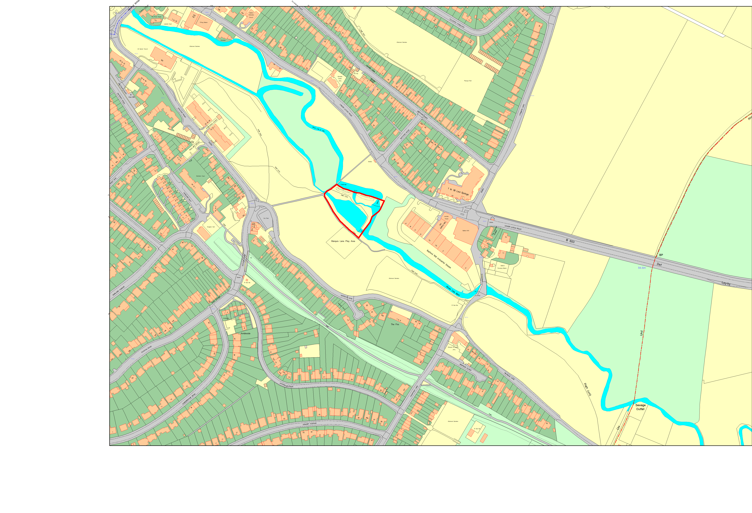

**Works Reference Map**

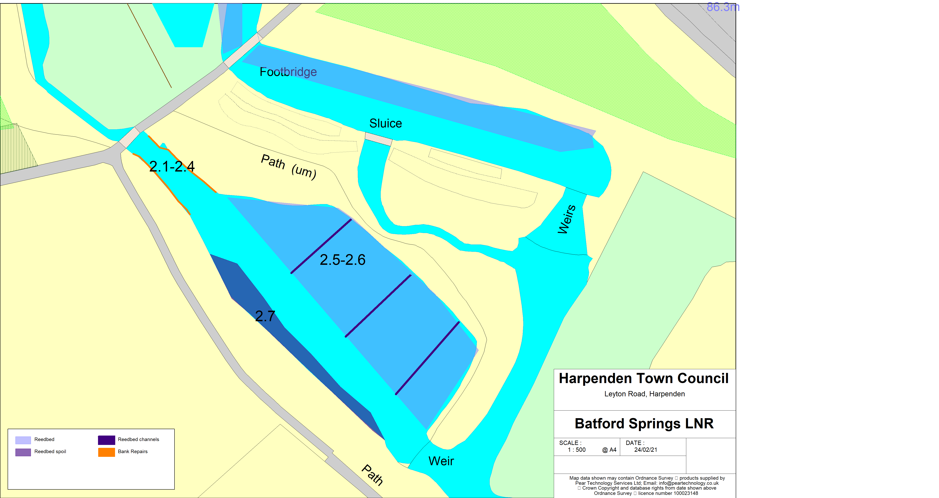

**APPENDIX C**

**FORM OF TENDER**

Figures quoted must be the total fixed price excluding VAT for the works concerned, including all parts, materials, labour and ancillary costs. Pricing should be all inclusive of every aspect so as to deliver the schedule of works within the timescale set.

**Form of Tender - General Notes and guidance:**

The Contractor is also required to complete the following documentation;

-Key Information

-Form of Tender

-Pricing Schedule

-Collusive Tender Certificate

**Schedule of works for Pricing:**

Please fill in the blank column spaces

|  |  |  |  |  |  |
| --- | --- | --- | --- | --- | --- |
| **Table 1: Other costs and Permit Applications** | | | | | |
| Ref. | Description | No. | Unit | Rate £ | Total £ |
| **Contract Preliminaries** | | | | | |
| **1.01** | Contract Preliminaries: Add costs arising out of Preliminaries that are not covered elsewhere* | item | item | N/A |  |
| **Permissions** | | | | | |
| **1.02** | Full application for Environment Agency Permits (excluding EA fees, to be paid by HTC in addition). | item | item |  | N/A |
| **1.03** | Provision of information to support HTC Environment Agency permit application. | item | item |  | N/A |
| **Table 1 Sub-Total (carried forward to Table 6: Summary Costs)** | | | | |  |

**Notes:**

* Please read Preliminaries carefully to ensure that you allow for items with cost implications particularly concerning potential reinstatement.

|  |  |  |  |  |  |
| --- | --- | --- | --- | --- | --- |
| **Table 2: Improvement Works** | | | | | |
| Ref. | Description | No. | Unit | Rate £ | Total £ |
| **Bank reinforcements of chalk stream ‘pool’** | | | | | |
| **2.1** | Remove and dispose of all existing reinforcement material on the north and south bank of the pool area, including any iron and timber works in the pool area. | item | item |  |  |
| **2.2** | Install bank reinforcements along both the north and south banks. Bank reinforcements should be in a suitable durable material, such as oak or recycled plastic, and may also include soft engineering options such as hazel faggots or spiling in areas with minor erosion, though long-lasting materials are preferred.  North bank – 12.5m of reinforcements starting at a height of 125cm, staggering down to a height of 40cm. Includes option of 4.5m of soft engineering at 40cm in height.  South bank – 12.5m of bank reinforcements starting at 1m in height and staggering down to 80cm, including option of 7.5m of soft engineering at 80cm in height. | 25 | m |  |  |
| **2.3** | Install a 1m wide step of a suitable durable material such as oak or recycled plastic into the pool area to create an access point on both the north and south bank, submerged to ease the transition from the bank into the water. | item | item |  |  |
| **2.4** | Backfill any voids behind reinforcement works with soil. Top the areas of access with at least 4” of clean inert 20mm gravel. | Item | item |  |  |
| **Reedbed channels** | | | | | |
| **2.5** | Cut and remove vegetation to access excavation areas. | item | item |  |  |
| **2.6** | Excavate 3 no. 1m channels from the edge of the chalk stream to the edge of the existing pathway. Channels should be equally distributed across the reedbed and excavated to the same depth of the chalk stream bed. | 3 | no. |  |  |
| **2.7** | Spread excavated soil evenly along the south bank of the chalk stream, grading to meet the existing bank. | item | item |  |  |
| **Table 2 Sub-Total (carried forward to Table 6: Summary Costs)** | | | | |  |

**Table 3: Summary cost:** Bring forward sub-totals from previous tables

|  |  |  |
| --- | --- | --- |
| Table no. | Description | £ |
| 1 | Other costs and Permit applications |  |
| 2 | Improvement Works |  |
| **Grand Total** *(excluding VAT)* | |  |

**Batford Springs Improvement Works**

**Key Information:**

|  |
| --- |
| Please Outline Details of your Insurance Coverage appropriate to undertake these works: |
|  |
| Please outline details of principal plant and equipment to be used to undertake this work: |
|  |
| Please provide details of project staff, their training and experience relevant to the works: |
|  |

Please note that the Contractor selected to undertake this Contract will have to provide documentary evidence of Insurances, Health and Safety policies and relevant operative training prior to Contract award. In addition, the Contractor selected will have to provide a Method Statement and Risk Assessment to demonstrate how the works will be carried out safely.

**FORM OF TENDER**

**Batford Springs Improvement works**

To: **Harpenden Town Council**

Having examined the Conditions of Contract, Specification, and Other Works for the carrying out of the above-named works, I/we offer to complete the whole of the said Works in conformity with the above for the sum of:

(Amount in words): ________________________________________________________

(Amount in figures): ________________________________________________________

I/We certify that:

1. the amount of this Tender has not been communicated to anyone except the Client;
2. the amount of the Tender has not been adjusted as a result of an arrangement with anyone other than the Client; and
3. no agreement has been made with anyone to refrain from tendering.

I/we undertake to enter into a Contract to be prepared by the Client incorporating such Conditions of Contract, Specification, and Drawings and agree that, until such Contract is prepared and executed, this tender together with your written acceptance thereof shall constitute a binding contract between us.

I am/We are able and willing to complete the whole of the Works on or before **March 2022**

I/We anticipate that the works will take___________________weeks to complete.

I/We understand that you are not bound to accept the lowest or any Tender you may receive, and you will not pay any expenses incurred by us in connection with the preparation and submission of this Tender.

I/We confirm that I/We have no objection to the amount of this Tender being included in a list to be submitted to all Contractors who provide a Tender for the Works.

|  |  |
| --- | --- |
| Date: |  |
| Signature: |  |
| Designation: |  |
| Company Name: |  |
| Address: |  |
|  |  |
| Contact Person: |  |
| Tel no. |  |

**COLLUSIVE TENDERING CERTIFICATE**

**BATFORD SPRINGS IMPROVEMENT WORKS**

In recognition of the principle that the essence of selective tendering is that the client shall receive bona fide competitive tenders from all those tendering.

WE CERTIFY THAT

1. The tender submitted herewith is a bona fide Tender intended to be competitive.
2. We have not fixed or adjusted the amount of the Tender under or in accordance with any Agreement or arrangement with any other person.
3. We have not done, and we undertake that we will not do any time before the hour and date specified for the return of the tender any of the following acts:
4. communicating to a person other than the person calling for those tenders the amount of approximate amount of the proposed tender, (except where the disclosure, in confidence, of the approximate amount of the tender was necessary to obtain insurance premium quotations required for the preparation of the Tender);
5. entering into any agreement or arrangement with any other person that he shall refrain from tendering or as to the amount of any tender to be submitted; and
6. offering or paying or giving or agreeing to pay or give any sum of money or valuable consideration directly or indirectly to any person for doing or having or causing or having caused to be done in relation to any person for doing or having or causing or having caused to be done in relation to any other tender or proposed tender for the said work any act or thing of the sort described above.

In this Certificate:

1. “Person” includes any persons anybody or association, corporate or unincorporated.
2. “Any agreement or agreement” includes any transaction of the sort described above, formal or informal, and whether legally binding or not.

DATED this ……………………………….. day of

...........................................…………….2021

SIGNED (as in Tender) ………………………………………………………………………...........................

Duly authorised to sign for and on behalf of

……………………….................………………………...

**APPENDIX D**

**CONSTRUCTION DESIGN & MANAGEMENT**

Guidelines for Method Statement required from Contractors.

From 6 April 2015 every construction project has to comply with the CDM 2015 Regulations. All tenders are received on the understanding that any company awarded a tender will provide Construction Design and Management procedures compliant with the Construction (Design and Management) Regulations 2015.

All tenders are received on the understanding that any company awarded a tender and entering into a tendered contract with Client will do so as the Principle Contractor.

*Please note that any works which are anticipated to last over 30 working days and have over 20 workers working at the same time at any point will be classed as ‘notifiable’ and will require the completion of a F10 form.*

**METHOD OF WORK**

Your method of work document should describe in detail the individual operations you’ll be doing on the site.

Include enough detail to show how, when, where and for how long you’ll be doing each part of the activity. You must include all temporary works, including ‘enabling works’ that support that main activity.

These documents might include:

* unloading and storing materials
* temporary works such as site hoarding
* the construction, engineering or installation methods you’ll use
* the sequence of steps or works