**Moss Side Farm Ditch Diversion Feasibility Study Scope**

Background information

Chat Moss is the largest remaining fragment of lowland peatland within Greater Manchester. It covers Salford, Wigan and Trafford, and it has a total area of 2,800ha. The expanse of the peatland has suffered from historical degradation, with peat extraction and nightsoil deposition taking place as a consequence of the area being opened up by the construction of a Manchester-Liverpool railway in 1830. Chat Moss is now largely agricultural land - intensively cultivated, criss-crossed with drainage ditches, and divided by the M62 motorway.

Natural England (NE) manages 154 ha of former arable land within Chat Moss and are currently working with partners to develop a National Nature Reserve in this landscape. Our work will connect surrounding sites through restoration and expansion of wetland habitat.

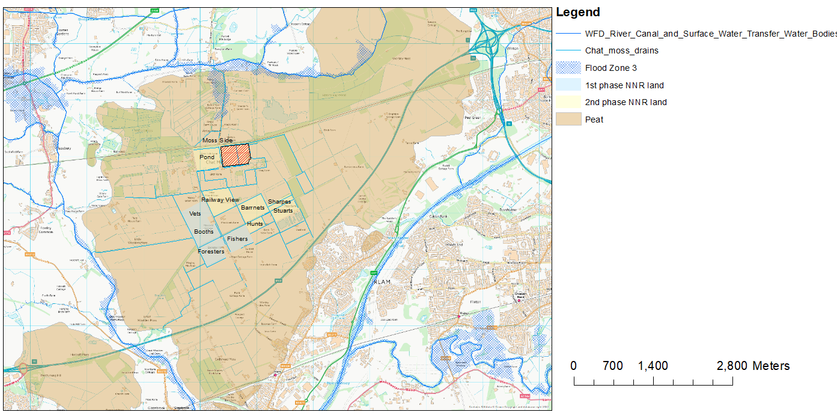

Figure 1: Area of proposed works shown in context of wider landscape.

Specification

NE is interested in developing new areas of wetland habitat on its land on Chat Moss. As part of this work, we are investigating the feasibility of restoring the hydrological function of Moss Side Field by potentially diverting one or more of the existing ditches, thereby creating more sustainable hydrological unit. The first ditch diversion will help to restore habitat by removing deep drainage from the centre on the field. We would also like to investigate the possibility to rise levels or to also divert the ditch we share with the adjacent Peel peat restation site to try and create a more natural hydrological function, and therefore increase its overall resilience. If either diversion are not feasible then piping of the drain should also be considered.

Outputs

Hydrological survey of existing ditch system

Flood risk assessment

Options development and detail design of selected interventions (including route plan, cross-sections, dimensions, land and bed levels).

Professional services

1. Chartered surveyor to carry out the level mapping:

Mapping to be produced using LiDAR

Spot heights to be given for invert level of the existing watercourse

Spot heights to be given for the land level adjacent to the watercourse and alongside the path of diversion

Dimensions of the existing watercourse to be measured

2. Hydrological engineer to produce the design plan, carry out the hydrological survey and assess flow rates and conveyance:

Hydrological survey to be produced for existing watercourse using the detailed information gathered by land mapping.

Assessment of current conveyance and flow rates of existing watercourse.

Assessment of watercourse network in area to understand context in relation to the local drainage network and main river. This will include potential impact of the suggested redirection and infilling on drainage and excessive water from the site.

The following key areas need to be considered-

-The ditch south of the track flowing to our perimeter ditch (A), and ditches running alongside lane (B & C) and water flowing in from adjacent landowners’ properties at D (see fig 2).

-We will need to be 100% clear on the impact of any re-direction proposed on the existing conduit for excess water and insure that the current standard is maintained.

-Understanding of hydrological connectivity and importance to drainage in the wider area of drains (E & F), and how they could be modified to improve the wetland creation potential within the study area (red hashed).

-High-pressure gas pipeline within the area at G that is a possible constraint.

Prediction of conveyance and flow rates within the new watercourse layout (based on proposed design). This information will inform an assessment of flood risk to demonstrate that there is no adverse effect on floor risk, either up- or downstream of stream diversion.

3. Civil/environmental engineer to create the detail drawings and diversion plan:

Design for new watercourse layout, including details of the invert level cross-sections. The Design will ensure the flow rate of the diversion route/new channel will be capable of taking the flood flow of the existing watercourse and the new channel shall be a uniform gradient. A proposed area of search is shown in fig 2, this is only a guide to the concept we wish to deliver, the final route needs to be selected based on the investigations listed above.

Details of size and invert level of culverts.

Provide estimation of quantities of soil and peat required to be moved during the excavation of the new watercourse, and the infilling of the old one.

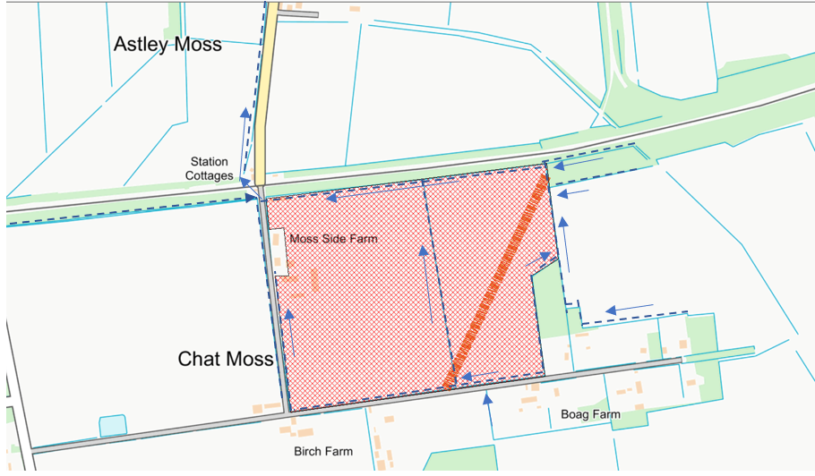

Chat Moss Peat restoration area

G

D

F

E

C

B

A

Figure 2: Map to show proposed ditch diversion scoping area and proposed new wetland.