# Go To Places Websites Hosting, Development and Support Brief

# Background

Go To Places Ltd (GTP) provides destination management services to UK destinations, using its considerable expertise to develop great places through innovative marketing, public & private sector partnerships, and investing in people.

The GTP team specialises in targeting UK and overseas markets to raise the profile of premier destinations, as well as working to improve quality and skills within the industry, and using its lobbying powers to grow investment in tourism. The team has extensive experience at local, regional and national levels of destination and attraction marketing & PR, consumer and location research, business development, and bid writing.

GTP evolved from the award-winning team behind Visit Kent Ltd, recognised as one of the country’s leading Destination Management Organisations. The company’s current portfolio of destinations includes Visit Kent and Visit Herts.

Visit Kent is the official Destination Management Organisation (DMO) for Kent & Medway and has been providing services to the visitor economy in the county for 20 years. It is widely recognised as one of England’s leading DMOs. The growth of the visitor economy in Kent over the past 20 years is testament to the partnership strategy that operates with both the public and private sector.

Visit Herts is the official DMO for Hertfordshire and was created by the Go To Places team in 2015. In 2017 and again in 2022 the contract from the County Council and the Local Enterprise Partnership was extended as a result of the delivery achieved during the preceding periods.

# Project Summary

Go To Places currently manage a suite of 20 websites and smaller auxiliary sites. The websites have been built using Umbraco. We are looking for a long-term partner who will undertake the following work:

* **Website Hosting:** Host the GTP suite of websites maintaining a minimum of 99.9% site availability.
* **Ongoing Support:** Take on the ongoing maintenance and support of the frontend websites and the CMS, this includes: bug fixes, minor feature development and technical optimisation.
* **New Feature Development:** Support us in improving the existing websites through the development of new features, functionality enhancements and design updates.

# Context

Go To Places commissioned the incumbent, Extended.Agency, to host and support the websites in 2018. After 5 years the contract is now due for review and renewal. To fulfil the process agencies are invited to submit their responses to this tender

## Websites

The following websites and smaller auxiliary sites / microsites were included in this project:

* Visit Kent – www.visitkent.co.uk
  + Visit Ashford – www.experienceashfordandtenterden.co.uk
  + Visit Medway - www.visitmedway.org
  + Visit Swale - www.visit-swale.co.uk
  + Visit Canterbury - www.canterbury.co.uk
  + Visit Thanet - www.visitthanet.co.uk
  + Visit Folkestone and Hythe - [www.visitfolkestoneandhythe.co.uk](http://www.visitfolkestoneandhythe.co.uk)
  + Visit Gravesham *under development*
  + Meet in Kent - www.meetinkent.co.uk
  + Visit Kent Business - [www.visitkentbusiness.co.uk](http://www.visitkentbusiness.co.uk)
  + Kent Travel Trade Hub - tradehub.visitkent.co.uk
  + Place marketing hub - placemaking.visitkent.co.uk
* Visit Herts – www.visitherts.co.uk
  + Visit Herts Business – www.visithertsbusiness.co.uk
  + Meet in Herts - [www.meetinherts.co.uk](http://www.meetinherts.co.uk)
* Go To Places - www.gotoplaces.co.uk
* Kent Big Weekend – www.kentbigweekend.co.uk
* Herts Big Weekend – www.hertsbigweekend.co.uk
* Essex Big Weekend – www.essexbigweekend.co.uk
* Jersey Big Weekend (On Hold) – www.jerseybigweekend.co.uk
* Big Ferry Fortnight – www.bigferryfortnight.com

The Big Weekend websites utilise our proprietary web application built on Umbraco.

## Traffic

As an indication, the traffic received by the two principal sites on the platform for the period 0/01/22 to 31/12/22 are as follows

**Visit Kent:**

* Sessions: 1,034,766
* Users: 868,703
* Page views: 1,670,205

**Visit Herts:**

* Sessions: 293,568
* Users: 234,631
* Page views: 471,861

A significant piece of project specific digital campaign activity was delivered through March – April 2022.

**Visit Ashford and Tenterden** (representative of one of the district sites within the suite)

* Sessions: 64,365
* Users: 58,033
* Page views: 107,472

The above graphs show that traffic is relatively steady throughout the year, increasing from the spring into the summer, there are some significant spikes in traffic which relate to key events or project specific campaign activity.

## Umbraco Setup

All sites are built using Umbraco 7.15.10 using a multisite setup with [www.visitkent.co.uk](http://www.visitkent.co.uk) and [www.visitherts.co.uk](http://www.visitherts.co.uk) acting as parent sites.

There is a core set of document types and page templates shared across the destination sites. With site specific config available to determine colours, logos, fonts, navigation and content settings.

Destination site content for Attractions, Accommodation and Events can be shared across sites within the same region, allowing content at district level to be surfaced elsewhere.

Within individual content items, the sites upon which the item can surface are checked.

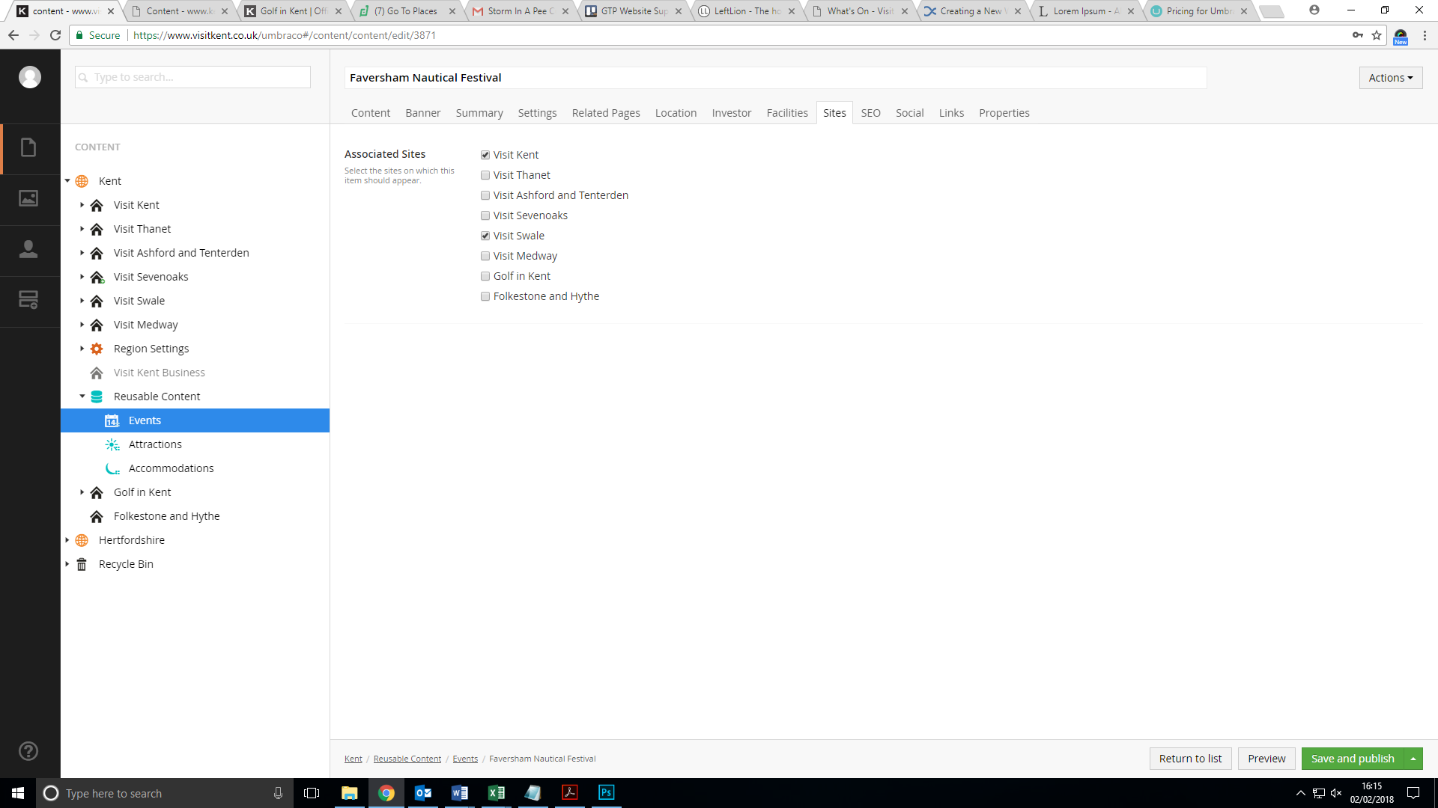

Umbraco is used by approx. 40 content editors across 10 locations with different user roles. Most authors have editor privileges which allow users to save and publish.

## Domain Management

Domain management does not form part of the scope of this project. This will be done by Go To Places. Domains either reside on GTPs nameserver host account or are managed by the district IT teams.

## Tracking

All Go To Places websites use Google Analytics. The parent sites for Kent and Herts have Google Tag manager applied.

# Response to Brief

Please submit your proposal by email to Jim Dawson, Head of Creative Digital and Marketing [jim.dawson@visitkent.co.uk](mailto:jim.dawson@visitkent.co.uk), by 5:30 pm on 27th October 2023.

Please address any questions you may have in the preparation of your response to the same contacts.

Your response must include:

* A brief outline of your agency’s current setup, to include capacity / resource to undertake the work, team makeup and skill sets, and an overview of current clients
* Experience of Umbraco and front-end development
* Experience of delivering DMO/tourism web solutions
* A project outline showing how you would manage the migration from our current agency to yours
* Your approach to identifying and managing risks during this migration
* Your approach to the delivery of support and new feature development, including key processes and SLAs
* Your approach to user acceptance testing and release management
* Cost breakdown for:
  + Hosting
  + Ongoing support (assuming 20-30h/month, to be reviewed quarterly)
  + New feature development (ad-hoc; please specify hourly or day rates)

**Tender Timetable**

Tender Submission Date: 27th October 2023 - All tenders must be received by 17:30

Decision date 10th November 2023

Contract start date: 1st January 2024

### **Evaluation procedure**

The quotations will be evaluated on the basis of the **economically most advantageous offer**; this allows Go To Places and partners to take account of various elements such as quality, technical merit and relevant experience.

Submissions from contractors who have not met the requirements in the tender questionnaire will not be considered further.

Returned quotations that have met the requirements in the tender questionnaire will be evaluated based on the criteria set out in the table below:

|  |  |
| --- | --- |
| **Cost - 30%**  (The lowest priced quotation will be awarded maximum points and all other quotations awarded points in proportion)  **Quality - 70%**   * Criteria 1 – Company Experience * Criteria 2 - Capacity and ability to deliver the work * Criteria 3 - Demonstrable understanding of the aims and objectives of the brief and an appreciation of issues * Criteria 4 - Understanding of the wider context of this contract * Criteria 5 - Recommended approach and quality of offer | **30%**    15% 10% 15%  10%  20% |

Each of the Quality sections within this submission will be scored based on the method detailed below:

|  |  |
| --- | --- |
| Exceptional demonstration by the Tenderer of the relevant ability, understanding & skills required to provide the service with evidence to support the response, where appropriate. | 5 – Excellent |
| Good demonstration by the Tenderer of the relevant ability, understanding & skills required to provide the service with evidence to support the response, where appropriate. | 4-Good |
| Contains minor shortcomings in the demonstration by the tenderer of the relevant ability, understanding & skills required to provide the services with evidence to support the response, where appropriate and/or is inconsistent or in conflict with other proposals with little or no evidence to support the response. | 3–Minor Reservations |
| Satisfies the requirement but with considerable reservations of the Tenderer’s relevant ability, understanding & skills required to provide the services, with little or no evidence to support the response. | 1–Serious Reservations  Submissions which receive a ‘1 – serious reservations’ will not be considered further |
| No response provided. | 0–no score – Fail  Submissions that ‘Fail’ will not be considered further |

If there appears to be an arithmetical error in a submission or supporting information, Go To Places shall, at its discretion, either disregard the quotation or invite the Contractor to amend, confirm or withdraw its bid. Except in the case of arithmetical errors, if any other error is found the Contractor will be invited to either stand by the original uncorrected quotation or to withdraw.

**Go To Places Not Bound**

Go To Places does not bind itself to accept the lowest or any tender for all or any part of the requirement and will not accept responsibility for any expense or loss which may be incurred by any tenderer in the preparation of the response.

Any discussions or correspondence between Go To Places and tenderers shall be conducted without any obligation whatsoever by Go To Places to enter into or become bound by any contract.

Go To Places will not be bound by any contract until the Contract is embodied in a formal document and signed by all parties.

### **Contract Award**

Go To Places may decide at its sole discretion to:

1. Not award the contract at all
2. Award only part of the intended contract
3. Discontinue the process at any time without liability
4. Reduce or increase the budget, redefining deliverables accordingly

**Questions about the brief**

If you need any further assistance or have any queries about the process, please contact Jim Dawson. E-mail: [jim.dawson@visitkent.co.uk](mailto:jim.dawson@visitkent.co.uk)

Any questions relating to the services must be raised via e-mail.