Site Wide PA System

Date: Nov 2017

Introduction:

The National Institute for Biological Standards and Control (NIBSC) is a multi-disciplinary scientific establishment whose purpose is to safeguard and enhance public health by standardising and controlling biological substances used in medicines. One of its key roles is the production of reference materials, which are used to ensure the high quality of biological medicines such as vaccines and blood products. The Institute is a designated World Health Organisation (WHO) laboratory for the production of International Standards and its scientists provide advice to a wide range of National and International bodies on product safety and efficacy. The NIBSC is funded in the main by the British Government and as such is obliged to comply with its Standing Financial Instructions (SFI’s) to ensure that quotations are obtained in a fair and effective manner ensuring optimum quality and cost. The SFI’s require that projects of this nature are subjected to a tendering process with an Invitation to Tender (ITT) posted on Bravo Solutions e Tendering Portal https://phe.bravosolution.co.uk/web/login.shtml with the aim to obtain a minimum of three contractors tenders. During the tender process every effort will be made to ensure impartiality and those contractors not appointed on this occasion will be given a further chance to tender for similar projects in the future.

Proposal:

It is proposed that Speakers will only be in the corridors and not individual offices and used only in the event of an incident to give instructions to staff members that are on site. The site has been split up into 26 zones as listed in the attached table – Table 1. Each zone will have a single circuit. It is understood that speakers should be approx. 9 m apart and will be driven by IP network connected amplifiers situated close to each zone. The amplifiers are to be rack mounted and situated in local equipment cabinets where available. The contractor is to undertake a full survey along with a representative from the NIBSC IT department. All amplifiers will be fully electronically protected against overload and short circuit line faults conditions.
Table 1 provides the length of corridor in each zone, it is highly recommended that contractors wishing to tender undertake a rigorous survey to verify adequate cover by their proposal. The system is to be provided with 125% capacity to allow for any future expansion.
Termination of incoming cables will be clearly labelled and identified in the terminal field situated at the rear of each rack.
The networked Public Address System is to have the functionality of multi paging, telephone paging and the scheduling of messages, lockdown messages or tones to any of the 26 zones. Each of the peripherals (e.g. amplifiers, microphones and any other components of the system) will have their own IP addresses which must be agreed with a representative from the NIBSC IT department.
Each zone is to be configured so that it may be called or addressed either together or entirely separately from any other zone or combination of zones.
The Institute’s preferred network cabling company is to be used and their details are:
Mike Gaskin:
ICS Services
Tel: 01483 685 270
Mob: 07966 144 546
www.ics-services.co.uk
The volume of each speaker is to be adjustable so that comfort levels can be individually attained.
The system is to have 2 IP Networked microphones, one on Reception and one in the Security Control Room.
Zones 15 & 16 cover the BSD building which currently has speakers to annunciate verbally an activation of the fire alarm. A survey is to be undertaken to determine if the speakers can be used for a dual role, i.e. fire alarm and PA system.
A network audio adapter is to be provided to enable the playing of pre-recorded voice announcements or tones to any of the on-site zones. Also, a software administration tool is to be provided with a user friendly Graphic User Interface (GUI) to allow control and management of the installation. The Administrator is to have the ability to manage functionality, create zones, set user rights, schedule announcements and media lists.
The corridor speakers are to be ceiling flush mounted where possible or wall mounted cabinet speakers where not possible.
All loudspeakers are to be tested for earth leakage and shorting as well as open circuit faults prior to commissioning.
System commissioning:
The system is to be commissioned out of normal working hours to avoid disturbing the staff too much. Each zone is to be tested individually and collectively with a pre-recorded message from both reception and the Security Control Room. The volume of each zone is to be adjusted to the level acceptable to the Project Manager and the message is to be clear without any distortion or interference.
Site Access
The logistical flow of lorries and large vehicles must be managed to prevent heavy vehicle congestion on site. All works that may have indirect or direct impact on staff welfare must be carried out of hours:

Mon- Fri 06:00 to 8:30
17:15 to 20:00
Sat & Sun With the permission of the project manager and site security

Access to the site will be via the main access to NIBSC, which is shared with the client’s employees, and visitors. All vehicles will be stopped at the security lodge and all drivers will be required to comply with the client’s security arrangements.

After 7pm no work can take place unless security and the project manager have agreed to this.

Waste removal and recycling
All waste materials are the responsibility of the contractor. All waste associated with the project will be disposed of in an environmentally acceptable way and in compliance with the Duty of Care under the Environmental Protection Act 1990. If a contractor brings his own skip onto site they should provide details and waste licenses/permits of the waste carrier and site where the waste will be disposed of.

A contractor’s skip can be located in the local area with agreement of the project manager, but must be maintained so no rubbish is left around it, or be blown around by the wind.

Welfare facilities
The site has toilets, power and water which will be provided to contractors with the Employer's permission. The site also has a staff restaurant that the Contractors’ staff may use subject to persons being properly dressed (no bare torsos or shorts) and in clean and tidy clothing. We have first aiders on site but we expect each main contractor to supply a first aider as part of their team.

Confidentiality
Contractors are expected to keep any information about the work of the Institute or staff details totally confidential at all times

List of Proposed Zones
Zone | Area | Length | No. Speakers | No of Amps
1 | South Lower | 67 | 7 | 2
2 | South Upper | 67 | 7 | 2
3 | Link Corridor | 27 | 3 | 1
4 | North Lower | 67 | 7 | 2
5 | North Upper | 67 | 7 | 2
6 | Amenities to Reception | 51.5 | 5 | 2
7 | Directors' Suite | 12.5 | 1 | 1
8 | Library | 37 | 4 | 1
9 | OH to Amenities | 16.3 | 1 | 1
10 | CBRM | 53.6 | 5 | 2
11 | IRC | 45 | 5 | 2
12 | UKSCB | 102 | 11 | 3
13 | Biotech | 38.3 | 4 | 1
14 | CL 4 | 75.8 | 8 | 2
15 | BSD Lower | 125.2 | 13 | 4
16 | BSD Upper | 124.6 | 13 | 4
17 | Ops Mgrs Office | 7 | 1 | 1
18 | Project Office | 8.4 | 1 | 1
19 | Workshop | 10 | 1 | 1
20 | Elec W/S | 8 | 1 | 1
21 | Stores Corridor | 13.4 | 1 | 1
22 | Admin | 18.7 | 2 | 1
23 | FCS | 36.3 | 4 | 1
24 | Amenities | 44 | 4 | 1
25 | LMR + SMR | 16 | 1 | 1
26 | SWS | 45 | 5 | 2
 | Subtotal | 1,184 | 122 | 43

NCTC could possibly be linked with neighbouring zones.
CBRM sales office could possibly be linked with neighbouring zones.
Herbal office and lab could possibly be linked with neighbouring zones.

Site plantrooms are to be priced separately; this will be discussed on the site visit.

Table 1

Assumptions:
- 1 speaker every 9 m
- 1 amp for every 4 speakers

The lengths of the above corridors are approx. and must be verified by a rigorous survey.

It may be possible that zones 17, 18, 19 & 20 can be treated as one zone with individual speakers fed from a sole amplifier. The contractor is to advise the most appropriate solution.
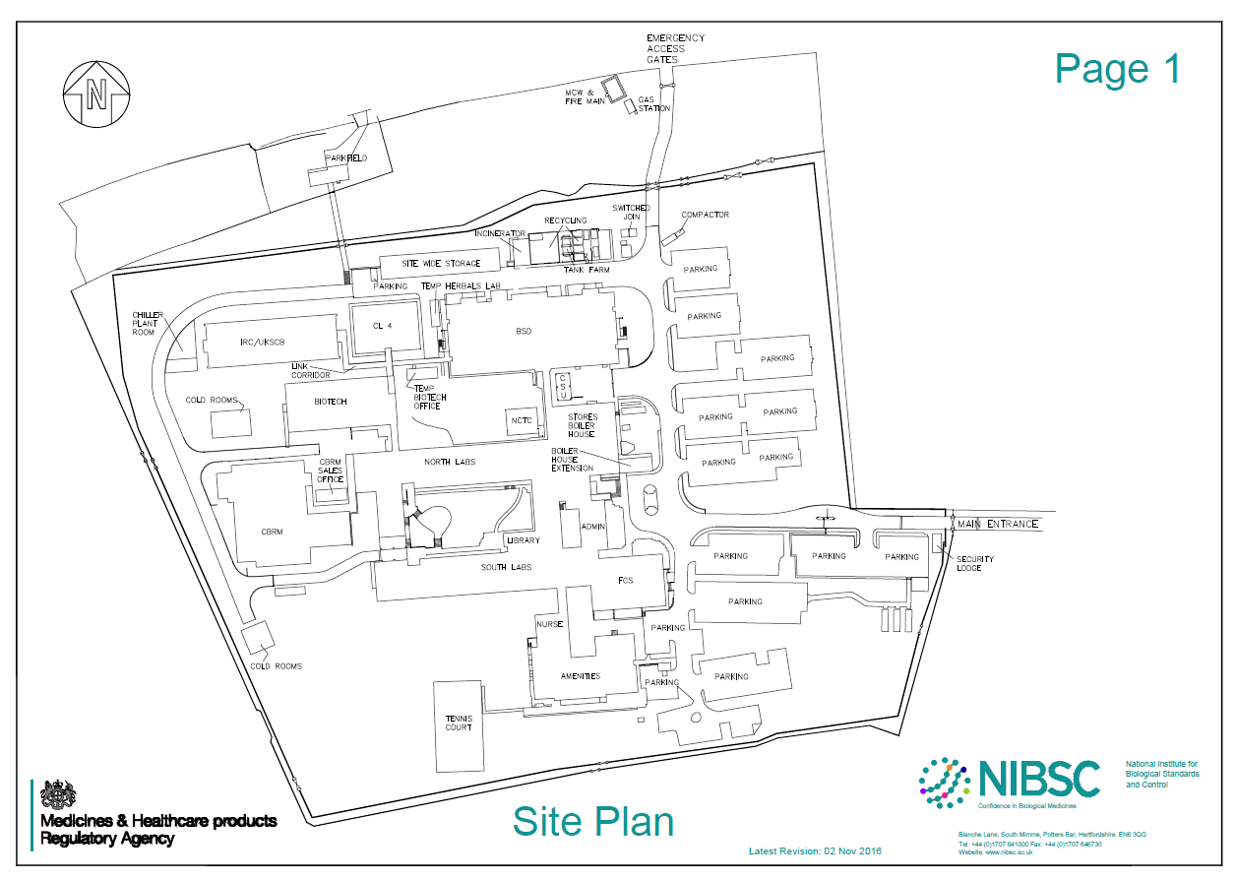
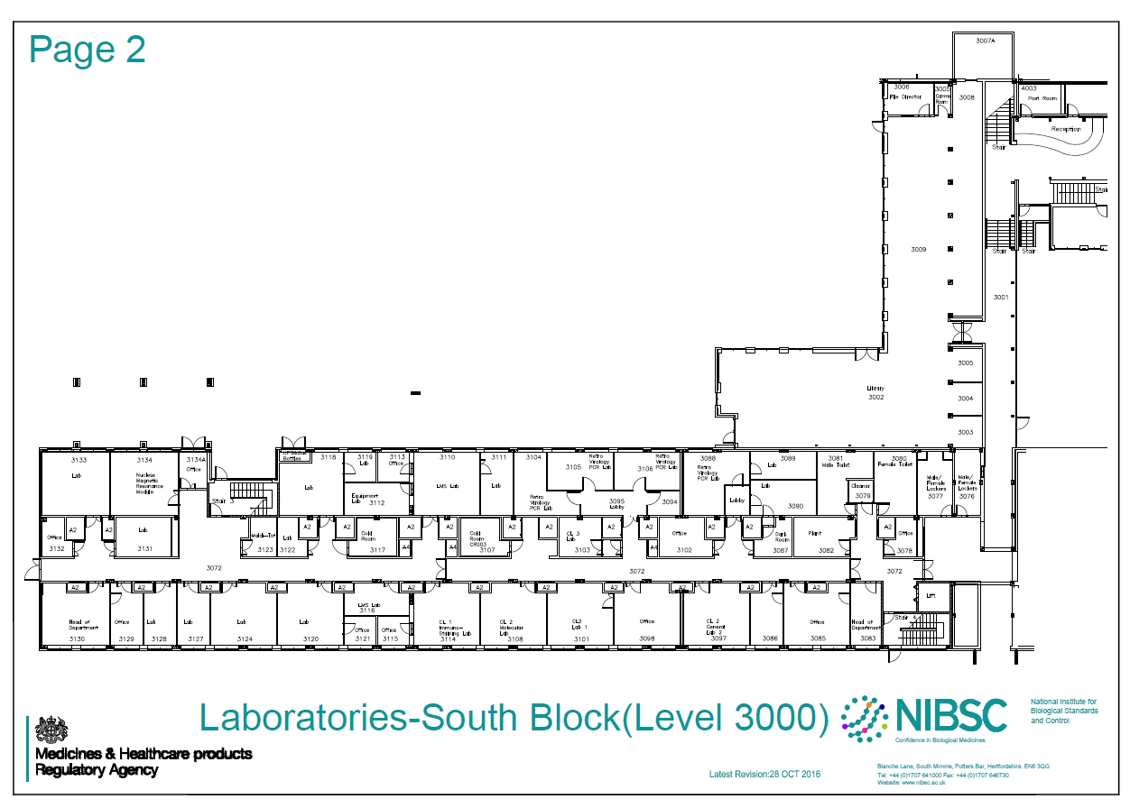
Zone 8
Zone 1
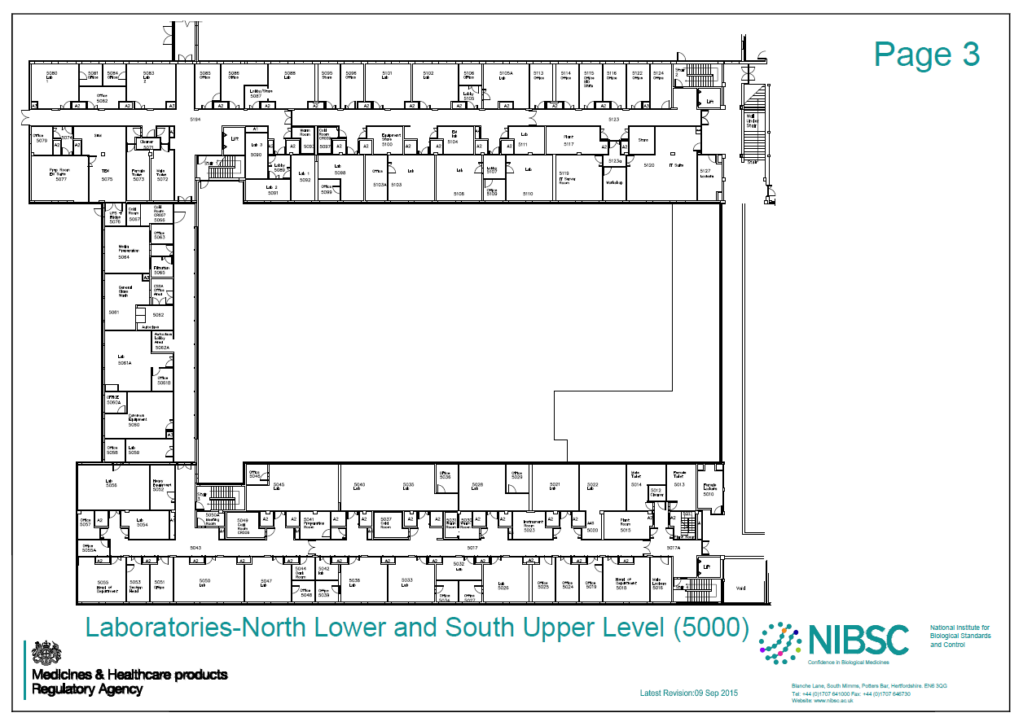
Zone 3
Zone 2
Zone 4
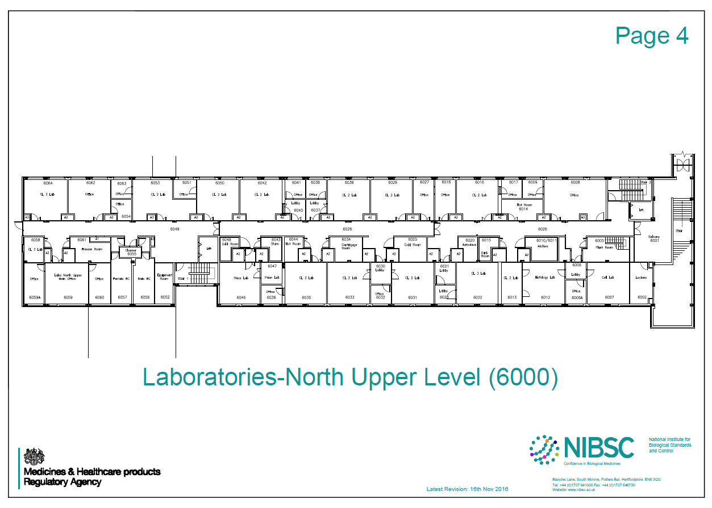
Zone 5
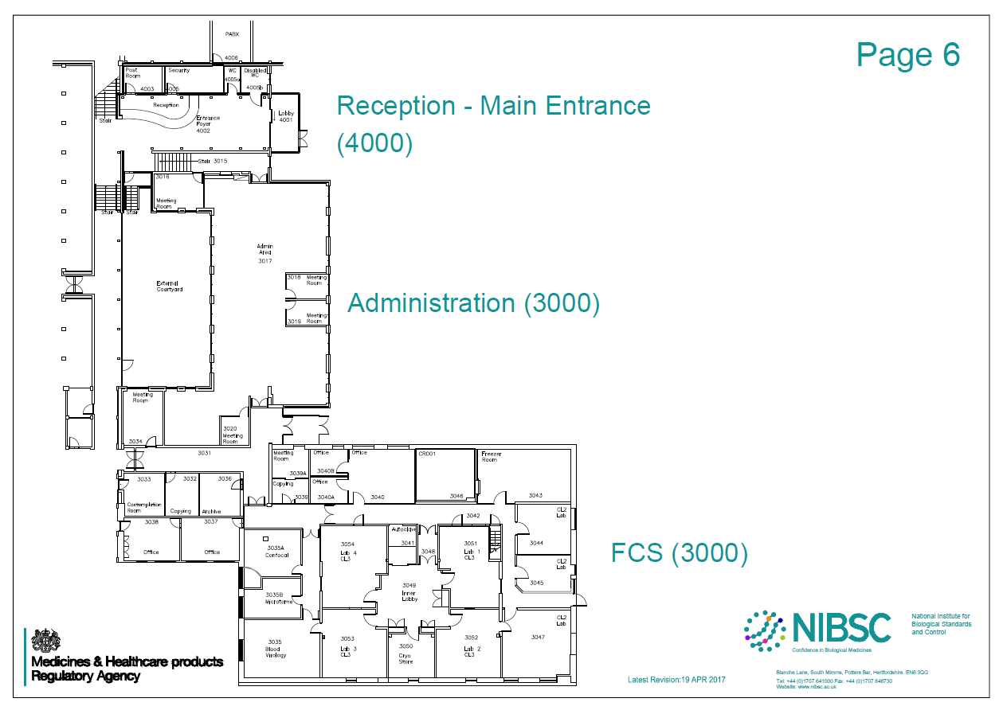
Zone 6
Zone 23
Zone 22
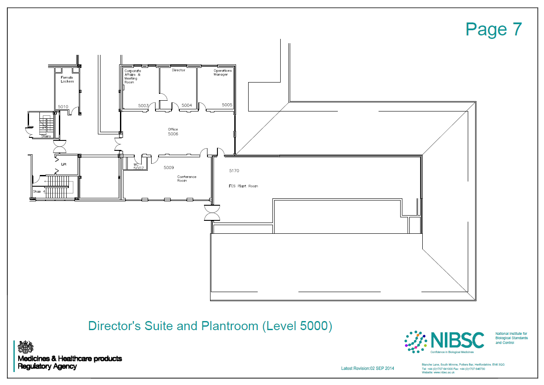
Zone 7
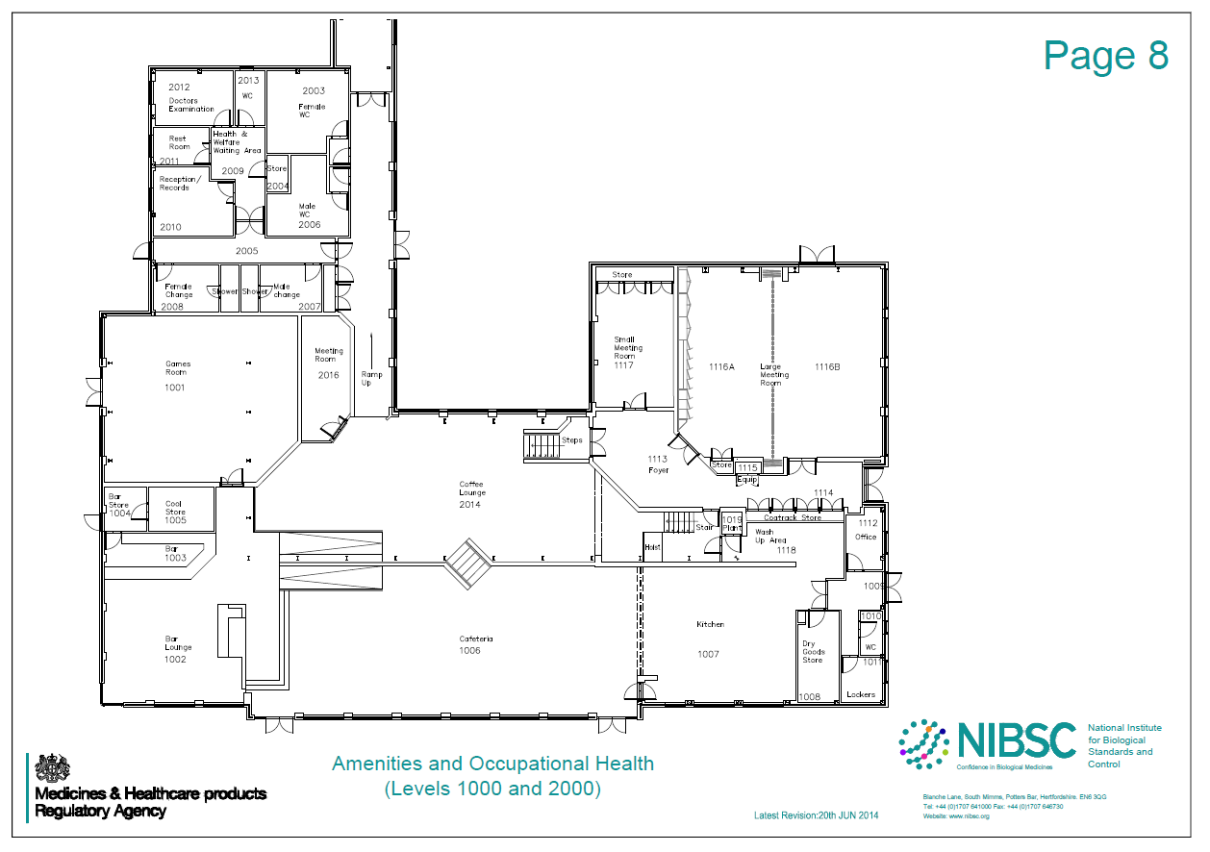
Zone 25
Zone 24
Zone 9
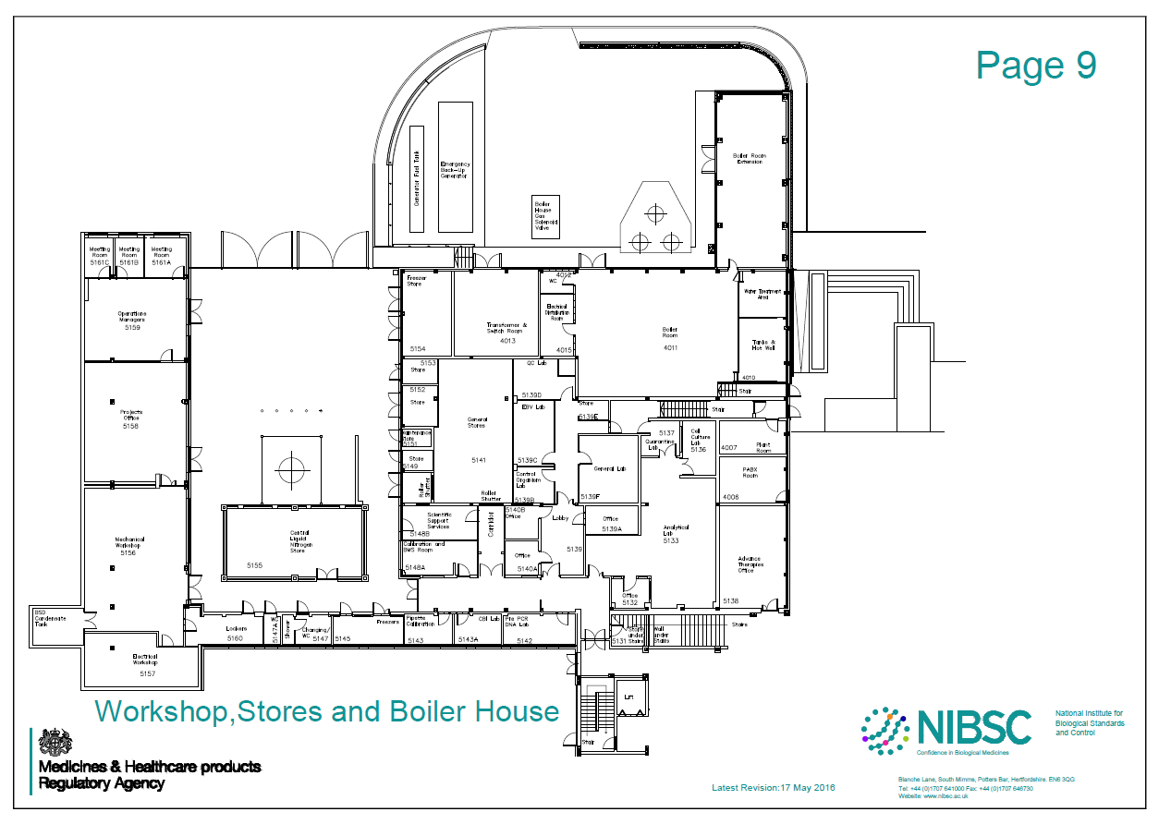
Zone 20
Zone 19
Zone 18
Zone 17
Zone 21
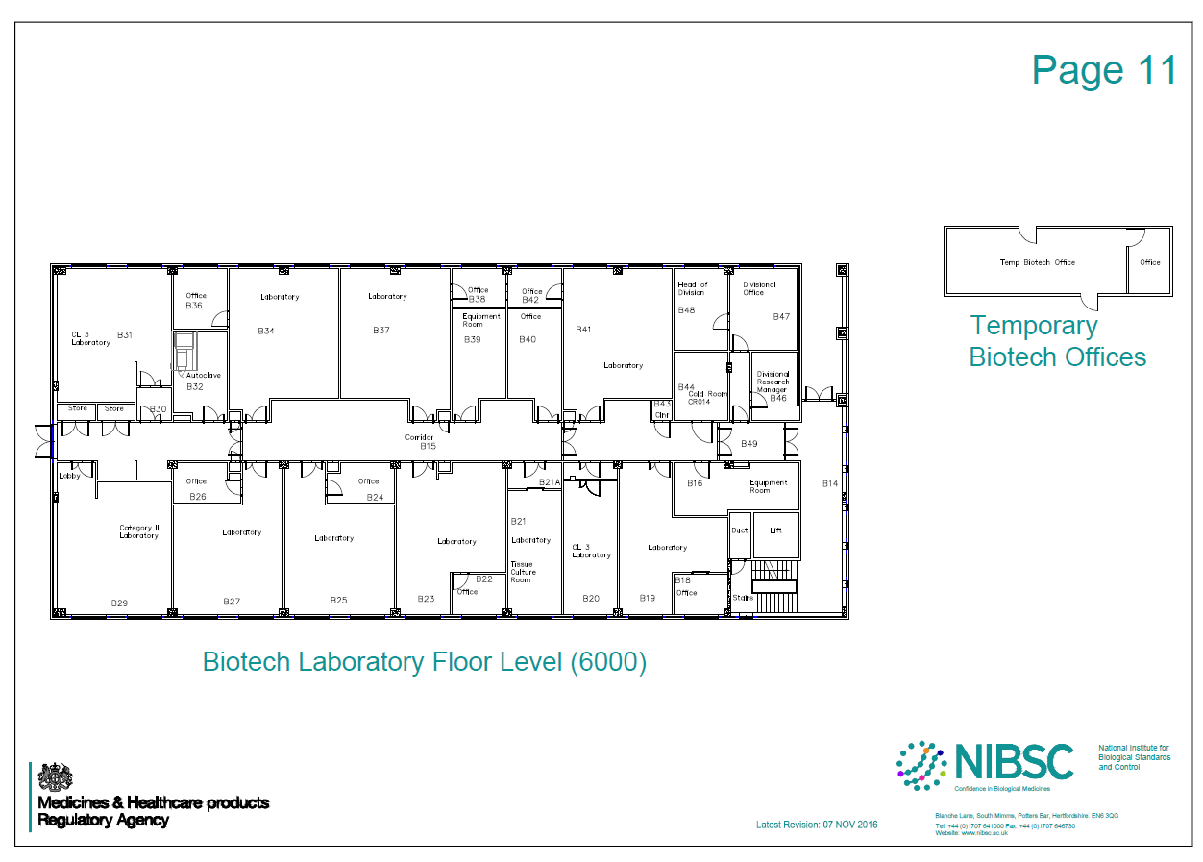
Zone 13
Zone 13b
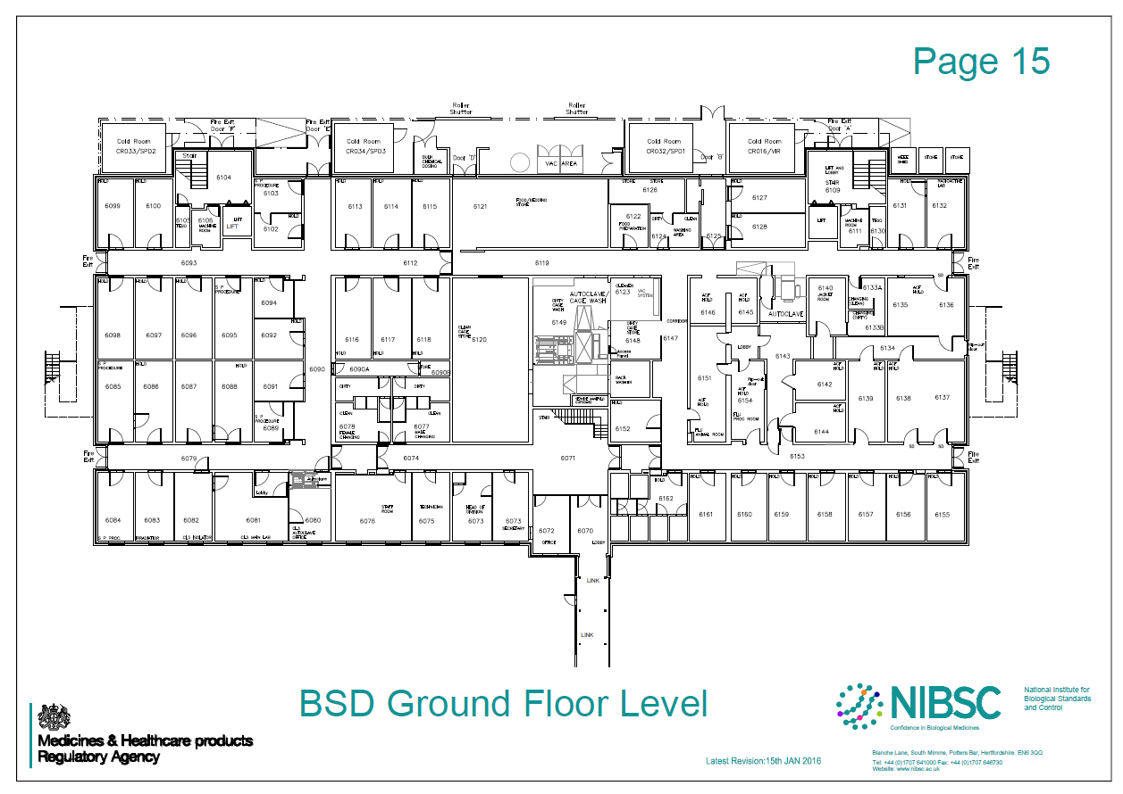
Zone 15
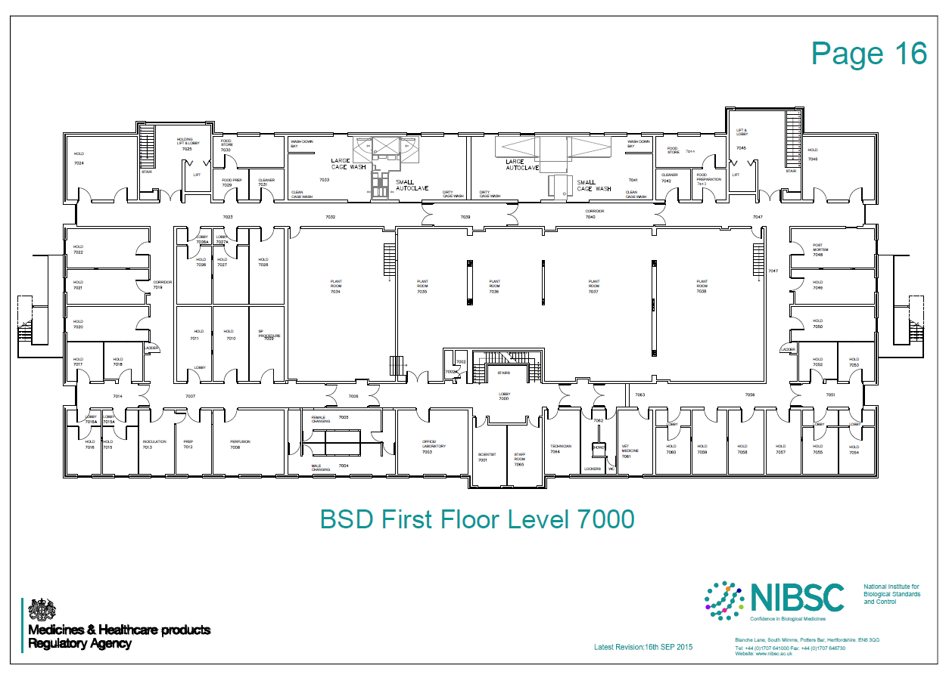
Zone 16
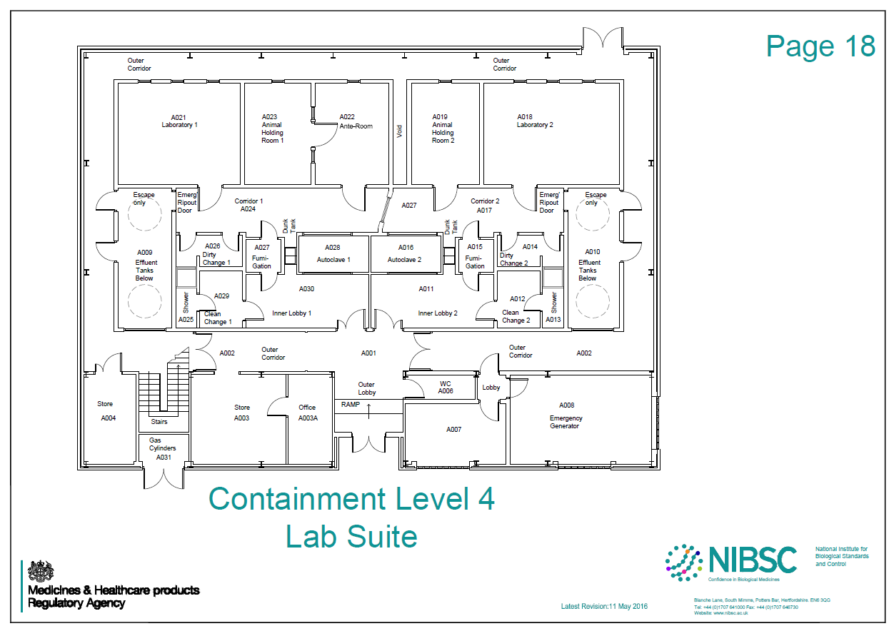
Zone 14
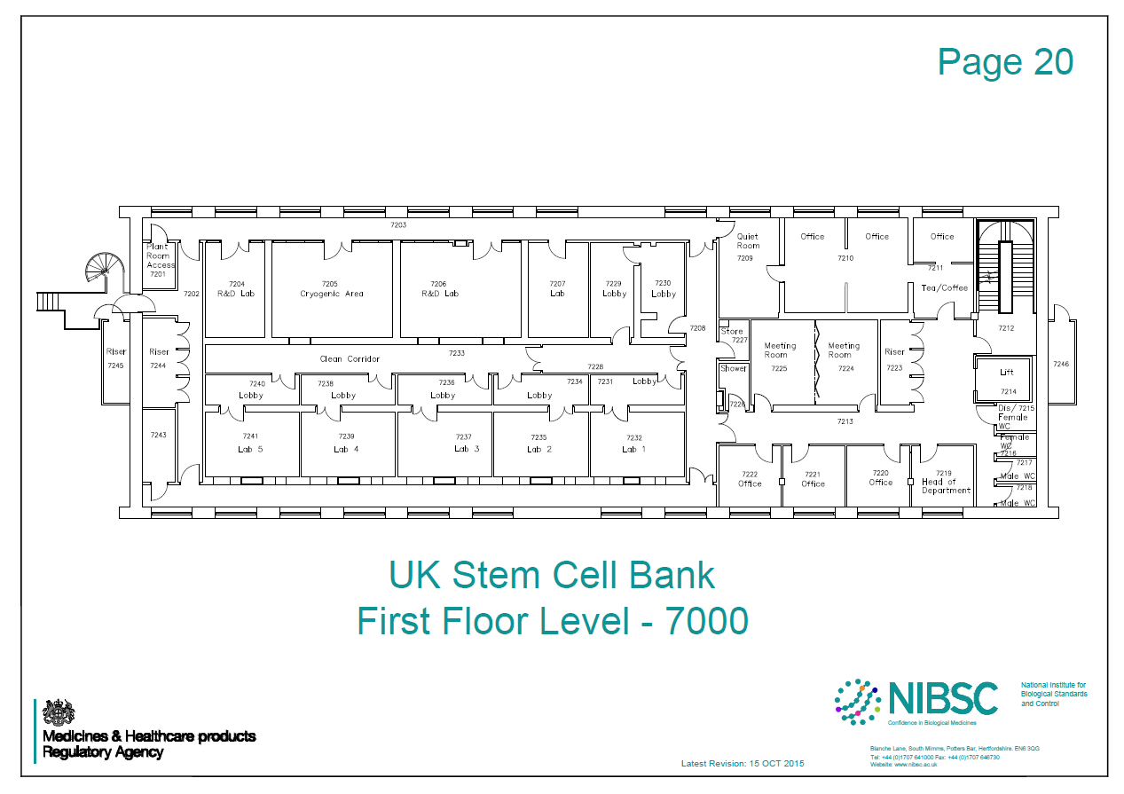
Zone 12
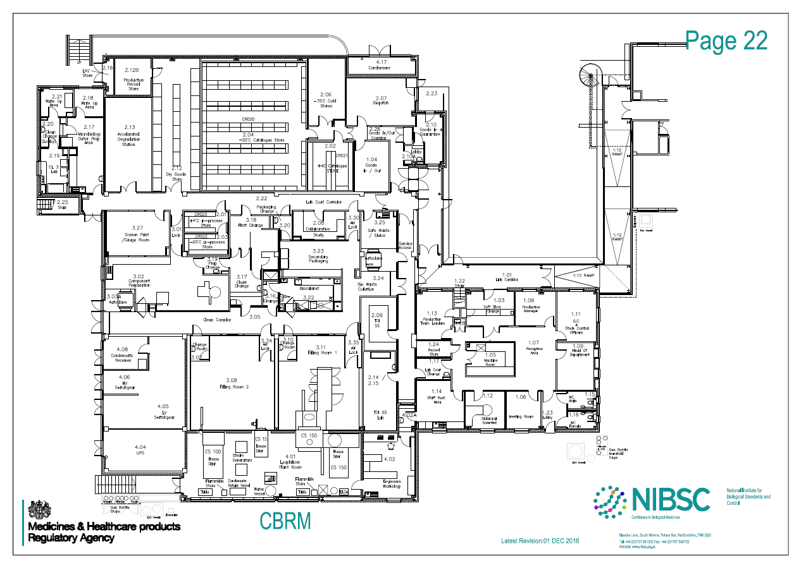
Zone 10
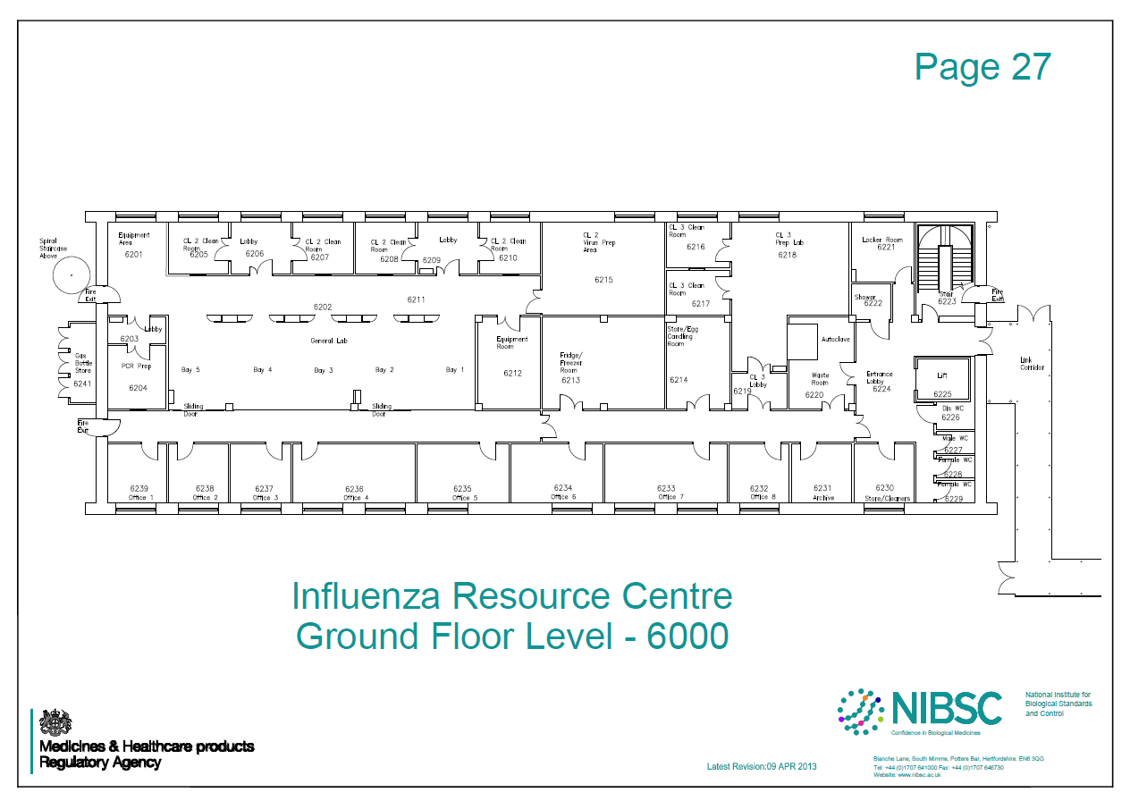
Zone 11
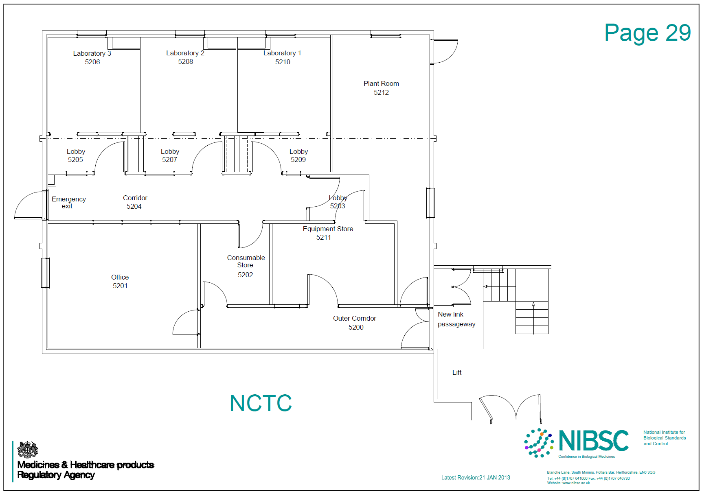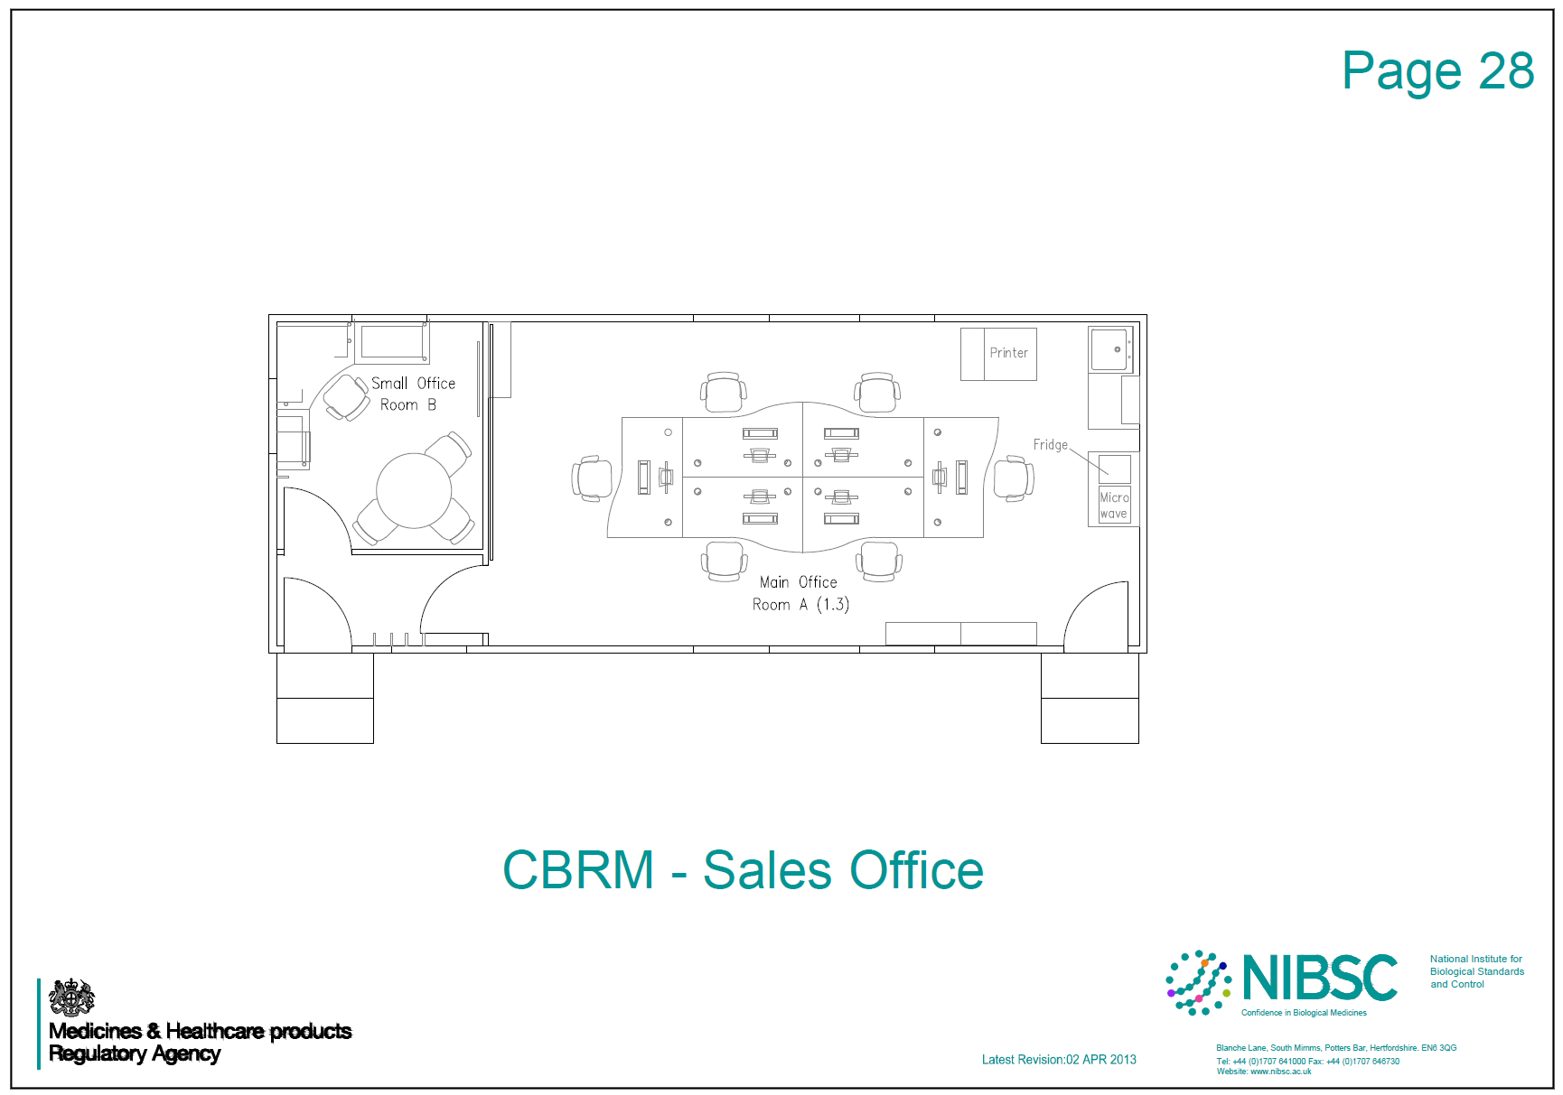

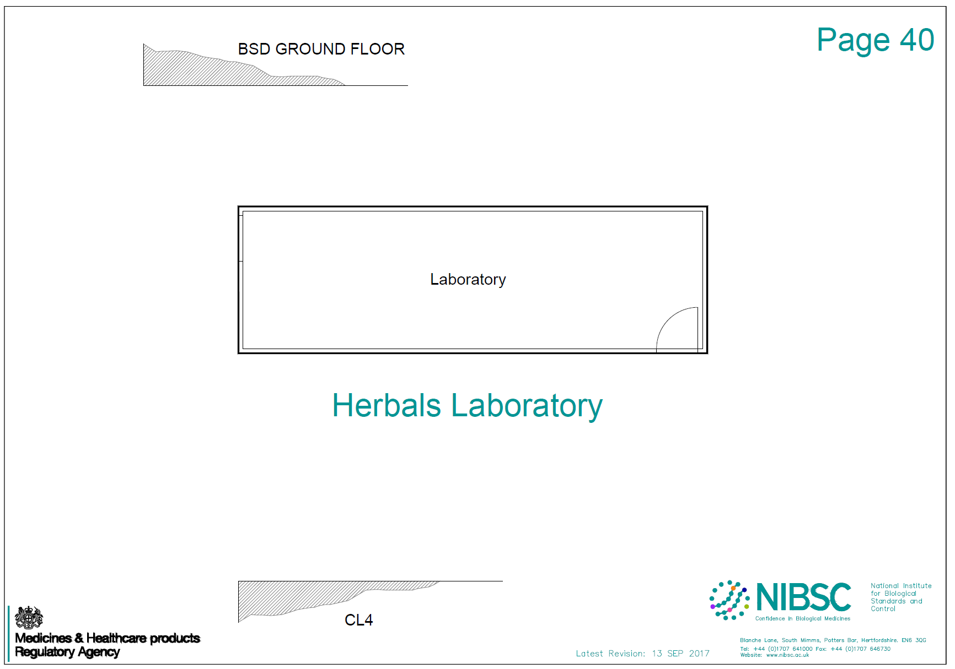
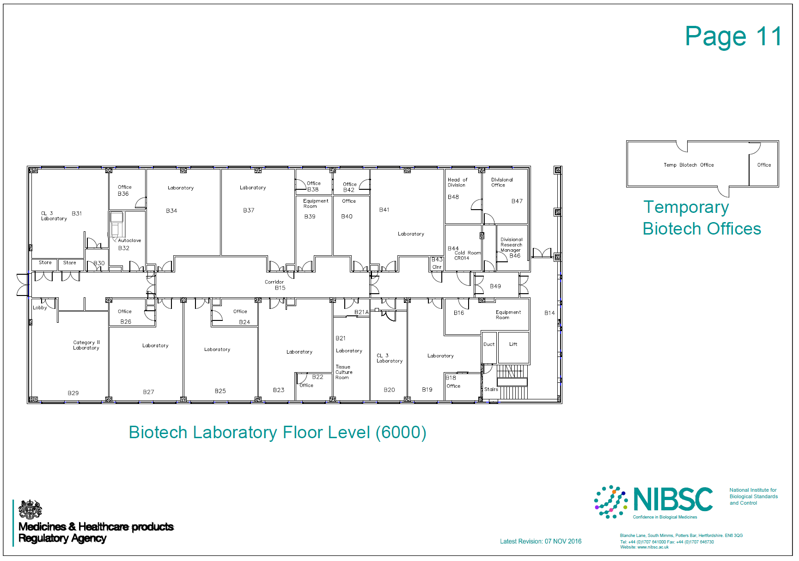
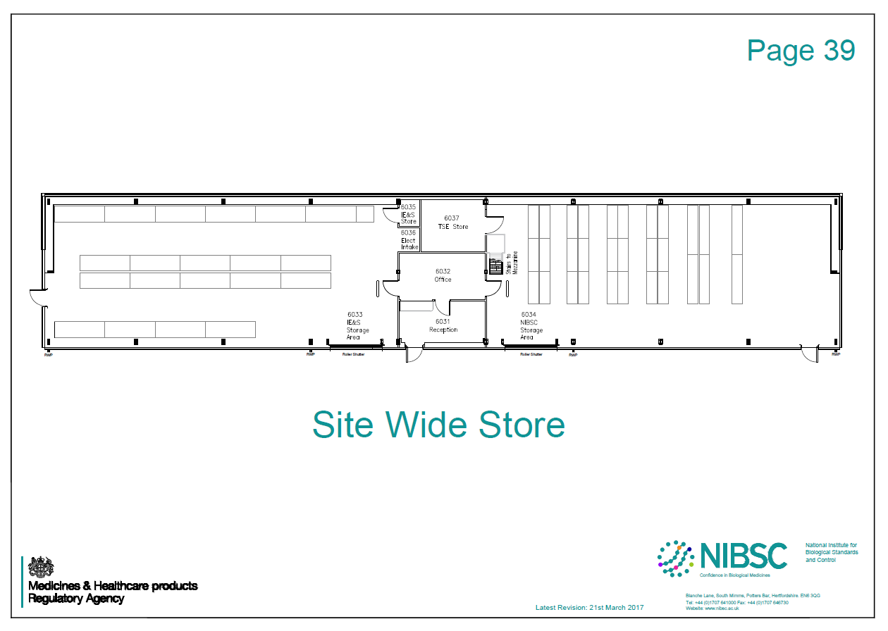
Zone 26

