_____________________________________

Schedule 1a
Tenderer’s Response Document – NOCRI

BMS Reference : 60323
_________________________________

Version: Final

Date: 03 March 2017

TABLE OF CONTENTS

INTRODUCTION 3

PART ONE - STATEMENT OF REQUIREMENT COMPLIANCE LIST 5

PART TWO - TENDER RESPONSE DOCUMENT 6

APPENDIX A - SUPPORTING INFORMATION regarding Partial or Non Compliance with the Department’s requirements 57

APPENDIX B - TENDER QUALIFICATIONS to Conditions of Contract 58

Schedule 1a – Tenderer’s Response

- Introduction.

The Tenderer’s Response Document is made up of the following parts:

  - Tenderer’s Responses
The Tenderers must respond to each row of Statement of Requirements (“SoR”) compliance list in their Final tender.

Where the Tenderer’s final Tender is only partially- or non-compliant, Tenderers must detail in Appendix A how they believe any alternative solution will meet the Authority’s requirements.

Please answer all questions as failure to do so may result in the final Tender being considered non-compliant and rejected. Where questions do not apply, please mark as “N/A” (Not Applicable) and provide a brief explanation as to why this is so.

Note: The Authority expects Tenderers’ final proposals to be consistent with their Initial Tender.

  - Appendix A
Where the Tenderer’s final Tender is only partially- or non-compliant, Tenderers must detail in Appendix A how they believe any alternative solution will meet the Authority’s requirements.

  - Appendix B
The Tenderer shall highlight areas of concern or show any specific amendments they wish to make to the Conditions of Contract. Feedback should include, but not be limited to, those parts which they will either not accept or would attach a significant risk premium and any proposed amendments should be shown as tracked changes. Tenderers must include a commentary to explain the reasons behind their proposed amendment(s) to the Conditions of Contract or the proposed inclusion of additional terms and identifying the value for money benefits to the Authority. The Authority reserves the right not to accept any or all amendments to its Conditions of Contract.

Tenderers are required to complete all the following sections and return the completed final Tender to the Authority. Please answer all questions as failure to do so may result in the final Tender being considered non-compliant and rejected. Where questions do not apply, please mark as “N/A” (Not Applicable) and provide a brief explanation as to why this is so.

Organisation details

Tenderer name
Please confirm the name of the Tenderer:
Tenderer Name: | LGC Limited
Full name of organisation tendering (or of organisation acting as the lead contact where a consortium bid is being submitted)

Contact details
Tenderers must provide contact details for this tender.
Contact Name* | Information redacted in line with section 40 of the FOIA
Telephone number | Information redacted in line with section 40 of the FOIA
Email address: | commercial.team@lgcgroup.com
Address: | Queens Road, Teddington, TW11 0LY
Contact is the person responsible for any queries relating to this proposal

Lot details
Tenderers must indicate by crossing the relevant box which lot this response is in relation to.
Lot 3 - NOCRI
Lot 3 – Multi bid (1&3)
Lot 3 – Multi bid (2&3) | x
NB: Lot three questionarie is separate.
Part 1 – Tenderer Response Document

For Tenderer’s ease, we have cross referenced the below set of questions with the relevant section in the Statement of Requirements, and the percentage of overall mark available for each question. Full details of the evaluation matrix, is shown in Table 3B: Technical Evaluation Matrix Lot 3, of Section 3 of Part A of the Invitation to Tender document

- Overview

Tenderers must provide a concise summary highlighting the key aspects of the proposal, and how their solution meets the Department’s objectives. Including the combination of lots for which they are tendering plus their ranked preference for the award of single and combined multiple lots. (as detailed in ISFT Part A section 1.19 to 1.25). This should include any strength, which in their opinion makes their proposal well placed to meet the Department’s requirements. Please include the overall price and any key assumptions made.

(This response is not evaluated and should be used to contextualise the Tenderer’s response.)
Question | D.1 | Weight | None | Word Limit | 750
Response 683 + 59 diag words = 742
Pressures on the health and social care system (H&SCS) are increasing due to demands from a population living longer with more chronic disease, and a simultaneous rise in the costs of new medical technologies/drugs. Effective clinical/industrial collaborations are essential to address these issues. LGC will provide NOCRI to identify and promote collaborations of the NIHR infrastructure with research partners, including industry.

LGC is a 175-year old, global life science company with over 3000 employees and is a trusted supplier to UK government, through its role as Government Chemist and as a National Measurement Institute. It has been responsible for delivering CCF and NOCRI since 2006 and 2009 respectively, through its Grant Management Group (GMG). LGC and its dedicated employees, have played an important role in the development of the NIHR over the last 10 years, and are firmly embedded within this health research system.

Together, LGC and GMG bring considerable benefits:
- Reputation and scale – delivering services on comparable contracts to UK government for > 20 years
- Information, systems, processes and security – robust, professional backoffice underpinning an international company often handing sensitive government work
- Commercial expertise – growth of LGC via Key Account Management (KAM) can be leveraged by NOCRI in professionalising Business Development (BD) functions
- Flexibility/responsiveness – LGC provides a highly adaptable service to meet evolving Authority needs, facilitating efficient prioritisation
- Scientifically/commercially qualified staff – expertise to identify, nurture and support development of research collaborations in Experimental Medicine (EM)
- Mind-set and understanding – staff continuously seeking opportunities to add value in pursuit of aims/objectives of OneNIHR
- Continuous Improvement (CI) – commitment to operating a new contract under the required CI methodology using IS09001/lean techniques already embedded within LGC, thereby realising benefits for future reinvestment
- CCF/NOCRI – capability and enthusiasm to build on current relationship and provide a virtual OneNIHR BD team with CRN, that appears industry seamless

The elements of LGC’s approach are competencies which underpin world class delivery and focus on continuous value-adding enhancements:

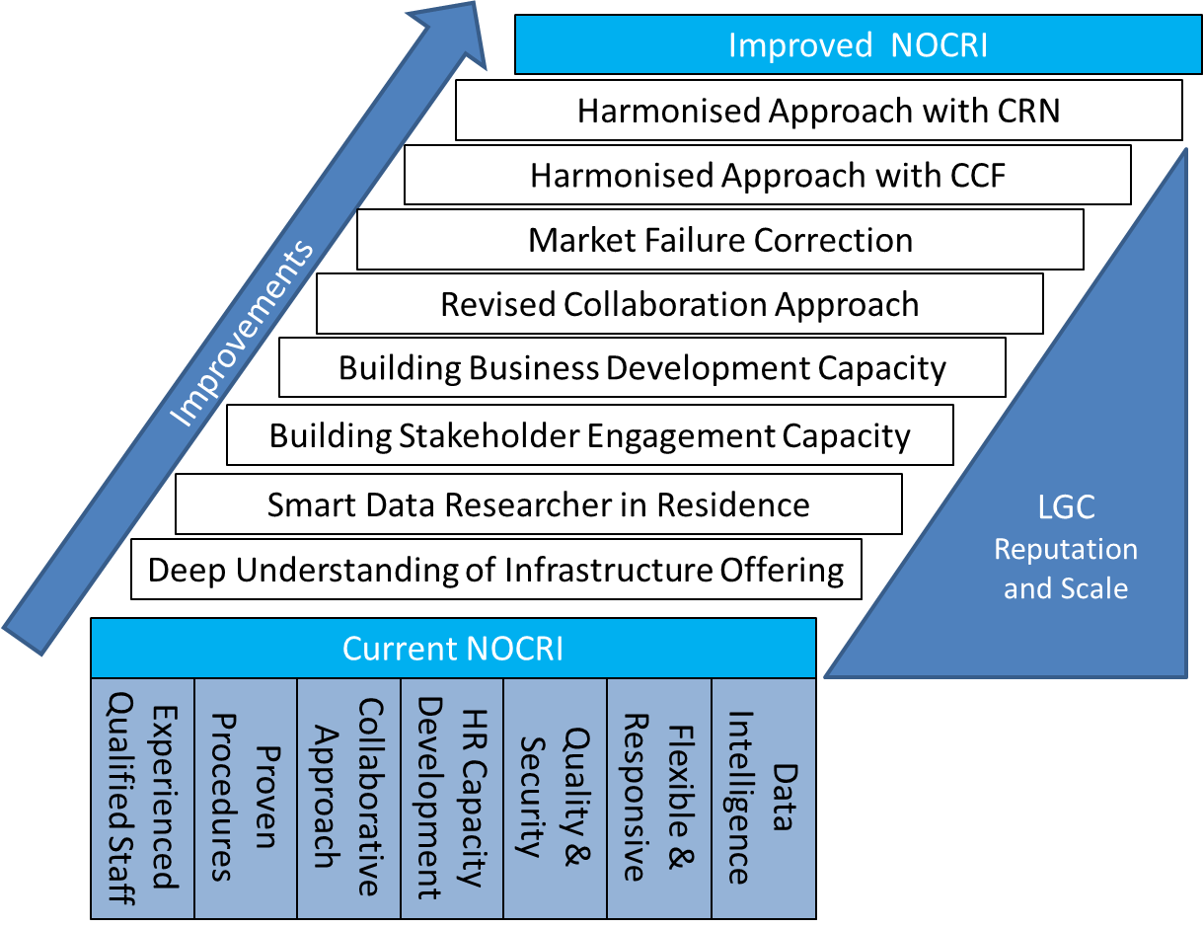

LGC welcomes the opportunity to refresh the NOCRI delivery model, providing a solution that safeguards the distinct and independent functionality unique to NOCRI. This London based model offers seamless collaboration with CRN and CCF in line with OneNIHR aims.

LGC recommends the following improvements to the Authority, which are all included in the contract price:
- Harmonising CRN and NOCRI – a virtual OneNIHR BD team; seamless customer experience for industry via a single point of entry and joint KAM embodied in an Memorandum of Understanding (MoU) and joint Standard Operating Procedures (SOPs)
- Harmonising CCF and NOCRI – deep collaboration embodied through SOPs covering cross-fertilising experience/capabilities and leveraging administrative efficiency savings to enhance the performance and impact of both functions
- Market failure correction – prioritisation of NOCRI resource ensuring focus on collaborations which would not occur without NOCRI’s intervention
- Revised collaboration approach – a light touch strategic management rather than operational delivery approach to setting up and monitoring collaborations
- Building BD and Stakeholder Engagement (SE), capability & capacity – reinvestment of administration cost savings in additional Business Support (BS) and SE posts with complementary sector expertise
- Better use and insight from the widest available set of data sources – NOCRI activities prioritised with insight from varied NIHR data sources; CCFs detailed understanding of the NIHR Infrastructure portfolio and wide-ranging Business Intelligence (BI) capabilities; Collaboration with the National Smart-Data Institute to improve NOCRI big data analytics

NOCRI Multi-lot is LGC’s preferred model where CCF is included within the remit because it will create value through synergies and cost savings for the Authority. By way of the efficiencies created and goodwill, NOCRI Multi-lot is offered at an average annual price of circa £1.34m. A ~£162k p.a. discount on the NOCRI Single-lot price (circa £1.5m p.a.).

Similarly we are able to discount CCF Single-lot by ~£60k p.a. and offer CCF Multi-lot at an annual average price of circa £9.6m. A total saving of ~£1.1m over 5 years.

LGC feel this represents significant value for a gold standard service which focuses on further developing the excellent relationship between LGC and the Authority, adding value at every opportunity through CI and realising efficiencies via closer working between NOCRI and CCF.

- Method Statement – A: Overall Delivery.

Write “Confirmed” to confirm acceptance that you are Fully Compliant with each row
Topic | Subject | SoR Requirement Reference | Type of Requirement Mandatory (M) or Desirable (D) | Compliance (to be completed by Supplier)  Confirm
Service Delivery | Requirements | 4.3 | M | Confirmed
Service Delivery | Working approach | 4.4.1 | D | Confirmed
Service Delivery | Working approach | 4.4.2 | D | Confirmed
Service Delivery | Working approach | 4.4.3 | D | Confirmed
Service Delivery | Working approach | 4.4.4 | D | Confirmed
Service Delivery | Functional Requirement | 5.15 | M | Confirmed
Service Delivery | Functional Requirement | 5.16 | M | Confirmed
Service Delivery | Premises/Location | 7.1 | D | Confirmed
 | Premises/Location | 7.2 | D | Confirmed

The Tenderer must detail the processes and resources it proposes to use in order to deliver the Authority’s requirements as set out in the descriptive document, noting that scope of work is comprehensive and consequently prioritisation of key functions and activities will be necessary. In the response Tenderers must evidence how they will :-

- Work effectively with industry-facing and business development staff working in NIHR-funded infrastructure, and for other research funders and UKTI, in order to build more strategic marketing to individual companies,
- Develop and maintain effective relations with industry trade associations.
- Assist investigators working within NIHR-funded facilities who are seeking industrial partners for collaborative research.
- Facilitate the establishment, co-ordination and operation of Translational Research Partnerships and Collaborations

Question | D.2 | Weight | 30% | Word Limit | 3000
Response 2807 + 103 diag words = 2910
NOCRI’s comprehensive scope will be delivered by LGC through a dedicated NOCRI Directorate within LGC’s GMG. The team will deliver SE, BD and Collaboration Development (CD) activities to catalyse, facilitate and prioritise the formation of impactful collaborations.

The team will work closely with colleagues in CRN (to present a harmonised virtual BD unit) and with LGC’s CCF teams, for a joined-up approach to infrastructure, BI, monitoring and Small Medium Enterprise (SME) / charity engagement, using processes agreed in joint SOPs.

The NOCRI Managing Director (MD), BD and SE teams will be predominantly based in central London to maximise collaboration and coordination opportunities with CRN and industry. The remaining team members will be based with the CCF team in Twickenham. There will be a daily flow of staff between the two locations and weekly, formal all-team meetings.

The main benefit of this approach is the emphasis it places on providing a true OneNIHR interface for potential charity/industry users of NIHR infrastructure and enhanced levels of knowledge sharing and collaboration between key staff working on the NOCRI/CCF/CRN services.

LGC will deliver NOCRI’s core purpose using the process shown below:

1. Oversight and Governance
Given the comprehensive scope of NOCRI, careful planning and prioritisation will be necessary to make best use of finite resources. LGC proposes to develop three year strategic and annual operational plans with input and direction from the Authority, NOCRI MD, the GMG Director and an External Reference Group (ERG).

The plans will incorporate information gained from previous engagement activities and CI processes. Strategic plans will ensure that NOCRI catalyses collaborations that meet national priorities and engages industrial groups with differing levels of experience of UK clinical research. Annual plans will include detailed deliverables reviewed quarterly, adjusted through agreement with the Authority as priorities evolve. These strategic and operational plans will be the key documents that drive all subsequent steps, ensuring that NOCRI contributes to achieving NIHR’s vision, aims and objectives. Effective planning will ensure that the margins of NIHR infrastructure and those areas requiring specific policy focus will be promoted in parallel to NOCRI working with large established groups.

The prioritisation of activities and allocation of resources will use an SOP-defined process and will involve consideration of multiple factors including:
- H&SCS priorities (such as a specific disease)
- Key characteristics of successful collaborations
- Industry trends
- Collaborations forecast added-value or potential to overcome key technical challenges

A risk-based portfolio approach will also be used to keep the Authority informed through regular open communications of the NOCRI pipeline, portfolio of collaboration opportunities, and more formal quarterly review meetings.

2. Stakeholder Engagement
NOCRI must identify opportunities for collaboration. This involves identifying leads, managing relationships with intermediaries, understanding needs and supporting the BD team with strategic marketing. Activities may be “reactive”, where organisations approach NOCRI directly, or “proactive”, where NOCRI identifies opportunities through analysis and discussion with researchers, funders, industry and charities.

LGC will ensure resources are allocated appropriately as each approach requires different skills and techniques:
- Reactive engagement must provide a simple management mechanism and a process to quickly but effectively evaluate enquiries
- Proactive engagement requires open, regular and productive relationships with a broad spectrum of researchers, funders, trade associations, industry and charities

Both approaches must be underpinned by a thorough understanding of the NIHR portfolio, healthcare and industry trends. Insight will be gained via access to data from NIHR Coordinating Centres (CCs) and through early access to the outputs of the NIHR Innovation Observatory (NIHRIO), which will over time identify infrastructure strengths, clusters of infrastructure expertise, healthcare research trends, H&SCS needs and links to healthcare charities.

LGC will provide an established and highly skilled SE and BD team, with a wide network of contacts that will, continually gain insight through a combination of sophisticated data analysis, KAM, SOPs, standard processes in industry signposting and strong personal networks managed through the NIHR Customer Relationship Management (CRM) system.

The team will collaborate with all parts of the NIHR and beyond to maximise the effectiveness of the UK clinical research infrastructure, including:
- UKCRF network
- Researchers
- UK Government departments/agencies including DIT
- Companies
- CRN
- ECMC Programme Office
- Overseas governments
- Trade associations (e.g. BIA, ABPI, Medlinks etc.)
- Charities
- NHS leaders
- The Authority

NOCRI will develop and maintain effective relations through trade association representation on the ERG, joint events and presentation by NOCRI staff at trade events.

Other routes to direct/indirect engagement and marketing will include:
- Publication of articles including references to NIHR infrastructure
- Participation in trade missions and roadshows
- Promotion through international Clinical Research Organisations (CRO) - see Question 4
- Development of thought leadership pieces
- Development of printed and digital marketing materials

NOCRI will receive a high proportion of enquiries from organisations whose interests are outside NOCRI’s mission. It is important that these enquiries are handled efficiently to avoid losing opportunities that may benefit the wider H&SCS. Enquiry signposting will be coordinated centrally via existing SOPs, as described below, and made to available other parts of the NIHR (e.g. CRN), NHS, other funders and charities as appropriate.

3. Business Development
Through collaboration with all CCs, NOCRI will exploit the valuable database of infrastructure applications, annual reports and public domain resources. This will use intelligence gathered from direct interaction with infrastructure contacts to identify areas where future research collaboration is needed. LGC’s internal resources will include Information Services (IS) staff, with expertise in big data analytics, applied to health research management. Coupled with inputs from NIHRIO, this will drive future strategic and operational plans to ensure that NOCRI prioritises areas of greatest need, significant capability gaps or high policy relevance.

The NOCRI (and CCF) teams will coordinate BD engagement with industry and with CRN as described below. This will include:
- The selection of NIHR wide key accounts to avoid duplication and maximise accountability
- Provision of a OneNIHR entry point for enquiries, information sharing and impact monitoring

To formalise this collaboration, LGC will seek a MoU with the CRN consortium, like that between LGC and the Wessex Institute, for CCF/NETSSC collaboration. In addition, a staff member from NOCRI (Director of Industry and BD), will act as the principal liaison point between NOCRI and CRN. In time, this point of liaison may evolve into a joint appointment.

Opportunities for the NIHR Infrastructure require the application of BD techniques in collaboration with BD resources based locally. LGC will assist in the marketing of opportunities via a mix of raising general awareness and targeted strategic marketing, both for the direct and indirect promotion of NIHR infrastructure and to catalyse collaboration opportunities.

In their simplest form, BD activities will involve direct introductions of infrastructure or NIHR collaborations to interested parties (and vice versa). More complicated collaborations will be built through iterative dialog with several infrastructure, industry and charity partners to help identify collaboration partners, NIHR partners and various technical aspects relating to trials.

4. Collaboration Development
LGC will facilitate the establishment, coordination and operation of Transitional Research Partnerships and Collaborations (TRP/Cs) as follows:

Facilitating Establishment: LGC benefits from 10 years’ experience in managing CCF programmes including the bulk of the NIHR Infrastructure contracts. LGC is therefore well placed to identify a possible collaboration opportunity from knowledge of the asset base. LGC will work with the local resources to evaluate, plan and market possible new structured research collaborations and Translational Research Collaborations (TRC) to interested parties. Approaches used will include broad and targeted communications with bespoke materials.

Co-ordination: LGC will use a light-touch approach to CD, guided by SOPs whereby NOCRI will provide guidance, tools and advice that support establishment of well-structured collaborations, which can then be marketed accordingly. Tools and guides have been developed throughout the current contract and will continue to be improved as best practice evolves. A portfolio of collaborations, (established and under development), will be maintained and be subjected to a risk-based portfolio management approach involving the Authority as required.

Operation: Established TRC’s may be looking for a steady supply of industry and charity collaborators. LGC can support these established collaborations with direct marketing support and matchmaking. New collaborations may be looking for advice and support which can be delivered through extensive dialogue.

NOCRI staff are more directly involved in the establishment and then operational delivery of selected established collaborations. In the short term, LGC will handle the transition in the monitoring of these collaborations from the current hands-on approach to a light-touch mode. In time, this may free resource for redeployment in other NOCRI activities.

5. Monitoring and Continuous Improvement
NOCRI will provide light-touch support to the local day-to-day operated delivery of collaborations. Once collaborations are established, NOCRI will retain a keen interest in the process, outcomes and issues, such that future tools, guides and best practice can be identified and disseminated. NOCRI and CCF Infrastructure will work together to use any existing contractual relationship (e.g. Biomedical Research Centres - BRC) to help resolve issues requiring BRC support for TRC activities.

In addition, LGC will focus on innovative solutions to streamline monitoring activities across the NIHR Infrastructure and wider NIHR portfolio by connecting key datasets (IFS annual reporting, 70 day benchmarks, CRN Commercial Portfolio, global recruitment data etc.) whilst ensuring no duplication. LGC will be able to provide as broad as possible insight and analysis of trends, outputs, progress and capabilities that will further enhance future NOCRI (and CRN) collaboration and promotion activities.

Presenting OneNIHR to external partners
Industrial groups and charities wishing to perform research in the NIHR-funded infrastructure need to have a OneNIHR experience. There is an opportunity for the NOCRI/CCF/CRN teams to build on previous close working, to launch joint industry contact mechanisms (BD and marketing activities) and working processes (SOPs).

Under the new contract, LGC aims to enhance the provision of a seamless experience of working with the NIHR, even though NOCRI/CCF/CRN and provide distinct functions. As set out in the chart below NOCRI/CCF/CRN teams have complementary strengths:
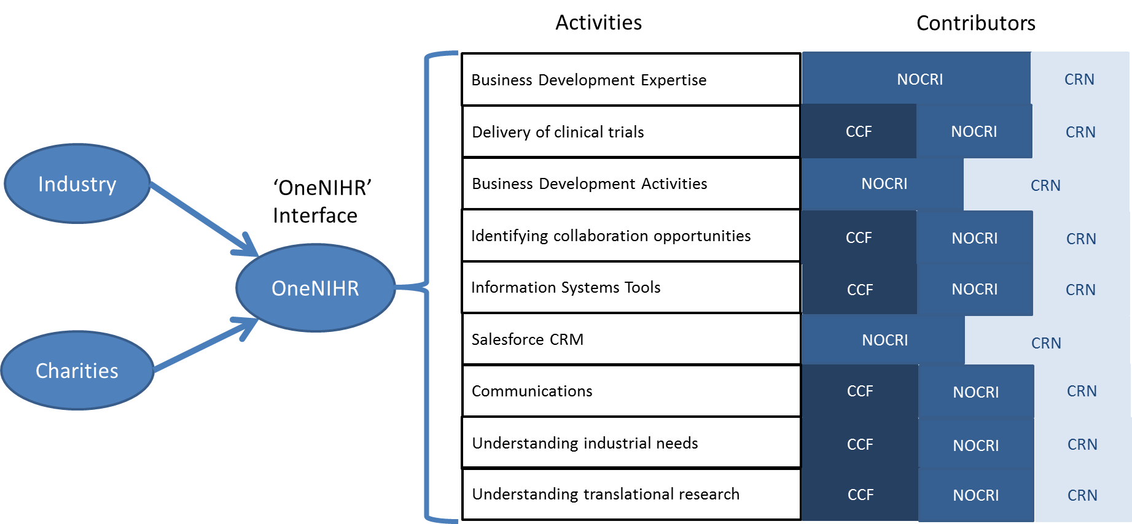
LGC’s aim is to leverage the intimate knowledge of the NIHR Infrastructure, gained through past NOCRI/CCF work, with the skills and experience in transactional style BD at CRN and the more consultative style NOCRI BD approach. The proposed high degree of collaboration will not detract from the obligations of the three teams embodied in their respective KPIs. In time, the joint approach may be extended to other industry/charity facing parts of the wider NIHR ecosystem, such as the ECMC Programme Office.
The elements of the proposed harmonised approach are set out in the following table. LGC would work with CRN during the transition period to implement these from Day One of the new contract.
Improvement | Approach and benefits
Jointly agreed and operated standard processes covering a broad range of activities | - Joint SOPs (CRN/CCF/NOCRI) covering:  - KAM  - Signposting  - Strategic marketing  - Events etc.  - Virtual BD team  - Shared audit and quality methodology  - Agreed data standards and collection methodologies  - Shared CI projects and priorities
Creation/co-management of intelligent reception for OneNIHR | - Utilise industry portal, single enquiry lines/email address, joint ‘scripts’  - Signposting decision trees, delivered across NOCRI/CCF/CRN teams
Implement regular (i.e. monthly) NOCRI/CRN/CCF BD portfolio meeting; could be extended to NETSCC | - Cultivating a single (virtual) OneNIHR BD team - sharing and reviewing opportunities, targets, active portfolios, marketing and engagement plans, horizon scan issues, process improvements and joint training initiatives  - Improved strategic planning and joint ownership of BD activity reinforcing the concept of a joint team across the organisations  - Allows Authority to participate, if desired, providing confidence in joined-up approach
Better planning/co-ordination of attendance at industry conferences/events | - Better use of resources (both people and financial) whilst improving reach  - NIHR represented with one voice  - Coordination with other Government Departments/bodies (e.g. DIT, Innovate UK and OLS)
Joint strategy for Industry marketing/BD | - Shared NOCRI/CRN/CCF annual marketing plan  - Common contact email/phone number, joint NIHR marketing plan, shared marketing materials and marketing script  - Joint meetings with potential industry partners where appropriate, joint industry conference attendance, sharing relevant opportunities  - Allows broader reach across industry/charities with relatively small team via shared connections, intelligence and opportunities (may not be realised if working separately)
Ensuring other organisations market the NIHR correctly | - Working with trade organisations/government departments (e.g. DIT) to present cohesive message about NIHR offer  - Ensure they signpost interested parties to NOCRI/CRN/CCF. This will be important for even stronger positioning of UK (and NIHR) post Brexit
Enhancing Software Tools | - NOCRI/CRN now use a bespoke ‘Salesforce’ CRM system; in future it will be necessary to use CCF IS team to create additional tools to harness the volume/sources of data required to proactively identify opportunities, set up new collaborations and monitor active collaborations
Charity engagement/BD | - Work with CRN and NETSCC to ensure that CCF, NETSCC, NOCRI, ECMC Programme Office, UKCRF and CRN interactions with charities are synchronised  - Targeted approach will enable NIHR to be proactive in defining charities with which it wishes to work with rather than responding to ad-hoc requests
Infrastructure communications | - Working with CCF and CRN communications and collaborative NOCRI/CCF/CRN forum to ensure aligned communications, LGC will continue to support flow of information to inform NIHR publications and delivering a consistent message to the outside world  - Note: The LGC-managed NOCRI has developed and chairs an Infrastructure Communications Group, bringing together those staff at NOCRI, CCF and CRN responsible for NIHR Infrastructure communications. This has now become a standing group under the NIHR Communications Programme Board
Ensuring study delivery for TRPs/TRCs | - NOCRI has worked with CRN study delivery team to ensure optimal delivery of TRP studies  - Close working with the CRN to address any escalated issues and concerns identified from TRCs
Industry website portal | - LGC will continue successful co-management of the NIHR-wide project to redevelop industry portal on NIHR website, resulting in NOCRI/CRN having a better aligned service offering to industry, supporting a more OneNIHR offer to industry
Development of joint industry key accounts | - Agree on NIHR wide key accounts for NOCRI/CRN/CCF BD teams  - Implement a KAM approach to build long term relationships with industry. This will help attract overseas investment in to the UK that will contribute to the industry  - All activities will be agreed and harmonised with CRN to avoid duplication and maximise accountability, information sharing and impact  - LGC has extensive experience of KAM from its commercial operations, including the investment in training programmes (Miller Heiman account management) and the use of Salesforce CRM, which will be leveraged to support the BD teams
Other NOCRI Functions
LGC will maximise the impact of NOCRI by providing further activities delivered across its comprehensive scope:
- Participating in working groups associated with cross-NIHR work such as Push-the-Pace (PtP) and the Digital Ecosystem
- Identifying through delivery of CD, potential new collaborators whose interest is in developing new competencies that will make the NIHR infrastructure more effective. These will be assessed, prioritised and marketed as appropriate
- Providing, as directed by the Authority, an oversight of the UKCRF Network
- Designating a staff member to act as the principal point of contact for answering all the Authority queries including parliamentary requests
- Assisting investigators working within NIHR-funded facilities, who are seeking industrial partners for collaborative research, often by signposting to local sources of support

Value-added improvements/enhancements
LGC’s CI processes and gain share mechanism (Question D9) will generate and agree regular enhancements.

Initial opportunities for value-adding include:
Innovation | Delivery Mechanism | Benefit to Authority | Resource Impact | Implementation Date
Harmonised working with CRN/NOCRI | As previously outlined | - More efficient use of resources  - Better experience for NIHR clients including industry and charities | Evolving to BAU | 1st April 2018
Harmonised working with CCF/NOCRI | - Joint SOPs covering multiple areas of mutual interest (e.g. SME/charity engagement, portfolio mapping, Intellectual Property (IP) & commercial services) and support (e.g. data and BI)  - CCF and NOCRI staff will be distributed between Twickenham and central London with staff moving between locations, generating gains in both CCF and NOCRI  - Cross-team knowledge exchange and resourcing will be implemented | - Cross-fertilising experience and capabilities  - Expanded workforce involved in monitoring of Infrastructure collaborations  - Better utilisation of pan NIHR data  - CCF will benefit from NOCRI’s input into Infrastructure annual reports, expertise in commercial interactions, KAM and stakeholder communications | Evolving to BAU | 1st April 2018
Joint working with AHSNs | - Strategic collaboration agreements  - More structured signposting  - Sharing of best practice in industry/(especially local SME engagement)  - Targeted promotion, engagement and BD in specific areas (e.g. Medtech, digital health)  - Support for developing “Innovation Exchanges” | - More collaborations  - Better information sharing  - Improvement in all KPIs | Evolving to BAU | 1st April 2018
Joint working with AHSCs | - Strategic collaboration agreements  - Supporting AHSC NHS engagement and SE/BD activities  - Working more closely with local BD/TTO staff associated with AHSCs | - NOCRI gains access to AHSC local contact networks and knowledge  - AHSCs benefit from NOCRI experience  - Potentially improves translation of new innovations | Evolving to BAU | 1st April 2018

Summary
LGC will deliver NOCRI in a harmonised approach with CCF, working with CRN to produce a OneNIHR perspective to industry and researchers. Combining LGC’s current operating model with innovations that leverage capabilities, NOCRI/CCF will ensure that the utilisation of NIHR clinical research infrastructure by industrial partners around the world, is diversified and enhanced for mutual benefit.

- Method Statement – B: Team

Write “Confirmed” to confirm acceptance that you are Fully Compliant with each row
Service Delivery | Functional Requirement | 5.17 | D | Confirmed

Tenderers must detail their resourcing model in order to demonstrate the teams’ knowledge and understanding of the wider NIHR and the research commissioning environment. Tenderers should give a clear explanation of how knowledge will be kept up to date and how they will demonstrate leadership in the wider context of NIHR commissioning and management.

Question | D.3 | Weight | 20% | Word Limit | 1500
Response 1408 + 88 diag words = 1496
LGC will deliver a self-sufficient NOCRI as a dedicated Directorate within its GMG. The GMG is part of LGC’s Laboratory and Managed Services Division, managed by Information redacted in line with section 40 of the FOIA

Resourcing Model
LGC will revise the current delivery model, to emphasise OneNIHR approaches to SE/BD, working (with CRN and CCF) and lighter-touch CD (with CCF), thereby enhancing the quality of service. Delivery of administration through the CCF Business Support Team (BST) enables expansion of NOCRI through addition of new SE and BD staff.

Three Mandated roles
LGC will deliver the roles mandated in the specification as follows:
- MD = MD
- Programme Manager NIHR TRC/TRPs = Director of Industry and BD
- Industry Liaison = shared between staff in the SE and BD teams

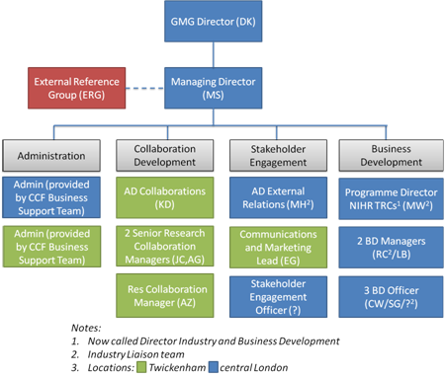

The NOCRI team will comprise 14 staff (shown in the Figure above, supported by two administration staff provided by CCF-BST and the apprentices as set out in Question D7. Line management will remain unchanged from the current model. Staff working across the NOCRI and CCF contracts will hot desk between the Twickenham and central London locations. Monthly whole NOCRI team meetings will be held. Ten seats in central London have been costed.

Managing Director
LGC will appoint a MD with the competencies to manage operational delivery, develop strategy and represent NOCRI. The MD will join the GMG Senior Leadership Team (SLT) which will focus on ensuring that NOCRI/CCF activities are delivered in an efficient and harmonised way. LGC will discuss the MD role with the Authority during transition.

External Reference Group
The ERG will be appointed from infrastructure stakeholders (e.g. BRCs, Medtech/pharmaceutical companies) and the Authority to aid NOCRI in prioritising activities. The unpaid ERG will meet twice a year to discuss industry trends and provide feedback on strategic plans.
Stakeholder Engagement
The Assistant Director (AD) External Relations will lead on Stakeholder Engagement across industry sectors and providing leadership gathering intelligence and guidance on methodologies for targeted and blanket marketing/promotion of collaborations. The AD will work with senior stakeholders to gather intelligence on the UK/NIHR research landscape. A NOCRI communications and marketing lead, responsible for delivering marketing campaigns and digital marketing, and a new Stakeholder Engagement Officer will support the AD.

Business Development
The BD team will include the Director of Industry and Business Development, BD Managers and BD Officers from diverse scientific, commercial and funder backgrounds so that LGC can:
- Engage with other research funders
- Engage with trade associations, international bodies and representatives
- Utilise CCF-BI and NIHRIO output for deep understanding of supply and demand
- Collaborate with the CRN, ECMC Programme Office and UKCRF Network

Collaboration Development
The CD team led by the AD Collaborations will focus on the development and initial establishment of research collaborations, including those with the potential to become TRCs. The CD team will:
- Develop tools, guides and best practice to facilitate collaboration establishment
- Identify risks, issues and mitigation factors to assist the smooth collaboration development
- Evaluate critical success factors and assist with implementation planning
- Analyse performance to gain insight from reported data
The CD team will also assist the transition of established TRPs towards a lighter touch performance monitoring model where day-to-day management is provided locally and any contractual monitoring provided through the CCF Infrastructure team.

LGC Team
LGC's existing NOCRI team combines understanding of the NIHR research commissioning environment with knowledge of NIHR infrastructure and collaborations/partnerships.

Current qualifications include:

PhD | Masters | BA/BSc | Prince2 | Chartered Manager | Other professional | Others
4 | 3 | 9 | 5 | 3 | 2 | 7

The team includes:
- Information redacted in line with section 40 of the FOIA, AD External Relations: 10 years in NIHR, background in clinical research and research management.
- Information redacted in line with section 40 of the FOIA, AD Collaborations: 8 years in NIHR, background in research management.
- Information redacted in line with section 40 of the FOIA, BDM: 15 years in the pharmaceutical and diagnostics industries.

Value-add of CCF/NOCRI Harmonisation
LGC will capitalise on hosting both CCF and NOCRI by:
GMG Directorate | Area | Value-added
NOCRI | CCF Operations | - Strengthen strategic marketing approaches  - Deep knowledge of international life sciences industry  - Tools and know how in the development/establishment of collaborations and support resources  - Breadth and depth of stakeholder engagement to support programmes  - Linkage strategic projects such as Growth, Charity and SME engagement
Infrastructure | NIHR Infrastructure | - Provide access/analysis of reports  - Provide visit reports  - Provide Infrastructure knowhow  - Understand organisation structures and key players
FOIS | BST | - See below
 | BI Manager | - Coordinate review by CCF colleagues of information results prior to the Authority feedback
 | IS | - Undertake searches in response to requests  - Develop enhanced search capability for retrospective trend analysis  - Coordinate with Smart-Data Researcher in Residence for trend analysis
 | Project Management Office (PMO) | - Oversight of CI processes
 | Quality Manager | - Internal quality audit
Innovations | IP & Contracting | - Support to NOCRI staff on advising collaborators on IP and contracting
 | Impact | - Developing multi-project and multi-programme impact frameworks
PPI/Comms | PPI | - Integrating PPI into new collaborations
 | Comms | - Design of materials to support cross promotion of CCF/NOCRI  - Social media marketing

Maintaining and Enhancing Knowledge and Understanding of NIHR and Wider Research Community
LGC knowledge will be kept up-to-date by:
- Smart-data analytics to understand NIHR portfolio and industry trends
- Networking with the research community and disseminating findings
- Recruiting/developing staff with required skills
- Analysing Infrastructure annual reports
- Intelligence from day-to-day SE
- Ad-hoc SE surveys

Demonstrating Leadership
LGC will ensure that NOCRI demonstrates leadership in NIHR commissioning/ management:
- Represent the Authority at key fora and meetings
- Working with the wider NIHR to build an environment to leverage the NIHR Infrastructure in the commercial sector and charities
- Briefing the Authority on important issues
- Leading relevant cross-NIHR group projects
- Convening ad-hoc industry meetings to capture sector specific feedback

Support Research Commissioning
The NOCRI team will support research commissioning by:
- Facilitating sector events (EME) or industry events (e.g. an SME event planned with CCF)
- Helping programmes understand market segments
- Better signposting of Programmes
- Helping Programmes identify co-funding opportunities with charities
- Highlighting industry and regulatory trends

Segregation
LGC has been contracted to carry out work on behalf of various government departments. LGC’s Group Information Security Policy & Arrangements, attached in response to Question D5 part 8, are intended to protect LGC’s and its customers’ information assets.

Confidentiality, and the processes to protect it, is central to the policy with no information sharing between LGC customers. The nature of NOCRI’s work for NIHR means that that it may have common connections with LGC’s customer base. However, LGC employees working in the NOCRI function understand that they:
- Are working on behalf of NIHR
- Are bound by the terms of the Authority contract, and
- Must not share information related to that activity with the wider LGC or any other party.

Value-added Improvements/Enhancements
LGC’s CI processes and gain share mechanism (Question D9) will generate and agree regular enhancements to NOCRI.

On-going value-added initiatives include:
Innovation | Delivery Mechanism | Benefit to Authority | Resource Impact | Implementation Date
GMG standardisation project | - Focus on CI projects designed to generate efficiency savings, increase speed, reduce costs throughout the term of the contract (see D9).  - All routine activities standardised with common processes and ways of working | - Higher quality of service by disseminating best practice and reducing errors  - Responsive, robust service with cross-trained staff | Evolving to BAU | 1st April 2018
BST | - Centralisation of all appropriate activities in the BST | - Efficient and consistent administrative functions that ensure quality  - Programme teams focus on specialised value adding activities | Evolving to BAU | 1st April 2018
Next Generation IS Tools | - Comprehensive data cleaning/ integration activities  - Data analysis toolbox including: utilities for absorbing unstructured data (Hadoop), complementary data sources (UberResearch) and presentation tools (QlikView) | - Provide strategic and operational insights through dashboards, analysis and visualisations which can direct/measure improvements  - Effective management and analysis of NOCRI data (See D5). | Costed in proposal | 1st April 2018
PMO | - CI resource focused on all NOCRI processes | - Driving CI of NOCRI activities to be channelled in to value adding activity | Costed in proposal | 1st April 2018
In addition to the above, LGC’s offers a set of new innovations:

Innovation | Delivery Mechanism | Benefit to Authority | Resource Impact | Implementation Date
NOCRI/NIHR Brand Awareness Audit | - SurveyMonkey questionnaire of key stakeholder groups  - Investigate current awareness of NOCRI and NIHR in client communities | - Provides a benchmark KPI for measuring the success of SE/BD activities across all NIHR in improving stakeholder awareness  - Provides a benchmark against which to measure improvements over time | Within marketing budget | 1st September 2018 and biannually thereafter
Enhanced Communications through Thought Leadership Articles | - Articles written by NOCRI staff and guest authors on infrastructure, industry and technology trends | - Higher profile for NOCRI and NIHR  - Education of readership  - Route for promoting Infrastructure and NIHR researchers | Evolving to BAU | Monthly from 1st September 2018

- Method Statement – C: Management and Governance.

Weighting: 15% of the overall marks)
Topic | Subject | SoR Requirement Reference | Type of Requirement Mandatory (M) or Desirable (D) | Compliance (to be completed by Supplier)  Confirm
Service Delivery | Working Approach | 5.17 | M | Confirmed
Contract and Management Requirement | Contract Monitoring Information | 11.2 | M | Confirmed
Contract and Management Requirement | Deliverables | 11.3 | M | Confirmed
Contract and Management Requirement |  | 11.4 | D | Confirmed
Contract and Management Requirement |  | 11.5 | D | Confirmed
Contract and Management Requirement | Key Performance Indicators | 11.6 | D | Confirmed
Contract and Management Requirement | Key Performance Indicators | 11.7 | D | Confirmed
Contract and Management Requirement | Key Performance Indicators | 11.10 | D | Confirmed
Contract and Management Requirement | Key Performance Indicators | 11.11 | D | Confirmed
Contract and Management Requirement | Key Performance Indicators | 11.12 | M | Confirmed
Contract and Management Requirement | Key Performance Indicators | 11.13 | M | Confirmed
Contract and Management Requirement | Remedies | 11.11 | M | Confirmed

Tenderers must provide a method statement which shows how they intend to manage the contract and their governance structure. (The Tenderer must demonstrate a reliable understanding of the contract to ensure that they meet the quality and deliverable requirements as detailed with section 11. In particular the supplier will outline the when, what and how management information will be provided to evidence and measure their performance. Further to this it should outline how the effective monitoring regime could be applied to not only demonstrate successful performance but to what extent improvement could be made if any to section 11. Tenderers will nedd to consider the importance of these measures and will form part of their KPIs.)

In addition, tenderers will be required to demonstrate (with reference to the NIHR and the funding streams delivered), knowledge and understanding of:
- the need for capacity development in key areas;
- the translational research environment and the “bridge” between basic and applied research;
- the need for “pull through” in terms of innovation;
- the importance of a research aware NHS;
- the need for a mixed economy of research opportunities and an understanding of how each of the existing funding streams meets a specific need;
- Key NIHR policies associated with research management and governance..

Question | D.4 | Weight | 15% | Word Limit | 1500
Response 1432 + 57 diag words = 1489
Management and Governance
LCG has robust, comprehensive, mature structures, processes and systems for management and governance, adapted over the last 10 years to meet the specific needs of the Authority.

The GMG SLT, incorporating the NOCRI MD, comes together as a Board and Directors Group to:
- Guide strategy
- Develop plans/CI
- Oversee delivery of client contracts

The NOCRI MD, as a member of GMG SLT, will ensure CCF directorates provide sufficient support for NOCRI.

Governance processes include compliance with international quality standards and SOPs (Question D5). NOCRI will receive advice/support from an ERG and will continue to take full account of the Authority/NIHR requirements through multiple interactions.

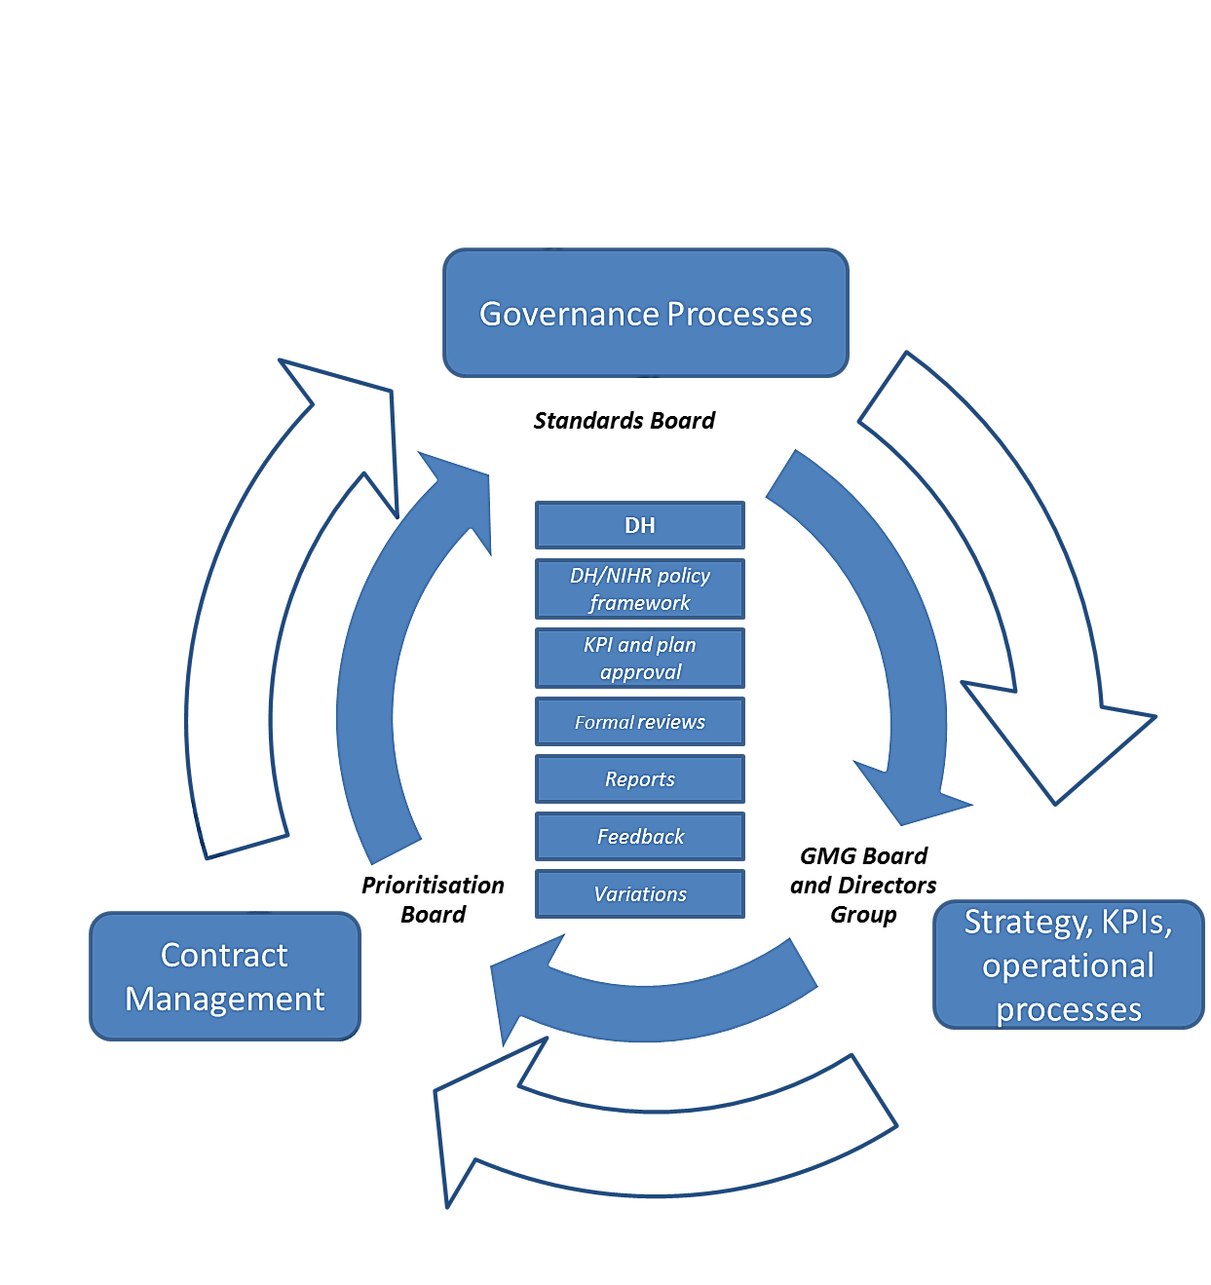
LGC will engage with the Authority to allow rapid feedback, priority changes and immediate recognition/resolution of concerns. Where appropriate, LGC will provide discussion papers for iteration with the Authority. LGC welcomes the Authority’s audit of processes/outputs.

The ‘when, what and how’ of management information (MI) reporting required to evidence and measure LGC’s performance of NOCRI, will follow the model agreed with the Authority during the transition period.

A summary of suggested Key Performance Indicators (KPI) provided by LGC to the Authority during the transition period is provided below. KPIs will be updated during the contract to reflect new NOCRI priorities.

What | How | When
Stakeholder feedback | Regular feedback questionnaires covering efficiency, quality, approachability and accessibility scores | Quarterly aggregate reports
Financial performance | Delivery of actual against budget | Annual
Staff vacancy rates | % vacant/total positions | Quarterly
Response to PQ requests | Exception report for failures | Quarterly aggregate response rate
Response to other requests | Exception report for failures | Quarterly aggregate response rate
New collaborations resulting from NOCRI activity | Number by type | Quarterly and annual reports
Funding leveraged from NOCRI activity | Value of contracts by type | Quarterly and annual reports
Enquiry conversion rate | % leads converted into collaborations | Annual
NOCRI/NIHR Brand Awareness | SurveyMonkey questionnaire (see D9) | Annual survey

LGC’s Knowledge and Understanding
LGC has deep knowledge and understanding of the H&SCS and wider environment, demonstrated by:

Capacity Development
Provides clinicians/institutions with the knowledge and capabilities needed to combat healthcare challenges including the skills to undertake/absorb research.

Currently LGC:
- Develops research collaborations that provide NIHR infrastructure investigators with the opportunity to build capacity in specific disease areas and learn to engage with industry
- Signposts infrastructure investigators to engage with industry

Translational Research Environment
NIHR funding sits within a wider funding environment which supports projects addressing unmet needs, often via new technologies, illustrated below:

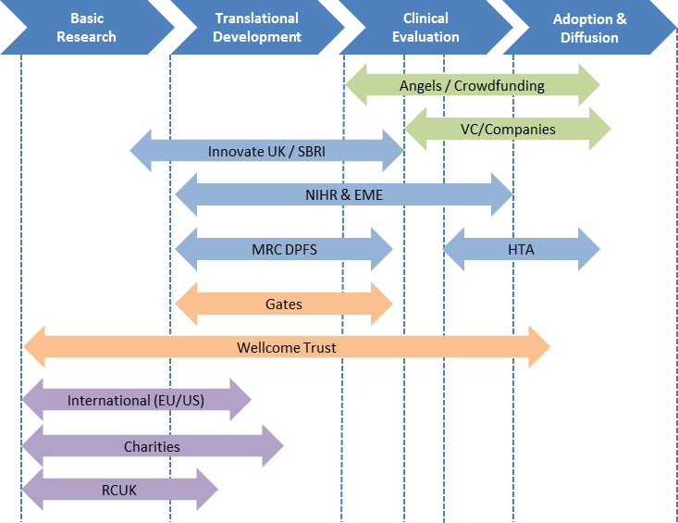

Maturing projects progress along the pathway via new funders or scheme-to-scheme transfers.

LGC facilitates this by:
- Maintaining expert knowledge of the NIHR
- Interacting with researchers furthering understanding of the translational research environment and the bridge between basic and applied research
- Understanding the opportunities and challenges researchers face
- Engaging with charities to understand potential synergies in strategic aims

Pullthrough
The Accelerated Access Review, aims to bring forward patient access to innovative medicines, technologies, diagnostics and digital products by years.

Currently LGC contributes by:
- Co-leading PtP projects. The “Handover” workstream, currently lead entirely by LGC, aims to improve handover of research from the NIHR infrastructure into different programmes on the NIHR pathway. Changes are across three themes:
  - Developing an accelerated Translational Pathway for promising projects
  - Implementing systems, processes and policies that could streamline pullthrough
  - Sharing best practise activities on translating promising findings into clinical practice
- Working with relevant NIHR programmes and funders to identify opportunities to pull research through the pathway
- Supporting companies who are working with NIHR’s translational research infrastructure, to seamlessly move their research development programmes into later phase studies supported by the CRN

Research Aware NHS/Social Care
Research evidence supports decision making that can improve health outcomes, reduce health inequalities and facilitate H&SCS transformation. NIHR provides decision makers with evidence and helps identify gaps so relevant research can be commissioned. Currently LGC is working closely with NHS England/CCGs/PHE to ensure CCF-funded research is relevant to H&SCS needs.

LGC currently interacts with a range of NHS-based staff, who are involved in research, to ensure they are aware of all research and collaboration opportunities in the NIHR. LGC will provide information, advice and tools to help raise awareness of research.

Research funding programmes
Pressures on the NHS arise from significantly increased demands from a population living longer with more chronic disease, and simultaneous increase in costs of new medical technologies/drugs. NIHR supports the H&SCS in meeting these challenges with patient and public involvement (PPI) at all stages of research design, execution, analysis and dissemination.

Currently LGC:
- Promotes strategic alignment and communication by engaging with those managing Infrastructure funding streams both at the Authority and CCF, and also regular engagement with Directors, Managers and researchers working in the NOCRI infrastructure
- Interacts with the NIHR funding programmes to be able to signpost companies and charities, to provide information to investigators who are looking for funding and influencing future calls for research in the NIHR Infrastructure
- Encourages collaborations to include PPI in their plans
- Helps NIHR investigators understand NIHR funding streams by promoting collaboration meetings

Policies
LGC will continue to support government health research policies, regulatory requirements and patients’ advocacy principles:
- By playing an active role in influencing the development of key NIHR policies associated with research management and government via membership on the NIHR Strategy Board and the NIHR Information Strategy Board
- Through interactions with NIHR infrastructure and NIHR collaborations, LGC will help to explain and reinforce key NIHR policies where required

LGC proposes the following value-added innovations for the NOCRI contract:
Innovation | Delivery Mechanism | Benefit to Authority | Resource impact | Implementation Date
Capacity - entrepreneurism | Infrastructure PhDs secondments to SMEs | Bridging cultures and creating opportunities for targeted innovation and commercialisation of healthcare | Low – part of career development/ secondment delivered collaboratively with TCC/KTNs | For discussion during transition
Capacity – collaboration | Increased CRN/CCF/NOCRI co-working | Greater intelligence available to infrastructure management – identification of funding gaps & collaboration opportunities | Very low - evolving to BAU | 1st April 2018
Translation – insight | Step change with BI via NIHRIO/IS/Smart-Data techniques | Insight and inform trends and update panels on new technologies/needs | Factored into new CCF contract | 30th September 2019
Translation – EM funders | Strengthen relationships with funders by visiting initiatives supported by other funders in order to assess opportunities for collaboration | Greater connectivity to the funding landscape, avoidance of duplication | Evolving into BAU | For discussion during transition
Pullthrough - International CRO and International Pharmaceutical Company Survey | - Building on the existing strong links with international companies of CCF/NOCRI/CRN and global LGC  - Desk and telephone survey of contacts  - Survey designed with stakeholders and approved by the Authority | - Better understanding of the perception of the UK as a destination for experimental medicine clinical trials (e.g. what are the perceived strengths and weaknesses of the UK? what kinds of trials are hard to place?)  - Better understanding of the international competitive environment  - Identification of key decision makers and opinion leaders | Factored into new contract | Periodically starting 1st April 2018
Pullthrough – BRC outputs | Explore need for dissemination support or for a BRC Challenge Fund to support BRC outputs translation | Greater translation | Evolving to BAU | For discussion during transition
Research Aware - Applied Health Collaboration | Incoming/outgoing placement with a CLAHRC, with potential extension to other infrastructure sites | - Helps NOCRI maintain and enhance knowledge of the applied health space  - Helps CLAHRCs develop their understanding of industry needs and methods or working  - Initiation of new industry collaborations | Low; resourced via utilisation and identified in collaboration with host | For discussion during transition
Research aware – KAM | KAM approach to leading researchers and centres | Professionalised approach more likely to lead to quality applications and avoid silos | Evolving to BAU, reorganised portfolios | 1st April 2018
Research aware – use of data | Pool/Share IS across CCF and NOCRI (and wider NIHR datasets such as CRN RDS) | Develop insight that facilitates more strategic connections with pharmaceutical, biotech, Medtech and care service companies (and SMEs) to align innovative technologies with H&SCS needs | Evolving to BAU across single GMG IS team | For discussion during transition
Programmes – awareness | - Infrastructure BD staff workshop meeting (as part of a broader NIHR event)  - NIHR programme scheme day whereby all NIHR and support functions can come to learn about the programmes in CCF/NOCRI/ NETSCC | Chance to share best practice, share case studies, highlight common concerns and build relationships | Factored into contract | Contact start

LGC will develop full Risk/Mitigation plans for the proposed enhancements according to the framework described in Question D9.

There are no direct cost implications of the Innovations proposed above. Many of the innovations would be expected to add value which can be measured through NOCRI KPI’s. Priorities will be set out in agreed annual operating plans which will be regularly reviewed with the Authority (quarterly) and the ERG (half yearly).

- Method Statement – D: Standard Operating Procedures.

Topic | Subject | SoR Requirement Reference | Type of Requirement Mandatory (M) or Desirable (D) | Compliance (to be completed by Supplier)  Confirm
Service Delivery | Working Approach | 5.18 | M | Confirmed

Tenderers must provide a detailed description, stating how their proposal is able to meet the requirements and highlighting those areas where the proposal can provide benefits to the Department, including meeting the desirable requirements.

Tenderers will be expected to demonstrate how they will:

- deliver a robust quality assured information system that supports Standard Operating Procedures
- deliver against requests from the Department of Health for routine monitoring and management information including urgent requests for information required in order to respond to Parliamentary Questions;
- support pan –NIHR data sharing projects as well as ad hoc requests for data or support;
- Utilise the corporate information systems provided by the NIHR central IS Function. Currently these are the NIHR Hub and NIHR Email service, built on the Google Apps for Business platform and the NIHR Website, built on SiteKit;
- ensure that all systems are consistent and comply with the overarching NIHR information policy documentation including but not exclusively, the NIHR Information Strategy and the NIHR Data Standards;
- make use of and where necessary provide data feeds to and from other parts of the NIHR directly;
- establish appropriate and robust financial reporting systems to support Standard Operating Procedures;
- handle policy sensitive information;
- comply with any information requirements in terms of financial and/or process audits;
- deliver appropriate communications activity taking account of the need to promote funding streams, encourage good quality research proposals, make research outputs available and comply with DH Comms requirements.

Question | D.5 | Weight | 5% | Word Limit | 750 + annexes*
Response 737 words
LGC has comprehensive systems, business and programme-level SOPs, guidelines, work instructions and other resources used by its skilled staff, ensuring quality delivery of its services. SOPs relating to each element of this question are summarised below (and are attached as appendices):

 | Coverage | Key Points | Filenames
1 | Research Management System (RMS) | - GMG Grant Management Services Manual  - Industry-leading RMS used (>700 funding calls delivered)  - RMS supplier (CC Technology) has 99.9% uptime guarantee  - Employ ITIL best-practice methodology  - Accreditation (ISO9001, ISO140001, Cyber Essentials)  - Conflict of Interest policy governing advisors (e.g. panellists, peer reviewers) and LGC staff/suppliers | Information redacted in line with section 43 of the FOIA
2 | Routine Monitoring and Parliamentary Questions | - Approved reporting schedules/templates  - Information requests managed centrally (reviewed before client submission)  - Quality of input data drives data management strategy  - Powerful information mining tools available | Information redacted in line with section 43 of the FOIA
3 | Data Sharing | - Formal Data Strategy  - NIHR Centre for Business Intelligence Project Board membership  - Dedicated software team develop new tools for CCF/NIHR | Information redacted in line with section 43 of the FOIA
4 | NIHR Central Systems | - NIHR Hub fully adopted (all staff trained)  - Flexible communication (Google Hangouts)  - Membership of NIHR Hub Change Board | Information redacted in line with section 43 of the FOIA
5 | Information Policy | - Membership of NIHR Information Strategy Board/Standards and Design Authority  - Regular quality audits (system/ information/data) | Information redacted in line with section 43 of the FOIA
6 | Data Feeds | - Fully embraced the Authority ‘cloud first’ policy facilitating data source exchange/linking (e.g. with CRN, RDS)  - Accessible feeds include social media (Altmetrics), mainstream news feeds, Companies House | Information redacted in line with section 43 of the FOIA
7 | Financial Reporting | - Reviewing project costings/financial DD  - Quarterly Research Management Overhead and Financial Outturn reporting  - Fully transparent CCF operational costs  - NIHR-wide (ASTOX) process assessing spend against awards  - Monthly cost centre expenditure/forecast; Internal control reporting  - Identifying task costs to evaluate CI | Information redacted in line with section 43 of the FOIA
8 | Handling Sensitive Information | - Research output publication management, highlighting sensitivities  - Policy-sensitive research managed through careful DD, restricted data access rights and appropriate partnering  - Data Protection Policy | Information redacted in line with section 43 of the FOIA
9 | The Authority Process Audits | - Full compliance with process audit requests | Information redacted in line with section 43 of the FOIA
10 | Communications | - Processes promoting funding streams/ encouraging good quality applications  - Research outputs made available  - Work as part of NIHR Communications Programme Board (with the Authority and NIHR stake-holders) to comply with/deliver NIHR corporate comms strategy | Information redacted in line with section 43 of the FOIA

Note: Pg15 of Information redacted in line with section 43 of the FOIA reflects the company’s focus on CI/managing change and is an important addition to the above table. Similarly resource planning by the SLT and BST is critical in supporting programmes so management tools have been developed to manage peaks in activity.
New joint SOPs will be developed during the transition period governing the joint working between NOCRI & CRN and NOCRI & CCF team.
LGC has a governance structure designed to manage risk at each level of activity. We use a tiered approach, set out in the table below, to ensure that each tier has risk managed in an appropriate manner with sufficient room for monitoring and escalation.
Level | Oversight structure | Monitoring and mitigation managed by (escalation)
Corporate Risk Register & BCDR Plans | LGC Board oversight; monthly review | LGC Head of Risk Management and Security (Board)
GMG/Site Specific Risk Register & BCDR | GMG Director; quarterly review | GMG Directors Board (GMG Director)
NOCRI Delivery Risk (RAG report) | NOCRI MD; biweekly review | NOCRI team (NOCRI MD and GMG Board by exception)
NIHR Project Risk | NOCRI MD; monthly review in 1-2-1s | Project milestone/risk register (GMG Directors Group as necessary)

During the life of the new contract LGC’s IS team will be responsible for providing improved data systems, analysis and insights to support delivery by the NOCRI team. In addition to answering routine queries the in-house resource will collaborate with the National Institute for Smart-Data Innovation, Newcastle University to initiate smart-data projects such as the following:

Priority | Risk | Area | Project | Impact
1 | Low | CCF and NOCRI: answering PQs | - Using Connotate tool to monitor and extract questions from the PQ website it should be possible for LGC to anticipate PQs  - LGC will automate a first run query of the dataset in advance of receiving the enquiry from the Authority | Better and timely (even predictive) PQ answers
2 | Medium | NOCRI: Collaboration development | - Develop an ontology for categorising infrastructure capacity based on papers, applications, reports etc.  - Establish a core set of industry demands by looking at industry trends  - Identify clusters of NIHR capacity which match with the emerging industry trends | New collaborations

* only limited to SOPs, no other information will be considered

- Partnership Working.

Write “Confirmed” to confirm acceptance that you are Fully Compliant with each row
Topic | Subject | SoR Requirement Reference | Type of Requirement Mandatory (M) or Desirable (D) | Compliance (to be completed by Supplier)  Confirm
Service Delivery | Functional Requirement | 5.19 | M | Confirmed
Service Delivery | Functional Requirement | 5.20 | M | Confirmed

Tenderers must detail their plan for partnership working to demonstrate their understanding and commitment to the:-
- NIHR partnership working across public, charity and industry research funders, and
- NIHR Patient and Public Involvement and Engagement as set out in “Going the Extra Mile”

Question | D.6 | Weight | 10% | Word Limit | 1500
Response 1445 + 23 diag words = 1468
Creating successful, enduring research partnerships requires detailed understanding of, and regular interaction with, the UK health research landscape. Connecting collaborators with complementary knowledge and capabilities is essential to maximise impact of the NIHR. LGC has developed a robust approach, formalised and quality controlled via SOPs, that catalyses the formation of high impact collaborations with the UK clinical research infrastructure.

Understanding of the Health Research Landscape
LGC understands how NIHR funding streams are components of the landscape. The specialised knowledge within NOCRI has been gained and integrated into LGC during successful delivery of the CCF/NOCRI. LGC will interact with stakeholders in a targeted way to identify collaborative research opportunities that will produce high impact outcomes for patients and the public.

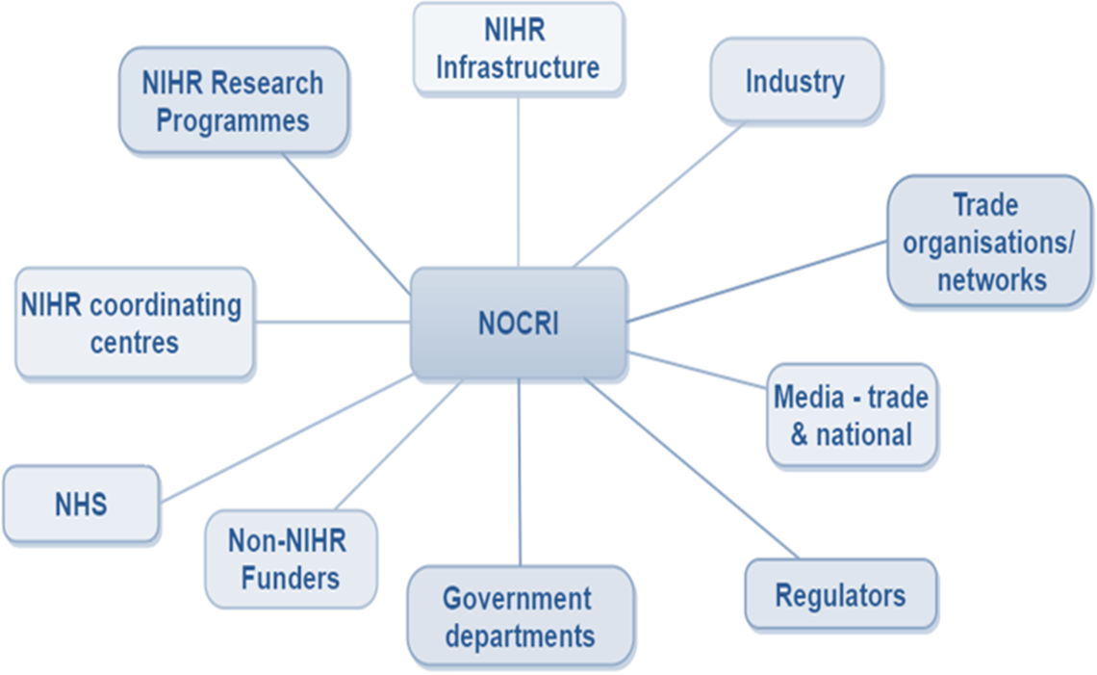

By delivering NOCRI in conjunction with the CCF, LGC will raise the profile of NIHR funding and leverage new funding opportunities which arise when stakeholders work together to establish joint/coordinated activities. These activities will arise from specific initiatives (e.g. co-developing with AMRC, an NIHR infrastructure collaboration event, with representatives from UK medical charities) or LGC’s broader engagement with the landscape produced by co-managing NOCRI and CCF.

Approach and commitment to Partnership working
- Stakeholder Engagement
Partnership working is underpinned by the close relationships that NOCRI SE activity nurtures. LGC works with stakeholders to understand their issues, drivers and motivations in order to identify where their contribution to the landscape lies. Through the matching of motivations, resources and ambitions parties can then be brought together to reach a productive and efficient partnership.

LGC provides a strong team with sound expert knowledge of the landscape, able to respond to NIHR and external stakeholder needs. This allows effective SE at operational and strategic levels.

As per Question D2, the elements of effective stakeholder management LGC will employ include:
- Adopting further and refining existing clear SOPs for SE processes
- Maintaining a list of stakeholders in a CRM system shared with CRN
- KAM approach, delivered collaboratively with CRN (and where appropriate the ECMC Programme Office and other CCs engaged in BD activities)
- Providing in collaboration with CCF and CRN an effective signposting service to facilitate reactive approaches

- Strategic Partnerships
LGC understands that the NIHR is one component within a complex landscape and we are committed to working in partnership to support this. To achieve significant outcomes it is essential to develop strategic partnerships with other parts of the ecosystem (e.g. joint funded calls and ‘matchmaking’ tools). Partnerships can aid productive understanding and assist articulation of the needs and demands of researchers and funders, including charities.

- Data insight
Partnership working is underpinned by insight gained from access to and analysis of relevant and up-to-date data sources, including those managed outside of NOCRI and CCF. This insight can be used to identify and pursue targeted opportunities, whilst avoiding those that would occur without NOCRI intervention.

LGC will:
- Continue to map the NIHR infrastructure with CCF and CRN data sets to identify hotspots of expertise and demand for collaboration (push)
- Collate data sources to understand industry trends and needs (pull)
- Analyse Infrastructure and Industry data sources using the Smart-Data Researcher-in-Residence and planned improvements to the CCF RMS

Patient and Public Involvement - PPI
Active public involvement in research commissioning/management adds significant value by ensuring that researchers always consider a patient’s perspective when conceiving, designing, performing and analysing research. LGC is committed to PPI and NOCRI will produce synergistic effects by being co-located with the Engagement and Involvement Directorate that has effective PPI tools and processes in place.

GMGs PPI team have delivered a number of key PPI activities into existing collaborations:
- Identified best practice mechanisms to include PPI in TRPs
- Supporting the UKCRF Network develop PPI activities
- Help the BRC Managers’ Working group to develop a PPI workstream

Based on the recommendations in the ‘Going the Extra Mile’ report, and also the needs identified from activities in the current NOCRI contract, LGC proposes that in delivering NOCRI services in the new contract the following innovative approaches are adopted:

- Developing a NOCRI-Charity PPI working group that brings together PPI leads from several charities to develop industry engagement strategies and processes
- In collaboration with charities, facilitate industry access to PPI for early phase research
- Implementing PPI into TRC governance & strategy
- Ensuring PPI occurs throughout project life cycles

This will improve:
- Engagement of people and communities
- The extent to which public priorities for research are reflected in NIHR funding and collaborations

Value-added by LGC hosting NOCRI and CCF
The combination of science expertise and business systems designed to provide a high quality and professional service to government-based customers means that LGC can leverage a number of strengths and capabilities that bring value to the contract and Authority, but always in line with established segregation (Question D2).

LGC’s strengths | LGC’s value to NOCRI
Commercial Experience | - Track record with public and private customers and developing accounts and partnerships globally  - Expertise that NOCRI can access (KAM, CRM software) – traditionally not available from HEIs or hospitals  - Pharma customer base and network (both LGC and KKR) can be leveraged by NOCRI BD (noting confidentially see D3)
Quality Management  System (QMS) | - Ensures work is performed to internationally recognised standards - subject to quality audits  - Commitment to CI in quality and efficiency - ISO9001:2008, ISO17025:2005, ISO17043  - Local GMG QMS applied to all activities under the NOCRI/CCF contracts and will continue to exceeding Authority’s baseline requirements (see D5)
IT Infrastructure | - Significant corporate ‘backend’ with enterprise-grade security systems support – particularly robust due to needs of government work  - NIHR’s Google Hub, RMS and ‘big data’ analytics tools underpinned by this same infrastructure
HR | - LGC (>3000 staff) has developed a significant HR function to help NOCRI and CCF to identify recruitment needs, advertise vacancies, interview candidates and induct new starters  - Ability to roll out initiatives such as rigorous appraisal programmes, apprenticeships, secondments
PMO | - LGC’s central PMO has 5 project managers and 2 IT project portfolio managers, which GMG is able to draw upon  - Expertise in project prioritisation, resourcing methodologies, risk management and hands-on support can be accessed as required by local GMG project managers
LGC Group Comms | - Supports GMG comms team with internal comms, external comms, website, press/PR and design - all benefitting NIHR’s internal and external promotion  - Access to preferred supplier pricing on printing etc.
Security Management | - Mandatory information security training induction is required for all staff via computer-based training (modules include Anti-bribery, Corruption Policy) – ongoing training via presentations, intranet articles, direct emails, posters  - Incident reporting is mandatory with board report generated monthly – security of confidential data taken very seriously due to nature of LGC’s work with government e.g. forensics
Business Continuity Management (BCM) | - Operates to BS65000:2014 – Business Resilience, to ensure an adaptive, agile and robust service delivery and ISO31000 risk management process, which measures, monitors and manages risk over risk lifetime  - Risk register maintained for all levels of business based on Business Continuity and Disaster Recovery policy document meaning LGC is prepared for issues that arise and any disruption is minimised
Quality, Safety, Health and Environment (QSHE) | - Central LGC QSHE team has wealth of legislative compliance expertise that is disseminated to all sites with internal audits conducted on regular basis to ensure legislative and policy compliance  - Commitment to ISO14001 - ensures that LGC works in an environmentally responsible way and contributes to achieving the goals of the NIHR Carbon Reduction Guidelines
CI | - Consistent drive across all sites to deliver operational efficiencies and increases in service quality (see D9)
Sector Experience | - LGC is a global life sciences company with significant understanding of UK health sector through the requirement to develop underpinning biological and chemical capability as a dedicated measurement institute supporting UK growth and international trade – leveraging significant clinical and commercial partnerships in the NHS and with independent CROs  - Well respected provider of independent analytical advice – held position of laboratory of government chemist since 1842 – a statutory function

Value-added enhancements
LGCs CI processes and gain share mechanism (Question D9) will generate and agree regular enhancements. Initial opportunities for adding value include:
Innovation | Delivery Mechanism | Benefit to Authority | Resource impact | Implementation Date
NHS Trust/HEI Event for their BD and technology transfer staff | - Meetings to share best practice in industry/charity engagement  - Meeting co-developed with CRN and CCF with NOCRI Success of event to be measured with questionnaires and desire for repeat events | - Should enhance service available to NIHR infrastructure researchers from their local support resources | Low | 1st April 2018
NIHR Showcase | - Via 3rd party events for NIHR researchers to highlight their work - showcases the up and coming research ‘stars’ | - Increases the credibility of NOCRI presentations of NIHR infrastructure capacity - might lead to introductions that result in collaborations (one way of measuring success idea) | Costs minimal as no cost for invited researchers | 1st April 2018

- Apprenticeships and Skills.

Write “Confirmed” to confirm acceptance that you are Fully Compliant with each row
Topic | Subject | SoR Requirement Reference | Type of Requirement Mandatory (M) or Desirable (D) | Compliance (to be completed by Supplier)  Confirm
Service Delivery | Apprenticeships & Skills | 8.1 | M | Confirmed
Service Delivery | Apprenticeships & Skills | 8.2 | M | Confirmed

Tenderers must provide a clear and appropriate strategy for an apprenticeship and skills programme, stating how their proposal is able to meet the requirements and highlighting those areas where the proposal can provide benefits to the Department, including meeting the desirable requirements.

Question | D.7 | Weight | 5% | Word Limit | 750
Response 692 + 55 diag words = 747
LGC is committed to the training and development of its employees because their in-depth knowledge and expertise in diverse scientific areas provides valuable solutions to our customers and promotes staff retention.

Apprenticeships
Apprenticeships provide an excellent opportunity for individuals to gain recognised qualifications and workplace experience. Our existing apprenticeship programme supports development of a pipeline of skilled employees across the business, e.g., 80% of LGC apprentices continue in the field of science at LGC or at university.

The LGC Advanced Apprenticeship Scheme (including office and laboratory based assignments) started in 2011 and became the first such scheme to be accredited by the Royal Society of Chemistry (RSciTech and RSci status).

To date, LGC has mentored:
- Three apprentices who gained an NVQ in Science that was 70% office-based
- Approximately 60 apprentices through its Advanced Apprentice (Laboratory Technician Level 3) and Higher Apprentice (Laboratory Scientist Level 5) schemes. Two recent apprentices were shortlisted for the Cogent Life Sciences Advanced Apprentice Award

LGC plans to offer GMG-based apprenticeships to allow individuals to develop into effective marketing assistants or assistant programme managers.

Digital Marketing Apprenticeship
CCF and NOCRI, together with LGC’s central marketing & communication function, provides an ideal starting point for an apprentice interested in a career in digital marketing:
- Exposure to a wide range of markets and stakeholders from government, private and non-for-profit sectors
- Mentoring to master entry-level marketing and communications tasks
- Enabling CCF and NOCRI to increase their marketing and communications activity
- Developing digital marketing skills that will benefit the apprentice, CCF and NOCRI

Business and Administration Apprenticeship
An administration apprentice will develop a broad range of administrative skills to enhance the BST. This will:
- Focus experienced BST members on more complex tasks
- Facilitate career progression to roles such as Assistant Programme Manager or finance
- Reduce staff turnover within BST, as LGC’s experience is that apprentices remain loyal to the organisation

Specification for the two schemes
- Qualifications:
  - City & Guilds Diploma in Digital Marketing (Level 3)
  - OCR NVQ Combined Diploma in Business and Administration (Level 3)
- Duration: 14 months, with first apprentice starting October 2017
- Cohort size: 1 apprentice/year recruited for each role
- Entry requirement: Prior office experience, 2 A Levels (preferably one in a science subject) or a personal interest in health research, and GCSEs A* - C in Maths and English
- Salary: Above minimum guideline salary to attract good candidates
- Training programme provider: Richmond upon Thames College (TBC)
- Placements: Apprentices primarily based in CCF and NOCRI with opportunities for short placements in other areas of LGC to support completion of relevant course units
- Apprentices would have dedicated time each week to study
- Peer support: Dedicated time for the two apprentices to share learning, discuss challenges/experiences and potential to link with apprentices on other LGC schemes

Graduate Trainee Programme
The CCF Graduate Programme launches in October 2017 to train and develop graduates on a fast track into research management:
- Comparable to those offered by big funders e.g., Wellcome Trust, CRUK
- Attractive to high calibre graduates with a passion for research and research management
- Creates pipeline of skilled, highly-effective, motivated research managers within GMG Cohort size: 3 per year
- 24-month programme of courses and on-the-job training
- Placements: 4 rotations in key areas of GMG, including NOCRI

Skills
Across LGC, employees benefit from skills training managed via Development Reviews. In response to LGC’s annual ‘staff satisfaction survey’ enhancements provided for GMG employees include training for employees to develop specific technical and general competencies. This will help staff retention.

We also offer:
- In-house training courses covering IT, health and safety, professional skills, management, leadership, scientific and technical areas
- Training delivered by experienced colleagues to others, (e.g. induction training, use of Research Management System)
- External courses, some leading to recognised qualifications (e.g. King’s College London Policy Unit delivering tailored research impact training programme; ARMA (Association of Research Managers and Administrators) ‘Certificate in Research Management - UK Funding Organisations’ qualification)
- Conferences and other fora entailing development of skills, networks and specialist knowledge

LGC also proposes creating an NIHR Training Hub for Health Research Management (see Question D5), allowing provision of bespoke, targeted training across all CCs, facilitating best practice and helping underpin the OneNIHR brand.

- Transition Implementation Plan section 10 of the Statement of Requirement

Weighting: 5% of of the overall marks

Topic | Subject | SoR Requirement Reference | Type of Requirement Mandatory (M) or Desirable (D) | Compliance (to be completed by Supplier)  Confirm
Transition Requirements | Timescale | 10.4 | M | Confirmed
Transition Requirements | Implementation Plan | 10.5 | D | Confirmed
Transition Requirements | Implementation Plan | 10.6 | M | Confirmed
Transition Requirements | Implementation Plan | 10.7 | D | Confirmed
Transition Requirements | Implementation Plan | 10.8 | D | Confirmed
Transition Requirements | Implementation Plan | 10.10 | M | Confirmed
Service Delivery | Premises/Location | 7.1 | D | Confirmed
Service Delivery | Premises/Location | 7.2 | D | Confirmed

Tenderers must provide an outline transition implementation plan to indicate its plans for the transition of services from their current operation into the new contract delivery phase.

Question | D.8 | Weight | 5% | Word Limit | 750 + annex**
Response 729 + 7 diag words = 736
The transition to the new delivery model of NOCRI integrated with CCF will require a detailed transition plan to ensure that the Authority receives full benefits of this improvement from the Commencement Date of the contract.

This will include:
- Changing the NOCRI/CCF reporting structure
- Recruiting the NOCRI MD and new staff (e.g. additional BD roles)
- Establishing terms of reference, recruiting and appointing the ERG
- Preparing strategic and operational plans
- Updating ways of working between teams including CCF/NOCRI and NOCRI/CRN service level agreements
- Resolving contractual issues e.g. office leases
- Finalising staff changes
Quality of service provided to the research community and the Authority will be maintained between contracts using a Detailed Implementation Plan (DIP) that will be produced within 3 months of the Award Date. The DIP will be developed and agreed with the Authority via a Transition Oversight Board (with members from both LGC and Authority).

LGC’s organisational change management process

Note: further detail available in appendix and Gantt chart.

LGC anticipates a significant difference in customer expectation and operational delivery of any new contract and as such we propose use of a full transition process to ensure clear change between the legacy and new contract.

Goals
The agreement of a new contract would define the short term goals of the new NOCRI with appropriate milestones put in place.

These will define the transition period and have several drivers:
- Contractual goals – the minimum expectations of the Authority in successful delivery of a new contract
- KPIs – measurable goals for the contract

We would look to identify our new goals in collaboration with the Authority before assessing our readiness to meet the new expectations through strategy, structure and systems. We would then seek to culturally embed our new ways of working through focus on staff, skills and style.

Strategy
The contract will define the goals but not how LGC would strategically deliver them. The following would need to be considered:
- Gap analysis – capacity of existing NOCRI/CCF to meet changed requirements
- Synergies and opportunities – what, within LGC’s existing contracts, complements the new requirements or could improve our offering (with LGC as a whole reviewed for synergies)
- Risks – identifying risks to delivering requirements of new contract and how they will be managed (includes during transition period)
- Stakeholder consultation – ensure impact of new delivery requirements fully understood and associated benefits maximised

Structure
A self-sufficient NOCRI delivering a high quality service with new efficiency savings and innovations.

Systems
Several aspects need to be considered:
- Quality management – update of operating procedures to reflect changes in requirements, staff trained on new processes, audit schedule implemented to monitor compliance
- Performance measurement – establishment of KPIs and reporting processes. The MD will identify management information (operational) that will supplement the KPIs to measure/monitor LGC’s performance in delivery of contract
- Technology – assessment of existing information management infrastructure, processes and systems versus new requirements. Identifying opportunities to harness technologies to deliver higher quality or more efficient solutions

Skills
LGC have developed, and will update for this contract, a ‘People Plan’ which provides a skills and competencies matrix required for our staff to be effective in their roles including any new positions.

Staff
Defining the operating procedures and associated skill requirements/role definitions of new work allows the recruitment/training process of existing and new staff to coincide with the Commencement Date.

Style
Communication of changes to requirements and how LGC intend to deliver these will be important for cultural acceptance and change. LGC management will consider the change in behaviours it expects to see from its staff and managers and how to encourage such behaviours. For example, an increased focus on process efficiency or cost effectiveness of process would be expected from all line managers and we would make this a formal assessment criterion in performance management.

Timetable
LGC would project plan against the 12 months from contract award to commencement Date. The transition plan is intended to be:
- Transparent – both for the Authority and GMG staff
- Managed – the PMO will manage the change documentation whilst the Transition Team will lead the operational impact assessment
- Quality Focused –maintaining focus on existing requirements whilst delivering value on the additional investment activity
- Measurable – performance, whether an innovation or not, needs to have measurable indicators to feed back to the customer
The key elements of the transition plan are expanded upon in the transition implementation plan provided as an Appendix and in the timeline Gantt accompanying it.

** The plan only

- Continuous Improvement

Weighting: 5% of the overall marks

Topic | Subject | SoR Requirement Reference | Type of Requirement Mandatory (M) or Desirable (D) | Compliance (to be completed by Supplier)  Confirm
Service Delivery | Continuous Improvement | 9.1 | M | Confirmed

The Tenderer must outline the processes it proposes to use in order to ensure that continuous improvement in line with paragraph 9.1 and any other pertinent aspects of the Specification to be delivered over the life of the contract with a view to reducing costs and improving the quality and efficiency of the services, highlighting those areas where the proposal can provide benefits to the Department, including meeting the desirable requirements.

Question | D.9 | Weight | 5% | Word Limit | 1500
Response 1489 + 3 diag words = 1492
LGC’s approach to CI is to eliminate administrative inefficiencies so that we can focus on value-adding strategic activities for the Authority, thus further strengthening the offer NIHR provides to the research community. This activity is encompassed within a wider business CI framework that spans operational teams, up to the GMG SLT and LGC Group.

Our behaviours and ways of working are set up to drive two types of change that deliver customer benefit:
- Incremental improvements designed to generate efficiency, allowing resources to be redirected to value-adding activities
- Disruptive innovations designed to offer novel value-added services that enhance the overall package provided to the Authority
This focus is reflected in the skills and qualifications of the staff within the GMG proposal:
- Prince2 practitioners
- Lean 6 Sigma (blue and green belts)
- OEE Advanced Lean Practitioner
- ITIL Foundation
- P3O training
- ISO training on implementation (9001, 14001, 31000)

The CI Environment
CI is embedded in LGC’s stated core values with successes across the Group recognised, communicated and celebrated. LGC’s overarching commitment to delivering a high quality, improvement-driven business is evidenced through its continued accreditation to ISO 9001, 14001 and 31000. Cascading down from Group level, the GMG SLT has strategic responsibility for defining expectations around CI, prioritising and sponsoring these activities and providing active oversight of its PMO and Quality Assurance group. Through monthly transparent communication with the PMO, the SLT oversees progress in the achievement of strategic goals.

CI Drivers and Authority Engagement
Regular communication between the Authority and GMG will be the primary driver for improvements. The wider NIHR and other stakeholders will also have fora for opinions to be voiced and needs to be identified. In addition to our natural, organisational inclination towards CI producing staff ideas for improvement, other CI drivers will include:
- Legislation and policy change
- Financial requirements (the Authority budget management including allocation to funding streams, operational costs and costing impact)
- Research community needs

This feedback is of utmost significance in our drive for improvement and we are poised to recognise, prioritise and deliver improvements highlighted in this manner.

LGC understands the importance of sharing its proposed improvement plans with the Authority in advance, to review prioritisation and secure engagement from invested parties, in order to deliver the best possible results and smooth implementation of change. Rather than seeking to ‘shine’ in improving unilaterally, LGC appreciates the high value of leading or contributing to improvements that improve the whole of NIHR.

CI Methods
Our delivery of CI is bolstered through our processes which include:
- Tracking achievement of KPIs as documented in the contract
- Development and improvement of SOPs
- Risk management
- Identification, prioritisation and delivery of important projects through the PMO
- Our continued ISO accreditations
The methodologies used to achieve this are:
- Lean with a focus on cause-and-effect to drive change (see LGC LOM in Appendices to Question D4)
- Agile principles that drive step-change
- IT development through ITIL
- PRINCE2 project management

CI Priorities
In line with the Authority’s requirements, and other identified drivers, we have prioritised our immediate CI plans which are coordinated through the PMO via a Plan-Do-Check-Act cycle and address the following:
- Workflow bottlenecks
- Resource allocation to maximise customer value
- External drivers that influence the timing of change

In LGC’s experience, CI projects lead to the following outcomes:
- Improved customer and employee satisfaction
- Quality gains
- Process efficiencies (cost reduction) with redeployment opportunities
- Environmental gains including reducing our carbon footprint

To date, LGC has delivered significant innovations in its processes and provide solutions that have provided measurable benefit to the Authority.

For example:
Area addressed | Example already implemented
Accountability, ownership and oversight (NOCRI example) | - LGC has a track record of delivering innovative and valuable ideas to the Authority, an example being where NOCRI successfully transitioned Therapeutic Capability Clusters (TCCs) into TRPs after a change in departmental responsibility from BIS to the Authority so that they came under the NIHR umbrella  - LGC then further transitioned them into a revised TRC model where: (1) the collaborating partners have a much greater sense of ownership of their collaboration, (2) with assistance from NOCRI the collaborations have developed clearer communications of their offer to industry, (3) resulting in better engagement with industry evidenced through a portfolio and pipeline of studies
Workflow bottlenecks (CCF example) | - Data analysis of Infrastructure annual reporting was a heavily manual, error-prone and time-consuming process  - Centralised data analysis within the IS team shifted resource to a single point, ensuring consistency of process and thus improved quality  - Further improvements and technology use enabled the ensuing annual reporting process to be reduced to 6 weeks  - Quality gains were also made, resulting in the Authority receiving high quality information in a far shorter timeframe than previous years
External drivers (CCF and NOCRI example) | - The Government now requires all suppliers have Cyber Essentials, a cyber security certification  - LGC has attained this certification following a full audit of IT infrastructure, followed by making required changes  - A further audit including penetration testing against cyber-attack was passed  - No disruption or change to service quality to the Authority was experienced during the certification process

Building on this experience, LGC will initiate further CI projects within the transition period, for example:
CI project | Efficiency & Assumptions | Financial Benefit | Quality Benefit | Risk
BST | BST drives improvements in standardisation across GMG, via the PMO-led Standardisation Project which assess all processes, rationalises them and assigns responsibility for activities via a RACI matrix.  . | From full implementation post RACI review, a number of tasks will be subsumed within the BST. LGC anticipates a saving of between 5-10% in non-admin staff time. | Consistent processes will allow for efficiencies across activities– a consistently high standard irrespective of timing or turnover. | Finding the correct balance between NOCRI and BST administrative procedure. This is mitigated by a conservative implementation and reassessment over time.
Harmonised SOPs | Harmonised SOPs between NOCRI & CRN and NOCRI & CCF will help to generate a OneNIHR offering with more ‘feet on the street’ and better connection of industry to Programmes (NOCRI/CCF/CRN/NETSCC); these CI projects will be treated as full CI projects. SOPs and KPIs will be developed. | Increased BD activity measured through agreed KPIs. | A genuine NIHR BD team. | Failure to agree or overly complex – mitigated through appropriate project management and oversight.

In the long-term the following CI projects may be put forward for consideration by the Authority:

CI Project | Efficiency & Assumptions | Financial Benefit | Quality Benefit | Risk
Shared Business Development Role | In response to the challenge of a coordinated business development function for NIHR, it would be possible to implement over time a joint business development post with costs split between CRN and NOCRI. Would complement new work on joint SOPs. | Half of a Business Development Manager Role per CRN and NOCRI. Capacity generated out of natural attrition. | A genuine NIHR BD team. | Possible lack of focus – mitigated through clear line management.
Collaboration Management | Over time integrating the management of TRC and TRP collaborations within the CCF Infrastructure team. Oversight of complex research collaborations and relationships is a core skill of CCF. | Collaborations Manager functions moving into CCF, freeing up 1 FTE in NOCRI for re-deployment. | Collaborations still managed professionally and with increased direct engagement with the infrastructure portfolio. | Delivery risk in infrastructure mitigated through appropriate knowledge transfer.

Outcomes
LGC anticipates that CI projects will lead to the following outcomes:
- Customer and employee satisfaction
- Performance excellence
- Quality gains including best-practice sharing
- Cost reduction or identifying redeployment opportunities
- Increased process efficiencies
- Environmental gains including reducing our carbon footprint*
- Driving growth

*Reducing Carbon Footprint
LGC tracks and measures environmental impact measures and we have a target of reduced impact per capita year-on-year. Twickenham is also ISO14001 certified. The following is a chart showing year on year electricity consumption reduction [(kWh) 2015 (Blue) and 2016 (Orange)]:

Benefits
Benefits from CI projects can accrue to the Authority through the gain share mechanism set out in the Agreement which allows for sharing of cost savings and/or reinvestment in value adding activities.

The reinvestment of CI cost savings gains can lead directly to new cost savings, quality enhancements or value adding activities. For example, the restructuring of the GMG group over the last few years into a Directorate and BST structure has allowed efficiency gains through the standardisation project. By reinvesting the saved salary resource in additional IS specialists, GMG has been able to develop an improved experience for applicants (through online application processes) and better quality (through use of available data sources to produce better citation analysis reports for panel meetings).

More generally CI objectives are expected to lead to:
- Enhanced capacity in the NOCRI workforce gained through multifunctional teamwork
- Identification of new best practice regarding innovation, quality, delivery and cost which can be shared with other NIHR CCs
- Administrative efficiency gains

The ultimate benefits are realised through value-adding activity; e.g. surveys of the attitudes of international CRO’s/pharma companies and secondment of staff from CLAHRCs should both lead to the development of even deeper understanding of attitudes and challenges faced by key stakeholder groups.

- Contract Transfer and Exit Strategy section 12 of the Statement of Requirement

Topic | Subject | SoR Requirement Reference | Type of Requirement Mandatory (M) or Desirable (D) | Compliance (to be completed by Supplier)  Confirm
 | Service Exit | 12.1 | M | Confirmed

Tenderers must indicate their plans for the transfer of knowledge and skills from this activity back to the Authority during and at the end of the contract.

Question | D.10 | Weight | 2% | Word Limit | 1500
Response 929 + 77 diag words = 1006
LGC’s partnership approach to managing a contract exit and transition process

LGC understands that the successful bidder will need a clear ‘Exit Plan’ to manage the transfer of knowledge, information and skills accrued during the delivery of the NOCRI contract to the Authority and/or Replacement Supplier (RS) at the Expiry Date (or during the Contract Period if necessitated by early termination). It is also understood that the Exit Plan and the relevant Registers will be agreed between LGC and the Authority within 3 months of the Commencement Date and will be reviewed annually by LGC in conjunction with the Authority during the Contract Period.

It is important to maintain service levels for government contracts throughout the entirety of the Contract Period and avoid dips in the quality of delivery at either end of the contract where transition between Suppliers is occurring.

During a transition phase LGC continues with ‘business-as-usual’, delivering to the contractual requirements, whilst engaging in parallel discussions with both the Authority and RS to determine the timing, order and pace of any work transferred. We treat the transition as a process, manage it as a project via an ‘Exit Manager’ (EM), and work in partnership with the Authority (and the RS where practical) to deliver a smooth handover of service using our rigorous, 5-stage Exit Plan process illustrated below:

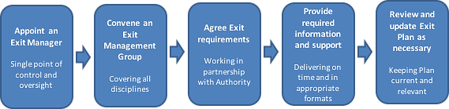

This combination of LGC’s 3-way partnership approach, flexibility and communication delivers benefits over the transition to both the Authority and the RS such that in this case there will be minimal impact on the research community.

A detailed Exit Plan (including our provision of Termination Assistance) will be generated through discussions between LGC and the Authority based on the Contract and with particular reference to Schedule 10: Exit Management.

LGC’s EM will devise the approach and activities during each of the following phases:
- Contract award – preparation of Exit Plan (first 3 months)
- Contract Period – review and update of Registers and Exit Information (over 5+4 years)
- Pre-tender preparations – support to Authority with Exit Information (approximately 3 months before tender notice)
- Tender – continuing to support the Authority with information requirements during the ‘live’ tender process e.g., clarification questions (approximately 6 months)
- Transition – working with the Authority and RP in preparing for Exit (approximately 1 year between award and Expiry Date)
- Post-Expiry Date – support to the Authority and RP with ad hoc queries and work to aid handover

Described below is an outline of how LGC will support the exit-related work and important areas for both parties to consider.

Oversight and control of the process through the Exit Manager (EM) and Exit Management Group (EMG)
The EM will be the PMO Manager, ensuring that the handover is handled by someone with an intimate working knowledge of the contract and its requirements.

The EM:
- Provides effective communication to specific operational/support departments and to Authority and RS during transition phase
- Has authority to arrange any resources deemed reasonably necessary to enable LGC to comply with contractual requirement
- Is responsible for updating the Exit Plan and reviewing the outline plan with Authority throughout the contract period
The EM will call together an EMG which will:
- Support handover and ensure all key areas are represented during the transition
- Ensure activities of transition process do not impact unduly upon service required under contract during the exit phase
The EMG includes senior service delivery personnel who take an active part in the transition and who ensure the segregation of duties between Exit and delivery. The EMG also includes representatives from HR, commercial & legal and senior management. Segregated responsibilities combined with oversight from senior management ensures coordinated activity during exit phase as illustrated below:

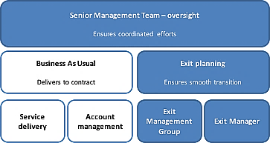

Maintaining service levels during transition
Segregation of duties between Service Delivery and Exit in the final phase of a contract (shown below) ensures services are delivered to contractual requirements up to, and beyond, Expiry Date.

Service Delivery managed by Operational Team | Exit Managed by EMG
Internal headcount allocation | TUPE alignment
Internal operational loading | Provision of data required for transition
Deliver to required service levels | Duration, order, phasing of transition
Contract adherence | Enduring terms
Business-as-usual customer liaison | Exit focused customer liaison
 | Intellectual property rights
 | Liaison with incoming supplier
Work-in-progress - prior to Expiry Date | Work-in-progress - as of Expiry Date
Management Information
Invoicing, Reporting

Key considerations when developing the Exit Plan

Consideration | Aspects to be detailed
Contract Period obligations | Ensuring all information and assets are identified e.g. subcontractor agreements, via Registers (online shared Portal, accessible by Authority in agreed format)
Transfer Period | Agreement over timeframe e.g. current transfer period is 12 months for Supplier
Exit Information provided ahead of re-tendering event | Gathering sufficient information/follow-up queries regarding Registers, Authority Data, 3rd party contracts, Transferring Supplier Employees and any ad-hoc/unforeseen issues
Information provided post-transition | Agreement on post-transfer support
Format of required information | Normally electronic but tbc
TUPE | Understanding LGC’s exposure during service transfer  Managing the transfer of skills and Staff to incoming supplier
Order of Transfer | Perhaps multiple Lots being transferred in preferred order
Scalability | Agreement on scale/speed of transfer
Subcontractors | Informing Authority on work transfer requirements and ensuring co-operation in subcontractor adherence to Exit Plan
Return of data | Identify and manage return of data and retention of data needing to be retained due to LGC Quality and Accreditation procedures.
Work-in-progress | List of work-in-progress at transfer date with recommended actions
Knowledge transfer | Confirming what information is to be shared. Appropriate management and assignment of IPR to the Authority and incoming supplier where required.
End of assistance date | Confirming to what point LGC’s assistance is required
Enduring terms and commitments | Agreement on ongoing commitments beyond transfer date

Appendix A

Supporting Information regarding Partial or Non Compliance with the Authority’s requirements.
None, we are compliant

Appendix B

Tender Qualifications to Conditions of Contract

As the Authority has now declared the negotiation closed, it will no longer negotiate with Tenderers on the Terms and Conditions at this stage of the procurement. However, if Tenderers still wish to highlight areas of concern or show any specific amendments they wish to make to the negotiated Conditions of Contract, (Annex A1 of the ITFT) they complete the table below and any proposed amendments should be shown as tracked changes. Tenderers must include a commentary to explain the reasons behind the proposed amendment(s) to the Conditions of Contract or the proposed inclusion of additional terms and identifying the value for money benefits to the Authority. The Authority reserves the right not to accept any or all amendments to its Conditions of Contract once Final Tenders have been submitted..

Weighting: 3% of the overall marks

Clause | Title | Description of change | Commentary and justification | Cost  Adjustment  (£)
 |  | We are in agreement with the Terms and Conditions as presented at this stage

The assumption is, that unless stated in this schedule, acceptance of the Conditions of Contract is made. As the Authority has now declared the negotiation closed, it will no longer negotiate with Tenderers on the Terms and Conditions at this stage of the procurement.

