Extract from Green Recovery Challenge Fund round one Evaluation Framework

The GRCF Theory of Change

Theory of Change for Nature Conservation and Restoration and Nature-based Solutions
The theory of change for investments in nature conservation and restoration, and nature-based solutions, is illustrated in ‎Figure 4.1.
These two GRCF objectives have common elements and hence are represented in a single theory of change. Both involve investments in the creation, restoration and maintenance of natural capital assets, which deliver benefits both for biodiversity (habitats and species) and the delivery of nature-based solutions (ecosystem services). Therefore, GRCF projects often contribute to both objectives, while projects prioritising one objective or the other may involve similar types of activities. However, the balance of objectives is likely to influence the specific activities undertaken. For example, projects planting trees to maximise carbon sequestration might use different species and methods to projects seeking to create woodlands primarily for biodiversity.
Most projects contributing to these objectives also have an element of engaging people with nature – even if the focus is primarily on nature conservation/ restoration or nature-based solutions, projects may engage volunteers in land management, work with land managers and other stakeholders in pursuit of their objectives, raise public awareness and engage the public to build support for conservation action, or allow people access to the habitats created or restored. All projects will also contribute in some way to the GRCF objectives of jobs and skills, and eNGO resilience and sustainability. Contributions to these objectives are shown in the later theories of change.
The theory of change for investments in nature conservation and restoration and nature-based solutions include the following elements:
Activities funded in pursuit of these two objectives focus on the creation/ restoration/ maintenance of habitats (including on designated sites) or green/ blue infrastructure, and the conservation of species. Some projects may prioritise nature conservation objectives by focusing on wildlife rich habitats and designated sites; others prioritising nature-based solutions may create or enhance other forms of green/blue infrastructure (such as sustainable urban drainage systems, green roofs or urban green spaces), and/or target activities in areas of greatest ecosystem service need (e.g. areas of flood risk, water catchments, centres of population). Species conservation actions often focus primarily on nature conservation objectives, but may also target nature-based solutions (e.g. actions for pollinators).
Outputs are the immediate deliverables of these activities, and will be observed and measured during and on immediate completion of the GRCF projects. They include the newly created habitats or green/blue infrastructure features, areas of land over which restoration/ maintenance work has been completed, species conservation actions completed, and training/ education/ communications delivered. They may potentially be measured at different levels of detail and for different types of habitats and ecosystems (e.g. hectares of new woodland created, or numbers of individual trees planted).
Outcomes are the benefits that each project delivers from its outputs. They include enhancements in habitat extent and condition, responses in species abundance locally, and improvements in ecosystem function and its contribution to service delivery. They may take several years to materialise and depend on the response of ecosystems to the actions undertaken, since newly created habitats take time to develop, habitat condition may take years to improve following restoration works, species may respond over time to conservation actions, and trees and vegetation take time to grow, store carbon and absorb water. As a result, outcomes are unlikely to be fully visible within the life of the GRCF funded projects and are likely to require longer term monitoring and evaluation. It should also be recognised that access to outputs may not be evenly distributed. For example, reduced flood risk may have a greater benefit for people from deprived backgrounds living in low quality housing in areas of high flood risk.
Impacts are measures of the overall contribution of the programme to its goals, and should include overall improvements in the conservation status of species and habitats, and the overall level and value of nature-based solutions delivered.
The theory of change includes a number of assumptions and dependencies which are implicit in linking the different stages. For example, the effectiveness of the activities undertaken may depend on the ability to recruit and engage volunteers and stakeholders, the efficacy of species management interventions and the response of vegetation to site management and restoration works. Outcomes for species, habitats and ecosystem functions may be uncertain and depend on wider environmental and climatic factors and be influenced by human pressures. There are therefore risks both in project delivery and in ecosystem responses to interventions. Measures can be taken to manage these risks and to ensure as far as possible that the necessary conditions are met in practice. For example, these may include the development and implementation of project plans, site management plans, financial management plans and post project plans, each with clearly defined timetables, allocation of responsibilities, monitoring and evaluation arrangements, and risk management/ contingency measures.

          - Theory of change for GRCF themes of ‘nature conservation and restoration’ and ‘nature-based solutions’

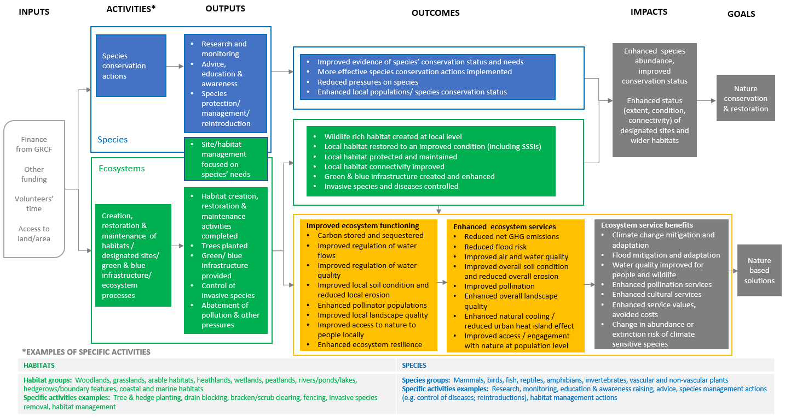

Theory of Change for Connecting People with Nature
‎Figure 4.2 illustrates the theory of change for the GRCF goal of connecting people with nature.
While some GRCF projects focus explicitly on this goal, many other projects which address the other goals of nature conservation and restoration and/or nature based solutions, also involve an element of engaging people with nature. This may include, for example, engagement of volunteers, land managers and the public in conservation activities; training, communications and awareness raising actions linked to nature conservation and/or nature based solutions; provision of access to newly created or restored woodlands or other habitats; and citizen’s science contributions to surveys, monitoring or research linked to species and habitats.
The theory of change for investments in engaging people with nature includes the following elements:
Activities include, for example, creating and/or improving access routes to nature (covering both physical access through e.g. footpaths, cycle paths and walkways, as well as virtual access), education and training, engagement and awareness raising, volunteering, recreational and social activities in nature, research and citizen science, and installation and repair of visitor infrastructure, as well as habitat and species actions. Project activities under this theme may target specific groups such as school children, young people (18-24s), people with disabilities, people from deprived backgrounds and/or certain ethnic groups.
Outputs of these activities relate to the completed people engagement activities and the numbers of people participating in or reached by these, as well as the areas and infrastructure provided. Specifically, these include the research and citizen science projects completed, and levels of participation in these; the training and education sessions provided, and the numbers of people trained or educated; the extent of accessible green spaces provided or improved; the events delivered and the number of participants; the interpretation/ information infrastructure and materials provided; the social prescribing activities delivered and levels of participation in these; and the green gyms, footpaths, cycleways, access infrastructure and visitor facilities and accessible environment/green space provided, improved or maintained and their capacity.
Outcomes resulting from the funded activities and their outputs mostly relate to behaviour change and levels of engagement with nature among the local populations reached by projects. These included enhanced knowledge and skills among volunteers, visitors and the general public; enhanced understanding of and compassion for nature; inspiration and empowerment of participants to support nature conservation objectives; increased time spent in nature, for recreation, exercise and refreshment; greater levels of participation in conservation activity; more journeys made by foot or bicycle; and greater engagement with nature among disadvantaged and/or underrepresented groups, including e.g. school children, young people (18-24s), people with disabilities, people from deprived backgrounds and ethnic minorities. Citizen science projects should also help to improve the evidence base on species and habitat conservation needs.
Impacts are measures of the overall contribution of the programme to its goals, and should include overall improvements in people’s connectedness with nature at a wider population level. These include overall increases in outdoor recreation and engagement with nature, resulting in improved physical and mental health; greater levels of equality in engagement with nature across society; greater integration of nature and the environment into policies and projects; more environmentally conscious decisions by consumers; and greater levels of employment and skills in environmental activities. Citizen science projects should also lead to enhanced access to and use of environmental evidence by decision makers.
The theory of change relies on assumptions and dependencies which are implicit in linking the different stages. For example, the effectiveness of the activities undertaken may depend on the ability to recruit and engage with volunteers, citizen scientists, land managers, visitors and the wider public. This in turn depends on the quality and content of the activities on offer but may also be affected by factors beyond the direct control of the projects, such as restrictions on movement and social interaction linked to Covid-19. Provision of visitor infrastructure and facilities depends on the ability to procure the services required, which may also face disruptions and uncertainties. The resultant outcomes and overall impacts relating to people’s engagement with nature depend on a wide range of factors that may be beyond the control of projects, such as wider social attitudes, competing priorities for attention and leisure time and changes in socio-economic circumstances.
There are therefore risks both in project delivery and in human responses to interventions. Because many of these risks relate to wider social, economic and attitudinal trends, they are difficult to manage. However, a variety of steps can be taken at the project level to mitigate risks, such as through appropriate project management, people engagement, financial and quality management plans, supported by social and market research where appropriate, and with clearly defined timetables, allocation of responsibilities, monitoring and evaluation arrangements, and risk management/ contingency measures.

          - Theory of change for GRCF theme of ‘connecting people with nature’
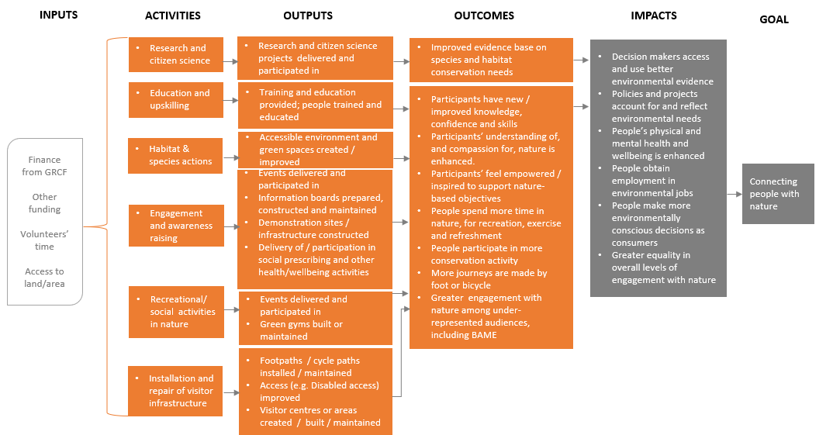

Theory of Change for eNGO Resilience, Jobs and Skills
The theory of change for the GRCF goals of enhancing environmental employment and skills and supporting the resilience and sustainability of environmental NGOs (eNGOs) is presented in ‎Figure 4.3.
This theory of change is linked to the theories of change for nature conservation and restoration, nature-based solutions and connecting people with nature. While some projects may only have targeted one or two of the three core environmental goals of the GRCF, all projects will contribute to the GRCF goals of supporting resilience, jobs and skills through the resources they deploy to undertake their project activities, and/or directly or indirectly through the activities they carry out. The GRCF provides finance to eNGOs to support them to maintain their on-going activities and to enable them to build back better after the pandemic (e.g. through retaining and creating skills for ongoing and future delivery of the 25YEP), thereby enhancing their resilience through the pandemic and into the longer-term.
The environmental and people engagement activities funded by the GRCF (detailed in the previous theories of change) will provide opportunities for funded organisations to retain, train and upskill existing staff; hire and train new staff; recruit and train apprentices and volunteers; and hire contractors. Grants will also be used to provide/improve visitor facilities/infrastructure, and people engagement activities, helping eNGOs to maintain, manage and develop their customer/supporter base. This, in turn, will support the capacity and resilience of eNGOs. Many projects also involve partnerships, helping to strengthen capacity and governance across the sector.
Outputs of relevance can therefore be considered in terms of jobs created and retained within lead/partner organisations; apprenticeships and traineeship opportunities created and retained within lead/partner organisations; skills developed and diversified among lead/partner organisations and among volunteers; and engagement with visitors, customers and supporters.
Outcomes include enhanced capacity and resilience of the eNGOs engaged in GRCF activities, as well as enhanced employment and skills in local economies, particularly among disadvantaged and under-represented groups. Projects’ and visitors’ spending circulates through the supply chain generating indirect employment in local economies. Impacts will include enhanced resilience and financial sustainability of the eNGO sector overall (including resilience to future pandemics or disruptions); enhanced employment and skills at sector level; and greater environmental employment opportunities, including for 18-24s (an age group of particular interest due to high levels of youth unemployment). Through enhancing the resilience and financial sustainability of eNGOs, and by increasing employment and skills within the sector, the GRCF should enhance the ability of the sector to deliver the 25 YEP.
The assumptions underpinning the resilience, jobs and skills theory of change are that emergency funding will be sufficient to plug gaps in income and enable eNGOs to retain their capacity and continue to deliver their project activities, and that targeted investments in skills and infrastructure will be effective in building resilience to adverse circumstances now and in the future. The theory of change relating to jobs and skills assumes that suitable staff and volunteers can be recruited, and that a significant proportion of expenditure by projects and their employees is retained in the local economy (thereby enhancing local incomes and employment rather than leaking outside the local economy). The risks that these assumptions are not satisfied can be mitigated by ensuring that the theories of change are evidence-based and carefully articulated, and by recruitment and procurement practices designed to enhance employment and economic impacts.

          - Theory of change for GRCF themes of ‘jobs and skills’ and ‘eNGO resilience and sustainability’
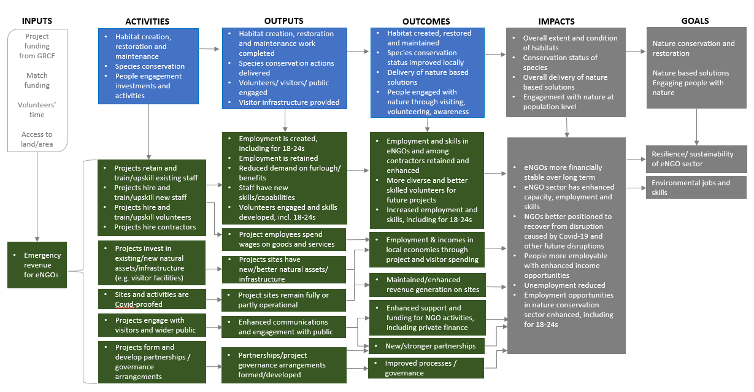

Output and outcome indicators
To determine whether the GRCF is delivering the effects intended, it is necessary to define specific and measurable indicators for each of the steps in the theory of change. Information for each of these indicators will be gathered from the projects and aggregated (to the extent feasible) at programme level. The results of the analysis will then show whether the GRCF is ‘on track’ and likely to meet its goals.
Indicators that are common to all (or at least most) of the projects are essential. Without common indicators and common units of measurement (e.g. km, hectares, £, number, etc.) it will not be possible to aggregate findings across the projects. The supported projects are expected to deliver a wide range of outputs and outcomes, ranging from habitat creation and restoration and species management actions to strengthening the relationship between people and nature, creating employment and opportunities for volunteering, upskilling the workforce and organisational resilience. Because the GRCF has funded such a diverse spectrum of projects, there are limits in the extent to which common indicators can be defined, and the degree to which they cover the full range of project outputs and outcomes.
Projects are obliged to provide data to support programme-level monitoring and, in April 2021, The Heritage Fund issued guidance to the projects in relation to the data they will be required to report on (see Table A2.1) The guidance covers several core common indicators that relate to elements of the theories of change and will therefore form important inputs to the programme level evaluation. Response rates for the core common indicators are expected to be good – a high proportion of those projects for which each indicator is relevant is expected to report on it. Consistency in the data provided by projects is expected to be moderate – some guidance has been provided on units and in some cases classifications and other relevant definitions, however flexibility has also been permitted to allow projects to adopt an approach which works for them in order to encourage the widest range and largest number of projects to respond - where different classifications or units of measurement have been used as the basis for reporting by projects, it may not be possible to aggregate their findings at programme level. The data collection approach for the core common indicators is still in development and will be refined by The Heritage Fund, in collaboration with Defra and its Arms-Length Bodies, in the coming months.
Projects will also be collecting additional data on their project outputs and outcomes for their own monitoring and evaluation, and/or for wider use (e.g. public engagement). It is likely that, in some cases, projects will gather this data using common metrics that may enable results to be aggregated across multiple projects and which could therefore serve as additional input to the programme-level evaluation. The relevance of these indicators will vary from project-to-project and the consistency of the data provided across projects is likely to be low. A confounding challenge is that the data for these additional common indicators will need to be gathered (by ICF) from the projects using an online survey (see Section ‎6) and the response rate to this is also currently unknown.
In their application forms, most projects stated or implied some of the indicators they intend to use as the basis for internal monitoring and evaluation – although the indicators used by the projects may differ from their original intentions and may change through the duration of projects and as their individual project evaluations are developed. Based on projects’ application forms, and discussions with grantees at the workshops, a number of additional indicators were identified that could provide information to supplement the monitoring data that The Heritage Fund will collect from the projects using core common indicators. This information would be collected from grantees during the online surveys conducted by the ICF research team.
The list of common output and outcome indicators is shown in Table 4.2. The indicators highlighted in bold may be captured within The Heritage Fund’s core common indicators for project monitoring, depending on the final format of these and so the list will need to be refined once The Heritage Fund has finalised the core common monitoring indicators. The timing of the evaluation of the GRCF coincides with the delivery of project activities and outputs and, for some projects, possibly their outcomes. However, the impacts of the projects will only be achieved in the longer term beyond the lifecycle of the evaluation. Since it will not be possible to monitor the impact of the projects until a later time, specific impact indicators have not been included in the table. For the outcome indicators, projects will be asked what outcomes they expect will arise, the assumptions underpinning these expected changes and the potential risks.

Output and outcome indicators
Aspect | Output indicators | Outcome indicators
Nature conservation and restoration and nature based solutions
Type of land benefitting from GRCF activity (information to be collected at site level) | - Whether the area where activity has been completed is protected or designated (e.g. SSSI).  - Yes/No. If yes, type of designation (e.g. SSSI) and area (ha) subject to designation  - Type of habitat at each site. [UK BAP Priority Habitats list]  - Baseline condition of habitat at each site  - Expected condition of habitat at each site by project completion (March 2022) | - Expected condition of habitat at each site by March 2030
Area benefitting from GRCF activity | - Area (ha) over which habitat creation activities have been completed  - Area (ha) over which habitat restoration activities have been completed  - Area (ha) over which maintenance activities have been completed  - Area (ha) over which invasive species have been controlled  - Area (ha) over which abatement of pollution has been conducted  - Area (ha) over which habitat change for carbon sequestration has been conducted (including e.g. woodland, peatland restoration, seagrass planting)  - Area (ha) over which activities for climate change adaptation have been conducted  - Number and type of natural flood management interventions delivered  NB. Habitats or features not measurable in hectares should preferably be measured in km (e.g. rivers or hedgerows) | - Area (ha) of wildlife rich habitat created at local level  - Area (ha) of habitat restored to an improved condition  - Area (ha) of local habitat protected and maintained  - Area (ha) of connective habitat created  - Area (ha) free of invasive species  - Area (ha) over which pollution has been reduced or eliminated  - Amount of CO2e to be sequestered up to 2030  - Area (ha) that is better adapted to climate change  - Expected reduction in likelihood and scale of flooding  NB. Habitats or features not measurable in hectares should preferably be measured in km (e.g. rivers or hedgerows)
Type and condition of species targeted | - Baseline condition of species at each site  - Number of species for which protection, management or reintroduction activities have been completed  - Names of species for which protection, management or reintroduction activities have been completed  - Expected condition of species at each site by project completion (March 2022) | - Expected condition of species at each site by March 2030
Tree planting (excluding replacement or replanting) | - Number of trees planted at each site by project completion (March 2022)  - Number of species planted at each site by project completion (March 2022)  - Names of species of trees planted | - Number of trees that projects expect to survive through to March 2030
Connecting people with nature
Visitor infrastructure improved or installed | - Length (km) of new routes to access nature installed  - Length (km) of routes to access nature improved, repaired or maintained  - Number of new signage/information points installed  - Number of new visitor facilities installed (e.g. visitor centres, green gyms, etc.)  - Number of visitor facilities improved, repaired or maintained  - Nature of visitor facilities installed, improved, repaired or maintained  - Number of visitor journeys made by foot or bicycle through each site during 2021  - Average duration of visit to site during 2021 (minutes)  - Number of people visiting each site for recreation, exercise and refreshment during 2021 | - Expected number of visitor journeys to be made by foot or bicycle through each site by 2025  - Expected duration of average visit to site by 2025 (minutes)  - Expected number of people visiting each site for recreation, exercise and refreshment during 2025
People engaging with project activities | - Number of engagement and awareness raising events and activities organised and held, by type of event/activity (e.g. workshop, guided walk, training, citizen science project)  - Number of people attending events and participating in activities  - Number of projects targeting specific under-represented audiences (e.g. young people, BAME communities, people from deprived backgrounds, etc.)  - Examples of approach to targeting specific under-represented groups  - Number of school children (under 18s) attending events  - Number of schools engaged | - Number of projects where event participants report improved connection with nature (e.g. through post-event surveys)  - Number of projects where event participants report improved knowledge/skills (e.g. through post-event surveys)
Resilience and employment
Employment  This will include:  Direct jobs – people employed by the grantee / a partner organisation.  Indirect jobs – for example someone employed by a contractor. | For lead organisations, partner organisations, contractors and freelancers:  - Jobs created by GRCF (number, FTE, contract length and role titles)  - Jobs retained for GRCF (number, FTE, contract length and role titles)  - Number of jobs supported through Full Cost Recovery (number and FTE)  - Number of Kickstart placements  - Equalities data on new staff recruited (where collected)  For lead and partner organisations:  - Examples of approaches to targeting specific under-represented groups during the recruitment process  - Amount spent (£) on wages and salaries for project staff  - Amount spent (£) on goods and services (if possible, split by labour vs. materials)  - Number of FTE positions that, without GRCF, would have been furloughed  - Amount saved (£) in furlough/benefit payments | - Jobs that will be retained by the lead/partner organisations beyond March 2022 (number, FTE, contract length and role titles)
Volunteering | - Number of new volunteers recruited  - Number of volunteer days worked in 2021  - Number of projects recruiting volunteers from under-represented groups  - Examples of approaches to targeting volunteers from under-represented groups | - Number of volunteers who will continue to be available for future projects beyond March 2022  - Number of volunteers with new knowledge/skills
Skills | - Number of new apprentices / trainees  - Age of apprentices / trainees  - Title and level of apprenticeship  - Number of other employees who have been trained through the project  - Number of volunteers who have been trained through the project | - Number of apprentices/trainees to be offered a permanent position with the lead/partner organisation
Resilience | - Number of projects that formed new partnerships in order to deliver the project  - Number of projects where existing partnerships have improved and become stronger as a result of the project  - Number of project sites that have remained fully or partly operational through 2021  - Total revenue and/or funds generated by project activities (£) | - Number of projects that have built on these new/stronger partnerships for future projects  - Total revenue and/or funds (£) to be reinvested in future projects

