Meteorological measuring equipment and Air Traffic Control Display System.
– Specification for Goods
May 2022

Contents
- List of Drawings and Reference Materials
- Specification of works
- Variations from specification (Variant bids)

1. List of Drawings and Reference Materials

1: St Mary’s Aerodrome chart windsock (Uploaded separately).

2: Windsock location and current cabling

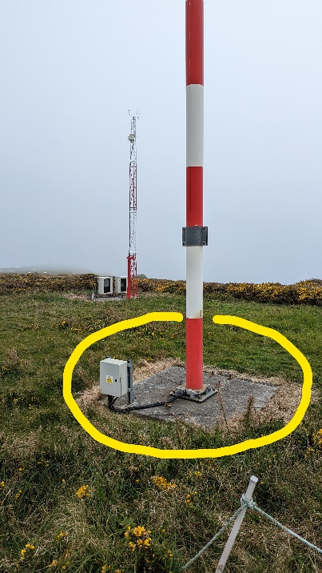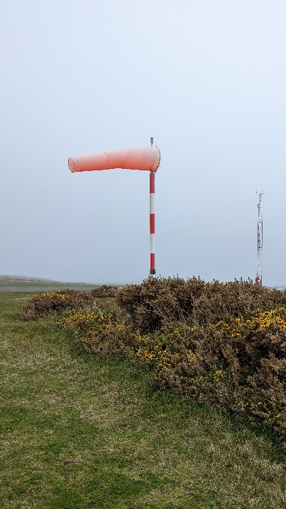

2. Specification
Response Requirement
The below table sets out the minimum specification required to be met for the turnkey replacement for the existing Air Traffic Control Met Display System. Responses to this tender will need to comply with the below specification as a minimum. The Aerodrome is certified under the EASA Common Requirements (Commission Implementing Regulation (EU) 2017/373) and thus all equipment must meet appropriate regulated standards.
Tenderers should provide confirmation that the equipment that they propose meets the specification by answering “Yes” or “No” against each aspect of the specification. Tenderers should also complete the declaration section underneath the table giving the company name, name of the individual providing the response and the date of completion of the form.
Where tenderers answer “No” to any of the below, tenderers should provide a comment so that the Council of the Isles of Scilly can understand any mitigating circumstance that may allow further consideration of the proposed Met System.
Each of the below will be subject to a Pass/Fail decision based on the answer provided and, where applicable, suitable mitigating commentary from the tenderer. Following this evaluation, any proposals containing 1 or more Fails will not be considered further in the evaluation process i.e. the evaluation of the quality criteria (QC 1 -3) and price contained within the procedural document.
Providers should be aware that following the selection of a preferred proposal i.e. the proposal that demonstrates compliance with the Pass/Fail evaluation (below) and which achieves the highest overall score in relation to the main quality/price evaluation (see the quotation form), the Council of the Isles of Scilly will provision suitable personnel to attend Factory Acceptance Test of equipment.
The cost of attendance will be financed by the Council of the Isles of Scilly and should not be included in the pricing of your proposal.
Where the above Factory Acceptance Test identifies that the proposal has seriously misrepresented the quality and specification of the equipment the Council will consider the proposal non-compliant, and it will be ejected from the procurement process.
Where the Factory Acceptance Test reveals issues that would be unlikely to have been known by the tenderer, the tenderer will be provided with the opportunity to make good these items (within the price identified in the proposal), bringing the equipment up to the level described within their submission, or withdraw their submission. The Council will not be able to consider a reduction in price (so that it can affect the required repairs) as this would both materially change the basis of your submission and potentially expose the Council to unquantified additional cost.
Where the Factory Acceptance Test reveals no significant issues or where issues were detected but were unlikely to have been known about by the tenderer and have subsequently been rectified, the Tenderer will then be authorised to continue to the site building phase. On completion of build, Site Acceptance Test and Temporary Approval by UK CAA the Council will conclude the quotation process and move to conclude the contract with that bidder. As part of the process of concluding the quotation process the Council will issue a purchase order for the final payment.
Where the preferred bidder is rejected or removes themselves from consideration (as identified above) the proposal that was formerly second place in the evaluation i.e. the proposal that following successfully passing the Pass/Fail element of the evaluation and whose combined score in relation to the quality criteria (QC1 -3) and price score was initially the second highest, will be considered the “preferred bidder”. The above process will be repeated until a satisfactory solution has been reached.
Suitability of the met station site, any existing cabling, mountings, power supplies and other infrastructure must be checked by tenderer prior to submitting tender.
SPECIFICATION
SPECIFICATION | PROVIDED  YES/NO | COMMENTS | Pass/Fail  (Council use only)
Meteorological Station complying with all applicable ATC standards for the UK. Including but not limited to ICAO, EASA, CAP670 & CAP746.
NOTE: Any equipment requiring a mast mounting such as anemometer is anticipated to be fitted to existing windsock mast.
Air Traffic Control Display System provisioning appropriate information to Air Traffic Controllers as per figure 1 of this document. ICAO, EASA, CAP670 and CAP746 Compliance as a minimum.
Communication links between the Met Station and the display equipment.
NOTE: Utilisation of existing cross site cabling is anticipated for the majority of communications. There is an additional cable run of <200m anticipated to join existing network.
Backup Power Supplies where appropriate for maintaining data display.
NOTE: Airfield and ATC have backup Generators which will support the equipment. ATC has dual backup UPS which will support the equipment.
An Anemometer and onsite spare providing Wind Speed and Direction IAW CAP746.
An Air Pressure sensor and onsite spare providing data IAW CAP746
A Temperature and Humidity Sensor and onsite spare providing data IAW CAP746
Cabling, mountings, shields etc for sensors listed above

Display System / Workstation Providing 2 screens in ATC. Must meet CAP670 requirements and provide Runway selection, Cross and Head / Tail Wind component.
Factory Acceptance test
Site Acceptance Test
Training for onsite maintenance personnel
Training for ATC personnel
Safety Case Assistance
Prior experience and evidence of similar installation and project management.

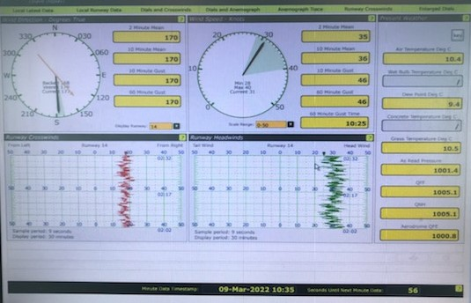Figure 1: Existing ATC Display

Declaration
I confirm that to the best of my knowledge that the statements provided above are accurate and I understand that any attempt to mislead the Council of the Isles of Scilly in this process may lead to my submission being rejected. We also agree to Council appointed personnel attending Factory Acceptance Testing of the final equipment setup if we are identified as the preferred bidder and acknowledge that the costs of attendance will be met by the Council.

Signed………………………………………………………….
Position………………………………………………………..
Company………………………………………………………
Date……………………………………………………………..

3. Variations from the Specification (Variant Bids)

The Council will accept variant bids relating to this procurement.
Where variants are allowed the participants will need to identify how the solution proposed provides an equivalent result to the materials, items, processes, methods or other aspects outlined in this specification (and any accompanying documents) for each and every variation from the specification. The participant shall also identify the means by which the equivalence can be verified (independently) by the Contracting Authority.

