National Army Museum Uniform Procurement for Customer Facing Staff and Volunteers

Brief for Procurement of Uniform at the National Army Museum

November 2016

Contents Page

1. Introduction
2. Scope of works
3. Budget
4. Schedule
5. Project team
6. Tender process
7. Appendices

For information:
Appendix A: Background to the National Army Museum Appendix B: Our Audiences Appendix C: A New Brand

For action:
Appendix D: Cost per unit, minimum order quantities and delivery charges
Appendix E: Form of Tender
Appendix F: Certificate of Bona-Fide Tender
Appendix G: Supplier Statement

1. Introduction

The National Army Museum (NAM) is working to transform its visitor experience and deliver a new brand identity. As part of this transformation the NAM is looking to appoint a uniform supplier to provide uniform for its Customer Facing staff and volunteers. Visitors will come in to contact with staff across a number of front facing platforms, including NAM’s Welcome Desk, Shop, Play Base, (NAM’s early years learning facility) and in the Galleries, it is therefore integral that staff members are well presented, easily identifiable as NAM staff and that the uniform reflects NAM’s brand identity.

NAM will be re-opening in Spring 2017 and is currently in the process of recruiting its Retail and Visitor Experience team and at this stage there is currently no uniform. The team will be made up of 29 paid staff and 14 volunteers, with a mix of full time and part time roles. NAM has its own brand model and values, which are expressed through various formats, one of which is the experience created and delivered to its visitors. For this reason it is important that the brand is represented visually through the uniform.

NAM will be asking staff to provide their own black trousers or skirt and this piece of work is for the provision of long and short sleeve shirt options and an accompanying jacket.

If you are interested in tendering for this this project, this document provides the following information:

- Scope of works
- Schedule
- Tender Process

We would welcome your application to work with us.

2. Scope of Works

NAM is seeking to appoint a company to provide uniform for its Retail and Visitor Experience team. It should be tailored to meet NAM’s requirements, which includes the following:

- The uniform needs to be an off the shelf solution, to which the NAM logo can be applied (embroidered is preferred).
- The pieces of uniform will need to be one single colour, with the colour taken from NAM’s colour palette, to visually represent NAM’s brand.
- There needs to be a male and female option.
- There needs to be a range of size options, to accommodate all sizes.
- The uniform needs to be practical, durable and have ease of movement for carrying out a range of duties across different working environments. In addition, in order to best represent the Museum it needs to be smart and well presented.
- Machine washable and easy to iron, must not become distorted in shape or size.
- Good quality fabric, which is suitable for both cold and warm working conditions.
- An alternative solution for the volunteer team, which makes the volunteers feel part of the team but also makes them recognisable as volunteers to our visitors and distinguishes them from paid staff.
- Long term viability to be able to maintain and fulfil orders to NAM’s requirements.

NAM has its own specific brand and colour palette. This is currently embargoed and in order to receive interested companies must sign a confidentiality agreement. Once the disclosure has been signed further brand details, including the logo and colour palette, will be issued to the uniform provider for consideration as part of the tender response.

NAM has identified three phases to this work, which are detailed below:

2.1 Phase One

Conception of Uniform

- To discuss and collaborate with NAM to provide uniform to meet NAM’s requirements, as detailed above.

- To summarise the findings and establish a uniform design which is:

- Reflective of NAM’s brand model.

- Sets NAM apart from other Museums and Galleries through visually promoting our brand identity.

- To provide samples of designs for staff testing, NAM approval and sign off.

2.2 Phase Two

Production and Delivery of Uniform

- To detail costing’s and quantities needed for set up, production of uniform, fulfilment of NAM’s order and delivery charges.

- In discussion with NAM establish a scheduled timeline with achievable deadlines to be met in order to meet NAM’s requirements for roll out.

- To fulfil NAM’s order quantities required at roll out and meet deadline.

2.3 Phase Three

On-going delivery and reorders

- Establish lead times for fulfilment of orders for replacement uniform.

- Establish costing’s, minimum order quantities, delivery charges and any other required information for future orders.

2.4 NAM’s Requirements in fulfilling these services

NAM is looking for a company with the ability to deliver quality, off the shelf uniform. They will need to be able to apply NAM’s brand through use of NAM’s colour palette and the application of NAM’s logo to each piece of uniform. The uniform provided will need to meet the minimum quantities required for roll out at re-opening and meet longer-term requirements for uniform fulfilment to accommodate wear and tear and turn over of staff.

As a start you will have:

- Previous experience and success in delivering and providing uniform for other organisations, ideally a museum or visitor attraction site.

- Ability to maintain high quality work while meeting tight deadlines.

- A good eye for detail and ability to transform specific requirements into a uniform that clearly represents the organisation.

3. Budget

All costs for individual elements detailed in the response must be fully disclosed along with all calculations.

Quoted fees must include all of the following:

- Professional fees

- Production and delivery costs

- Detailed breakdown of cost per unit, MOQs needed to meet these costs and delivery charges, utilising table at Appendix D.

- Travel and expenses

- Disbursements

- An estimate of any contingency

- All third party fees

- Report, printing and presentation costs

- All other expenses and costs required in the delivery of the project.

The fees should indicate if they include or exclude VAT.

4. Schedule

NAM would like to discuss the delivery schedule in detail with the appointed company as part of the contract kick-off phase. However, the following list provides some indicative delivery milestones.

- Dec 2016 – Contract kick-off, phased and detailed production and delivery schedule sign off
- Jan 2016 – Uniform conception discussions
- Jan 2016 – NAM sign off on uniform
- Jan/Feb 2016 – Uniform produced and delivered
- March 2016 – Uniform roll out for re-opening
- March 2016 – Long term ordering and delivery schedule sign off

5. Project Team

Project Sponsor Team
Dawn Watkins – Assistant Director (Commercial & Visitor Experience)

Project Manager
Kathryn Haggerston – Retail and Visitor Experience Manager

6. Tender Process

6.1 Tender Requirements

Proposals should comprise the following.

6.1.1 Response to Brief

Response to the brief should demonstrate:
- A clear methodology statement for the development and delivery of the Works detailed in Section 2.
- An outline work plan identifying key milestones and sign-off points informed by this brief.
- Confirmation of team members, including sub-contractors if relevant.
- Cost plan detailing the tasks and staff responsibilities, daily and hourly rates and expenses.
- At short-listing suppliers may be asked to supply images of potential products, which meet NAM’s requirements.
- Suppliers invited to interview may be required to supply samples, including logo size and placement.

6.1.2 Tenderers Project Team, Qualifications and Experience

Provide details of three relevant projects that demonstrate qualifications and experience. For each project, include a description of the project, you, your company’s and/or sub-contractors’ role, client, budget and project dates.

6.1.3 Fee

The Fee is to be a fixed sum for the provision of all Works as outlined in the Scope of Works.

The Fee is to include all expenses. This will include travel costs, accommodation, disbursements, reports and all other expenses and costs required in the provision of the Works. The fee should exclude VAT at the prevailing rate.

6.1.4 Instalment Payments

Provide a suggested fee drawdown schedule in your response. NAM reserves the right to amend any suggested drawdown schedule.

6.1.5 Insurance

Please provide copies of up-to-date insurance - NAM requires Public
Liability with a minimum of £10 million, Employers Liability with a minimum £10 million and Professional Indemnity Insurance to the value of £2 million.

6.1.6 References

Provide reference details of three recent contracts that are relevant to this project. Include the name and contact details of the clients’ representatives who could be approached for references. References will be taken up before confirmation of appointment.

6.1.7 Financial

Please provide a copy of the company’s published accounts for the last three years.

6.1.8 All company documentation as requested below:

- The completed Form of Tender (Appendix E)
- The completed Certificate of Bona-Fide Tender (Appendix F)
- The completed Supplier Statement (Appendix G)
- The completed Cost per Unit, Minimum Order Quantities and Delivery Charges (Appendix D)
- All forms (Appendix D, E, F and G) should be signed by the Tenderer or, in the case of a Company by the Secretary or other authorised person
- Any other information that is required to clarify the tender.

6.2 Tender Submission

Tenders should comprise 2x hard copies and 1 x electronic on DVD/memory stick of all tender content as outlined below:

- NAM Uniform Procurement tender proposal
- The completed Form of Tender (Appendix E)
- The completed Certificate of Bona-Fide Tender (Appendix F)
- The completed Supplier Statement (Appendix G)
- The completed Cost per Unit, Minimum Order Quantities and Delivery Charges (Appendix D)
- Any other information that is required to clarify the tender.

6.3 Tender Return

Tenders must be submitted no later than 1200hrs on 8th December in a plain envelope labelled only with the address below and clearly marked “Tender – Uniform Procurement”. No other marks or wording (including pre-paid franked stamps), which might indicate the identity of the sender, shall appear on the envelope containing the tender.

The tender shall be submitted to:

Mr John Foster
National Army Museum
Royal Hospital Road
Chelsea
London SW3 4HT

Tenders can also be returned via email at the above date and time to: jfoster@nam.ac.uk. The subject of the email should state “Tender –Visitor Experience and Front of House Proposal”. Any electronic tenders received before this date will be rejected.

Tenders are to remain open for acceptance for a period of 60 days.

6.4 Tendering Costs

NAM will not be responsible for or pay for any costs or expenses that are incurred by any tendering consultant in preparing and submitting their tender.

6.5 Contract Award Criteria

The tender board may consist of the following NAM representatives:

- Assistant Director (Commercial & Visitor Experience)
- Retail and Visitor Experience Manager

Tenders will be assessed on the following criteria:

- Response to brief 30%
- Experience 20%
- Project Team and Resourcing 20%
- Fee 30%

Each proposal will be given a score. A proposal considered to be unsuitable shall be rejected at this stage if it does not respond to important aspects of the brief. NAM shall notify unsuccessful tenderers of the rejection of their proposal after completing the selection process.

Tenders will be awarded on the absolute discretion of the Board of NAM, in accordance with internal policies and statutory regulations. NAM is not required to accept the lowest priced tender.

The decision will be final and binding, no correspondence will be entered into.

Short-listed tenders will be invited in to give a ten-minute overview of how they would approach and deliver NAM’s project requirements, followed by questions and answers.

6.6 Tender Programme

The key dates in relation to this tender exercise are detailed below.
Activity | Date
Brief issued | 16 November 2016
Tender submission deadline | 12:00hrs 08 December 2016
Notification shortlisted candidates | 09 December 2016
Interviews | w/c 12 December 2016
Appointment of chosen company | 16 December 2016
Initial contract start up meeting – agreement of timings going forward | w/c 19 December 2016

The above programme is indicative of NAM’s timescales. However, the project currently sits within the BftF Master Programme and may be subject to alteration.

The forward programme will be developed in discussion with the appointed company.

6.7 Enquiries

Any enquiries arising must be submitted in writing via email to:

Kathryn Haggerston, Retail and Visitor Experience Manager, National Army Museum
Email: khaggerston@nam.ac.uk

Enquiries will be answered within three working days.

Appendix A : Background to The National Army Museum

A New Museum

In spring 2017, a new national Museum will open in London. The Museum’s vision is bold. To use its rich historical and developing contemporary collections to foster people’s awareness, understanding and knowledge of the British Army, its soldiers and legacy. And through this exploration, encourage debate about an institution that is little understood but is intrinsically part of our democratic society and enables us to live with the freedoms we enjoy everyday.
Building for the Future
This new Museum is being created through the auspices of the Building for the Future (BFTF) project. Set to cost £23.75million, the project has been funded by a Heritage Lottery Fund grant of £11.5m, with the remainder covered by fundraising carried out by the Museum.
The project is realising the wholesale transformation of the Museum’s offer onsite, offsite and online, across seven main work streams.
1. A wholly new visitor experience. A major restructure of the building has created: five new thematic galleries – Soldier, Army, Battle, Society, Discovery; a new 500m² temporary exhibition gallery; a new three-room learning centre; a new early years learning facility – Play Base; a new research centre and archive; new café; new shop; new boardroom. All are being realised within a building designed to create a more welcoming and engaging physical experience and supported by a fresh approach to public programming (see below).

2. New programmes for learning and outreach. The closure of the Museum has provided unprecedented opportunities to pilot new approaches to delivering our learning purpose and to test how the Museum can extend its reach whilst also providing the depth and breadth of offer required of a national museum. On opening the Museum will offer relevant, thought provoking and challenging opportunities to engage with the Collection and our stories through community engagement and curation, new learning services aimed at early years, schools, families, adults and lifelong learners, and new a public programme that seeks to encourage active participation and debate in a wide range of topics from military history to present day conflicts and world geopolitics. It is a place that will spark conversations.

3. New working models of service delivery and public engagement.
The project has enabled the Museum to review its structure, the ways it fulfils its purpose, the services it offers and its enabling and supporting systems and processes. As the project moves into delivery phase, new teams, processes, services and training are being put in place to deliver an audience-focused, commercially sustainable and more goal driven organisation. This is being facilitated by new working models with a focus on process and cross-departmental and cross-divisional collaboration.

4. A sharper focus on generating income. The new visitor experience whilst creating a more welcoming and engaging physical experience has also sought to ensure a focus on facilities and activities to drive earned income. In order to achieve this commercial spaces and the overall offer within the Museum have been designed to be visible, enticing and reflect the growing expectation of Museum audiences.

5. Better conservation of and access to the Collection. The project has enabled the conservation of thousands of objects for the new displays. In addition, it has enabled a significant programme of digitisation that will provide easier and greater access to the Museum’s national archives online that through an accompanying cataloguing and external partnerships, will provide a modern, flexible and customer-centred online enquiry services, aimed at meeting the needs of a broad range of researchers from the school pupil to the family historian to the expert academic.

6. A new brand and marque
During 2014-15 the Museum worked to create a new brand model to help direct and inform the development of the new Museum. It has influenced every aspect of the new Museum, from permanent displays, to interior design to signage to the extent that the new building physically embodies the new brand, helping to transform the Museum from a dark and traditional place to a modern, bright, and relevant Museum fit for the 21st century.

7. Going digital. Digital transformation underpins much of the new Museum’s work. Whilst attention is necessarily focused on what needs to be done to deliver the modern services expected of a 21st century museum. The creation of the Museum’s new website is seen as the first step in a medium- to long-term digital journey that will see a wholesale review, modernisation and streamlining of the Museum’s systems as digital becomes central not only to realising efficiencies but to delivering a world-class national museum service, locally, nationally and internationally. Digital is central to the Museum achieving a greater sphere of influence and impact and in developing brand awareness.

Appendix B : Our Audiences

The Museum’s Audience Segments

As part of Building for the Future, the Museum has undertaken extensive audience research, working with market research company Morris Hargreaves McIntyre. This work identified the following seven market segments for the Museum before its closure in 2014. The Museum has used these segments to guide the development of the exhibitions and services within the project and to target and monitor audience development work to date within the delivery of the Building for the Future Activity Plan.

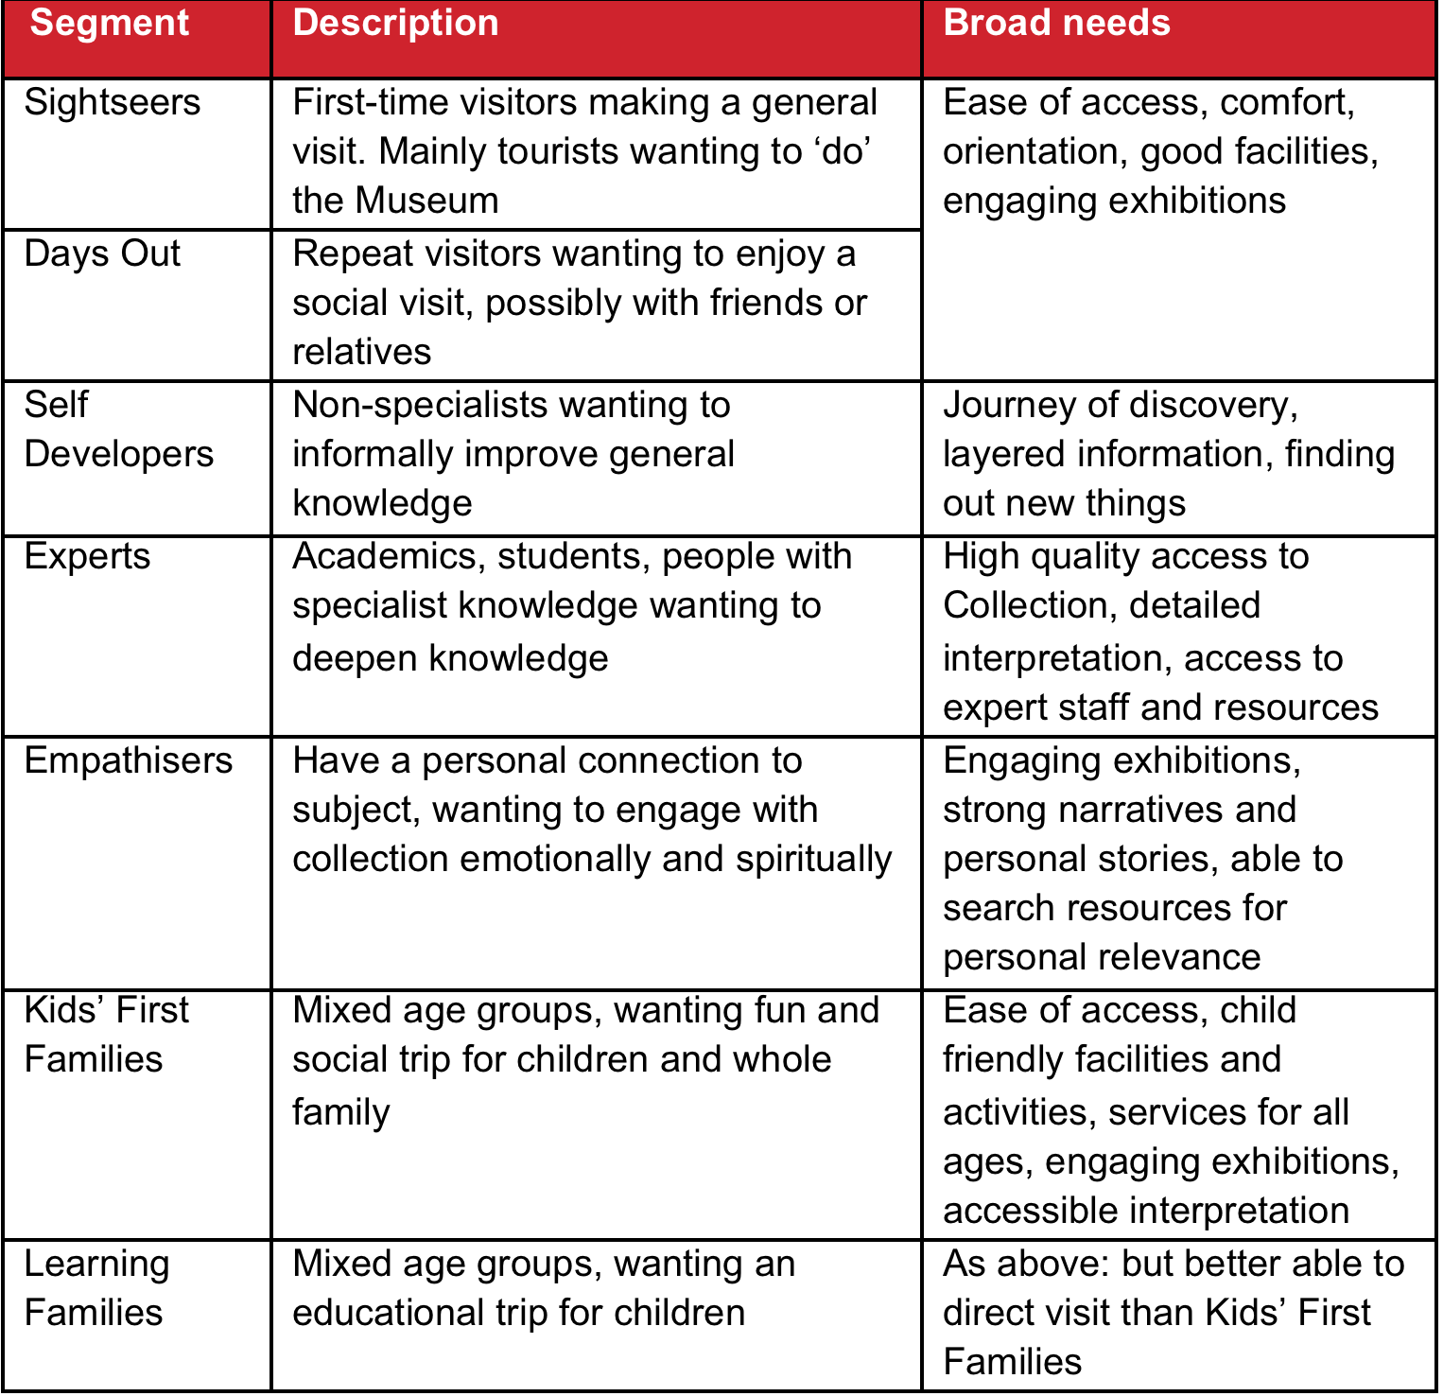
Figure 1: National Army Museum - Visitor segmentation

On opening, the Museum will continue to engage with each the above segments but there will be a particular focus on the following audience segments that have been identified as having the strongest potential for growth in visitor numbers:

- Learning Families
- Kids' First Families
- Empathisers
- Self-Developers.

Of these, Learning Families and Kids' First Families will be further prioritised. Whilst project also expects to attract a greater number of curiosity-driven first time visits amongst Sightseers – either from the UK or overseas – these are not seen as a high priority in the short-term.

An important strategy in achieving this growth is to grow participation to reflect the population diversity of modern Britain particularly certain demographic groups who are under-represented in the Museum’s pre-closure audiences:

- Women
- Non-specialists
- Local residents from such culturally and socially diverse boroughs as Southwark, Wandsworth, Hammersmith and Fulham and Lambeth.

In addition, the Museum will continue to build relationships and deepening engagement with:

- Schools – particularly from local socially and culturally diverse boroughs in London
- Students and academics – in military history; social history; politics
- Members of the armed services – active and retired.

And as the Museum seeks greater participation and breadth in its audiences, it is looking to improve participation across Black, Asian and Minority Ethnic (BAME) groups, disability groups, young people, older people and N-Sec 5-8, continuing the work achieved through the Activity Plan.

Appendix C: A New Brand

As part of Building for the Future, the Museum has developed a new brand and approach to visual communications.

The new brand model was developed in 2014-15, and has guided the development of the Museum – from the galleries themselves to the interior design of the Museum and its facilities – the new Museum is literally a physical manifestation of the new brand rather than it being applied after the design of the new Museum.

Whilst detailed information will be provided to the successful consultant, NAM’s new brand model is provided here to convey the nature of our new brand

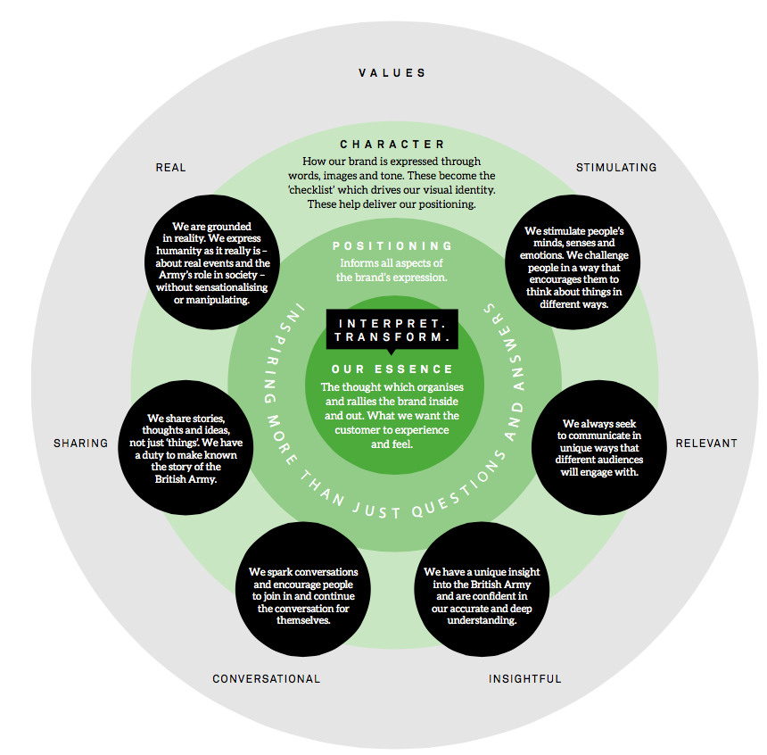
Figure 2: National Army Museum – new brand model

Appendix D: Cost per unit, Minimum order quantities and Delivery Charges

Staff Provision 2017 |  |  |  | Re-order in 2018
Product | Quantity Required by NAM at roll out | Minimum Order Quantities | Price per Unit | Minimum Order Quantities | Price per Unit
Long Sleeve | 85
Short Sleeve | 85
Jacket | 46

Volunteer Provision 2017 |  |  |  | Additional in 2017
Product | Quantity Required by NAM at roll out | Minimum Order Quantities | Price per Unit | Minimum Order Quantities | Price per Unit
Long Sleeve | 25
Short Sleeve | 25
Jacket | 25

Delivery Charges: Initial and Ongoing
Price for delivery at initial roll out
Price for delivery per unit
Price for delivery of bulk re-orders in 2018

Signed: ____________________________________________________

In the capacity of

Duly authorised to sign the tender on behalf of:

Date:

Appendix E: Form of Tender

Tender for: National Army Museum Uniform Procurement

To: The Council and Director of the National Army Museum

Sirs,

I/We the undersigned, having examined the enclosed tender documents and Appendices, do hereby offer to execute and complete in accordance with the said documents the works described therein:

For the sum as listed in the attached document:

Tenderer Reference:

I/We hereby affirm our agreement to enter into a contract with the Council of the National Army Museum for the due performance of the Works in the form described by the above said documents.

I/We have completed the Certificate of Bona-Fide Tender included in this document.

I/We understand that the Trustees are not bound to accept the lowest or any tender which may be received nor or responsible for any cost incurred in the preparation of any tender.

I/We declare that this offer is to remain open for acceptance for a period of 60 days from the date fixed for the receipt of tenders.

Signed: ____________________________________________________

In the capacity of

Duly authorised to sign the tender on behalf of:

Date:

APPENDIX F: CERTIFICATE OF BONA-FIDE TENDER

Tender for: National Army Museum Uniform Procurement Project

I/We certify that this is a bona-fide tender and that I/we have not fixed or adjusted the amount thereof by or under in accordance with any agreement or arrangement with any other person.

I/We also certify that I/We have not done and I/We undertake that I/we will not do at any time any of the following acts:

- Communicate to a person other than the person calling for these tenders the amount or approximate amount of the proposed tender except where the disclosure, in confidence, of such amount(s) was necessary to obtain insurance premium quotations required for the preparation of the tender.

- Enter into any agreement or arrangement with any other person that he shall refrain from tendering or as to the amount of any tender to be submitted;

- Offer or pay or give or agree to pay or give any sum of money or valuable consideration directly or indirectly to any person for doing or having done or causing or have caused to be done in relation to any other tender or proposed tender for the said work any act or thing of the sort described above.

In this certificate the word “person” includes any person and any body, association, corporate or un-incorporated; and “any agreement” includes such transaction, formal or informal, and whether legally binding or not.

Signed: ____________________________________________________

In the capacity of

Duly authorised to sign the tender on behalf of:

Date:

APPENDIX G: SUPPLIER STATEMENT

We certify that the information supplied is accurate to the best of our knowledge and that we accept the conditions and undertakings requested in the assessment. We understand that false information could result in our exclusion from the Tender process or the Approved Suppliers List at any time, even after initial inclusion. We also understand that it is a criminal offence to give or offer any gift or consideration whatsoever as an inducement or reward to any servant of a public body and that any such action will empower such body to cancel any contract currently in force and will result in exclusion from the Tender and / or the Approved Suppliers List.

Signed by: _____________________________________________________

Name: (in BLOCK LETTERS) ______________________________________

Title: _________________________________________________________

Date: _________________________________________________________

For and on behalf of: _____________________________________________

This form should be signed by a Director, Partner or other authorised signatory of the organization and returned as part of the Tender Response

