

**Laverstock & Ford Parish Council**

**Incorporating Milford, Bishopdown Farm, Old Sarum & Longhedge**

3 Pilgrims Way, Laverstock, Salisbury, SP1 1RZ

Tel: 01722 411847

Email: [parish-clerk@laverstock-ford.co.uk](mailto:parish-clerk@laverstock-ford.co.uk)

Invitation to Tender

Whitebridge Boardwalk

March 11, 2019

**CONTENTS**

Section 1 of this pack contains all the information you need to draw up a good quality response to our Invitation to Tender. Please read everything in the pack carefully. We aim to provide everything you will require in the pack, however if additional information is required please refer to the contact information in Section 1, Part 1.

**SECTION ONE – Information**

**Section 1 - Contact Information Page: 3**

**Section 2 - Background Information, Brief and Timetable Page: 4-6**

**Section 3 - Conditions of Tender Page: 7**

**Section 4 - How Tenders will be Evaluated and Awarded Page: 8-9**

**Section 5 - How to Return Tender Documents Page: 10**

**Appendix- Maps and photographs of area Page 11-16**

**Section 1 - Contact Information.**

Name: Andrew Prince

Email parish-clerk@laverstock-ford.co.uk

Tel: 01722411847

Address: 3 Pilgrims Way,

Laverstock,

Salisbury,

SP1 1RZ

**Section 2 - Background Information, Brief and Timetable.**

Laverstock and Ford Parish is situated in the south of the county of Wiltshire, bordering the city of Salisbury to the west and running with open countryside to all other points of the compass. The Parish is rural in character. Arable farmland predominates together with some outdoor pig, cattle and sheep farming. The Parish also has a rich heritage of both historic and natural features including the remains of prehistoric settlements and burial mounds, a First World War Airfield, ancient chalk grasslands and the River Bourne chalk stream. The Old Sarum hill fort and historic settlement lies just outside of the Parish, to the west of the new residential development of Old Sarum.

Currently Laverstock and Ford Parish Council own a wooden boardwalk which runs alongside the River Bourne chalk stream which forms part of the Hampshire Avon SSSI/SAC. The boardwalk joins Milford with Laverstock in the south of the Parish. The boardwalk is currently in a bad state of repair and needs urgent replacement.

The Parish Council proposes to enter into contract for the removal of the current boardwalk (approximately 225m) that lies between Riverbourne Road and its entry to the Whitebridge green open space (see map attached) plus a new replacement boardwalk on the same site.

In addition, two short spurs are required. One to go towards the River Bourne and the existing bench and the second spur 50m north, again to go towards the river. A new bench needs to be installed at the end of this spur.

The boardwalk is to be constructed in recycled HDPE plastic such as Duraplas or similar with a textured slip-resistant finish and consist of three post cross sections at 1.4 centres, bearers, deck boards and kick rails. We require replacement handrails where the ground is sloped at the Riverbourne Road end of the boardwalk and also where the existing boardwalk meets concrete at the Whitebridge end.

The price should provide storage units on site/security fencing and provision for a low ground pressure forklift to remove old boardwalk (if necessary) and any associated skips.

The scope of the Works will be confirmed during the accompanied site visits.

The project is being funded with a Heritage Lottery Fund Grant and from Council Reserves.

1. Tenderers should be aware that information provided as part of this tender exercise will be subject to current legislation.

2. Prospective Tenderers are advised to read the documentation and any schedules and appendices carefully to ensure that they are fully familiar with the nature and extent of the obligations to be accepted by them if their Tender is successful.

3. Laverstock and Ford Parish Council does not bind itself to accept the lowest or any tender and reserves the right to accept the whole or any part of any tender, unless the Tenderer stipulates otherwise. Every effort will be made to reach a decision on award of the contract as soon as possible after submission of tenders.

1. Tenderers must submit a Standard Bid for the supply of the whole of the Services specified under the terms of the contract.
2. Tenders should be received by Laverstock and Ford Parish Council no later than **1pm on Friday 3 May 2019**. Late or incomplete Tenders will not be considered.

6. Due diligence checks will be conducted, before the awarding of the contract, to ensure the Council is able to work with the successful bidder.

7. Environmental Approvals from the relevant Statutory Authorities must be obtained by the successful bidder before work commences. The requirements from the Environment Agency as the lead Statutory Authority are outlined below. Natural England has arrangements in place with the Environment Agency with respect to licensing of works on the Hampshire Avon SAC and SSSI in which the site of works are located so a separate application to Natural England will not be required.

**Strategic Overview (PSO) team at** [**bridgwater.frap@environment-agency.gov.uk**](mailto:bridgwater.frap@environment-agency.gov.uk) **will require:**

* **A 12-figure grid reference for the exact location of the proposed works. You can find this information using the tool online at** [**https://gridreferencefinder.com/**](https://eur01.safelinks.protection.outlook.com/?url=https%3A%2F%2Fgridreferencefinder.com%2F&data=02%7C01%7C%7C62edb5415a0c4db4e4d408d64a45fd25%7C84df9e7fe9f640afb435aaaaaaaaaaaa%7C1%7C0%7C636778061789089958&sdata=LHWGy%2B%2B8nO6tkxGFcNmIqjmSdY1O91npvU6VYOjL3VU%3D&reserved=0)
* **A description of the planned work. Please include a method statement if available.**
* **The duration of the work.**
* **The details of any machinery, temporary structures and materials to be used (e.g. excavator, scaffolding, concrete, sheet piling) and the length of time this will be in/across the water course.**
* **The length / width of watercourse or bank affected by the works on the distance from watercourse in metres (if near the river)**

**Timetable & Administration**

It is intended that this procurement will run to the following timetable. In the event that changes are required we will endeavour to keep you fully informed. Every effort shall be made to avoid changes.

Should the closing date for tenders be amended all tenderers will be notified.

**Procurement timetable**

Invitation to tender issued: **Monday 11 March 2019**

Deadline Notification Intention to tender: **Monday 25 March 2019**

Accompanied site visits : By appointment during week **Monday 1 April 2019**

Tender submission deadline: **Friday 26 April 2019**

Evaluation: **During week of 29 April to 3 May 2019**

Contract award: **Friday 10 May 2019**

Project start: **Tuesday 27 May 2019**

Project completion: **Friday 26 July 2019**

**(*These are target dates only and subject to review, contract start and completion date will be agreed with the preferred supplier on the awarding of the contract).**

**Section 3- Conditions of Tender.**

1. Information supplied is for the general guidance of Tenderers only. Tenderers must satisfy themselves by their own investigations with regard to the accuracy of all such information and no responsibility is accepted by LFPC for any loss or damage of whatever kind and howsoever caused arising from the use of such information.
2. The full cost of responding to this ITT and tender process, including but not limited to any costs and/or expenses involved in the preparation of the Tender response and for any subsequent presentations and/or demonstrations and/or negotiations, will be borne by the tenderer. Laverstock and Ford Parish Council shall have no liabilities in this regard.
3. Tenderers shall be deemed to have satisfied themselves before submitting their Tender as to the correctness and sufficiency of the rates and prices stated in their Tender which shall (except in so far as it is otherwise provided in the Contract) cover all their obligations under the Contract and shall be deemed to have obtained for themselves all necessary information as to risks, contingencies and all other circumstances influencing or affecting the Tender.
4. Tenders must not be qualified but must be submitted **STRICTLY** in accordance with the tender document. Only tenders submitted without qualification strictly in accordance with the tender documents will be accepted for consideration. Tenderers should not include in the tender any extraneous information which has not been specifically requested, for example, standard terms of trading, sales literature etc.
5. The tender document must be treated as private and confidential. Tenderers should not disclose the fact that they have been invited to tender or release details of the tender document other than on an 'in confidence' basis to those who have a legitimate need to know or whom they need to consult for the purposes of preparing the tender.
6. The Tenderer shall be required to give an undertaking which shall become a condition of the contract that the amount of the Tender has not been calculated or arranged with any person other than LFPC, that the amount of the Tender has not been communicated to any person other than LFPC and will not be communicated to any person until after the closing date for the submission of Tenders.
7. The tenderer shall not approach any employee of Laverstock and Ford Parish Council (other than those designated as contacts in the Invitation to Tender) with a view to providing or requesting information on any part of their tender.
8. This section details the key actions that are required by LFPC of all Tenderers. Tenderer non-compliance may be regarded as breach and may result in LFPC removing the Tenderer from the process.

**Section-4 – How Tenders will be evaluated and awarded**

These notes provide details on how tenders will be evaluated. The tender process will be conducted to ensure that tenders are treated equally and fairly.

**Evaluation of Tenders**

Evaluation of tenders will always rely upon the information that you have provided. If you fail to provide all the information requested, you will put your tender at a disadvantage.

Your tender submission should provide:

* A fully priced breakdown / bill of quantities.
* A detailed Method Statement (including proposed designs, with appropriate drawings, for boardwalk and spurs etc).
* Evidence of how the required work is to be approached in the form of references from similar contracts and appropriate case studies.
* Demonstration of your understanding of the Health & Safety issues associated with the proposed works and how these issues will be managed.
* A copy of your public liability insurance to £10 million or confirmation that this insurance will be obtained if your tender is successful
* Your proposal should include a scalable plan of the proposed designs. All images should also be provided electronically.
* It is imperative that the contracts phase of the works is managed effectively with communication being maintained with the supervising officer throughout the duration of the scheme.
* Tenderers must provide full details of their policy, in this respect, describing how they will manage this element of the project from the tender award (if successful) to satisfactory completion.
* A Gantt chart should also be included detailing the construction phase timeline.
* Full details of guarantees and warranties construction and materials shall be provided.
* All construction drawings must be provided to the Council on the handover of the completed project, complete with details of any maintenance requirements.
* The successful Bidder will also make good any surfaces damaged in accessing the site and leave the site as found
* The successful Bidder will comply with all current Health and Safety regulations as laid out in the Health and Safety at Work Act 1974.
* All site security including equipment, fencing, machinery etc is the responsibility of the successful Bidder, until an official handover has been concluded.
* Parking Restrictions contractors and employee’s vehicles:

1. Minimum number of vehicles
2. No parking on paths
3. No obstruction of residential drive ways
4. Observe the Highway Code
5. Minimise impact on busy estate roads

* Do not use the site for any other purpose other than carrying out the works.
* The following health and safety hazards are or may be present at the site:

Underground low voltage electricity cable serving existing street-lighting columns. Soil may have raised water levels. The area is a well-used place by the public to walk dogs and children.

* The tender must explain how the site shall be protected during construction to prevent access by the public.
* The site works lies within the Hampshire Avon Special Area of Conservation and Site of Scientific Interest. A full method statement will be required for scrutiny by the relevant Statutory Authorities (See Section 2, item 7) The tender should quote some examples of previous work by the contractors within Protected Sites to demonstrate the contractor’s experience of minimising environmental impacts and achieving legal compliance when operating within SACs and SSSIs. There is sensitive ground flora adjacent to the boardwalk and minimising disruption to this should be part of the method statement’s consideration.

**Evaluation criteria**

**Designs will be evaluated using the following criteria and score weighting**

Price 60 points

Method Statement(s) & Design(s) 25 points

Health and Safety information and evidence of similar work 15 points

Written answers will be evaluated alongside the method statement, drawings and plans, and the breakdown of costs. All submitted documents should demonstrate how your proposal meets our requirements.

**Clarity**

A clear and easily understood tender increases the chances of success.

Once the deadline for receipt of tenders has been reached, a group of at least 3 members and officers of the Parish Council will evaluate the written tenders.

**Section 5- How to return your Tender Submission**

The information in this document will help you offer a quality response to our invitation to tender. Please read the notes carefully as they address many of the frequently asked questions.

The deadline for delivery is given in **Section 2 – Background Information and Timetable.**

Tenders received after this time will not be considered apart from in exceptional circumstances when they may be considered at the discretion of the Council. Tenders received ahead of the deadline will remain unopened until the tender submission deadline.

Tenders should be returned in a sealed envelope clearly marked across the top **“Private and Confidential: Laverstock and Ford Boardwalk Project’’** and addressed to:

The Parish Clerk

3 Pilgrims Way

Laverstock

Salisbury

Wiltshire

SP1 1RZ

An electronic copy of the tender on a USB memory stick is also required.

Please only return items specifically asked for in the tender.







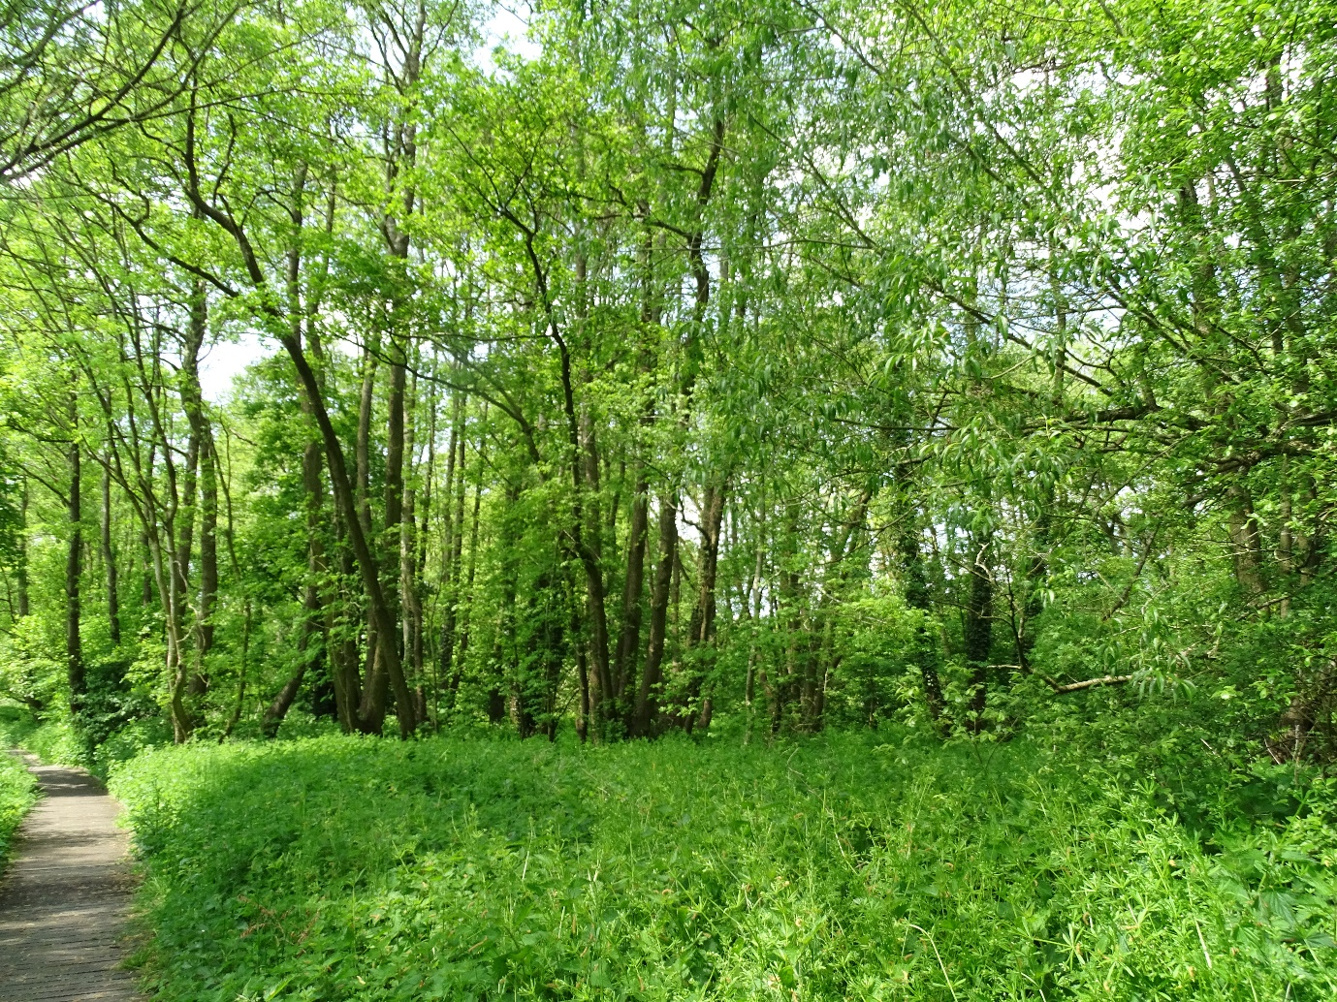

**Looking North-River on left of boardwalk.**

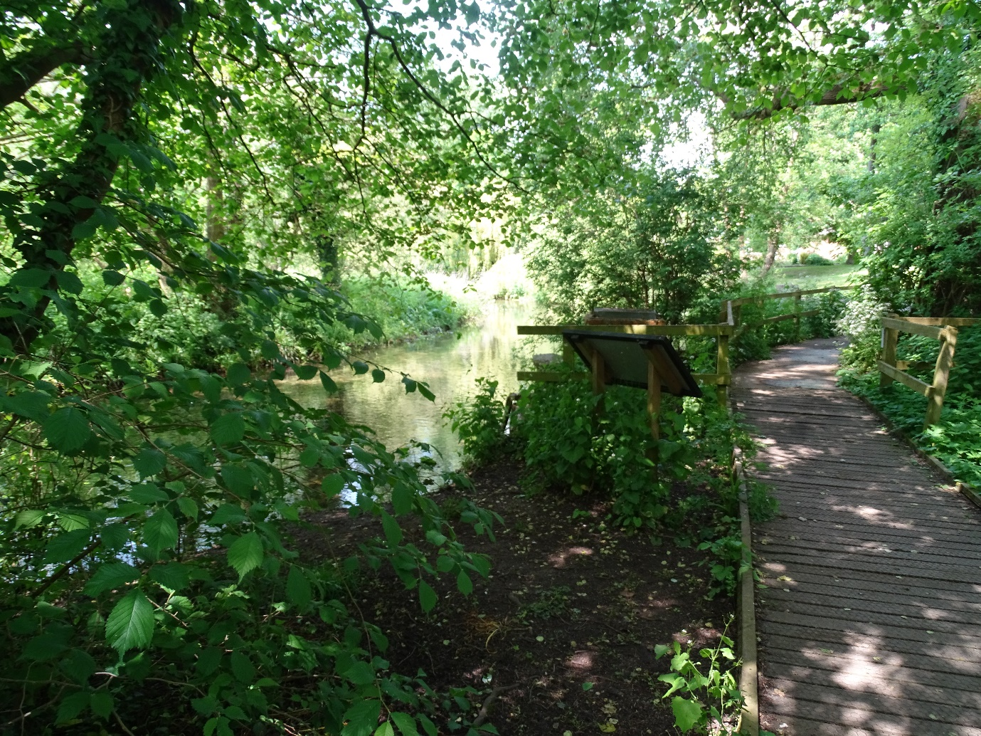

**Northern end of boardwalk where it joins short concrete section**

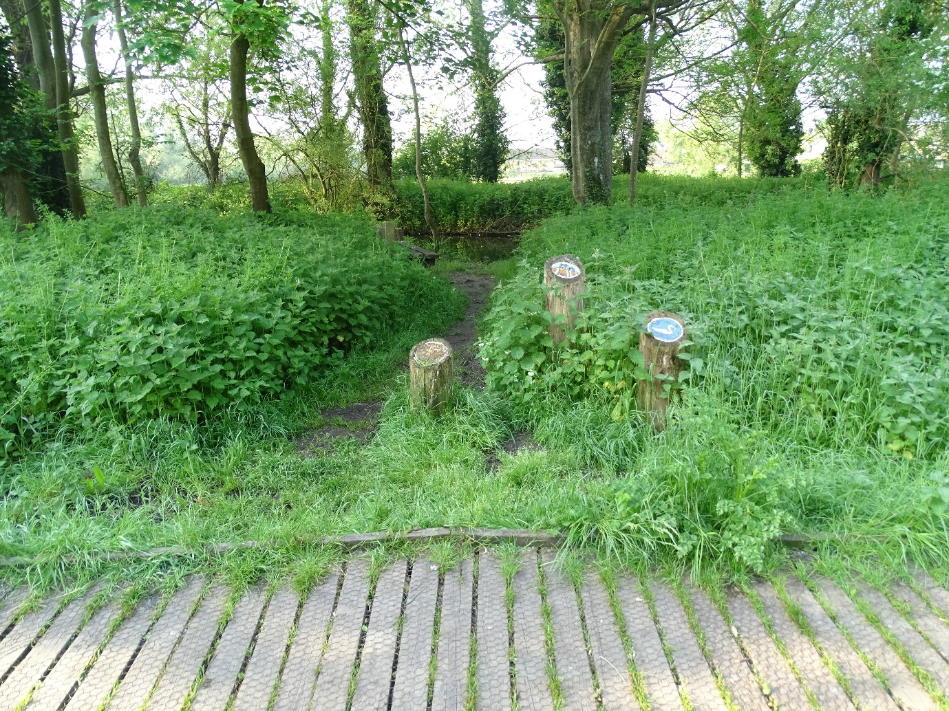

**Section for new spur to river adjacent to existing bench**

Invitation to Tender

Laverstock and Ford Boardwalk

March 11, 2019

The deadline for delivery is given in Section 2 – Background Information and Timetable.

Tenders received after this time will not be considered apart from in exceptional circumstances when they may be considered at the discretion of the Council. Tenders received ahead of the deadline will remain unopened until the tender submission deadline.

Tenders should be returned in a sealed envelope clearly marked across the top “Private and Confidential: Laverstock and Ford Boardwalk Project’’ and addressed to:

The Parish Clerk

3 Pilgrims Way

Laverstock

Salisbury

Wiltshire

SP1 1RZ

An electronic copy of the tender on a USB memory stick is also required.

Please only return items specifically asked for in the tender.