**SCHEDULE OF REQUIREMENTS FOR THE SUPPLY OF** **DAO Digitalised Qualification Management System (QMS)**

|  |  |  |  |  |  |  |  |  |  |  |  |
| --- | --- | --- | --- | --- | --- | --- | --- | --- | --- | --- | --- |
| **Deliverables** | | | | | | | | | | | |
| **Item Number** | **MOD Stock Reference No.** | **Part No. (where applicable)** | **Specification** | | **Consignee Address Code** (full address is detailed in DEFFORM 96) | **Packaging Requirements inc. PPQ and DofQ**(as detailed in DEFFORM 96) | | **Delivery Date** | **Total Qty** | **Firm Price (£) Ex VAT** | |
| **Per Item** | **Total inc. packaging**  **(and delivery if specified in the Purchase Order)** |
| 1 |  |  |  | |  |  | |  |  |  |  |
| 1 |  |  |  | |  |  | |  |  |  |  |
| 1 |  |  |  | |  |  | |  |  |  |  |
| 1 |  |  |  | |  |  | |  |  |  |  |
|  |  |  |  | |  |  | |  |  | **Total Firm Price** |  |
| **Item Number** | | | | **Consignee Address (XY code only)** | | |

**STATEMENT OF REQUIREMENT FOR DAO NEW QMS**

**PURPOSE**

1. The Defence Awarding Organisation (DAO) requires a digitalised qualification management system (QMS) to improve efficiency, reduce regulatory risk and grow capacity to meet increasing Defence demand.
2. The awarding organisation (AO) landscape is moving from physical printed certification to digital certificates and the regulatory burden is increasing, resulting in the DAO requiring stronger compliance processes across its centres; otherwise, DAO risk the chance of regulatory sanction. Consequently, to help future proof, and reduce risk, DAO requires a QMS that provides:
   * Governance control
   * Qualification development and management
   * Centre control
   * Digital certification
3. DAO needs to align with Defence Academy’s (DefAc), intent to become a digital academy and offer eCertificates and only physical ‘printed’ qualification certification as an option for the learner, thus removing default manual certificate process that currently exists within DAO and across all centres.

**BACKGROUND TO REQUIREMENT**

1. The DAO was established in 2009 to give the MOD an ‘in house’ awarding body.  The DAO is affiliated and regulated by the Office of Qualifications and Examinations Regulations (Ofqual), a Government sponsored organisation that regulates all awarding bodies within, England and Wales. DAO are committed to comply with Ofqual’s General Conditions of Recognition (GCoR). The DAO’s mission is to award vocational qualifications to Service Personnel (Regular and Reserve) and CS in order to recognise quality and competence gained through Defence training and experience. To-date, DAO has issued >70k qualification certificates and the growth is shown below:

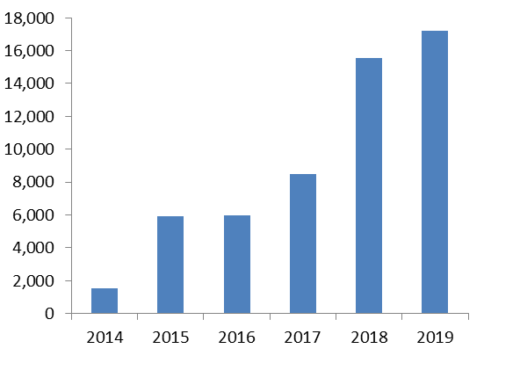

1. The DAO currently manages the 123 regulated qualifications, which are managed across 32 active centres. DAO has out-grown the extant in-house QMS system which is no longer future proofed without significant overhawl and cost. The current DAO QMS is limited to producing management information on qualifications only and not a more holistic assessment of the regulatory position of DAO.

**REQUIREMENT**

1. The requirement is for a new scalable DAO QMS, to support the existing DAO portfolio of 123 regulated qualifications, with freedom to expand, managed across 32+ active DAO centres and awarding qualifications to 20-30k+ learners per year.
2. The system it is to:
3. Provide a QMS which has capability to undertake:
   1. Governance control of DAO. Ability to demonstrate compliance against all GCoR and help link all processes to regulatory position.
   2. Regulated qualification development and management. Functionality to manage the development of new qualifications and manage existing qualifications.
   3. Awarding Centre (AC) management and control. Ability to manage and control of all ACs, for compliance, including centre details, staff contacts, satelite sites, IQAs, Assessors, through-put, risk and compliance status, outstanding actions, malpractice, conflicit of interest, Reasonable adjustments, appeals and sanctions.
   4. Digital certification. Provide a digitalised solution with an eCertification capability, with QR code, to ensure greater control and security; and functionality to print learner qualification certificates.
4. Align with DefAc being a digital academy (and DefAc Digital Transformation Project aims) and the Government agenda of digital by default.
5. Provide a solution that is kept uptodate and is automatically updated/aligned to changes imposed by regulators, ie Ofqual/SQA, that will strengthen DAO goverance arrangements. A QMS that is robust, with business continuity functionality and able to provide a continuous service remotely.
6. Be endorsed by the Federation of Awarding Bodies (FAB).
7. Provide an enduring branded ‘DAO’ system, with a specific organisation (DAO) domain capability.
8. Provide a help-desk facility for DAO staff and DAO centre/EQA queries.
9. Provides an income generation/billing option. To allow payment by individual learner for qualification certificates.
10. Web-enabled and Cloud-based solution, ie no hardware/server requirement. Solution provides secure access and is system agnostic, ie not tied to DefAc IS or MODNet (can allow access from ‘@mod.gov.uk’ emails); can be assessed via any ‘www’ browser/Internet Explorer and potential to export qualifications to ePortfolio, eg Mahara.
11. Provide interface to external systems such as CSCS scheme – to verify qualifications.
12. Provide evidence of data security meeting Defence’s high standards of data assurance with alignment to DPA 2019.
13. Provider of QMS has significant AO experience within organisation and holds the following certifications to support the system:

ISO 9001 Quality Management System.

ISO 20000 IT Service Management System.

ISO 22301 Business Continuity Management System.

ISO 27001 Information Security Management System..

Public Service Network (PSN) Certification.