Specification for Christmas Lights in Westfield

We are looking to hire Christmas Lights on a 4- or 5-year contract. The Contract should start with the Christmas 2025 display. We require installation, removal and storage.
Background
Westfield has had a Christmas Lights display on lampposts since 2015. Originally a Roman road, the A367 (Wells Road / Fosse Way) is long and straight, accommodating a magnificent series of 40 lights on lampposts. A green space on the corner of Wells Road and Elm Tree Avenue forms the centre of Westfield for the Christmas Lights. It has a living Christmas Tree which we would like to see drenched in lights and local shops where we would like to see six complementary designs on the walls. Full details of the lighting scheme requirements are on pages 4-7.
The lamp-posts are modified internally with isolator switches, a timer and a plug and socket externally (at height).
The successful contractor will be required to enter into a three-way agreement with the local authority, Bath & North East Somerset (owner of the columns), and the Parish Council, which includes the following requirements:
- Evidence of risk assessments and safe systems of works
- Evidence of training
- Traffic management – application for street works licence prior to working on the main road to install the lights

Tender Process
You are very welcome to arrange a site visit with us. Please contact us to arrange this or indeed if you require any further information. 01761 410669 or council@westfieldparishcouncil.co.uk
Tenders should be marked CHRISTMAS LIGHTS TENDER and emailed to Lesley Close, Parish Clerk on parishclerk@westfieldparishcouncil.co.uk by 5pm on Friday 28th March 2025.
The tenders will be assessed by Committee with a view to making a decision by 24th April 2025.
Please answer the questions below and complete the attached pricing schedule, giving as much information as you can. Please send a proposed design(s) which would be accommodated in the budget shown below.

General
Yes / No
Please attach evidence that you are an approved contractor for NICEIC, IPAF and G39
Please complete the attached Approved Contractor form and send the required attachments
We require two attendees for our Christmas Lights Switch On Event for the last Thursday of November (one hour max) to switch on the lights at the appropriate moment. We only require the two columns closest to the event to be switched on with the countdown, the rest of the columns are illuminated afterwards. Can you accommodate this?

What is your guaranteed response time in the event of a fault in the display?

Environment – what steps have you taken to reduce the adverse impact of the scheme on the environment?

Looking at the light display and the existing infrastructure, please outline which items are included in the contract and which are invoiced separately.
Please outline in item (5) of the Pricing Schedule all extra costs, for example replacing a faulty timer.

Budget
Our Budget is £15,000.
- Lights on 40 lampposts as per the diagram on page 4.
- To dress the Living Christmas Tree with lights, photo on page 5
- 6 x lights on the wall of the local shops at Elm Tree Avenue/Wells Road, photos on pages 6-7
Please send a proposed design(s) to accommodate the three items above within the specified budget.

Pre-loved Option
On the Pricing Schedule please quote separately for the option of a pre-loved Lights Display giving the terms on which this would be offered. We understand that this would be subject to availability and most likely a quick decision would be required.

Lights required on the Wells Road / Fosse Way, Westfield - 40 lamp columns:
17, 18, 19, 20, 21, 23, 24, 25, 26, 27, 28, 30, 31, 32, 33, 35, 36, 37, 38, 39, 40, 41, 42, 43, 44, 45, 46, 47, 50, 51, 52, 53, 55, 56, 57, 58, 61, 62, 64, 65
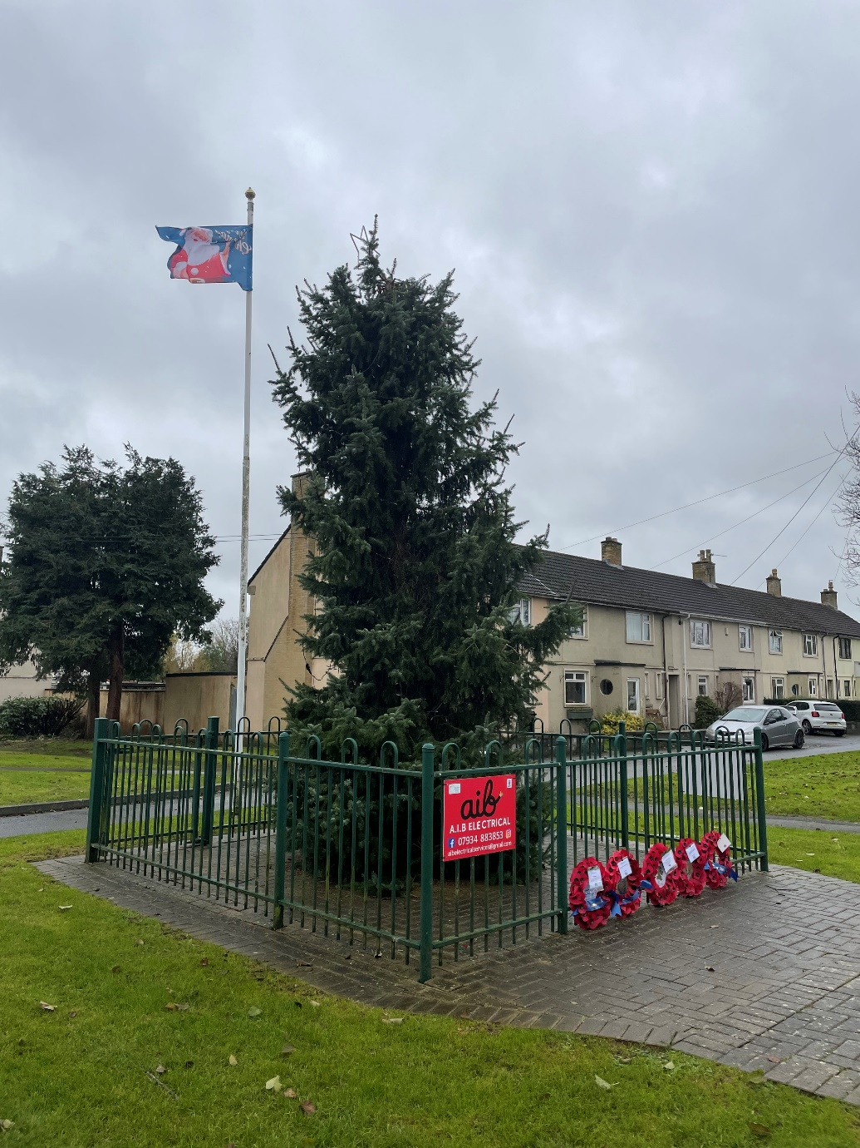 Living Christmas Tree at Elm Tree Avenue / Wells Road Junction
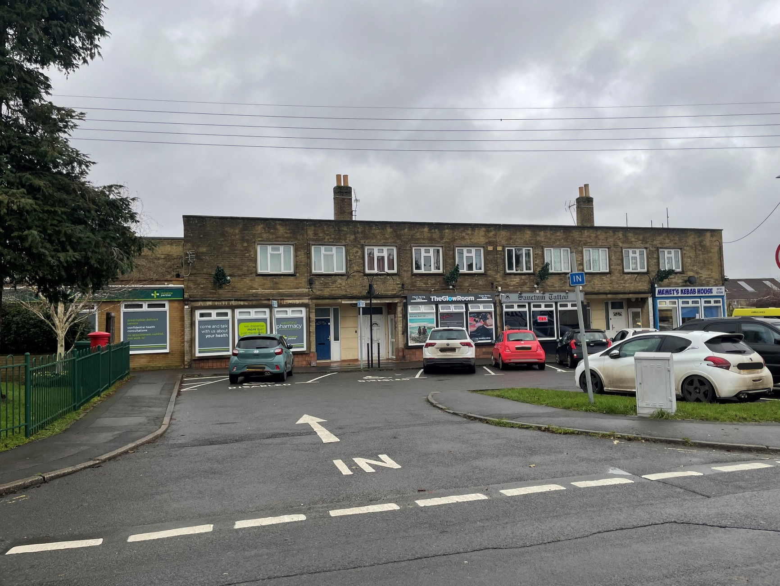
Local shops at Elm Tree Avenue / Wells Road Junction
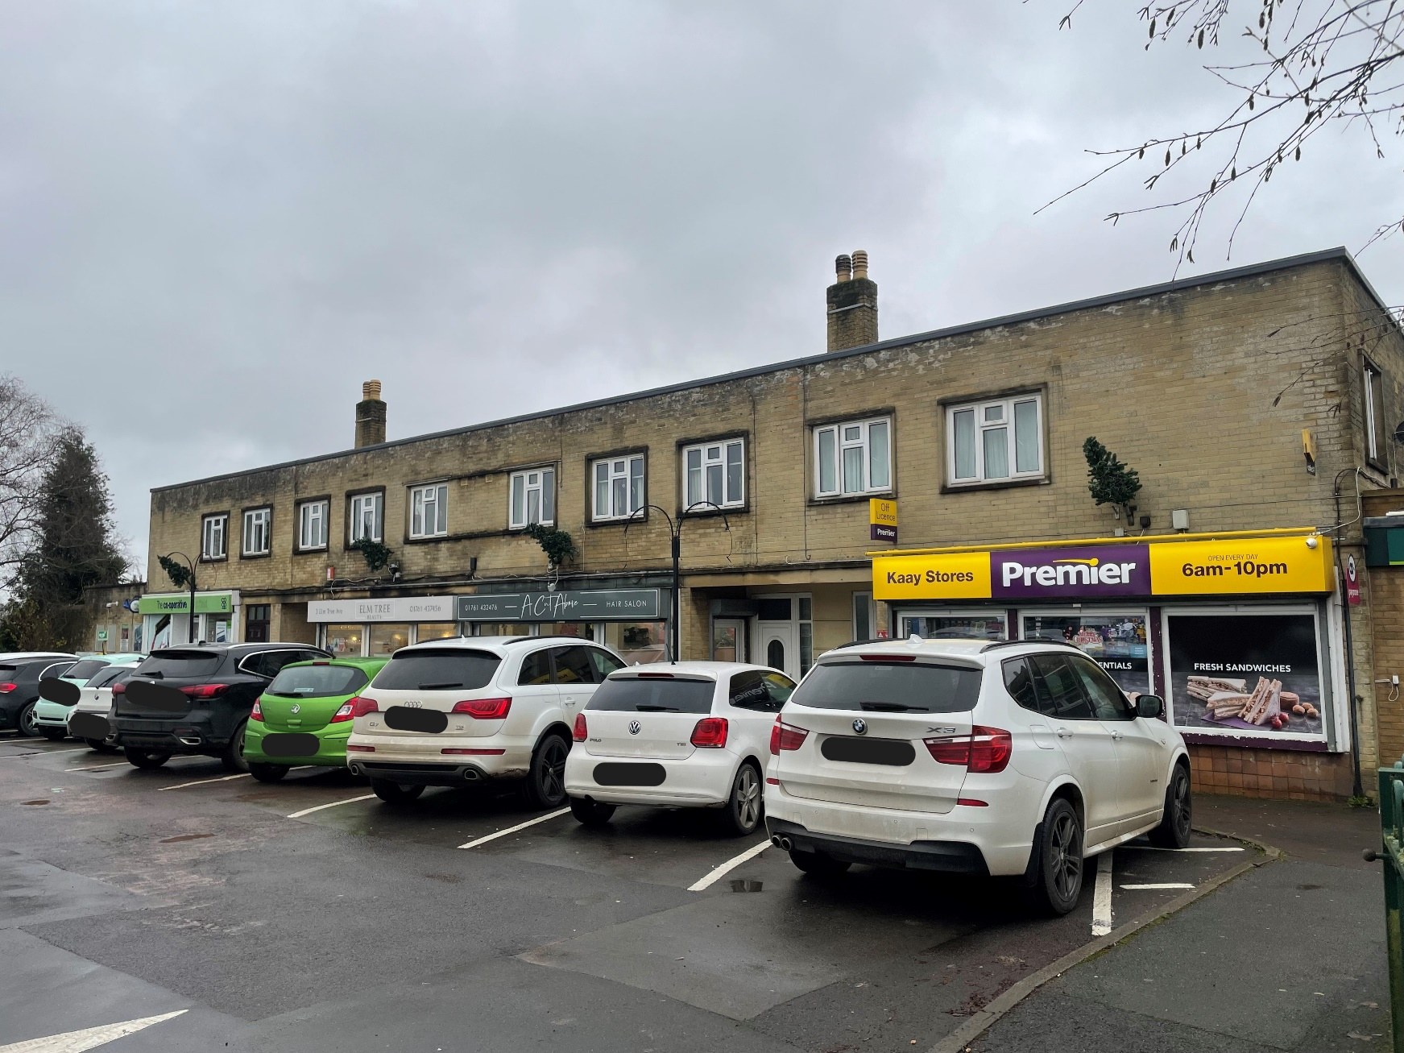
Local shops at Elm Tree Avenue / Wells Road Junction

PRICING SCHEDULE – All prices net of VAT
- 40 Christmas Lights on Lampposts on the A367
 | Price per annum for a four-year contract | Price per annum for a five-year contract | Wattage for the whole design and for LED lights indicate the angle of light achieved per bulb eg 100 degrees
To hire new lights
Installation and removal, including setting the timers
Storage
Total
To hire pre-loved lights
Installation and removal, including setting the timers
Storage
Total

- To dress the Living Christmas Tree in Lights
 | Price per annum for a four-year contract | Price per annum for a five-year contract | Number of lights to go on the tree and wattage for the whole design and for LED lights indicate the angle of light achieved per bulb eg 100 degrees
To hire new lights
Installation and removal, including setting the timers
Storage
Total
To hire pre-loved lights
Installation and removal, including setting the timers
Storage
Total

- 6 x lights on the walls of the local shops at Elm Tree Avenue/ Wells Road
 | Price per annum for a four-year contract | Price per annum for a five-year contract | Wattage for the whole design and for LED lights indicate the angle of light achieved per bulb eg 100 degrees | One-off cost to renew any degenerating Christmas Lights cabling on the outside of the building
One-off cost of Installation of all infrastructure such as brackets etc to accommodate the new wall display
To hire new lights
Installation and removal, including setting the timers
Storage
Total
To hire pre-loved lights
Installation and removal, including setting the timers
Storage
Total

- Cost of 2 engineers to attend the Christmas Lights Switch On Event
 | Price per annum for a four-year contract | Price per annum for a five-year contract | Notes
Total

- Extras
 | Price per annum for a four-year contract | Price per annum for a five-year contract | Notes
Total

