Padiham Townscape Heritage: Crafting the Future

Architectural Support & Cost Consultancy in Respect of the Padiham Townscape Heritage Programme: To Review Grant Applications, Grant Payments and Building Works.

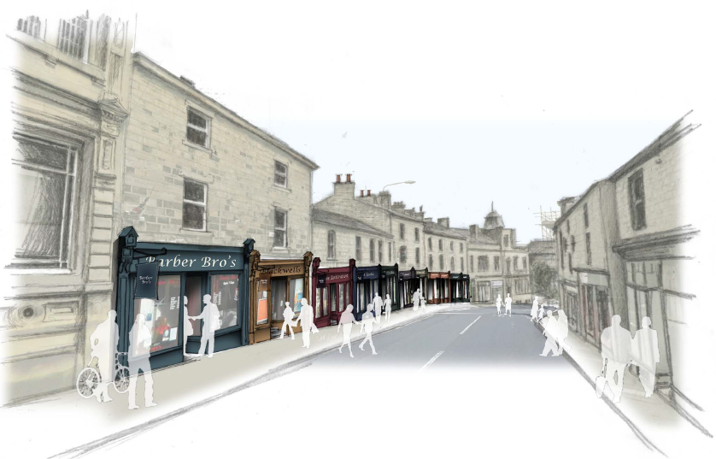

Tender Brief

Date of issue: Tuesday 10th April 2018
- Purpose
  - Burnley Council requires the support of an Architect/Chartered Surveyor experienced in historic building repair and restoration to support the administration of the Padiham TH (Townscape Heritage) Programme, and offer internal assurance throughout its delivery when required. The role of the Consultant is to ensure value for money and that high standards of building repair and conservation are achieved.

- Background
  - Burnley Council has been successful in securing Heritage Lottery Funding for a Townscape Heritage Project within Padiham town centre. The Padiham TH is a five year scheme totaling approx. £2million which has now commenced to support the growth and development of the town centre through three key areas:
- £1.17million for repair and restoration works to buildings – this will involve grant aided works available to property owners within the TH boundary at a fixed grant rate of 75% to cover the cost of external repair and restoration works to retain the historic nature of the area.
- £430,000 is earmarked for environmental improvements within the TH area to include decluttering of street furniture, introduction of traffic calming measures, new paving surfaces and public art.
- Wider activity programme – working with local partners, the Padiham TH will deliver a Borough wide programme of community engagement events and heritage skills training activities to run throughout the lifetime of the project.

  - The Padiham TH scheme focuses on a compact area of mostly Victorian buildings predominately in retail use on Burnley Rd, an area known locally as ‘the hill’. This tight grained area of historic townscape lies on a key gateway into the town. It represents a significant cluster of buildings of architectural merit within the Conservation Area, including four listed buildings and a number of locally listed buildings.

  - This area has been highlighted as an area for concern within the Conservation Area Appraisal and Conservation Area Management Plan, due to: the large number of vacancies within buildings; visible signs of under investment in repairs and maintenance; loss of historic detail and inappropriate changes to decorative features, shop fronts, signs and advertisements. Through the TH scheme, the Council will assist physical works to priority buildings with the aim to address the immediate threats to heritage, build confidence among owners, investors, existing & potential businesses and residents to secure the long-term future of Padiham as a distinctive and creative town.
  - The scope of the TH scheme is concentrated on a cluster of buildings to achieve a greater impact within the townscape and a more visible difference in the streetscape. It is thought that having a well-focused target area will help to maximise the impact of the scheme.

  - Projects have been prioritised and grouped into:
- High Priority – essential to the delivery of the scheme, making a fundamental difference to the overall townscape.
- Medium Priority – clearly contributing to the enhancement of the Conservation Area.
- Reserve – worthwhile pursuing should funding become available or if some of the priority projects fail to come forward for a grant.

  - The extent of the Padiham TH area is shown on the map:

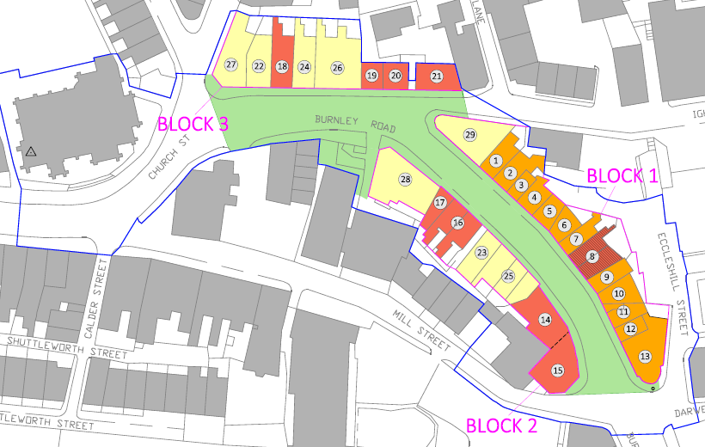
TH Boundary
High Priority Projects
Medium Priority Projects
Reserve Projects
Public Realm Works
A detailed scheme plan is available on request.

- Scope of Services Required
  - Review of third party grant applications. The Consultant will have responsibility for assessing grant applications for building repair and restoration projects to ensure cost effectiveness and quality assurance. This will include in the region of 20 small-mid size building projects over a period of 4-5 years. Grant applications will be prepared in advance by the property owner/tenant & their agent appointed to develop the scheme.

Grant Applications will be accompanied by a number of required documents to be reviewed by the appointed Consultant, including a detailed breakdown of costs and works, scheme plans/drawings, tender reports for contractors/sub-contractors and statutory permissions. The Consultant will be expected to assess each application to ensure that:
- Proposed works are eligible for grant funding i.e. appropriate repair and restoration works in respect of the character of the building, and in accordance with HLF/TH criteria and relevant policies (Inc. the Council Conservation Area Management Plan and Shop front Guidance).
- Appropriateness of materials and methods proposed.
- That suitable market testing has been undertaken in the form of tenders obtained to carry out the works.
- All statutory permissions have been satisfied.
- And all required documents/evidence has been provided.

The Consultant will be expected to provide a summary report to the Council following their assessment of each Grant Application to include a recommendation to approve/or reject the application and the basis for the recommendation.

  - Project monitoring and assessment of grant claims. When projects have commenced on site, the appointed Consultant will be expected to review interim third party grant claims that property owners will submit to the Council throughout each building project. This will include certified invoices and a breakdown of costs for the period. Grant claims and payment arrangements will be prepared by the TH Officer in advance for assessment. Funding will only be paid against defrayed expenditure.

The Consultant will be expected to check the value of works carried out, which will include occasional site visits to inspect the standard of works and compliance with the conditions of the grant, and provide any recommendations to the Council.

  - Review of project completion and final grant claims for payment. The Consultant will be expected to review completed projects and conduct site visits to ensure that schemes delivered as part of the TH programme are of a high standard. Also to assess any recommended snagging. The Consultant will also review final claims for payment upon project completion which will be prepared by the TH Officer in advance.

The Consultant will be expected to produce a short written report for each project upon completion stating whether or not the project has been completed to satisfaction, or any recommendations.

  - Following receipts of documents to be reviewed, the consultant will be expected to produce a summary report within 10 working days.

- Timescales
  - The timescales for the appointment of an appropriate Consultant is shown below:
Milestone | Indicative Date
Issue Invitation To Tender (ITT) | 10th April
Form of Acknowledgement Returned | 20th April
ITT Clarification Questions Cut Off Date | 24th April
Deadline: Return of Completed ITT | 27th April
Post submission Clarification Meetings with Tenderers (where required) | Wk/c 7th May
Evaluation of Tenders | 14th May
Approval – Burnley Borough Council and the Heritage Lottery Fund | 17th May
Notification of result and appointment of successful firm | 18th May
Inception Meeting | Wk/c 21st May
Contract Implementation | Wk/c 28th May
Please note: dates set out in the table above are indicative only and may be subject to change. Any changes will be notified to all Tenderers.

  - The TH Programme has now commenced and is expected to complete by the end of 2022. The appointed Consultant will need to be flexible and able to carry out tasks within a reasonable timeframe as and when they arise throughout the lifetime of the programme.

- Estimate Value of Works
  - Budgetary resources are limited and the Council is seeking good quality advice from an appropriately experienced professional at competitive rates. The Council anticipates that the contract value arising from this opportunity would be in the range of £20,000 - £30,000.

- Project Team
  - The Consultant will work closely with the Council’s professional project team, including:
- Suzanne Pickering, Townscape Heritage Officer
- Sarah Heslop, Development Officer
- Erika Eden-Porter, Conservation Officer
- Catherine Price, Town Centre Manager
- John Killion, Project Officer (empty housing)

- Tender Response

  - Consultants will need to demonstrate a proven track record in delivering high quality outputs on time, to budget and in accordance with client expectations. The Council requires the following elements, as a minimum, to comprise the tender response. Please present all information in a clear and concise manner:

Insurance information
Self-certification as to whether you already have or can commit to obtain the levels of insurance cover indicated below (please provide copies of certificates where possible):
- Public Liability Insurance - £5m
- Consultant Indemnity Insurance - £5m

Conflict of Interest Statement
- Provision of a clear statement showing that your practice does not have any conflicts of interest related to the Council or this scheme.

Accreditations
- Provision of a clear statement showing that you/r practice has appropriate RICS / RIBA / IHBC / AABC or other appropriate accreditation, providing copies as appropriate.

Method Statements
- An interpretation of the brief (Weighting 15%)
- A description of the methodology proposed to complete the work (Weighting 15%)
- The name, qualifications, relevant experience and contact details of the individual(s) who will primarily undertake this work (Weighting 15%)
- A timescale/approximate number of hours needed to review grant applications, grant claims and undertake site visits. Also, a commitment to work within the timescales as outlined within the brief (Weighting 15%)
- Examples of previous relevant work completed within the last 5 years (up to 3 examples). Examples should include HLF Townscape Heritage projects and/or projects which demonstrate experience/expertise in delivering a range of specialist services of a similar nature (Weighting 10%).

Fee Schedule
- A fee schedule to undertake tasks as set out in section 3 of the brief. The TH programme will include approximately 20 building project over a 4-5 year period. Please use the table below to provide this information.

Task | Amount / Frequency (estimate) | No. of Hours | Hourly Fee | Total
Review of Grant Applications including summery report/ recommendations | 20
Assessment of interim third party grant claims including occasional site visits | 80
Review of the project completion and final grant claim for payment including final summary report | 20
Total

- In addition, an hourly rate or fee for any other work that could potentially arise outside to scope of the brief.

References
- The names and contact details of two referees (preferably related to the examples provided). References will only be taken up for the preferred Tenderer.

  - In addition to the information required in section 7.1, the Council requires the following documents to be submitted (please refer to the ITT document):
- Form of Tender
- Certificate of Non-Collusion and Non-Canvassing
- Certificate the Tender is Bona Fide

- Evaluation Criteria
  - Tenders will firstly be checked for compliance in relation to providing the required documents and information as stated within section 7.

  - Tenders will be evaluated against quality (70%) and price (30%) criteria to establish the most advantageous tender. Please refer to Part 5 & 6 of the ITT document for full details concerning the tender evaluation.

  - Quality is worth 70% of the overall evaluation score and will be evaluated through an analysis of the applicants responses to the Method Statements outlined in section 7 above. Scores will be attributed to these responses by the stakeholder evaluation panel based on the methodology given in the table below.

  - Quality will be evaluated using the formula shown below:

Weighted Tender Quality Score =

Score Awarded by Evaluation Panel / Max Score Available x Weighted Percentage

Table 1 – Scoring Method
Score | Criteria
4 | Excellent: Response clearly meets all requirements. Clearly describes the bidder’s capabilities in delivering the requirements in scope; and demonstrates exceptional understanding. All information provided is consistent with all other areas of the tender response.
3 | Good: Response clearly meets all requirements satisfactorily. Clearly describes the bidder’s capabilities in delivering the requirements in scope, and demonstrates understanding. All information provided is generally consistent with all other areas of the tender response.
2 | Satisfactory: Response meets most requirements but is lacking or inconsistent in a few identifiable areas, leading to minor reservations. Describes the bidder’s capability in relation to the requirements, and demonstrates some understanding. Information provided is generally consistent with all other areas of the tender response.
1 | Weak: Response meets some requirements but is lacking in several identifiable areas, leading to serious reservations. Provides little indication of the bidder’s capability of delivering the requirements; or only partially meets the requirements; and / or demonstrates partial understanding. Some information provided is inconsistent with other areas of the tender response.
0 | Poor/ Non-Compliant. Has a number of deficiencies or concerns in certain areas where the lack of detail requires the evaluator to make assumptions, or no information is provided. Little or no description of the potential bidder’s capability of delivering the requirements is provided, leading to major reservations; or does not meet the requirement; and / or demonstrates no understanding. Information provided is inconsistent with other areas of the tender response.

  - Price will be evaluated using the formula shown below:

Weighted Tender Price Score =

(Lowest Tendered Price / Your Tender Price) x Weighted Percentage

  - The tender with the highest overall score will be determined as the most economically advantageous tender. The following evaluation approach will be applied to the tender submission:

Table 2 – Weighting Criteria
Criteria | Sub-Criteria | Demonstrated by | Weighting
Adequate Insurance Cover |  | Self-certification as to whether you already have or can commit to obtain the required insurance. | Pass/Fail
No conflict of interest declared |  | Self-certification as to whether your practice has any conflicts of interest. | Pass/Fail
RICS/RIBA/IHBC or equivalent accreditation |  | Self-certification as to whether your practice has appropriate accreditation. | Pass/Fail
Quality | Interpretation of the Brief | Understanding of the Padiham TH Programme; the grant application/claim process; heritage buildings; and requirements of the work. | 15
 | Methodology proposed | A clear overall approach to the work and an appropriate methodology outlined for completing each section of the brief. | 15
 | Identified team / staff | Suitably qualified staff/s identified with relevant experience of undertaking this type of work. | 15
 | Timetable | Ability to work within the timescales outlined in the brief. | 15
 | Past Experience | Relevant experience of undertaking this type of work. | 10
Price | Fees and Rates |  | 30
References* |  |  | Pass/Fail
Total Score Available |  |  | 100

*References will only be taken up for the preferred Tenderer. References will be subject to a Pass/Fail assessment and in the case of inadequate references being supplied, the Council will take up references for the next highest scoring Tenderer.

- Instructions for tendering
  - In the first instance, please acknowledge receipt of the Tender Brief and Invitation to Tender (ITT) documents and confirm that you intend to submit a tender by 15:00 hours on Friday 20th April 2018 using the ‘Form of Acknowledgement’ included at Appendix 1 in the ITT document.

  - Please note that this Tender Brief is a summary version of the process by which the tender should be completed and submitted; please refer to the ITT document for comprehensive instructions.

  - Tender responses should be submitted electronically via The Chest https://www.the-chest.org.uk/ (registration is free).

  - The last date and time by which the Tender submission should be submitted to the Council is: 15:00 hours on Friday 27th April 2018.

- Further Information
  - Any questions concerning any aspect of this Tender Brief, ITT Document or the tender process should be directed in writing to: Suzanne Pickering, TH Officer spickering@burnley.gov.uk

  - The following documents have been provided for further information:
- Grant application guidance notes
- A detailed scheme plan (which is available on request)

