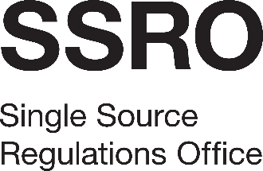

Stakeholder Survey 2022
Appendix 5: Form of Tender
[Name of Bidder]
To the SSRO:
On behalf of [Name of Bidder], of [Address] (“the Bidder”) –
- Having considered the invitation to tender and all accompanying documents (including without limitation, the Terms and Conditions and the Specification) we confirm that we are fully satisfied as to our experience and ability to deliver the services in all respects in accordance with the requirements of this invitation to tender.
- We hereby tender and undertake to provide and complete all the services required to be performed in accordance with the Terms and Conditions of contract and Specification for the amount set out in the Pricing Schedule.
- We agree that any insertion by us of any conditions qualifying this tender or any unauthorised alteration to any of the Terms and Conditions of contract made by us may result in the rejection of this tender.
- We agree that this tender shall remain open to be accepted by the SSRO for 90 days from the last date for the receipt of tenders.
- We understand that if we are a subsidiary, if requested by the SSRO we may be required to secure a Deed of Guarantee in favour of the SSRO from our holding company or ultimate holding company, as determined by the SSRO in their discretion.
- We understand that the SSRO is not bound to accept the lowest or any tender it may receive.
- We certify that this is a bona fide tender.

……………………………………………........
Signature (duly authorised to sign tenders on behalf of the Bidder)
Print name:
Date:

