**Clarifications: Cornwall Workspace Demand RFQ**

**Question 1:** What mapping including OS base and land use shapefiles may be available from the Council to the consultant? Can GIS files be made available – e.g. site allocations, any previous effort to map potential sites)?

**Response 1:** The Council has shapefiles for site allocations, and any relevant data produced through the Good Growth Plan will also be made available

**Question 2:** Can you provide – subject to appropriate agreement for use of data – a database of businesses (type / address)?

**Response 2:** The Council does not have suitable datasets of business details to share.

**Question 3:** We have some relevant work we can illustrate although are a young company. Rather than trying to find a way around your requirement (see Ref 9.3) can we present an additional short summary of similar experience we produced when at another organisation?

**Response 3:** We are content to review recent relevant work undertaken by your employees in order to respond to the condition below providing in doing so you can assure that no NDA, GDPR of confidentiality has been breached in doing so:

***9.3 Provide two examples of similar work that you or your organisation have produced in the last three years and include links to any publications of similar reports or analysis (Max. 2 sides of A4).***

**Question 4:** Will the winning suppliers work be used to support local plan allocations?

**Response 4:** It is anticipated the work will potentially input into the Local Plan

**Question 5:** Is there a definition of workspace that the Council are working to?

**Answer 5:** Workspace is a generic term for buildings used for places of work or employment, comprising offices, industrial and warehouse accommodation, leased or owned by businesses, where the activity produces gross added value to the economy.

Accommodation or premises that fall within the latest Town & Country Planning legislation use classes order (post Sept 2020), under the following categories:

B2 General Industry

B8 Storage and distribution

E Commercial Business and Service g (i), (ii) and (iii). And

Some sui generis uses that fall within the general description above.

If you disagree with this definition and want to vary it as part of your proposal please state your assumptions explicitly and if required price separately.

**Question 6:** Can 2 consultancies partner together to deliver this project?

**Answer 6:** Yes, providing your response clearly identifies the relevant areas of responsibilities of each partner. However, we only wish to contract with one entity, so one of the partners would need to be the lead and take responsibility for fulfilling the contract.

**Question 7:** Does the Council already have data showing vacant and available office buildings across Cornwall?

**Answer 7:** No.

**Question 8:** At 4.1, the RFQ references ‘Local Super Output Area’. Does this mean Lower or Middle Super Output Area?

**Answer 8:** Lower: <https://assets.publishing.service.gov.uk/media/5605116040f0b6036d000001/Cornwall_and_the_Isles_of_Scilly_Map_CLLD_250915.pdf>

**Question 9:** How are you defining workspace for this study?

**Answer 9:** See answer to Question 5.

**Question 10:** Approximately how many workspaces do you consider in scope?

**Answer 10:** See answer to Question 5

**Question 11:** Are site assessments required as part of this study? If so, approximately how many?

**Answer 11:** None

**Question 12:** Pg 27 of the Cornwall Good Growth Plan refers to economic data which will be published alongside the growth plan in relation to growth in industrial sectors. Does this data include forecasts of employment growth by sector over the 10-years or are you looking for this study to produce new sectoral employment forecasts?

**Answer 12:** Yes but to a limited extent and will be provided to the winning bidder**.** However, your response could include new sectoral employment forecasts depending on your approach.

**Question 13.** How will the study relate to the Local Plan evidence base? Will it need to fulfil the NPPF requirements of a ENA/ELR or will these be produced in addition?

**Answer 13:** It will be based on the evidence base and the progress within that plan (see table below):

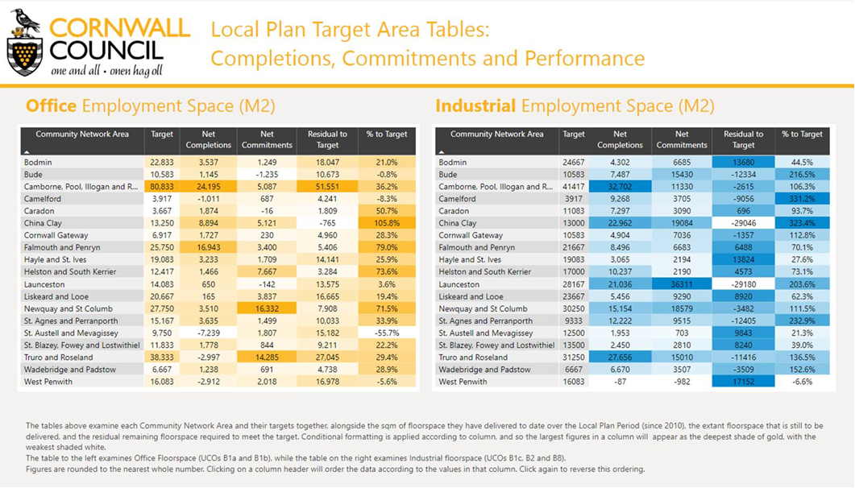

It will not need to fulfil the NPPF requirements of a ENA/ELR

**Received 09082024**

**Question 14**: Paragraph 3.3 of the RFQ document notes that the supplier will be able to make use of the economic evidence base prepared by the Business, Economy and Skills Service. Could you please let us know what this existing evidence base includes?

**Answer 14:** Please see data available at:

<https://www.cornwall.gov.uk/planning-and-building-control/planning-policy/adopted-plans/#examination>

<https://www.cornwall.gov.uk/the-council-and-democracy/data-and-intelligence/>

<https://www.cornwall.gov.uk/planning-and-building-control/planning-policy/adopted-plans/cornwall-site-allocations-dpd-examination-library/>

<https://www.economyhub.cornwall.gov.uk/>

<https://www.cornwall.gov.uk/planning-and-building-control/planning-policy/adopted-plans/cornwall-site-allocations-development-plan-document/>

**Question 15**: Would the Council be able to provide planning records showing permissions, take up and losses of employment land / individual premises to inform the study? How far back do these planning records extend?

**Answer 15:** See table at 13

**Question 16**: Would the Council be able to provide information on enquiries for business space?

**Answer 16:** No

**Question 17:** Are we able to put in CVs separate from the page limits/word counts mentioned?

**Answer 17:** Please refer to the following from the RFQ:

**9.4 Details of all staff involved, including CVs showing relevant past experience (Max. 2 sides of A4).**

**Question 18:** Can you confirm if there is a word or page limit on the methodology statement asked for at para 9.2 of the Specification document?

**Answer 18:** No limit.

**Question 19:** Para 4.1: When you ask about “*workspace*” do you mean space in planning use classes B2, B8, and E(g) or do you have a broader definition?

**Answer 19:** See answer to question 5.

**Question 20:** Para 4.1: When you ask about “*currently available workspace*”, do you mean all existing workspace (i.e. registered with the VOA) or do you mean workspace available to the market (i.e. currently to let and/or vacant)?

**Answer 20:** Both

**Question 21:** Para 4.1: When you ask about “*latent capacity in underused existing workspace, including town centre voids*” are you asking about workspace in planning use classes B2, B8, and E(g) or opportunities in other types of premises?

**Answer 21:** See reply to question 5

**Question 22:** Further to the previous point, are you asking for primary data on every commercial property in Cornwall (which will be a significant exercise and probably beyond the scope of this study), or are you looking for commentary on particular towns?

**Answer 22:** Those areas referred to in the local plan

**Question 23:** If we focus on particular key towns, do you have a list of priority towns in Cornwall?

**Answer 23:** See response to 22 and 14

**Question 24:** Para 4.2: where you ask about “*detailed analysis of demand across Cornwall* …” do you want an assessment of Cornwall as a whole, or particular places within Cornwall (i.e. the key towns mentioned above)?

**Answer 24:** See responses to 22, 23 and 14.

**Question 25:** Is Para 4.2 only asking about unmet demand, or do you want commentary on all demand?

**Answer 25:** Unmet

**Question 26:** Para 4.2b: can you clarify what you mean by “*potential missed opportunities*”?

**Answer 26:** When there was identified demand but no availability to meet the demand

**Question 27:** You ask for details of all staff including CVs, with a limit of two pages. Can we provide two pages of team pen-portraits and one-page CVs for each team member in addition to this?

**Answer 27:** Individual CVs can be 2 pages each. If the individual pen-portrait and the CV combined would need to be within the 2 page limit.