

Date: October 31st 2022.

Dear Sir or Madam,

**TENDER FOR THE SHINGLE RESTORATION OF TWO LAGOON ISLANDS AT WEST HAYLING LOCAL NATURE RESERVE**

Period February 2023 (preferred) or September 2023 (September works subject to license extension).

You are invited to tender in competition with others to provide the goods and/or services specified above to the RSPB.

The following documents are enclosed and must be, where applicable, completed and signed on behalf of the supplier.

|  |  |
| --- | --- |
| Document A | Instruction and Information |
| Document B | RSPB: A Brief Introduction |
| Document C | Specification of Goods / Services |
| Document D | Company Information |
| Document E | Form of Offer |
| Document F | Terms and Conditions |
| Document G | Certificate of Bona Fide Offer |

Your tender response should be emailed to [Wez.Smith@RSPB.org.uk](mailto:Wez.Smith@RSPB.org.uk) by 23:59 Sunday December 5th 2022.

Only tenders submitted in accordance with the RSPB’s Terms and Conditions will be considered. Any tenders that are incomplete, or received after the time indicated, may be disregarded.

If you wish to discuss any aspect of this tender prior to tendering, please email [Wez.Smith@rspb.org.uk](mailto:Wez.Smith@rspb.org.uk) or [David.Whelan@rspb.org.uk](mailto:David.Whelan@rspb.org.uk).

If you do not wish to tender on this occasion, please let us know.

Yours faithfully

David Whelan – Warden, RSPB Langstone Harbour Reserves

Wez Smith – Senior Project Manager, LIFE on the edge

|  |  |
| --- | --- |
|  | **Document A**  **Instructions and information** |

1. This document is designed to be completed electronically. You are required to mark boxes, insert information or submit additional documentation in response to the questions herein. Whilst the text boxes should expand as you add text, if there is insufficient space for your response please attach a separate document clearly marked with the name of your Company, the reference number and the number(s) of the question(s) to which it relates. Please ‘sign’ this document by adding your name to the end of Document G.
2. If you are unable to comply with a request for information or provide documentation requested then a written account explaining the absence of the information must accompany the return of this tender. Please be aware that the failure to respond to any of the questions, without a written reason, may result in a negative evaluation of that element within the overall evaluation of this questionnaire.
3. The RSPB may require supplementary information or clarification or further evidence of the information given. The RSPB may wish to visit reference sites given as evidence of relevant experience.
4. The RSPB may request interviews with all or a selection of applicants or none. Applicants will be notified in due course. The ability of suppliers may also be determined by, amongst other factors, references, certification, site visits and ‘mystery shopping’.
5. Please answer the questions specifically for your company, NOT for the group if you are part of a group of companies. Please note the term “Company” refers to: Sole proprietor, partnership, incorporated company, co-operative, or voluntary organisation as appropriate.
6. During the term of this agreement and for 1 year thereafter, neither party shall solicit to work for it any person who is or was employed by the other party and who has been involved in the provision of the Services at any time during the preceding 12 months. For the avoidance of doubt, if a person who is or was employed by the other party at the relevant time responds to a publicly advertised recruitment campaign, the recruiting party shall not be deemed to have solicited that person from the other party. If either party is in breach of this it shall pay to the other party an amount equivalent to the gross salary paid by that other party to the relevant employee for the final 12 months of employment.
7. No charge will be made to the RSPB by applicants for any preparation costs accrued during the tender process, whether the applicant was successful or not.
8. You are invited to submit your best offer for the work as detailed below. The RSPB reserves the right to undertake post-tender negotiations.
9. If you require any further information or clarification regarding this tender please email [wez.smith@rspb.org.uk](mailto:wez.smith@rspb.org.uk) or [David.whelan@rspb.org.uk](mailto:David.whelan@rspb.org.uk).
10. It should be noted that in any contractual relationship that is subsequently entered into, reference will be made to the detailed information provided in the formal response to this tender document provided by the successful organisation. Thus answers and information given in your reply will become a binding part of the contractual obligations between yourselves and the RSPB.
11. Timetable

|  |  |
| --- | --- |
| Invitation to Tender document sent out | October 31st 2022 |
| Tender documents to be returned | December 5th 2022: 11:59pm. |
| Award of contract | December 2022 (subject to permissions being granted). |
| Commencement of works | February 2023 |
| End of contract | Upon site work completion. |

1. The RSPB does not bind itself to accept the lowest or any Tender and reserves the right to accept part only of a Tender. RSPB reserves the right to procure individual elements of the required solution from one or more supplier as appropriate.

Whilst the RSPB aims to provide feedback on failed submissions this may not always be possible, and the RSPB is under no obligation to do so.

1. Tender Evaluation Process

Tenders that fail to meet essential requirements may be excluded from consideration.

Tenders that fulfil essential requirements will be evaluated on the basis of the most economically advantageous tender. Weightings as detailed below.

|  |  |
| --- | --- |
| **Criterion** | **Weighting** |
| Ability to meet the tender criteria, setting out a proposed methodology for its completion. | 30% |
| Cost of services and any added value. | 40% |
| Health & Safety plus Environmental considerations | 30% |

|  |  |
| --- | --- |
|  | **Document B**  **A Brief Introduction** |

For details on the RSPB’s challenges and achievements in the previous financial year please go to [How the RSPB is Run | About Us - The RSPB](https://www.rspb.org.uk/about-the-rspb/about-us/how-the-rspb-is-run/)

For an overview of the RSPB please go to: [About the RSPB - The RSPB](https://www.rspb.org.uk/about-the-rspb/)

**Background context to the project and site**

The low-lying coastlines of north-west Europe support globally important numbers of breeding, migrating and wintering waterbirds. These birds and their habitats are protected within an extensive network of SPAs, but are nevertheless under great and growing pressure. This is due partly to natural erosion and deposition, partly to climate change-induced sea-level rise, and partly to developmental and recreational impacts. The RSPB Sustainable Shores report (2018) highlighted the past losses, poor quality of remaining, and predicted future losses of coastal habitat and recommends a programme of habitat management/creation to address this. The report highlights where losses will be greatest, and where the best opportunities occur to address these problems. This project builds on these recommendations and aims to bring significant benefit to multiple breeding and wintering shorebird species locally by safeguarding a uniquely used area of shingle habitat and where possible, improving upon its availability.

Since a successful habitat creation and restoration project in the late 1990’s, the West Hayling Local Nature reserve has become a vitally important breeding site for multiple seabird and shore nesting bird species as well as an important feeding and roosting location for the designated winter assemblage of birds within the Langstone and Chichester Harbours Special Protection Area. The nature reserve is much loved by the local community as well as visitors from further afield and offers a relaxing place to walk and enjoy nature whilst taking in the views across the harbour. Despite this, the reserve is increasingly threatened by degradation as the years pass. The shingle habitat here is becoming visibly unsuitable to the species using it with erosion and storm surges all taking their toll. The RSPB has secured funding via ‘LIFE on the edge’, our core charitable funding and potentially others, to carry out habitat creation and restoration for shore birds both at the West Hayling LNR and on our extensive offshore reserve in the harbour.

We’d like to use this rare opportunity to restore West Hayling back into a thriving shore bird location, raising the key shingle islands and adding a profiled shingle layer to completely cover the exposed rubble, future proofing the breeding sites as much as possible against the immediate impacts of climate change. By strategic placement of different grades of shingle as well as providing for the development of vegetated shingle in certain locations, we aim to be able to initiate a better long term outcome for the wildlife using the site and address the present annual threat of total colony failure due to tidal flooding.

The West Hayling LNR is situated in the north east corner of Langstone Harbour which has been designated a SSSI, SPA, Maritime SAC and Ramsar site. The RSPB have been liaising with Natural England, Marine Management Organisation and licensing/permissions have been granted to carry out works. A planning permissions application is currently being processed with Havant Borough Council.

This project is one of two taking place in 2023 which the RSPB are aiming to follow with a further eight similar projects of larger and smaller scale throughout the Solent before 2028.

**BRIEF DESCRIPTION OF WORK ON SITE**

The aim of this project is to use shingle to increase the height of the main lagoon islands at the West Hayling Local Nature reserve by 0.7m. In order to do this, an estimated 2,293 tonnes of shingle will need to be delivered to the site, transported to the correct location (potentially via a floating pontoon or baily bridges) and then placed using plant machinery.

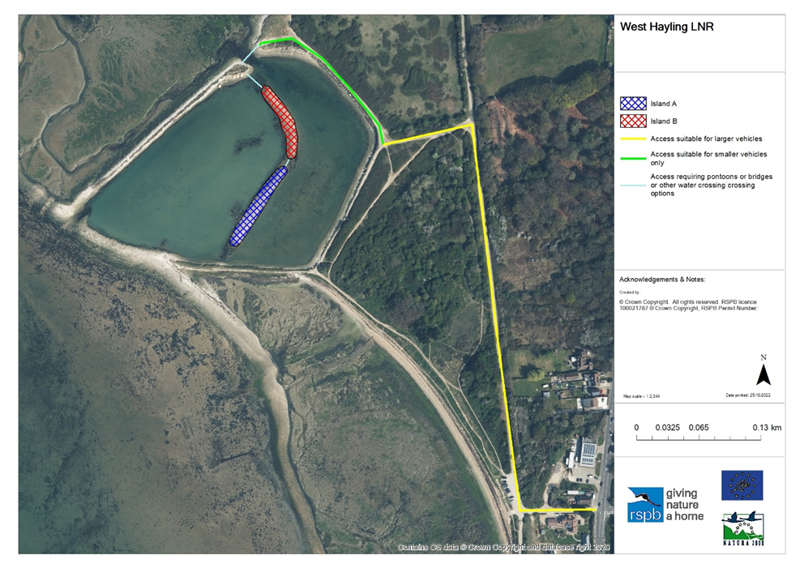

**Figure 1: A map showing the location of the islands to be raised and a non-exhaustive appraisal of access options.**

Our vision for the shingle placement is to have the bulk of base material being larger pieces (100-250mm) which are more resistant to wave action, with a heavy capping of smaller shingle (10-25mm) more suitable for nesting and roosting bird use. An approximate ratio of larger to smaller shingle would be 85/15%. All of the shingle will be placed onto the existing the island footprints.

Creativity in how this is achieved is open to the tendering party, but a brief methodology is set out in section 4.1 of the attached shadow HRA.

Subject to the relevant permissions being finalised in November/December 2022, it is envisaged that works will take place in February 2023. There is the potential that works may need to take place during September 2023 but this would require further permissions.

The windows of opportunity have been selected in order to limit the disturbance to the designated birdlife for who the project is being carried out. Birds start prospecting the site in late February and courtship/nest building begins in March. The breeding season on site usually ends in late August.

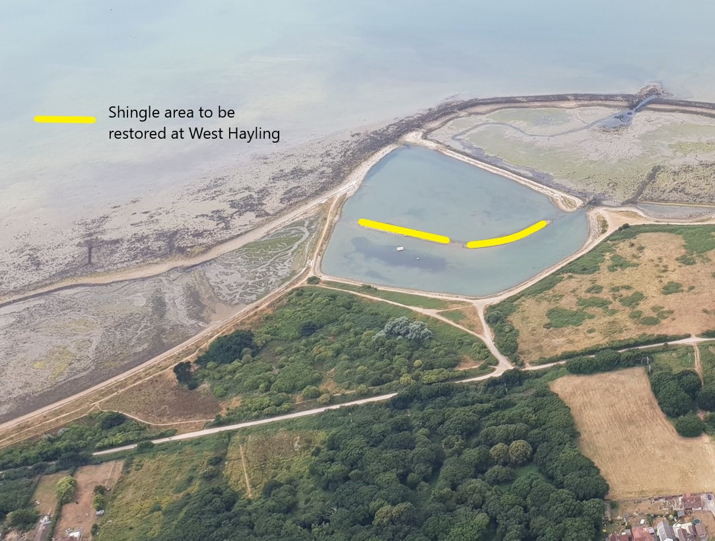

**Figure 2: A site overview of the West Hayling LNR showing the islands to be restored and the access route along the Hayling Billy trail (left to centre on this image).**

**Figure 3: The lagoon islands during the breeding season, packed with nesting birds.**

The West Hayling Local Nature Reserve is situated within Langstone Harbour, which has the following designations:

* Special Protected Area (SPA)
* Special Area of Conservation
* RAMSAR site
* Site of Special Scientific Interest (SSSI) <https://designatedsites.naturalengland.org.uk/SiteDetail.aspx?SiteCode=s1001182>

We expect the selected contractor to manage their operations within the law and spirit of those environmental designations and leave minimal trace of presence upon completion of the task.

The site is a local nature reserve accessed via a public area. Multiple trails (not rights of way) cross the site and work areas will need to be closed with appropriate signage as necessary. Deliveries to the site will need to be shepherded with a banksman system or similar from the road access via a public car park in order to ensure safety. No storage of materials is allowed on the approaching Hayling Billy Trail, carpark or access routes away from the immediate vicinity of the lagoon.

**Figure 4: A map showing the known risks to consider on site.**

**Figure 5: A basic cross section showing the lagoon islands and shingle addition.**

**Figure 6: a basic block plan showing the cross section point.**

|  |  |
| --- | --- |
|  | **Document C**  **Specification** |

The successful supplier will supply a service to which the following points will apply:

The information below is a statement of minimum requirements and is not intended to limit creative or original thinking in the preparation of proposals.

1. Liaising with the RSPB and the aggregate supplier, the tendering party must accept shingle (which the RSPB will procure), onto the site, meeting lorries transporting 20 tonnes each at Victoria Road (unless a marine option is identified) and using a banksman system to safely convey deliveries though the site until they reach the vicinity of the lagoon where the islands are. At that point, the shingle must be transferred to the lagoon islands A (grid ref SU 71451 03269) and B (grid ref SU 71486 03362). The methodology is open for the tendering party to suggest but our initial vision is for shingle to be moved along the route in figure 1, at low water via baily bridges, pontoons or specialist plant. The amount of shingle to be transported will be either a) 2000 tonnes (our preferred, full option), b) 1000 tonnes or c) 500 tonnes. In your tender, please identify the cost for transporting each option across site.

*Are you able to meet this specification in full? If so please give details below*

*If not please state any differences in service offered*

|  |
| --- |
| Specification met? Yes /Part met  / No (tick as appropriate)  Details |

1. Using the shingle delivered, the supplier must raise the height of the lagoon islands A (grid ref SU 71451 03269) and B (grid ref SU 71486 03362) within their current footprint by 0.7m. The area covered will depend on the amount of shingle but will be either a) circa 2000 square metres, b) approx. 1000 square metres or c) approx. 500 square metres. In your tender, please identify the cost for placing each option. The shingle will consist of two sizes, with the base layer (approx. 85% of the delivery) being larger cobbles and the surface (approx. 15% of the delivery) being smaller shingle.

*Are you able to meet this specification in full? If so please give details below*

*If not please state any differences in service offered*

|  |
| --- |
| Specification met? Yes /Part met  / No (tick as appropriate)  Details |

1. The supplier must comply with the conditions set out within the attached draft Marine Licence (for example the need to adhere to the Clean/Check/Dry code and supply a brief on how this will be done).

*Are you able to meet this specification in full? If so please give details below*

*If not please state any differences in service offered*

|  |
| --- |
| Specification met? Yes /Part met  / No (tick as appropriate)  Details |

1. The supplier should be able to deliver the needed works in February 2023 (subject to planning permission being granted in November/December 2023). It is feasible that works may need to take place in September 2023 if there are unavoidable delays, but costs should be quoted assuming works will take place in early 2023 at this stage. Please outline your ability to meet these timelines.

*Are you able to meet this specification in full? If so please give details below*

*If not please state any differences in service offered*

|  |
| --- |
| Specification met? Yes /Part met  / No (tick as appropriate)  Details |

1. The supplier must meet the Construction (Design & Management) Regulations irrespective of whether or not the project is notifiable to the HSE and also be able to share appropriate health and safety documentation/planning via an exchange of information before commencement. For the purpose of this project, the supplier will take on the role of principle contractor.

*Are you able to meet this specification in full? If so please give details below*

*If not please state any differences in service offered*

|  |
| --- |
| Specification met? Yes /Part met  / No (tick as appropriate)  Details |

1. As part of the tender, the supplier must set out in a brief their proposed scheme of works to meet these specifics above (1 to 5). Please use this opportunity to set out your proposed approach to the project, details of the machinery, method etc. We’d also welcome an introduction to the supplier’s company and their existing experience if appropriate. New or original solutions to the projects aims are welcome.

*Are you able to meet this specification in full? If so please give details below*

*If not please state any differences in service offered*

|  |
| --- |
| Specification met? Yes /Part met  / No (tick as appropriate)  Details |

|  |  |  |  |
| --- | --- | --- | --- |
|  | | | **Document D**  **Company Information** |
| **1.0** | **General** | | |
|  |  | | |
| **1.1** | **Registered Name**    **Trading Name (if different)** | | |
|  |  | | |
| **1.2** | **Correspondence Details**  **Name of person applying on behalf of the company**    **Address:**    **Telephone:**    **Mobile:**    **Email:** | | |
|  | **Registered office Address (if different from above)** | | |
|  |  | | |
| **1.3** | **Company Registration No (if applicable)**    **VAT registration number (if applicable)** | | |
|  |  | | |
| **1.4** | **Date company was founded (if a limited company, date of incorporation)** | | |
|  |  | | |
| **1.5** | **Company structure and nature of company**  Please outline the nature of the company, whether it is a partnership, sole trader, plc etc.    Is the company proposed as party to the contract part of a larger organisation? If so please explain the relationship between the various parts of the organisation, up to the ultimate holding company.    Current number of full time equivalent staff currently employed by the company (not larger parent company) | | |
|  |  | | |
| **1.6** | **Accreditation by / Membership of Trade Association(s)**  **Is your Company registered with any industry accreditation body? YES  NO**  **If yes, please provide details:**    **Is your Company on any public sector Framework agreements? YES NO**  **If yes, please provide details:**    **Please state membership of any professional bodies/ other associations below:** | | |
| **1.7** | **Quality Assurance**  **Is all / part of your company ISO9001 Quality Assured? YES NO**  **Is all / part of your company ISO14001 Quality Assured? YES NO**  **If yes please provide copy of certification**  **Do you have any other Quality Assurance? If Yes, please summarise details below** | | |
|  |  | | |
| **1.8** | **Environmental Commitments**  **Is all / part of your company registered under Science Based Targets (**[**https://sciencebasedtargets.org/net-zero**](https://sciencebasedtargets.org/net-zero)**), Business Climate Hub (**[**https://businessclimatehub.org/uk/**](https://businessclimatehub.org/uk/)**) or equivalent? YES NO**  **If Yes, please summarise details below** | | |
|  |  | | |

|  |  |
| --- | --- |
| **2.0** | **Financial & Business Probity** |
|  |  |
|  |  |
|  |  |
| **2.1** | | **Judgements etc.**  **Are there any judgements, claims or suits pending or outstanding against your company?**  **Yes  No** If Yes, please provide full details  **Has your company ever failed to complete a contract?**  **Yes  No** If Yes, please provide full details |
| **2.2** | | Please answer all of the following questions as they apply to your Company’s circumstances. Please confirm that:  1) being a company, no resolution has been passed or Order of the Court made for the company’s winding up otherwise than for the purposes of bona fide reconstruction or amalgamation, nor has a receiver, manager or administrator on behalf of a creditor been appointed in respect of the company’s business or any part thereof, nor is it the subject of any proceedings for any of the above procedures, nor is it the subject of similar procedures under the law of any other state.  **Confirmed  Not confirmed  Non-applicable**  2) being a partnership, it has not granted a trust deed or become otherwise apparently insolvent, or it is not the subject of a petition presented for sequestration of its estate.  **Confirmed  Not confirmed  Non-applicable**  3) being an individual, you are not bankrupt, or have not had a receiving order or administration order made against you, or have not made a composition or arrangement or trust deed with or for the benefit of your creditors, or have not made any conveyance or assignment for the benefit of your creditors, or have not had a petition presented for sequestration of your estate or do not appear to be able to pay or to have no reasonable prospect of being able to pay a debt within the meaning of the Insolvency Act or any similar procedure under the law of any EC member state.  **Confirmed  Not confirmed  Non-applicable**  4) no Directors, Partners, Associates or the Company Secretary have been involved in any Company which has been liquidated or gone into receivership.  **Confirmed  Not confirmed  Non-applicable**  5) none of the Directors, Partners, Associates or the Company Secretary have been convicted of a criminal offence relating to the conduct of their business or profession.  **Confirmed  Not confirmed  Non-applicable**  6) neither the Company nor any of the Directors, Partners, Associates or Company Secretary has committed an act of grave misconduct in the course of their business or profession.  **Confirmed  Not confirmed  Non-applicable**  7) all obligations relating to the payment of taxes under the law of any part of the United Kingdom or the EC member state in which the Company is established has been fulfilled  **Confirmed  Not confirmed  Non-applicable**  8) all obligations relating to the payment of social security contributions under the law of any part of the United Kingdom or the EC member state in which the Company is established have been fulfilled.  **Confirmed  Not confirmed  Non-applicable**  If you have ticked **‘Not confirmed’** for any questions above please give details here |

|  |  |
| --- | --- |
| **2.3** | Please list the names of any Director, Partner, Associate or Company Secretary who have been employed by the RSPB, giving department and dates.    Please give details of any Director, Partner, Associate or Company Secretary who have a relative who is employed by the RSPB at a senior level.    Please list the names of any Director, Partner, Associate or Company Secretary who have any involvement in other Companies who provide services to the RSPB    Is any work being undertaken or likely to be undertaken during the next three years by the Company or staff within it which could give rise to a conflict of interest through acting for third parties or otherwise? If yes, please explain the actual or likely circumstances and how such potential conflicts of interest would be handled. |

|  |  |  |  |  |  |
| --- | --- | --- | --- | --- | --- |
| **2.4** | **Insurances (a scanned copy of each certificate may be requested)** | | | | |
|  |  | **Insurer** | **Policy No** | **Value of Cover** | **Expiry Date** |
|  | Employers Liability |  |  |  |  |
|  | Public Liability |  |  |  |  |
|  | Prof. Indemnity |  |  |  |  |
|  | All Risks  (if applicable) |  |  |  |  |

|  |  |
| --- | --- |
| **2.5** | **Has your company (or any building/project you have undertaken) won any awards, accolades or recognition?**  **YES  NO** If yes please provide full details. |

|  |  |
| --- | --- |
| **3.0** | **Health & Safety and Environment** |
|  |  |
| **3.1** | Has your company been served with any enforcement or prohibition notices or been prosecuted in the past 5 years for breaches of health & safety legislation?  **YES**  **NO** If yes please provide full details. |
| **3.2** | Has your company been served with any enforcement or prohibition notices or been prosecuted in the past 5 years for breaches of environmental legislation?  **YES  NO** If yes please provide full details. |
| **3.3** | Has your company been served with any enforcement or prohibition notices or been prosecuted in the past 5 years for breaches of data protection legislation?  **YES  NO** If yes please provide full details. |
| **3.4** | Have any restrictive clauses in relation to your company’s Employer’s Liability, Public Liability or Professional Indemnity Insurance policies been enforced in the last 5 years due to past Health & Safety performance?  **YES**  **NO**  If yes please provide full details. |

|  |  |
| --- | --- |
|  | **Document E**  **Form of Offer** |

Please state your costs assuming work to be carried out in Feb 2023. If the work is delayed until September 2023 the successful supplier will be given an opportunity to revise their prices if necessary.

Indicate full details of expected payment terms including any upfront payments required to cover the cost of equipment/materials.

**Cost**

|  |  |
| --- | --- |
| Cost of completing project as outlined in specifications (Document C) for **option A** (2000 tonnes of shingle/ 2000 square metres area). Please provide a breakdown of costs. | £      + VAT |
| Cost of completing project as outlined in specifications (Document C) for **option B** (1,000 tonnes of shingle/ 1000 square metres area). Please provide a breakdown of costs. | £      + VAT |
| Cost of completing project as outlined in specifications (Document C) for **option C** (500 tonnes of shingle/ 500 square metres area). Please provide a breakdown of costs. | £      + VAT |

**Added Value**

As well as any charity rate that you may be able to offer, the RSPB is always open to corporate partnerships that deliver benefit to your organisation, the RSPB and nature. Working as part of your CSR agenda we can provide opportunities for fundraising, secondments, interns and volunteering, offering your staff both personal and career development opportunities. We also welcome all forms of gifts in kind as valuable contributions to our work.

Suppliers should provide details of any associated added value features/services/gifts in kind available to the RSPB under the terms of this Tender. (Attach separate document if needed).

Please note, added value donations will not be part of the criteria we use to decide on which supplier to choose.

**References**

Suppliers are requested to provide details of three references from their existing clientele, supplying full name, address, telephone number, email address, contact name, period of Contract and the estimated annual value of the Contract. In supplying this information, Suppliers shall have granted the RSPB permission to seek such information as deemed necessary, in relation to the Suppliers performance with their nominated references.

Reference 1

|  |  |  |
| --- | --- | --- |
| Company Name |  | |
| Address |  | |
| Telephone No |  | Ext |
| Email |  | |
| Contact |  | Dates of work |
| Nature of work done |  | Value of contract |

Reference 2

|  |  |  |
| --- | --- | --- |
| Company Name |  | |
| Address |  | |
| Telephone No |  | Ext |
| Email |  | |
| Contact |  | Dates of work |
| Nature of work done |  | Value of contract |

Reference 3

|  |  |  |
| --- | --- | --- |
| Company Name |  | |
| Address |  | |
| Telephone No |  | Ext |
| Email |  | |
| Contact |  | Dates of Work |
| Nature of work done |  | Value of contract |

|  |  |
| --- | --- |
|  | **Document F**  **RSPB Terms and Conditions** |

The basis of the contractual agreement between RSPB and the applicant is detailed in the [‘RSPB Terms and Conditions of Purchase of Goods and Services’](https://www.rspb.org.uk/about-the-rspb/about-us/how-the-rspb-is-run/supplier-terms-and-conditions/) – please click on this link to download. In applying for this tender you are explicitly agreeing to be bound by these Terms and Conditions for the duration of the contract. If you require any alterations to these Terms and Conditions please state your issues below. (Attach separate document if needed)

The RSPB expects that all suppliers it works with to adhere to certain ethical and environmental standards. Please download the [RSPB Ethical and Environmental Procurement Policy](https://www.rspb.org.uk/about-the-rspb/about-us/how-the-rspb-is-run/supplier-terms-and-conditions/) and tick this box if you agree to be bound by its terms and conditions 

|  |  |
| --- | --- |
|  | **Document G**  **Certificate of Bona Fide Offer** |

We certify that this offer is made in good faith, and that we have not fixed or adjusted the amount of the offer by or under or in accordance with any agreement of arrangement with any other person. We also certify that we have not, and we undertake that we will not:

1 a) communicate to any person other than the person inviting these offers the amount or approximate amount of the offer or proposed offer, except where the disclosure, in confidence, of the approximate amount of the offer was necessary to obtain insurance quotations required for the preparation of the offer;

b) enter into any agreement with any other person that s/he shall refrain from making an offer or as to the amount of any offer to be submitted;

2 pay, give or offer or agree to pay or to give any sum of money or other valuable consideration directly or indirectly to any person for doing or having done or causing or having caused to be done in relation to any offer or proposed offer for the goods/services any act or thing of the sort described in 1 a) or 1 b) above.

We acknowledge that if we acted or shall act in contravention of this certificate, the RSPB will be entitled to cancel the agreement and to recover from ourselves the amount of any loss and expense resulting from such cancellation.

I state that everything in this tender submission is truthful, that if found to be untruthful the RSPB can terminate any agreement between the RSPB and the company formed on the basis of this tender, and we will pay to the RSPB any loss or expenses the RSPB suffers as a result of such untruthfulness, whether an agreement is entered into or not.

In this certificate, the word “person” includes any persons and any body or association, corporate or unincorporated; “any agreement or arrangement” includes any transaction, formal or informal, and whether legally binding or not.

|  |  |
| --- | --- |
| Signed |  |
| On behalf of |  |
| Date |  |

**Please note: a name added in an electronic document is functionally equivalent to a signature.**