**Tendring District Council *in partnership with* Essex County Council**

**Specification**

**RFQ**

**Consultant for bespoke advice on options for purchase and installation of solar photovoltaic / renewable energy systems**

**8th June 2022**

**Version 0.1**

**Our Vision**

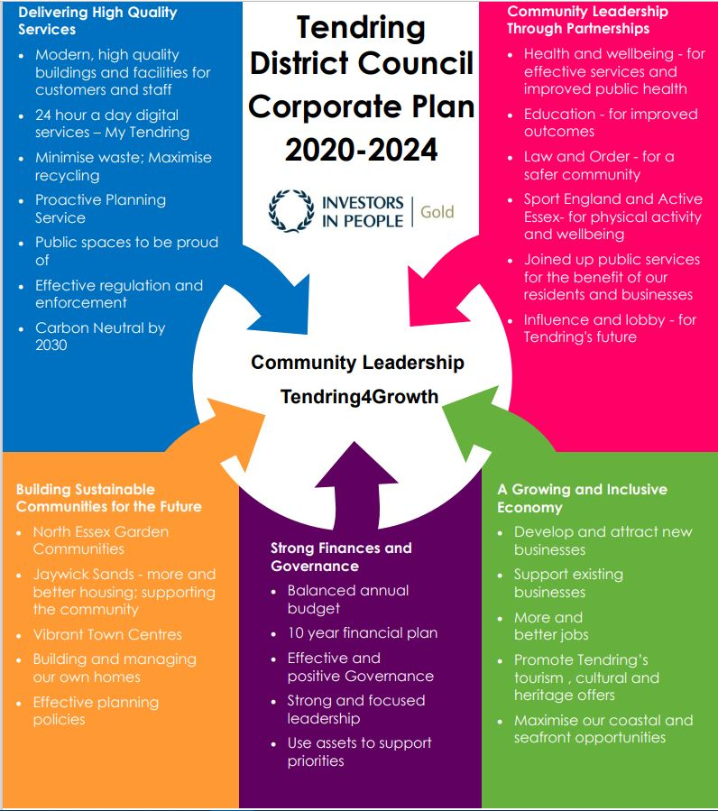***To put community leadership at the heart of everything we do through delivery of high quality, affordable services and working positively with others.***

**Our Values**

♦ Councillors and staff uphold **personal integrity, honesty,** and **respect** for others

♦ **Innovative, flexible, professional** staff **committed** to delivering excellence

♦ Recognising the diversity and equality of individuals

♦ Working **Collaboratively**

1. **Specification**

**Context**

The Tendring District is 33,740 hectares in size (approximately 130 square miles), with a population of 144,700 (2017). It has 60km of coastline and manages 19km using its permissive coast protection powers. The port of Harwich and the resort towns of Clacton, Frinton and Walton-on the Naze will be familiar and provide an identity for this attractive part of North-East Essex.

Energy prices are rising exponentially which coupled with the Council’s published commitment to achieve net zero carbon emissions by 2030 means that the Council must invest in renewal energy production.

Solar as a key part of government push for more renewables and although there have been changes to government support for solar, and end of feed in tariffs it still appears to present an attractive option.

The Council is not an especially large organisation but it does hold a number of key assets including:

2 x depots

3 x leisure centres including swimming pools

2 x office buildings

10 plus car parks of varying sizes

A housing stock of over 3000 dwellings

Council’s Climate Action Plan set out aims to reduce and offset carbon emissions, and the council operates on a 10 year plan for financial savings

To date the Council has received basic, essentially free, limited advice from experienced consultants and would now like to obtain bespoke advice focussed mainly on installing solar PV on our office and leisure buildings. We would also be interested in advice on other renewable energy options if the consultant feels they are appropriate for the circumstances.

We want impartial advice to develop a business case for investment in solar that reduces carbon and provides a financial return at a scale deliverable for a district council of our scale.

If the Council agrees to proceed with particular options, we will want advice on implementation.

1. **Requirements**

**Outputs**

We will require the consultant to:

Stage 1 - Provide impartial advice on the options available for solar PV and other renewable energy generation on council buildings including the housing stock. The Council will then select which options if any to pursue. In addition, we would like advice on grant funding streams that are available for renewable energy schemes.

Stage 2 - Develop detailed business cases and implementation plans for agreed options for installation of solar PV or alternatives at council owned assets, including any additional resource required to manage delivery. The Council then decide on which business cases, if any, to pursue further.

Stage 3 - Based on options selected from Stage 2 by the Council to pursue further, to develop a specification to put out to tender for the installation.

Stage 4 - Provide advice during the implementation of any options, to ensure informed decisions are made during the implementation phase.

1. **Timescales**

The proposed timetable for this employment for guidance:

|  |  |
| --- | --- |
| *Invitation to Tender issued* | 08.06.2022 |
| *Final Date for Clarifications from Bidders* | 22.06.2022 |
| *Tender Return Date* | 29.06.2022 |
| *Preferred Bidder Shortlisted* | 06.07.2022 |
| *Contract Preparation* |  |
| *Contract Signature* | 18.07.2022 |
| *Contract Start Date* | 01.08.2022 |

Explain the timeline – i.e. we are putting an options paper to Cabinet in November.

1. **Budget**

* We are inviting quotations excluding VAT.
* Please also quote a day rate for further advice on solar / renewable energy options.

The potential supplier should provide a fixed cost fee proposal including disbursements, and excluding VAT. The fee proposal should be broken down by team member and task. CV’s should be provided for each team member where appropriate. Suppliers should break their price down to a per asset basis for Stages 2, 3 and 4.

It is anticipated that most if not all of the required meetings and/or milestone sessions will be carried out online via MS Teams. Site visits to selected assets will be expected and the Council can supply detailed energy audit reports that have already been undertaken.

Submitted quotations will be assessed via a scoring matrix that will take into account total cost as a key metric, but will also include the importance of social value considerations and will recognise that the lowest quote does not necessarily represent the best value for money. The scoring matrix will take into account the cost quote for the financial and economic cases only, with the day rates for strategic, management and/or commercial cases as a supplementary.

TDC reserves the right to not commission any bidder. If successful, the Council intends to enter into a contract with the Supplier, using the Council’s standard terms and considerations, as set out in the draft Services Contract.

1. **Key Documents**

We have appended/provided a link to the following documents:

1. Profile of Tendring: [Profile of Tendring | Tendring District Council (tendringdc.gov.uk)](https://www.tendringdc.gov.uk/business/regeneration/profile-tendring)
2. **Payment**

Payment will be made on receipt of invoice AFTER the completion of each works and in accordance with the Council’s procurement, contractual provisions and payment policies.

1. **Evaluation Criteria**

The RFQ will be evaluated on passing the mandatory requirements, and a submission weighting of 50% Quality (Section A) and 50% Price (Section B).

**SECTION A – QUALITY – 50% Weighting**

**Quality Technical Questions**

**Scores will be awarded on a 0-5 basis and then weighted in accordance with the table below.**

**If on any question you score below 3, this will classify as a failed score and a failed bid overall.**

**Scoring Methodology Table A:**

|  |  |
| --- | --- |
| **0** | **Wholly Unsatisfactory -** No response or the whole response is irrelevant to all of the question and evaluation criteria**.** |
| **1** | **Unsatisfactory -** The response only covers a minor element of the question and evaluation criteria and lacks relevant evidence regarding competence, capacity and ability to successfully fulfil the requirements of the question. |
| **2** | **Partially Acceptable -** The response covers more than one element of the question and evaluation criteria but lacks relevant evidence regarding competence, capacity and ability to successfully fulfil the requirements of the question. |
| **3** | **Acceptable -** The response addresses most of the question and evaluation criteria but some areas contain limited relevant evidence regarding competence, capacity and ability to successfully fulfil the requirements of the question. |
| **4** | **Very good -** The response fully addresses the question and evaluation criteria and provides relevant evidence regarding competence, capacity and ability to successfully fulfil the requirements of the question. |
| **5** | **Outstanding -** The response fully addresses the question and evaluation criteria and provides relevant evidence regarding competence, capacity and ability to successfully fulfil the requirements of the question and goes beyondexpectations tooffer an outstanding level of performance or an additional benefit which exceeds specified requirements. |

|  |  |  |  |
| --- | --- | --- | --- |
| **Technical Evaluation**  **50%** | **Question** | **Evaluation Criteria** | **Weighting and Page Limit** |
| 1. **25%** | Please evidence and demonstrate your previous experience carrying out advice on solar installation for local authorities, including business case development.  Please give a minimum of two examples of previous work undertaking a similar brief. | Clear and detailed evidence of previous work whereby you have reviewed and carried out economic and financial appraisals. | 2x pages of A4 |
| 1. **25%** | Please detail how you would approach this work. Giving key details on how you will meet each milestone set on Pg 6.  Please also state the breakdown of team members and for each task. | A clear and detailed approach with evidence of how each project milestone will be met. | 2x pages of A4 |

**The following parameters are shown as a guide to the scoring:**

The total score for each Technical Question statement scored will not exceed 5 and will carry equal weight. There are mandatory minimum assessments set out below; failure to reach these scores in anyone may result in a failure mark and the consultant will be excluded before price evaluation takes place.

|  |  |
| --- | --- |
| Questions 1-2 | Mandatory Minimum |
| Q1 – Technical Question 1 | Score 3 – Satisfactory Response |
| Q2 – Technical Question 2 | Score 3 – Satisfactory Response |

**SECTION B – PRICING – 50% Weighting**

A pricing matrix spreadsheet has been included as part of the RFQ documentation issued.

Please complete the spreadsheet as per the instructions stated within the document and return the completed spreadsheet as part of your RFQ submission.

All prices should be exempt of VAT and include any additional costs.

For more information, please refer to the Tendring RFQ – Appendix A.

1. **The** **Authority’s Policies** **& Statements**

The bidder will need to adhere with the below policies and statements.

* Data Protection (please see Appendix D)
* Freedom of Information (please see Appendix F.

**Modern Slavery**

The bidder self-certifies that they are taking steps to ensure that there is no modern slavery or human trafficking (as defined in the Modern Slavery Act 2015) in their organisation or supply chain relating to the requested services/supplies requirements.

Here is a link to the Act: <http://www.legislation.gov.uk/ukpga/2015/30/contents/enacted>

**Health and Safety**

The bidder self-certifies that they adhere to the Health & Safety at work Act. Here is a link to the Act: <http://www.hse.gov.uk/legislation/hswa.htm>

**Environment**

The bidder confirms that they are aware of Tendring District Council’s Environmental Statement, and should they be successful, they are committed to working with the Council fulfil the vision outlined in the Statement.

<https://www.tendringdc.gov.uk/environment>

1. **E-procurement requirements**

Tendring District Council has a fully automated Purchase to Pay (P2P) system.

The successful bidder will be able to:

* View their orders online;
* Update their status;
* Notify delivery; and
* Submit and monitor the status of electronic invoices, once they have been submitted.

Orders will be sent electronically to the successful bidder’s central e-mail address from the contract start date.

The successful bidder will be expected to submit electronic invoices from the contract start date. On approval of the electronic invoice an automatic payment will be made via BACS, direct to the successful bidder’s bank account supported by an e-mailed remittance advice, in line with Tendring District Council’s contracted payment terms.

1. **Submission**

The deadline for receipt of your quotation is 29th June at 12:00 noon and it must be sent to our locked email address [democratictenderbox7@tendringdc.gov.uk](mailto:democratictenderbox7@tendringdc.gov.uk)

Submissions will only be accepted by this method and before the deadline.

As the above email address will remain locked until after the final deadline, please direct any clarification questions or queries to [TendringDC@essex.gov.uk](mailto:TendringDC@essex.gov.uk) before 22nd June 2022 at 12:00 noon. After this deadline for questions, responses will be collated and circulated to all bidders.

Additional copies **must not** be submitted in hard copy to any other recipient or member of the Council, or email copied or forwarded to additional email recipients. This is likely to disqualify your submission and could nullify the quotation exercise.

There is a receipt limit of 20 megabytes per email on the Council email system. We do not accept files from download sites. For large files you may like to send zip files up to 20 Meg per email. (We have a large file rejection automated notice set up.)

There is an automated delivery receipt on our secure email accounts. If you do not receive this response from the Procurement team it is likely that your submission has failed to reach our Server so please resend and failing that contact procurement@tendringdc.gov.uk.

You are advised to allow enough time before the deadline for any delays or errors reaching our server or rejection for oversize etc.

The onus is on you, the responder, to ensure that emails are received by us before the deadline.

The Council does not bind itself to accept the lowest or any quotation.