**Framework Schedule 6 (Order Form Template and Call-Off Schedules)**

**Order Form**

CALL-OFF REFERENCE: SR2022642627

THE BUYER: The Commissioners for His Majesty’s Revenue & Customs

BUYER ADDRESS 100 Parliament Street, London, SW1A 2BQ

THE SUPPLIER: Computacenter (UK) Ltd

SUPPLIER ADDRESS:100 Blackfriars Road, London SE1 8HL

REGISTRATION NUMBER: **01584718**

This Order Form, when completed and executed by both Parties, forms a Call-Off Contract. A Call-Off Contract can be completed and executed using an equivalent document or electronic purchase order system.

APPLICABLE FRAMEWORK CONTRACT

This Order Form is for the provision of the Call-Off Deliverables and dated the last signature.

It’s issued under the Framework Contract with the reference number RM6098 for the provision of Technology Products & Associated Service 2.

CALL-OFF LOT(S): Lot 3 Software

CALL-OFF INCORPORATED TERMS

The following documents are incorporated into this Call-Off Contract. Where numbers are missing, we are not using those schedules. If the documents conflict, the following order of precedence applies:

1. This Order Form including the Call-Off Special Terms and Call-Off Special Schedules.
2. Joint Schedule 1 (Definitions and Interpretation) RM6098
3. Special Terms
4. The following Schedules in equal order of precedence:

* Joint Schedules for RM6098
  + Joint Schedule 3 (Insurance Requirements)
  + Joint Schedule 11 (Processing Data)
* Call-Off Schedules for RM6098
  + Call-Off Schedule 23 (HMRC Terms)

No other Supplier terms are part of the Call-Off Contract. That includes any invoicing terms, terms added to this Order Form, or terms presented at the time of delivery.

CALL-OFF SPECIAL TERMS

The following Special Terms are incorporated into this Call-Off Contract:

Special Term 1 – For the purposes of Clause 10.2.2 of the Core Terms, the Buyer shall not terminate this Call-Off Contract without reason.

Special Term 2 - Third party software (if any) shall be licensed subject to the third-party licensor’s standard license terms which shall govern the supply, the Buyer’s use of and obligations relating to the software in their entirety and which shall prevail in the event of any conflict with the terms and conditions of this Call-Off Contract.

Software Support & Maintenance Terms

Third party services (if any) shall be supplied subject to the applicable third party’s standard service terms.

Special Term 3.

All Services will be performed in accordance with the agreed statement of work and where applicable subject to third party standard service terms

The acceptance procedures and warranties in respect of the deliverables shall be as set out in the statement of work only.

CALL-OFF START DATE: 22 January 2025

CALL-OFF EXPIRY DATE: 21 September 2025

CALL-OFF INITIAL PERIOD: 9months

CALL-OFF DELIVERABLES

|  |  |  |  |  |  |  |  |
| --- | --- | --- | --- | --- | --- | --- | --- |
| **Serial Number** | **Device** | **Quantity** | **Support/Licence** | **SLA** | **Support Type** | **Support / Licence Start Date** | **Support / Licence End Date** |
| JMX2402L02E | CISCO FIREPOWER 4115 ASA APPLIANCE | 1 | Support | 8x5xNBD | Direct Cisco Support only | 22/01/2025 | 22/09/2025 |
| JMX2402L02K | CISCO FIREPOWER 4115 ASA APPLIANCE | 1 | Support | 8x5xNBD | Direct Cisco Support only | 22/01/2025 | 22/09/2025 |
| JMX2402L02F | CISCO FIREPOWER 4115 ASA APPLIANCE | 1 | Support | 8x5xNBD | Direct Cisco Support only | 22/01/2025 | 22/09/2025 |
| JMX2402L02J | CISCO FIREPOWER 4115 ASA APPLIANCE | 1 | Support | 8x5xNBD | Direct Cisco Support only | 22/01/2025 | 22/09/2025 |
| n/a | CISCO ASA 9.12.1 SOFTWARE FOR FIREPOWER 4100 APPLIANCES | 4 | Licence | 8x5xNBD | Cisco Licence | 22/01/2025 | 22/09/2025 |
| n/a | CISCO FIREPOWER STANDARD ASA LICENCE 1 APPLIANCE ESD | 4 | Licence | 8x5xNBD | Cisco Licence | 22/01/2025 | 22/09/2025 |
| n/a | CISCO FIREPOWER STRONG ENCRYPTION (3DES/AES) LICENCE | 4 | Licence | 8x5xNBD | Cisco Licence | 22/01/2025 | 22/09/2025 |

LOCATION FOR DELIVERY

HMRC  
Ironmasters Way  
Telford Shropshire  
TF3 4NT  
United Kingdom

DATES FOR DELIVERY

22 January 2025

TESTING OF DELIVERABLES

None

WARRANTY PERIOD

The warranty period for the purposes of Clause 3.1.2 of the Core Terms shall be the duration of any guarantee or warranty period the Supplier has received from the third party manufacturer or supplier

MAXIMUM LIABILITY

The limitation of liability for this Call-Off Contract is stated in Clause 11.2 of the Core Terms.

The Charges used to calculate liability in the first Contract Year is £30,431.58

CALL-OFF CHARGES

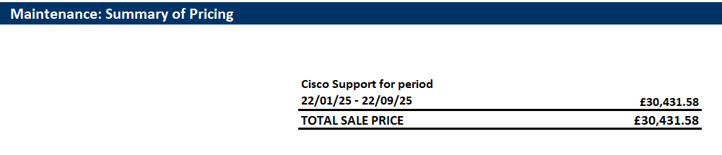

PAYMENT METHOD

The payment method for this Call-Off Contract is by electronic BACS transfer.

BUYER’S INVOICE ADDRESS:

Invoices will be sent via the SAP Ariba system.

BUYER’S AUTHORISED REPRESENTATIVE

SUPPLIER’S AUTHORISED REPRESENTATIVE

Hatfield Business Park, Hatfield Avenue, Hatfield AL10 9TW

SUPPLIER’S CONTRACT MANAGER

SERVICE CREDITS

Not applicable

ADDITIONAL INSURANCES

Not applicable

GUARANTEE

Not applicable

SOCIAL VALUE COMMITMENT

The Supplier agrees, in providing the Deliverables and performing its obligations under the Call-Off Contract, that it will comply with the social value commitments in its tender response.

|  |  |  |  |
| --- | --- | --- | --- |
| **For and on behalf of the Supplier:** | | **For and on behalf of the Buyer:** | |
| Signature: |  | Signature: |  |
| Name: |  | Name: |  |
| Role: |  | Role: |  |
| Date: |  | Date: |  |