Supplier Briefing Pack – National TST

Overview of Technical Surveys & Testing (TST) Contract

Dear Sir or Madam,

Highways England is changing the way it provides maintenance services across a number of regions (currently Areas 1 & 2, 6 & 8, 7, 10, 13 and 14 and from November 2020 Area 4). Highways England will therefore be procuring a series of new contracts, direct with the supply chain, to provide all goods and services associated with maintaining the Highways England asset. Your company is therefore invited should you be able to provide a range of surveys and tests required that fall under the following categories:

- Asset Condition
- Topographic
- Drainage
- Pavement
- Asbestos
- Structures
- Electrical and Communications
- Environmental
- Traffic and Non-Motorised User
- Utility

Asset Delivery Roll-Out (Areas 1 & 2, 6 & 8, 7, 10, 13 and 14 and soon to be Area 4)

Following the transition to the new Asset Delivery model in Highways England’s East Midlands region (Area 7), Highways England has now rolled out this model to the North West, Cumbria and North Lancashire, and North East (Areas 13 & 14), the South West (Areas 1 & 2), North West (Area 10), East (Areas 6 and 8) and in November 2020 South East (Area 4).

The Asset Delivery registration process will therefore become the default route to procure TST to determine and test asset condition across our network

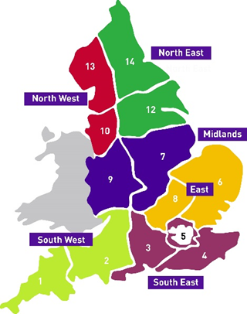
Asset Delivery Region Map
The TST Procurement method

In order to meet the requirements of the new Asset Delivery model, the aim of TST contracts is to have the ability to procure relatively low risk, low value surveys and tests quickly whilst maintaining a balance of both value for money and quality. In order to achieve this, a more flexible method of procuring these services is required to suit the ad-hoc nature of the surveys and tests.

This innovative method invites interested suppliers to go through an open stage registration process in order to become part of Highways England’s supply chain prior to any work being tendered, in order to reduce the tender process at quotation stage.

Stage 1: Registration Stage

The registration stage requires the supplier to set-up an account on the e-tendering system BRAVO which then provides access to the registration documentation. This includes the Registration Questionnaire (RQ), the National ARP Surveys & Test datasheet (which require completion) and other supporting documentation.

The RQ document consists of a series of standard pass/fail questions covering Health & Safety, Finance and Technical Ability. Suppliers are also asked to supply Reference Contracts Documents to evidence their ability (for each survey or test applied for) as well as to confirm whether they have or are working towards the specified accreditation/standards required for the tests and surveys they intend to bid for when work arises. Highways England reserves the right to check all accreditation/insurance and financial checks necessary prior to award of any potential contract (via the quotation stage) and disqualify any supplier whom is found to be non-compliant.

Suppliers are encouraged to read ‘Registration Questionnaire Evaluation Process’ on page 40 of the registration questionnaire document when completing the RQ.

Documents Supplied

- Supplier Briefing pack v9 (This document)
- Registration Questionnaire Issue 3 Revision 7
- National ARP Surveys and Tests Annex 0 Issue 5 Revision 0
- Reference Contract Document (National TST) – this document is embedded within the RQ document, but is also supplied for ease of use.
- Data_Handling_Policy_-_Supply_Chain_Version_V3 (for information only)
- Company Records Policy v1 (for information only)
- Information Assurance Policy (for information only)

For the purpose of pre-registration, suppliers will need to provide (and return) the following

- Completed RQ (including Part 1, Part 2, Part 3)
- Completed Table - National ARP Surveys & Tests
- Contract Reference Document(s) – One required for each survey that you wish to apply for
- A copy of your slavery and human trafficking statement (if applicable)
- Health and Safety Policy and Capability Part 1 (evidence)
- Health and Safety Policy and Capability Part 2 (evidence)
- Information Assurance (evidence)
- Sub-contracting arrangements appendix (if applicable)
- Consortia arrangements appendix (if applicable)
- Special Purpose Vehicle (SPV) appendix (if applicable)
- Conflicts of interest appendix (if applicable)
- Self-cleaning appendix (if applicable)
- Compliance with Equality Legislation appendix (if applicable)
- Environmental Management appendix (if applicable)

Further guidance on the RQ can be found on Annexe A

If successful, the successful supplier will notified by Highways England and therefore be eligible for tendering for discreet technical surveys and testing work packages. These discreet packages of work will therefore be available at the subsequent quotation stage of this process. Notifications of packages will be issued via BRAVO to successfully registered suppliers when a need for a survey or test is identified by Highways England. As BRAVO is the platform used for the tender process, it is therefore vital that account details are stored safely and contact details are kept up to date at all times by the supplier. If a supplier is not registered onto BRAVO, further details will be provided upon successful registration.

Stage 2: Quotation Stage

At quotation stage, suppliers who have successfully registered their company details on BRAVO but have also passed the relevant criteria by providing both the necessary documentation and Reference Contracts Documents to evidence their ability (as detailed within stage 1), will be invited to tender as and when a need arises. Tender documents will be published and uploaded into BRAVO by Highways England. There will not be a requirement to go through the registration process again unless current legislation changes. However there may be a requirement to ensure that suppliers remain compliant and therefore accreditation documentation can be requested that ensures suppliers are fully certified.

Suppliers who may have failed the Registration Stage but still wish to be considered as a pre-approved supplier can re-apply but will need to re-submit a new RQ and be fully re-assessed prior to acceptance and be invited to tender for future opportunities.

This process is illustrated on the flowchart Annexe B

Every time there is a requirement for a survey or test, a new contract will be issued. Therefore the form of contract, contract documents, contract period and value of the contract will vary for every need.

There are two forms of contract being used from the NEC3 suite for TST, Professional Service Short Contract (PSSC) and the Engineering and Construction Short Contract (ECSC).

Annexe C identifies the range of potential tests and surveys that may be required through TST. It indicates which form of contract is recommended to be used and the required accreditation/qualifications needed for each survey type or test.

Highways England is subject to EU Directives which dictate the thresholds at which contracts must be advertised to the European Union by publication of an OJEU Notice. These are currently £4.1m for works and £106k for services (from the Public Contracts Regulations (PCR), 2015). Because all of the work packages that form part of TST are anticipated to be below the OJEU thresholds and of low risk, legal and business compliance is adhered to.

Tender documents prepared by Highways England (and therefore required to be completed by tenderers) will be assessed on the basis of identifying the suppliers’ proposal for providing the works (i.e. method statement prepared based on the scope of requirement) including the programme (timeline of activities), resources (to be provided), risk register (including identification and mitigation) and Health & Safety.

Where tender proposals are found to be compliant, the assessors will then conduct a Financial Evaluation and then a Performance Evaluation.

Tender (Quality & Price) Evaluation

Evaluation of tenders will be based on a combination of price and assessment of the proposal to undertake the work (i.e. method statement.) Price can generally mean the lowest, however the proposal under consideration will also need to demonstrate that this overall package represents real value by being robust, affordable, and sustainable but is also a proposal that offers assurance that the supplier can provide the works as detailed within a number of documents; Works Information/Site Information and Instructions for Tenderers.
Performance Assessment

The Performance Evaluation will be based on past performance on suppliers who have undertaken work on previous TST contracts. This is unique to TST contracts in the Asset Delivery Model suite. TST suppliers will be given an overall performance score reflecting their performance against the following key areas; Health & Safety, Working to Programme and Quality. This overall score will then be carried forward and used in the evaluation of tenders when that supplier bids for future work.
The details of the performance metric and assessment is described in Technical Surveys and Testing - Performance Management Manual and within the Instructions for Tenderers document.
The winning bid will be awarded based on a providing both an acceptable proposal, and also has the highest combined performance score and the financial score. The ratio 60:40 is applied to the performance (60%) and financial scores (40%) respectively.

If we do not hold any performance metrics for a supplier, they are automatically scored 60%.

Annexe A – Further Guidance on the Registration Questionnaire (RQ)

The Registration Questionnaire (RQ) consists of a series of standard pass/fail questions covering Health & Safety, Finance, Technical Ability, Quality etc. Suppliers are also asked to supply Reference Contracts Documents to evidence their ability as well as confirm they have or are working towards the specified accreditation/standards required.

When submitting a completed RQ the supplier will also need to select the surveys and tests they intend to bid for when work arises (by completing the document National ARP Surveys). Where applicable, suppliers are asked to have the relevant qualifications or accreditation to undertake that specific survey or test (column B). Suppliers are also asked to provide reference contract documents (for each survey type) to demonstrate they have previously undertaken that particular survey and test they are registering for;
e.g. a supplier submitting an RQ for undertaking Geotechnical Slope Surveys will also need to be a member of the British Drilling Association and provide a Reference Contract Document evidencing they have undertaken Geotechnical Slope Surveys previously for a client in a similar environment. Therefore, upon completion and acceptance by Highways England their RQ upon is valid at Quotation Stage when bidding for Geotechnical Slope Surveys only.
A single RQ with multiple reference contracts can be submitted for each survey type or test. Alternatively a single reference contract may be submitted to demonstrate a supplier has undertaken more than one type of survey or test for a particular project; however this must be made clear.
The RQ will be assessed on a pass/ fail basis to determine the suitability of the supplier for that particular survey or test. Suppliers who have passed registration can use their RQ to bypass generic checks when bidding for work for the specified test or survey at Quotation Stage. Those who have failed can re-submit a new RQ at any time.
The RQ is valid indefinitely for the particular survey type or test the supplier originally registered for. However suppliers are asked to self-certify that the information supplied at Registration Stage is still valid and accurate. Where circumstances / information have changed from the initial RQ submission, the supplier should indicate this and either resubmit a new RQ or the relevant section of the RQ with any additional supporting information. This should be agreed by Highways England and re-assessed where appropriate.
If a new need for a survey or test is identified, suppliers who have already registered will not need to submit a new RQ. However suppliers must submit a new reference contract and have the relevant accreditation to undertake that new requirement. New suppliers, who have not registered, will need to complete the full RQ.

Highways England reserves the right to check accreditation and disqualify any supplier whom is found to be non-compliant.

Annexe B – TST Procurement flowchart
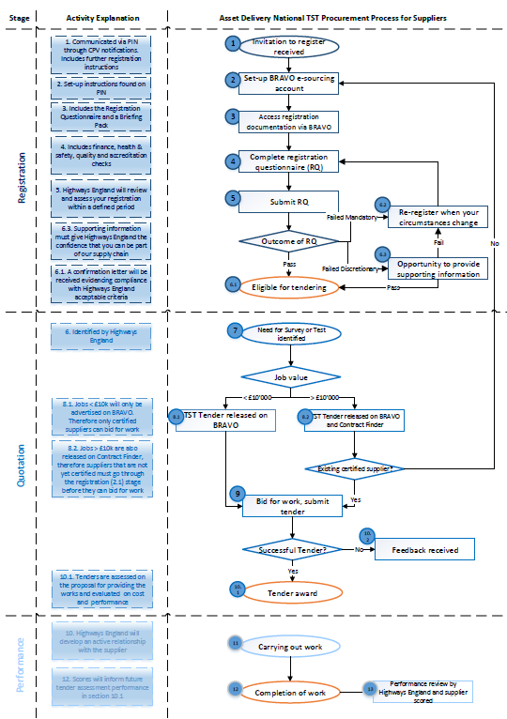

Annexe C – List of TST requirements
Category | Survey or Test | Accreditation Requirement
Asset Condition | Traffic sign retro-reflectivity survey in accordance with TD25 | none identified
 | Road marking and road stud retro-reflectivity survey in accordance with TD26 | none identified
Topographic | Topographical surveys | None identified
Drainage | Full drainage asset surveys | Experience or a proven methodology of Drainage Data Management System essential
 | Drainage connectivity surveys | Experience or a proven methodology of Drainage Data Management System essential
 | Drainage validation surveys | Experience or a proven methodology of Drainage Data Management System essential
 | Priority culvert, outfall and soakaway assessment | Experience or a proven methodology of Drainage Data Management System essential
 | Water quality testing, including but not limited to testing for Sampling Metals (including non-standard metals), Trade Effluent and Suspended Solids etc. | UKAS accredited in laboratory analysis
Pavement | Pavement coring, test pits and material testing in accordance with HD 29/08 | Laboratories must be UKAS accredited.
 | Falling Weight Deflectometer (FWD) pavement surveys in accordance with HD 29/08 | All FWD’s must be tested and approved in an annual FWD correlation trial as per HD 29/08.
 | Pavement visual conditions surveys | none identified
 | Ground Penetrating Radar pavement surveys in accordance with HD 29/08 | none identified
 | Dynamic Cone Penetrometer (DCP) pavement foundation test in accordance with HD 29/08 | none identified
 | Deflectograph testing in accordance with HD 29/08 | Current approval of Deflectometer correlation trial as per HD 29/08.
 | Sideways-force Coefficient Routine Investigation Machine surveys in accordance with HD 28/15 | none identified
Asbestos | Asbestos surveys and reporting | UKAS accredited to ISO 17020
 | Asbestos testing and reporting | UKAS accredited to ISO 17025
 | Asbestos removal works
Structures | Structural waterproofing pull-off testing | none identified
 | Structural survey and in-situ testing, including but not limited to: concrete sounding survey, concrete defects survey, cover to reinforcement survey, potential mapping (half-cell testing), concrete resistivity, in-situ testing for carbonation | EngTech TMICE or CEng MICE, and UKAS accreditation
 | Paint inspection and testing, including but not limited to: resin analysis, toxic elements content, dry film thickness, adhesion, soluble salt, holiday test, surface profile | Inspector to be Icorr level 1 minimum, and UKAS accreditation
 | Laboratory testing or materials and samples, including but not limited to:  - Steelwork: weld inspection and testing inc NDT, mechanical fastener properties, material composition, mechanical properties  - Reinforcement: material composition and mechanical properties  - Concrete cores: chloride and cement content | UKAS accreditation
 | Lighting column or post thickness survey, including but not limited to eddie current and guided wave methods | none identified
Electrical and Communications | Electrical testing | Highway Electrical Registration Scheme (HERS) training and competence assessments. All site workers must hold a valid ECS card.
 | Communications testing | Highway Electrical Registration Scheme (HERS) training and competence assessments. All site workers must hold a valid ECS card.
 | Fault testing and diagnosis | Highway Electrical Registration Scheme (HERS) training and competence assessments. All site workers must hold a valid ECS card.
 | Traffic signals inventory and condition surveys | National Highways Sector Scheme 8
 | Electrical and communication duct surveys | Highway Electrical Registration Scheme (HERS) training and competence assessments. All site workers must hold a valid ECS card.
 | Stability dynamic push pull testing | Highway Electrical Registration Scheme (HERS) training and competence assessments. All site workers must hold a valid ECS card.
Environmental | Arboriculture Surveys including tree decay surveys (BS5837 & tree hazard assessment) | Full Member of the Arboriculture Association or Institute of Chartered Foresters. Experience of undertaking BS5837 & tree hazard assessments
 | Water Resources & Water Quality Assessment/management | Member of the Chartered Institute of Water & Environmental Management (CIWEM) with relevant linear infrastructure experience.
 | Ecology: European & UK protected Species Surveys including, but not limited to: Birds, Bats, Great Crested Newts, Otters, Water Vole, Reptiles, Invertebrates, Badger, White-Clawed Cray Fish. | Relevant Knowledge, skills & experience in line with Chartered Institute for Ecology & Environmental Management CIEEM) competencies for species survey & relevant Natural England licence.
 | Ecology: Phase I & II (NVC) Habitat Survey | Relevant Knowledge, skills & experience in line with CIEEM competency framework accomplished level.
 | Ecology: Ecological appraisal and assessment | Relevant Knowledge, skills & experience in line with CIEEM competency framework accomplished level.
 | Flood Risk Assessment | Member of CIWEM with relevant linear infrastructure experience.
 | Landscape & Visual Impact Assessment (LVIA) | Chartered member of the landscape institute or equivalent.
 | Noise & Vibration Survey | Full Member of the Institute of Acoustics or equivalent.
 | Noise & Vibration Impact Assessment & Modelling | Full Member of the Institute of Acoustics or equivalent.
 | Air Quality Monitoring | Full Member of the Institute of Air Quality Management (IAQM).
 | Air Quality Assessment & Modelling | Full Member of the Institute of Air Quality Management (IAQM).
 | Archaeological Survey (Geophysical Survey, Excavation & Watching Briefs) | Full member of the Institute for Archaeologists.
 | E-DNA Testing | Natural England recognised laboratory
Traffic and Non- Motorised User | Traffic Counts: Automatic Traffic Counts | none identified
 | Traffic Counts: Manual Classified | none identified
 | Traffic Counts: Junction Turning Counts | none identified
 | Traffic Counts: Automatic Number Plate Recognition | none identified
 | Traffic Counts: Video Surveys | none identified
 | Non-Motorised User surveys and counts | none identified
 | Journey time surveys | none identified
 | Roadside Interview Surveys | none identified
 | Origin Destination Movements by Automatic Number Plate Recognition (ANPR) | none identified
 | Origin Destination Movements by Bluetooth Detector | none identified
 | Parking Surveys | none identified
 | Spot Speed Surveys | none identified
Utility Survey | Buried utility survey to locate and verify underground utilities via scanning and trial pit in accordance with PAS 128:2014Type A | none identified

