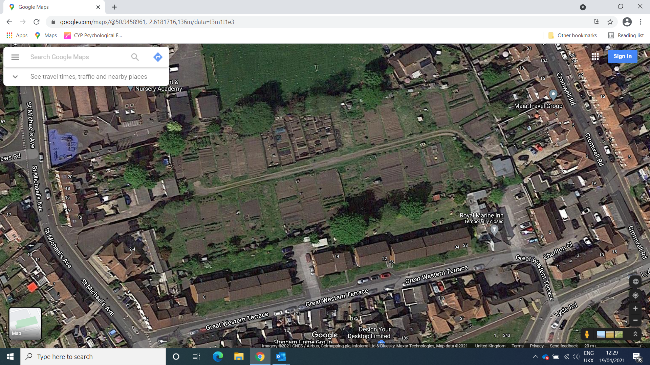

Goar Knap Allotments

Great Western Terrace

Yeovil

BA21 5AA