Benefits Management Framework

**Operational instruction 1334_16** **Issued** 10/05/2017

|  |  |
| --- | --- |
| What’s this document about? | This document provides a framework for managing project and programme benefits in the Environment Agency. |

|  |  |
| --- | --- |
| Who does this apply to? | The document is for anyone with an interest in benefits management, in particular:   * Portfolio, programme, project Management (PPPM) practitioners; * Portfolio, programme and project management leaders; * Business strategy managers, change managers, operational business areas and programme/project teams; * Those actively involved in benefits management from an operational, continual improvement and business context; |

|  |  |
| --- | --- |
| Contact for queries and feedback | * The primary contact for this document is the Project Improvement Team [projectimprovementteam@environment-agency.gov.uk](mailto:projectimprovementteam@environment-agency.gov.uk). * Please give [anonymous feedback](http://intranet.ea.gov/33345.aspx) for this document. |

|  |  |
| --- | --- |
| Contents | 1. Purpose, Context and Background 3  2. Principles: 5  2. Managing Benefits at a Programme Level: 6  3. People 8  4. Process 11  5. Tools and Techniques 15  6. Challenges 17  7. Where to Find Out More 19  Appendix 1: Benefits Documentation & Templates 20  Appendix 2: Benefits Mapping 24  Appendix 3: Benefits Classification & Measures 28  Appendix 4: Valuing and Quantifying Benefits 32  Appendix 5: How to do Benefits Management in Practice 33  Glossary 38 |

1. Purpose, Context and Background

|  |  |
| --- | --- |
| Context | * As a public body the Environment Agency has a responsibility to spend tax payer’s money wisely. We need to ensure we deliver value for money for every £1 we invest/spend. * With projects representing around 40% of the Environment Agency budget, benefits management is one of the key ways we deliver this responsibility. * All projects and programmes must manage their benefits. This framework provides guidance on how projects/programmes can go about this. |

|  |  |
| --- | --- |
| Purpose of the Framework | The purpose of this Framework is to provide:   * A single, consistent standard approach to the management of benefits across the Environment Agency in order to help achieve maximum return on our investments; * Best practice principles and concepts that can be tailored for a range of Environment Agency programmes and projects; * Increase the capability of the Agency in delivering change; * A tool to embed a culture of benefits management in the organisation which enables us to ‘focus on outcomes and not process’, and will help ‘more communities to achieve the outcomes they want’. |

|  |  |
| --- | --- |
| Why is it important to manage benefits? | The delivery of benefits is why an investment is made. Benefits management is vital in ensuring that an initiative achieves what it set out to do. It starts with defining the business change needed and the benefits and outcomes required.  Projects and programmes that fail to deliver to the full extent of their promises, can lead to customers/stakeholders not receiving the outcomes and benefits expected, and planned financial savings not being fully realised:  “Change without effective management that fails to deliver benefits is simply expensive chaos”[1]  “It is only possible to be sure that change has worked if we can measure the delivery of benefits it is supposed to bring”[2]  Effective benefits management will enable us to better deliver project and programme outcomes that contribute to our objectives and strategic goals. |

|  |  |
| --- | --- |
| What is benefits management? | Benefits management enables us to deliver the right things in the right way, obtaining a good financial and non-financial return on our investment. In practice this means we:   * Determine where we are today; * Establish end goals – where we want to get to; * Provide a mechanism to move from the ‘as is’ to the ‘to be’ position; * Monitor and track progress towards the end goal; * Identify the desirable and undesirable improvements from change; * Do this with the engagement of stakeholders;   “Benefits Management aims to make sure that desired business change or policy outcomes have been clearly defined, are measurable, and provide a compelling case for investment – and ultimately to ensure that the change or policy outcomes are actually achieved.”[3]  A ‘benefit’ is defined as ‘an outcome of change that is perceived as positive by a stakeholder’, or in simpler terms, an advantage or profit gained.  Benefits Management needs to start at the very beginning of the planning process (the ‘as is’ position) and continues until all benefits are realised (the ‘to be’ position), which in the majority of cases will be long after project closure. Benefits management is key in realising benefits, achieving objectives and ultimately the delivering the project or programme vision (as shown in the diagram below). |

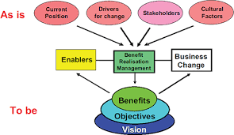

2. Principles:

|  |  |
| --- | --- |
| Benefits | * Are why investment is made – ‘start with the end goal in mind’. * Must be aligned to the Environment Agency’s strategic, directorate and functional goals. * Are not automatic – specific activities are required to realise benefits. * Are dynamic – they need to be regularly reviewed and updated. * Can be both financial and non-financial. * Must be measurable and measured. * Must be owned. |

|  |  |
| --- | --- |
| Benefits Management | * Is mandatory – but will need to flex depending on the size and complexity of the work. * Requires good governance. * Requires active leadership from the project/programme executive and sponsor. * Requires ownership of benefits by the business beneficiary. * Needs to be integrated into portfolio, programme and project management (PPPM) – ‘use successful delivery methods’. * Needs to be integrated with other management functions (such as financial management, business change, business planning). * Is an end-to-end process during the full lifecycle of the investment. |

Using a benefits realisation process enabled us to align project objectives with all the different partner’s organisational objectives” [4]

2. Managing Benefits at a Programme Level:

|  |  |
| --- | --- |
| Programme or Project? | This Framework can be applied to a stand-alone project or a programme or work. However, it is good practice to focus benefits management at a programme level wherever possible to align with corporate strategy.  If your project is part of a programme of work, you must agree with your Programme Manager how benefits will be managed and support programme benefits management. For example, agreement on whether you will work to a programme level benefits map, or be required to have one at a project level which interlinks with the programme level map .  Stand-alone projects will be required to report on progress towards benefits realisation to the Portfolio Office/Board or Project Board. |

|  |  |
| --- | --- |
| Links between programme management and benefits management | There are several principles of programme management which relate to benefits management:   * Ensuring there is alignment with corporate strategy; * Leading change; * Focusing on the benefits and threats to them; * Adding value;   As Managing Successful Programmes states “Best practice programme management aligns everything towards satisfying strategic objectives by realising end benefits……the ultimate success of a programme is judged by its ability to realise these benefits”.  Where project benefits management is delivered as part of a programme best practice should be followed (as outlined in this document and frameworks such as Managing Successful Programmes (MSP)).  Benefits management and programme management are interlinked and dependant on each other for success. |

|  |  |
| --- | --- |
| The role of Programme Manager | The Programme Manager acts on behalf of the SRO to ensure changes are designed and implemented, and planned benefits are realised. Key tasks for the Programme Manager include:   * Developing and managing a programme Benefits Management Strategy and Benefits Realisation Plan; * Developing a programme level Benefits Map with the programme board and key stakeholders; * Establishing a benefits tracking and reporting mechanism, working with project managers; * Ensuring outputs that enable benefits to be realised are built/procured; * Working with change managers to embed changes alongside Business as Usual activities * Reporting progress to the Programme Board and highlighting any risks to benefits realisation; * Identifying benefit owners and ensuring they understand their role and accountabilities; |

3. People

|  |  |  |  |  |  |  |  |  |  |  |  |
| --- | --- | --- | --- | --- | --- | --- | --- | --- | --- | --- | --- |
| What do you need to do?  Benefit roles | Benefit management roles (or tasks) can be combined depending on the size and complexity of the project. As a minimum there needs to be effective leadership of benefits from senior management (the sponsor or SRO role), along with ownership of benefits.  The key roles with responsibilities and tasks are summarised below. Further guidance can be found [Operational Instruction 776_13 Project roles, responsibility and guidance](http://ams.ea.gov/ams_root/2013/751_800/776_13.doc)     |  |  | | --- | --- | | Benefit Role: | Summary Responsibilities/Tasks: | | Sponsor or Senior Responsible Owner (SRO) | Overall accountability for the realisation of all benefits as outlined in the business case to ensure there is a good return on investment. Through regular reporting, ensures benefits are owned and managed by the business beneficiary, including tracking and measurement during and after project delivery. | | Business Change Manager | This role has responsibility for defining and implementing all aspects of operational change management/transformational activities required for the transition and embedding of project or programme outcomes. The role is the key ‘enabler’ for the realisation of benefits. They engage with key users/stakeholders to ensure benefits are as planned and work very closely with the benefits realisation manager and benefits owners. | | Benefits Realisation Manager | Managing the benefits realisation process including all tracking and reporting – benefit maps, benefits strategy, benefit profiles, benefits reviews. | | Benefit Owner | The named individual that receives ‘the benefit’. They will play a key role for the whole benefit lifecycle; having responsibility for benefit definition and ensuring benefits are delivered. They are the person from the business who requires the change/benefit (the business beneficiary).  (There could be a number of benefit owners – depending on the number and type of benefits identified) | |

|  |  |
| --- | --- |
| Examples of how benefits management roles work in practice | Larger more complex projects:  In this case there are individual people dedicated to working in benefits management roles, probably full time, rather than roles being performed as part of other project/programme activities and tasks.  Projects that are part of a programme:  The Programme Manager role would be key to the management of benefits in this case – taking responsibility for activities to realise benefits and deliver business change.  Smaller projects:  For smaller projects benefits management tasks would be part of project management activities, but are just as important as focusing on day to day activities. The Senior User would take on management of benefits once project delivery is complete.  More information on the challenges around governance of benefits is given in Section 6. |

|  |  |
| --- | --- |
| Stakeholder & User Engagement and Management | For benefits management to be effective stakeholder/user engagement is key. This is much more than communication. Active participation of stakeholders is encouraged throughout the change lifecycle to build commitment to realising benefits and outcomes, and ultimately strategic objectives. A good understanding of stakeholders/users and the people involved in the change is an ‘enabler’ to benefits realisation. Without good stakeholder engagement many benefits are unlikely to be identified , owned or realised |

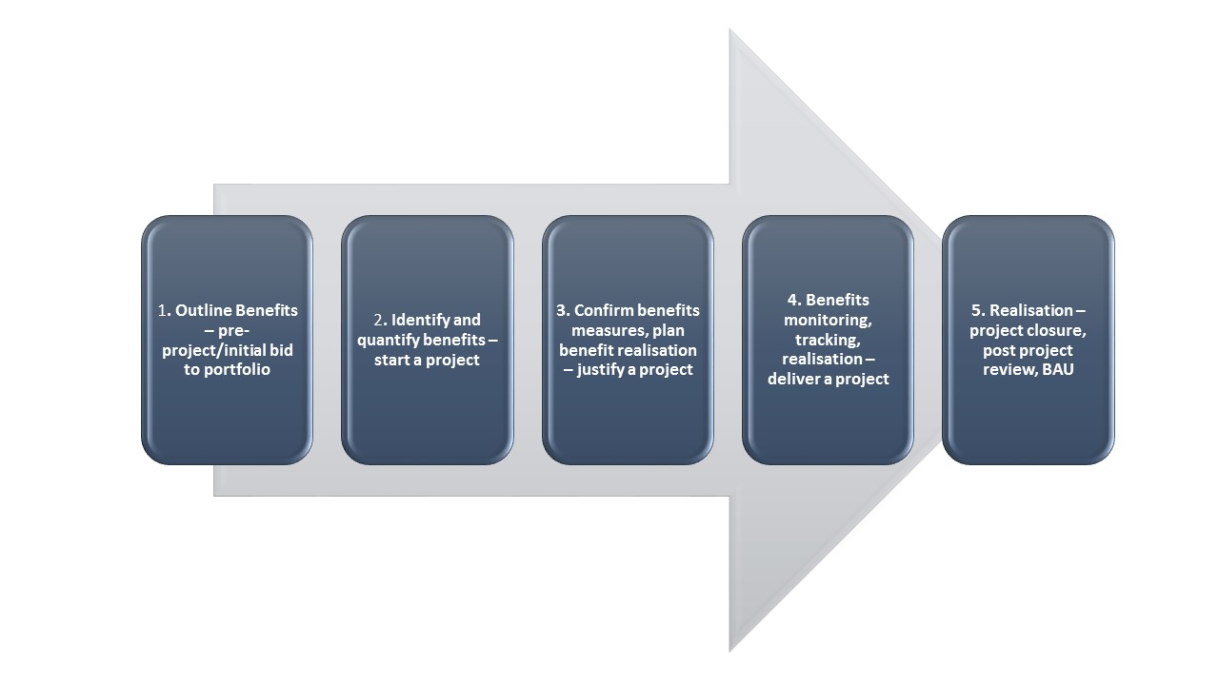4. Process

This sections sets out the various stages in the lifecycle of managing benefits, and how they link to our corporate [project lifecycle](http://intranet.ea.gov/policies/62382.aspx) and approach to [business case development](http://intranet.ea.gov/policies/61492.aspx). The lifecycle can operate at a project or programme level.

|  |  |  |
| --- | --- | --- |
| Benefits lifecycle stage and activities  (note – benefits documents are highlighted in bold text) | Link to Project Lifecycle | Link to Business Case |
| 1. Outline Benefits:  Draft objectives of initiative – ensure link to business strategy  Identify potential end benefits - “what measurable benefits will be realised by this change initiative?”  Include benefits in proposal form to secure funding through relevant business portfolio  Initial stakeholder engagement | Portfolio planning & programme planning | Pre-business case |
| 2. Identify and quantify benefits:  Confirm/agree objectives with stakeholders  Benefits Mapping – identify all potential end and intermediate benefits  Prioritise benefits and select those that can be ‘realised’  Initial valuation/quantification of benefits  Use benefits to help identify short list of options from long list of options (business case)  Develop Benefits Realisation Strategy:  – including benefit management roles and responsibilities  Ongoing stakeholder engagement | Start a project | Strategic Outline Case |
| 3. Confirm benefits measures, plan benefit realisation:  Develop Benefits Profile  Decide benefits measures/metrics  Confirm benefits valuation/quantification  Agree baseline position  Agree target ‘to be’ position  Develop Benefits Register:  Complete cost benefit analysis of short list options, including benefits valuation/quantification of preferred option  Sensitivity analysis of benefits and impact on identification of preferred option  Ongoing stakeholder engagement | Justify a project | Outline Business Case |
| 4a. Benefits monitoring, tracking and realisation:  Develop Benefits Realisation Plan providing information to enable tracking and realisation of all benefits  Further refinement of benefits profiles, means of measurement and valuation.  Ongoing stakeholder engagement.  Confirm final cost benefit analysis based on confirmed costing  Confirm ownership of benefits | Justify a project | Full Business Case |
| 4b. Benefits monitoring, tracking and realisation:  Ongoing tracking/monitoring/reporting  Identify emergent benefits and disbenefits  Realisation of benefits during delivery (e.g. cost savings)  Ongoing stakeholder engagement  Plan business change  Assess readiness for change | Deliver a project | Delivery of chosen option |
| 5. Realisation  Implement business change activities  Maximise planned benefits and emergent benefits  Minimise disbenefits  Ongoing reporting – post project by business/benefit owner  Monitor outcomes from change  Final reporting and sign-off  Post Project Appraisal and Review | Close a project  Post-project review(s  BAU – benefits realisation | Realisation of Business Case |

|  |  |
| --- | --- |
| Benefits and 5 Case Business Case | Benefits are the reason why an investment is made – ‘start with the end goal in mind’. The focus should be on answering the following questions:   * Is it worth spending £x to get the identified benefits? * Does the initiative represent value for money for our stakeholders? * Will the benefits be realised – are they realistic? * What is the likelihood of the benefits not being realised?   Benefits are identified and quantified in the Strategic Outline Case (SOC) and Outline Business Case (OBC) documents as the economic appraisal is carried out and the preferred option identified. An outline of how benefits are to be managed is required as part of the Management Case. Most of the work on benefits identification and valuation should be completed at OBC level allowing the preferred option to be identified. The table above sets out the benefits management activities that should be completed at each stage of business case production.  The following is the classification of benefits used in the 5 Case Business Case:  Financial:  Cashable (cash releasing) – a benefit that can be measured in monetary terms and will result in actual cashable savings to the organisation.  For example: Savings from use of changes and rationalisation in telephony systems within the organisation; savings from reduced IT service charges; savings from sale of assets/property; more efficient process leading to reductions in numbers of staff required to manage process.  Non-cashable (cost avoidance) – these tend to be financial benefits in the future and relate to what might have happened if the change didn't take place.  For example: if a new IT systems isn't installed then the cost would be £2m to continue to upgrade every year;  Non-financial:  A benefit that is not measured in financial terms and is usually an improvement (in environmental terms), increase in staff morale, reputation or similar:  For example:   * Carbon (CO2) saving per year from increased use of electric vehicles via installation of more charging points; * Improved employee engagement (fewer absences and reduced staff turnover); * People feeling safer and less anxious due to new flood protection schemes   More help is provided on benefit measures and sources of evidence in Appendix 3. Go to 672_15 Business Case Guidance: Five Case Model for the Business Case Template. |

|  |  |
| --- | --- |
| Links between Benefits Management and Business Change | Benefits happen when something changes. This usually involves permanently changing attitudes and behaviours as well as physical changes. Changes to the way people work need to be embedded to ensure that benefits continue to be realised. A business change manager needs to modify people’s behaviour and ensure the business has the right capability to adapt to and track realisation to ensure that the change is permanent. |

**Business Change Management**

**Benefits Realisation**

**Embedded change**

**Post-transition**

**Transition**

**Pre-transition**

5. Tools and Techniques

|  |  |
| --- | --- |
| Use of Benefits Documents | The following are the main documents used in benefits management:  Benefits Realisation Strategy: - details the approach to benefits management and is a governance-focused document.  Benefits Mapping: – a pictorial representation of all the linkages between the ‘enablers’ (outputs e.g. new system) that will be delivered and the project/programme objectives to be achieved (e.g. cost savings from new system).  Benefits Profile: – a collection of all the information for an individual benefit.  Benefits Register: - information on all project/programme benefits and dis-benefits.  Benefits Realisation Plan: – provides all information to enable the tracking and realisation of all intended benefits.  They will help you identify, monitor, track and realise benefits. (Examples, templates and more information on each is provided in Appendix 1). |

|  |  |
| --- | --- |
| Benefits Identification | As outlined previously, benefits need to aligned with strategic objectives and actions. For the Environment Agency these currently are:   * A cleaner healthier environment which benefits people and the economy * A nation better protected against natural threats and hazards, with strong response and recovery capabilities * Higher visibility, stronger partnership and local choices   The Corporate Strategy includes a range of ‘aspirations’ which should provide a good basis for identifying benefits and making them relevant to your own project/programme.  The best way is to start with the project/programme objective(s) and identify what benefits will need to be realised for achievement of those objectives. Wherever possible this should involve stakeholders. One technique used to begin identifying benefits is as follows:  The main tool to identify benefits is through Benefits Mapping. A benefits map shows the path between the ‘where we are now’ state through to the ‘where we want to be’ position.  Benefits maps can be produced for each objective, or for the whole project depending on its complexity. More detail on benefits maps is provided in Appendix 2. |

|  |  |
| --- | --- |
| Measuring and Quantifying | The main objectives of measuring benefits are to:   * Monitor progress towards the end goal over time * Inform decision making and drive action – either to prioritise work, take remedial action or to change direction * Encourage desired behaviours to realise benefits and achieve a positive end result.   What is needed?   * An identified benefit * A Baseline – where we are now * A Target – where we want to get to * An agreed measure – to track progress against, and which relates to the target   Who is responsible?   * The ‘benefit owner’ is responsible for measurement, although the project/programme team may help and then handover responsibility once the project/programme is delivered.   How to track and report?   * The easiest method is via a simple red/amber/green status against each benefit with accompanying risks/issues. Alternatively you may be able to actually measure benefits delivery if it is a cashable benefit (£ saved) or efficiency benefit (days saved). |

|  |  |
| --- | --- |
| Benefits Valuation and Measurement | Benefits need to be valued so that resources are allocated to those change initiatives which will achieve the most for limited funds, and collectively represent value for money. The [HM Treasury Green Book](https://www.gov.uk/government/publications/the-green-book-appraisal-and-evaluation-in-central-governent) is a good starting point to find out more on valuation of benefits.  Benefits are valued in monetary terms wherever possible to facilitate options appraisal at business case stage, and in portfolio prioritisation.  Valuing cashable financial benefits is relatively straightforward  Non-financial benefits have targets and measures and tend to be seen as a stepping stone to the achievement of financial benefits. They therefore are important and should not be ignored.  Examples of benefits are given in Section 4 (5 case) and further help and support is given in Appendix 3 - Benefits Measures and Sources of Evidence |

6. Challenges

|  |  |
| --- | --- |
| Governance | The Benefits Realisation Strategy:  Defines the approach to managing benefits and provides clarity on responsibility for benefit management tasks/roles. Without this clarity benefits management tasks may be missed. In some cases many of the roles outlined in Section 3 are delivered by the same person, and benefits realisation may slip down the priority list as delivery of outputs becomes the main focus. Good governance is therefore key. The SRO/Project Sponsor is accountable for ensuring that benefits are realised and stakeholders/users happy that we have delivered what we promised – engagement between those responsible for benefits management and the SRO on a regular basis is therefore important.  Other governance challenges include:   * Ownership of benefits – the operational owner of the benefit needs to understand their ownership role, and the need to continue to monitor and track benefits realisation following project completion. This can be delivered by progress reporting and involvement of benefit owners early on in planning monitoring and tracking. * Engagement with stakeholders – stakeholders and users need to be involved from the initial stages of the benefits process right through to realisation. They are the ones who should shape delivery to ensure output and outcomes are as required, and objectives achieved. |

|  |  |
| --- | --- |
| Senior Management Sponsorship | The right level of Senior sponsorship is required to make benefits management effective at both an organisational level and initiative level; this will involve a time commitment. This can be sustained through:   * Having a compelling business case (and ensuring the business case remains an active document – referred to often) * Having a good monitoring and tracking system to ensure benefits can be evidenced * Progress reporting on benefits at portfolio/programme level to communicate progress to other senior managers. |

|  |  |
| --- | --- |
| Business Case Development and Optimism Bias | The challenge for many in quantifying benefits is understanding and applying optimism bias - be realistic on what size of benefits you will achieve. The advice from the [HM Treasury Green Book](https://www.gov.uk/government/publications/the-green-book-appraisal-and-evaluation-in-central-governent) should be followed where possible. This states business cases should be based on data from past projects, to ensure optimism bias is based on a track record and learning from other projects. Where there is no evidence or past performance to base optimism bias on then there are a number of approaches which can be used for example:   * Baseline current performance to provide the base measure to compare future change against. * Use a benefits quantification workshops with subject matter experts. * Run pilot studies to provide the learning and evidence. * Carry out sensitivity analysis to determine the impact of benefits optimism bias on the selection of the preferred option. |

|  |  |
| --- | --- |
| Quantification and Measurement | There are many challenges with forecasting/estimating the benefits anticipated. Inaccurate and unreliable benefit forecasts means the success of the initiative can be compromised as you might not deliver customer expectations.  For example, if cash savings are required to fund future work and have been over-estimated then the new initiative may stall due to lack of funds. The best advice is to use the knowledge and expertise of others where possible, either from within the project delivery profession or from finance.  Do not be tempted find a solution (new telephone system or IT) and then hunt for the benefits to justify the investment. This is unlikely to deliver the benefits forecast and savings required in the longer term - focus on the premise of knowing what the customer/stakeholder needs and where you want to get to before you set out - 'start with the end in mind'. |

|  |  |
| --- | --- |
| Focus on Delivery Rather than Delivery of Benefits | A focus on maximising the realisation of benefits will move forward our delivery of value from our investments from the project centred quality/time/cost approach. This Framework provides the direction and guidance needed for a shift of culture towards good benefits management to enable us to achieve the maximum return on public investment. |

7. Where to Find Out More

|  |  |
| --- | --- |
| Further Reading | Managing Successful Programmes (Published by The Stationery Office)  Managing Benefits – Stephen Jenner  Benefits Realisation Management – Gerald Bradley  Fundamentals of Benefits Realisation – Gerald Bradley  Management of Portfolios – Stephen Jenner  HM Treasury Green Book: Appraisal and Evaluation in Central Government |

|  |  |
| --- | --- |
| Training | The Project Improvement Team have organised benefits training which will be delivered via our external PPPM training providers. This can be accessed via the [Learning Zone](http://intranet.ea.gov/knowledge/training/91036.aspx) |

|  |  |
| --- | --- |
| Contact Us | Please contact the Project and Programme Improvement Team [projectimprovementteam@environment-agency.gov.uk](mailto:projectimprovementteam@environment-agency.gov.uk) with any questions or for more guidance |

“Benefits Management is not about form filling, it’s a mindset that drives benefits accountability and delivery”[5]

Appendix 1: Benefits Documentation & Templates

Benefits Realisation Strategy:

The Benefits Realisation Strategy defines the governance, control and approach to realising benefits.

The complexity of the Strategy will depend on the size and nature of the work and be tailored accordingly. If your initiative is part of a larger programme the benefits realisation strategy should be produced at a programme level, or link with programme level benefits.

See the template overleaf/attached.

Benefits Maps:

A Benefits Map is visual document which shows how the network of benefits are interlinked - one benefit leading to another which will eventually lead to realisation of the end benefit. It shows:

- how benefits (when realised), will deliver outcomes/end benefits and objectives.

- enablers (outputs) which are required to achieve outcomes and benefits;

- potential disbenefits which need to be managed.

If your initiative is part of a larger programme, the benefits roadmap should be produced at a programme level.

Benefit maps can take time to develop and this be done with the involvement of key stakeholders. They are invaluable in identifying the key benefits to be delivered (the 'must dos'), so this is time well-spent. The process for mapping is as follows:

More detailed information on how to run a benefits mapping workshop and create a benefits map is given at Appendix 2 with some examples.

Benefits Realisation Plan:

The benefits realisation plan serves as a management tool to monitor, track and manage the collective set of benefits associated with an initiative on an ongoing basis. Information would be taken from benefits profiles (see below), and the plan acts as a tool to manage all information on the realisation of all benefits. If your initiative is part of a larger programme, the benefits realisation plan should be produced at a programme level.

See the template attached/overleaf.

Benefits Profile:

This document identifies all the details associated with each benefit and should be updated as the work progresses.

See the template attached/overleaf.

Benefits Register:

A benefits register is a list of all your benefits and disbenefits, with headline information taken from benefit profiles. It usually takes the form of a simple spreadsheet with a single line for each benefit, with all information captured via separate columns and acts as a reporting tool.

BENEFITS REALISATION STRATEGY (Template)

XYZ Project/Programme:

Background

Summary of what the project is about, what it is trying to achieve and key objectives. Details of how it aligns with organisational strategy. Similar to the executive summary from the Business Case.

Summary of Benefits

* Include information from the Benefits Map(s) – End benefits and intermediate benefits showing links to objectives.
* Detail whether benefits are financial (cashable or non-cashable) or non-financial
* Details how benefits have been prioritised – what are the immediate ‘must dos’?

Roles and Responsibilities

Include details of:

* Who will take on the responsibilities for ownership and accountability for benefits management:
* Who is the Senior Responsible Owner?
* Who will own the each of the benefits?
* Who will act a benefits realisation manager – ensuring benefits are tracked, monitored and reported?
* Is there a Business Change Manager who will facilitate the change and ensure it runs smoothly? If no Change Manager who will oversee the transition to new ways of working/new system etc.?
* What resources have been allocated to managing benefits during project delivery and after project closure?

Measurement methods to be used

* Provide details the measures which will be used to track progress benefits:
* If financial have finance been involved to provide guidance and advice on cost/benefit analysis?
* If non-financial what measures will be used and are they evidence based? (refer to Appendix 3 of the Benefits Management Framework)

Benefits Reporting and Reviews

* How will benefits be reported to the Project/Programme Board?
* Is there an agreed process to track and monitor benefits?
* Provide details of when will benefit reviews will take place (to check progress against the business case)
* Provide details of how risks to realisation will be communicated and reported

Relationship/Dependencies on other work

* Is this work part of a wider programme?
* If yes how does it align with programme benefits and objectives?
* Details of dependant projects and linked benefits and any risks associated in realisation of benefits.

Benefit Realisation Plan (Template):

|  |  |  |  |  |  |  |  |  |
| --- | --- | --- | --- | --- | --- | --- | --- | --- |
| Last review date | Benefit Description | Owner | Measure | Baseline | Target | Target Date | Comments | RAG status |
|  | Benefit x |  |  |  |  |  |  |  |
|  | Benefit y |  |  |  |  |  |  |  |
|  | Benefit Z |  |  |  |  |  |  |  |

Benefit Register (Template)

|  |  |  |  |
| --- | --- | --- | --- |
| Benefit ID | Benefit Title | Benefit Description/Measure | Benefit Owner |
| 123 | Reduction in time to process permit | Reduction in time from receipt of permit request to issue of permit | E&B - Permitting team |
| 124 | Reduction in complaints | Fewer customer complaints against baseline measure | E&B - Permitting team |

|  |  |  |  |
| --- | --- | --- | --- |
| BENEFITS PROFILE (Template) | | | |
| Benefit No. | [unique number] | Benefit owner | [named individual or role] |
| Profile agreement date | [sign-off date] | Profile last reviewed | [insert last review date] |
| Benefit overview | | [high level description of the benefit including how it links to strategic drivers and objectives] | |
| Detailed description: | | | |
| [Describe the main attributes of the benefit and its relationship with other benefits. May also include a description of the unexpected side-effects or dis-benefits] | | | |
| Benefit category | [cost reduction (e.g. cash saving, headcount reduction)]  [efficiency (e.g. productivity, reduced turnover, improved quality]  [outcome (e.g. health, environment, customer, reputation)] | | |
| Stakeholders | [major individuals or groups impacted by the benefit] | | |
| Key assumptions | [assumptions used in the valuation, for example estimated numbers of the benefit] | | |
| Benefits valuation | [monetary valuation] | | |
| Risks to the benefit | [list specific risks associated with realising the benefit] | | |
| Realisation confidence | [give % confidence level for realising the benefits, including evidence – this should be estimated from consideration of the risks associated with the benefit] | | |
| Realisation date | [date when benefit realisation will start] | | |
| Costs and Resources | [costs and resources associated with measuring or realising the benefit] | | |
| Performance measure(s) | [describe how you will measure delivery/realisation of the benefit] | | |
| Target performance | [expected performance at key milestones] | | |
| Measurement source | [system or information source(s) required for measurement] | | |
| Measurement frequency | [monthly, quarterly, annually] | | |
| Measurement roles | [named role/individual responsible for collecting the data] | | |
| Dependencies | [cross reference other benefits or dependencies required to realise this benefit] | | |
| Benefit review dates | [what are the dates that the benefit will be reviewed] | | |
| Actions taken from benefit reviews | [list significant actions taken as a result of benefits reviews] | | |

Appendix 2: Benefits Mapping

Approach: Depending on the size, complexity and number of stakeholders benefits mapping can be done alone (not advisable), with one or two others or as a workshop. For medium/large projects it is recommended that a workshop is held with key users and stakeholders to ensure that all benefits are captured.

A workshop may be considered as time consuming – but it is invaluable in identifying all key benefits and checking that the objectives of the initiative are realistic, robust and achievable.

The following guidance assumes that a workshop is required – but the approach can be tailored depending on the size and complexity of the work.

Identify Key Participants: The number of participants will depend on the size and scope of the initiative - too many people will create a challenge. The recommended size is no more than 6 for an initial workshop. If more people need to be involved consider holding subsequent workshops following on from the initial one.

Getting the right people is key – factors to consider are:

* Strategy and objectives – decision makers need to be involved, along with those who will be responsible/accountable for the realisation of benefits
* Breadth vs depth of knowledge – to provide technical ‘know-how’
* Departments/third parties/partners – business users and potential benefit owners need to be involved
* Facilitation – the workshop should have a trained facilitator who has some experience in benefits mapping.

Time commitment: Allow a full day (to include travel) for the workshop with 4 hours minimum for the actual workshop.

Pre-requisites: Face to face is best as there will need to be discussion and activity, so a large room is required to provide space to move around and wall/floor space- video conferencing may be an option but this will require careful facilitation.

Coloured post-its or cards are useful as follows:

|  |  |
| --- | --- |
| Blue | Enablers |
| Green | Benefits |
| Red | Disbenefits |
| Yellow | Objectives |

Copies of definitions would also be useful to remind people what benefits/enablers/disbenefits are (refer to the Glossary at the end of this document)

THE WORKSHOP

Step 1. Confirm the Objectives:

Based on the principle of ‘starting with the end in mind’ the first task is to confirm what the objective(s) of the initiative/change are (the ‘to be’ state), and confirm the understanding of those objectives with participants. Objectives need to link to strategic objectives. If possible objectives should be confirmed prior to the workshop to ensure there is sufficient time to focus on mapping benefits. You should aim for about 3 or 4 objectives per initiative.

Objectives should be transferred to yellow cards/post its and put to the right hand side of the wall or floor where they are clearly visible and can provide a focus for Step 2.

Step 2. Identify Intermediate and End Benefits:

This is achieved through facilitated brainstorming, focusing on the following key question:

What benefits will enable the objective to be delivered, or contribute to the objective?

Depending on time and complexity of the initiative, it may be wise to work through each individual objective (if there is more than one), rather than all at once.

Participants are given a specific time and are asked to write down benefits on the green cards/post-its (silent brainstorm). Each benefit should start with an appropriate adjective (more, less, faster, slower, reduced, increased etc.)

Participants may also identify additional enablers plus disbenefits (red card) (see Glossary).

Thinking should not be constrained by benefit measures at this point. The benefit map is ‘an exploration’ – prioritising and measuring come later.

The facilitator should provide examples of benefits for participants as needed, and prompt if there is a lack of understanding.

Once all participants have run out of ideas then the cards/post-its can be moved around to create a benefits map.

Step 3. Benefits Map:

The facilitator will run through the benefits with participants – identifying duplicates or groups of benefits with a very similar theme.

Cards are laid on the floor/put on the wall using the key question in Step 2 above. The group will create a logical map from the objective(s) through ‘end benefits’ to ‘intermediate benefits’.

Intermediate benefits are required to ensure end benefits are realised (steps on the way) – the end benefit is the benefit that contributes directly to the objective (the final step). This discussion should be done as a group with input from all – it is similar to developing a cause and effect diagram as one benefit should lead to another, finally to an end benefit which will deliver the objective and which is measurable.

Links can then be drawn to show the logical flow and relationships between outputs/enablers, intermediate benefits, end benefits and objectives. Everything should be connected in some way.

Any additional enablers/outputs identified are transferred to blue cards, and potential disbenefits (negative outcomes) to red cards.

Once complete it is best to take photos of the benefit map produced on the floor/wall – to ensure all the outputs from the workshop aren’t lost. It should end up looking something like this:

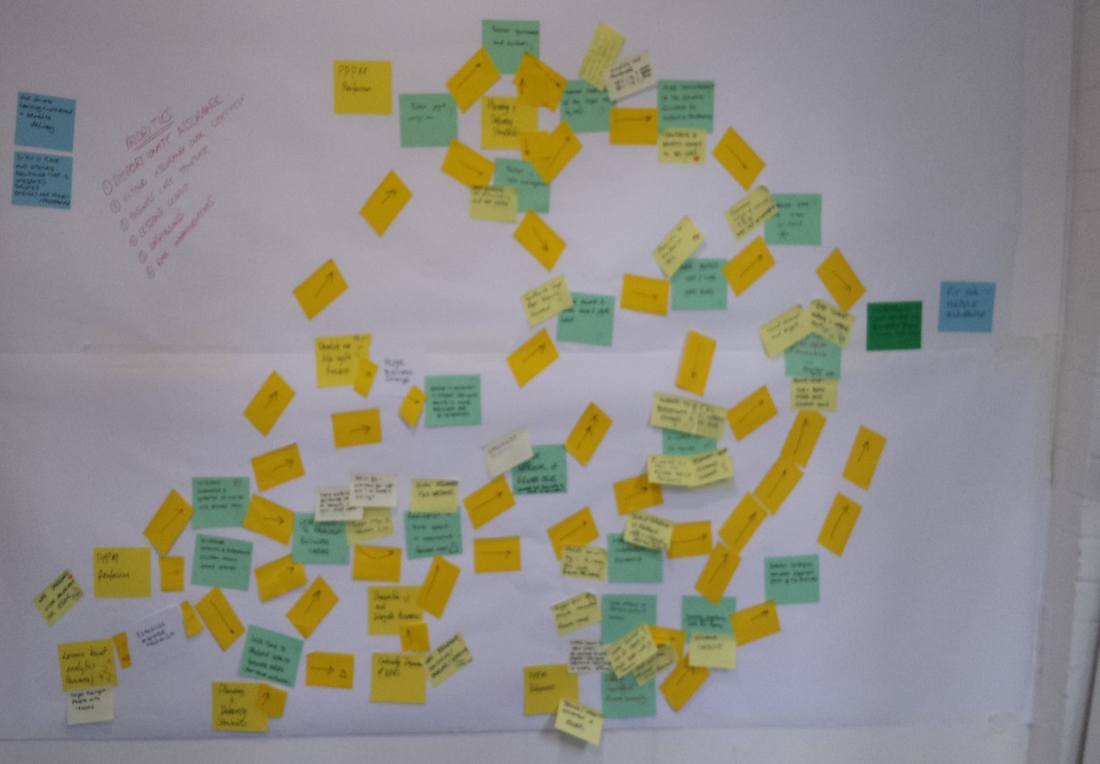

Important Considerations:

There are some things to check before the map is complete:

* Prioritise those benefits which the project can 'own' and actively deliver - the 'must do's'. Recognise that you are unlikely to be able to deliver all the intermediate benefits, focus on those that will deliver the 'end benefits' and which you will have some control over.
* Is the identified benefit necessary (or just a 'nice to do')? Is it required to achieve the end benefit or objective?
* Are all the benefits sufficient – will they achieve the objective or are there gaps where another benefit is required?

Step 4. Electronic Format

Using the outputs from the workshop create an electronic version of the map using Visio, Powerpoint or similar. Ensure that it can be seen on one page in either A4 or A3. The output should look something like this:



Step 5. Review and Development of the Benefit Map

Once complete share the output with the participants to ensure nothing has been lost either physically or in understanding. Prioritise the key measure which will deliver the greatest benefits – the ‘must do’s’, and ‘park’ those that the project/programme cannot influence in any great details. Measures can then be developed for each benefit along with an agreed baseline. Further information on measures and where to go for evidence to measure benefits is given in Appendix 3. The following is the final version from the mapping exercise above:

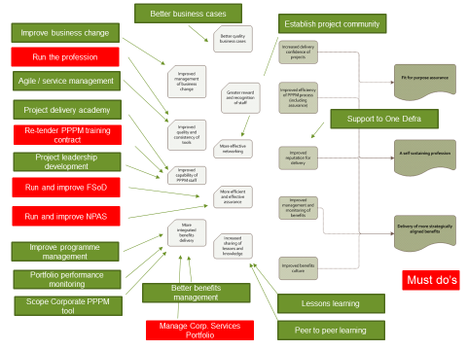

Appendix 3: Benefits Classification & Measures

There are a wide range of sources and evidence for benefit measurement depending on whether the benefit is:

* Financial
* Economic
* Social
* Environmental
* Other Non-Financial

One of the first places to go to for advice on measuring and evidencing benefits and cost/benefit analysis is [The Green Book](https://www.gov.uk/government/publications/the-green-book-appraisal-and-evaluation-in-central-governent) – which is the HM Treasury guidance on appraisal of projects, but contains valuable information including a section on “Valuing Non-Market Impacts’. The Green Book website also has a number of useful publications which can help in providing ways to measure benefits, including valuing environmental effects, air quality, health and energy use – see [supplementary guidance](https://www.gov.uk/government/collections/the-green-book-supplementary-guidance).

The following provides some pointers and guidance as to where to source information and help. Please note that this is not a definitive list and serves as a basic introduction. You may need to consult with colleagues across the Agency to identify other measures as needed:

FINANCIAL:

Examples of benefit:

Cashable

* Reduced annual running costs
* Increased revenue/income
* One off savings (switching IT systems off)

Measures/Sources of Evidence:

Net Present Value – i.e. the difference between the present value of future cash flows from an investment and the amount of the investment. This is as used in Cost Benefits Analysis (see Appendix 4) and 5 Case Business Case guidance on the Easinet [here](http://intranet.ea.gov/policies/61492.aspx)

Non-cashable/cost avoidance

* Efficiency savings which result in speedier processes - fewer steps in a process
* Reductions in time spent - quicker performance of tasks
* Improved processes leading to reduced waste
* Better customer service leading to reduced complaints and time saved

Measures/Sources of Evidence:

Employee Surveys

Reductions in mileage/travel

Fewer complaints

Fewer calls to query process or help desk calls

ECONOMIC

Examples of Benefits:

* Improved Productivity - efficiency savings (also a financial benefit)
* New opportunities for tourism/leisure
* Encouraging new investment in an area as a direct result of new flood protection and reduced insurance costs
* Increased measures to protect infrastructure and reduce economic disruption
* Enhanced regeneration of coastal towns

|  |
| --- |
| Measures/Sources of Evidence: |
| All Local Economic Partnerships (LEPs) produce Quarterly Economic Bulletins on the economic health of LEP areas. |
| The Office for National Statistics (ONS) is the primary source of economic data such as:   * Business Trade and Industry * Economy * House Price Index * Employment and Labour Market * People, population and community * GDP (Gross Domestic Product) – the economic performance of the country   Go to <https://www.ons.gov.uk/economy> |

SOCIAL

Examples of benefits:

* Lives saved/casualties avoided – Cost of life saved
* Increased numbers of communities protected from flooding (also economic)
* Increased health and well-being
* Decreased stress and mental health issues (linked to benefits from flood prevention schemes)
* Better education, learning and training
* Social justice and environmental equality
* Engagement with minorities and deprived communities
* Regeneration of deprived communities
* Influencing attitudes, behaviours and cultures towards environment awareness and sustainability

|  |
| --- |
| Measures/Sources of Evidence: |
| Social Return on Investment (SROI) - SROI is a tool that takes you through the process of estimating the economic, social and environmental value of an intervention in terms of benefits which add real value to people’s lives. It places monetary value on the non-financial returns of an investment including the impact of well-being.  The Big Lottery and Cabinet Office have both produced guidance on using SROI:  [A-guide-to-social-return-on-investment](http://www.neweconomics.org/publications/entry/a-guide-to-social-return-on-investment)  [SROI](https://www.biglotteryfund.org.uk/research/making-the-most-of-funding/impact-and-outcomes/measuring-the-value-of-your-project) (scroll to the bottom of the page) |
| Deprivation Indices – There is comprehensive information available via the Dept for Communities and Local Government – go to [English-indices-of-deprivation-2015](https://www.gov.uk/government/statistics/english-indices-of-deprivation-2015) |
| Social Impact - The Environment Agency working with Forest Research commissioned research on the social impact from our activities, to provide and evidence base for use in future work. The research outlined six social impact categories (social capital, human capital, natural capital, individual well-being, inequalities and behaviour change) which were used to create an evidence base. |
| Health & Wellbeing Indicators: the Dept for Work and Pensions has produced a series of baseline indicators in 2010 (last updated 2013) around the connections between wellbeing, health and work:  <https://www.gov.uk/government/publications/health-work-and-wellbeing-indicators-baseline-data> |

ENVIRONMENTAL (Including Flooding)

Examples of benefits:

* Improved air quality
* Improved landscapes and habitats
* Reduced risk of flooding - increased numbers of properties protected
* Increased Carbon savings/reduced CO2 emissions
* Improved bathing water quality
* Improved inland water quality
* Increased biodiversity
* Habitat creation
* Improved condition of environmental assets
* Increased awareness of environmental issues
* Increased access to green space

|  |
| --- |
| Measures/Sources of Evidence: |
| River Basin Planning – please refer to the Easinet guidance on [River Basin Management Planning - Economic Appraisals](http://intranet.ea.gov/policies/environmentalwork/83629.aspx) where there is a specific document on ‘Valuing Environmental Benefits’ |
| Flood Economics:   * Costs of 2007 floods * Costs of 2013/14 floods * Costs of flood impacts on agriculture   (search title via Easinet) |
| Multi-Coloured manual and website: (link) Used to estimate the benefits of flood risk management interventions via cost/benefit analysis <http://www.mcm-online.co.uk> |
| Defra – Adapting to Climate Change: Advice for Flood and Coastal Erosion Risk Management Authorities (2012) (link) |
| Environmental Value Look-Up Tool (eftec) – [Environmental look-up tool](http://www.eftec.co.uk/eftec-news/environmental-value-look-up-evl-tool)  a searchable database which contains indicative monetary values for a range of environmental impacts developed for Defra. |
| Defra – England Natural Environment Indicators (Aug 2016) |
| The ‘Frontier Toolkit’ (Defra) – details the local economic benefits of flood and coastal protection. It is designed to help partner organisations considering applying for funding under the Partnership Funding scheme:  [Frontier-toolkit-on-local-economic-benefits-of-flood-and-coastal-protection/](https://www.frontier-economics.com/news/defra-publishes-frontier-toolkit-on-local-economic-benefits-of-flood-and-coastal-protection/) |
| Met Office – Public Weather Service Value for Money review Includes data on flood damage avoidance (£64million per annum) and storm damage avoidance (£80 million per annum) <http://www.metoffice.gov.uk/about-us/what/pws/value> |

OTHER NON-FINANCIAL

Examples of Benefits

* Reduced reputational risk
* Compliance with policy or legal requirements
* Faster response times – fewer steps in a process leading to time savings and greater satisfaction
* Better equipment for workforce

MEASURES

* Reduced costs of legal cases/casework due to fewer cases brought to court
* Customer satisfaction surveys (internal and external) - several over a period of time
* Time savings due to e.g. less site visits

The other place to search for a full range of information which may help to evidence and measure benefits is the [Enviropedia](https://enviropedia.eakb.org/index.php/Enviropedia_Home)

Appendix 4: Valuing and Quantifying Benefits

You will need to be clear how benefits can be quantified or valued as part of your business case. The guidance is BE REALISTIC. Don’t overstate benefits in the hope that this will get a project approved – it will only lead to problems in delivery and realisation.

Things to bear in mind:

* Don’t ignore risks and assumptions in calculations (see video conferencing case study for examples of assumptions)
* Don’t claim benefits that haven’t been validated by stakeholders/finance
* Don’t claim staff time savings in full if that time isn’t going to be used on other activities – use a %
* Don’t ignore costs associated with benefits realisation which may go on for a while after project closure, for example the upkeep of a website to track feedback or finance system to capture savings

Some guidance on how to forecast benefits:

Evidence based forecasting – look at similar projects, how did they forecast benefits? Use the guidance in the Green Book (see the link given below), which advises that business cases should be based on data from past projects. Remember to use optimism bias guidelines.

Baseline current performance – Establish what the ‘as is’ state is and forecast the ‘to be’ from this. Check what existing data is currently available. Start tracking benefits as soon as possible.

Use subject matter experts – Use a group of staff who have some experience in the subject area to provide forecasts, or those that have been involved in similar past projects. This will provide a better spread of knowledge and experience.

Cost Benefit Analysis (CBA)

Cost-benefit analysis (CBA) compares the costs of undertaking a project with the benefits achieved. It involves estimating the value of costs and the value of benefits in monetary terms and the results are typically shown as a ratio. The focus of a CBA is to ensure that there is sufficient evidence to demonstrate whether the benefits of your project outweigh the cost. The current Agency approach is to use Net Present Value to measure the difference between the present value of future cash flows from an investment against the amount of the investment. For more see the links provided below.

The [Green Book](https://www.gov.uk/government/publications/the-green-book-appraisal-and-evaluation-in-central-governent) provides more help on valuing benefits and outcomes.

There is also a [cost benefits analysis template](http://ams.ea.gov/ams_root/2014/1001_1050/1020_14.xlsx) available via the EA Easinet site. – see ‘New documents and templates’: [Business Case New documents and templates](http://intranet.ea.gov/policies/61492.aspx)

If in doubt please speak to your Business Finance Partner

Appendix 5: How to do Benefits Management in Practice

Benefit Management Case Study 1: Tracking and Monitoring Financial Benefits

VIDEO CONFERENCING

The Video Conferencing (VC) project was delivered as an internal project managed by CIS. It was required to deliver a fully supported, room based video conferencing solution to 17 sites across the Environment Agency. It followed on from a 9 month trial at 4 sites to assess potential benefits/savings and take-up. It is currently still capturing information on benefits realised, but is a real life example of cost savings to the Agency.

What are the key business benefits?:

* Reduced business costs
* Increased productivity costs (reduce non-productive travel time)
* Reduced carbon footprint

Key baseline Measure:

Reduction to annual costs of travel to meetings from current baseline of £10million.

Measurable Financial Benefits as outlined in the Business Case:

* Generate travel cost savings estimated at c. £440k per annum., once fully implemented
* Generate CO2 savings estimated at 78 tonnes p.a.;
* Generate travel time savings / productivity benefits estimated at 8800 employee hours and £293k per annum;
* Provide financial payback in just over 2 years, roughly in line with the industry average;
* There were a range of financial and non-financial benefits – financial/CO2 benefits are captured here for the purposes of this case study.

Agree assumptions on which to base calculations:

Before any calculations were made assumptions were agreed, which detail the basis on which benefits are calculated. For Video Conferencing a sample of these is given below:

* Assume average 6 people in meeting (all endpoints), so an average of 4 people would be travelling if a meeting was NOT a VC
* Assume average cost of travel is £100 per person per meeting - advice from Finance is that this is quite a conservative figure taking into account that some trips would include accommodation & subsistence
* Assume that 50% of travel time is spent working, so only claim 50% as a productivity saving
* Assume that average travel time for each person (return trip between 2 sites) is 4 hours
* Assume 1 tonne CO2 = £5k travel cost savings, based on extrapolation of IEM figures
* Cost of travel time is based on the average total direct manpower cost for a G6 as provided by Finance in Basic staff costing model 2014/15 for Business Cases - based on 220 working days, and 7.5 hour day hourly rate is 33.34

Use assumptions produce benefits forecast:

Once assumptions are agreed then a benefits forecast can be produced, forecasting the payback period, using cost benefit management techniques and based on net present value (the economic payback).

Capturing benefits in real time:

Using all this information a s’sheet was set up to capture real data to monitor and track towards benefits targets and forecasts used in the pay back above. This includes actual data from each meeting and reported on a monthly basis.

Communicating:

Benefits are 'owned' and being managed by the Finance team. The savings from Video Conferencing are captured in graphical format by the team and used by a wide variety of people in the Agency (see below). The project is used as an example of real cost savings – but only because the team spent time on working out to basis for benefits identification and measurement, ensuring that finance team know when the project will break even and achieve real cost savings for the Agency.

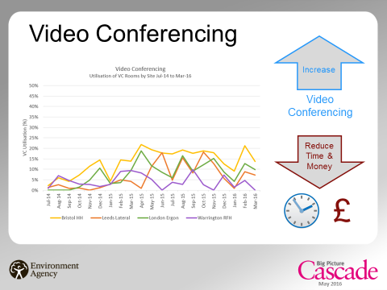

Benefit Management Case Study 2: The Benefits Lifecycle

RESTORE - (Rivers: Engaging, Supporting and Transferring Knowledge for Restoration in Europe)

The RESTORE project ran between 2010 and 2013 and was part-funded through the EU LIFE+ programme. It launched with six European partners working to share and promote information on the best and most effective means of carrying out river restoration in Europe. The objectives were as follows:

* Support river restoration practices across Europe
* Build up existing river restoration network capacity
* Promote effective river restoration knowledge transfer
* Establish long term river restoration knowledge sharing

The Value of mapping for benefits identification:

RESTORE used benefits mapping in the early development of the project to ensure that ensure that outcomes, benefits and objectives of all six partners were aligned. This was delivered as a workshop with partners and stakeholders. The initial session was valuable to develop a working relationship between partners, break down barriers and ensure that work could be planned against an agreed set of benefits and outcomes. The main output from the initial mapping session was as follows:

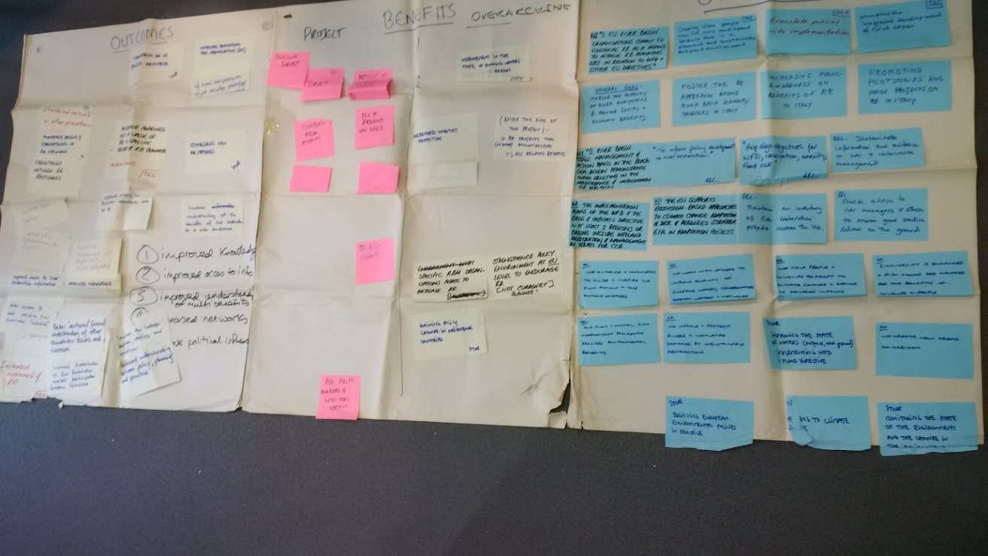

This partnership approach ensured that there was ‘buy-in’ from participants and agreement between all six partners on a benefits-led approach. The benefits-led approach ensured that:

* The benefits matched the overall project objectives.
* Involvement of our main target audience in developing the strategy.
* Ensuring sufficient resources were allocated to deliver the strategy.
* Identification and allocation of accountabilities and responsibilities.
* The strategy was integrated with other plans and strategies related to the project.
* Ensuring benefits management was a key part of Programme Board agenda time.

The benefits realisation approach enabled the project to deliver, shape and direct the RESTORE programme and to inform decision-making along the way. The project team planned for and achieved benefits by translating business objectives into identifiable, measurable benefits that could be easily tracked and measured. This provided the evidence needed to keep the focus of deliverables within the project on achieving the overall objectives. From the initial benefits mapping session the following roadmap was produced to ensure activities were related to benefits and outcomes.



Tracking and Measuring Impact of Non-financial Benefits:

The benefits from RESTORE were mainly non-financial. Various method were used to track and monitor progress towards realisation of benefits during the lifetime of the project including:

* A baseline survey
* Ongoing surveys during delivery and into realisation
* Numbers of articles in the news/ media and likely levels of readership
* Feedback from events
* Interviews during events
* Number of projects on the Wiki
* Interviews with selected people
* Interviews with contacts from the communications plans
* Questionnaires
* Network participation
* Asking policy makers if the wiki tool was useful
* Direct events/workshops/conferences
* Poll of website use
* Monitoring use of online communications such as knowledge management tools, website and social media
* Ad hoc comments received
* Number of people attending events/workshops/conferences
* Use of Google Analytics.

Realisation – Beyond the delivery stage:

The RESTORE project team recognised that the benefits would not be fully delivered during the project delivery period. A three year ‘After-Life Plan’ was developed to ensure that activities created by the project were continued after the project ended. Plans included ensuring that the website/Wiki work would continue and be used by many more people, continuing to grow the knowledge bank on river restoration. Agreements were drawn up with partners to ensure that funding to maintain the website and other products would continue to ensure benefits were fully realised along with the full value of the project outcomes. A key ‘lesson learnt’ was the requirement for ongoing input and funding to take forward the After Life Plan, and this learning should be transferred to other projects. Without commitment and funding benefits may not be realised, along with the full return on investment.

If you would like to learn more about RESTORE please [click](https://restorerivers.eu/wiki/index.php?title=Main_Page) here.

IF YOU HAVE A CASE STUDY YOU WOULD LIKE TO FEATURE PLEASE LET US KNOW.

Glossary

|  |  |
| --- | --- |
| **Business As Usual (BAU)** | The normal conduct of business after a change has been delivered and embedded. |
| Benefit | An outcome of change that is perceived as positive by a stakeholder and measurable. |
| Benefit Owner | The person with accounatbility for the realisation of a benefit - usually from within a business area. |
| Benefit Profile | Used to define each benefit (and dis-benefit) and provide a detailed understanding of what will be involved and how the benefit will be realised. |
| Benefits Management | The process from identification to realisation of the optimum benefits from a change. |
| Benefits Management Strategy | Defines the approach to realisation of benefits and the framework within which benefit realisation will be achieved. |
| Benefits Map | A network of benefits, usually linked to an objective in a cause and effect relationship diagram. |
| Benefits Realisation Plan | The document used to track realisation of benefits across the programme and set review controls. |
| Business Case | The justification for an organisational activity which typically contains costs, benefits, risks and timescales and against continued viability is tested. |
| Business Change | Activities carried out to support the implementation og changewithin the business/operational environment such as a training, communication and new ways of working. |
| Disbenefit | Outcomes perceived as negative by one or more stakeholders and measurable. |
| Emergent Benefit | Benefits that emerge during the delivery of the project/change process rather than being identified at the start. |
| Enabler | An enabler is something that needs to be developed/built/acquired before benefits realisation can occur. Enablers include IT systems, communication systems, buildings, policies, skills and tend to be tangible. |
| End Benefit | One of a set of benefits which will deliver against the objective(s). |
| Intermediate Benefit | Benefits which occur between the implementation of early changes and the realisation of the end benefits. |
| Net Present Value | A statement of the value of future costs and benefits, expressed at today's value. A monetary measure. |
| Objective | The intended outcome or goal of a change. |
| Portfolio | "The totality of an organisation’s investment (or segment thereof) in the changes required to achieve its strategic objectives”. |
| Project | A temporary organisation that is created for the purpose of delivering one or more business products/outputs according to an agreed business case. |
| Programme | "A temporary flexible organisation structure created to co-ordinate, direct and oversee the implementation of a set of related projects and activities in order to deliver outcomes and benefits related to an organisation's strategic objectives"[6] |

1. Gerald Bradley – Fundamentals of Benefits Realisation
2. Cabinet Office
3. OGC Managing Benefits – An Overview
4. EA RESTORE Lessons Learnt report
5. DVLA Change Programme – Benefits Management
6. Managing Successful Programmes (MSP)