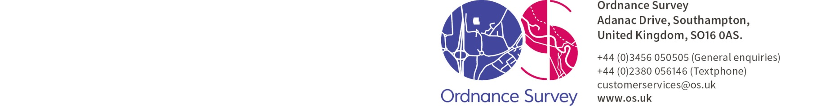

procurementgroup@os.uk
15th November 2016

Dear Sir/Madam
FLOODING DATA - REQUEST FOR QUOTATION (RFQ)
Ordnance Survey Limited is a limited company registered in England and Wales (company registration number 09121572) whose registered address is at Explorer House, Adanac Drive, SOUTHAMPTON, SO16 0AS, UK (OS) the entire share capital of which is owned by the Secretary of State for Business, Energy and Industrial Strategy.
OS is Britain’s mapping agency. We make the most up-to-date and accurate maps of the country. But we’re also a digital business, and we use our content to help governments, companies and individuals be more effective both here and around the world. Further information on us can be found on our website http://www.os.uk
OS are requesting quotes from potential suppliers who can provide Flooding Data, for onward use in a Commercial Valuation API.
Update - 15/11/2016
Due to the overall volume and nature of clarification questions received in respect of this RFQ, OS will revise and publish updated documentation that addresses the questions raised. As a consequence of this, OS has decided to extend the deadline for submission of responses, in order to allow participants time to consider the revised documentation.

Extension of Contracts Finder Notice - 15th November 2016

Publication of revised RFQ Documentation via Contracts Finder - 16th December 2016

Deadline for submission of revised RFQ clarification questions - 6th January 2017

Deadline for submission of RFQ responses - 19th January 2017

