Howden Town Council

To Whom it May Concern,

Howden Town Council is tendering for a ‘Project Loo’.

Project Loo is a ‘Changing Place’ at the public toilets in Howden that will be open 24/7. A Changing Place is a large disabled toilet with toilet and changing facilities, which include a shower, an adult changing bench, hoist, and space for their carers. In the United Kingdom, it is estimated that 1 in 260 people NEED a changing place.

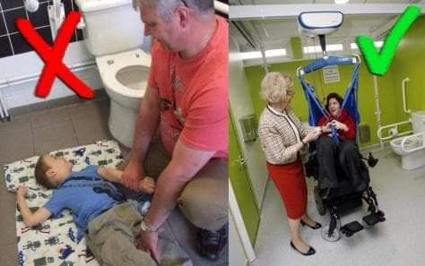

The image on the left is of a disabled child, being changed on the floor of a standard disabled toilet. The image on the right is of a person being hoisted from their wheelchair for their basic care needs to be fulfilled. Vulnerable people and their carers must plan their daily ventures based on where these changing facilities are and because they are so few and far between and not always open 24/7, it often results in these vulnerable people and their carers being isolated within their homes and unable to feel part of their community.

Please see the attached documents to help with the tender process.

We are looking for tenders for both the external (building) and external (fixtures and fittings)

We have had a very successful start to the project:

During public consultation, we received a lot of support from the local residents, documenting an estimate of 300+ signatures, letters of support from the local medical practice and schools, as well as case studies of the needs and benefits of changing places from people and carers who access them.

In 2019, Project Loo was adopted by Howden Town Council. The Town Council will be responsible for the building once it has been built and will help, wherever possible with its construction. Because of their mediation efforts, The Town Council has been granted the use of the land next to the public toilets located at Charles Briggs Avenue in Howden by the East Riding of Yorkshire Council who own and manage the public toilets in Howden and owner of the land where the Project Loo will site.

The present Public Conveniences in Howden – Project Loo will go to left of the building where the black railings are:

* In January 2020, Howden Town Council’s Resource and Asset Management Committee approved £5000 to be ear-marked towards Project Loo, funds can be used to facilitate the development of the project, such as planning fees, architect fees, structural engineer fees etc..
* Howden Town Council has been working closely with a local architect to plan and design the changing place and in February 2020, Howden Town Council was granted planning permission to build an extension onto the public toilets, to facilitate a Changing Place

**The closing date for tenders is Monday January 31st 2022 at 4pm**