Annex C to 706672450

DSMarE-DC-3712

Dated 6 Jul 22

**Statement of Requirement**

**The Provision of a Statutory Portable Lifting Equipment Contract at HMS Sultan**

| Ref | Requirement | | | |
| --- | --- | --- | --- | --- |
| **A** | **General Requirements** | | | |
| **A.1** | **Scope of Requirement** | | | |
| A.1.a  A.1.b  A.1.c  A.1.d  A.1.e  A.1.f  A.1.g  A.1.h | This Statement of Requirement covers a Framework Agreement contract for Statutory Portable Lifting Equipment, examination, testing and repairs in support of training equipment and delivery of training on HMS Sultan site only.  To provide a competent person, as defined in ACoP (refer to A.4.a), to undertake statutory examination and certification of Portable Lifting Equipment.  The current list of Portable Lifting Equipment to be maintained is within the link in Annex A and is subject to change throughout the contract to reflect addition/removal of items.  To examine Portable Lifting Equipment at 6 MONTHS and 12 MONTHS intervals and colour code to identify current period of which items have been examined and certified safe to use (LOLER Regulation 9(3) refers).  To provide State Boards (calendar date and colour status) in local areas to indicate status and expiry date of validity (see Annex C for an example of a State Board).  To test and certify statutory Portable Lifting Equipment at HMS Sultan site or Contractor’s works as required in accordance with current legislation (refer to Section A.4).  To conduct to industry standard suitable repairs to statutory Portable Lifting Equipment at HMS Sultan or Contractor’s premises as required.  To carry out statutory examination of Portable Lifting Equipment in accordance with current legislation (refer to Section A.4): | | | |
|  |  | | | |
| **A.2** | **Definitions** | | | |
| A.2.a | In addition to the definitions detailed in the Terms and Conditions of the Contract the following definitions shall also apply. Where the definitions below contrast to those detailed in the Terms and Conditions of the Contract then the definitions within the Terms and Conditions of the Contract shall take precedence. | | | |
|  | Definition | Interpretation | | |
|  | Contractor’s Personal Use | Any use of MOD furnished property, facilities or equipment intended for the primary benefit of the Contractor or the Contractor’s Personnel which is contrary to the MOD’s interests is considered personal use. | | |
|  | Contractor’s Personnel | Any employees, including sub-contractors or other agents working on behalf of the Contractor, shall be deemed the Contractor’s Personnel. | | |
|  | Designated Officer | The Designated Officer is the MOD representative responsible for the Requirement. | | |
|  |  | | | |
| **A.3** | **Abbreviations and Acronyms** | | | |
| A.3.a | In addition to the abbreviations and acronyms detailed in the Terms and Conditions of the Contract the following abbreviations and acronyms will be used. | | | |
|  | Abbreviation or Acronym | Interpretation | | |
|  | ACoP  BPSS  COSHH  DO | Approved Code of Practice  Baseline Personnel Security Standard  Control of Substances Hazardous to Health  Designated Officer | | |
|  | DSMarE | Defence School of Marine Engineering | | |
|  | HMS  LOLER  MMS-COORD  MoD  PUWER  SC | Her Majesty’s Ship  Lifting Operations and Lifting Equipment Regulations  Maintenance Co-Ordinator  Ministry of Defence  Provision and Use of Work Equipment Regulations  Security Check | | |
|  |  | | | |
| **A.4** | **References** | | | |
| A.4.a | In addition to the references detailed in the Terms and Conditions of the Contract the following references shall also apply as well as any subsequent revisions and amendments to the references. This list does not absolve the Contractor from conforming to any other relevant publications. | | | |
|  | Reference | | Version | Source |
|  | Data Protection Act 2018 | | 2018 c. 12 | <http://www.legislation.gov.uk/ukpga/2018/12/contents/enacted> |
|  |  | |  |  |
|  | Government Security Classifications | | 1.0 | <https://www.gov.uk/government/publications/government-security-classifications> |
|  | Health and Safety at Work etc Act 1974 | | 1974 c. 37 | <https://www.legislation.gov.uk/ukpga/1974/37/contents> |
|  | Lifting Operations and Lifting Equipment  Regulations (LOLER) UK Statutory  Instruments | | 1998  No. 2307 | <https://www.legislation.gov.uk/uksi/1998/2307/contents/made> |
|  | Lifting Operations and Lifting Equipment Regulations 1998. Approved Code of Practice and guidance (ACoP)  Dec 2014 (with amendments 2018) | | L113  2nd Edition | <https://www.hse.gov.uk/pubns/books/l113.htm> |
|  | Provision and Use of Work Equipment  Regulations 1998 (PUWER)  Nov 2014 (amendments made 2018) | | L22  4th Edition | <https://www.hse.gov.uk/pubns/books/l22.htm> |
|  | ISO 9001:2015 Quality Management Systems | | 2015-09  Edition: 5 | <https://www.iso.org/standard/62085.html> |
| **A.5 – A.11** | **Processes and Related Taskings** | | | |
| **A.5** | **Inspection** | | | |
| A.5.a | Any items which fail inspection shall be marked/labelled as appropriate by the Contractor, to indicate that it is not to be used and the site point of contact, MMS-COORD is to be informed immediately by phone and email. | | | |
| **A.6** | **Testing/Certification** | | | |
| A.6.a | The Contractor is to supply a certificate for each item tested to HMS Sultan site point of contact and send a copy by email to MMS-COORD. | | | |
| A.6.b | Any items which fail inspection shall be marked/labelled as appropriate by the Contractor, to indicate that it is not to be used and the site point of contact, MMS-COORD is to be informed within 24 hours by email. | | | |
| **A.7** | **Planning Site Visits** | | | |
| A.7.a | A calendar month prior to each visit, the Contractor is to provide MMS-COORD with a list of equipment requiring inspection and the date of the next visit. This information shall be forwarded to MMS-COORD by email. | | | |
| A.7.b | Due to operational requirements, some Statutory Portable Lifting Equipment may not be available for inspection at the arranged time. The Contractor is to arrange new dates with MMS-COORD by email in such instances. | | | |
| A.7.c | Refer to A.21 for Points of Contact. | | | |
| **A.8** | **Recording of Data** | | | |
| A.8.a | The Contractor will be required to maintain a database of all Statutory Portable Lifting Equipment details and results, for the duration of the contract. | | | |
| A.8.b | The software is to be “Microsoft Office” (Excel) compatible. | | | |
| A.8.c | The Contractor will be responsible for updating the database and providing ‘read’ access to the data to MMS-COORD. | | | |
| A.8.d | The inspections shall be recorded as Pass or Fail along with a reason for failing. Should the item not be presented at the time of the site visit it shall be recorded as Not Presented. In the event of an item not being presented on the third visit it shall be recorded as Removed or Discontinued. | | | |
| A.8.e | Following Contractor’s engineer visit, test results shall be entered on to the database and provided to MMS-COORD within one week. | | | |
| A.8.f | All data is, and will remain, the property of the MoD, and must be passed to MoD within one month at the end of the Contract, or on request. | | | |
| **A.9** | **Additional Requirements** | | | |
| A.9.a | The Contractor shall supply all tools and lifting equipment (with current certification) and any other equipment as necessary to complete the required task. | | | |
| A.9.b | The whole of the work covered by this specification shall be undertaken without MoD assistance unless otherwise stated. | | | |
| A.9.c | All materials required to carry out a required task shall be supplied by the Contractor unless otherwise stated. | | | |
| **A.10**  A.10.a  A.10.b | **Work Orders – ESS7 Forms**  Work Orders (ESS7 – Annex B), shall be issued for each site visit and provides authority to the Contractor to attend site and undertake the work. Acknowledgement of the order along with the details of who is attending, when and vehicle details forms an audit trail and prevents undue delay at the security gate when attending site.  The Contractor’s engineer attending site shall report to MMS-COORD on arrival and again on completion of the site visit. The Contractor’s engineer shall obtain a signature on Part 3 of the works order (ESS7) which forms part of the audit trail. | | | |
| **A.11** | **Health and Safety** | | | |
| A.11.a | Prior to starting work the Contractor will be required to forward the following: | | | |
| A.11.b | Risk Assessment - It should be noted that the Risk Assessment should include the following elements:   * + 1. The tasks should be identified.     2. All hazards should be identified     3. Hazards should be eliminated where possible.     4. Persons at risk should be identified.     5. All risks should be evaluated.     6. Controls should be developed for these risks.     7. The Assessment should be recorded.     8. Controls should be implemented.     9. The Assessment should be reviewed and monitored as necessary. | | | |
| A.11.c | Proposed Safe System of Work / Method Statement - It should be noted that the Method Statement should include the following elements:   * + 1. Details of work to be done.     2. Method of doing this work     3. Location of the worksite.     4. Project timing and phasing.     5. Details of Personnel, their skills, training and competence.     6. Details of equipment to be used including Maintenance procedures and records. | | | |
| A.11.d | Copy of the company’s Health and Safety Policy. | | | |
| A.11.e | History of the Company’s safety performance. | | | |
| A.11.f | Certification and Tests of Plant and Equipment being employed no more than every 6 months and two checks a year as a minimum on each piece of equipment. | | | |
| A.11.g | COSHH assessments for any hazardous materials being brought and used on site. | | | |
| **A.12** | **Hours of Operation and Times of Delivery** | | | |
| A.12.a | The Contractor will be required to work within the normal working hours of the Establishment i.e. 0800-1600 Monday to Friday. Work outside of these hours will not usually be required except in cases of emergency therefore any work at weekends, UK Bank Holidays and Public Holidays must be agreed with TESM before any work commences. | | | |
| **A.13** | **Work Site** | | | |
| A.13.a | The worksite for the delivery of all services is HMS Sultan. HMS Sultan is situated in Military Road, Gosport, Hants, PO12 3BY. | | | |
| A.13.b | The Worksite is always to be kept clean and tidy. | | | |
| **A.14** | **Security** | | | |
| A.14.a | The Contractor is to ensure that all the Contractor’s personnel have BPSS clearance. Where the Contractor’s personnel do not have BPSS clearance the individuals will not be allowed access to MOD facilities. | | | |
| A.14.b | All information related to or generated by this Contract is to be treated in the appropriate manner in accordance with Government Security Classifications. The classification of the material to be handled shall not exceed OFFICIAL-SENSITIVE in nature. | | | |
| A.14.c | All personal data processed under this Contract is to be treated in accordance with the Data Protection Act 2018. | | | |
| A.14.d | The Authority will bear no costs incurred by the Contractor or any employees of the Contractor for BPSS. | | | |
| **A.15** | **Site Access** | | | |
| A.15.a | The Contractor will submit initial site pass applications by email to the Authority’s Designated Officer. | | | |
| **A.16** | **Safety and Environmental Provisions** | | | |
| A.16.a | When on the HMS Sultan Site, the Contractor is to comply with all MOD Safety, Health and Environmental Protection regulations and policy. Copies held in each building on HMS SULTAN site. | | | |
|  |  | | | |
| **A.17** | **Quality Assurance** | | | |
|  |  | | | |
| A.17.a | No specific Quality Management System requirements are defined. This does not relieve the Supplier of providing conforming products under this contract. CoC shall be provided in accordance with DEFCON 627. | | | |
|  |  | | | |
| A.17.b | No Deliverable Quality Plan is required reference DEFCON 602B 12/06. | | | |
|  |  | | | |
| **A.18** | **Contract Monitoring** | | | |
|  |  | | | |
| A.18.a | For the purposes of contract monitoring, representatives of the Contractor will routinely report to the TESM on the performance of the Contract. | | | |
| A.18.b | The Contractor is responsible for the performance of the Contract by any sub-contractors or other agents working on behalf of the Contractor. The Contractor is to deal with any issues relating to any sub-contractors or other agents working on behalf of the Contractor, this however does not exclude sub-contractors or other agents working on behalf of the Contractor from attending any Contract Monitoring meeting or contributing to any report where it is appropriate for such sub-contractors or other agents to do so. | | | |
| A.18.c | If any sub-contractors or other agents working on behalf of the Contractor are found unsuitable, for whatever reason, the Contractor is to engage with the relevant sub-contractors or other agents to broker a resolution. | | | |
|  |  | | | |
| A.19 | **Personnel Qualification Requirements and Training** | | | |
| A.19.a | The Contractor and Contractor’s Personnel are required to confirm with current legislation. (Refer to A.4.a.) | | | |
| A.19.b | The Contractor is responsible for the sourcing of the appropriate training for the Contractor’s Personnel. | | | |
| A.19.c | The Contractor is responsible for all costs for training of the Contractor’s Personnel to meet their obligations under the Contract. | | | |
|  |  | | | |
| **A.20** | **Certification and Accreditation** | | | |
|  |  | | | |
| A.20.a | The Contractor shall be ISO 9001:2015 Quality Management Systems certificated with a suitable scope for the work required. (Refer to A.4.a.) | | | |
| **A.21**  A.21.a  A.21.b | **Points of Contact**  Authority’s Designated Officer:  Ms Lisa Cook  Business Development Officer  Room 7, Allied Trades 1  HMS SULTAN  Military Road  Gosport  PO12 3BY  Telephone number: 0300 154 8363  Email: [Lisa.Cook294@mod.gov.uk](mailto:Lisa.Cook294@mod.gov.uk)  Training Equipment Support Manager (TESM):  Mr Gary Miles  Training Equipment Support Manager  Room 1-29, Parsons Building  HMS SULTAN  Military Road  Gosport  PO12 3BY  Telephone number: 02392546174  Email: [Gary.Miles@babcockinternational.com](mailto:Gary.Miles@babcockinternational.com)  or [Gary.Miles981@mod.gov.uk](mailto:Gary.Miles981@mod.gov.uk) | | | |
| A.21.c | Maintenance Co-Ordinator (MMS-COORD):  Mr Jim Casey  MMS-COORD  Room 1-34, Parsons Building  HMS SULTAN  Military Road  Gosport  Hants  PO12 3BY  Telephone number: 02392 543180  Email: [Jim.Casey104@mod.gov.uk](mailto:Jim.Casey104@mod.gov.uk) | | | |

|  |  |
| --- | --- |
| **B** | **Deliverable Requirements** |

| Ref | Requirement | Additional Information | Frequency | Standard of Performance |
| --- | --- | --- | --- | --- |
|  |  |  |  |  |
| B.1 | To carry out Statutory Inspection of lifting equipment. | To provide a competent person, as defined in ACoP (refer to A.4.a), to undertake statutory examination and certification of Portable Lifting Equipment.  To examine Portable Lifting Equipment at 6 MONTHS and 12 MONTHS intervals and colour code to identify current period of which items have been examined and certified safe to use (LOLER Regulation 9(3) refers).  To provide State Boards (calendar date and colour status) in local areas to indicate status and expiry date of validity (see Annex C for an example of a State Board).  To test and certify statutory Portable Lifting Equipment at HMS Sultan site or Contractor’s works as required in accordance with current legislation (refer to Section A.4). | 6 month and 12-month inspections  (see link at Annex A) | To the satisfaction of the Authority and in accordance with the references in A.4. a. |
| B.2 | The current list of Portable Lifting Equipment to be maintained is at the link in Annex A and is subject to change throughout the contract to reflect addition/removal of items. |  | As required | To the satisfaction of the Authority and in accordance with the references in A.4. a. |
| B.3 | To conduct to industry standard suitable repairs to statutory Portable Lifting Equipment at HMS Sultan or Contractor’s premises as required. |  | As required | To the satisfaction of the Authority and in accordance with the references in A.4. a. |
| B.4 | To provide a report of thorough examination as soon as practically possible. |  | Within 7 days |  |
| B.5 | Maintain master register database of all lifting equipment at HMS Sultan. |  | As required |  |
| B.6 | Provide read only access to master register database. |  | As required |  |

**Annex A to SOR**

**List of anticipated 6- and 12-Month Statutory Inspections can be found at the following link:**

[20230622 - DSMarE-DC-3712 Stat Lifting Equip List.xlsx](https://modgovuk.sharepoint.com/:x:/r/teams/14508/1/DSMarEProjLTD/20230622%20-%20DSMarE-DC-3712%20Stat%20Lifting%20Equip%20List.xlsx?d=wc400760e83bd46cfb73e8aed96cbe09a&csf=1&web=1&e=xaa2aV)

The list of equipment at the link is the anticipated inspection requirement and correct at the time of publishing (26 Jun 2023). The list is not exhaustive and can be added to prior to the inspection or items removed prior to the inspection at the Authorities discretion. Prior to beginning the inspection, the Contractor is requested to contact the Authority to establish the exact requirements for the next inspection at least 4 weeks prior to the commencement date.

**Annex B to SOR**

ESS7 Works Form:

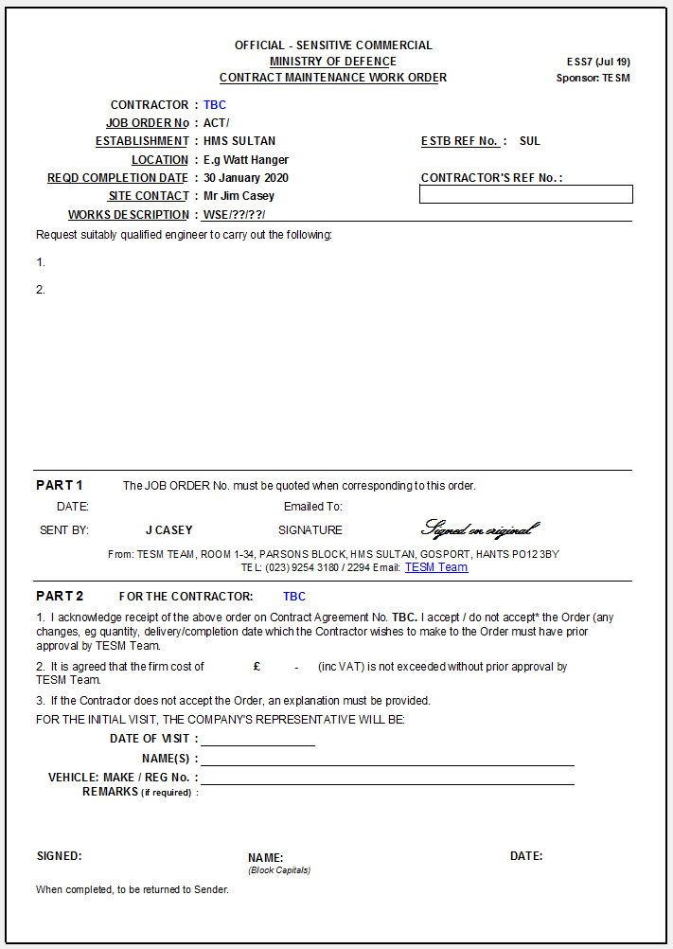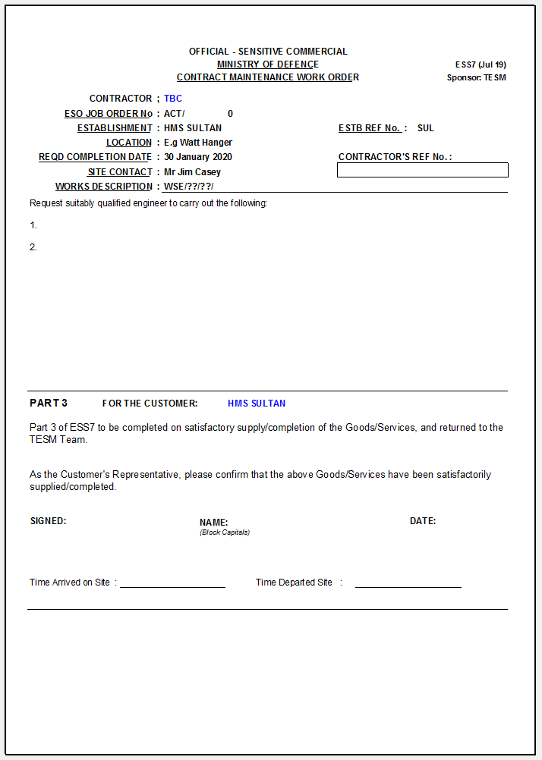

**Annex C to SOR**

Example of a State Board:

