**Species Evidence Base – version 2**

**Guidance on completing the template spreadsheet**

Introduction

This guidance note is intended to clarify aspects of the provisional template spreadsheet to help prospective suppliers gain a better understanding of the requirements of the assignment. After the workshop at the beginning of contract period, where suppliers will have an opportunity to QA the design of the data fields and suggest / agree improvements, we will produce more detailed guidance to support work delivery.

Because the template spreadsheet is provisional, so too are the contents of this guidance.

Confidence ratings

We require suppliers to base the information they provide on evidence wherever possible. However, where this is not possible (i.e., due to lack of evidence), suppliers should use expert opinion.

For each theme in the template spreadsheet (i.e., each tab), there is a field for suppliers to indicate whether the information provided is based on evidence, expert opinion, or a combination of both.

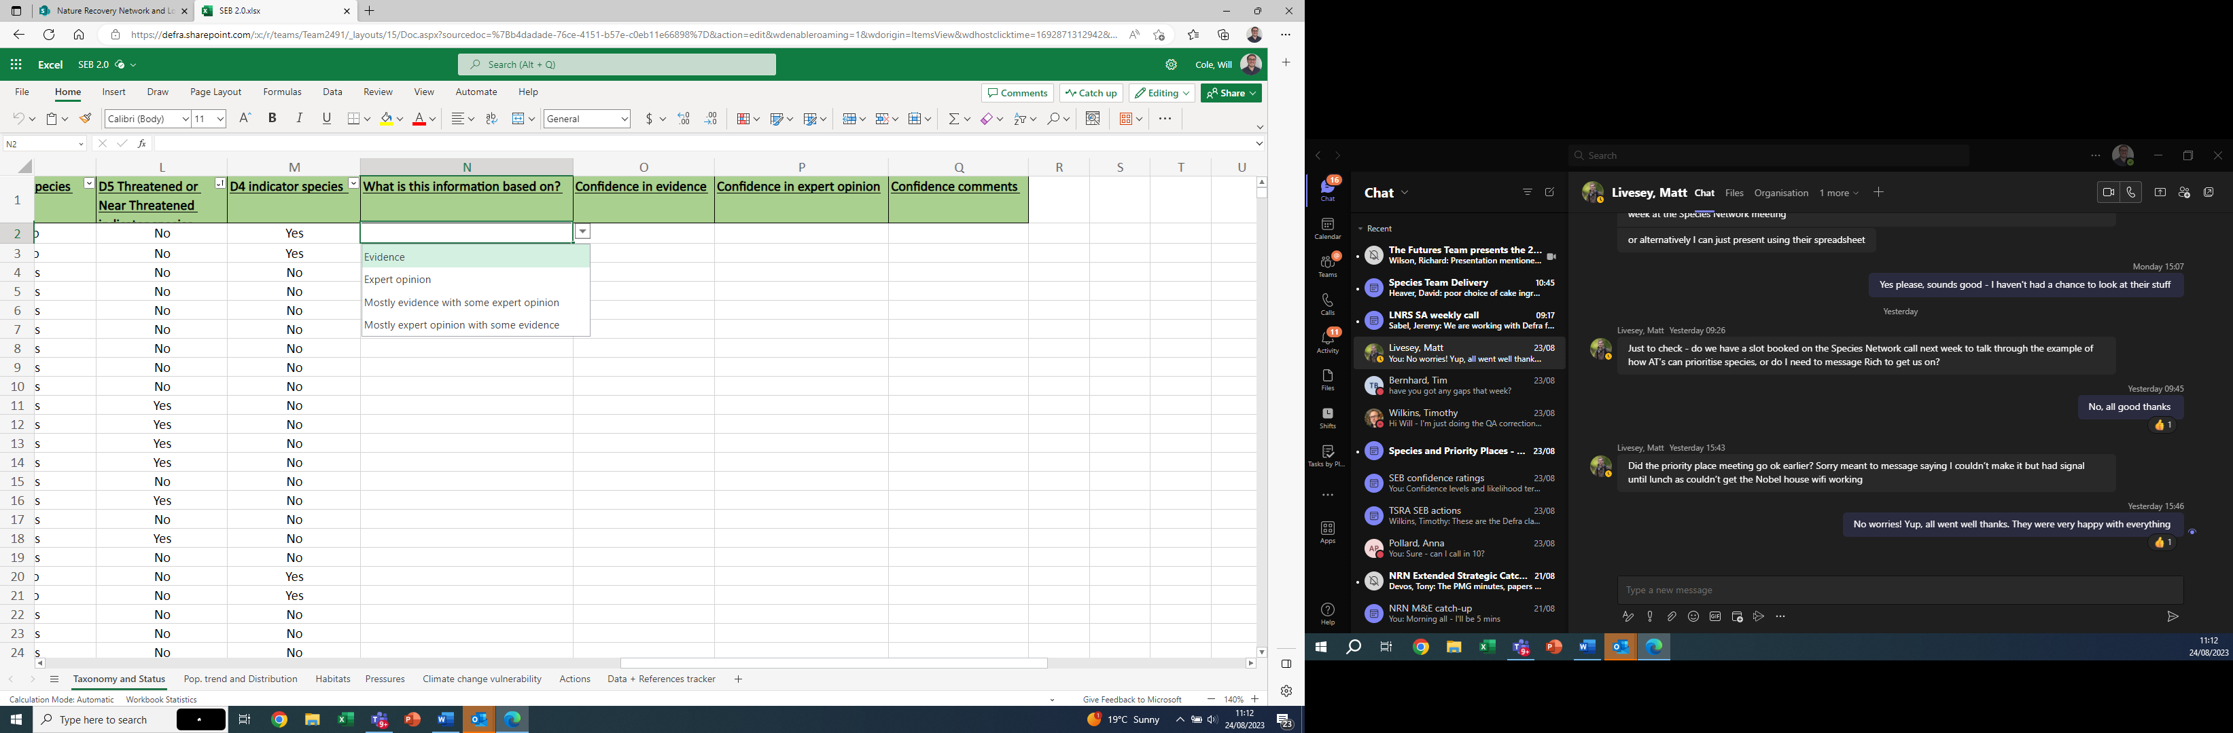

There are also fields for suppliers to indicate their confidence in the evidence / expert opinion underpinning the information provided (and, thereby, their confidence in the information itself). Two of these fields have a drop-down menu of five confidence rating options (N/A should be selected for ‘confidence in evidence’ if the information was based solely on expert opinion, and vice-versa; where information is based on a combination of evidence and expert opinion, suppliers should rate confidence in each). One field is freetext, providing opportunity for suppliers to add further detail and explanation to their confidence ratings.

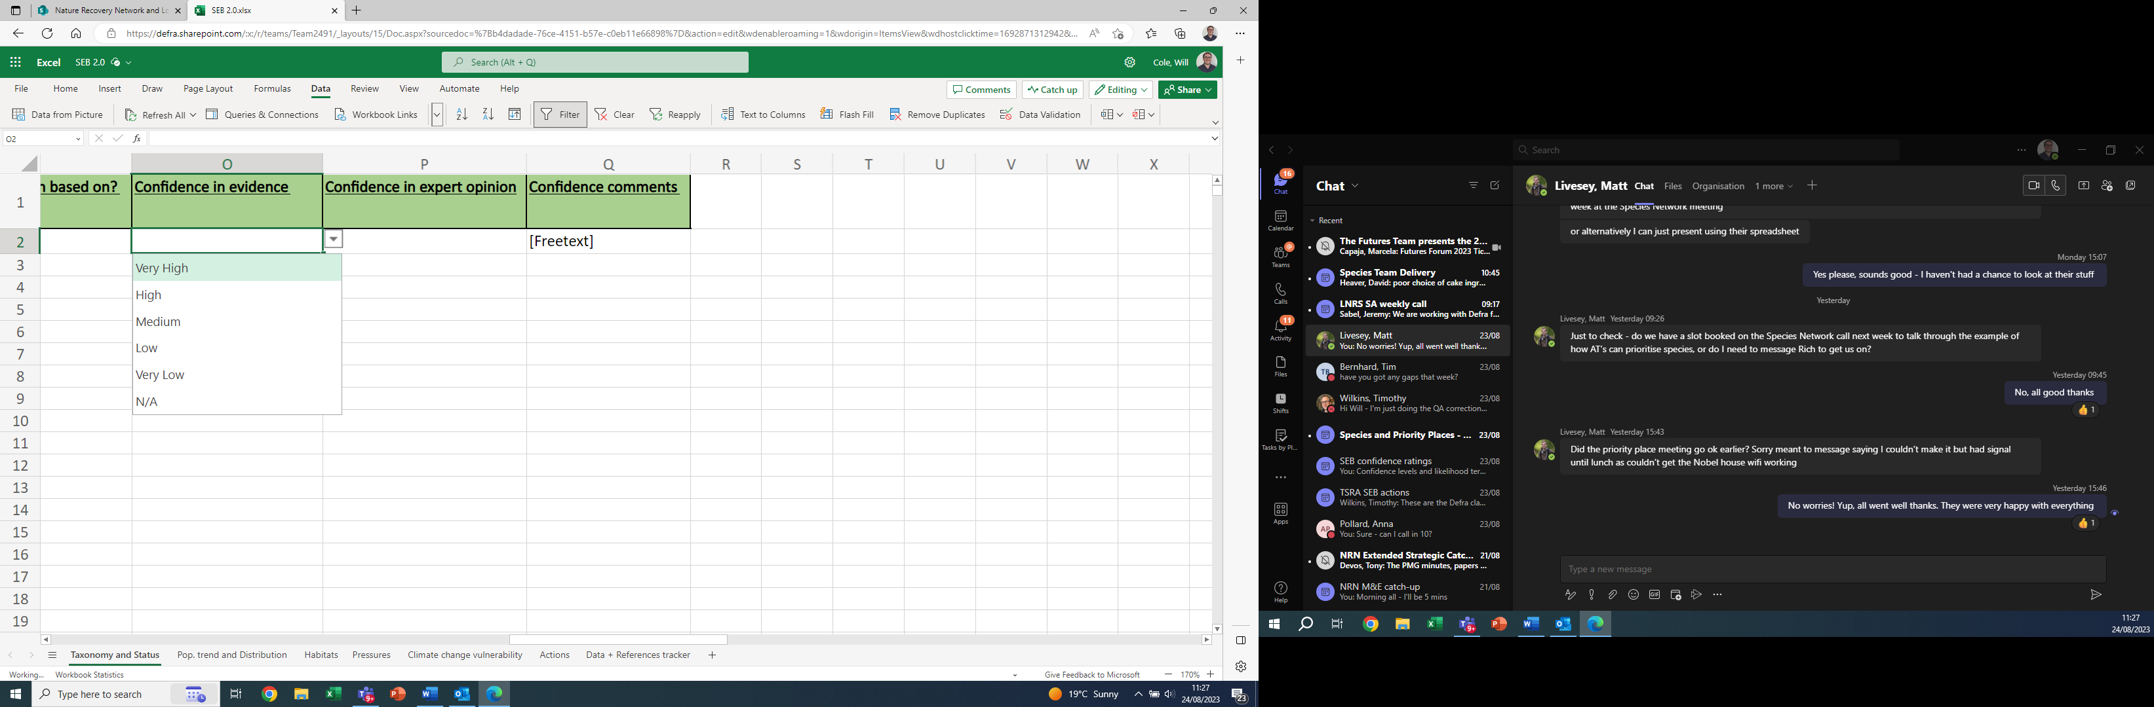

The five confidence ratings – ranging from ‘very high’ to ‘very low’ – inversely indicate the supplier’s judgement on the potential for error in the information provided. ‘Very high’ confidence indicates the lowest potential for error; ‘very low’ confidence indicates the highest potential for error.

Suppliers should use descriptions in the table below to inform their confidence ratings.

For ‘confidence in evidence’, there are three broad factors for suppliers to base their judgements on (following [Mastrandrea et al. 2010](https://www.ipcc.ch/site/assets/uploads/2017/08/AR5_Uncertainty_Guidance_Note.pdf)): **strength** of the evidence underpinning information provided (NE will provide advice on how to assess this at the start of the contract); **amount** (single / multiple piece/s) of evidence underpinning information provided; **levels of agreement** among (or consistency of) the evidence.

‘Confidence in expert opinion’ follows the same broad principles. Suppliers should note that the table below **does not imply equivalence** between confidence in information based on evidence and confidence in information based on expert opinion. The two systems are distinct from one another.

|  |  |  |  |
| --- | --- | --- | --- |
| **Rating** | **Confidence in evidence** | **Confidence in expert opinion** | **Potential for error** |
| **Very high** | High levels of agreement among multiple pieces of high-strength evidence | Strong consensus among multiple independent specialists | Lowest  Highest |
| **High** | Single piece of high-strength evidence (no known inconsistencies with other evidence)  High levels of agreement among multiple pieces of medium-strength evidence  Acceptable levels of agreement among multiple pieces of high-strength evidence | Individual direct knowledge of species in question |
| **Medium** | Acceptable levels of agreement among multiple pieces of medium-strength evidence  High levels of agreement among multiple pieces of low-strength evidence | Extrapolation based on evidence available for other species with similar functional traits / ecological requirements |
| **Low** | Single piece of medium-strength evidence (no known inconsistencies with other evidence)  Low levels of agreement among multiple pieces of high or medium strength evidence | Extrapolation based on evidence available for wider factors |
| **Very low** | Single piece of low-strength evidence  Acceptable or low levels of agreement among multiple pieces of low-strength evidence | Best estimate |

These descriptions are intended as a guide, and there may be other factors to consider when rating confidence.

Taxonomy and Status theme

Most of the fields on the ‘Taxonomy and Status’ tab are pre-populated. Suppliers only need to complete column F (‘England Native Status’), column G where applicable (‘if [England Native Status is] multiple or other, explain’), and columns N-Q to indicate basis of information provided and confidence ratings.

Population Trends and Distribution theme

Suppliers need to complete columns D – R.

In column D, suppliers indicate the prevailing population trend of the species **in England**. The timescale for assessing population trend is over the **last 10 years or three generations**, whichever is the longer. Suppliers can select ‘unclear’ where differing trends in different parts of the country create no obvious overall national trend, or where population changes year-by-year are very erratic, making an overall trend impossible to discern. ‘Unknown’ is for cases where the data and expert opinion are simply insufficient to come to a conclusion.

In column E, suppliers indicate the rarity of the species **in England**. The drop-down options are defined as follows (modified from the GB rarity scale):

**Widespread**: Occurring in 150 or more 10km squares

**Restricted**: Occurring in 50 – 149 10km squares

**Nationally scarce**: Occurring in 9 – 49 10km squares

**Nationally rare**: Occurring in 8 or fewer 10km squares

**Found at ≤ 5 sites**: Occurring in 5 or fewer sites

**Unknown:** Data and expert opinion are insufficient to come to a conclusion

In columns F – M, suppliers indicate whether a species occurs in each English region (drop-down = Yes, No, Unknown). The constituent LNRS areas (see [Data Map | LNRS Data Viewer (arcgis.com)](https://experience.arcgis.com/experience/7c5242fdec7f433aa4ee4510383e3909/page/Data-Map/)) of the regions are as follows:

**South West**: Cornwall and Isles of Scilly, Devon, Dorset, Somerset, West of England, Wiltshire and Swindon; Gloucestershire

**South East**: Isle of Wight, Hampshire, Berkshire, Oxfordshire, Buckinghamshire and Milton Keynes, Greater London, Kent and Medway, East Sussex and Brighton & Hove, West Sussex

**East of England**: Bedfordshire, Hertfordshire, Essex, Cambridgeshire and Peterborough, Suffolk, Norfolk

**East Midlands**: West Northamptonshire, North Northamptonshire, Leicestershire and Rutland, Greater Lincolnshire, Nottinghamshire, Derbyshire

**West Midlands**: Herefordshire, Worcestershire, Warwickshire, West Midlands, Staffordshire, Shropshire

**North West**: Cheshire, Greater Manchester, Liverpool City Region, Lancashire, Cumbria

**Yorkshire and The Humber**: West Yorkshire, South Yorkshire, East Yorkshire, North Yorkshire

**North East**: Tees Valley, County Durham, South of Tyne and Wear, North of Tyne

In column N, suppliers indicate ‘Areas of Particular Importance’ for the species in question. These may be specific sites, protected landscapes, districts, counties / LNRS areas, National Character Areas, rivers, catchments, or other type of area up to regional scale. Suppliers can indicate as many areas as they feel are appropriate. All areas indicated should be followed by the relevant LNRS area/s in parenthesis: for example, ‘Alde-Ore Estuary SSSI (Suffolk)’ or ‘New Forest National Park (Hampshire, Wiltshire)’.

Suppliers should also provide information on *why* the area is of particular importance for the species in question. For example, X% of national population occurs here, or actions here are particularly important for recovery / resilience of the species.

For some species, it may not be appropriate / possible to identify areas of particular importance. In these cases, suppliers should write N/A followed by the reason. For example, ‘N/A – widespread generalist’.

Habitats theme

Suppliers need to complete columns D – DO.

In column F, suppliers write a description of the species’ ‘Habitat Niche’. This should define the specific habitat and micro-habitat requirements of species, including nested and ephemeral habitats, and how these might vary at different life stages. Some examples:

*‘Dry, humid heathland with stands of gorse. Favours areas with 1-2 metre high gorse bushes / thickets among extensive stands of tall (>30 cm high) heather’.*

*‘Roosts in a variety of underground sites, including caves and mines, and buildings (often undisturbed and disused). Forages in woodland edge, scrub, along hedgerows and tree lines, and riparian habitat. Requires good vegetation linkages for commuting between roosts and foraging sites’.*

*‘Rough well-drained grassland. Dead grass stems for cover during long larval periods. Larvae feed on various herbaceous plants and require a mosaic of broken ground and dead grass-tussock vegetation. Heavily grazed sites are unsuitable.’*

*‘Breeding: spring-tilled arable land, extensive open short grassland, ideally damp with winter flooding and invertebrate abundance. Wintering: wet pasture, grazing marsh, saltmarsh, lagoons, gravel pits.’*

In columns G – DK, suppliers indicate the species’ habitat associations. For each habitat type (i.e., each column), there are three drop-down options:

**Critical**: The species needs this habitat to complete its lifecycle

**Secondary**: The species may also use this habitat (for example, in the absence of its critical habitats in an area)

**N/A**: The species is not associated with this habitat / there is no evidence to suggest the species would use this habitat

**Suppliers should indicate as many ‘critical’ and ‘secondary’ habitats as are appropriate for the species in question.** Beyond the critical / secondary distinction, there is no hierarchy of habitat importance here. For example, there may be multiple ‘critical’ habitats for a species and, although it may spend more time in some than others, all are considered critically important. Suppliers can provide detailed information on how the species uses (e.g., proportion of time spent in) its critical habitats in the ‘habitat niche’ description.

Pressures theme

Suppliers need to complete columns D – W.

In columns D – R, suppliers indicate 5 main pressures that are affecting the species. **These are not ranked in terms of importance.** For each of these 5 pressures, there are 3 fields to complete. In the first, suppliers select the relevant pressure from a drop-down menu. In the second, suppliers select the primary impact of this pressure from a drop-down menu. In the third, suppliers provide further details (freetext) on the pressure and how the pressure is impacting the species – here, suppliers can provide information on the relative importance of the pressure (e.g., ‘most important of the 5 pressures’).

Column S is a free-text field in which suppliers can describe additional pressures and their impacts.

Climate change vulnerability theme

Suppliers need to complete columns D – N.

Column D asks suppliers to indicate (Yes / No) whether they’ve selected ‘habitat loss / degradation due to climate change’ as one the 5 main pressures for the species (on the previous tab).

Column E asks suppliers to indicate (Yes / No) whether adverse impacts of climate change are being observed on the species’ population and / or distribution, and Column F gives opportunity to provide further information (free-text).

Column G asks suppliers to assess the likelihood of loss of climate space in England for the species. The drop-down options are defined as follows:

**High:** species likely to experience significant loss in parts of its range in England within the next 20 years

**Medium:** species likely to experience minor loss in parts of its range in England within the next 20 years, or significant loss over the longer term

**Low:** species unlikely to experience loss in its range in England

**Unknown:** data and expert opinion are insufficient to come to a conclusion (unless absolutely necessary, avoid this option and use confidence ratings to qualify information provided)

Column H asks suppliers to assess the species’ climatic niche specificity. The drop-down options are defined as follows:

**High:** species only tolerates a very narrow range of climatic conditions

**Medium:** species is climate sensitive but can survive in a moderate range of climatic conditions

**Low:** species can thrive in a broad range of climatic conditions

**Unknown:** data and expert opinion are insufficient to come to a conclusion (unless absolutely

necessary, avoid this option and use confidence ratings to qualify information provided)

Column I asks suppliers to assess the species’ dispersal ability. The drop-down options are defined as follows:

**High**: species can easily spread to and become established in new areas

**Medium**: species can spread to and become established in new areas, but with some difficulty; for example, dispersal may slow, only possible over short distances, or contingent on certain environmental conditions

**Low**: species unlikely to move beyond current site

**Unknown:** data and expert opinion are insufficient to come to a conclusion (unless absolutely

necessary, avoid this option and use confidence ratings to qualify information provided)

In column J, suppliers indicate the species’ overall vulnerability to climate change. **This assessment is an aggregate of the answers provided in columns D – I.** The table below attaches a numerical value to the drop-down options selected in columns D – I. (Note, the values for dispersal ability are inverted relative to corresponding options in other fields, with ‘Low’ having highest value and ‘High’ having lowest).

|  |  |  |  |  |
| --- | --- | --- | --- | --- |
| Column D:  Is habitat alteration due to climate change a main pressure for the species? | Column E:  Are adverse impacts of climate change being observed? | Column F:    Likelihood of loss of climate space | Column G:  Climatic niche specificity | Column I:  Dispersal ability |
| Yes = 1 | Yes = 1 | High = 2 | High = 2 | High = 0 |
| No = 0 | No = 0 | Medium = 1 | Medium = 1 | Medium = 1 |
|  |  | Low = 0 | Low = 0 | Low = 2 |

Suppliers should add up the total score for their answers and use this to determine the species’ overall vulnerability. The drop-down options correspond to the following scores:

**Very high**: 7 – 8

**High:** 4 – 6

**Medium:** 1 – 3

**Low:** 0

**Unclear:** Suppliers use this option if they have selected ‘unknown’ for any field in columns E – G.

Actions theme

Suppliers need to complete columns D – R.

In columns D – M, suppliers indicate the top 5 actions that would likely benefit the species. **These are not ranked in terms of importance.** For each of these 5 actions, there are 2 fields to complete. In the first, suppliers select the relevant action from a drop-down menu. In the second, suppliers provide further details (freetext) on the action and how the species may benefit from the action – here, suppliers can provide information on the relative importance of the action (e.g., ‘most important of the 5 actions’).

If suppliers select ‘species-specific action’ (which may include conservation translocations), they should provide full details **unless they are also developing actions for the species in question as part of NE’s Threatened Species Recovery Actions project, in which case they should write ‘see TSRA’ in the details field.** Where deemed appropriate, suppliers can indicate a mixture of species-specific and other actions that are likely to benefit the species.

Column N is a free-text field in which suppliers can describe additional actions.

Data and references tracker

Suppliers need to cite all sources used for each species. For each reference, there are 9 columns to complete, each with an explanatory note. If suppliers use more than 10 sources, they should copy and paste and fill out all 9 columns for every additional reference.

For further information / clarifications

Contact Will Cole, [william.cole@naturalengland.org.uk](mailto:william.cole@naturalengland.org.uk)