Vendor Managed Inventory PRIOR INFORMATION NOTICE Questions

Introduction & background

Cell & Gene Therapy Catapult (CGT) is part of a world leading network of technology and innovation centres looking at bridging the gap between businesses, academia, research and government. The long term Government investment being made, is to transform the UK’s ability to create new products and services within the cell and Gene Therapy arena, opening up global opportunities for the UK and generate sustained economic growth for the future.

The current CGT facilities based on the 12th Floor of Guys St Thomas Hospital in London hosts around 130 personnel with laboratories covering a square metre space 1,200m.

CGT is currently building a £55M large scale advanced therapy medicinal product (ATMP) manufacturing centre (CGTMC) at Stevenage Biocatalyst in Hertfordshire. The CGTMC is planned to open in May 2017 and will be operated as a multi-occupier (collaborator) facility for UK and global companies that are looking to scale-up the manufacture ATMPs for Phase III studies.

This document is designed to inform the structure and requirements of a subsequent tender process. The document relates to a wider decision as to whether to commission a VMI service to manage the supply chain and warehouse operations within the CGTMC, or a Warehouse Management Service. A separate prior information notice will be published to inform the WMS option.

An indicative timeline for the potential VMI procurement process is given below;

1. PIN responses back by 17th June 16
2. Invitations to tender send out on 1st July 16
3. ITTs due back 15th August 16
4. Review ITTs by 15th Sep16
5. Award contracts on 16th Sep 16
6. 2 week standstill complete by 1st Oct 16
7. Successful bidders formally start work on contracts

Initial Estimated Value: £500k per annum.

We plan to Let a contract for a duration of: 3 years with the option to extend a further five years.

It must be stated all comments received will be kept in commercial confidence and no Prior Information Notice response will be considered binding in anyway.

Cell & Gene Therapy Catapult would like to engage the supply market at this early stage to understand and interpret market intelligence into our decision making process. Your comments are invited on all questions raised below.

Instructions on completion & return

Please send completed response documents and any communication via email to: [will.baxter@ct.catapult.org.uk](mailto:will.baxter@ct.catapult.org.uk).

The deadline for submitting completed responses is 3pm, Friday 17th June 2016.

Operational requirements

The VMI service provider would manage the CGTMC supply chain, on and off site warehousing & all storage & supply processes associated with the management of raw materials, consumables, product contact materials, excipients and environmental monitoring plates ensuring regulatory compliance at all times. The VMI solution must include:

* Recruitment, training & management of all supply chain & on and offsite warehouse personnel
* Installation & management of a computerised supply chain/warehouse management system which must be:
  + Eudralex Volume 4 Annex 11, 21 cfr part 11 & GAMP 5 compliant
  + We plan to interface with the current CGT Enterprise Resource Planning (ERP) system, SAP by design.
  + Give confidential, segregated access to CGT/collaborator personnel
  + Provide a testing strategy and test scripts for the testing of the IT applications and there operational functionality
  + Have the capability to be hosted locally, within the public or CGT cloud
* Management of the supply chain
* Management of the onsite warehouse facility & all the associated Standard Operating Procedures
* Management of the offsite warehouse facilities together with all the GMP compliant procedures including the Standard Operating procedures
* Delivery of the materials to the production clean room material air locks & transfer to the CGT/collaborator personnel
* Compliance with current health and safety & HTA regulations
* It must be scalable
* Demonstration of Value for money & performance monitoring

In addition the VMI solution must:

* Integrate with the CGT/collaborator operating philosophies
* Be installed and operational by May 2017 and validated by December 2017
* Provide a detailed implementation plan within agreed time lines together with the associated methodologies.
* During testing, must provide a sandbox multi environment to enable the isolation of untested changes and outright experimentation from the production environment.
* Satisfy requirements of ‘EUGMP’ (Eudralex) in full.

Business model

1. What capabilities are included in your Vendor Managed Inventory (VMI) service?
2. Is your VMI system Good Manufacturing Practise (GMP)/(Human tissue Authority (HTA) compliant?
3. Do you currently provide a GMP/HTA compliant service to any UK based bio/pharma companies? If so please give three examples?
4. What information would your company require to provide a VMI tender and if selected set up the VMI service?
5. Service Level Agreement – what options are available?
6. When providing a VMI service what KPIs do your company typically provide and how regularly are these KPIs reported?
7. How would you propose the CGT/VMI relationship be managed over the life time of the contract?
8. How will your company price the VMI service to ensure CGT value for money?
9. Given the requirement overview above, what estimate would you give on cost including initial supply and installation, maintenance and licensing?
10. Does your model allow for multiple collaborators to procure collaborator specific materials?
11. How would your company propose to work with CGT to design and configure the VMI solution to meet all of CGTs operating practises?
12. We plan on tendering on the basis of a standard set of terms, however for background, can you provide a copy of your VMI service Terms & Conditions
13. What in your experience are the most crucial factors in the successful commissioning of a system such as this?
14. What in your experience are the biggest risks associated with commissioning a system such as this?

Forecasted activity levels - CGTMC

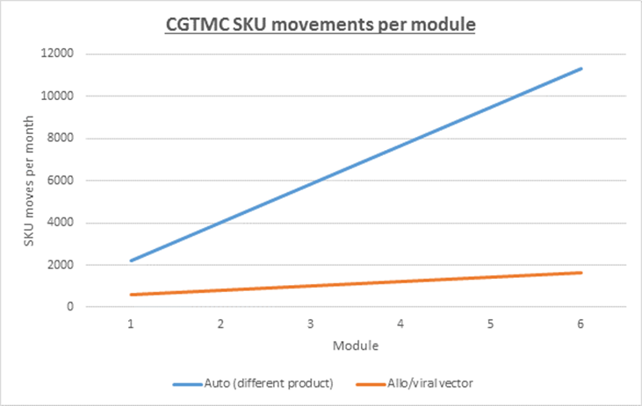

Notes:

1. The warehouse will need to cater for 300 to 500 SKUs
2. CGT defines a SKU as ‘an item required within the production process at a volume/number appropriate for the production process.  This is not necessarily the same as the stock keeping unit.

People

1. How does your company determine the number of staff required for the VMI service?
2. Would CGT be involved in the selection of staff?
3. Is there provision within your VMI service for CGT purchasing/ warehouse/ logistics personnel to work alongside one another in the same teams?
4. Would your VMI service provide back-up resources?
5. Do you have a formal system to record training of your staff by CGT trainers?
6. What is the VMI service training policy?

Supply chain including procurement

1. What is your company’s preferred method for managing the supply chain? What other options are available?
2. How would your VMI service ensure:
   1. Regulatory compliance. E.g. GMP/HTA
   2. On time delivery of materials
   3. Value for money
   4. Confidentiality
3. Stock ownership. Please define how this operates within your VMI service model?
4. Do you have the capability to transport temperature sensitive materials from an off-site warehouse to the Manufacturing Centre in a GMP compliant manner?

IT Systems

1. Are your IT systems (e.g. warehouse management system, sample tracking system etc) Eudralex Volume 4 Annex 11, 21 cfr part 11 & GAMP 5 compliant?
2. Will your company’s IT systems interface with the current CGT Enterprise Resource Planning (ERP) system, SAP by design?
3. How will your company give confidential, segregated access to the warehouse management system so for example collaborators are aware of the stock levels for critical stock items?
4. Will your IT systems reporting functions be configurable be CGT & collaborator staff?
5. Will your VMI service include the development and delivery of a testing strategy and test scripts for the testing of the IT applications and there operational functionality?
6. Will your VMI service have the capability to be hosted locally, within the public or CGT cloud?
7. Are you able to provide a software validation package for the warehouse management system to demonstrate GMP compliance (refer to 1 above)?
8. Is the warehouse management system capable to segregating between items potentially with the same part and batch number but procured by different collaborators?
9. Are you able to segregate materials by status electronically, or would you rely on a physical segregation strategy?
10. Provide IT support from them for interfacing the systems?

On-site forward picking area & off-site warehouse facilities

1. How and when would the VMI service determine the design & management systems for the off-site warehouse and on-site forward picking area?
2. Where would the off-site VMI warehouse be located?
3. How would your company ensure:
   1. Regulatory compliance at all times. E.g. GMP/HTA
   2. On time delivery of materials
   3. Value for money
   4. Health & safety compliance
   5. Collaborator confidentiality

Equipment

1. Would the VMI service include the purchase, installation and maintenance of the all equipment within the off-site warehouse facility and the on-site forward picking area? E.g. racking, fork lift trucks, fridges, freezers etc..
2. Would your company validate the fridges and freezers? E.g. provide IQ, OQ & PQ.
3. Would your company authorise CGT to undertake the environmental/temperature monitoring of the VMI storage equipment?

Stock management

1. How does your company propose to work with CGT to design and configure the VMI solution to meet all of CGTs operating practises? For example CGT would expect:
   1. As a minimum does your Warehouse Management System have the following stock status’s:
      1. Quarantine
      2. Released goods
      3. Rejected goods?
   2. How will your company provide generic processing streams for the following types of SKUs:
      1. Consumables?
      2. Product contact materials?
      3. Raw materials?
      4. Excipients?
      5. Environmental Plates?
   3. How will the VMI service manage the:
      1. CGT/collaborator min/max stock levels?
      2. Docking/booking in process?
      3. Put away process?
      4. Picking process?
   4. Will your VMI service include the provision of Standard Operating Procedures (SOPs) etc..?

Waste

1. How would the VMI service manage the packaging waste stream?

Project Management

1. What is your company’s process for meeting with the client to design and configure the VMI solution?
2. How much time does your company estimate it will take to implement a VMI system within a new facility such as the CGTMC in Stevenage?
3. Would your VMI service provide the scope/methodology together with a detailed project plan, within the agreed time scales for the implementation?
4. Would we have a contact person over the contract life time? If yes how senior is this person in terms of decision making?

Termination of contract

1. How does your company ensure normal service is maintained during the termination/transition of the contract?