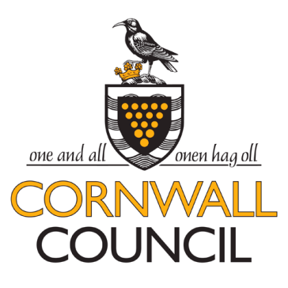
Request for Quotation for

RFQ Clarification Questions & Answers VERSION 1 dated 09.12.2015

This is a live document and will be updated every time any significant queries are raised regarding this opportunity and the responses will be shared for the benefit of prospective service providers via the same website portal that the opportunity was originally and DIRECTLY advertised on by the Council.

1.Q | Question-How do I access the ITT details?
1.A | Answer- You need to access the contracts finder website  Contracts finder is a government website that public procurements are advertised on.  If you google contracts finder you will find the website. (www.gov.uk) Please see below. You just need to click on start now to search for opportunities.  If you are having difficulties you can e-mail the service support team- ContractsFinder@crowncommercial.gov.uk  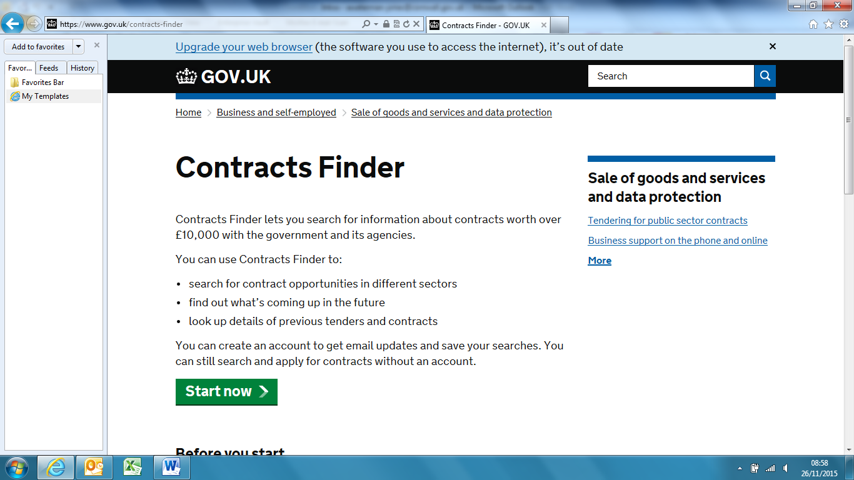
2.Q | Question-There is an error in the timetable specification between Bude and Wadebridge. The codes SSV and SD are over the wrong journeys. The SSV code should be over the journey starting from Bude at 1533 and the SD code over the journey starting at 1527
2.A | Answer - The SSV code should be over the journey starting from Bude at 1533 and the SD code over the journey starting at 1527
3.Q
3.A
4.Q
4.A
5.Q
5.A
6.Q
6.A
7.Q
7.A
8.Q
8.A
9.Q
9.A
10.Q
10.A
11.Q
11.A
12.Q
12.A

