Question No. | Date | Question | Response | Date response provided
2 | 7/12/23 | If I may ask, ahead of any formal tender stage, the documentation already highlights VMO2 as a Delivery Partner:  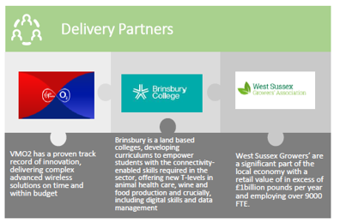  For a 5G Private Network, we would consider VMO2 a competitor and that would imply there is no role to play for ourselves or any other competitor with a 5G solution, even though the competition is open to all suitably qualified suppliers.  There is also the key consideration about access to spectrum – the solution must not be dependent on the use of any single spectrum band or licence which is tied to any given operator. This would indicate that VMO2 could not use it’s own 5G spectrum, even as a slice.  If there is a possibility to clarify the role that VMO2 will assume as a Delivery Partner that would be most appreciated.  All the best and again, thank you for confirming 9th January and we look forward to meeting yourselves and other interested parties at that time. | Please see Clarification Log 1 Q1. | 19/12/23
3 | 6/12/23 | I see VMO2 are one of your delivery partners. We provide services to VMO2 for both the fixed (fibre) and mobile (4G, 5G etc) parts of their business so I assume they will be providing the 5G infrastructure and fibre connectivity for this programme?  So is the delivery partner you are seeking to procure, an organisation that will provide, integrate and manage the technology at the user end which will be connected to the VMO2 5G network? | Please see Clarification Log 1 Q1. | 19/12/23
4 | 6/12/23 | Within the Summary document, it mentions several delivery partners on page 5, of which VM02 are listed.  Are you able to expand on the nature of this relationship? Obviously, given you are seeking a partner to deploy a hybrid 5G network, it would be useful to understand the nature of this relationship further as they are clearly able to offer this themselves. | Please see Clarification Log 1 Q1. | 19/12/23
5 | 8/12/23 | How will the Supplier Engagement sessions will be organised please:  - Will there be open sessions with other interested parties as well as 1-2-1s?  - How long are those sessions?  - Will we be expected to present the overall solutions / answers to the RFI?  - How many of us can attend? | We have not planned to have an open session, however in the RFI there is an opportunity to share your contact details with other interested parties. The 1-2-1 sessions will include an introductory presentation from WSCC, which will be the same for each supplier. The 1-2-1 session will be a minimum of 1 hour, but we may have time for longer. We will confirm the exact duration when we send you your time slot. There is not an expectation to present the overall solution, we will have agenda items to be covered which align with the RFI questions. This will be an opportunity to jointly discuss and ask questions. If you wish to prepare and present slides to support this, you are very welcome. We planned for approx. 3 to 4 attendees per supplier, but please do let us know if you want to bring more individuals and we will make every effort to accommodate. | 19/12/23
6 | 14/12/23 | The document says  “DSIT funding will accelerate the use of advanced wireless infrastructure by growers understanding the benefits and being able to invest in technology through an affordable commercial model, supported by financial assistance through a Framework if required. A clustered approach will help lower the costs of adoption by providing private services over shared passive infrastructure”  Is it the intention to operate the use cases over a public 5G network with the service provider upgrading signal strength for all in the region to use. Or for the service provider to install private 5G technology limited to users allocated by the council? | We are open and interested in hearing your thoughts regarding the technical solution and we anticipate a variety of advanced wireless solutions will be utilised. We have provided details about other nearby businesses and premises and an indication of the speeds they are currently experiencing. Of course the solution must meet the needs of the sector specific Use Cases. | 19/12/23

