 |  | Item | £ | P
 | Schedule of Works for Extension and Renovation Works

Note all quantities given are for guidance only. The contractor shall form their own opinion of the works involved, take his own measurements from site visits as required, and price the items accordingly. No adjustments will be made from differing quantities. Reference to left and right taken as though facing the front elevation from the road to the front. The contractor is to price for all the works necessary to complete the building whether specifically itemised or not, providing it could be reasonably inferred from the specification and the drawings.

All works are to comply with the Building Regulations 2015 and any later editions, and the NHBC code of practice. All materials must additionally comply with the British Standards and or better. All materials to be installed in accordance with manufacturers recommendations. Any heating and plumbing to be installed by a ‘Gas Safe’ registered engineer. Electrical installations to be installed in compliance to the latest IEE regulations by an NICEIC registered contractor. Contractor to advise the chosen Building Control Officer as to requirements of the inspections.

The contractor is to allow to protect any existing fixtures/fittings where applicable to facilitate the works in conjunction with the CL’s instructions, allowing to set aside fixtures/fittings and re-fixing on completion.

Once the contractor takes possession of the site they become responsible for the safety and protection of the property against any unforeseen issues, they should satisfy himself that he has the necessary resources to carry out the works and all insurances to indemnify himself against any liability/damage however caused.

Contractor is to allow to alter and adapt all services as required in order to facilitate the works. Allow for all site meetings, telephone calls, liaisons etc as required to complete the contract.

The porch works are to be covered under a building control application (notice) submitted & paid by the client.
Contractor is to allow here for any costs associated with arranging site inspections etc to obtain Local Authority approval and completion certificate at end of project.

 | GENERAL
A | Please state percentage for overheads and profit on variations that may arise in the contract.  Percentage Rate_____________% (Do not exceed) | Note
 | PROTECTION
A | Provide all necessary protections and sheeting’s to external areas notably the parking deck to the left hand side of the offices. | Note
B | Locate and mark out all known services and concealed service runs preceding the works commencements to the property, any unreasonable or avoidable damage sustained to such items will be at the expense of the contractors to rectify the issue. | Note
 | GENERAL CLEARANCE, STRIPOUT AND DEMOLITION
C | Cart Away  Include in this item for removal of debris (weight & Load) from site to landfill. Include here for the segregation of plasterboard waste to skip in accordance with Environmental Agency directive. | Item
 | SOUTH LODGE
 | STRIP OUT WORKS
A | Price here for the scaffold hire for roof alteration works. | Item
B | Price here for the removal of internal partitions as per clients instructions to be confirmed and measured at pricing up visit. | Item
C | Price here for the removal of the existing mineral felt and replacing with EPDM to match new porch roof. | Item
D | Allow within this item for cleaning of Moss to roof slopes | Item
E | Price here for removal of Mens urinal from existing toilet and neat cutting back of existing plumbing and drainage. | Item
F | Allow to remove existing Windows and cart away | Item
G | Remove existing fire door to left hand flank and cart away | Item
H | Remove existing external lighting and cart away | Item
 | Replacement/Alteration works
A | Replace existing gutters fascias and soffits with White UPVC and install new black gutters into exiting drainage. Allow for Gulley covers where required, | Item
B | Allow to replace existing mineral felt roof with EDPM applied as per the manufacturers Instructions. | Item
C | Allow the Prov Sum of £500.00 for repointing small pockets of mortar externally to include any mortar damaged with the window/door installation. | Prov Sum | 500 | 00
D | Allow to make good wall surfaces following removal of existing wall ready for decoration. Prices elsewhere.
E | Internally, Scrim joints and screw heads, reinforced tape joints and apply 3mm Gypsum “Multi-finish” plaster to new boards to give smooth wall/ ceiling finish, free from blemishes. | Item
F | Prime all walls with Dulux primer and prepare for redecoration. Allow for one base coat and 2 top coats of emulsion. Include here for carpet protections. | Item
G | Supply and install new Steel Fire Exit with 1 number Georgian wired glazing portion door to existing opening left hand side, with frame, stops etc, as https://doorsforsecurity.co.uk/steel-fire-exit-doors/single-steel-fire-exit-door (Or Similar). Door to be PART M Compliant | Item
H | Allow to open up, supply and install new Beams to contractors own engineers design. Prov Sum £5,000 | Prov Sum | 5000 | 00

I | Supply and Install partitions as https://www.toiletcubiclesonline.co.uk/collections/ranges/eco-range Eco range. Colours to be agreed with clerk of the council (client) prior to ordering. | Item
J | Extend existing car parking deck to dimensions agreed with client. To be reinforced concrete to a suitable depth. | Item
K | Within corridor area, allow for a carpenter to form new doors on existing shelving system to client’s specification. | Item
L | Within existing council chambers remove existing radiator from rear wall and relocate. | Item
M | Allow to remove dado from the rear wall of the council chambers. | Item
N | Allow here the provisional sum of £2,000.00 for the creation of floor to ceiling wall units with sliding doors in council chambers. | PROV SUM | 2000 | 00
O | Remove existing smart projector, screen and set aside for salvage by client. | Item
 | KITCHEN
A | The contractor is to allow a P. C. Sum of £2,000.00 (Four thousand pounds) for supply only of kitchen units to client’s choice. To include for single sink& taps and work surface  Add for ………. % profit and attendance on the above. | PC SUM | 2,000 | 00
B | Allow to price here for liaison and installation of said kitchen (assumed HOWDENS).  Liaise with the manufacturer for lead in times for the kitchen and notify Client if the lead in period would affect the works programme.  Place order with, take delivery of the kitchen units and check all items delivered prior to installation. Install the kitchen in accordance with the manufacturer’s instructions, allowing for all labour, corner fillets packing, treated softwood bearers, fixings, trims, adaptations as required to complete the installations. All base and wall units are to be properly and securely fixed to walls.  30mm thick 600mm deep post formed worktops spanning all worktops, white goods etc.  Allow for jointing strips as necessary.  Treated softwood battens to support worktops over appliances as required, plugged and screwed to walls  Cut worktop to suit services, inset sink etc as required, seal all exposed cut edges with PVC sealant.  Allow to seal all edges of sink with clear mastic  The contractor is to allow within this item for all other operations as described for the full and complete installation.  Leave full installation in perfect functioning order. | Item
C | To the kitchen floor Lay POLYFLOR POLYSAFE STANDARD NORDIC GREY 4090 Laid to manufacturer’s instructions to floor area. Include in this item for all trims and laps to leave the floor ready for use. To be laid under kitchen kick boards. | Item
 | WALL TILING
A | Allow the prime cost sum of £240.00 for supply of tiles.  (8m2 @£ 30.00 /m2) (Splash back areas to sinks only)  Plus  Contractors profit & attendance @ …….. %  (Location: Bathroom, Kitchen) | PC SUM | 240 | 00
B | Allow to price here for the fitting of ceramic tiling to wall surfaces.  Tiles to be laid to fit within window reveals, cills and on pipe ducting etc. Apply white sealant at junctions of worktops with tiling and at internal tiled angles.  Client to select tiling  - Include for all plastic cover strips at edges, cutting around  projections, openings etc to complete the installation  - All grout and adhesive to be waterproof quality  - Tiles to be laid true and level and laid in accordance with manufacturers instructions.  - Tiles to laid into cills and reveals of windows.  - On completion all tiles are to be cleaned and polished  (Location: WCs, kitchen)
 | SANITARYWARE
A | Allow for the supply and installation of 1 Number Ideal standard VUE Close coupled, dual flush WC. To include leaving in full working order(in place of former male urinal). | Item
B | Allow for the supply and installation of 1 Number Ideal Standard Della Full 540mm with single tap Hole.
 | DRAINAGE CONNECTIONS
A | Allow to connect WC’s, basins, bath, kitchen sink, washing machine, to existing foul drainage outlets, allow for all traps, fixings, fixtures etc to complete the installation. Include for replacement SVP to replace the Cast Iron pipe.  Appliance Dia of Trap (mm) Depth of seal (mm) to soil pipe Depth of seal (mm) to gully  Wash basin 32 75 75  Sink 40 75 38  WC pan 75 siphonic 50 n/a | Item
 | ELECTRICAL & PLUMBING INSTALLATION WORKS | Item
A | All works are to be carried out by an NICEIC approved Part P installer and certified on completion. (provide CL with a copy of the certificate)  All works are to be carried out in accordance with BS76712001(Inc amd 1&2) and IEE Regulations 17th ed.  Leave full installation in perfect functioning order.  Confirm all positions of sockets/outlets with the client  All wiring is to be concealed and all sockets etc to be recessed into wall surfaces, contractor is to allow for chasing out walls, notching drilling etc to facilitate this.  Any wiring run within insulation is to be rated  Any new pipe work shall be concealed beneath the timber floors and neatly clip runs in unobtrusive locations on the ground floor, above skirtings, vertical runs shall be in unobtrusive positions and boxed in.  Allow for all draining down etc as required to carry out the works. | Note
B | Price here for the electrical installation as outlined in the accompanying documents “eCal Consulting Ltd document – Scope of works, DWG no PH500 – E200 – E300 – E500 – F100 – M200 – M300 – M400 – M500 – PH200 | Item
 | WINDOWS & DOORS
A | Allow the provisional sum of £4,150.00 for the supply and installation costs for the following double glazed UPVC Top hung, sash effect windows in existing openings with matching opening configuration, glazing bars, furniture, and white cills. By named Fensa company. New Lintel Costs elsewhere in this Schedule. Window to New Front porch to be fixed glazed and sized as close as brick dims allow to drawing number “CHORLEYWOOD PARISH – PLANS AND DETAILS-DWG No.1”  Windows to be to Part L1 & N compliant (Min 1.7 U Value)  with 8000mm2 background vents. | Prov Sum | 4,150 | 00
B | New Entrance door to Be Part M Compatible including any manifestations. Allow a Prov Sum of £1,500.00 for entrance door | PROV SUM | £1,500 | 00
 | INSULATION AND ROOF WORKS
A | Allow here to Install Knauff EKO roll insulation (or similar) to existing loft void. | Item
B | Allow for the installation of a new loft hatch Manthorpe GL250 Insulated drop down loft hatch to include all trimmers etc | Item
 | FLOOR COVERINGS
A | Contract Carpets tiles allow £12 pm2 to supply only all office and corridors (WC and Kitchen vinyl priced elsewhere). 3 samples to be provided to client prior to selection | PM2
B | Allow to fit carpet tile as above to include all adhesive and threshold strips etc (chrome) .Carpet to run up to skirting. | Item
A | EXTERNAL COMPLETION WORKS  On completion the Contractor is to clear all rubble arising from the work from site and is to wash down all surfaces throughout free from all dust and builders grime. Include glazing, Soffits and Fascias and window frames to existing doors etc. Works to be undertaken from a suitable scaffold.  Allow in this item to jet clean & brush down hardstanding surfaces to right hand side of property on completion of the works  Rod through all existing drain runs prior to handover. | Item
B | Allow for filling any decorative stonework, cills etc around windows prior to redecoration with a suitable Stone paint. | Item
C | Allow to replace all external lighting with suitable Bulkhead light, to Be LED and as per clients specification. | Item
D | Allow to paint all Exposed brick walls with Dulux weathershield or similar following suitable preparation. | Item
 | PART 2 – MESS ROOM WORKS
 | These works include the creation of Doc M pack WC and mess room. These works are to be undertaken at the same time as South Lodge. | Note
A | Allow here for the digging of trench fill foundations to a depth of 800mm and width of 600mm to support exterior walls. concrete foundations (GEN 3) to approx 150mm below ground level. | Item
 | 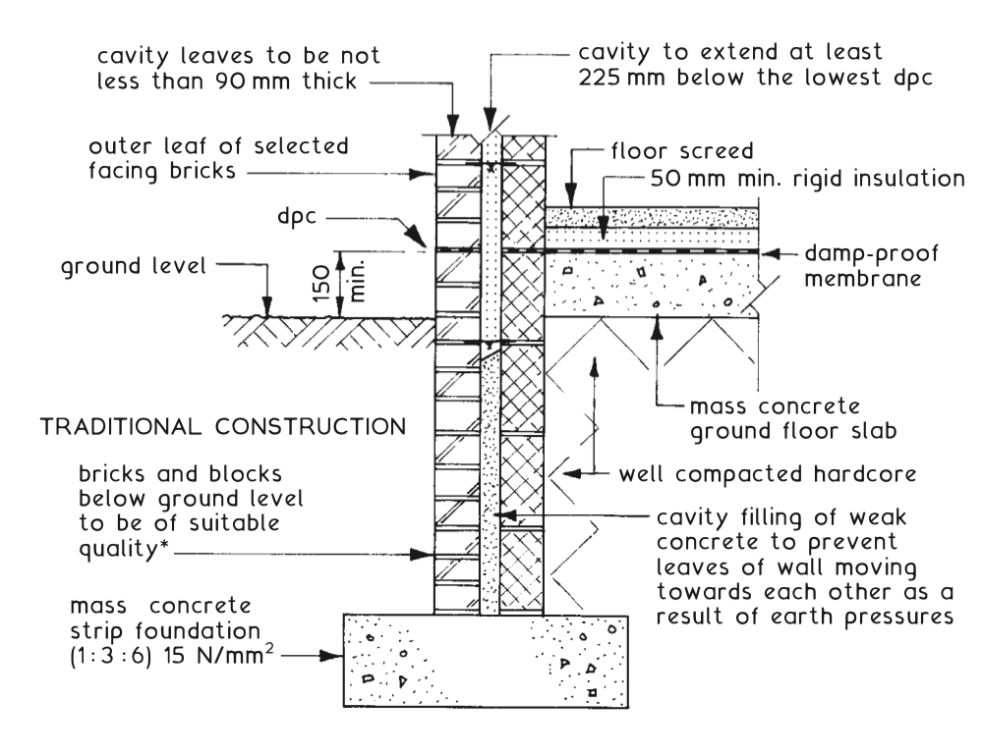
B | Price Here for slab and wall build up as above. Slab Insulation to be Kingspan TF70. | Item
C | Price here for the construction of walls to include wall plate. Walls to be faced bricked externally to match the existing mess room and blockwork internally. Blockwork as 7kn Block acceptable ready for dot and dab plasterboard finish. Walls to incorporate ancon or similar wall starter kits with flexible movement joints. Block work to not be toothed in. Walls to include dressed damp proof course into existing structure. Brickwork on external faces to be per Planning officers approval. Include for all weepholes around DPC and window heads as required. | Item
D | Allow here for brick on edge detail over lintels to window openings x2. Include within this item for cutting of brick and blockwork for installation of Mechanical extractor within the newly created WC wall. | Item
E | Allow to create the new porch roof structure as Warm Deck build up. Marine ply deck to be overlaid with Vapour control barrier and. Celotex XR4000 sized in order to meet roof timber sizing. Allow to overlay with EPDM membrane. Timber sizes to be C16 150mm x 47mm laid back to front to achieve fall for drainage. | Item
F | Price here for alterations of existing roof slope to dress roof tiles onto EPDM roof to include any insect mesh as required. | Item

G | Over new window openings, allow here to install 2 number lintels as IG lintels correctly sized for openings to include 150mm bearing either side of opening on concrete padstones. Please note that the roof timbers will likely bear on to these lintels. | Item
H | Price here for the provision of 2 number grey anthracite plastic UPVC toughened glazed windows with top hung opening portion. To be sized as per planning drawings. | Item
I | Price here for the installation of slot drain to be added to the perimeter of the mess room. Covering to be plastic and to discharge into existing rainwater system. | Item
 | Internal
 | Disability WC
A | Allow here for level access steel door, door furniture and frame including RADAR key. Minimum 1000mm width with push bar on inner leaf. Door colour to be Anthracite Grey to match windows. | Item
B | Price here for the installation of latex self levelling floor screed to newly formed floor slab. Include within this item for installation of mastic to the perimeter. | Item
C | Allow here for the supply and installation for grip vinyl flooring as clients colour choice. | Item
D | Include within this item for supply & installation of Doc M pack toilet to include drop down arm grip, Wall hung sink with Doc M taps, WC & Cistern. Allow within this item for alarm sounder cord attached to visual/ sounder to be installed within mess room. | Item
E | Allow within this item for installation of UPVC wall cladding to be fitted to walls in line with manufacturers instructions. As per clients colour specification. | Item
F | Price here for supply and installation of wall mounted circular bulkhead led light as IP44 rated 300mm dia. To be operated from ceiling mounted IR sensor on 5 minute timer. | Item
G | Allow here for the supply and installation of mechanical extraction unit as Expel air GXC9 to right hand side wall. | Item
H | To the ceilings, allow to install, tape and jointed plasterboard as 18mm ready for decoration. | Item
I | Price here for one mist coat and 2 top coats of emulsion to newly plaster boarded. ceiling | Item
 | Mess Room
A | Price here for the installation of latex self levelling floor screed to newly formed floor slab. Include within this item for installation of mastic to the perimeter. | Item
B | Allow here for the supply and installation for grip vinyl flooring as clients colour choice. | Item
C | Price here for supply and install of 18mm plasterboard to walls on dot and dabs as per manufacturers instructions. Include here for all cuts for 2 number windows. 4 number double sockets to the perimeter. | Item
D | Price here for cavity closing window cills following installation of mineral wool insulation into cavity. | Item
E | Allow to tape and joint plasterboard ready for decoration. | Item
F | Price here for one mist coat and 2 top coats of emulsion to newly plaster boarded walls. | Item
G | Price here for installation of plasterboard to be screwed into rafters to form new ceiling. Allow here for cutting of plasterboard of 4 new led downlights to be switched from existing mess room lobby. | Item
H | Allow here for one mist coat and two top coats of emulsion following taping and jointing of ceiling. | Item
 | Services
A | Please find attached “Ecal” Scope of works for pricing and including with this tender return. | NOTE
B | Assume 4 number double sockets to perimeter of newly created space | Item
C | Assume 4 led downlights as warm white within newly created space | Item
D | Assume supply and install of 2 number Finesse Myson Electric radiators of 500mm H x 1000mm L | Item
E | Assume Light Switch within existing mess room | Item
F | Assume installation of new fuseboard by NICEIC registered electrician or similar. To include certification. | Item
 | END

