 | 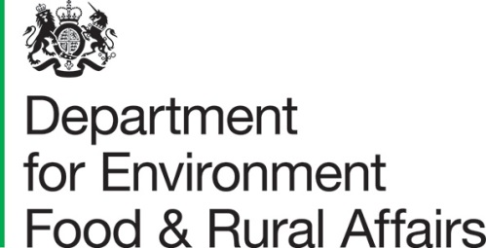 | DEFRA Group Commercial  Richard Fairclough House  Knutsford Road  Latchford, Warrington  WA4 1HT | T: 03459 335577  helpline@defra.gov.uk  www.gov.uk/defra
All Suppliers |  |  | Our ref: project_ 35432  Date: 10 May 2022

Dear ,

Provision of an Evaluation of the Counter Illegal Wildlife Trade Ranger Training Programme.
The Department for Environment, Food & Rural Affairs (DEFRA) is carrying out market engagement in anticipation of an upcoming procurement opportunity for the Evaluation of the Counter Illegal Wildlife Trade Ranger Training Programme.

DEFRA will require a Supplier to undertake this evidence review and analysis. The draft Terms of Reference (ToR) enclosed provides an overview of our requirements.

DEFRA plans to approach the market in the coming months to procure a Supplier. Ahead of our approach to the market we are undertaking a piece of market engagement activity, principally testing our proposed ToR for this work.

We have enclosed a working draft of our ToR, including details on objectives, scope and potential role and responsibilities of any Supplier to this letter and invite your review. Please follow the link where you will find a market engagement questionnaire with more specific questions that we would value your feedback on.

Market Engagement Questionnaire - Link

This market engagement piece will inform our approach to the market. In the interest of momentum, we are seeking responses no later than 11am 23rd May 2022.

Yours sincerely

Clare Mead
Category Officer

Enc. Draft Terms of Reference

