

Request for Expression of Interest

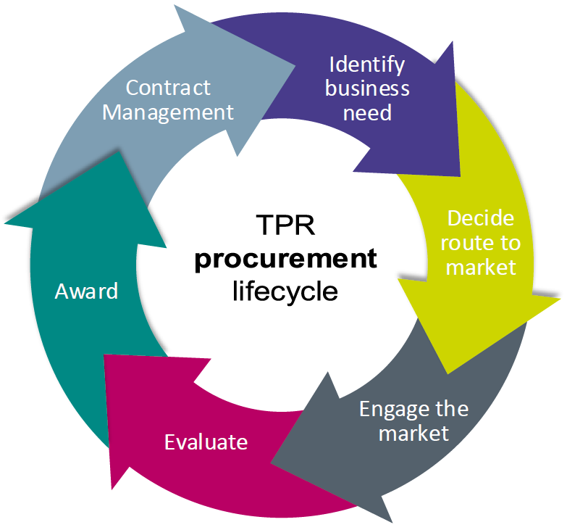

|  |  |
| --- | --- |
| **Procurement title:** | **Health and Safety Equipment** |
| **Reference number: TPR** | TPR1412 |

The Pensions Regulator (TPR) will shortly be tendering for Health and Safety Equipment Services for a 24-month contract (with 2 x optional 12-month extensions) via an Invitation to Tender through our e-Sourcing portal.

This communication is designed to provide you with a brief overview of the timescales involved in order for your company to decide whether to be involved in the tender when it is anticipated to be issued on the 28/11/2022.

**You are required to please confirm your interest by email to** [**Hannah.Clarke@tpr.gov.uk**](mailto:Hannah.Clarke@tpr.gov.uk) **no later than 18/11/2022 at 5pm. If we do not receive a response by this time, we will assume that you do not wish to be considered on this occasion.**

* All companies must confirm in their expression of interest that they have registered to our e-Sourcing portal in order to tender. To register:
  + 1. Click on the link here: <https://thepensionsregulator.bravosolution.co.uk/web/login.shtml>
    2. Click ‘Register Now’ (this is only required once)
    3. Accept the terms and conditions and click ‘Continue’
    4. Enter your business and user details
    5. Note the username you chose and click ‘Save’ when complete
    6. You will shortly receive an email with your unique password (please keep this secure).

Please note, more than one email address can be added to enable multiple users to receive notifications from the portal.

For information about TPR, our remit and activities, please visit: **www.tpr.gov.uk**

Background to the requirement

|  |  |
| --- | --- |
| **The purpose of this procurement exercise is to** | The Pensions Regulator requires specialist orthopaedic and ergonomic items of equipment in order to comply with Health & Safety legislation and, in particular, with the Display Screen Equipment Regulations for its staff at our office in Brighton. We currently have approximately 1000 staff and carry out in the region of 150 – 200 desk assessments per year. |

Scope/Specifics

In many cases, the items we would be looking to purchase are recommended after a staff member has been assessed by an occupational health practitioner or qualified workstation assessor. These items include but are not limited to:

* Specialist Chairs
* Laptop risers
* Ergonomic mice
* Ergonomic keyboards
* Lumbar supports

We would be looking for delivery options both to our office location but also potentially directly to staff members homes as part of our new hybrid working model. An online ordering function would be beneficial, and one that can show our prices if a discounted rate is offered. Delivery would be expected to be no more than 5 working days from the receipt of the order/PO for sundry items such as laptop risers, mice, keyboards, support cushions etc with a 10-15 day lead time on bulkier items such as chairs or standing desk units

Anticipated timeframes

|  |  |
| --- | --- |
| ITT issued by: | 28/11/2022 |
| Return of ITT | 16/12/2022 (5pm) |
| Award of contract: | 26/01/2023 |
| Start of contract: | 01/03/2023 |
| Anticipated duration of contract | 24 months |
| Anticipated extension options: | 2 x 12 months |

Summary

Please confirm your interest, contact details and registration within our e-Sourcing portal. If you are aware of any conflicts of interest, please advise below.

Supplier response

|  |
| --- |
|  |

Supplier contact details

|  |  |
| --- | --- |
| **Primary contact name** |  |
| **Telephone number** |  |
| **Email address** |  |
| **Confirmation of registration within  our e-Sourcing portal** |  |